Evaluation of Emissions and Exposures at Workplaces Using Desktop 3-dimensional Printers

Stefaniak AB^{a,†}, Johnson ARª, du Preez S^{b}, Hammond DR^{c}, Wells JRª, Ham JEª, LeBouf RFª, Menchaca KW^{c}, Martin SB, Jrª, Duling MGª, Bowers LNª, Knepp AKª, Su FCª, de Beer DJ^{d}, du Plessis JL^{b}

ª National Institute for Occupational Safety and Health, Morgantown, WV, USA (AStefaniak@cdc.gov; AJohnson13@cdc.gov; RWells@cdc.gov; JHam1@cdc.gov; RLebouf@cdc.gov; SMartin1@cdc.gov; MDuling@cdc.gov; LBowers@cdc.gov; AKnepp@cdc.gov; FengChiaoSu@cdc.gov)
^{b} North-West University, Occupational Hygiene and Health Research Initiative, Private Bag X6001, Potchefstroom, South Africa, 2520 (dupreezsonette@nwu.ac.za; Johan.DuPlessis@nwu.ac.za)
^{c} National Institute for Occupational Safety and Health, Cincinnati, OH, USA (DHammond@cdc.gov; KMenchaca@cdc.gov)
^{d} North-West University, Technology Transfer and Innovation Support Office, Private Bag X6001, Potchefstroom, South Africa, 2520 (Deon.deBeer@nwu.ac.za)

† Address to whom correspondence should be sent
Aleksandr B. Stefaniak
National Institute for Occupational Safety and Health
Respiratory Health Division
1095 Willowdale Road
Morgantown, WV, USA 26505
Tel.: +1-304-285-6302
E-mail: Astefaniak@cdc.gov

SUPPLEMENTAL FILE
Additional details on the facilities, analytical methods, emission rate calculations, and results are provided herein.
FACILITIES
The prototyping space in Facility A contained 10 desktop 3-d printers and a station for acetone vapor polishing of printed objects that was equipped with local exhaust ventilation. The prototyping space in Facility B contained a single desktop 3-d printer that lacked direct ventilation. The room did have a wall-mounted recirculating air conditioning unit that was briefly turned on and off during printing but it had no influence on emissions. Room C-1 contained the sheer printer as well as a print wash station (enclosed glove box for removal of water-soluble support material) and a table where finished parts were stored; the wash station was not operated during sampling.
At Facility D only, a custom-built ventilated enclosure tested to evaluate its efficacy in reducing particle and organic vapor concentrations in the print room. Figure S1 is a photograph of the enclosure attached to the shelving.
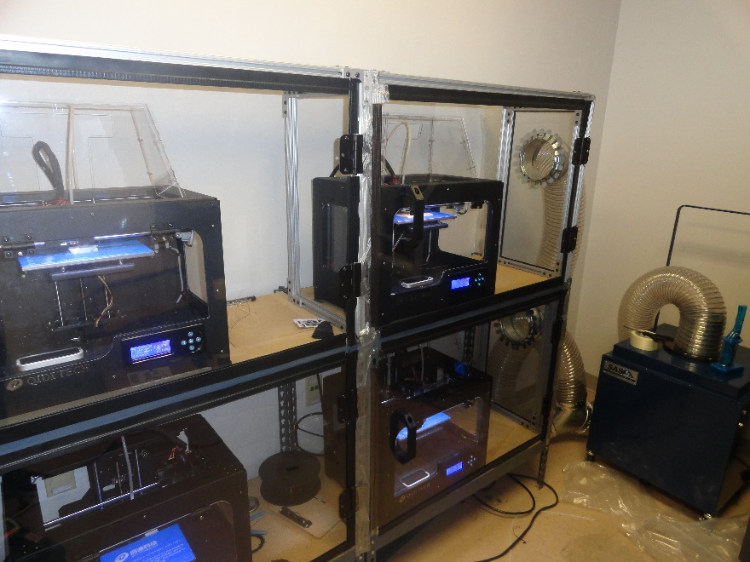
Figure S1. Photograph of a portion of the acrylic panel ventilated enclosure used to remove particles and vapors from the print room at Facility D. The exhaust ductwork connected to the portable floor fan with particle and vapor filters are visible to the right of the 3-d printers.
METHODS
Thermal Desorption Tube Sample Analysis
Thermal desorption tube samples were analyzed in recollect mode onto a new tube using a thermal desorption unit (ATD650, Perkin Elmer, Waltham, MA) attached to a 7890B/5977A GC/MS system (Agilent Technologies, Inc., Santa Clara) with a Rxi-1ms® capillary column 60 m long x 0.32 mm ID x 1 μm film thickness (Restek Corporation, Bellefonte, PA). ATD conditions were the following: an initial trap temperature of 10ºC, ramped to 325ºC at a heating rate of 40ºC/min, trap hold 10 min, no inlet split flow, desorb flow of 50 mL/min, and recollect flow of 10 mL/min. Recollected tubes were subsequently analyzed to obtain mass loadings within the calibration curve by adjusting inlet, desorb, and recollect flows. Gas chromatograph (GC) conditions were: oven temperature at 35°C for 5 min, followed by 6°C/min ramp to 95°C and then 10°C/min ramp to 140°C, followed by a 15 °C/min ramp to 220°C held for 5.17 min; and column flow rate 1.5 mL/min. Mass spectrometer (MS) analysis conditions were: combination SIM/scan mode, scanning 35-350 amu; threshold at 150; scan speed at 4.5 scans/sec; SIM on 43 and 86 m/z with dwell times of 100 ms; solvent delay to 4 min; source temperature at 300°C; and quadrapole temperature at 150°C.
Evacuated Canister Sample Analysis
Details of the canister analysis procedure were described previously.⁽¹⁾ Canisters were concentrated prior to analysis using an autosampler (Model 7016CA, Entech Instruments, Inc., Simi Valley, CA) with a 10 °C transfer line attached to a pre-concentrator (Model 7200, Entech Inc., Simi Valley, CA). The pre-concentrator was coupled with a 6890N/5973N GC-MS system (Agilent Technologies, Inc., Santa Clara, CA) with a RTX-1 capillary column 60 m long x 0.32 mm ID x 1 µm film thickness (Restek Corporation, Bellefonte, PA, USA, Bellefonte, PA). Pre-concentration conditions were: modified cold trap dehydration; module 1 (empty) at -20°C, desorbed at 10°C, and baked at 150°C for 7 min; module 2 (glass beads) focused at -80°C, desorbed at 180°C, and baked at 190°C; and module 3 (focuser) focused at -150°C. GC conditions were: oven temperature program set to 35°C for 2 min, followed by 8 °C/min ramp to 170°C, then 20°C/min ramp to a final temperature of 220°C, which was held for 3 min; injector temperature was set to 250°C with a 20:1 split (split flow 20.2 mL/min); detector temperature was 280°C; and column flow rate was set to 1 mL/min. Mass spectrometer analysis conditions were: scan mode 35–350 amu; threshold at 150; scan speed at 2.84 scans/s; solvent delay to 4.5 min; source temperature at 230°C; and, quadrapole temperature at 150°C. A one-point calibration check standard (10 ppb) and instrument blank (UHP nitrogen gas) were analyzed with each set of samples within a 24-hour period. MSD Chemstation D.02.00.275 (Agilent Technologies Inc., Santa Clara, CA) was used for data acquisition. Chromatograms were integrated and the resulting data was transferred to spreadsheets for subsequent blank correction and data handling prior to statistical analysis; final concentrations were calculated based on the response of the closest internal standard (bromochloromethane, 1,4-difluorobenzene, and chlorobenzene-d5). All quantitative measurement results were background corrected for the concentration of VOCs measured on background samples collected in workplaces.
Bubbler (Liquid Impinger) Sample Analysis
For all carbonyl impinger samples, after collection, the water was decanted into 40 mL vials, then derivatized with 100 µL aqueous 250 mM O-tert-butylhydroxylamine hydrochloride (TBOX, Sigma Aldrich, St. Louis, MO) and placed in a heated water bath at 70°C for 2 hours. After removing the vial from the water bath and allowing to cool to room temperature, 0.5 mL of toluene was added to the vial. The vial was then shaken for 30 seconds and allowed to separate into a toluene layer and aqueous layer. Then 100 µL of the toluene layer was removed with a pipette and placed in a 2 mL autosampler vial with a 100 µL glass insert (Restek, Bellefonte, PA). Then 1 µL of the TBOX-derivatized extract was analyzed using a Varian (Palo Alto, CA) 3800/Saturn 2000 GC-MS system operated in the electron impact (EI) mode. Full-scan EI ionization spectra were collected from m/z 40-650. Compound separation was achieved by an Agilent (Santa Clara, CA) HP-5MS (0.25 mm I.D., 30 m long, 0.25 µm film thickness) column and the following GC oven parameters: 40°C for 2 min, then 5°C/min to 200°C, then 25°C/min to 280°C and held for 5 min. One µL of each sample was injected in the splitless mode, and the GC injector was returned to split mode 1 min after sample injection, with the following injector temperature parameters: 130°C for 2 min then 200°C/min to 300°C and held for 10 min. The Saturn 2000 ion trap mass spectrometer was tuned using perfluorotributylamine (FC-43).
Emission Rate Calculations
Emission rates (ER) were calculated using a model developed to describe emission sources in indoor environments.⁽²⁾ This model was previously applied by Stabile et al.⁽³⁾ to describe desktop-scale FDM™ machine emissions in a room. According to He et al.,⁽⁴⁾ an emission source in a room can be described by the following equation:
(1)
where V = the room volume, C_{peak} = peak concentration of the contaminant during printing, C_{out} = the outdoor concentration of the contaminant during printing (assumed to be equal to the background concentration in each printer room), Δt = the time difference between C_{peak} and C_{out}, = average total removal rate of the contaminant (AER = air exchange rate in the room, k = rate of contaminant loss due to deposition onto surfaces), and = the average concentration of the contaminant during printing. As noted by He et al. (2004) some factors in this equation, such as C_{in} and C_{out}, are functions of some other factors and can vary in time. Hence to estimate the average emission rate, the equation is simplified by using average values instead of functions. This equation ignores the effects of particle dynamics (i.e., condensation, evaporation, and coagulation) as they are considered to be minor.⁽⁴⁾ For indoor environments, k can be taken to be ≈ 1/hr.⁽²⁾ The rooms in Facilities A, C, and E were not supplied by mechanical ventilation and the average AER value was taken to be 0.22/hr.⁽⁴⁾ In Room D-1, the average AER was known to be 2/hr from the building engineer. In Room D-2, the average AER was calculated to be ≈ 1/hr based on the volume of the space and number of occupants observed during sampling.⁽⁵⁾

RESULTS
Figure S2 is a plot of particle number concentration in the high bay at Facility E that was measured using the NanoScan instrument during warm-up and operation of the injection molding machine. During warm-up, a reservoir that contained pre-loaded ABS pellets was heated from 40 to 235°C and particle number concentration rapidly increased in the room. During injection molding of six parts, particle number concentration was relatively constant (20,000 to 26,000 particles/cm³).
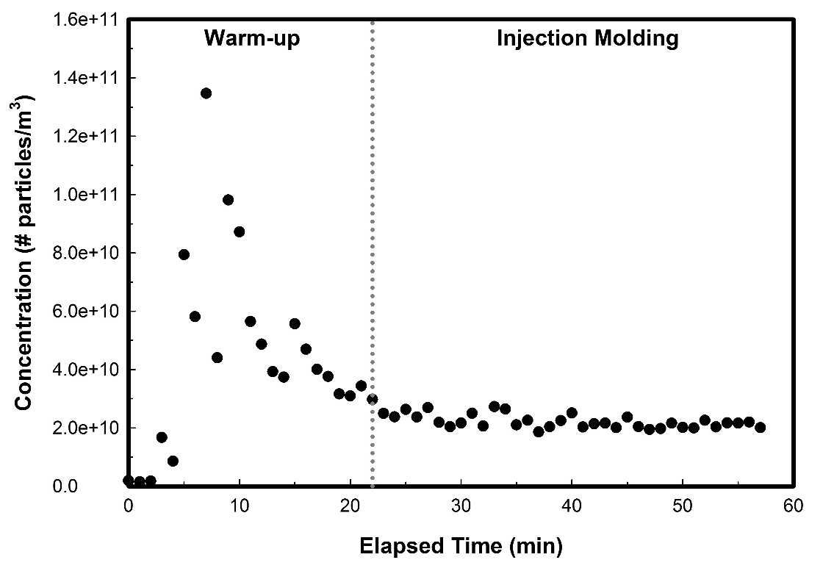
Figure S2. Particle number concentration in the high bay at Facility E: background (t = 0 to 5 min), machine warm-up (t = 5 to 22 min), injection molding six parts (t = 22 to 58 min).

Instantaneous (10 to 15 second) canisters samples were collected at the start of warm-up (40°C) and when the injection molding machined reached its set temperature (235°C). Additionally, a canister sample was collected at the hopper opening where ABS pellets are added to the pre-heated reservoir. Table S1 summarizes the identities and concentrations of individual quantified VOCs. Both the identity and concentrations of chemicals were similar during warm-up; however, at the hopper opening more VOCs were identified and at higher concentrations.
Table S1. Concentrations (µg/m³) of volatile organic compounds in the high bay (Facility E) during warm-up of an injection molding machine

Chemical | Start (40 °C) | Set point (235 °C) | At hopper opening
Acetaldehyde |  | 4.7 | 102.2
Acetone |  |  | 207.4
Benzene |  |  | 329.7
Ethanol | 36.6 | 29.4 | 63.1
Ethylbenzene |  |  | 33.0
Isopropyl Alcohol | 1289 | 1304 | 5312
Methyl Methacrylate |  | 0.7 | 93.8
Styrene |  |  | 96.7
Toluene |  |  | 14.7
m,p-Xylene |  | 0.2 | 3.0
o-Xylene |  |  | 3.5
Empty cell = not detected above background

Figure S3 is plots of personal TVOC exposures for a 3-d printer operator at Facility D. The plots show daily peaks associated with entering the print room (all days) as well as peaks from specific tasks, such as applying polyurethane to printed parts using a brush (day 2). Tasks performed by other employees, including cleaning 3-d printer build plates with isopropyl alcohol also transiently influenced this employees’ exposure on day 3.
Used polyurethane
Isopropyl alcohol
used in Print Room
Figure 3. Personal TVOC profile of 3-d printing worker at Facility D

REFERENCES
1 LeBouf, R.F., Stefaniak, A.B., Virji, M.A. J. Environ. Monit. 2012, 14, 977.
2 He, C., Morawska, L., Hitchins, J., Gilbert, D. Atmos. Environ. 2004, 38(21), 3405.
3 Stabile, L., Scungio, M., Buonanno, G., Arpino, F., Ficco, G. Indoor Air. 2017, 27(2), 398.
4 He, Z., Li, G., Chen, J., Huang, Y., An, T., Zhang, C. Environ. Int. 2015, 77, 85.
5 ASHRAE: 62.1-2016 -- Ventilation for Acceptable Indoor Air Quality. [Standard] Atlanta, GA: ASHRAE, 2016.

