Supplement to Evaluating Vaccination Policies to Accelerate Measles Elimination in China: a Meta-Population Modeling Study
Lixin Hao,¹ John W Glasser,² Su Qiru,¹ Ma Chao,¹ Zhilan Feng,³ Zundong Yin,¹ James L Goodson,² Ning Wen,¹ Chunxiang Fan,¹ Hong Yang,¹ Lance E Rodewald,^{1,2,4} Zijian Feng,¹ Huaqing Wang¹

¹Chinese Center for Disease Control and Prevention, 27 Nanwei Road, Xicheng District, Beijing 100050 PRC
²Centers for Disease Control and Prevention, 1600 Clifton Road NE, Atlanta, GA 30333 USA
³Purdue University, 150 North University Street, West Lafayette, Indiana 47907 USA
⁴Office of the World Health Organization Representative in China, 23 Dongzhimenwai Dajie, Chaoyang District, Beijing 100600 PRC

Overview
Here we describe methods, subsidiary or illustrative calculations and disaggregate results presented in the main text. In section I, we describe three methods for estimating forces of infection in vaccinated populations. In section II, we derive the age-specific probabilities of infection on contact with an infectious person from the 2006 forces of infection, contact rates and mixing matrix (i.e., proportions of the contacts that members of each group have with members of all groups including their own). We perform these calculations using information from contact studies in Southern China and Europe to demonstrate why we use the European observations in our modeling of vaccine-preventable diseases in China. We also derive the basic reproduction number for age-structured SEIR population models without demographic dynamics, sub-population contributions and prevalence via the next-generation approach. In section III, we compare the respective impacts of vaccinating the age group contributing the most and older and younger people to illustrate what we mean by evaluating analytical results by simulation. We also describe the harmonic function by which we force the infection rates in our simulation models and compare simulation and surveillance results from 2005 until 2009. For the calculations in subsequent sections and entire main text, we use the 2014 forces of infection and our age- and location-stratified SEIR population model. In section IV, we tabulate the provincial reproduction numbers illustrated in the main text (figures 3) and their ratio, an indication of vaccination program effectiveness. In section V, we describe the immune profiles required to derive the provincial effective reproduction numbers from basic ones and vaccination rates required to evaluate the gradient, presented by province. In the main text, we aggregate constituents of this vector-valued function by region (figures 5-7).

I. Estimating forces of infection in vaccinated populations
Given immunization (uptake × efficacy) histories, p_{a,t}, one can back-calculate the numbers susceptible by age and time from historical births, N_{0,t}, and disease surveillance, I_{a,t}, together with an estimate of under-reporting. The forces or hazard rates of infection, λ_{a,t} are simply incidences among those susceptible:
Given proportions with antibodies from a cross-sectional serological survey, the forces of infection may be estimated independent of disease surveillance in two ways:
If the proportion seropositive at age a is the complement of the proportion that escaped both immunization and infection, assumed to be independent,where p_{a} is the proportion immunized at age a and λ(s) is the force of infection among those susceptible aged s ≤ a, we can solve for λ at any exact age, a for example, as
Alternatively, we can write cumulative infections at ages a and a – 1 as and where p_{a} and p_{a – 1} are proportions immunized and N_{a} and N_{a – 1} are numbers of people in a population aged a and a – 1, respectively. Then
All three approaches rely on accurate historical vaccine uptake and efficacy. Because the third does not require independent vaccination and infection, comparison with the second might enable us to evaluate that assumption. Similarly, by comparing approaches that involve disease surveillance and serology, one might be able to assess under-reporting.
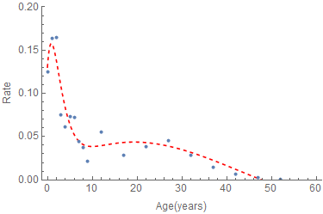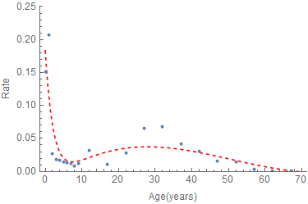
Figure A1. Hazard rates of infection among persons susceptible to measles by age in China during 2006 and 2014 estimated via the first method.

II. Probabilities of infection on contact, basic reproduction number and associated eigenvectors deduced from SEIR models with 2006 forces of infection and Chinese and European contact studies
Our model of measles in China has 31 discrete locations and 15 age groups. We calculate the forces of infection and proportions infected as continuous functions of age and then average them over the requisite intervals. If immunity is lifelong, the probability of remaining susceptible at age α, where λ(s) is the force or hazard rate of infection at age s. Consequently, given λ(s), one can calculate the proportions infected, or vice versa.
In discrete age-structured models, we write the force of infection as where a_{i} is the per capita contact rate and β_{i} the probability of infection on contact with an infectious person, c_{ij} are the proportions of their contacts that members of the i^{th} age group have with members of the j^{th}. Quotients of I_{j} and N_{j} are probabilities that randomly encountered members of the j^{th} age group are infectious, usually called attack rates. Given the contact rates, a_{i} and mixing matrix, c_{ij} from a study of inter-personal contacts, one can then solve the system of λ_{i} equations for the unknown β_{i} (figure A2.2).
Proportions infectious and probabilities of infection on contact with infectious persons calculated from 2006 forces of measles infection (which are positive only through 49 years of age, figure A1 left) and contact rates and mixing matrices from southern China⁴ and Europe⁵ are compared on the left and right of figures A2.1 and A2.2, respectively:
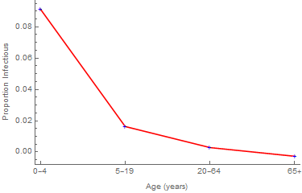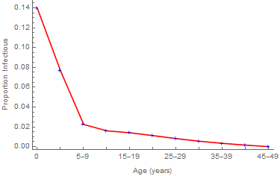
Figures A2.1. Proportions infectious by age calculated using information from the contact studies in southern China and Europe on the left and right, respectively.
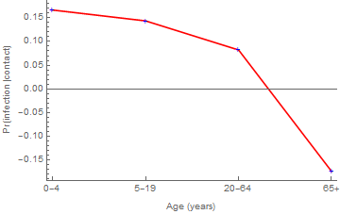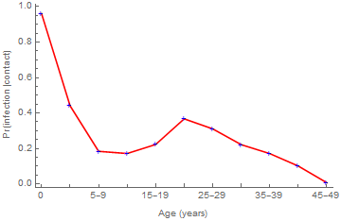
Figures A2.2 Probabilities of infection upon contact with infectious people using information from the contact studies in southern China and Europe on the left and right, respectively.
In population biology, the next-generation matrix K multiplies the numbers by age in one generation to yield those in the next. Its dominant eigenvalue, or average factor by which successive generations differ in magnitude, is denoted ℜ₀. In infectious disease epidemiology, reproduction numbers are average numbers of secondary infections per infectious person. And next-generation matrices are commonly derived from transmission models via the approach of van den Driessche and Watmough.¹ They may be written as products of diagonal matrices, whose elements are ℜ_{0i} (defined as a_{i}β_{i}/γ, where γ is the recovery rate and other terms are as previously defined in age-stratified SEIR models without demographic dynamics), and mixing matrices.² The dominant eigenvalue has two associated nonzero vectors whose dot products with Κ or its transpose equal their products with the eigenvalue. These eigenvectors also have biological interpretations: one is the prevalence of infection and other is contributions to ℜ₀.³
Measles ℜ₀ is about 18 regardless of contact study, but the age-specific contributions and prevalence are much more informative when we use the European observations (cf. figures A2.3 and A2.4):
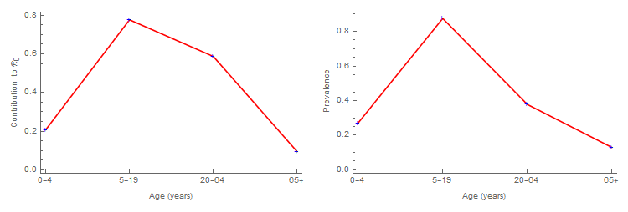
Figures A2.3. Age-specific contributions to ℜ₀ and prevalence, right and left eigenvectors associated with the dominant eigenvalue of the next-generation matrix, calculated using information from reference 4.
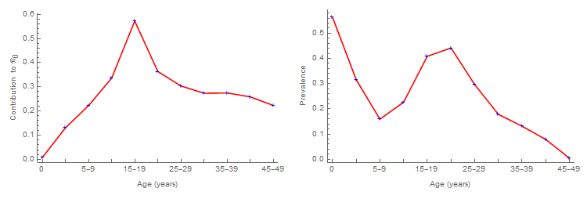
Figures A2.4. Age-specific contributions to ℜ₀ and prevalence, right and left eigenvectors associated with the dominant eigenvalue of the next-generation matrix, calculated using information from reference 5.
In their figure S4, Read et al.⁴ compare their participants’ age-specific contact numbers and durations with those of the PolyMod⁵ participants. Aside from contact age resolution, results are quite similar. Consequently, in our modeling of the transmission of pathogens causing respiratory diseases in China, we use the more informative European observations.
In our modeling of the transmission of the pathogens causing vaccine-preventable diseases in China, we assume that the probabilities of infection on contact vary only with age, but that the contact rates vary with population density and diminish with inter-location distances at age-specific rates (figures A2.5) calculated as described in reference 6.
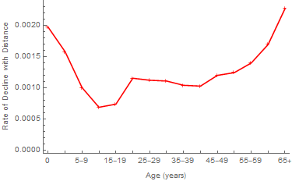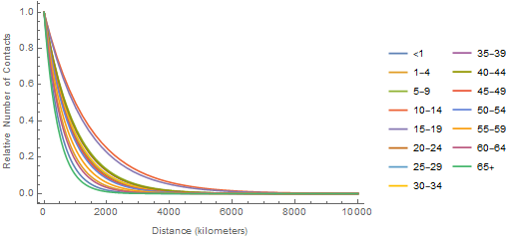
Figures A2.5. Age-specific rates at which contacts decline with distance (left) and relative contact rates by age as a function of distance in China (right).

III. Evaluation of Analytical Results
In 2006, the age-specific contributions to ℜ₀ peak from 15-19 years of age. Consequently, vaccinating susceptible people in that age range should reduce the effective reproduction number, ℜ_{E} the most. As figure 1a indicates that about 20% of those people were susceptible, we evaluated this analytical result by simulation.
From disease surveillance from 2005-14, we estimated age-specific coefficients (a, b, …, h) of harmonic functions, F_{i} by which we force the contact rates:
,
where t is measured in months. With independent estimates of all other parameters, our age-structured SEIR model reproduces reported cases well, especially at the younger ages (figures A3.1):
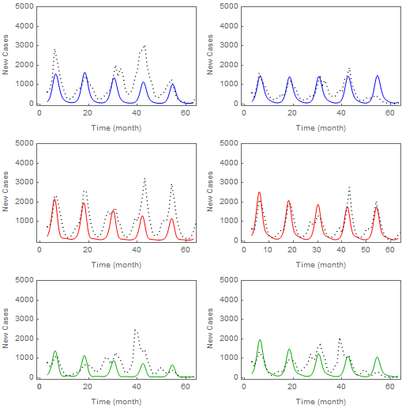
Figures A3.1. Incident cases of measles among infants (left) and children aged one to four years (right) from January of 2005 through December 2009 in, top to bottom, eastern, central and western China. The dots and solid lines represent monthly reported and predicted numbers of infections, respectively.
Using this model, the simulated impact of administering the same number of doses to successive age groups and numbers of doses required to have the same impact in each group are consistent with our analytical results:
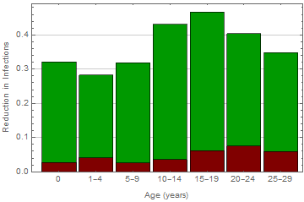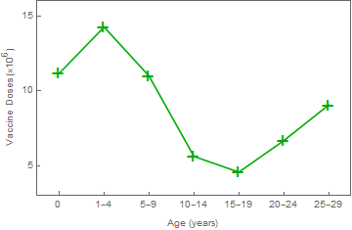
Figures A3.2. Reductions in infections during a 5-year period and doses of vaccine required to attain 40% reductions, left and right, respectively, both by virtue of vaccinating successive 5-year age classes.
Simulations indicate that, when adolescents aged 15-19 years are vaccinated, the reduction in infections is greatest and doses of vaccine required to attain a 40% reduction are least (figures A3.2). As noted in the main text, substantial proportions of averted infections, shown in green, are in unvaccinated age groups.
Analyses are time-independent, whereas simulations involve numerical solution of the full model, a system of differential equations with time-varying infection rates and vaccination strategies. Comparing results of these very different approaches evaluates our methods. Absent independence, however, the observed consistency does not validate them.

IV. Sub-Population Reproduction Numbers
Because ℜ_{Ei} = ℜ_{0i}×(1 – p_{i}) where p_{i} is the proportion of sub-population i that is immune, the ratio ℜ_{Ei}/ℜ_{0i} is interpretable as proportion of sub-population i that is susceptible. While one can become immune naturally as well as by vaccination, to some extent this proportion reflects the quality of provincial immunization programs.
Province | ℜ_{0i} | ℜ_{Ei} | Ratio
Anhui | 22.108783 | 1.142294 | 0.051667
Beijing | 20.107494 | 1.383034 | 0.068782
Chongqing | 20.927711 | 2.020126 | 0.096529
Fujian | 17.808397 | 1.902456 | 0.106829
Gansu | 18.709664 | 2.101917 | 0.112344
Guangdong | 17.085565 | 1.783269 | 0.104373
Guangxi | 17.393271 | 3.315139 | 0.190599
Guizhou | 18.86048 | 1.799579 | 0.095415
Hainan | 13.677372 | 0.781802 | 0.05716
Hebei | 21.264046 | 2.382902 | 0.112062
Heilongjiang | 11.35635 | 1.248225 | 0.109914
Henan | 22.757798 | 3.032706 | 0.13326
Hubei | 22.429552 | 2.359369 | 0.10519
Hunan | 20.910025 | 2.617713 | 0.125189
Inner Mongolia | 17.338563 | 2.739128 | 0.157979
Jiangsu | 20.87285 | 2.490975 | 0.11934
Jiangxi | 20.615014 | 2.148026 | 0.104197
Jilin | 13.821466 | 1.254235 | 0.090745
Liaoning | 16.74131 | 1.561169 | 0.093252
Ningxia | 19.219726 | 1.521853 | 0.079182
Qinghai | 15.916729 | 1.603178 | 0.100723
Shaanxi | 21.511764 | 0.976037 | 0.045372
Shandong | 21.407715 | 1.957926 | 0.091459
Shanghai | 19.12581 | 1.339039 | 0.070012
Shanxi | 21.615313 | 2.833584 | 0.131092
Sichuan | 19.192622 | 1.306478 | 0.068072
Tianjin | 20.54142 | 0.864014 | 0.042062
Tibet | 10.04588 | 2.505965 | 0.249452
Xinjiang | 6.8536583 | 1.645769 | 0.24013
Yunnan | 15.068596 | 2.572486 | 0.170718
Zhejiang | 19.153635 | 0.889115 | 0.04642

V. The Gradient
The gradient calculations illustrated for Eastern, Central and Western China (figures 5) and by province below require ℜ_{Ei}, products of ℜ_{0i} (derived in reference 6 for the meta-population SEIR model with age and spatial strata and two-dimensional mixing) and proportions susceptible (1 – p_{i}), and vaccination rates, χ_{i}.
For the proportions susceptible, we used complements of sub-population immune profiles (slices through complements of the 3D surfaces below, bivariate logistic regressions in which we represent time and age as first and third order polynomials, respectively, with – because these main effects are related biologically – all interactions). We calculate routine vaccination rates χ₀ from differences between proportions immune (one-year intervals corresponding to infancy on these 3D surfaces) and infected from provincial disease surveillance as follows:
where subscripts denote age, p is total and λS/N is naturally acquired immunity. For present purposes, we performed this calculation for t = 2014. But historical calculations would indicate the evolution of provincial vaccination programs, if not the impact of SIAs.
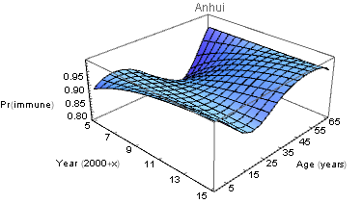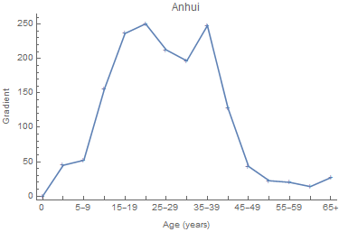
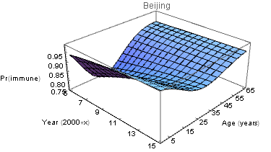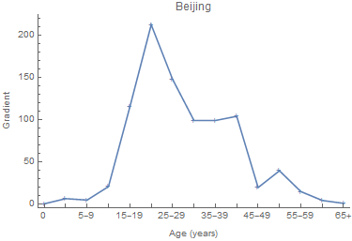
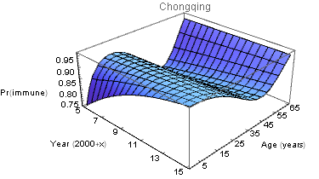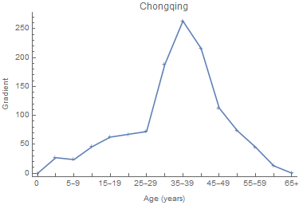
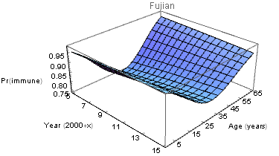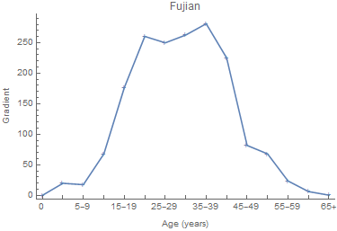
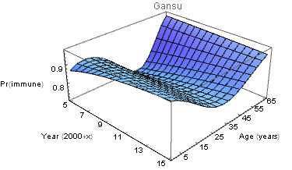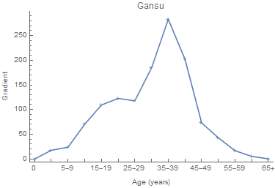
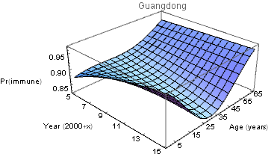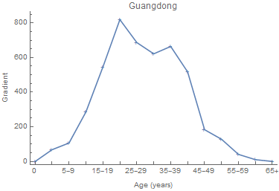
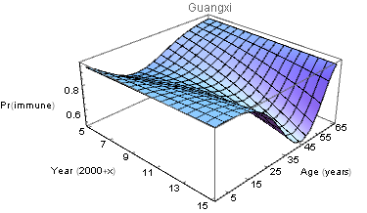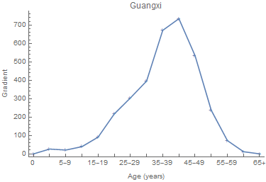
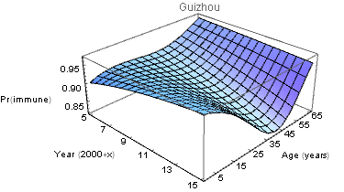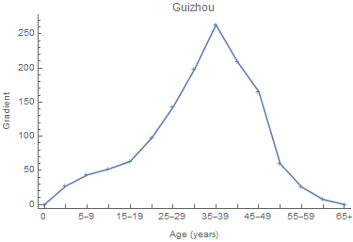
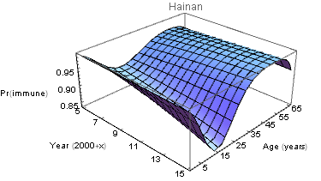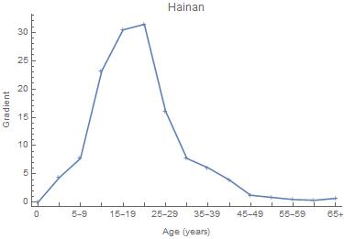
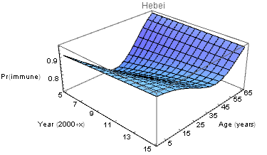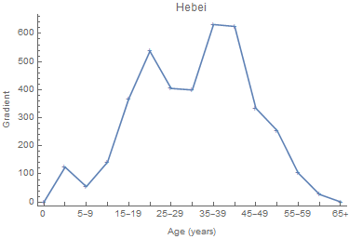
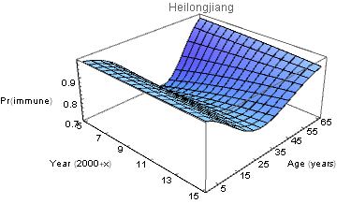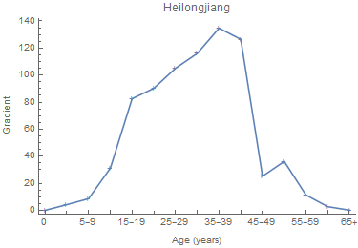
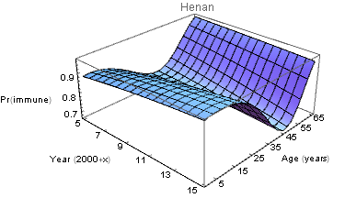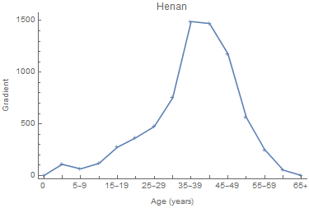
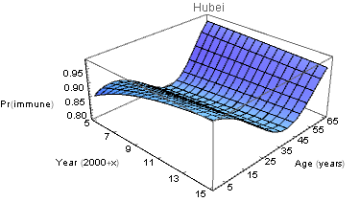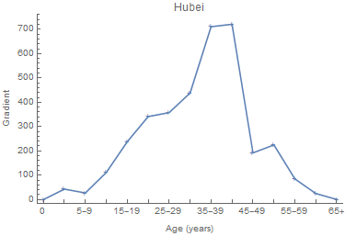
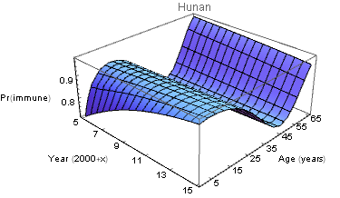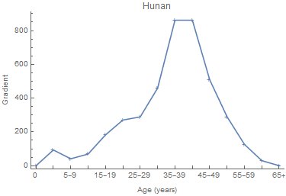
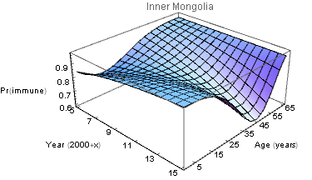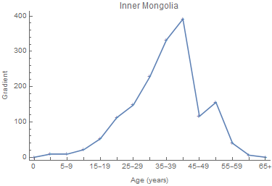
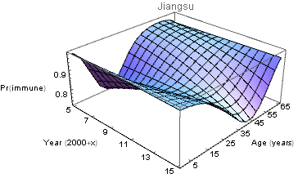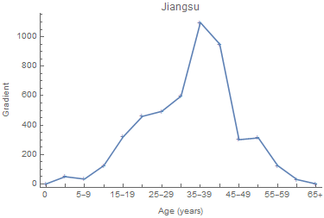
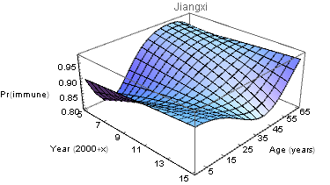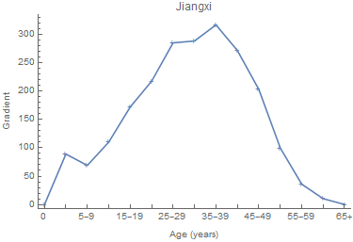
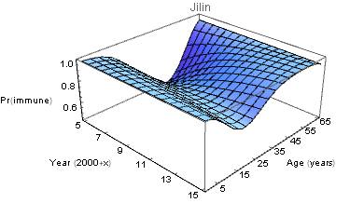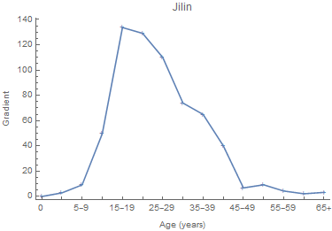
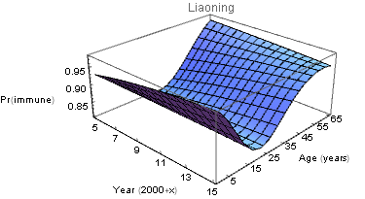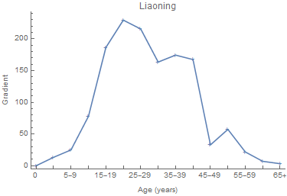
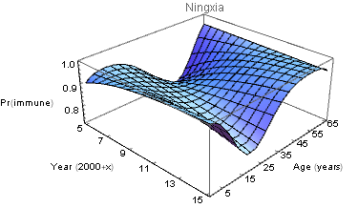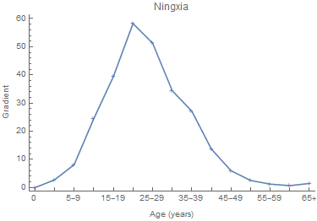
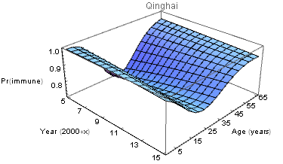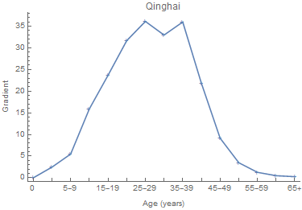
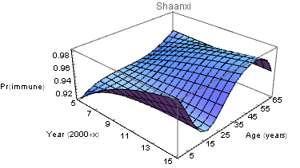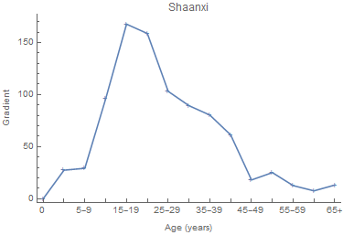
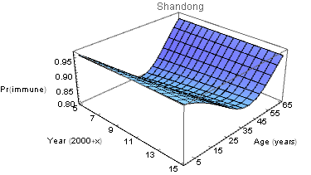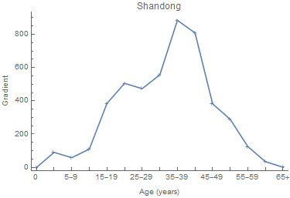
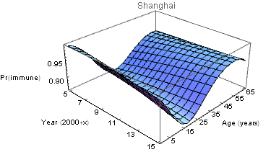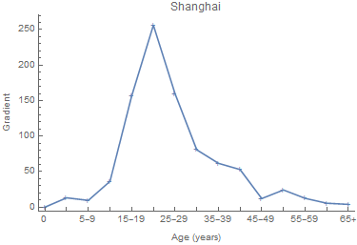
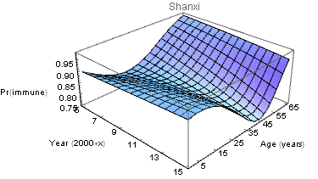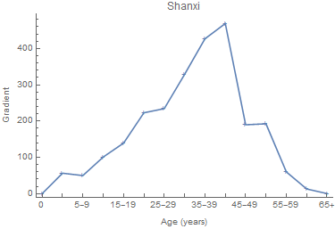
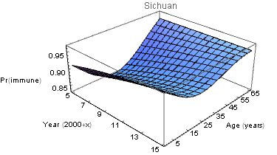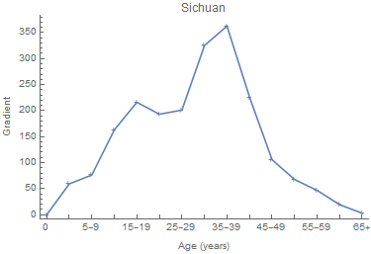
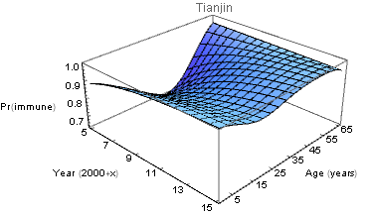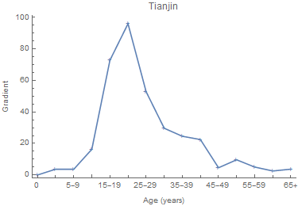
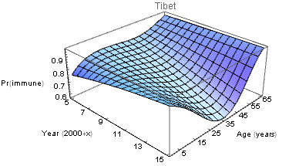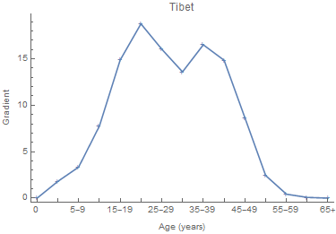
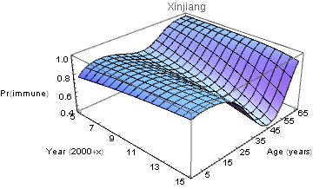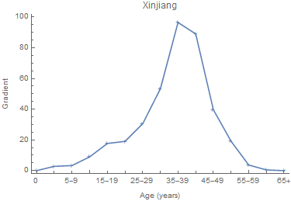
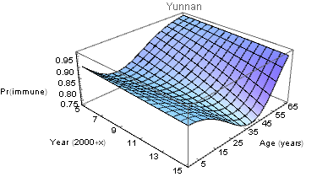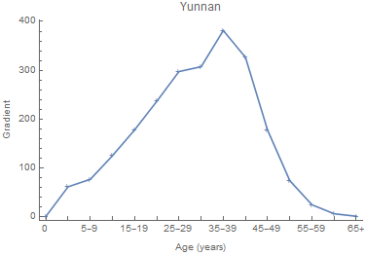
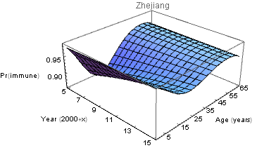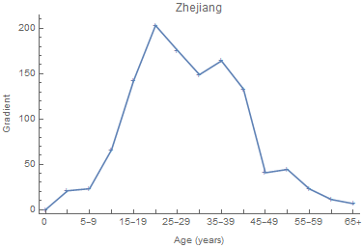
Figures A5. a) Immune profile 2005-15 and b) 2014 gradient by province, PR China. We extended these 3D surfaces beyond the ages of survey participants by adding a few centenarians with immunity, 1 – 1/ℜ₀ to the 2006 and 2014 datasets. Coefficients and goodness-of-fit criteria for the 31 bivariate regressions are available from the authors.
References
1. van den Driessche P, Watmough J. Reproduction numbers and sub-threshold endemic equilibria for compartmental models of disease transmission. Math Biosci 2002; 180:29–48
2. Feng Z, Hill AN, Smith PJ, Glasser JW. An elaboration of theory about preventing outbreaks in homogeneous populations to include heterogeneity or non-random mixing. J Theor Biol 2015; 386:177–87
3. Caswell H. Matrix Population Models: Construction, Analysis and Interpretation, Second Ed. Sunderland, MA: Sinauer Associates, 2001
4. Read JM, Lessler J, Riley S, et al. Social mixing patterns in rural and urban areas of southern China. Proc R Soc B 2014; 281:20140268
5. Mossong J, Hens N, Jit M, et al. Social contacts and mixing patterns relevant to the spread of infectious diseases. PLoS Med 2008; 5:381–91
6. Feng Z, Hill AN, Curns AT, Glasser JW. Evaluating targeted interventions via meta-population models with multi-level mixing. Math Biosci 2017; 287:93–104

