**Supplementary materials**

STable 1 Correlation coefficients and p-values between ambient air pollution concentrations averaged across gestational weeks 2 to 8

|  |  |  |  |  |  |  |  |
| --- | --- | --- | --- | --- | --- | --- | --- |
|  | PM2.5 | PM10 | NO2 | NO2 max | SO2 | SO2 max | O3 |
| PM10 | 0.57 (<.001) |  |  |  |  |  |  |
| NO2 | 0.25 (<.001) | 0.21 (<.001) |  |  |  |  |  |
| NO2 max | 0.22 (<.001) | 0.30 (<.001) | 0.91 (<.001) |  |  |  |  |
| SO2 | 0.07 (<.001) | -0.13 (<.001) | 0.43 (<.001) | 0.26 (<.001) |  |  |  |
| SO2 max | 0.13 (<.001) | -0.12 (<.001) | 0.24 (<.001) | 0.19 (<.001) | 0.83 (<.001) |  |  |
| O3 | -0.12 (<.001) | 0.23 (<.001) | -0.36 (<.001) | -0.08 (<.001) | -0.41 (<.001) | -0.16 (<.001) |  |
| CO | 0.39 (<.001) | 0.27 (<.001) | 0.49 (<.001) | 0.47 (<.001) | 0.10 (<.001) | 0.029  (0.09) | -0.33 (<.001) |

STable 2 Crude and adjusted* odds ratios (ORs) of overall CLDs per interquartile range (IQR) change in air pollution levels (overall and weekly averages**) from single-pollutant models

|  |  |  |  |  |  |
| --- | --- | --- | --- | --- | --- |
| Pollutant  *** | IQR | Time  window | Crude  OR (95% CI) | Adjusted model 1  OR (95% CI) | Adjusted model 2  OR (95% CI) |
| PM2.5 | 5.6 | overall | 0.99 (0.91, 1.08) | 0.95 (0.86, 1.04) | 0.92 (0.84, 1.02) |
|  | µg/m3 | 2 | 1.01 (0.95, 1.08) | 0.98 (0.92, 1.05) | 0.97 (0.90, 1.03) |
|  |  | 3 | 1.02 (0.96, 1.09) | 1.00 (0.94, 1.07) | 0.99 (0.92, 1.05) |
|  |  | 4 | 0.97 (0.90, 1.04) | 0.95 (0.88, 1.02) | 0.93 (0.86, 1.01) |
|  |  | 5 | 1.03 (0.97, 1.09) | 1.00 (0.94, 1.07) | 0.99 (0.93, 1.06) |
|  |  | 6 | 0.96 (0.90, 1.03) | 0.94 (0.87, 1.00) | 0.93 (0.86, 1.00) |
|  |  | 7 | 0.97 (0.90, 1.04) | 0.94 (0.88, 1.01) | 0.94 (0.87, 1.01) |
|  |  | 8 | 0.97 (0.91, 1.04) | 0.95 (0.89, 1.02) | 0.95 (0.88, 1.02) |
| PM10 | 11.3 | overall | 0.99 (0.90, 1.08) | 0.89 (0.80, 0.98) | 0.91 (0.82, 1.02) |
|  | µg/m3 | 2 | 0.98 (0.92, 1.04) | 0.93 (0.87, 1.00) | 0.94 (0.88, 1.01) |
|  |  | 3 | 1.02 (0.96, 1.09) | 0.98 (0.92, 1.05) | 0.99 (0.93, 1.06) |
|  |  | 4 | 1.01 (0.96, 1.07) | 0.98 (0.91, 1.04) | 0.99 (0.93, 1.05) |
|  |  | 5 | 0.99 (0.93, 1.05) | 0.94 (0.88, 1.01) | 0.96 (0.89, 1.03) |
|  |  | 6 | 0.98 (0.92, 1.05) | 0.93 (0.87, 1.00) | 0.95 (0.88, 1.02) |
|  |  | 7 | 0.99 (0.93, 1.05) | 0.94 (0.87, 1.00) | 0.96 (0.89, 1.02) |
|  |  | 8 | 1.00 (0.94, 1.06) | 0.96 (0.90, 1.02) | 0.98 (0.92, 1.04) |
| CO | 0.8 | overall | 1.11 (0.99, 1.24) | 1.11 (0.99, 1.24) | 1.10 (0.96, 1.25) |
|  | ppm | 2 | 1.10 (1.01, 1.21) | 1.10 (1.00, 1.21) | 1.07 (0.96, 1.20) |
|  |  | 3 | 1.09 (1.00, 1.20) | 1.08 (0.99, 1.19) | 1.06 (0.95, 1.18) |
|  |  | 4 | 1.09 (0.99, 1.20) | 1.09 (0.98, 1.20) | 1.06 (0.95, 1.19) |
|  |  | 5 | 1.08 (0.98, 1.19) | 1.08 (0.98, 1.19) | 1.06 (0.95, 1.18) |
|  |  | 6 | 1.08 (0.98, 1.18) | 1.07 (0.97, 1.18) | 1.07 (0.96, 1.19) |
|  |  | 7 | 1.07 (0.96, 1.18) | 1.06 (0.96, 1.18) | 1.06 (0.94, 1.19) |
|  |  | 8 | 1.10 (0.99, 1.21) | 1.10 (0.99, 1.22) | 1.11 (0.99, 1.24) |

Table 2 (continued)

|  |  |  |  |  |  |
| --- | --- | --- | --- | --- | --- |
| Pollutant  *** | IQR | Time  window | Crude  OR (95% CI) | Adjusted model 1  OR (95% CI) | Adjusted model 2  OR (95% CI) |
| NO2 | 8.5 | overall | 1.12 (0.99, 1.26) | 1.10 (0.96, 1.26) | 1.07 (0.91, 1.24) |
|  | ppb | 2 | 1.15 (1.03, 1.28) | 1.13 (1.01, 1.28) | 1.09 (0.96, 1.24) |
|  |  | 3 | 1.12 (1.00, 1.25) | 1.11 (0.99, 1.25) | 1.07 (0.94, 1.22) |
|  |  | 4 | 1.09 (0.97, 1.21) | 1.08 (0.95, 1.21) | 1.03 (0.90, 1.18) |
|  |  | 5 | 1.11 (1.00, 1.24) | 1.09 (0.97, 1.23) | 1.06 (0.93, 1.21) |
|  |  | 6 | 1.05 (0.94, 1.17) | 1.03 (0.91, 1.16) | 1.00 (0.88, 1.14) |
|  |  | 7 | 1.06 (0.95, 1.19) | 1.04 (0.92, 1.18) | 1.02 (0.89, 1.16) |
|  |  | 8 | 1.10 (0.98, 1.23) | 1.08 (0.96, 1.22) | 1.08 (0.95, 1.24) |
| NO2 | 12.6 | overall | 1.08 (0.94, 1.23) | 1.04 (0.90, 1.21) | 1.01 (0.86, 1.18) |
| max | ppb | 2 | 1.10 (0.99, 1.23) | 1.08 (0.95, 1.22) | 1.05 (0.92, 1.19) |
|  |  | 3 | 1.08 (0.97, 1.21) | 1.06 (0.94, 1.20) | 1.03 (0.91, 1.17) |
|  |  | 4 | 1.03 (0.92, 1.15) | 1.01 (0.89, 1.14) | 0.98 (0.86, 1.11) |
|  |  | 5 | 1.06 (0.95, 1.18) | 1.02 (0.91, 1.15) | 1.00 (0.88, 1.13) |
|  |  | 6 | 1.02 (0.91, 1.14) | 0.99 (0.87, 1.11) | 0.97 (0.85, 1.10) |
|  |  | 7 | 1.04 (0.93, 1.16) | 1.01 (0.89, 1.14) | 0.98 (0.87, 1.12) |
|  |  | 8 | 1.10 (0.98, 1.23) | 1.08 (0.95, 1.22) | 1.07 (0.94, 1.21) |
| SO2 | 2.6 | overall | 1.04 (0.93, 1.15) | 1.10 (0.97, 1.25) | 1.04 (0.91, 1.20) |
|  | ppb | 2 | 1.03 (0.93, 1.13) | 1.07 (0.96, 1.19) | 1.00 (0.88, 1.12) |
|  |  | 3 | 1.04 (0.94, 1.14) | 1.09 (0.98, 1.21) | 1.02 (0.91, 1.15) |
|  |  | 4 | 1.02 (0.93, 1.12) | 1.06 (0.95, 1.18) | 1.00 (0.89, 1.12) |
|  |  | 5 | 1.03 (0.94, 1.13) | 1.08 (0.97, 1.20) | 1.03 (0.92, 1.16) |
|  |  | 6 | 1.03 (0.94, 1.13) | 1.08 (0.97, 1.20) | 1.04 (0.93, 1.17) |
|  |  | 7 | 1.02 (0.93, 1.12) | 1.07 (0.96, 1.18) | 1.04 (0.93, 1.17) |
|  |  | 8 | 1.02 (0.93, 1.12) | 1.06 (0.95, 1.18) | 1.05 (0.93, 1.17) |
| SO2 | 8.3 | overall | 1.03 (0.91, 1.17) | 1.10 (0.95, 1.27) | 1.06 (0.91, 1.23) |
| max | ppb | 2 | 1.00 (0.90, 1.11) | 1.03 (0.92, 1.16) | 1.00 (0.88, 1.12) |
|  |  | 3 | 1.03 (0.93, 1.14) | 1.07 (0.96, 1.19) | 1.03 (0.92, 1.16) |
|  |  | 4 | 1.00 (0.90, 1.10) | 1.03 (0.92, 1.15) | 1.00 (0.89, 1.12) |
|  |  | 5 | 1.04 (0.93, 1.15) | 1.08 (0.96, 1.21) | 1.05 (0.94, 1.19) |
|  |  | 6 | 1.05 (0.95, 1.16) | 1.10 (0.98, 1.23) | 1.08 (0.96, 1.21) |
|  |  | 7 | 1.02 (0.93, 1.12) | 1.05 (0.95, 1.16) | 1.04 (0.93, 1.15) |
|  |  | 8 | 1.01 (0.91, 1.12) | 1.04 (0.93, 1.17) | 1.03 (0.92, 1.16) |
| O3 | 19.9 | overall | 0.99 (0.86, 1.13) | 0.98 (0.84, 1.13) | 1.03 (0.83, 1.28) |
|  | ppb | 2 | 0.91 (0.80, 1.03) | 0.88 (0.77, 1.00) | 0.89 (0.74, 1.07) |
|  |  | 3 | 0.98 (0.86, 1.10) | 0.95 (0.84, 1.08) | 1.02 (0.86, 1.22) |
|  |  | 4 | 0.92 (0.81, 1.04) | 0.90 (0.79, 1.02) | 0.88 (0.74, 1.06) |
|  |  | 5 | 0.99 (0.87, 1.11) | 0.96 (0.85, 1.09) | 1.00 (0.84, 1.19) |
|  |  | 6 | 1.02 (0.90, 1.15) | 1.00 (0.88, 1.13) | 1.03 (0.87, 1.22) |
|  |  | 7 | 1.01 (0.90, 1.15) | 1.01 (0.89, 1.14) | 1.05 (0.88, 1.24) |
|  |  | 8 | 1.09 (0.96, 1.23) | 1.07 (0.94, 1.21) | 1.12 (0.95, 1.32) |

*adjusted model 1 includes study center, maternal age, race/ethnicity, and education;

adjusted model 2 includes model 1 and quadratic terms for day of year at conception to adjust for seasonality.

**overall: averaged across gestational weeks 2-8; 2-8: gestational-week specific averages.

***daily average values unless otherwise specified.

STable 3 Adjusted odds ratios (aORs) of overall CLDs per interquartile change in air pollution concentrations from co-pollutant models (adjusted for maternal age, race/ethnicity, and education)

|  |  |  |  |  |  |
| --- | --- | --- | --- | --- | --- |
| Model | Time  window | CO | | Additional pollutant | |
| aOR (95% CI) | IQR | aOR (95% CI) | IQR |
| CO + | overall | 1.20 (1.00, 1.43) | 0.8 ppm | 0.88 (0.79, 0.98) | 5.6 µg/m3 |
| PM2.5 | 2 | 1.07 (0.93, 1.24) |  | 0.97 (0.90, 1.04) |  |
|  | 3 | 1.09 (0.94, 1.25) |  | 0.96 (0.89, 1.04) |  |
|  | 4 | 1.17 (1.01, 1.35) |  | 0.92 (0.84, 1.00) |  |
|  | 5 | 1.10 (0.96, 1.28) |  | 0.96 (0.88, 1.04) |  |
|  | 6 | 1.09 (0.95, 1.26) |  | 0.92 (0.85, 1.00) |  |
|  | 7 | 1.15 (0.99, 1.33) |  | 0.91 (0.83, 0.98) |  |
|  | 8 | 1.13 (0.96, 1.32) |  | 0.93 (0.85, 1.01) |  |
| CO + | overall | 1.16 (1.03, 1.32) |  | 0.84 (0.75, 0.95) | 11.3 µg/m3 |
| PM10 | 2 | 1.14 (1.03, 1.26) |  | 0.91 (0.85, 0.99) |  |
|  | 3 | 1.12 (1.01, 1.23) |  | 0.93 (0.86, 1.01) |  |
|  | 4 | 1.08 (0.97, 1.21) |  | 0.96 (0.89, 1.03) |  |
|  | 5 | 1.11 (1.00, 1.23) |  | 0.91 (0.84, 0.99) |  |
|  | 6 | 1.11 (1.00, 1.24) |  | 0.92 (0.85, 0.99) |  |
|  | 7 | 1.09 (0.97, 1.23) |  | 0.92 (0.85, 0.99) |  |
|  | 8 | 1.12 (1.00, 1.25) |  | 0.94 (0.87, 1.01) |  |
| CO + | overall | 1.12 (0.96, 1.29) |  | 0.99 (0.83, 1.18) | 8.5 ppb |
| NO2 | 2 | 1.09 (0.97, 1.23) |  | 1.04 (0.90, 1.21) |  |
|  | 3 | 1.08 (0.96, 1.21) |  | 1.02 (0.88, 1.18) |  |
|  | 4 | 1.09 (0.96, 1.24) |  | 0.99 (0.85, 1.16) |  |
|  | 5 | 1.08 (0.96, 1.22) |  | 1.01 (0.87, 1.18) |  |
|  | 6 | 1.09 (0.96, 1.23) |  | 0.95 (0.82, 1.11) |  |
|  | 7 | 1.07 (0.93, 1.23) |  | 0.99 (0.84, 1.15) |  |
|  | 8 | 1.05 (0.91, 1.21) |  | 1.04 (0.89, 1.22) |  |
| CO + | overall | 1.23 (1.06, 1.42) |  | 1.01 (0.88, 1.17) | 2.6 ppb |
| SO2 | 2 | 1.19 (1.06, 1.34) |  | 1.00 (0.88, 1.13) |  |
|  | 3 | 1.14 (1.02, 1.28) |  | 1.05 (0.93, 1.18) |  |
|  | 4 | 1.18 (1.04, 1.34) |  | 1.01 (0.90, 1.14) |  |
|  | 5 | 1.18 (1.04, 1.33) |  | 1.01 (0.90, 1.14) |  |
|  | 6 | 1.14 (1.01, 1.28) |  | 1.02 (0.90, 1.15) |  |
|  | 7 | 1.17 (1.01, 1.35) |  | 0.99 (0.87, 1.11) |  |
|  | 8 | 1.18 (1.03, 1.36) |  | 1.00 (0.89, 1.13) |  |
| CO + | overall | 1.07 (0.93, 1.24) |  | 1.02 (0.87, 1.21) | 19.9 ppb |
| O3 | 2 | 1.08 (0.97, 1.22) |  | 0.91 (0.79, 1.05) |  |
|  | 3 | 1.07 (0.95, 1.19) |  | 1.00 (0.87, 1.14) |  |
|  | 4 | 1.01 (0.90, 1.15) |  | 0.91 (0.79, 1.05) |  |
|  | 5 | 1.03 (0.91, 1.16) |  | 0.96 (0.84, 1.11) |  |
|  | 6 | 1.06 (0.94, 1.20) |  | 1.02 (0.89, 1.17) |  |
|  | 7 | 1.05 (0.93, 1.20) |  | 1.03 (0.89, 1.18) |  |
|  | 8 | 1.14 (1.00, 1.29) |  | 1.12 (0.97, 1.28) |  |

a) SO2 max-CLDs association modified by BMI

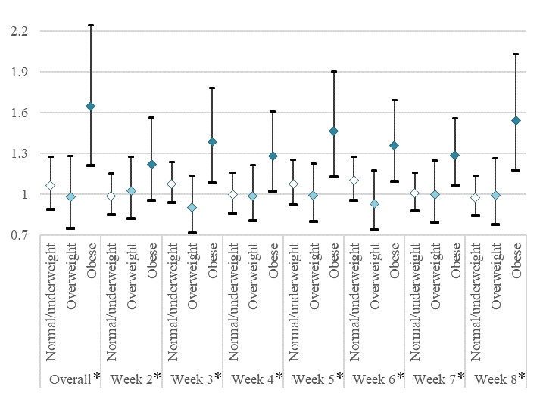

b) SO2 max-CLDs association modified by smoking status

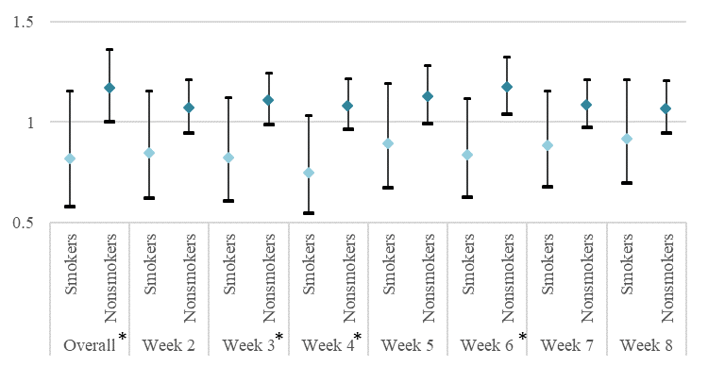

c) CO-CLDs association modified by folic acid use

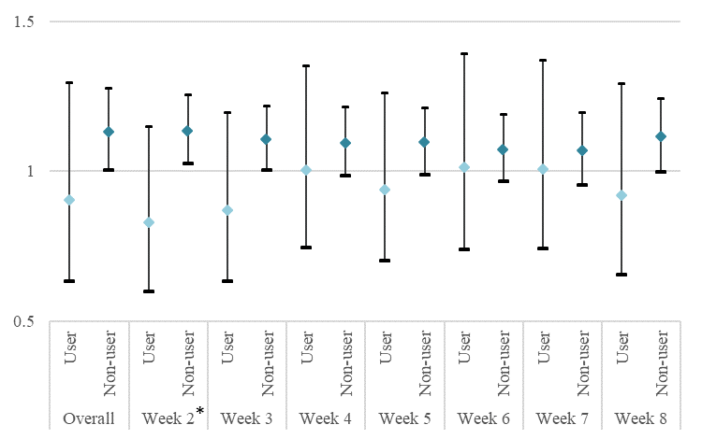

SFigure 1. Modification by folic acid use (a), BMI (b), and smoking status (c): stratified odds of CLDs with an IQR increase air pollution, adjusting for maternal education, race, age, and center.

*p-values of interaction terms < 0.1