Appendix 1. Eligible Medical Specialties - Knowledge, Behaviors, Attitudes and Practices of HIV-Related Care among Providers in the Southeast (K-BAP) Study, 2017

- Adolescent Medicine
- Community Health
- Emergency Medicine Specialist
- Family Practitioner
- Women’s Health Specialist
- Geriatrician
- General Practitioner
- Gynecologist
- Infectious Disease Specialist
- Internal Medicine
- Internal Medicine/Pediatrics
- Obstetrics & Gynecology
- Obstetrics
- Pediatrician
- Primary Care
- Preventive Medicine Specialist

Appendix 2. American Association for Public Opinion Research (AAPOR Response Rates)* by Provider Type and MSA - Knowledge, Behaviors, Attitudes and Practices of HIV-Related Care among Providers in the Southeast (K-BAP) Study, 2017

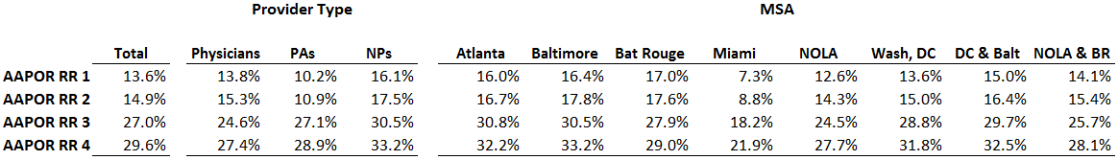
*Reference: The American Association for Public Opinion Research. Standard Definitions: Final dispositions of case codes and outcome rates for surveys, 9th edition. 2016. https://www.aapor.org/AAPOR_Main/media/publications/Standard-Definitions20169theditionfinal.pdf. Accessed September 4, 2018.

Appendix 3. American Association for Public Opinion Research (AAPOR)-Adjusted Response Rate 4 by Provider Type and MSA - Knowledge, Behaviors, Attitudes and Practices of HIV-Related Care among Providers in the Southeast (K-BAP) Study, 2017

