MONACO

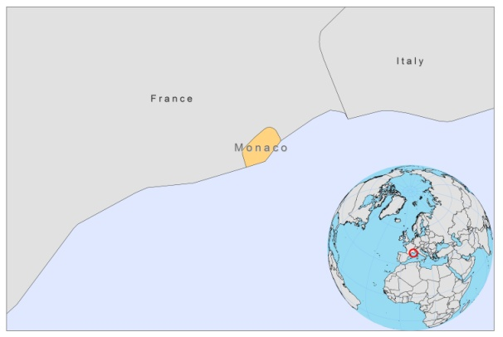

BASIC COUNTRY DATA

Total Population: 35,407
Population 0-14 years: 18%
Rural population: 0%
Population living under USD 1.25 a day: no data
Population living under the national poverty line: no data
Income status: High Income economy
Ranking: Very high human development
Per capita total expenditure on health at average exchange rate (US dollar): 7,137
Life expectancy at birth (years): 82
Healthy life expectancy at birth (years): 73

BACKGROUND

The Alpes Maritimes are a known VL endemic region and Monaco is no exception. VL has a high prevalence in dogs in Monaco [1]. It is relatively rare in humans, but between 1991-1992, 8 cases were diagnosed in Monaco and Beausoleil [1]. The sandfly vector was identified in 1993, and was found to be present at Monaco beach, the harbour, as well as in the surrounding hills. There was a high rate of infected Phlebotomus spp. (3%), which marked Monaco as an active focus of VL. In a screening of blood samples taken from 565 donors at the Monaco bloodbank, 13.4% was infected subclinically with L.infantum [2].

PARASITOLOGICAL INFORMATION

Leishmania  species | Clinical form | Vector species | Reservoirs
L.infantum | VL | P. perniciosus | Canis familiaris

No further information is available

SOURCES OF INFORMATION

1. Izril MA, Marty P, Fauran P, Le Fichoux Y, Rousset J-J (1996). Presumed vectors of leishmaniasis in the Principality of Monaco, Trans R Soc Trop Med Hyg 90:114.

2. le Fichoux Y, Quaranta JF, Aufeuvre JP, Lelievre A, Marty P et al (1999). Occurrence of Leishmania infantum Parasitemia in Asymptomatic Blood Donors Living in an Area of Endemicity in Southern France. J Clin Microbiol 37(6): 1953–1957.

