DJIBOUTI

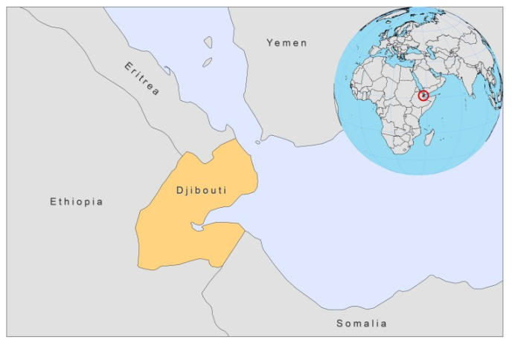

BASIC COUNTRY DATA

Total Population: 888,716
Population 0-14 years: 36%
Rural population: 12%
Population living under USD 1.25 a day: no data
Population living under the national poverty line: no data
Income status: Lower middle income economy
Ranking: Low human development (ranking 165)
Per capita total expenditure on health at average exchange rate (US dollar): 84
Life expectancy at birth (years): 57
Healthy life expectancy at birth (years): 43

BACKGROUND

CL as well as VL,are endemic in Djibouti. The first case of VL was described in 1971 [1]. VL is sporadic in Djibouti; between 1971 and 2003, 59 cases have been reported: five between 1971 and 1976 [2], 10 between 1994 and 1996 [3] and 44 between 1996 and 2000 [4,5]. VL was confirmed to be caused by L.donovani, zymodemes MON-268 and MON-287, unique to Djibouti and very similar to MON-37 found in Kenya [5]. MON-268 was identified in a coinfected patient.

CL is also sporadic and only few data are available. Between 1971 and 1976, five cases were reported. Only a few more cases have been described since then, one of which was resistant to antimonials [6].

It seems that VL infections were acquired in the vicinity of Hoi Hoi and Ali Sabieh, in the south, and that CL infections originated in the mountainous northern region Randa [2]. However, it is difficult to establish defined endemic regions as the population is largely nomadic.

Although the vector remains unconfirmed, a countrywide survey revealed extensive presence of P.alexandri, but not of P. orientalis. P. alexandri is a suspected vector for VL, as well as CL, in Djibouti [7].

Ten cases of HIV/Leishmania co-infection have been reported.
PARASITOLOGICAL INFORMATION
Leishmania species | Clinical form | Vector species | Reservoirs
L.donovani | VL | Unknown
Unknown | CL | Unknown | Unknown

CONTROL, DIAGNOSIS & TREATMENT, ACCESS TO CARE , ACCESS TO DRUGS

No information available.

SOURCES OF INFORMATION

1. Courtois, D (1971). Leishmaniose viscérale en territoire français des Afars et des Issas (TFAI). Méd Trop 31: 535–537.

2. Ardouin C, Carteron B, Morvan D, Rodhain F (1978). La leishmaniose en République de Djibouti. Bordeaux Médical 2699–2704.

3. Faure S, Faure E, Massenet D, Masseron T, Fabresse FX et al (1996). La leishmaniose viscérale à Djibouti. A propos de dix cas. In Deuxièmes Journées Médicales de la Corne de l’Afrique. Djibouti: Ministère de la Santé Publique et des Affaires Sociales.

4. Bronstein JA, Galzin M, Hovette P, Simon F, Cellarier G et al (2002). La leishmaniose viscérale à Djibouti: à propos d’une série de 41 patients suivis au CHA Bouffard. Méd Trop 62: 287.

5. Pratlong F, Debord T, Garnotel E, Garrabé E, Marty P et al (2005). First identification of the causative agent of visceral leishmaniasis in Djibouti: Leishmania donovani. Annals of Tropical Medicine & Parasitology 99 (1) 21–25.

6. Rapp C, Imbert P, Darie H, Simon F, Gros P et al (2003). Liposomal amphotericin B treatment of cutaneous leishmaniasis contracted in Djibouti and resistant to meglumine antimoniate. Bull Soc Pathol Exot.96(3):209-11.

7. Fryauff DJ, Cope SE, Presley SM, Hanafi HA, Bailly C et al (1995). Sand Flies of the Republic of Djibouti: Ecological Distribution, Seasonal Population Trends, and Identification of Species. J Vect Ecol 20(2):168 -188.

