ZAMBIA

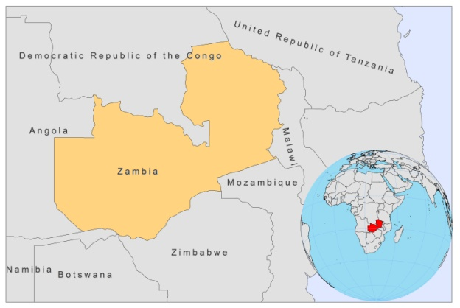

BASIC COUNTRY DATA

Total Population: 12,926,409
Population 0-14 years: 46%
Rural population: 64%
Population living under USD 1.25 a day: no data
Population living under the national poverty line: 59.3%
Income status: Lower middle income economy
Ranking: Low human development (ranking 164)
Per capita total expenditure on health at average exchange rate (US dollar): 61
Life expectancy at birth (years): 48
Healthy life expectancy at birth (years): 35

BACKGROUND INFORMATION

The first two parasitologically proven cases of VL were reported in 1973, from a village near Chip Ata (eastern area), and in 1976 [1], from southern Zambia (Katete). Both had cutaneous manifestations, with generalized macules, papules and nodules, without ulceration and both also had coexisting tuberculosis. No more cases have been documented. CL is unknown.

In 1997, the first case of canine leishmaniasis was reported, which necessitates further investigation of the dog as a suspect reservoir for VL in Zambia [2].

PARASITOLOGICAL INFORMATION

Leishmania species | Clinical form | Vector species | Reservoirs
Unknown | VL | Unknown | Unknown

No further information available on distribution, control, case management, access to care or drugs.

SOURCES OF INFORMATION

1. Naik KG, Hira PR, Bhagwandeen SB, Egere JU, Versey AA (1976). Kala-azar in Zambia: first report of two cases. Trans R Soc Trop Med Hyg 70(4):328-32.

2. Matsukawa K, Chiti L, Yoshima M, Sayer PD (1997). Onderstepoort J Canine visceral leishmaniosis: first case in Zambia Vet Res 64(1):77-9. No abstract available. PMID: 9204507.

