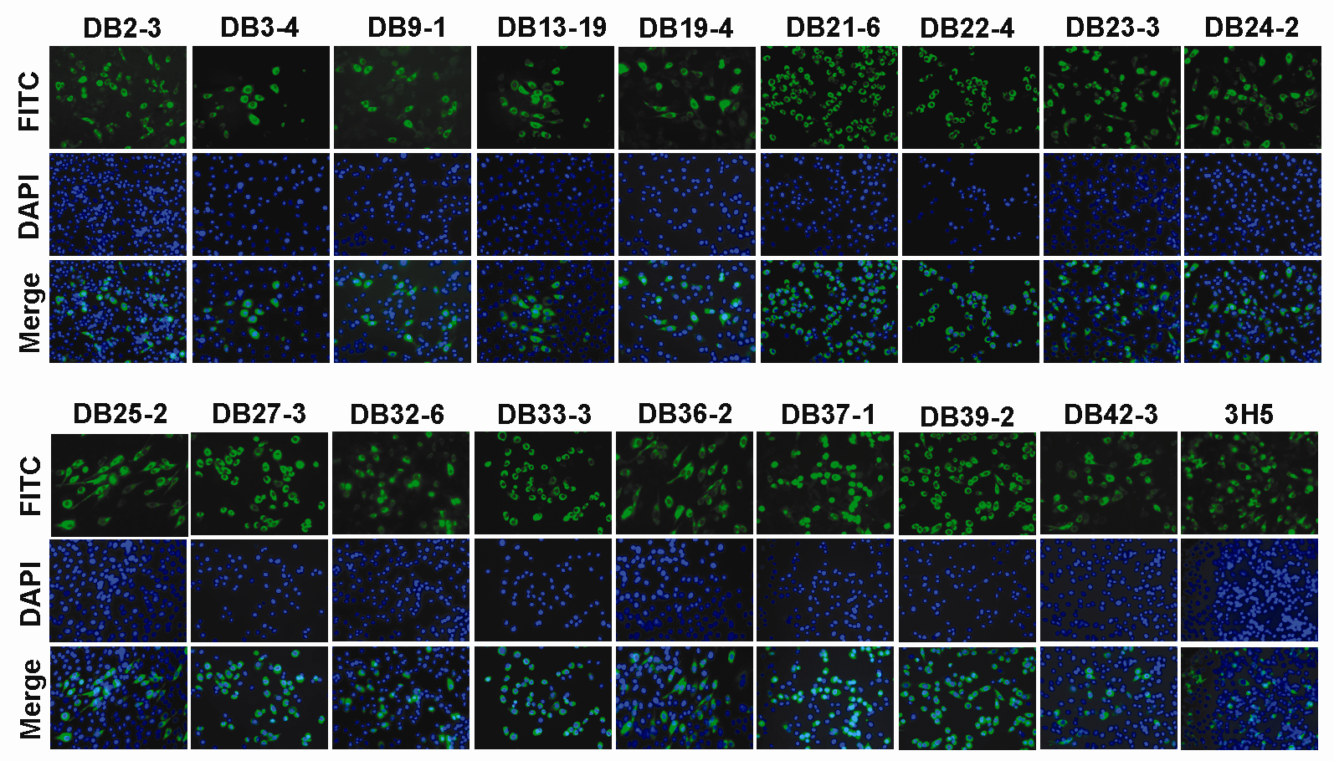

Figure S1. Specificity of mAbs against DENV. mAbs recognized DENV-2 (16681) infected BHK-21 cells by immunofluorescence assay. BHK-21 cells were infected at a multiplicity of infection (MOI) of 0.5 with DENV-2. At 48 hours post-inoculation, antigen was detected by staining with mAbs to DENV-2, followed by staining with FITC conjugated goat anti-mouse IgG antibodies (green). Cells were counterstained with DAPI (blue) and examined under fluorescence microscopy (Zeiss). Cells images were acquired at 400× magnification.

