Supplementary Online Content

Overall Prenatal Healthy Maternal Lifestyle and Offspring Obesity Risk during Childhood through Early Adulthood

Supplemental Table 1. Number of low risk lifestyle factors pre-pregnancy and risk of obesity in offspring
Supplemental Table 2. Number of low risk lifestyle factors pre-pregnancy and risk of obesity in offspring stratified by gender.
Supplemental Table 3. Association between maternal lifestyle factors and the risk of persistent obesity in offspring
Supplemental Table 4. Combined maternal low risk lifestyle factors and risk of obesity in offspring independently of maternal BMI status.
Supplemental Table 5. Number of low risk lifestyle factors pre-pregnancy and risk of obesity in offspring by using repeated measures from 2004 to 2013.
Supplemental Figure 1. Study design of NHS2 and GUTSII
Supplemental Figure 2. Distribution of diet before and after pregnancy.
Supplemental Figure 3. Number of low risk lifestyle factors pre-pregnancy and risk of obesity in offspring stratified by gender.

Table 1. Number of low risk lifestyle factors pre-pregnancy and risk of obesity in offspring
No. of low risk factors | No (%) of women | No (%) of offspring | No (%) of obese offspring | Relative risk (95%CI) | PAR†
0 | 53 (1.1) | 56 (1.0) | 12 (21.4) | 1 (reference) | 0 (reference)
1 | 657 (14.0) | 822 (14.4) | 140 (17.0) | 0.72 (0.44, 1.19) | 2.6 (-1.7, 5.1)
2 | 1768 (37.6) | 2152 (37.8) | 201 (9.3) | 0.40 (0.25, 0.66) | 25.1 (14.2, 31.4)
3 | 1473 (31.4) | 1798 (31.5) | 120 (6.7) | 0.30 (0.18, 0.49) | 39.3 (28.6, 46.0)
4 | 747 (15.9) | 873 (15.3) | 47 (5.4) | 0.25 (0.14, 0.43) | 55.1 (41.9, 63.2)
Adjusted for mother’s age at birth (years), mom’s race/ethnicity (white, others), parity (null-parity, 1, 2, 3, ≥4 previous pregnancies), pre-pregnancy alcohol intake (0, 0-5, 5-15, ≥15g/day), educational attainment of spouse/partner (high school/college, graduate school), and gender of the offspring (boy, girl). Reference group for relative risk is all other women not in low risk group as defined in table.
†Percentage of offspring obesity cases theoretically attributable to non-adherence to particular group.

Table 2. Number of low risk lifestyle factors pre-pregnancy and risk of obesity in offspring stratified by gender.
 | Boys | Girls
No. (%) of offspring | 2675 (46.9) | 3026 (53.1)
No. (%) of obese offspring | 289 (10.8) | 231 (7.6)
Low risk factors | Relative risk (95%CI) | Relative risk (95%CI)
0 | 1 (reference) | 1 (reference)
1 | 0.61 (0.32, 1.16) | 0.93 (0.43, 1.98)
2 | 0.38 (0.20, 0.71) | 0.45 (0.21, 0.95)
3 | 0.29 (0.15, 0.56) | 0.31 (0.14, 0.67)
4 | 0.29 (0.14, 0.57) | 0.19 (0.08, 0.46)
Adjusted for mother’s age at birth (years), mom’s race/ethnicity (white, others), parity (null-parity, 1, 2, 3, ≥4 previous pregnancies), pre-pregnancy alcohol intake (0, 0-5, 5-15, ≥15g/day), educational attainment of spouse/partner (high school/college, graduate school). Reference group for relative risk is all other women not in low risk group as defined in table.
Table 3. Association between maternal lifestyle factors and the risk of persistent obesity in offspring
 |  |  | Persistent obese in two subsequent visits* |  | Persistent obese in three subsequent visits**
Variable | No (%) of women | No (%) of offspring | No (%) of obese offspring | Relative risk (95%CI) | No (%) of obese offspring | Relative risk (95%CI)
0 | 53 (1.1) | 56 (1.0) | 4 (7.1) | 1 (reference) | 3 (5.4) | 1 (reference)
1 | 657 (14.0) | 822 (14.4) | 77 (9.4) | 1.15 (0.44, 2.98) | 30 (3.7) | 0.63 (0.19, 2.02)
2 | 1768 (37.6) | 2152 (37.8) | 73 (3.4) | 0.42 (0.16, 1.09) | 33 (1.5) | 0.27 (0.08, 0.87)
3 | 1473 (31.4) | 1798 (31.5) | 39 (2.2) | 0.28 (0.11, 0.76) | 13 (0.7) | 0.14 (0.04, 0.48)
4 | 747 (15.9) | 873 (15.3) | 19 (2.2) | 0.30 (0.11, 0.84) | 7 (0.8) | 0.16 (0.04, 0.59)
Adjusted for mother’s age at birth (years), mom’s race/ethnicity (white, others), parity (null-parity, parous), pre-pregnancy alcohol intake (0, 0-5, 5-15, ≥15g/day), educational attainment of spouse/partner (high school/college, graduate school), and gender of the offspring (boy, girl).
*If a child is obese in two subsequent self-reports, for instance in 2004 and 2006, or in 2006 and 2008, or 2008 and 2011, or 2011 and 2013.
**If a child is obese in three subsequent self-reports, for instance in 2004 and 2006 and 2008, or in 2006 and 2008 and 2011, or 2008 and 2011 and 2013.
Table 4. Combined maternal low risk lifestyle factors* and risk of obesity in offspring independently of maternal BMI status.
No. of low risk factors | No (%) of women | No (%) of offspring | No (%) of obese offspring | Relative risk (95%CI)* | Relative risk (95%CI)**
0 | 174 (3.7) | 193 (3.4) | 21 (10.9) | 1 (reference) | 1 (reference)
1 | 1868 (39.8) | 2276 (39.9) | 238 (10.5) | 0.88 (0.58, 1.34) | 0.86 (0.58, 1.29)
2 | 1726 (36.7) | 2135 (37.5) | 184 (8.6) | 0.76 (0.50, 1.15) | 0.79 (0.53, 1.18)
3 | 930 (19.8) | 1097 (19.2) | 77 (7.0) | 0.64 (0.41, 1.00) | 0.76 (0.49, 1.16)
*Having three factors in low risk category (healthy eating, moderate/vigorous physical activity ≥150 min/week, and not smoking)
Adjusted for mother’s age at birth (years), mom’s race/ethnicity (white, others), parity (null-parity, 1, 2, 3, ≥4 previous pregnancies), pre-pregnancy alcohol intake (0, 0-5, 5-15, ≥15g/day), educational attainment of spouse/partner (high school/college, graduate school), and gender of the offspring (boy, girl).
** Additionally adjusted for pre-pregnancy BMI (<18.5, 18.5-25, 25-30, ≥ 30)

Table 5. Number of low risk lifestyle factors pre-pregnancy and risk of obesity in offspring by using repeated measures from 2004 to 2013.
Low risk factors | No. of observations (%) in offspring | No. (%)* of  obese offspring | Relative risk (95% CI)
0 | 280 (1.0) | 21 (12.9) | 1 (reference)
1 | 4110 (14.4) | 284 (11.7) | 0.81 (0.40, 1.64)
2 | 10760 (37.8) | 364 (5.5) | 0.36 (0.18, 0.72)
3 | 8990 (31.5) | 193 (3.5) | 0.22 (0.11, 0.45)
4 | 4365 (15.3) | 82 (3.0) | 0.20 (0.09, 0.42)
Adjusted for mother’s age at birth (years), mom’s race/ethnicity (white, others), parity (null-parity, 1, 2, 3, ≥4 previous pregnancies), pre-pregnancy alcohol intake (0, 0-5, 5-15, ≥15g/day), educational attainment of spouse/partner (high school/college, graduate school); and offspring factors including gender (boy, girl) and age (year) during follow-up.
*Proportion is calculated only among GUTS participants who had information of BMI during follow-up (2004-2013).
Figure 1. Study design of NHS2 and GUTSII

NHS2
1989 | 1991 | 1993 | 1995
Assessment of pre-pregnancy lifestyle factors
Birth of GUTSII participants
 |  |  |  | GUTSII
 |  |  |  | 2004
 |  |  |  | Baseline assessment of GUTSII

Figure 2
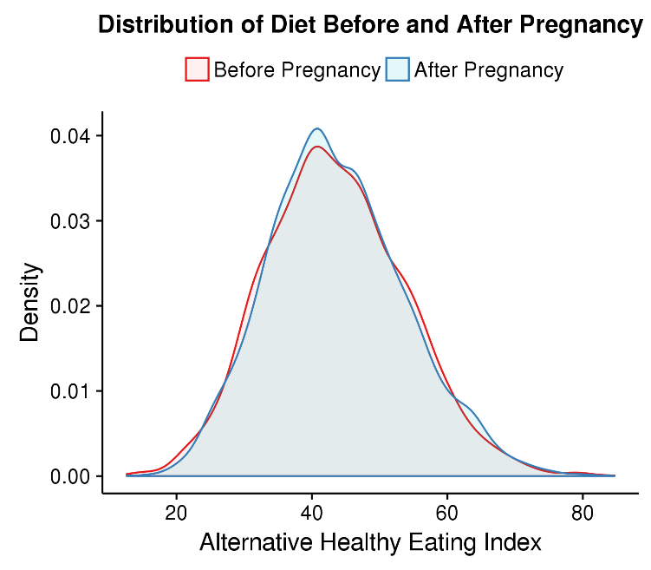
Changes in diet distribution before and after pregnancy in a sample of mothers (n=2831) who had a pregnancy between 1991 and 1995. Diet was assessed in visit of 1991 and 1995.
There is no difference in mean of alternative healthy eating index score before and after pregnancy (p-value = 0.509).

Figure 3
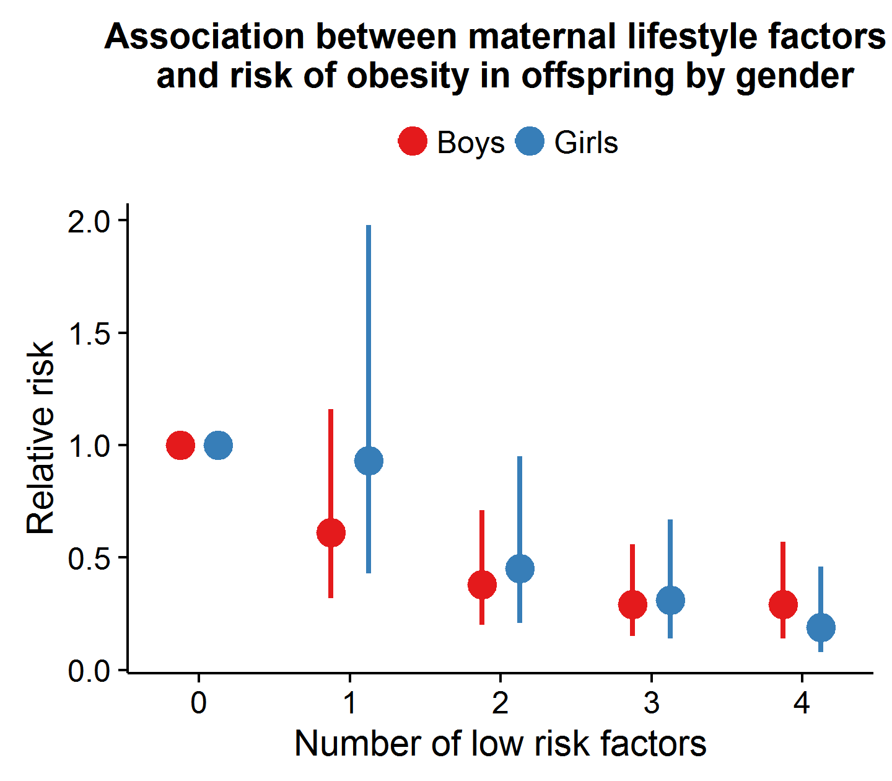
Adjusted for mother’s age at birth (years), mom’s race/ethnicity (white, others), parity (null-parity, 1, 2, 3, ≥4 previous pregnancies), pre-pregnancy alcohol intake (0, 0-5, 5-15, ≥15g/day), and educational attainment of spouse/partner (high school/college, graduate school). Reference group for relative risk calculation is all other women with no low risk factor.
Table S2 in supplement for the numeric estimates of relative risk.

