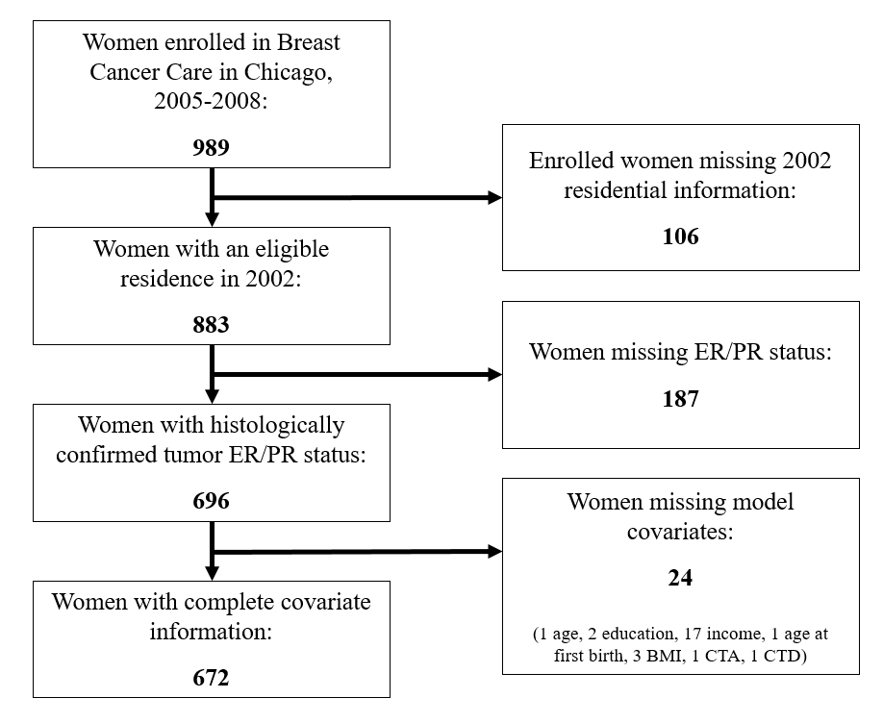Supplemental Figure 1. Flowchart showing step-wise approach for final analytic sample size. Abbreviations: ER/PR, estrogen and progesterone receptor; BMI, body mass index; CTA, census tract advantage; CTD, census tract disadvantage.
Supplemental Table 1. Spearman correlation coefficients of the participant characteristics and the airborne heavy metal concentrations
 | Participant characteristics
Metals | Age (yrs.) | Education (yrs.) | Income ($) | Age first birth (yrs.) | Parity  (live births)
Sb | 0.06 | 0.08 | -0.01 | 0.02 | -0.10
As | -0.05 | -0.18 | -0.13 | -0.09 | 0.11
Be | -0.05 | 0.10 | 0.09 | 0.19 | -0.15
Cd | 0.11 | 0.05 | -0.07 | -0.05 | -0.05
Cr | -0.03 | 0.02 | 0.01 | 0.09 | -0.09
Co | -0.02 | 0.07 | 0.04 | 0.09 | -0.11
Pb | 0.06 | -0.10 | -0.10 | -0.08 | 0.01
Mn | 0.07 | 0.06 | -0.01 | -0.00 | -0.09
Hg | 0.05 | 0.09 | 0.03 | 0.06 | -0.13
Ni | 0.06 | -0.03 | -0.08 | -0.01 | -0.05
Se | -0.01 | 0.05 | 0.05 | 0.07 | -0.08

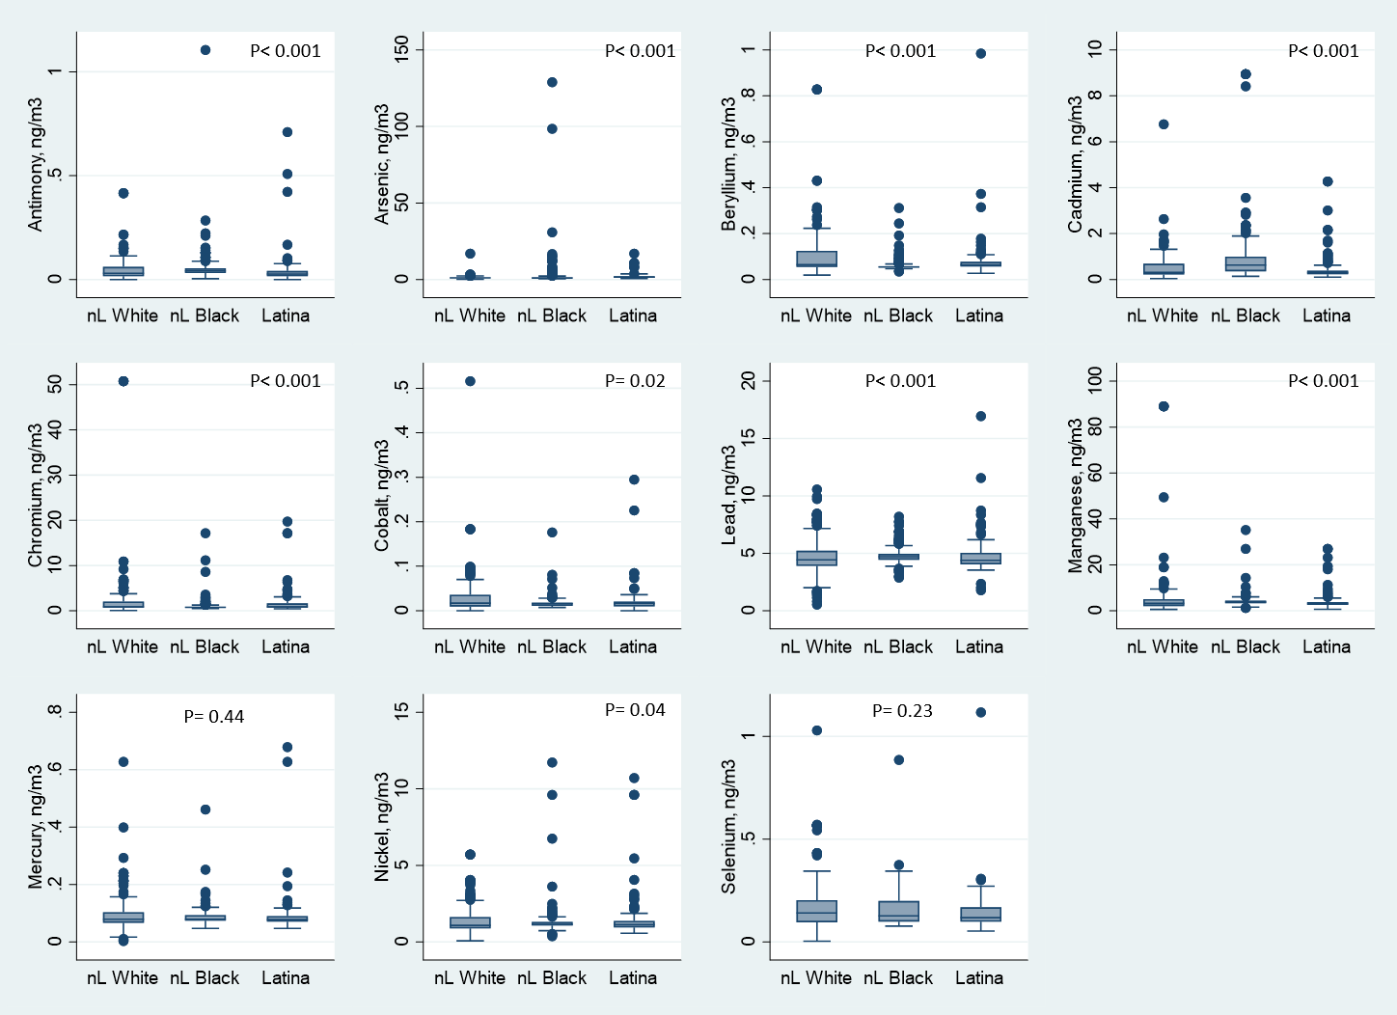

Supplemental Figure 2. Distribution of the airborne metal concentrations by race/ethnicity. P-values represent Kruskal-Wallis test for differences between groups.

Supplemental Table 2. Airborne metal concentrations (median and interquartile range) by ER/PR status (missing vs not)
 | ER/PR status
Metals | Not missing | Missing | P-value¹
Sb | 0.04 (0.02-0.05) | 0.04 (0.02-0.05) | 0.23
As | 1.08 (0.86-1.61) | 1.05 (0.87-1.46) | 0.79
Be | 0.06 (0.05-0.07) | 0.06 (0.05-0.08) | 0.52
Cd | 0.39 (0.25-0.80) | 0.46 (0.28-0.86) | 0.21
Cr | 0.79 (0.67-1.36) | 0.79 (0.67-1.36) | 0.74
Co | 0.02 (0.01-0.02) | 0.02 (0.01-0.02) | 0.74
Pb | 4.60 (4.21-5.07) | 4.60 (4.15-5.04) | 0.96
Mn | 3.46 (2.71-4.44) | 3.68 (2.84-4.38) | 0.50
Hg | 0.08 (0.07-0.10) | 0.08 (0.07-0.10) | 0.35
Ni | 1.14 (0.96-1.36) | 1.13 (0.99-1.41) | 0.47
Se | 0.13 (0.10-0.20) | 0.12 (0.10-0.20) | 0.77
¹Mann-Whitney test for differences between groups

Supplemental Table 3. Distributions of the airborne heavy metal concentrations (ng/m³)
 | Mean (SD) | Min | P25 | Median | P75 | Max
Antimony | 0.05 (0.07) | 0.00 | 0.02 | 0.04 | 0.05 | 1.11
Arsenic | 1.94 (6.43) | 0.15 | 0.86 | 1.08 | 1.61 | 128.92
Beryllium | 0.08 (0.08) | 0.02 | 0.05 | 0.06 | 0.07 | 0.98
Cadmium | 0.65 (0.89) | 0.04 | 0.25 | 0.39 | 0.80 | 8.95
Chromium | 1.61 (3.71) | 0.05 | 0.67 | 0.79 | 1.36 | 50.77
Cobalt | 0.02 (0.03) | 0.00 | 0.01 | 0.02 | 0.02 | 0.52
Lead | 4.79 (1.24) | 0.53 | 4.21 | 4.60 | 5.07 | 16.95
Manganese | 4.46 (6.57) | 0.59 | 2.71 | 3.46 | 4.44 | 89.05
Mercury | 0.09 (0.05) | 0.00 | 0.07 | 0.08 | 0.10 | 0.68
Nickel | 1.36 (1.02) | 0.07 | 0.96 | 1.14 | 1.36 | 11.73
Selenium | 0.16 (0.10) | 0.00 | 0.10 | 0.13 | 0.20 | 1.12
Abbreviations: standard deviation, SD; minimum, min; percentile, P; maximum, max

