**SUPPLEMENTARY FIGURES**

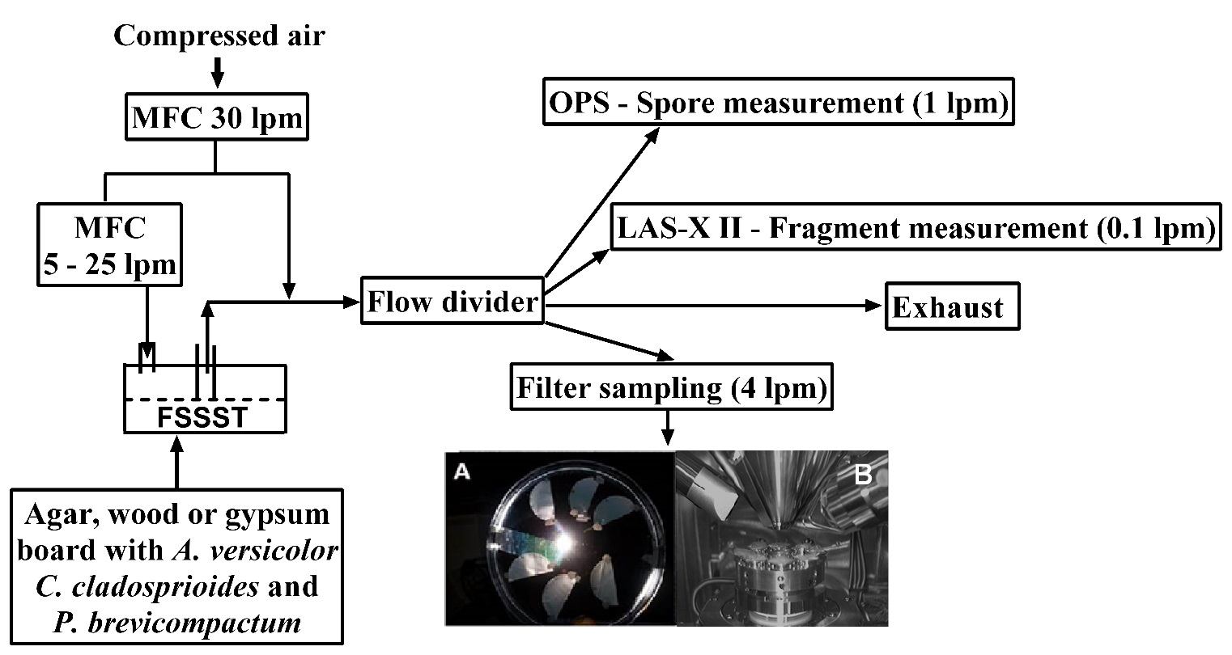

Fig. S1 Experimental setup for fungal particle release and measurements. A = Gold coated membrane filters, B = variable chamber pressure Field Emission-Scanning Electron Microscope (FE-SEM) equipped with two Energy Dispersive X-ray Spectroscopy (EDX) detectors. MFC = Mass flow controller for air flow.



Fig. S2. Typical average fungal particle size distribution measured by the LAS-X (40 size bins) and OPS (15 size bins). The dashed lines indicate the standard deviation of three repeats *P. brevicompactum* species released from the growth surfaces.

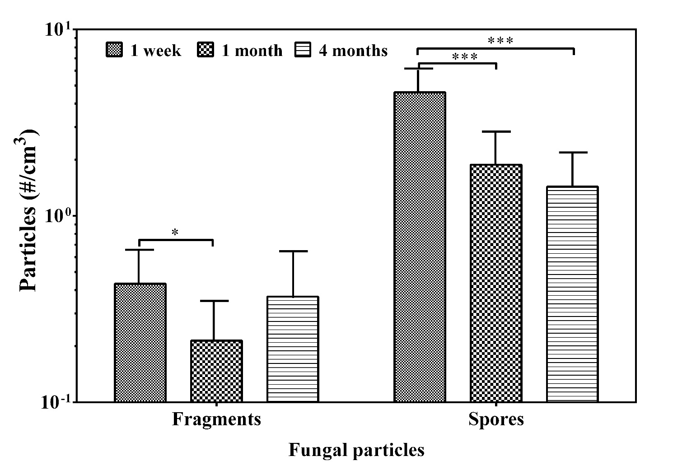

Fig. S3. Total concentration of fragments and spores released from agar at three incubation times. Bars are the geometric means of all data obtained from all fungal species and air velocities, n = 27. Error bars represent the geometric standard deviations. Asterisks indicate the level of significance (*, p < 0.05; ***, p < 0.001).

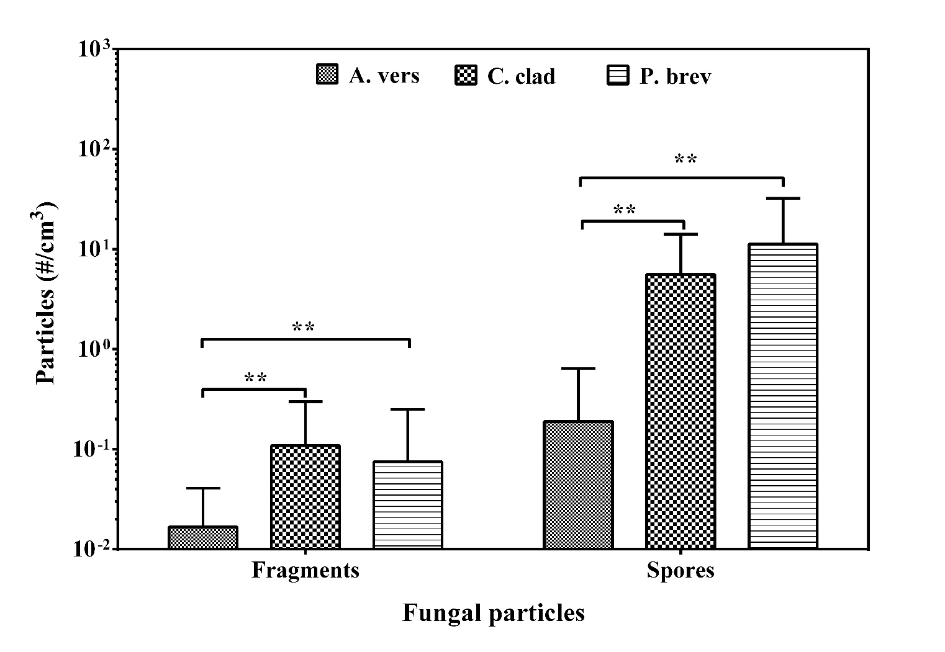

Fig. S4. Total concentration of fragments and spores released from the three fungal species at 1 month of cultivation. Bars are the geometric means of all data obtained from all materials and air velocities, n = 9. Error bars represent the geometric standard deviations. Asterisks indicate the level of significance (**, p < 0.01).

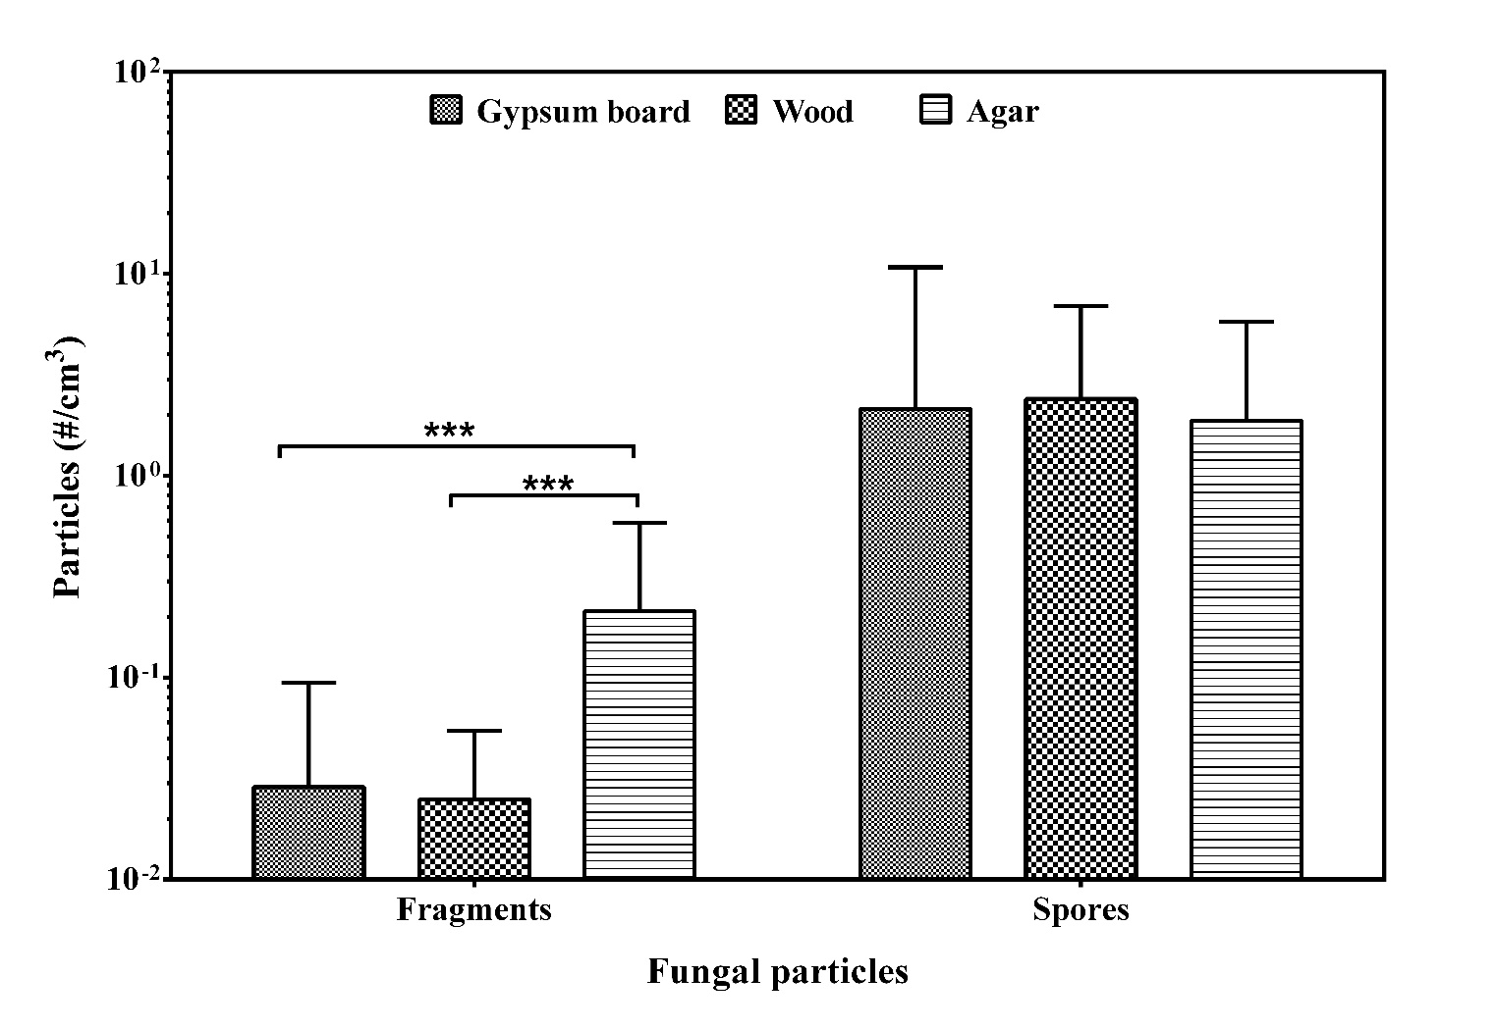

Fig. S5. Total concentration of fragments and spores released from the three growth materials at 1 month of cultivation. Bars are the geometric means of all data obtained from all species and air velocities, n = 9. Error bars represent the geometric standard deviations. Asterisks indicate the level of significance (***, p < 0.001).

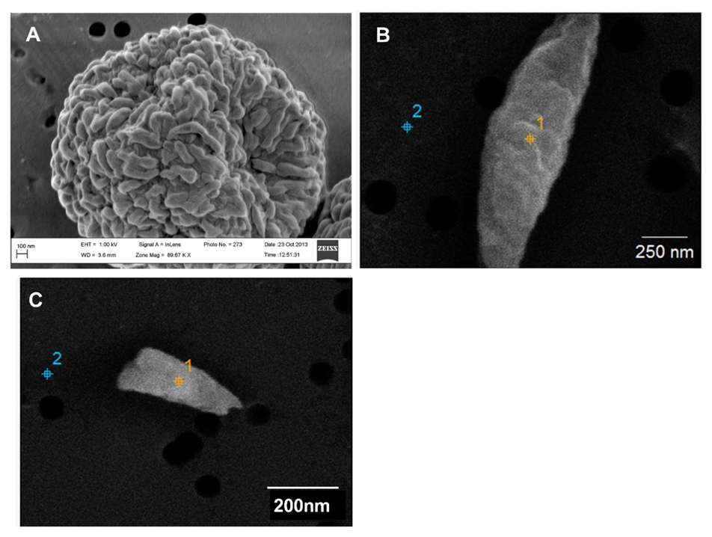

Fig. S6. SEM images of *P. brevicompactum* spore with rodlets (A), fragments that have their surfaces covered with gold layer making it difficult to distinguish fragments from different sources. (B, C).