Quantification of DEET and neonicotinoid pesticide biomarkers in human urine by online solid phase extraction-high performance liquid chromatography-tandem mass spectrometry

Authors:
Samuel E. Baker¹, Amanda Bishop Serafim¹, Pilar Morales-Agudelo², Meghan Vidal², Antonia M. Calafat¹, Maria Ospina¹
¹ Division of Laboratory Sciences, National Center for Environmental Health, Centers for Disease Control and Prevention, 4770 Buford Hwy, MS F17, Atlanta, GA 30341, USA
² Battelle Memorial Institute, 2987 Clairmont Rd, Suite 450, Atlanta, GA 30329, USA

SUPPORTING INFORMATION

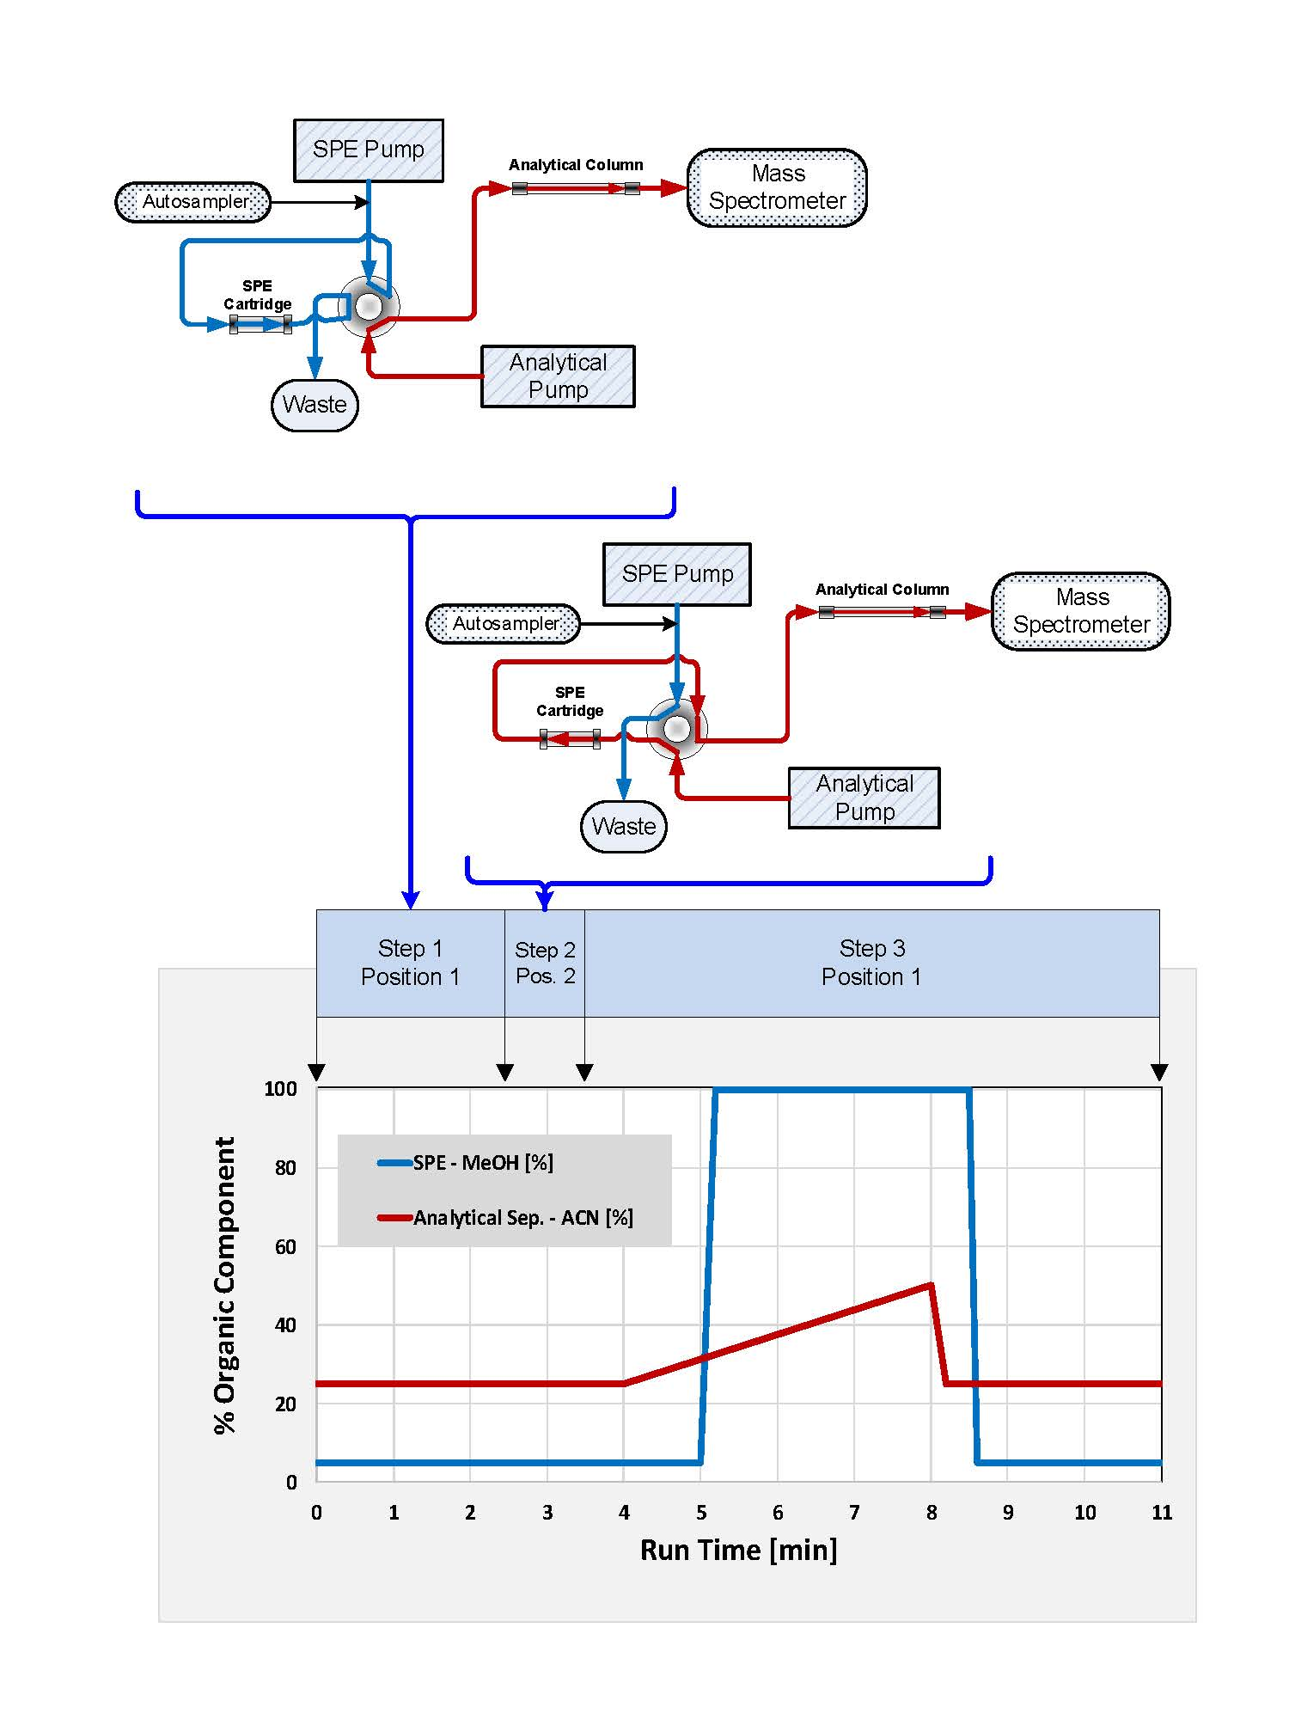

Figure 1S: HPLC online SPE pump system with switching valve timing chart and mobile phase flow and constitution diagram. Adapted from Kuklenyik et al., 2013 [42]

