**Early Impact of the State Innovation Model Initiative on Diagnosed Diabetes Prevalence among Adults and Hospitalizations among Diagnosed Adults**

# Appendix

Figure A1 shows the 12 states in our analyses, including the 6 states that received a State Innovation Model (SIM) Initiative test award in Round 1 and 6 comparison states that received a SIM Initiative test award in Round 2.

Figure A1: States by Round of SIM Initiative Test Award Funding

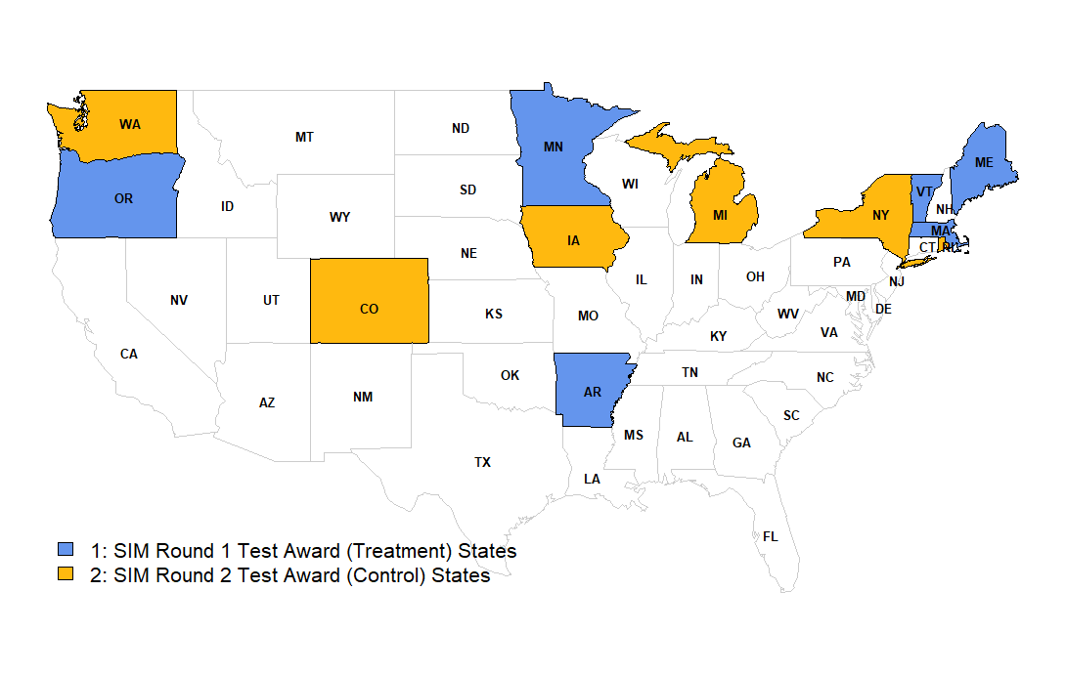

Source: Centers for Medicare and Medicaid Services (1)

Table A1 shows how the covariates balanced before and after applying stabilized inverse probability of treatment weights (IPTW). Prior to weighting, the standardized differences of female and household income < 100% FPL were both above 25%, but weighting reduced those differences to 5.8% and 9.8%, respectively. The weighted standardized differences of the other variables decreased to below 5% in absolute terms, except for the uninsured, which remained at 15.2%. However, its actual difference was only 0.7 percentage points.

Table A1: Covariate Balance with Inverse Probability of Treatment Weights



FPL indicates federal poverty level

Notes: Unweighted sample included 240 SIM counties and 343 comparison counties (N=583). Weighted sample was reduced to 580 counties with common support. County-level variable values were their mean values from 2010 to 2013.

Sources: Authors’ analysis of Centers for Disease Control and Prevention’s county-level estimates, Healthcare Cost and Utilization Project’s State Inpatient Databases, and Area Health Resources File

Figure A2 shows the unadjusted, mean diagnosed diabetes prevalence among adults in SIM versus comparison counties.

Figure A2: Unadjusted, Mean Diagnosed Diabetes Prevalence among Adults in SIM versus Comparison Counties, 2010-2014



Notes: Annual means are based on the analytic sample of 240 SIM and 343 comparison counties.

Sources: Authors’ analysis of Centers for Disease Control and Prevention’s county-level estimates

Figure A3 shows the unadjusted, mean ambulatory care-sensitive condition (ACSC) hospitalization rate per 1000 adults diagnosed with diabetes in SIM versus comparison counties.

Figure A3: Unadjusted, Mean ACSC Hospitalization Rate per 1000 Adults Diagnosed with Diabetes in SIM versus Comparison Counties, 2010-2014



Notes: Annual means are based on the analytic sample of 240 SIM and 343 comparison counties.

Sources: Authors’ analysis of Centers for Disease Control and Prevention’s county-level estimates and Healthcare Cost and Utilization Project’s State Inpatient Databases

Figure A4 shows the unadjusted, mean all-cause hospitalization rate per 1000 adults diagnosed with diabetes in SIM versus comparison counties.

Figure A4: Unadjusted, Mean All-Cause Hospitalization Rate per 1000 Adults Diagnosed with Diabetes in SIM versus Comparison Counties, 2010-2014



Notes: Annual means are based on the analytic sample of 240 SIM and 343 comparison counties.

Sources: Authors’ analysis of Centers for Disease Control and Prevention’s county-level estimates and Healthcare Cost and Utilization Project’s State Inpatient Databases

# Appendix References

1. Centers for Medicare and Medicaid Services. State Innovation Models Initiative: General Information. 2018. Available at: <https://innovation.cms.gov/initiatives/State-Innovations/index.html>. Accessed March 27, 2018,