Supplemental Appendix
Microbiological Methods for Patient-Derived Specimens
Swabs for MDRO organisms were inoculated onto chromID™ MRSA agar, chromID™ VRE agar (bioMérieux Inc., Durham, NC), CHROMAgar™ Acinetobacter (CHROMAgar, Paris, France). Single colonies were isolated prior to further analysis and freezing.
Swabs for C. difficile culture were anaerobically incubated in 5 mL tubes of Cycloserine Cefoxitin Mannitol Broth with Taurocholate and Lysozyme (CCMB-TAL, Anaerobe Systems, Morgan Hill, CA). Cultures demonstrating growth at 24 or 48 hours were sub-cultured onto Cycloserine Cefoxitin Fructose Agar (CCFA) for selection and isolation. Phenotypical colonies of C. difficile were sub-cultured on Brucella Blood Agar (BRU, Anaerobe Systems, Morgan Hill, CA) to confirm purity. Overnight anaerobic Brain Heart Infusion (BHI, BD, Franklin Lakes, NJ) broth cultures were concentrated by centrifugation and the resulting cell pellets used for DNA extraction for molecular analysis.

Microbiological Methods for Environmental Sites
Dey/Engley (D/E) Neutralizing Agar or Clostridium difficile Selective Agar was used in the Rodac plates. All plates were incubated at 37°C for 48 hours; all C. difficile plates were incubated anaerobically. Two quantitative microbiologic outcomes were determined: the total number of colony-forming units (CFUs) of any organism present on each plate and the total number of CFUs of the targeted pathogen present on each plate. For C. difficile, only the total number of CFUs of the targeted pathogen present on each plate was determined. In either scenario, the number of targeted pathogens was quantified by first identifying morphologies suggestive of the target organisms. These colonies were then sub-cultured and identified using standard, validated microbiological methods.¹³

Molecular analysis and relatedness testing
We used molecular approaches to define the relatedness of bacteria found on and transferred between patients and hospital room surfaces. Specimens of Staphylococcus aureus and Enterococci were compared through Pulsed Field Gel Electrophoresis (PFGE). Candidate MRSA isolates were analyzed with PFGE using the protocols and conditions described by McDougal et al.¹⁴; enterococci were analyzed using methods described by Murray et al. ¹⁵ After electrophoresis, gels were stained, the images captured with a GelDoc XR instrument (BioRad, USA) and compared using the Bionumerics software package (Applied Maths, Belgium) using the unweighted pair group method (UPGM) based on Dice coefficients with band position tolerance and optimization set at 1.25 and 0.5% respectively. Isolates with similarities greater than 80% were considered to be of the same pulsotype.
Isolates of Clostridium difficile were compared using previously described ribotyping techniques. ¹⁶ Briefly, total DNA from C. difficile cultures was isolated using DNaeasy Blood and Tissue Kit (Qiagen, Valencia, CA), PCR reactions were assembled and fragments resolved on a 3% SeaKem LE agarose gel with TBE buffer. The gels were stained and images captured with a GelDoc XR instrument. The resulting ribotype patterns were compared for similarity using the Bionumerics software package as described above.

Supplemental Figure 1: Dendrogram for Methicillin-resistant S. aureus (MRSA) Molecular Evaluable Isolates Involved in Microbiological Bacterial Transfer Events.
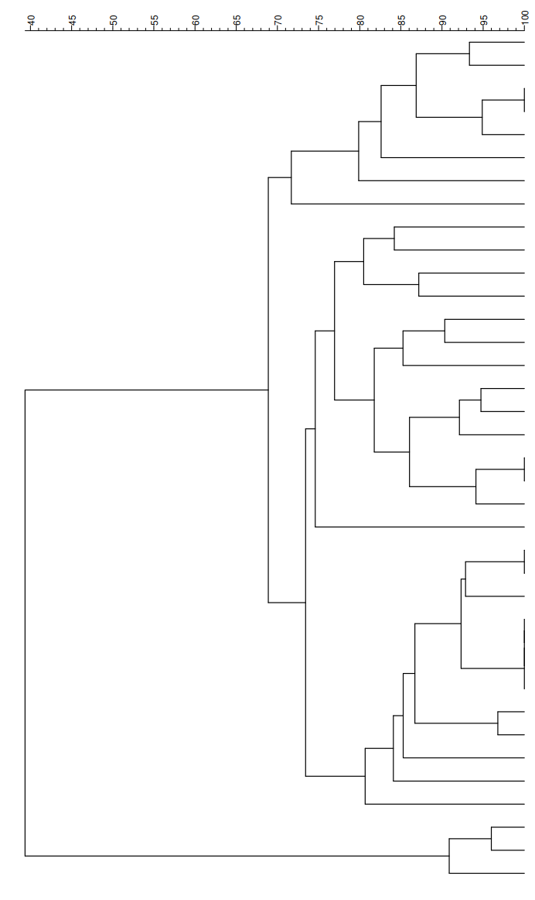
Same colored bars indicate samples from the same patient. * denotes a patient-derived sample; samples without * indicate an environmental sample.
*

*

*

*

*

*

*

*

Supplemental Figure 2: Dendrogram of Vancomycin-resistant Enterococci (VRE) Molecular Evaluable Isolates Involved in Microbiological Bacterial Transfer Events
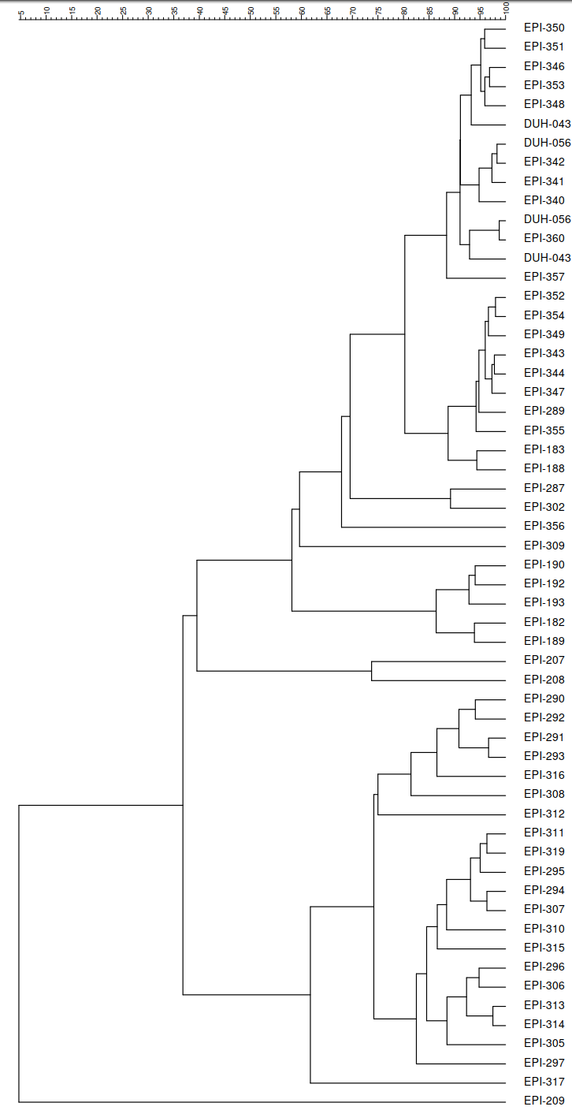
*

*

Supplemental Figure 3: Ribotype Dendrogram for C. difficile Molecular Evaluable Isolates Involved in a Microbiological Bacterial Transfer Event
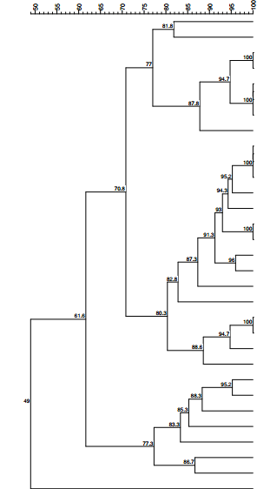*
Same colored bars indicate samples from the same patient. * denotes a patient-derived sample; samples without * indicate an environmental sample.
Same colored bars indicate samples from the same patient. * denotes a patient-derived sample; samples without * indicate an environmental sample.
Same colored bars indicate samples from the same patient. * denotes a patient-derived sample; samples without * indicate an environmental sample.
*

*

*

*

*

*

*

*

