Accrued Interpulse Phase with Laminar Flow Distribution
Laminar flow distribution p(v), or the area of the blood vessel cross-section containing blood traveling at velocities between v and v+dv, can be incorporated to determine the interpulse phase accrual Δφ(n).

Using Eq. [2] in Eq. [1], Δφ(n) can be written as:

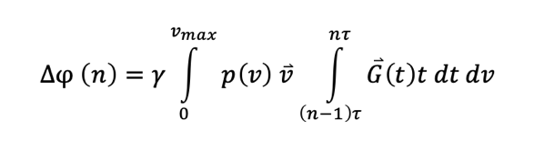 [S1]

Considering that there should only be velocities at or less than v_{max}, the velocity function v in [S1] can be solved such that
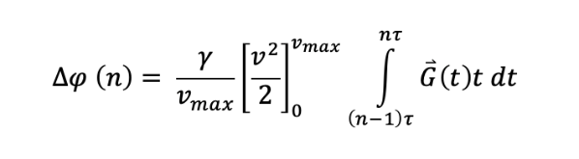 [S2]
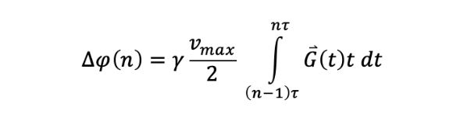 [S3]
Therefore, Eq. [1] still applies in the case of a laminar flow distribution, with v being the average velocity of blood flow or half of v_{max}.

Supplementary Figures
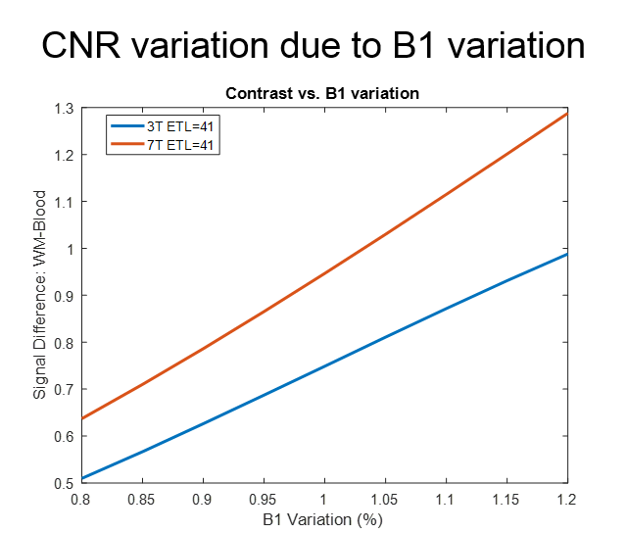
Supplementary Figure S1. The effect of B1 variation on contrast between arterial blood and background white matter.
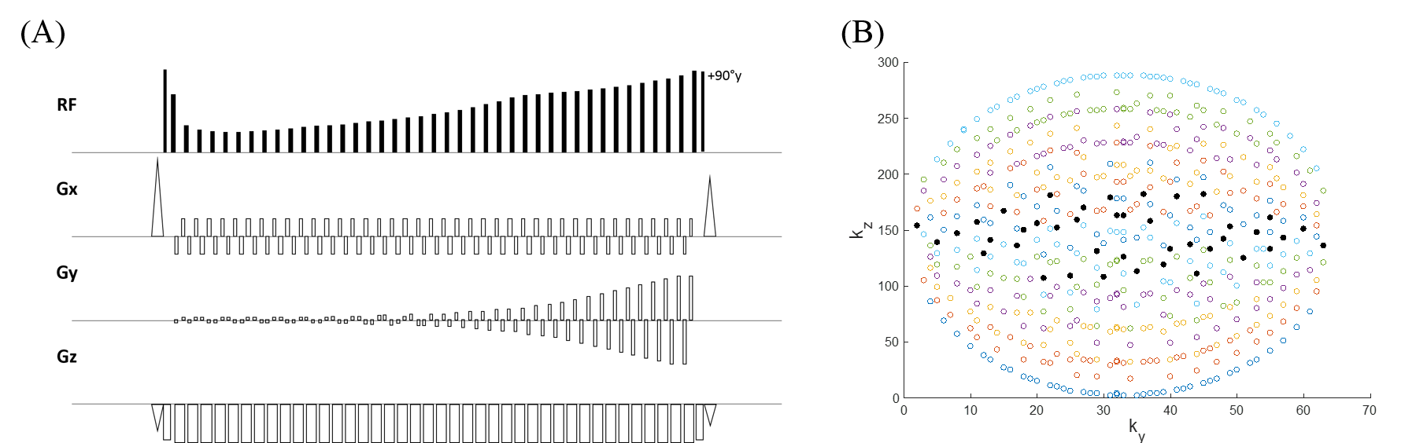

Supplementary Figure S2. The pulse sequence diagram (A) for T1-weighted TSE-VFA, demonstrating the gradient pulses involved in the ellipitcal-centric k-space ordering (B). For each echo train, the central echo in k-space is the second echo.

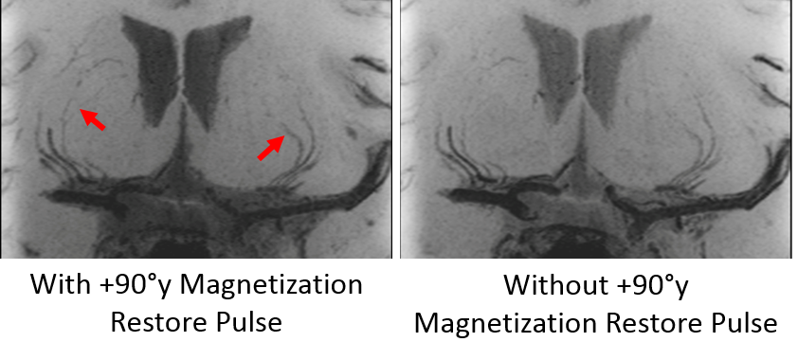
Supplementary Figure S3. Thin 10mm minimum intensity projection images of a pilot subject scanned with the +90°y Magnetization Restore Pulse (left) and without the the +90°y Magnetization Restore Pulse (right). The magnetization restore pulse further suppresses the signal in the distal portions of the LSAs (red arrows) while also suppressing the CSF signal. However, the improved CNR of vessel and tissue enables improved manual segmentation.

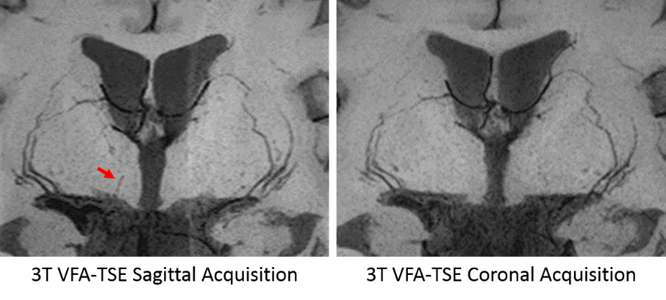
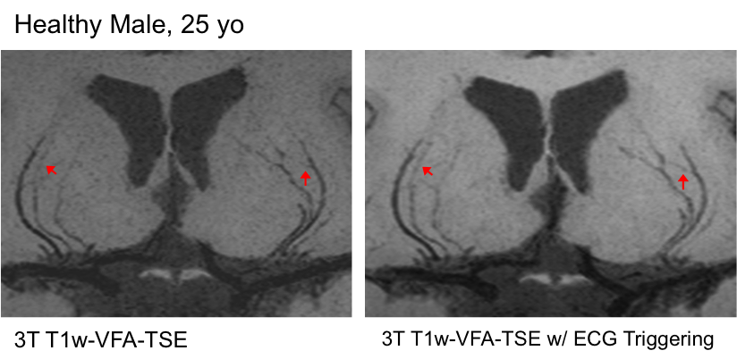
Supplementary Figure S4. Thin 10mm minimum intensity projection images of a pilot subject without (left) and with ECG triggering (right). Despite the improved delineation of LSAs at distal regions, the prolonged scan time was a strong limitation.
Supplementary Figure S5. Thin 10mm minimum intensity projection images of a pilot subject scanned using a sagittal acquisition (left) and a coronal acquisition (right). While the coronal acquisition offers more efficient coverage of LSAs and reduced imaging time, LSAs branching off the medial portion of MCA were often missed (red arrow).

Supplemental Table 1. Summary of Sagittal vs. Coronal TSE-VFA Parameters
 | Sagittal Acq. | Coronal Acq.
Bandwidth (Hz/pixel) | 360 | 360
Resolution (mm³) | 0.51 x 0.51 x 0.64 | 0.5 x 0.5 x 0.5
TE/TR (ms) | 12/1000 | 12/1000
Orientation | Sagittal | Coronal
FOV Read | 230 | 230
FOV Phase | 84.4% | 73.7%
Turbo Factor | 44 | 44
Echo train duration (ms) | 162 | 162
Slices | 160 | 160
Slice Oversampling | 1.1 | 1.1
Y Partial Fourier | 0.61 | 0.61
Z Partial Fourier | 0.78 | 0.78
Accel. Factor PE | 2 | 2
Echo Spacing (ms) | 5.78 | 5.78
Acquisition Time | 8:39 | 7:31

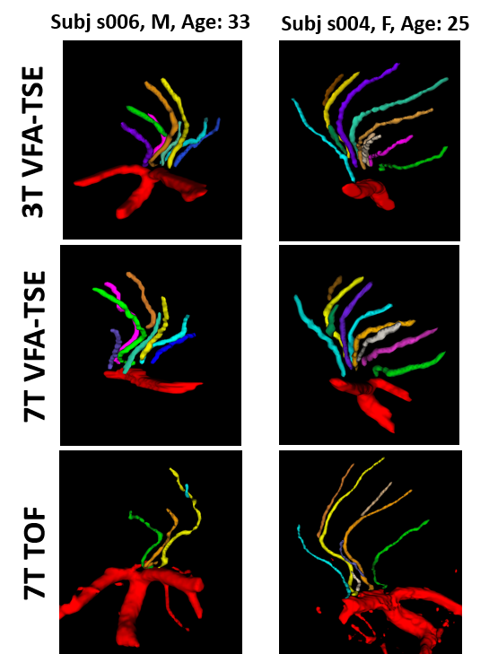
Supplementary Figure S6. Additional examples of the 3D renderings of the manual vessel segmentation for two younger subjects with larger number of vessels and branches detected.

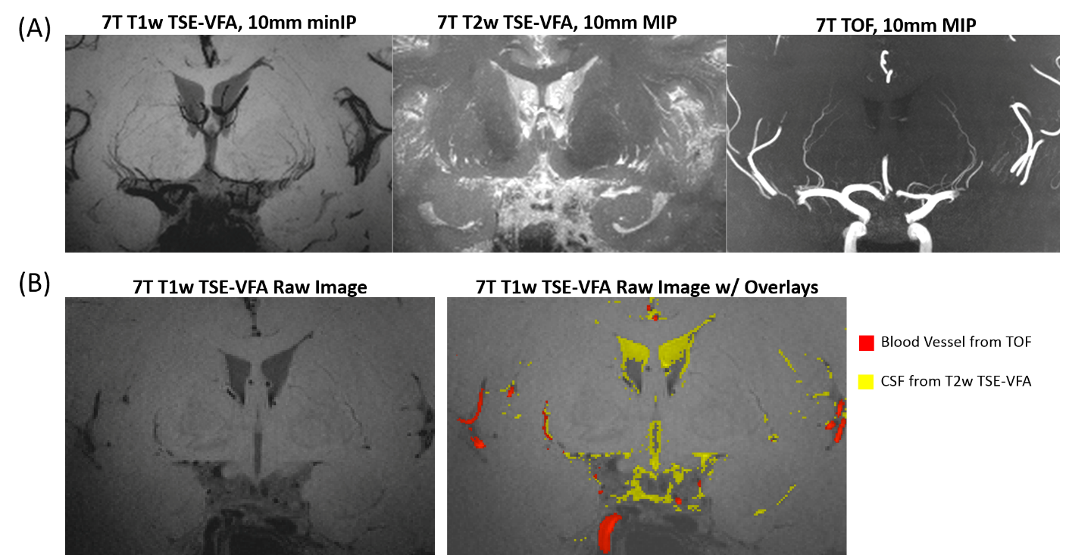

Supplementary Figure S7. (A) Co-registered 7T 10mm thin slice intensity projection images from a 40 year-old female participant (left to right: 10mm minimum intensity projection (minIP) of T1w TSE-VFA and 10mm maximum intensity projections (MIP) of T2w TSE-VFA and TOF, respectively). (B) Raw images of 7T T1w TSE-VFA without and with overlays of bright TOF (red) and T2w TSE-VFA (yellow) signals, which indicate blood vessels and cerebrospinal fluid in perivascular spaces, respectively. Although CSF also appears dark in T1w TSE-VFA thereby enlarging the apparent thickness of the LSAs, the perivascular spaces filled with CSF appear more prominently toward the middle rather than the stem of the LSAs. There are also LSA branches/stems that can only be visualized in T1w TSE-VFA but not in T2w TSE-VFA or TOF images.

