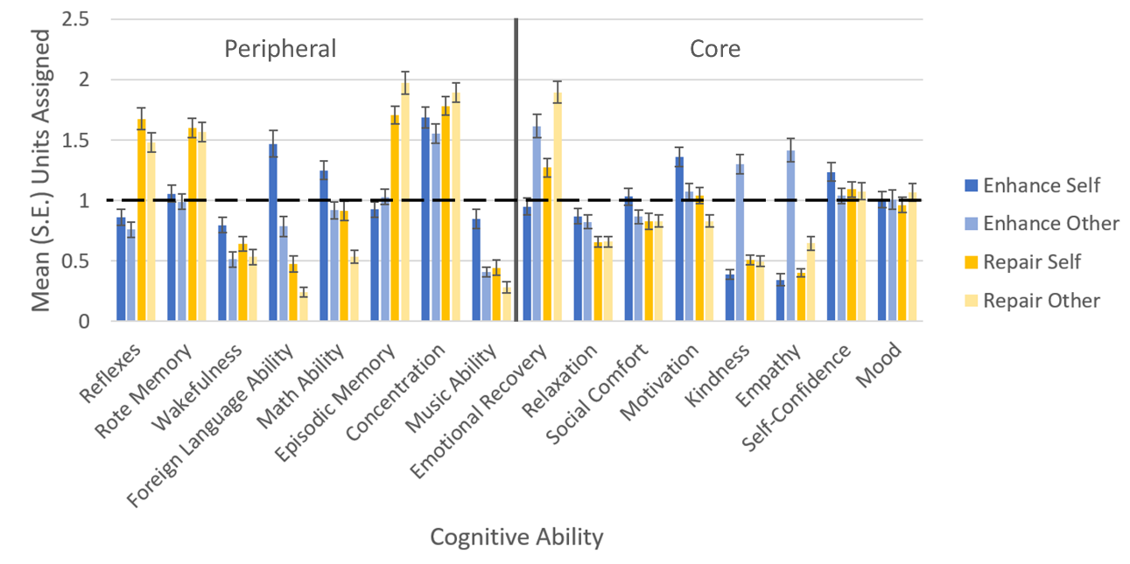
Supplementary Figure 1: In the exploratory zero-sum survey condition, each subject was asked to assign a total of 16 units of Ceremode to enhance or repair each cognitive ability within each survey condition. This allows us to quantify how subjects would hypothetically prioritize uses of brain stimulation. Notable differences in mean units from 1 (the value if the assignment was consistent with a uniform distribution) were observed. Differences were also observed across conditions and items. For instance, Reflexes, Rote Memory, Episodic Memory, and Concentration were relatively more highly emphasized for Repair in the Self and Others. Kindness, Empathy, Foreign Language Ability, Wakefulness, and Foreign Language Ability were de-emphasized overall with the exception to enhance Foreign Language Ability in the Self and enhance Kindness and Empathy in others. Future studies on these or similar data could investigate individual differences in demographic, ideological, and baseline perceived or objective cognitive ability as predictors of dispositions to prioritize specific types of optimization. The solid vertical line separates the Peripheral and Core items. The horizontal dashed line represents the expected null value of 1 for each condition. Error bars represent the standard error of the mean (S.E.).

