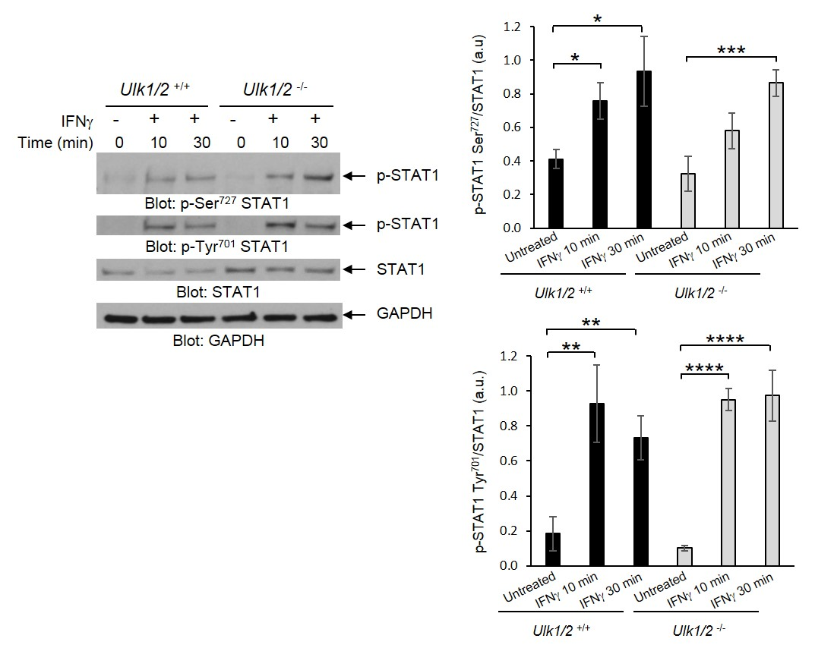
Fig. S1. ULK1/2 activity is not required for IFNγ-induced phosphorylation of STAT1. Western blot analysis of pSTAT1 in lysates from Ulk1/2^{+/+} and Ulk1/2^{-/-} MEFs treated with IFNγ for the indicated times. Blots (left) are representative of 4 independent experiments. Quantified band intensity values are means ± SEM from all experiments. *P< 0.05, **P< 0.01, ***P< 0.001, and ****P< 0.0001 by two-way ANOVA and post-hoc t-tests.
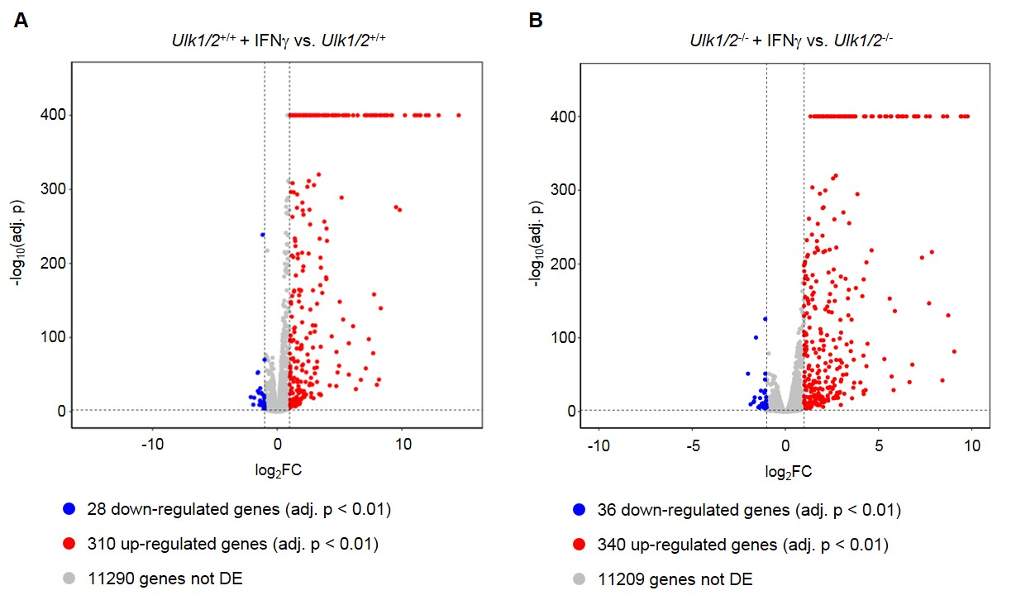

Fig. S2. Effects of targeted disruption of Ulk1/2 gene expression on IFNγ-dependent gene transcription. (A to B) RNAseq analysis of transcript expression in Ulk1/2^{+/+} and Ulk1/2^{-/-} MEFs treated with IFNγ, as indicated. Volcano plots of differentially expressed genes after IFNγ treatment from (A) Ulk1/2^{+/+} and (B) Ulk1/2^{-/-} MEFs are from 4 biological replicates per condition.

Fig. S3. Genes differentially expressed in both Ulk1/2^{+/+} and Ulk1/2^{-/-} MEFs after IFNγ treatment. RNAseq analysis of transcript expression in Ulk1/2^{+/+} and Ulk1/2^{-/-} MEFs treated with IFNγ, as indicated. Data are from 4 biological replicates per condition. Genes are listed in Table S3.

Fig. S4. Genes differentially expressed only in Ulk1/2^{+/+} MEFs after IFNγ treatment. RNAseq analysis of transcript expression in Ulk1/2^{+/+} and Ulk1/2^{-/-} MEFs treated with IFNγ, as indicated. Data are from 4 biological replicates per condition. Genes are listed in Table S4.

Fig. S5. Genes differentially expressed only in Ulk1/2^{-/-} MEFs after IFNγ treatment. RNAseq analysis of transcript expression in Ulk1/2^{+/+} and Ulk1/2^{-/-} MEFs treated with IFNγ, as indicated. Data are from 4 biological replicates per condition. Genes are listed in Table S5.
Fig. S6. Gene ontology analysis of IFNγ-dependent differentially expressed genes. (A) Gene ontology analysis of the 268 differentially expressed genes identified in both Ulk1/2^{+/+} and Ulk1/2^{-/-} MEFs after IFNγ treatment. (B) Gene ontology analysis of the 70 differentially expressed genes identified only in Ulk1/2^{+/+} MEFs. (C) Gene ontology analysis of the 108 differentially expressed genes identified only in Ulk1/2^{-/-} MEFs. Data are from 4 biological replicates per condition.
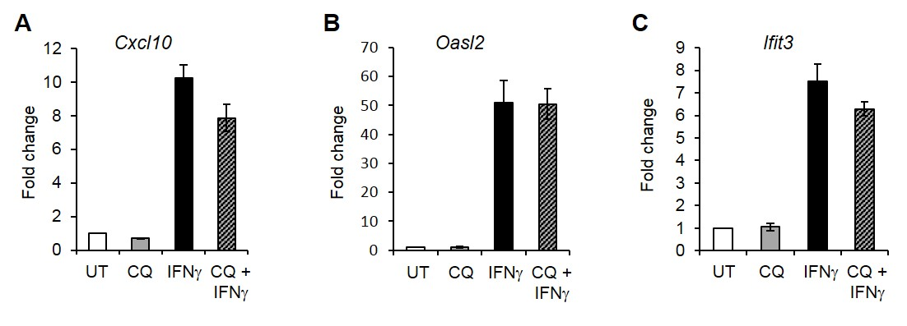
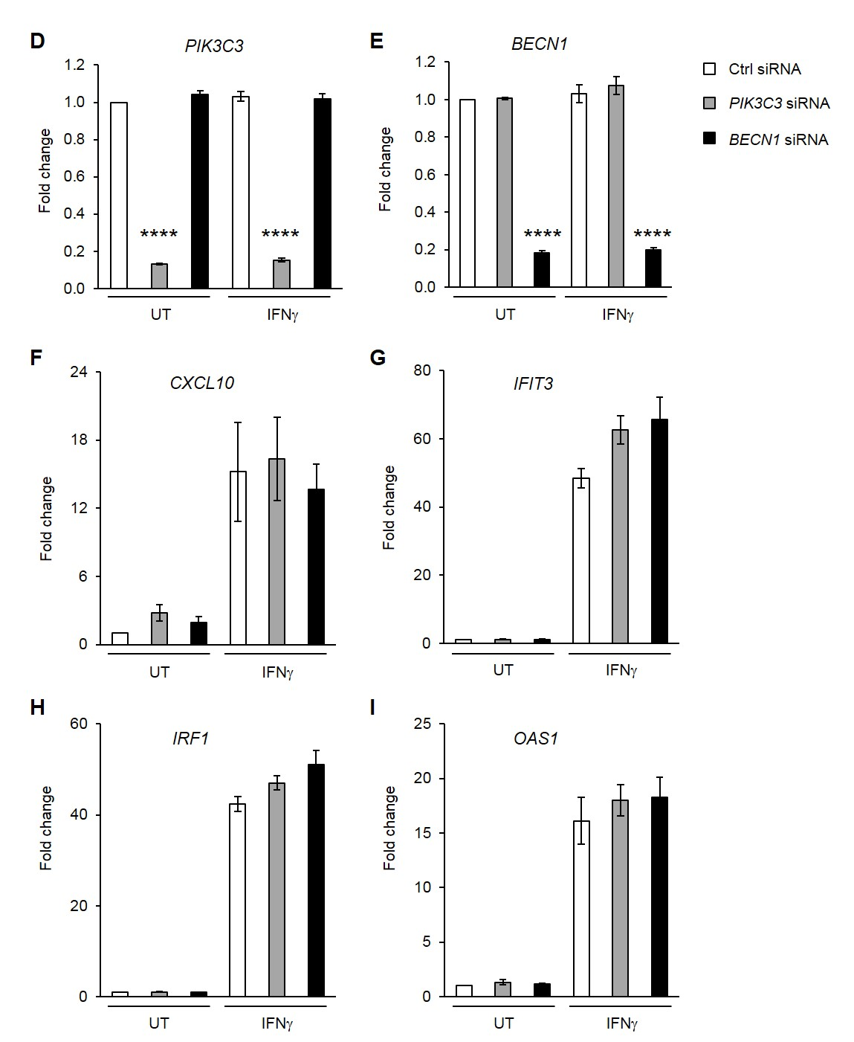
Fig. S7. Inhibition of autophagy does not affect transcription of antiviral ISGs. (A to C) qRT-PCR analysis of expression of the indicated genes in MEFs left untreated (UT) or treated with chloroquine (CQ) and/or IFNγ. Data are means ± SEM from 3 independent experiments. (D to I) qRT-PCR analysis of expression of the indicated genes in KT-1 cells transfected with control (Ctrl) siRNA, PIK3C3, or BECN1-specific siRNA and left untreated (UT) or treated with IFNγ. Data are means ± SEM from 3 independent experiments. ****P< 0.0001 by one-way ANOVA analysis followed by Tukey’s multiple comparisons test.

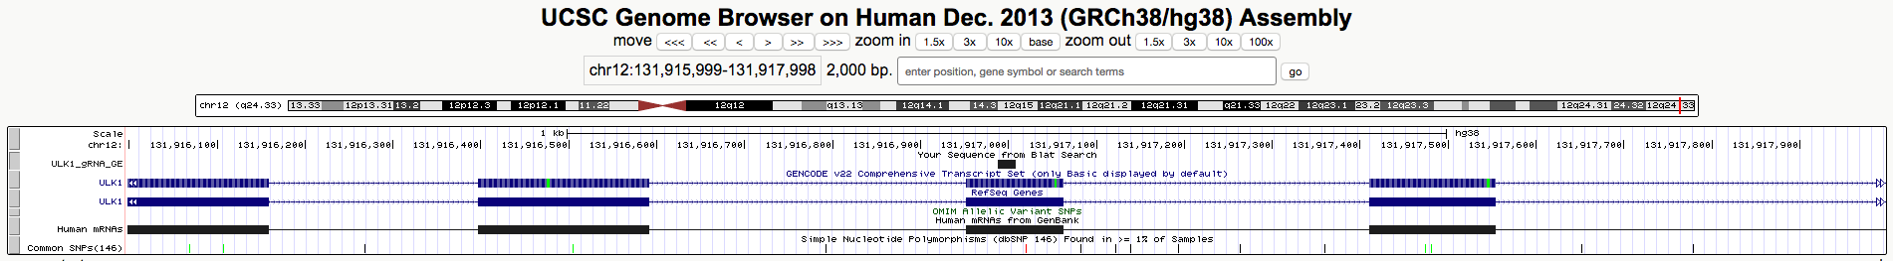

Fig. S8. Genomic location for the ULK1 single-guide RNA in the human ULK1 open reading frame (red rectangle).

Supplementary Tables
Table S1. Putative ULK1 interactors in untreated versus IFNγ-treated KT-1 cells identified by mass spectrometry analysis. Gene ontology groups of proteins found to interact with ULK1 under untreated, IFNγ-treated, and both conditions are shown.
Table S2. Putative ULK1 interactors identified after IFNγ stimulation by mass spectrometry analysis. Gene ontology groups of proteins found to interact with ULK1 only after IFNγ treatment are shown.
Table S3. Genes differentially expressed in both Ulk1/2^{+/+} and Ulk1/2^{-/-} MEFs after IFNγ treatment. Log2 Fold change and FDR adjusted p values between IFNγ-treated and untreated samples for each genotypic group are presented. Data are from 4 biological replicates per condition.
Table S4. Genes differentially expressed only in Ulk1/2^{+/+} MEFs after IFNγ treatment. Log2 Fold change and FDR adjusted p values between IFNγ-treated and untreated Ulk1/2^{+/+} samples are presented. Data are from 4 biological replicates per condition.
Table S5. Genes differentially expressed only in Ulk1/2^{-/-} MEFs after IFNγ treatment. Log2 Fold change and FDR adjusted p values between IFNγ-treated and untreated Ulk1/2^{-/-} samples are presented. Data are from 4 biological replicates per condition.
Table S6. Gene ontology analysis of differentially expressed genes identified in both Ulk1/2^{+/+} and Ulk1/2^{-/-} MEFs after IFNγ treatment. Genes, –log₁₀ p values, enrichment, and z-scores are shown for the top 25 gene ontology groups.

Table S7. Gene ontology analysis of differentially expressed genes identified only in Ulk1/2^{+/+} MEFs after IFNγ treatment. Genes, –log₁₀ p values, enrichment, and z-scores are shown for the top 25 gene ontology groups.

Table S8. Gene ontology analysis of differentially expressed genes identified only in Ulk1/2^{-/-} MEFs after IFNγ treatment. Genes, –log₁₀ p values, enrichment, and z-scores are shown for the top 25 gene ontology groups.

