Figure 1

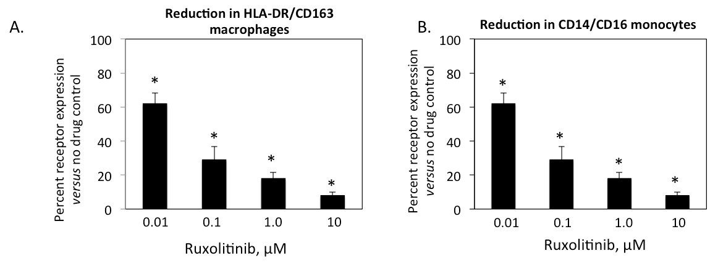

Figure 2

E.
C.
B.
**
*
A.
D.
C.
B.
A.

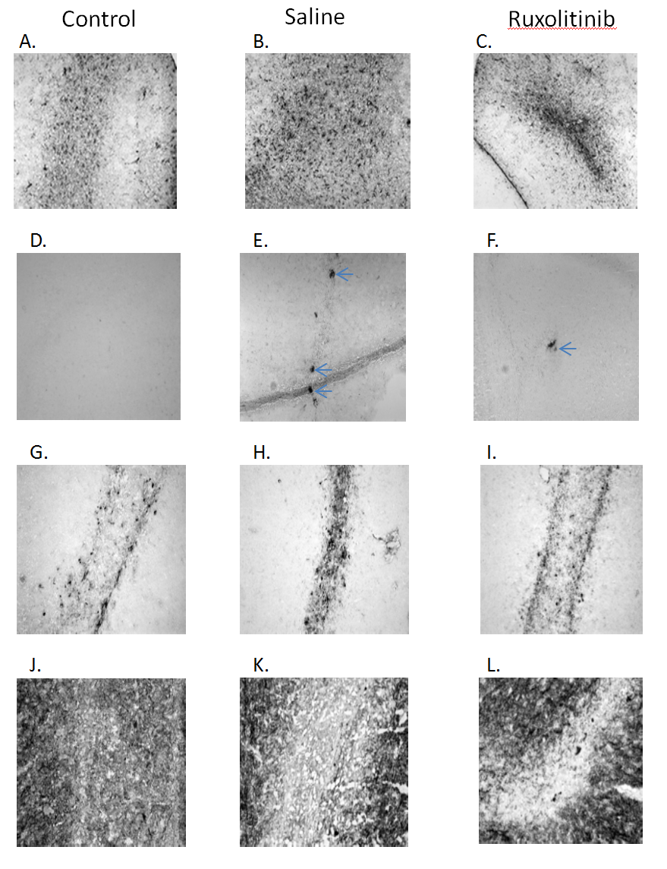
Figure 3

Sample # | Ruxolitinib (ng/g)
1 | 133.9
2 | 247.2
3 | 34.1
4 | 139.2
5 | 141.8
6 | 130.2
Table 1

Supplemental Table 1

 | Antiviral Potency |  | Toxicity |  | Safety
Compound | Anti-HIV-1 EC₅₀ in acutely infected human Mϕ (µM) | Anti-HIV-1 EC₉₀ in acutely infected human Mϕ (µM) | IC₅₀ in human  Mϕ (µM) | IC₅₀ in human  monocytes (µM) | Therapeutic Index
Ruxolitinib | 0.3 ± 0.1  (> 100) | 3.1 ± 1.8 (48) | > 100 | > 100 | > 100
AZT | 0.01 ± 0.02  (> 100) | 0.07 ± 0.12  (> 100) | > 100 | > 100 | > 100

