Integrating Comprehensive Two-dimensional Gas Chromatography Mass Spectrometry and Parallel Two-dimensional Liquid Chromatography Mass Spectrometry for Untargeted Metabolomics

Md Aminul Islam Prodhan^{1,2,3,4}, Biyun Shi^{1,4}, Ming Song^{2,3,6}, Liqing He^{1,2,3,4}, Fang Yuan^{1,2,3,4}, Xinmin Yin^{1,4}, Patrick Bohman⁸ , Craig McClain^{2,3,5,6,7}, Xiang Zhang^{1,2,3,4,5}

¹Department of Chemistry, ²University of Louisville Alcohol Research Center, ³University of Louisville Hepatobiology & Toxicology Program, ⁴Center for Regulatory and Environmental Analytical Metabolomics, ⁵ Department of Pharmacology & Toxicology, ⁶ Department of Medicine, University of Louisville, Louisville, KY 40208, USA,⁷Robley Rex Louisville VAMC, Louisville, Kentucky 40292, USA, ⁸Thermo Fisher Scientific International Inc., 3000 Lakeside Dr., Bannockburn, IL, 60015, USA

*CORRESPONDING AUTHOR

Prof. Xiang Zhang, Department of Chemistry, University of Louisville, 2210 South Brook Street, Louisville, KY 40208, USA. Phone: +01 502 852 8878. Fax: +01 502 852 8149. E-mail: xiang.zhang@louisville.edu.

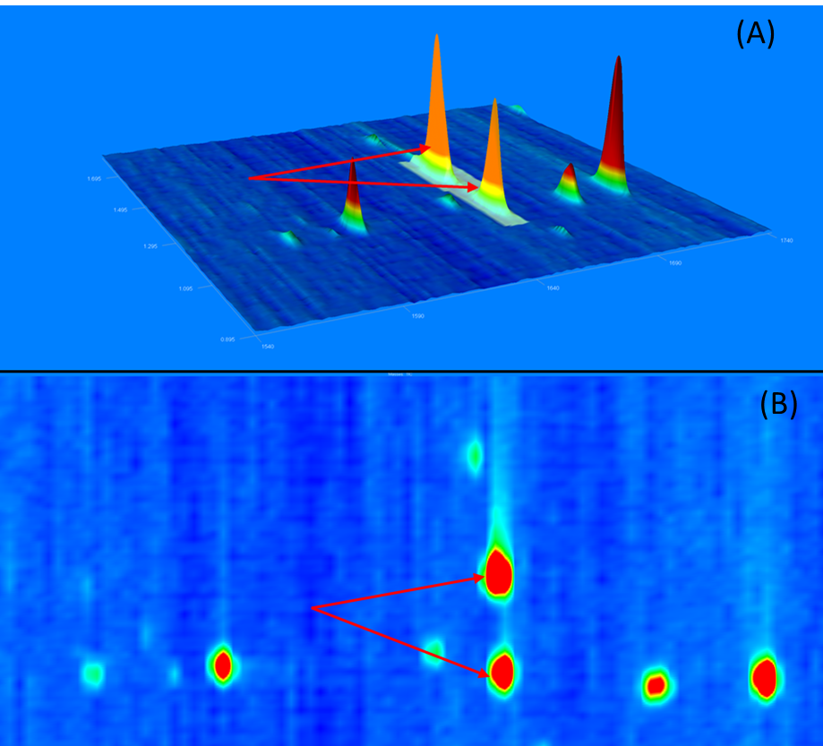

Figure S1. Two compounds co-eluted from the first dimension GC but separated by the second dimension GC. (A) is a three-dimensional view, and (B) is a contour plot.

Table S1. Data processing parameters used in LECO ChromaTOF software

Data processing parameters used in LECO ChromaTOF.
Baseline Offset | 1
Number of Data Points Averaged for Baseline Smoothing | Auto
Peak Width for Peak Finding | GC-MS: 4, GC×GC-MS: 7.5
Minimum Number of Apexing Masses for Peak Finding | 2
Minimum SNR for Peak Finding | 10
Library Search Mode | Normal, Forward
Library Hits Returned per Peak | 10
Minimum/Maximum Molecular Weight Allowed | 29/850
Relative Mass Threshold for Library Searching | 10
Minimum Similarity Match Before Name is Assigned | 600
Libraries Used for Searching | In-House, NIST-14
Mass Used for Area/Height Calculation | Unique
Match Required to Combine Peaks in the Second Dimension | 500
Second Dimension Peak Width | 0.15
Minimum SNR for Subpeak to be Retained | 6
Integration Approach | Traditional

Table S2. Details of metabolites identified by MS/MS matching in 2DLC-MS (-) mode
Name | m/z | Retention time (min) | Database
(±)13-HODE | 295.2273 | 13.96 | In-house DBª
(R)-2-Hydroxybutyric acid | 103.0399 | 2.13 | In-house DB
2-Hydroxycaproic acid | 131.0712 | 2.45 | CD^{b}
2-Methylglutaric acid | 145.0505 | 2.17 | CD
2-Oxobutyric acid | 101.0242 | 5.54 | CD
2-Oxoglutaric acid | 145.0141 | 5.36 | CD
2-Phosphoglycerate (2PG) | 184.9854 | 0.88 | In-house DB
3-AMP | 346.0552 | 1.20 | In-house DB
3-Hydroxybutyric acid | 103.0400 | 1.68 | In-house DB
3-Phosphoglyceric acid | 184.9854 | 6.30 | CD
4-Dodecylbenzenesulfonic acid | 325.1837 | 4.52 | CD
4-Methyl-2-oxovaleric acid | 129.0556 | 7.53 | In-house DB
4-Oxoproline | 128.0352 | 4.53 | CD
5-CMP | 322.0443 | 0.94 | In-house DB
Alanine | 88.0402 | 0.83 | In-house DB
Alpha-D-Glucose 1-phosphate | 259.0234 | 0.83 | In-house DB
alpha ketoglutaric acid | 145.0141 | 1.15 | In-house DB
Arabitol | 151.0610 | 5.16 | CD
Asparagine | 131.0461 | 0.83 | In-house DB
Aspartic Acid | 132.0301 | 0.83 | In-house DB
Azelaic acid | 187.0974 | 9.05 | In-house DB
Benzoic acid | 121.0294 | 0.10 | CD
Citrate | 191.0196 | 1.21 | In-house DB
Citrulline | 174.0882 | 0.85 | In-house DB
Cystathionine | 221.0598 | 0.80 | In-house DB
D-Erythrose-4-phosphate | 199.0011 | 0.88 | In-house DB
D-Glucosamine-6-phosphate | 258.0381 | 5.97 | In-house DB
D-Glucose (Glc) | 179.0559 | 0.88 | In-house DB
D-Glucose 6-phosphate | 259.0218 | 6.20 | CD
D-Glyceraldehyde 3-Phosphate (GADP) | 168.9905 | 0.91 | In-house DB
Dihydroxyacetone Phosphate (DHAP) | 168.9905 | 4.96 | In-house DB
DL-alpha-Glycerol phosphate | 171.0062 | 0.86 | In-house DB
DL-β-Leucine | 130.0872 | 4.96 | CD
Dodecanedioic acid | 229.1442 | 9.59 | CD
D-Ribulose-5-phosphate | 229.0116 | 0.85 | In-house DB
D-Saccharic acid | 209.0300 | 0.86 | CD
Esculin | 339.0735 | 0.89 | CD
Ethyl-β-D-glucuronide | 221.0665 | 1.46 | CD
Fructose | 179.0559 | 5.56 | CD
Fumaric acid | 115.0036 | 1.53 | In-house DB
Glutamic acid | 146.0457 | 0.85 | In-house DB
Glutamine | 145.0617 | 5.74 | CD
Glutaric acid | 131.0349 | 2.44 | In-house DB
Glutathione | 306.0761 | 1.15 | In-house DB
Glycerol 3-phosphate | 171.0062 | 5.75 | CD
Glycine | 74.0246 | 0.83 | In-house DB
Glycyl-L-leucine | 187.1086 | 5.25 | CD
Histidine | 154.0620 | 0.79 | In-house DB
Hypotaurine | 108.0123 | 5.70 | CD
Hypoxanthine | 135.0311 | 1.18 | CD
Inosine | 267.0732 | 1.60 | In-house DB
Isobutyric acid | 87.0450 | 2.45 | In-house DB
Isocitric acid | 191.0195 | 0.89 | In-house DB
Isoleucine | 130.0872 | 1.75 | In-house DB
Itaconic acid | 129.0192 | 6.16 | CD
Lactic acid | 89.0243 | 1.24 | In-house DB
L-alpha-Aminoadipic acid | 160.0614 | 0.90 | In-house DB
L-alpha-Amino-n-butyric acid | 102.0559 | 0.85 | In-house DB
L-Ascorbic acid 2-sulfate | 254.9813 | 0.97 | CD
Leukotriene B4 | 335.2224 | 2.42 | In-house DB
Levulinic acid | 115.0400 | 2.43 | In-house DB
Glutathione reduced | 306.0760 | 5.62 | CD
L-Glutathione oxidized | 611.1434 | 1.17 | CD
Lipoxin A4 | 351.2171 | 2.43 | In-house DB
Lipoxin B4 | 351.2174 | 10.39 | In-house DB
Phenylalanine | 164.0716 | 4.93 | CD
Pyroglutamic acid | 128.0352 | 1.35 | In-house DB
Serine | 104.0352 | 5.96 | CD
Lysine | 145.0981 | 0.75 | In-house DB
Malic acid | 133.0141 | 1.04 | In-house DB
Maleic acid | 115.0035 | 1.20 | In-house DB
Malonic acid | 103.0036 | 1.11 | In-house DB
Maltose | 341.1083 | 5.74 | CD
Mannitol | 181.0715 | 5.36 | CD
Mesaconic acid | 129.0192 | 0.89 | CD
Methionine | 148.0437 | 1.21 | In-house DB
Monobutyl phthalate | 221.0817 | 10.73 | CD
N-Acetylalanine | 130.0508 | 1.65 | CD
N-Acetyl-alpha-D-glucosamine 1-phosphate | 300.0485 | 0.84 | In-house DB
N-Acetyl-D-Glucosamine | 220.0823 | 0.95 | In-house DB
N-Acetyl-L-glutamic acid | 188.0562 | 1.22 | In-house DB
N-Acetyl-L-glutamine | 187.0722 | 4.61 | CD
N-Acetylneuraminic acid | 308.0982 | 0.91 | CD
N-Acetyl-α-D-glucosamine 1-phosphate | 300.0484 | 5.85 | CD
Nicotinic acid | 122.0246 | 1.16 | In-house DB
N-α-Acetyl-L-asparagine | 173.0565 | 5.79
O-Phosphoethanolamine | 140.0117 | 0.82 | In-house DB
O-Phosphorylethanolamine | 140.0117 | 6.22 | CD
Ornithine | 131.0824 | 0.78 | In-house DB
Orotic acid | 155.0097 | 4.85 | CD
Oxalic acid | 88.9879 | 0.89 | In-house DB
Pantothenic acid | 218.1032 | 3.97 | CD
Phosphoenolpyruvate | 166.9749 | 0.90 | In-house DB
Phosphoenolpyruvic acid | 166.9750 | 6.03 | CD
Prostaglandin G2 | 367.2113 | 2.63 | In-house DB
Pyruvate | 87.0086 | 1.07 | In-house DB
Quinolinic Acid | 166.0147 | 1.19 | In-house DB
Ribose | 149.0454 | 4.81 | CD
Salicylic acid | 137.0243 | 9.35 | In-house DB
Succinate | 117.0193 | 1.61 | In-house DB
Sucrose | 341.1083 | 0.89 | In-house DB
Taurine | 124.0072 | 0.85 | In-house DB
Taurochenodeoxycholic acid | 498.2890 | 9.71 | CD
Thiamine | 263.0967 | 0.78 | In-house DB
Threonine | 118.0508 | 0.86 | In-house DB
trans-4-Hydroxy-L-proline | 130.0508 | 0.89 | In-house DB
trans-Ferulic acid | 193.0506 | 2.43 | In-house DB
Tryptophan | 203.0825 | 5.12 | CD
Tyrosine | 180.0665 | 1.20 | In-house DB
UMP | 323.0279 | 1.08 | In-house DB
Uracil | 111.0199 | 1.15 | CD
Uric acid | 167.0209 | 1.12 | CD
Uridine | 243.0618 | 4.57 | CD
Valine | 116.0716 | 1.05 | In-house DB
Xanthine | 151.0260 | 1.32 | CD
Xanthosine | 283.0679 | 4.72 | CD
α-D-Mannose 1-phosphate | 259.0219 | 6.02 | CD
β-D-Glucopyranuronic acid | 193.0351 | 6.05 | CD
δ-Ribono-1,4-lactone | 147.0297 | 5.91 | CD
Υ-Aminobutyric acid (GABA) | 102.0559 | 5.91 | CD

ª In-house database
^{b} Compound Discoverer database

Table S3. Details of metabolites identified by MS/MS matching in 2DLC-MS (+) mode
Name | m/z | Retention time (min) | MS/MS database
1-Methyl-L-histidine | 170.0920 | 0.75 | In-house DBª
2-Aminobutyric acid | 104.0704 | 5.39 | CD^{b}
3-Aminobutanoic acid | 104.0704 | 0.87 | In-house DB
3-Hydroxypyridine | 96.0442 | 0.93 | In-house DB
4-Acetamidobutanoic acid | 146.0810 | 5.38 | CD
4-Guanidinobutyric acid | 146.0922 | 1.03 | CD
4-Indolecarbaldehyde | 146.0599 | 5.08 | CD
4-Methyl-5-thiazoleethanol | 144.0476 | 6.18 | CD
5-Aminovaleric acid | 118.0861 | 0.88 | In-house DB
5-Methylcytosine | 126.0660 | 1.19 | CD
Alanine | 90.0548 | 0.84 | In-house DB
alpha-Aminoadipic acid | 162.0757 | 0.93 | In-house DB
Arginine | 175.1187 | 7.18 | CD
Asparagine | 133.0606 | 5.84 | CD
Aspartic acid | 134.0446 | 6.23 | CD
Betaine | 118.0861 | 5.06 | CD
Carnitine | 162.1123 | 4.31 | CD
Choline | 104.1068 | 0.83 | CD
cis-4-Hydroxy-D-proline | 132.0655 | 5.57 | CD
Citrulline | 176.1027 | 0.85 | In-house DB
Creatine | 132.0766 | 5.85 | CD
Cystathionine | 223.0738 | 0.81 | In-house DB
Cystine | 241.0303 | 6.29 | CD
Cytosine | 112.0504 | 6.22 | CD
D-Serine | 106.0497 | 6.02 | CD
Ethanolamine | 62.0601 | 0.80 | In-house DB
Glucose 1-phosphate | 261.0361 | 6.28 | CD
Glutamic acid | 148.0604 | 5.88 | CD
Glutamine | 147.0762 | 0.86 | In-house DB
Glycine | 76.0392 | 0.81 | In-house DB
Histidine | 156.0765 | 0.79 | In-house DB
Homoserine | 120.0655 | 5.74 | CD
Hypotaurine | 110.0269 | 5.72 | CD
Hypoxanthine | 137.0456 | 4.62 | CD
Isoleucine | 132.1017 | 1.75 | In-house DB
Leucine | 132.1019 | 1.87 | In-house DB
Leucylproline | 229.1539 | 4.81 | CD
Lysine | 147.1126 | 7.04 | CD
Methionine | 150.0582 | 1.20 | In-house DB
Methylimidazoleacetic acid | 141.0658 | 5.74 | CD
N3,N4-Dimethyl-L-arginine | 203.1497 | 6.15 | CD
N6,N6,N6-Trimethyl-L-lysine | 189.1595 | 6.31 | CD
N6-Acetyl-L-lysine | 189.1231 | 1.02 | CD
N-Acetyl-D-galactosamine | 222.0968 | 5.59 | CD
N-Acetyl-D-Glucosamine | 222.0965 | 0.92 | In-house DB
N-Acetyl-L-glutamic acid | 190.0708 | 1.44 | In-house DB
N-Acetyl-α-D-glucosamine | 222.0967 | 5.23 | CD
Nicotinamide | 123.0551 | 1.18 | CD
Nicotinic acid | 124.0391 | 1.17 | In-house DB
O-Phosphoethanolamine | 142.0261 | 0.82 | In-house DB
Ornithine | 133.0969 | 0.75 | In-house DB
Phenylalanine | 166.0860 | 3.00 | In-house DB
Phosphoenolpyruvate | 168.9894 | 0.92 | In-house DB
Pipecolinic acid | 130.0860 | 0.75 | CD
Proline | 116.0704 | 5.31 | CD
Pyridoxal | 168.0651 | 0.92 | CD
Pyroglutamic acid | 130.0497 | 5.74 | CD
Serine | 106.0497 | 0.83 | In-house DB
Stachydrine | 144.1017 | 0.91 | CD
Taurine | 126.0219 | 5.61 | CD
Threonine | 120.0653 | 0.85 | In-house DB
Tryptophan | 205.0967 | 5.08 | CD
Tyrosine | 182.0810 | 1.44 | In-house DB
Uracil | 113.0344 | 4.53 | CD
Urea | 61.0397 | 0.92 | In-house DB
Uric acid | 169.0353 | 5.28 | CD
Urocanic acid | 139.0500 | 1.03 | CD
Valine | 118.0861 | 4.33 | In-house DB
Υ-Aminobutyric acid (GABA) | 104.0704 | 6.11 | CD

ª In-house database
^{b} Compound Discoverer database

Table S4. Metabolites in rat liver detected with significant changes in their abundance levels between G1 and G2 by different platforms
Metabolite ID | Metabolite name | p-value | Fold-change
GC×GC-MS
1 | 1,2-Benzisothiazol-3-amine | 4.3E-04 | 0.8
2 | 1-Butanol | 2.2E-02 | 0.9
3 | 2-Pyrrolidone-5-carboxylic acid | 7.4E-04 | 0.5
4 | 3-Aminobutyric acid | 1.9E-02 | 0.6
5 | 3-Hydroxy-3-phenylpropionic acid | 1.5E-02 | 1.4
6 | 3-Hydroxybutyric acid | 2.5E-02 | 0.5
7 | 5-chloroindoline-2,3-dione | 2.6E-02 | 0.7
8 | 5-Hexen-1-ol | 3.0E-02 | 0.7
9 | Acetimidamide | 3.5E-02 | 0.6
10 | Alanylglycine | 9.3E-03 | 1.9
11 | Benzoic Acid | 2.7E-02 | 1.3
12 | cis-11,14-Eicosadienoic acid | 1.2E-02 | 1.8
13 | DL-Glyceraldehyde | 1.0E-02 | 0.1
14 | Doconexent | 5.5E-04 | 1.4
15 | Eicosapentaenoic Acid | 2.1E-02 | 2.2
16 | Ethanolamine | 3.8E-03 | 0.5
17 | Heptadecanoic acid | 3.4E-04 | 1.8
18 | Hypoxanthine | 8.6E-04 | 0.7
19 | Isobutyl alcohol | 9.1E-05 | 0.7
20 | l-Aspartic acid | 5.4E-04 | 0.5
21 | l-Glutamine | 4.5E-02 | 0.6
22 | l -Leucine | 4.5E-02 | 0.7
23 | l -Lysine | 8.5E-03 | 2.0
24 | l -Malic acid | 5.0E-02 | 1.6
25 | l -Ornithine | 4.1E-02 | 0.6
26 | l -Phenylalanine | 2.8E-02 | 0.6
27 | l -Pyroglutamic acid | 2.9E-02 | 0.7
28 | l -Threonine | 7.3E-05 | 0.4
29 | Maleic acid | 4.1E-03 | 1.5
30 | Methylmalonic acid | 5.7E-03 | 0.7
31 | Niacinamide | 3.2E-03 | 0.7
32 | Nonanoic acid | 1.2E-04 | 2.0
33 | Octadeca-9,12-diynoic acid | 9.8E-03 | 2.6
34 | O-phosphoethanolamine | 1.6E-03 | 0.5
35 | Oxalic acid | 7.9E-03 | 2.2
36 | Propylene glycol | 1.6E-02 | 1.7
37 | pyruvate | 1.3E-02 | 0.5
38 | Stearic acid | 9.7E-04 | 1.3
39 | Taurine | 4.6E-04 | 5.6
40 | Uracil | 4.4E-02 | 1.2
41 | α-Aminobutyric acid | 5.6E-04 | 0.4
2DLC-MS (-)
1 | 2-Methylglutaric acid | 8.7E-03 | 2.3
2 | 4-Methyl-2-oxovaleric acid | 3.1E-02 | 0.7
3 | 4-Oxoproline | 3.9E-05 | 0.6
4 | 5-CMP | 4.0E-02 | 1.4
5 | Hypotaurine | 1.4E-03 | 2.2
6 | l -Glutathione oxidized | 1.2E-04 | 2.0
7 | l -Malic acid | 4.9E-02 | 1.3
8 | l -Ornithine | 4.1E-02 | 0.7
9 | N-acetylalanine | 1.1E-02 | 1.5
10 | Pyruvic acid | 4.7E-02 | 0.5
11 | Taurine | 1.7E-03 | 1.8
12 | Taurochenodeoxycholic acid | 7.8E-05 | 8.4
13 | α-Ketoglutaric acid | 9.8E-03 | 0.4
2DLC-MS (+)
1 | 4-Acetamidobutanoic acid | 1.1E-02 | 1.4
2 | 4-Guanidinobutyric acid | 6.5E-05 | 2.9
3 | Carnitine | 1.0E-02 | 0.8
4 | Cytosine | 4.7E-02 | 10.9
5 | Hypotaurine | 1.6E-03 | 2.3
6 | l -Ornithine | 3.2E-02 | 0.9
7 | l -Phenylalanine | 2.4E-02 | 0.7
8 | N-acetyl-D-Glucosamine | 4.5E-02 | 1.5
9 | Proline | 9.2E-03 | 0.9
10 | Serine | 1.8E-02 | 0.9
11 | Taurine | 3.2E-02 | 1.7

Table S5. Detection of metabolites from the “biosynthesis of unsaturated fatty acid pathway” by different platforms.
Compound Name | GC×GC-MS | 2DLC-MS(-) 2DLC-MS(+)
α-linolenic acid, ALA | xª | x | x
Stearidonic acid | x | x | y^{b}
Arachidonic acid | y | y | x
Eicosapentaenoic acid, EPA | y | y | y
Docosapentaenoic acid (DPA) | x | y | y
Docosahexaenoic acid, DHA | y | x | x
Linoleic acid, LA | y | x | x
Gamma-linolenic acid, GLA | y | x | x
Dihomogamma-linolenic acid, DGLA | y | x | y
PG2 (prostaglandin G2) | x | y | x
TXA2 (thromboxane A2) | x | x | x
leukotriene B4 | x | y | x
LXA4 | x | y | x
LXB4 | x | y | x
ªx stands for a compound was not detected in the corresponding platform.
^{b}y stands for a compound was detected in the corresponding platform.

