Supplementary Information

Supplement 1. Question series for the practitioner elicitation, Sets A, B, and C.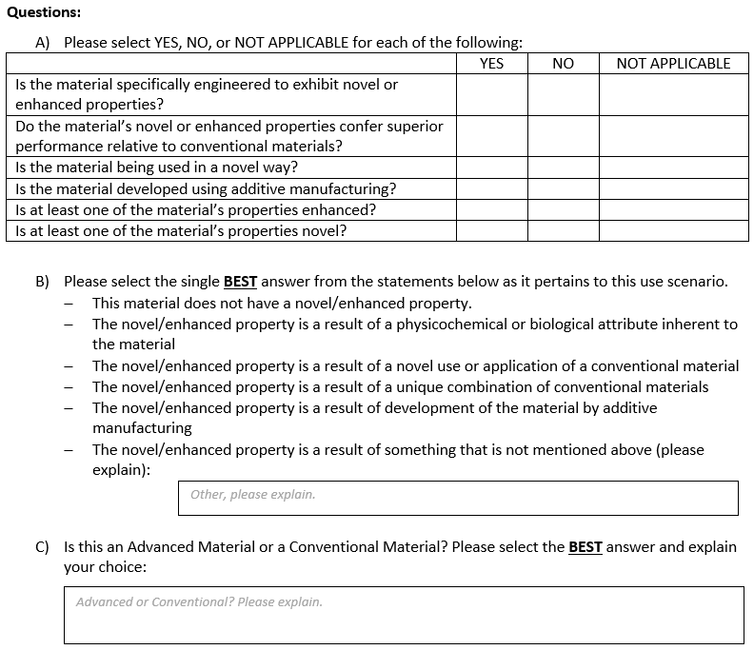

Supplement 2. Complete web survey administered in the practitioner elicitation portion of the study to validate the AdM categorization method.

Instructions

You will be presented with six materials, one at a time, and provided a picture of the material along with its name, description, application, manufacturing method, and a comparator material. You will then be asked a combination of YES/NO, multiple choice, and free-response questions about the material to find out whether you consider the material to be “Conventional” or “Advanced” (see definitions below) and why. Responses should be based on your best professional judgment using the information provided for each material even if you do not have prior experience with the material. If you are not sure about a response, please provide your best guess.

Before you begin, it is important for you to understand what we mean by the following terms:

- Advanced Material (Current ERDC definition; subject to change based on the results of this survey): “Advanced Materials are materials that are specifically engineered to exhibit novel or enhanced properties that confer superior performance relative to conventional materials. As a result of their unique characteristics, advanced materials have a highly uncertain hazard profile and the potential to require special testing procedures and methods to assess potential for adverse environmental health and safety impacts.”
- Specifically Engineered (ERDC definition): “Intentionally and knowingly designed for a particular purpose.”
- Novel (adapted from Merriam-Webster definition): “New and not resembling something formerly known or used, such as a physical phenomenon not previously known for a given material or application, or an entirely new physical phenomenon.”
- Enhanced (Oxford Dictionaries definition): “Increased, intensified, or further improved in quality, value, or extent.”
- Superior (Cambridge Dictionary definition): “Better than average, or better than others of the same type.”
- Additive Manufacturing (Adapted from U.S. Government Accountability Office (GAO) definition): “Additive Manufacturing is a layer-by-layer process of producing 3-dimensional objects directly from a digital model, unlike conventional or subtractive manufacturing processes.”
- NOTE: Materials or applications developed using additive manufacturing techniques (e.g., 3-D printing) must meet the above definition of an Advanced Material in order to be considered an Advanced Material.

Quick (Fictional) Example using Definitions:

The material being evaluated is copper coated with nanosilver particles. The material goes by the trade name “CuNDUCTOR.” CuNDUCTOR is being used in electrical wiring because it demonstrates improved conductivity relative to conventional pure-copper wire. CuNDUCTOR would meet the ERDC definition of an AdM because it satisfies both parts of the definition – it is specifically (intentionally and knowingly) engineered to exhibit an enhanced (improved) property and the enhanced property confers superior (better than others) performance relative to the conventional material used in the intended application. Although CuNDUCTOR would not be considered to have a “novel” (new) property because conductivity is a known physical property of copper, it still satisfies the first part of the ERDC definition of an AdM which requires the material to have either a “novel” or an “enhanced” property – in this example the property is “enhanced.”
Material 1
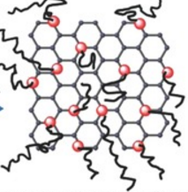
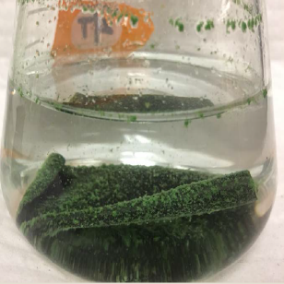
Material Name: Chitosan Graphene Oxide Composite (CSGO)
Description: Chitosan Graphene Oxide Composite is graphene oxide crosslinked with the polymer chitosan. It is used in water treatment for its adsorptive and antimicrobial properties. In wastewater filtration, CSGO demonstrates very high removal of suspended solids and microorganisms while providing long-term prevention of biofilm formation.
Application: Chitosan Graphene Oxide Composite applied in wastewater filtration for higher removal of suspended solids and microorganisms with reduced biofouling.
Comparator Material: Dow Chemical FILMTECTM reverse osmosis membrane applied in wastewater filtration for standard removal of suspended solids and microorganisms.
Manufacturing Method: Chitosan Graphene Oxide Composite developed using a top-down approach.
Questions:
- Please select YES, NO, or NOT APPLICABLE for each of the following:
 | YES | NO | NOT APPLICABLE
Is the material specifically engineered to exhibit novel or enhanced properties?
Do the material’s novel or enhanced properties confer superior performance relative to conventional materials?
Is the material being used in a novel way?
Is the material developed using additive manufacturing?
Is at least one of the material’s properties enhanced?
Is at least one of the material’s properties novel?

- Please select the single BEST answer from the statements below as it pertains to this use scenario.
- This material does not have a novel/enhanced property.
- The novel/enhanced property is a result of a physicochemical or biological attribute inherent to the material
- The novel/enhanced property is a result of a novel use or application of a conventional material
- The novel/enhanced property is a result of a unique combination of conventional materials
- The novel/enhanced property is a result of development of the material by additive manufacturing
- The novel/enhanced property is a result of something that is not mentioned above (please explain):
Other, please explain.

- Is this an Advanced Material or a Conventional Material? Please select the BEST answer and explain your choice:
Advanced or Conventional? Please explain.

Material 2
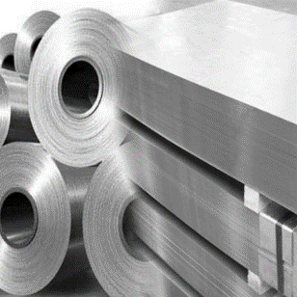
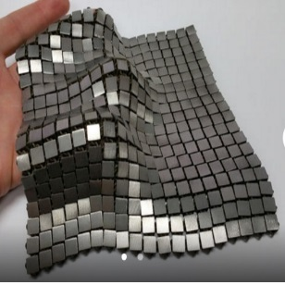
Material Name: 3D-Printed Stainless Steel
Description: Stainless steel is a steel alloy that is commonly used for its high tensile strength, corrosion-resistance, and durability. It also has high solar and thermal reflectance which prevents it from overheating when exposed to electromagnetic energy.
Application: 3D-Printed Stainless Steel printed as a fabric made up of many small interlocking squares and applied to spacecraft foot pads giving landers and rovers a firm footing without melting the ice beneath them.
Comparator Material: Aluminum thin-film laminate applied to spacecraft foot pads giving landers and rovers a firm footing without melting the ice beneath them.
Manufacturing Method: 3D-Printed Stainless Steel fabric developed using bottom-up approach.
Questions:
- Please select YES, NO, or NOT APPLICABLE for each of the following:
 | YES | NO | NOT APPLICABLE
Is the material specifically engineered to exhibit novel or enhanced properties?
Do the material’s novel or enhanced properties confer superior performance relative to conventional materials?
Is the material being used in a novel way?
Is the material developed using additive manufacturing?
Is at least one of the material’s properties enhanced?
Is at least one of the material’s properties novel?

- Please select the single BEST answer from the statements below as it pertains to this use scenario.
- This material does not have a novel/enhanced property.
- The novel/enhanced property is a result of a physicochemical or biological attribute inherent to the material
- The novel/enhanced property is a result of a novel use or application of a conventional material
- The novel/enhanced property is a result of a unique combination of conventional materials
- The novel/enhanced property is a result of development of the material by additive manufacturing
- The novel/enhanced property is a result of something that is not mentioned above (please explain):
Other, please explain.

- Is this an Advanced Material or a Conventional Material? Please select the BEST answer and explain your choice:
Advanced or Conventional? Please explain.

Material 3
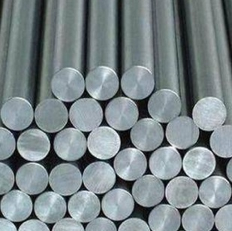

Material Name: 3D-Printed Cobalt-Chromium Alloy
Description: Cobalt-chromium alloy is a light, tough, and corrosion resistant material that can operate in temperatures as high as 982°C (1800°F). It can be 3D-printed into single-part shapes that have intricate cooling pathways and support ligaments that give it greater durability while using less material.
Application: Cobalt-chromium alloy applied to single-component 3D-printed fuel nozzles in aircraft engine combustion systems for greater durability and lighter weight.
Comparator Material: Cobalt-chromium alloy fuel nozzles produced by welding 18 individual components together for standard durability-to-weight ratio.
Manufacturing Method: Cobalt-chromium alloy fuel nozzle developed using bottom-up approach.
Questions:
- Please select YES, NO, or NOT APPLICABLE for each of the following:
 | YES | NO | NOT APPLICABLE
Is the material specifically engineered to exhibit novel or enhanced properties?
Do the material’s novel or enhanced properties confer superior performance relative to conventional materials?
Is the material being used in a novel way?
Is the material developed using additive manufacturing?
Is at least one of the material’s properties enhanced?
Is at least one of the material’s properties novel?

- Please select the single BEST answer from the statements below as it pertains to this use scenario.
- This material does not have a novel/enhanced property.
- The novel/enhanced property is a result of a physicochemical or biological attribute inherent to the material
- The novel/enhanced property is a result of a novel use or application of a conventional material
- The novel/enhanced property is a result of a unique combination of conventional materials
- The novel/enhanced property is a result of development of the material by additive manufacturing
- The novel/enhanced property is a result of something that is not mentioned above (please explain):
Other, please explain.

- Is this an Advanced Material or a Conventional Material? Please select the BEST answer and explain your choice:
Advanced or Conventional? Please explain.

Material 4
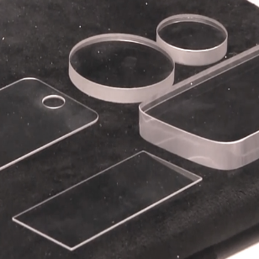
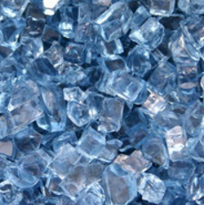
Material Name: Sapphire glass (a form of aluminum oxide, Al₂O₃)
Description: Sapphire is a gemstone that is transparent and has high compressive strength. Synthetic sapphire can be formed into sheets of glass that are rated as a “9” on the Mohs hardness scale, making it the third hardest mineral.
Application: Synthetic sapphire glass applied to an electronic display for improved durability and high scratch-resistance.
Comparator Material: Gorilla Glass, toughened aluminosilicate glass that is transparent and is rated as a “6.8” on the Mohs hardness scale, applied to an electronic display for durability and scratch-resistance.
Manufacturing Method: Sapphire glass electronic display developed using a top-down approach.
Questions:
- Please select YES, NO, or NOT APPLICABLE for each of the following:
 | YES | NO | NOT APPLICABLE
Is the material specifically engineered to exhibit novel or enhanced properties?
Do the material’s novel or enhanced properties confer superior performance relative to conventional materials?
Is the material being used in a novel way?
Is the material developed using additive manufacturing?
Is at least one of the material’s properties enhanced?
Is at least one of the material’s properties novel?

- Please select the single BEST answer from the statements below as it pertains to this use scenario.
- This material does not have a novel/enhanced property.
- The novel/enhanced property is a result of a physicochemical or biological attribute inherent to the material
- The novel/enhanced property is a result of a novel use or application of a conventional material
- The novel/enhanced property is a result of a unique combination of conventional materials
- The novel/enhanced property is a result of development of the material by additive manufacturing
- The novel/enhanced property is a result of something that is not mentioned above (please explain):
Other, please explain.

- Is this an Advanced Material or a Conventional Material? Please select the BEST answer and explain your choice:
Advanced or Conventional? Please explain.

Material 5
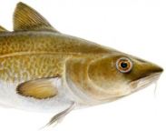
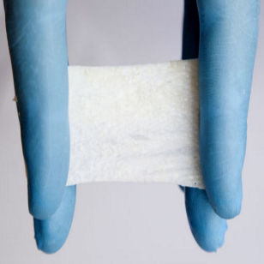
Material Name: Cold-Water Fish Skin
Description: Cold-Water Fish Skin is skin from cold-water species of fish such as the Icelandic Codfish. It has been found to have a protein composition closely resembling that of human skin. When applied to damaged human tissue, Cold-Water Fish Skin demonstrates very good wound-closure rates and biocompatibility (low immunogenicity and low risk of transmitting viral disease to humans). Minimal processing is required prior to application to human wounds.
Application: Cold-Water Fish Skin is shaped into a skin graft that will not elicit an immune response when applied to a patient’s burn wound.
Comparator Material: Human skin is processed as a skin graft that will not elicit an immune response when applied to the patient’s burn wound.
Manufacturing Method: Cold-Water Fish Skin graft developed using top-down approach.
Questions:
- Please select YES, NO, or NOT APPLICABLE for each of the following:
 | YES | NO | NOT APPLICABLE
Is the material specifically engineered to exhibit novel or enhanced properties?
Do the material’s novel or enhanced properties confer superior performance relative to conventional materials?
Is the material being used in a novel way?
Is the material developed using additive manufacturing?
Is at least one of the material’s properties enhanced?
Is at least one of the material’s properties novel?

- Please select the single BEST answer from the statements below as it pertains to this use scenario.
- This material does not have a novel/enhanced property.
- The novel/enhanced property is a result of a physicochemical or biological attribute inherent to the material
- The novel/enhanced property is a result of a novel use or application of a conventional material
- The novel/enhanced property is a result of a unique combination of conventional materials
- The novel/enhanced property is a result of development of the material by additive manufacturing
- The novel/enhanced property is a result of something that is not mentioned above (please explain):
Other, please explain.

- Is this an Advanced Material or a Conventional Material? Please select the BEST answer and explain your choice:
Advanced or Conventional? Please explain.

Material 6
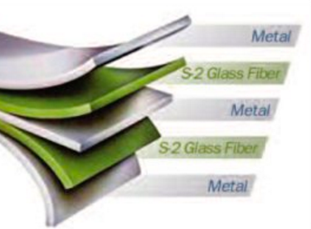

Material Name: Glass Reinforced Aluminum (GLARE)
Description: GLARE is a member of the family of materials known as fiber metal laminates. It is a sandwich material constructed from alternating layers of aluminum and glass fiber. GLARE demonstrates excellent fatigue behavior (very slow crack growth rates), high damage tolerance, resistance to corrosion and fire, and is lightweight.
Application: GLARE applied to aircraft skins (outer surface) for desirable mechanical properties combined with weight savings.
Comparator Material: Aluminum Alloy 7075-T6 is an aluminum alloy with zinc as the primary alloying element. It is commonly used in aircraft airframes and has a better strength-to-weight ratio than steel with good fatigue behavior (slow crack growth rates).
Manufacturing Method: GLARE aircraft skin developed using a top-down approach.
Questions:
- Please select YES, NO, or NOT APPLICABLE for each of the following:
 | YES | NO | NOT APPLICABLE
Is the material specifically engineered to exhibit novel or enhanced properties?
Do the material’s novel or enhanced properties confer superior performance relative to conventional materials?
Is the material being used in a novel way?
Is the material developed using additive manufacturing?
Is at least one of the material’s properties enhanced?
Is at least one of the material’s properties novel?

- Please select the single BEST answer from the statements below as it pertains to this use scenario.
- This material does not have a novel/enhanced property.
- The novel/enhanced property is a result of a physicochemical or biological attribute inherent to the material
- The novel/enhanced property is a result of a novel use or application of a conventional material
- The novel/enhanced property is a result of a unique combination of conventional materials
- The novel/enhanced property is a result of development of the material by additive manufacturing
- The novel/enhanced property is a result of something that is not mentioned above (please explain):
Other, please explain.

- Is this an Advanced Material or a Conventional Material? Please select the BEST answer and explain your choice:
Advanced or Conventional? Please explain.

Free-Response Question

Is there a material that you consider to be an Advanced Material that cannot be classified using any of the four categorical statements listed below? If yes, please describe the material and explain why you consider it to be an Advanced Material that cannot be classified using any of the four categorical statements. If no, please enter ‘No’ in the field below.

- The novel/enhanced property is a result of a physicochemical or biological attribute inherent to the material
- The novel/enhanced property is a result of a novel use or application of a conventional material
- The novel/enhanced property is a result of a unique combination of conventional materials
- The novel/enhanced property is a result of development of the material by additive manufacturing

If yes, please describe the material and explain why you consider it to be an Advanced Material that cannot be classified using any of the four categorical statements. If no, please enter ‘No’.

Images from:

Material 1
  - Chitosan decorated graphene. Available at: http://noticiasargentinas.info/new/g/graphene-group.awp (accessed 05 November 2017).
  - Nye, K (2017). Antimicrobial Activity: Graphene Oxide Polymer Composites. Engineering Research and Development Center, Vicksburg, MS.
Material 2
  - M&K Metal Co. Stainless Steel Sheet and Plate. Available at: https://www.mkmetal.net/stainlesssteel/sheetplate#1 (accessed 05 November 2017).
  - NASA (2017). ‘Space Fabric’ Links Fashion and Engineering. Available at: https://www.nasa.gov/feature/jpl/space-fabric-links-fashion-and-engineering/ (accessed 05 November 2017).
Material 3
  - Tiger International Co., Ltd. Biomedical Cobalt-Chromium Alloys. Available at: https://timetals.en.ecplaza.net/products/biomedical-cobalt-chromium-alloys_1687770 (accessed 05 November 2017).
  - Titsch, M. (2015). GE Aviation Receives Award for LEAP Engine Fuel Nozzle. 3D Printer World. Available at: http://www.3dprinterworld.com/article/ge-aviation-receives-award-for-leap-engine-fuel-nozzle (accessed 05 November 2017).
Material 4
  - Whitwam, R. (2014). What is sapphire glass and why is it in the next iPhone? Geek.com. Available at: https://www.geek.com/apple/what-is-sapphire-glass-and-why-is-it-in-the-next-iphone-1599335/ (accessed 05 November 2017).
  - Sapphire Blue Crystal Diamond Fire Pit Glass. Firepitglass.com. Available at: http://firepitglass.com/product/sapphire-blue-crystal-diamond-fire-pit-glass/ (accessed 05 November 2017).
Material 5
  - Groundfish Species: Atlantic Cod (Gadus morhua). Marz Seafood. Available at: https://marz.is/products/groundfish-species/ (accessed 05 November 2017).
  - Fish-Skin Wound Treatment. Kerecis. Available at: http://www.kerecis.com/ (accessed 05 November 2017).
Material 6
  - Product Information: GLARE® Laminate with S-2 Glass® Fiber. AGY. Available at: https://www.agy.com/wp-content/uploads/2014/03/GLARE_Laminate-Aerospace.pdf (accessed 05 November 2017).
  - Sperl, A. (2004). An Insight into Airbus Profitability. Airbus. Available at: https://company.airbus.com/dam/assets/airbusgroup/int/en/investor-relations/documents/2004/presentations/naif2004/naif2004_airbus_profitabiliyt_sperl.pdf (accessed 05 November 2017).

