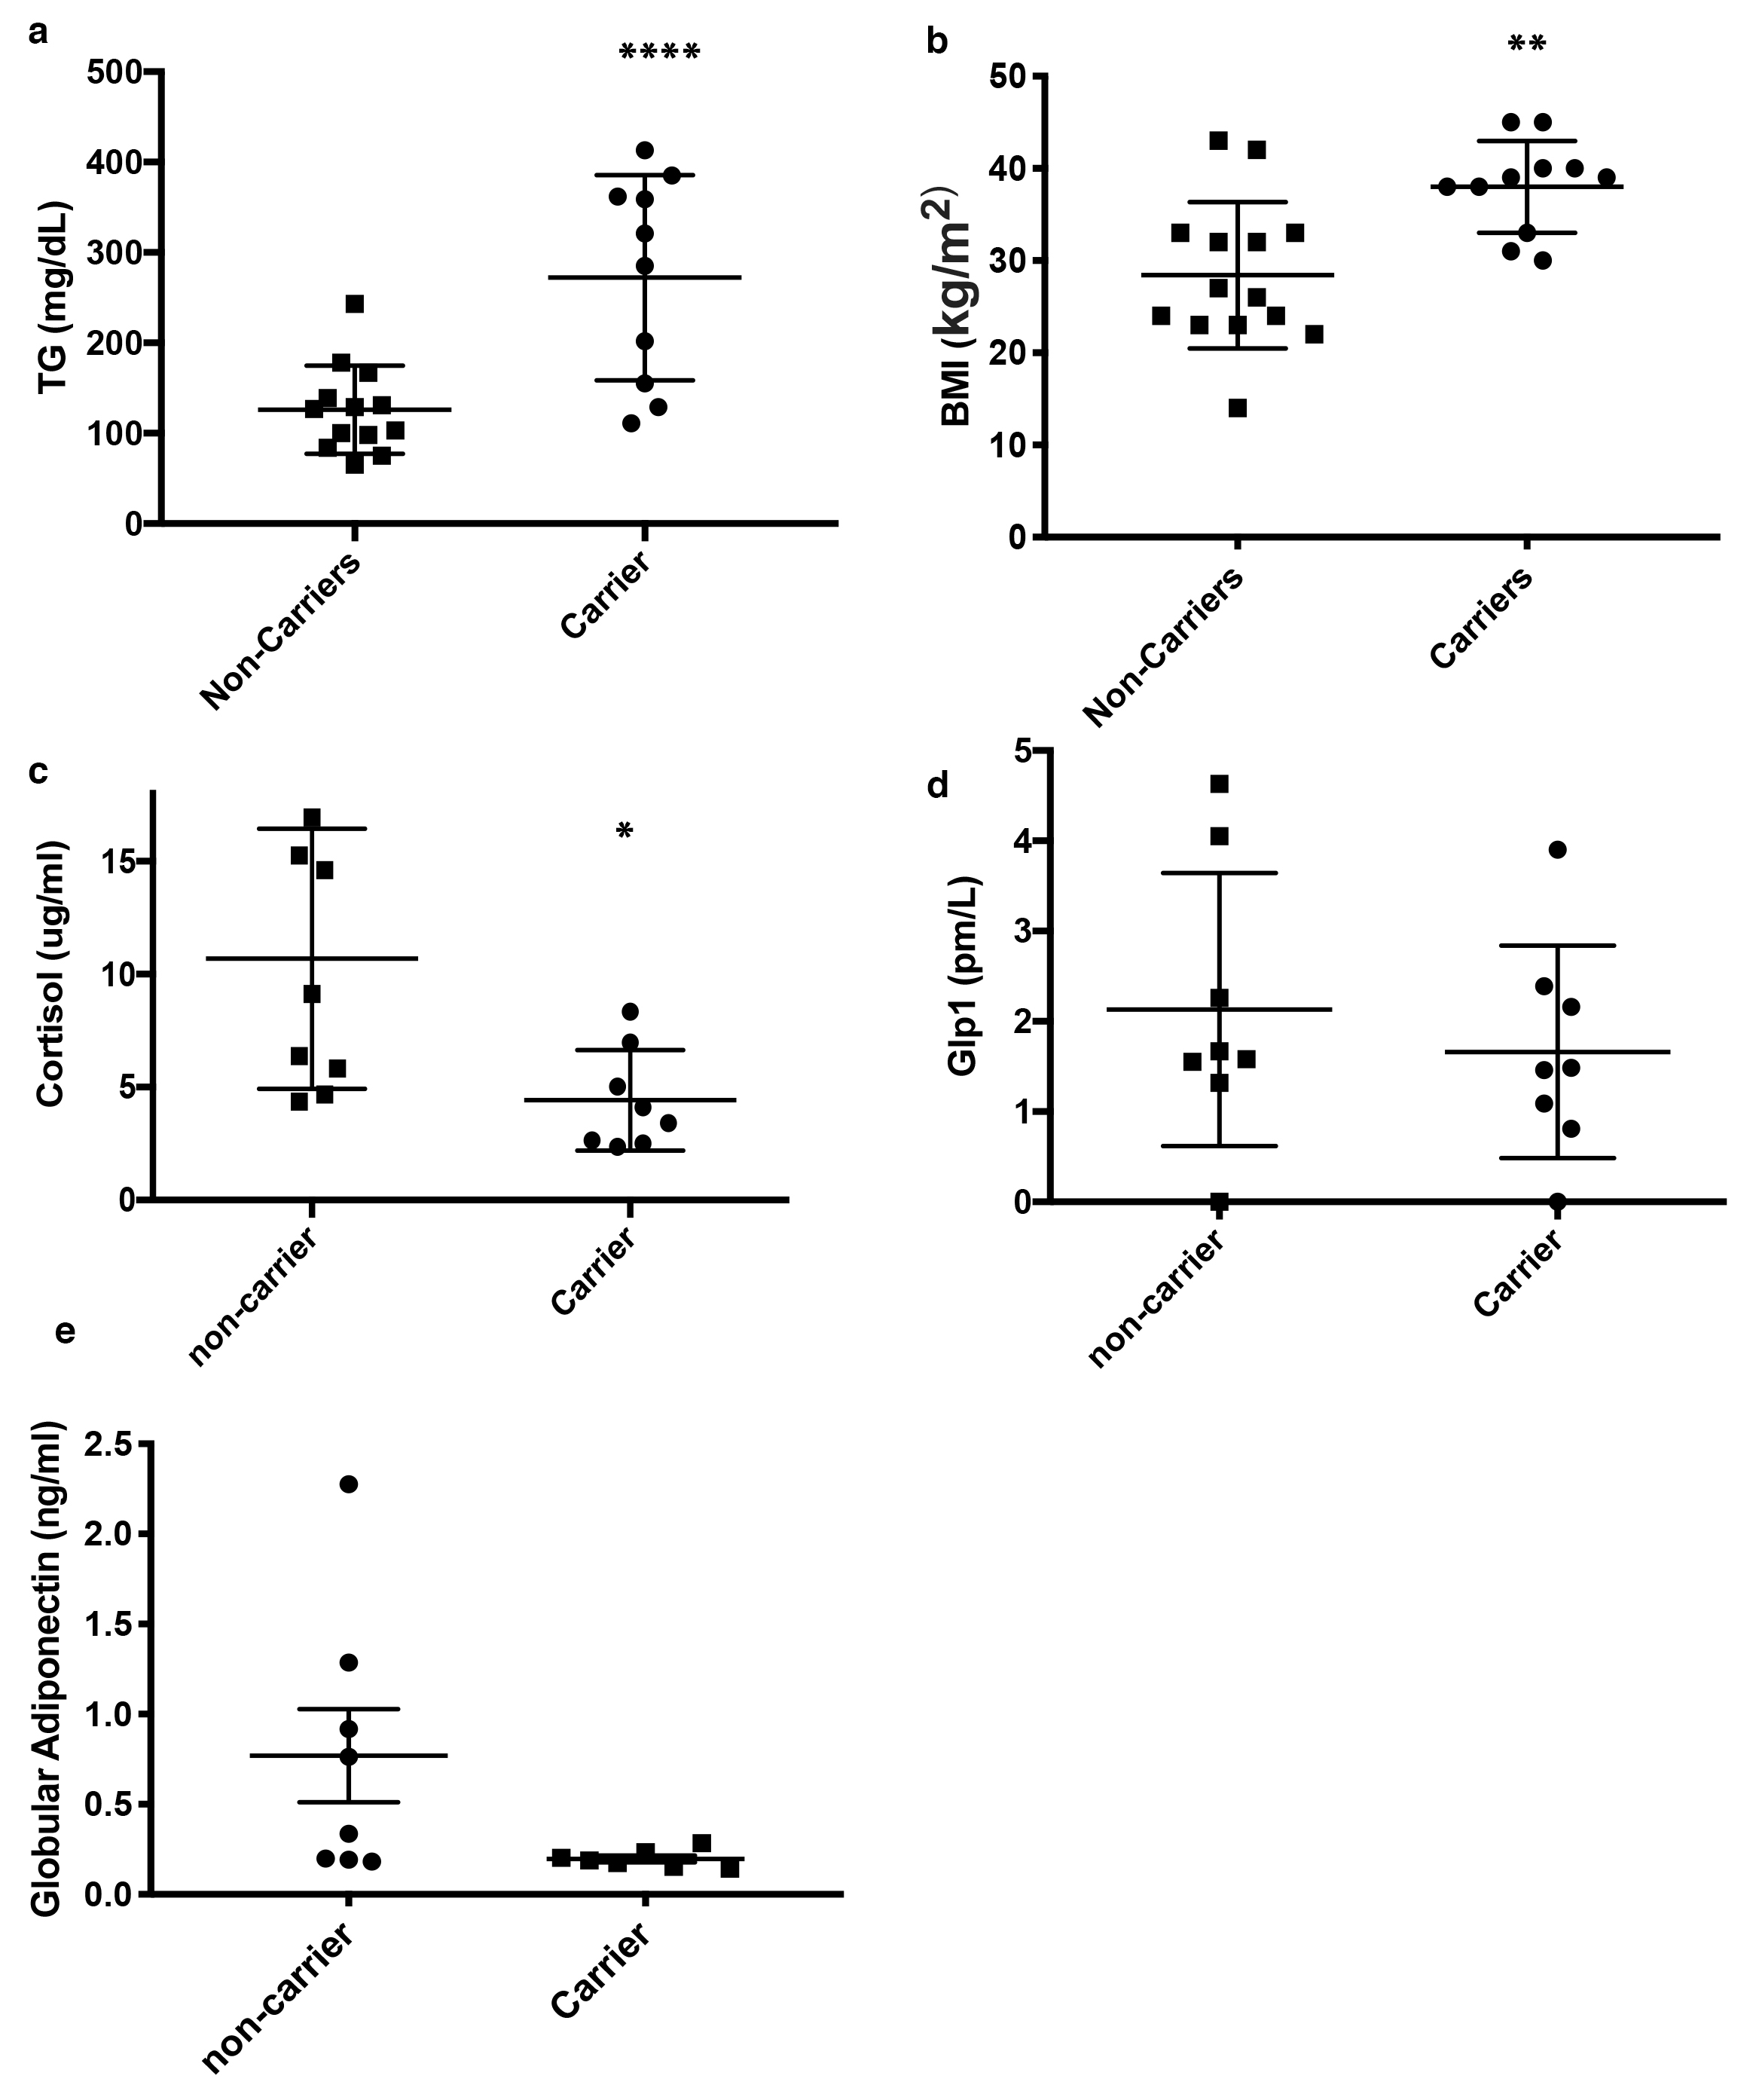
Supplementary Figure 1

Selected laboratory and clinical data in p.D121N carriers vs. non-carriers of the kindred CAD-2001.
a, Plasma TG levels (mg/dl; mean ± s.e.m.; n = 14 non-carriers vs. n = 10 carriers; Student’s t-test, two-sided at **P < 0.0001). b, BMI (kg/m²) (mean ± s.e.m. ; n = 14 non-carriers vs. n = 13 carriers; Student’s t-test, two-sided at **P = 0.002). c, Plasma cortisol levels (μg/ml; mean ± s.e.m.; n = 8 non-carriers vs. n = 8 carriers; Student’s t-test, two-sided at *P = 0.011). d, Plasma GLP1 levels (pm/L; mean ± s.e.m; n = 8 non-carriers vs. n = 8 carriers; Student’s t-test, two-sided, P = n.s). e, Plasma globular adiponectin levels (ng/ml; mean ± s.e.m.; n = 8 non-carriers vs. n = 7 carriers, Student’s t-test, two-sided; P = n.s). TG, triglycerides; BMI, body mass index; GLP1, Glucagon-like peptide 1.
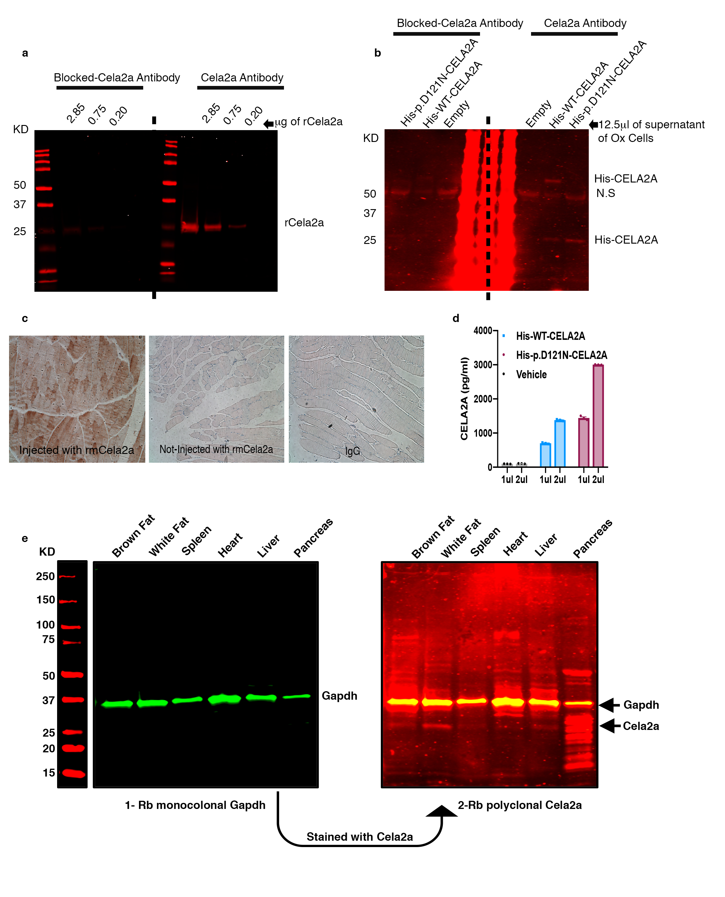
Supplementary Figure 2

Validation of CELA2A antibody used in western blot analysis and immunohistochemistry.
a, Western blot image of different quantities of rCela2a using CELA2A-specific antibody and CELA2A antibody (Sigma-Aldrich, SAB1104798) pre-blocked with rCela2a (MyBiosource, MBS1246487). The 25-kDa rCela2a bands are almost invisible in the western blot carried out using pre-blocked antibody (n = 2 independent experiments). b, Western blot analysis using the supernatants of the 293T cells overexpressing either empty vector, WT-CELA2A or p.D121N His-CELA2A. The 25-kDa and 75-kDa His-CELA2A bands are no longer visible in the western blot carried out using pre-blocked antibody; the MW marker (middle) has been greatly overexposed to allow visualization of the CELA2A bands (n = 2 independent experiments). c, Immunohistochemistry staining of mouse skeletal muscle for CELA2A in WT mice injected with rCela2a vs. saline. IgG staining was used as negative control (n = 5 independent experiments). d, Validation of the ELISA kit assay for human CELA2A using known concentrations of purified WT-CELA2A and p.D121N-CELA2A represented as bar charts with mean ± s.e.m. The vehicle served as a negative control (n = 3 independent experiments; triplicates of one experiments have been represented). e, Whole membrane of the western blot for Cela2a, shown in Figure 3b.
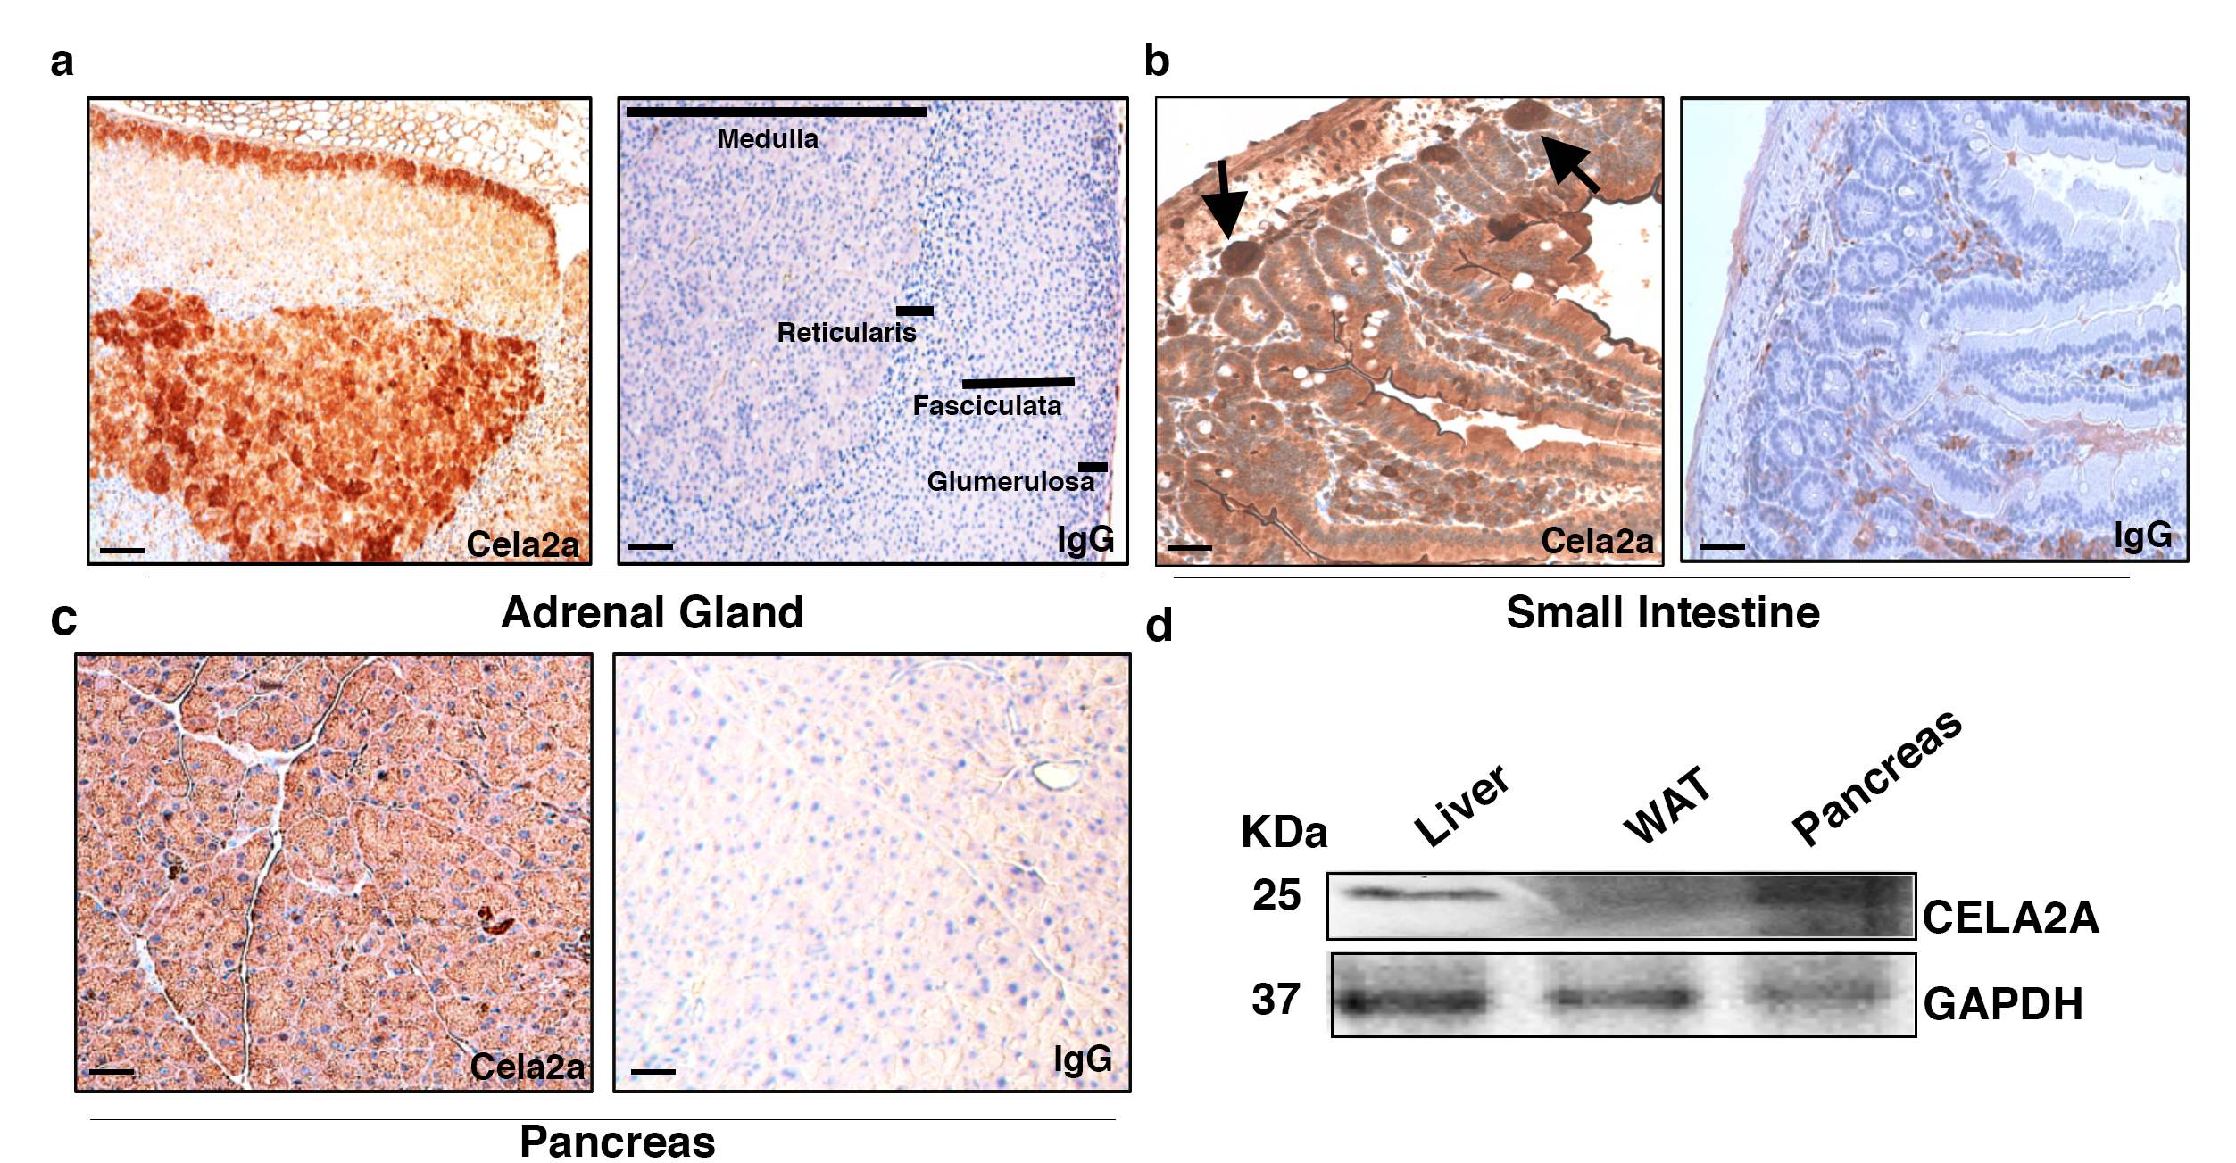

Supplementary Figure 3

Tissue distribution of CELA2A.
a-c, Immunohistochemical staining of mouse adrenal gland cortex and medulla (a) (n = 3 independent experiments), small intestine (b) (n = 3 independent experiments), and exocrine pancreas (c) (n = 5 independent experiments). Scale bar, 100 μm. Arrows indicate lymphoid follicles in the small intestine. Different zones in the adrenal gland are shown. d, Western blot analysis of CELA2A in human cadaveric liver, white adipose tissue (WAT) and pancreas.
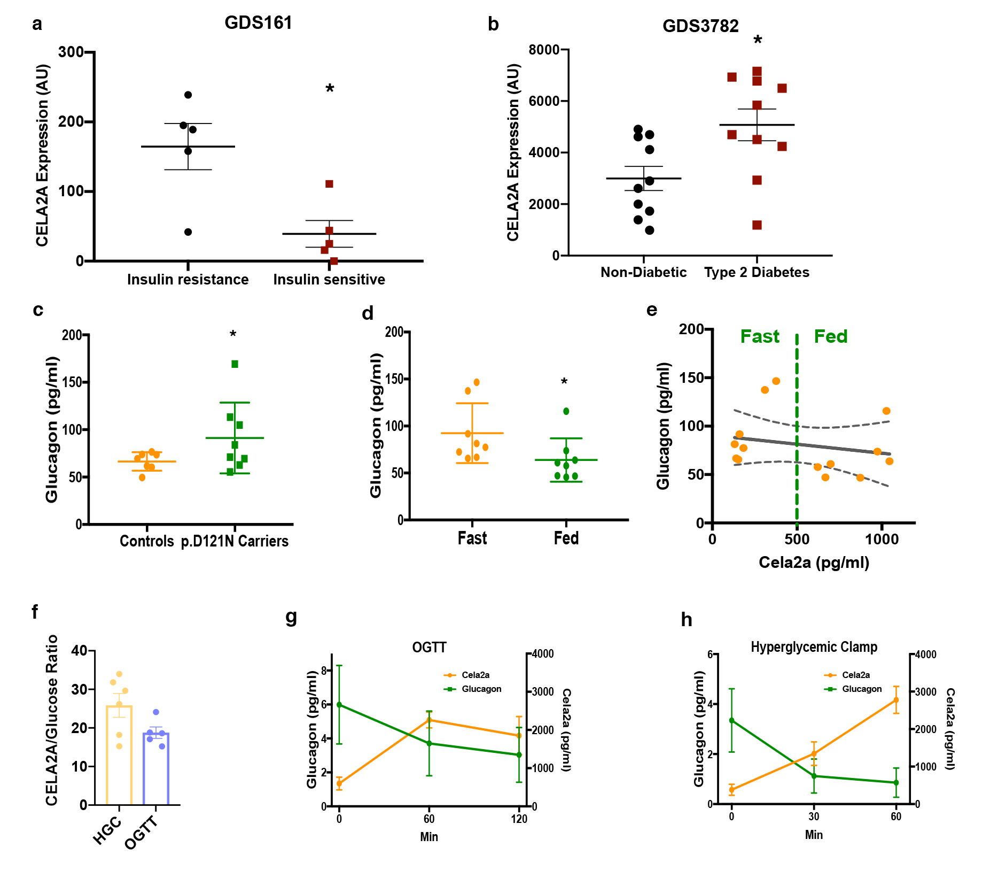
Supplementary Figure 4

Expression of CELA2A in disease states from Gene Expression Omnibus (GEO) datasets and insulin, glucose and glucagon levels before and after the meal in human subjects.
a, Relative expression of CELA2A mRNA in vastus lateralis muscle samples from insulin-resistant obese (n = 5) and insulin sensitive (n = 5) Pima Indians. b, Beta-cell enriched pancreatic tissues obtained from subjects with T2D (n = 10) and without T2D (n = 10), shown as dot plots (mean ± s.e.m). Data were derived from GEO database (see the references in the text). Statistical analyses were carried out using two-sided Student’s t-test; P = 0.0115 and P = 0.0150, respectively. c, Glucagon level (pg/dl; mean ± s.e.m) in p.D121N-CELA2A carriers compared to controls (n = 7 control samples vs. 8 p.D121N-carriers). Statistical analyses were carried out using two-sided Student’s t-test, P = 0.033. d,e, Plasma glucagon levels (pg/dl; mean ± s.e.m) in fast/fed healthy individuals and correlation with plasma CELA2A in healthy subjects before and after meal (n = 8 samples). Statistical analyses were carried out using two-sided Student’s t-test; P = 0.049. Correlation coefficient (r² = -0.72) for e was performed using GraphPad. f, CELA2A to glucose ratios (mean ± s.e.m) at 60 min hyperglycemic clamp and OGTT represented as bar chart (n = 5 samples, Student’s t-test, two-sided, P = n.s.). g,h, Average values of CELA2A and glucagon (pg/dl; mean ± s.e.m) during hyperglycemic clamp and OGTT studies (n = 5 samples). OGTT, oral glucose tolerance test. AU, arbitrary units. All human studies were performed only once.
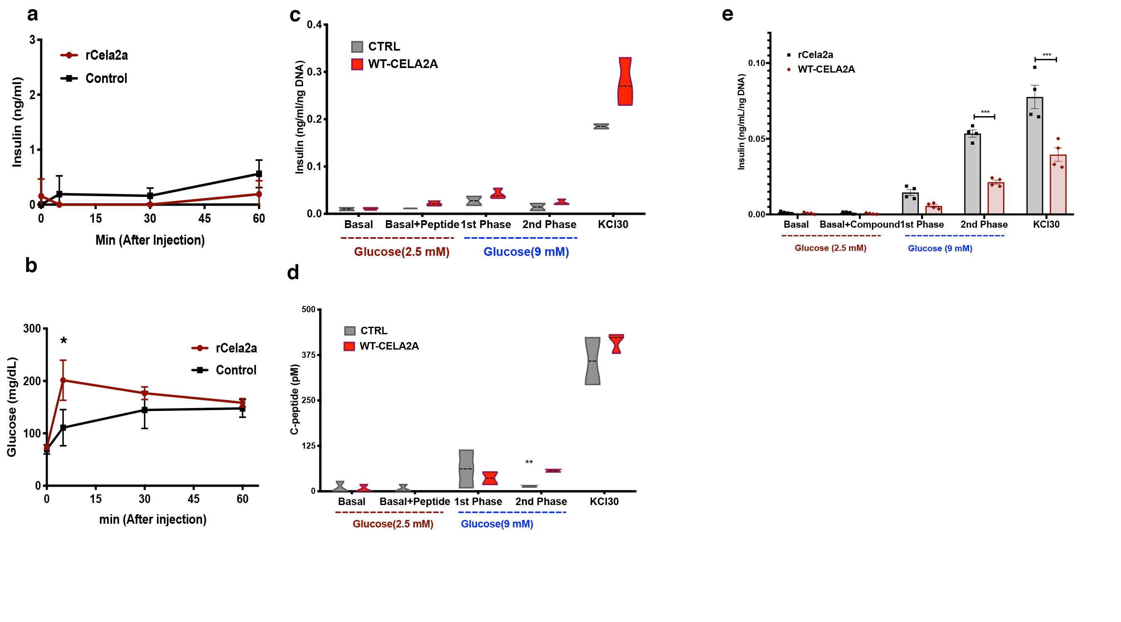
Supplementary Figure 5

rCela2a administration in vivo and in human islets.
a,b, Plasma insulin and glucose levels (mean ± s.e.m.) after intravenous administration of rCela2a to normoglycemic wild-type C57BL/6 mice (n = 5 in each group). Statistical analyses were carried out using two-sided Student’s t-test. *P < 0.05. c,d, Insulin and C-peptide secretion of human islets in response to WT-CELA2A. Response to KCl is used as a positive control and test of viability. Violin plots represent median, minimum and maximum. Statistical analyses were carried out using two-sided Student’s t-test per condition (n = 4). **P <0.01. e, Insulin secretion of human islets in response to WT-CELA2A (human) compared to rCela2a (mouse) represented in bar charts (mean ± s.e.m; n = 4 samples). Statistical analyses were carried out using two-sided Student’s t-test per conditions (***P <0.001). Response to KCl is used as a positive control and test of viability.
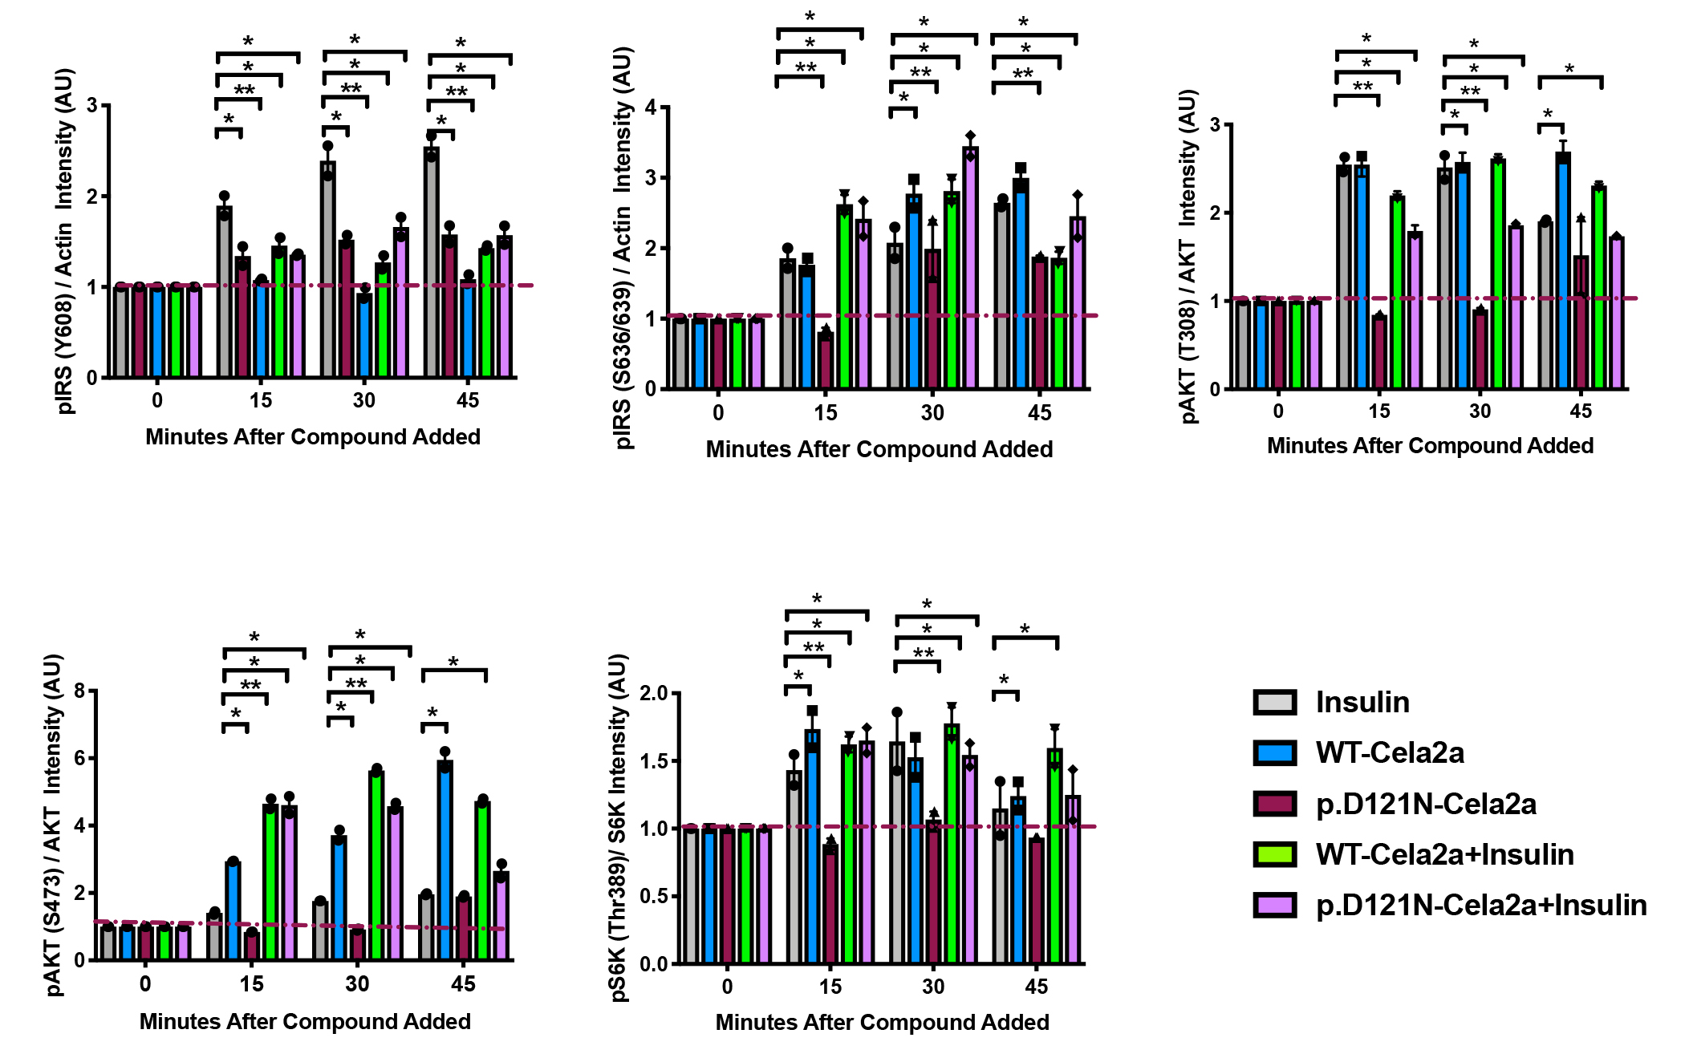
Supplementary Figure 6

Quantification of insulin signaling activation by WT-CELA2A and p.D121N-CELA2A protein.
a-e, Plots show relative intensities compared to controls for the phosphoproteins in the western blots shown in Figure 5g displayed as bar charts (mean ± s.e.m.; n = 2 independent experiments). Statistical analyses were performed using one-way ANOVA. *P < 0.05, **P < 0.001.
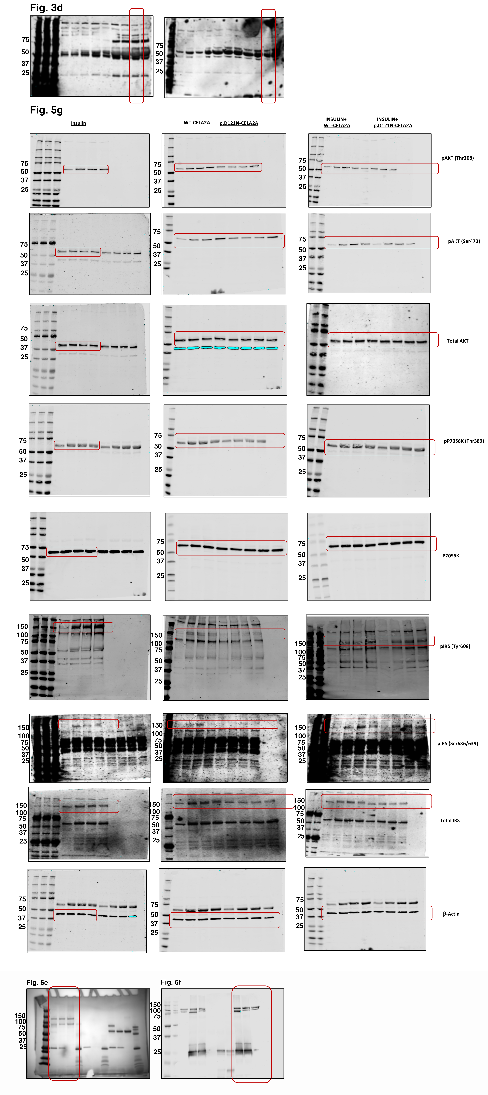
Supplementary Figure 7

Whole blot figures used in the study.
Whole blots from western blot analysis of CELA2A in human serum in Figure 3d; insulin/mTOR signaling pathways in 3T3L1 cells treated with insulin, WT- or p.D121N-CELA2A, and predigested insulin with WT- or p.D121N-CELA2A in Figure 3g; Coomassie blue and western blot of GPIIb/IIIa in Figure 6e,f.

