Supplemental Information

Signal level differences between 28-day old Alport and WT mice
The signal levels corresponding to m/z 776.4978 and m/z 888.61936 were significantly lower in 28-day-old Alport mice compared to WT mice. Figure S1a shows the signal from m/z 776.4978 in 28-day-old Alport and WT mice. The figure indicates the signal is found in the cortex of the kidney. Figure S1b shows a PAS stain of the same Alport tissue section that was imaged in S1a. Figure S1c demonstrates the great decrease in abundance in signal at m/z 776.4978 that is clearly evident in the mass spectrum. The mass spectrum is the average mass spectrum of all spectra collected over the tissue. The red trace represents signal from the Alport kidney, the blue trace represents signal from the WT kidney. The signal at m/z 776.4978 (Fig. S1c, arrow) is ~25 times higher in the Alport compared to WT mouse. The signal to the right at ~ m/z 776.56 is likely a phosphatidylserine, based on precursor mass, and it is abundant in both the WT and Alport tissue (Fig. S1c). For the m/z 776.56 signal, there were small variations in intensity depending on the individual sample as exemplified by Fig. S1c (~0.4 a.u.; ~26% decrease in Alport vs. WT), In contrast, for the m/z 776.4978 signal the difference was highly reproducible across all the experiments and the overall difference (~1.2 a.u.; ~2000% increase) was highly significant. As stated in the main text, absolute quantitation by MALDI IMS is very challenging, due to the complex sample matrix, uneven topography, and challenges associated with standardization. However, the relative signal intesities shown in Figure S1 clearly demonstrate the significant difference for m/z 776.4978.

Localization of signal: co-localization of m/z 776.4978 and m/z 888.61936 signals in the tubules
Figure S2 compares images of m/z 776.4978 and m/z 888.61936 signals in renal tissue of Alport vs. WT mouse. The image for m/z 776.4978 is the same as shown in Figure S1a. This image demonstrates the co-localization of the two signals in the cortex of the tissue. Figure S3 shows that the m/z 888.61936 signal is absent from the glomeruli while being present in tubules.

Dection of other lipid species in sample
Sample preparation for lipid imaging by MALDI IMS involves minimal washing, in order to remove non-lipid molecules. Due to the untargeted nature of MALDI IMS, many types of lipids were detected and their identities (based on the mass measurements) are given in Table S1. As stated in the methid section of the main text, the mass were recorded on a FT-ICR mass spectrometer with a <5ppm mass accuracy. The table shows the Expected mass, measured mass, mass accuracy, and putative ID, based on the mass measurement. Most of the detected lipids were phospholipids, although others, including ceramides were detected, as well.

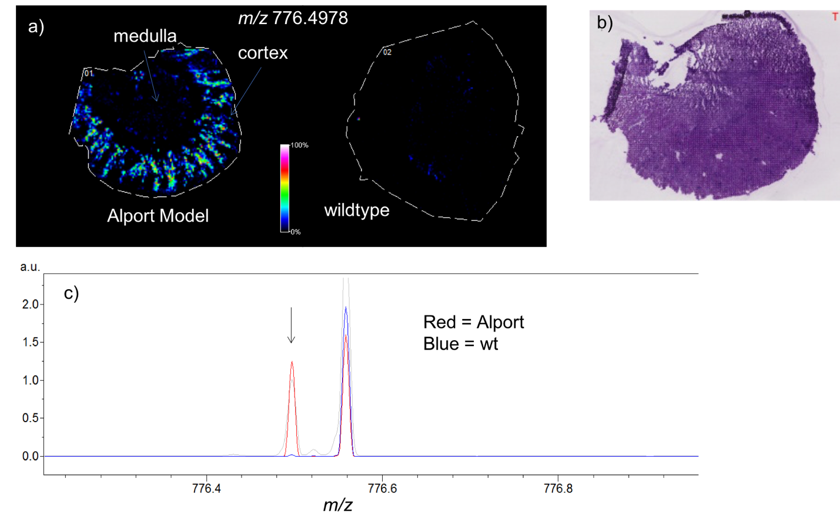
Figure S1 a) Comparison of images of m/z 776.4978 28-day-old Alport and WT kidneys. The medulla and cortex are labeled and images were recorded at 30 μm resolution, b )PAS-stained section from Alport kidney in (a), c) The average mass spectra from the image of the Alport (blue trace) and WT kidneys (red trace). An arrow points to the peak corresponding to m/z 776.4978.

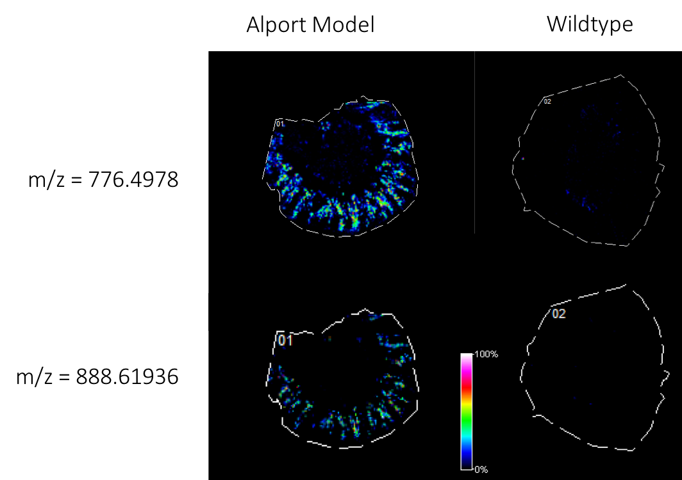
Figure S2 Images of m/z 776.4978 (top) and m/z 888.6193 (bottom) signals in 28-day-old kidneys from Alport (left) and WT mice (right). Images show co-localization of the signals.

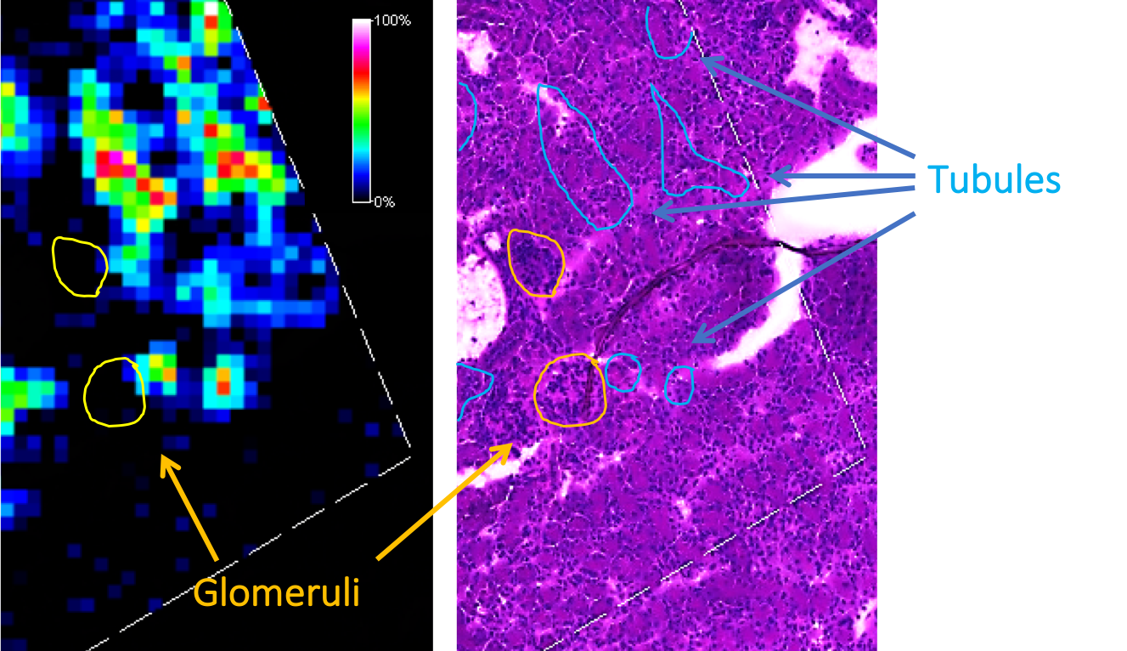

Figure S3 MALDI IMS image of m/z 888.61936 in a 28-day-old Alport kidney at 15 um resolution (right) and corresponding PAS stain of the same tissue section, after imaging (right). Tubules and glomeruli are marked with blue and yellow, respectively on the PAS stain. The location of glomeruli are marked with yellow on the MALDI IMS image.

Table S1
List of signals detected and putative identification in the kidney tissue of wild-type and Alport mice in MALDI IMS analysis. Putative identification is based on masses measured using an FT-ICR mass spectrometer. The measured mass (experimental), expected mass (calculated) and mass accuracy are provided for each lipid.

Experimental m/z | Calculated m/z | Mass Accuracy (ppm) | Putative Identification | Molecular Formula | Ion
599.3196 | 599.3202 | 1.00 | LPI(18:0) | C27H52O12P | [M-H]-
616.4709 | 616.4712 | 0.52 | CerP(d34:1) | C34H67NO6P | [M-H]-
618.4868 | 618.4868 | -0.02 | CerP(d34:0) | C34H69NO6P | [M-H]-
619.4336 | 619.4344 | 1.32 | PA(30:0) | C33H64O8P | [M-H]-
620.5982 | 620.5987 | 0.74 | Cer(d40:1) | C40H78NO3 | [M-H]-
621.3017 | 621.3045 | 4.47 | LPI(20:3) | C29H50O12P | [M-H]-
632.4294 | 632.4297 | 0.46 | PE(28:1) | C33H63NO8P | [M-H]-
634.4451 | 634.4453 | 0.35 | PE(28:0) | C33H65NO8P | [M-H]-
637.4084 | 637.4086 | 0.28 | PG(26:0) | C32H62O10P | [M-H]-
638.6092 | 638.6093 | 0.11 | Cer(d40:0(2OH)) | C40H80NO4 | [M-H]-
644.5020 | 644.5025 | 0.71 | CerP(d36:1) | C36H71NO6P | [M-H]-
645.4498 | 645.4501 | 0.46 | PA(32:1) | C35H66O8P | [M-H]-
646.4811 | 646.4817 | 0.88 | PE(P-30:0) | C35H69NO7P | [M-H]-
647.4655 | 647.4657 | 0.39 | PA(32:0) | C35H68O8P | [M-H]-
648.3877 | 648.3882 | 0.71 | PS(26:1) | C32H59NO10P | [M-H]-
648.6301 | 648.6300 | -0.17 | Cer(d42:1) | C42H82NO3 | [M-H]-
650.4035 | 650.4039 | 0.68 | PS(26:0) | C32H61NO10P | [M-H]-
658.4447 | 658.4453 | 0.85 | PE(30:2) | C35H65NO8P | [M-H]-
659.5130 | 659.5134 | 0.59 | PE-Cer(d34:1) | C36H72N2O6P | [M-H]-
671.4657 | 671.4657 | 0.06 | PA(34:2) | C37H68O8P | [M-H]-
671.5126 | 671.5134 | 1.25 | SM(d32:2) | C37H72N2O6P | [M-H]-
672.5337 | 672.5338 | 0.18 | CerP(d38:1) | C38H75NO6P | [M-H]-
673.4812 | 673.4814 | 0.31 | PA(34:1) | C37H70O8P | [M-H]-
673.5279 | 673.5290 | 1.60 | SM(d32:1) | C37H74N2O6P | [M-H]-
675.4966 | 675.4970 | 0.59 | PA(34:0) | C37H72O8P | [M-H]-
678.4351 | 678.4352 | 0.15 | PS(28:0) | C34H65NO10P | [M-H]-
685.5289 | 685.5290 | 0.09 | PE-Cer(d36:2) | C38H74N2O6P | [M-H]-
687.5443 | 687.5447 | 0.63 | PE-Cer(36:1) | C38H76N2O6P | [M-H]-
690.5077 | 690.5079 | 0.25 | PE(32:0) | C37H73NO8P | [M-H]-
695.4658 | 695.4657 | -0.14 | PA(36:4) | C39H68O8P | [M-H]-
697.4814 | 697.4814 | 0.07 | PA(36:3) | C39H70O8P | [M-H]-
699.4971 | 699.4970 | -0.14 | PA(36:2) | C39H72O8P | [M-H]-
700.5653 | 700.5651 | -0.21 | CerP(d40:1) | C40H79NO6P | [M-H]-
701.5126 | 701.5127 | 0.20 | PA(36:1) | C39H74O8P | [M-H]-
701.5589 | 701.5603 | 1.97 | SM(d34:1) | C39H78N2O6P | [M-H]-
704.4503 | 704.4508 | 0.71 | PS(30:1) | C36H67NO10P | [M-H]-
704.5228 | 704.5236 | 1.15 | PE-NMe(32:0) | C38H75NO8P | [M-H]-
706.4665 | 706.4665 | 0.03 | PS(30:0) | C36H69NO10P | [M-H]-
707.5023 | 707.5021 | -0.21 | PA(P-38:4) | C41H72O7P | [M-H]-
714.5067 | 714.5079 | 1.72 | PE(34:2) | C39H73NO8P | [M-H]-
715.5759 | 715.5760 | 0.18 | PE-Cer(d38:1) | C40H80N2O6P | [M-H]-
716.5234 | 716.5236 | 0.25 | PE(34:1) | C39H75NO8P | [M-H]-
718.5383 | 718.5392 | 1.25 | PE(34:0) | C39H77NO8P | [M-H]-
721.4814 | 721.4814 | -0.06 | PA(38:5) | C41H70O8P | [M-H]-
722.5123 | 722.5130 | 1.00 | PE(P-36:4) | C41H73NO7P | [M-H]-
723.4966 | 723.4970 | 0.55 | PA(38:4) | C41H72O8P | [M-H]-
724.5302 | 724.5287 | -2.02 | PE(P-36:3) | C41H75NO7P | [M-H]-
725.5133 | 725.5127 | -0.76 | PA(38:3) | C41H74O8P | [M-H]-
726.5806 | 726.5807 | 0.19 | CerP(d42:2) | C42H81NO6P | [M-H]-
727.5283 | 727.5283 | 0.07 | PA(38:2) | C41H76O8P | [M-H]-
728.4512 | 728.4508 | -0.48 | PS(32:3) | C38H67NO10P | [M-H]-
728.5968 | 728.5964 | -0.49 | CerP(d42:1) | C42H83NO6P | [M-H]-
730.5754 | 730.5756 | 0.33 | PE(P-36:0) | C41H81NO7P | [M-H]-
736.4906 | 736.4923 | 2.38 | PE(36:5) | C41H71NO8P | [M-H]-
738.5079 | 738.5079 | -0.04 | PE(36:4) | C41H73NO8P | [M-H]-
740.5233 | 740.5236 | 0.46 | PE(36:3) | C41H75NO8P | [M-H]-
742.5388 | 742.5392 | 0.59 | PE(36:2) | C41H77NO8P | [M-H]-
743.6061 | 743.6073 | 1.65 | PE-Cer(d40:1) | C42H84N2O6P | [M-H]-
744.5555 | 744.5549 | -0.75 | PE(36:1) | C41H79NO8P | [M-H]-
745.4807 | 745.4814 | 0.91 | PA(40:7) | C43H70O8P | [M-H]-
746.5714 | 746.5705 | -1.18 | PE(36:0) | C41H81NO8P | [M-H]-
747.4967 | 747.4970 | 0.43 | PA(40:6) | C43H72O8P | [M-H]-
747.5170 | 747.5182 | 1.63 | PG(34:1) | C40H76O10P | [M-H]-
749.5135 | 749.5127 | -1.05 | PA(40:5) | C43H74O8P | [M-H]-
749.5332 | 749.5338 | 0.85 | PG(34:0) | C40H78O10P | [M-H]-
750.5439 | 750.5443 | 0.57 | PE(P-38:4) | C43H77NO7P | [M-H]-
751.5297 | 751.5283 | -1.81 | PA(40:4) | C43H76O8P | [M-H]-
754.6126 | 754.6120 | -0.82 | CerP(d44:2) | C44H85NO6P | [M-H]-
755.5597 | 755.5596 | -0.13 | PA(40:2) | C43H80O8P | [M-H]-
756.4820 | 756.4821 | 0.09 | PS(34:3) | C40H71NO10P | [M-H]-
756.6306 | 756.6277 | -3.83 | CerP(d44:1) | C44H87NO6P | [M-H]-
760.5143 | 760.5134 | -1.18 | PS(34:1) | C40H75NO10P | [M-H]-
762.5084 | 762.5079 | -0.70 | PE(38:6) | C43H73NO8P | [M-H]-
764.5244 | 764.5236 | -1.03 | PE(38:5) | C43H75NO8P | [M-H]-
766.5397 | 766.5392 | -0.64 | PE(38:4) | C43H77NO8P | [M-H]-
768.5571 | 768.5549 | -2.85 | PE(38:3) | C43H79NO8P | [M-H]-
770.5714 | 770.5705 | -1.21 | PE(38:2) | C43H81NO8P | [M-H]-
772.5284 | 772.5287 | 0.39 | PE(P-40:7) | C45H75NO7P | [M-H]-
772.5868 | 772.5862 | -0.80 | PE(38:1) | C43H83NO8P | [M-H]-
773.5332 | 773.5338 | 0.81 | PG(36:2) | C42H78O10P | [M-H]-
774.5440 | 774.5443 | 0.43 | PE(P-40:6) | C45H77NO7P | [M-H]-
775.5488 | 775.5495 | 0.94 | PG(36:1) | C42H80O10P | [M-H]-
777.5646 | 777.5651 | 0.66 | PG(36:0) | C42H82O10P | [M-H]-
778.5144 | 778.5145 | 0.10 | (3'-sulfo)Galbeta-Cer(d34:1) | C40H76NO11S | [M-H]-
778.5760 | 778.5756 | -0.46 | PE(P-40:4) | C45H81NO7P | [M-H]-
782.4984 | 782.4978 | -0.74 | PS(36:4) | C42H73NO10P | [M-H]-
782.6524 | 782.6516 | -1.07 | GalCer(d40:1) | C46H88NO8 | [M-H]-
783.6376 | 783.6386 | 1.29 | SM(d40:2) | C45H88N2O6P | [M-H]-
785.6542 | 785.6542 | 0.05 | SM(d40:1) | C45H90N2O6P | [M-H]-
786.5283 | 786.5291 | 1.04 | PS(36:2) | C42H77NO10P | [M-H]-
788.5242 | 788.5236 | -0.72 | PE(40:7) | C45H75NO8P | [M-H]-
788.5450 | 788.5447 | -0.39 | PS(36:1) | C42H79NO10P | [M-H]-
790.5400 | 790.5392 | -0.97 | PE(40:6) | C45H77NO8P | [M-H]-
792.5549 | 792.5549 | 0.05 | PE(40:5) | C45H79NO8P | [M-H]-
794.5707 | 794.5705 | -0.28 | PE(40:4) | C45H81NO8P | [M-H]-
796.5892 | 796.5862 | -3.78 | PE(40:3) | C45H83NO8P | [M-H]-
802.5751 | 802.5756 | 0.67 | PE(P-42:6) | C47H81NO7P | [M-H]-
806.5459 | 806.5458 | -0.10 | (3'-sulfo)Galbeta-Cer(d36:1) | C42H80NO11S | [M-H]-
807.5520 | 807.5546 | 3.26 | PG(P-40:5) | C46H80O9P | [M-H]-
808.5125 | 808.5134 | 1.08 | PS(38:5) | C44H75NO10P | [M-H]-
809.5170 | 809.5186 | 2.01 | PI(32:0) | C41H78O13P | [M-H]-
810.5290 | 810.5291 | 0.16 | PS(38:4) | C44H77NO10P | [M-H]-
812.5462 | 812.5447 | -1.86 | PS(38:3) | C44H79NO10P | [M-H]-
814.5364 | 814.5392 | 3.39 | PE(42:8) | C47H77NO8P | [M-H]-
816.5545 | 816.5549 | 0.48 | PE(42:7) | C47H79NO8P | [M-H]-
818.5709 | 818.5705 | -0.54 | PE(42:6) | C47H81NO8P | [M-H]-
820.5872 | 820.5862 | -1.19 | PE(42:5) | C47H83NO8P | [M-H]-
822.5404 | 822.5407 | 0.43 | (3'-sulfo)Galbeta-Cer(d36:1(2OH)) | C42H80NO12S | [M-H]-
822.5980 | 822.6018 | 4.67 | PE(42:4) | C47H85NO8P | [M-H]-
826.6775 | 826.6778 | 0.41 | GlcCer(d42:1(2OH)) | C48H92NO9 | [M-H]-
827.5812 | 827.5808 | -0.48 | PG(40:3) | C46H84O10P | [M-H]-
832.5120 | 832.5134 | 1.71 | PS(40:7) | C46H75NO10P | [M-H]-
833.5182 | 833.5186 | 0.54 | PI(34:2) | C43H78O13P | [M-H]-
834.5294 | 834.5291 | -0.31 | PS(40:6) | C46H77NO10P | [M-H]-
835.5335 | 835.5342 | 0.85 | PI(34:1) | C43H80O13P | [M-H]-
836.5470 | 836.5447 | -2.80 | PS(40:5) | C46H79NO10P | [M-H]-
837.5502 | 837.5499 | -0.37 | PI(34:0) | C43H82O13P | [M-H]-
838.5615 | 838.5604 | -1.34 | PS(40:4) | C46H81NO10P | [M-H]-
850.5721 | 850.5720 | -0.14 | (3'-sulfo)Galbeta-Cer(d38:1(2OH)) | C44H84NO12S | [M-H]-
857.5192 | 857.5186 | -0.68 | PI(36:4) | C45H78O13P | [M-H]-
860.6143 | 860.6105 | -4.38 | LacCer(d34:1) | C46H86NO13 | [M-H]-
861.5504 | 861.5499 | -0.56 | PI(36:2) | C45H82O13P | [M-H]-
862.6083 | 862.6084 | 0.08 | (3'-sulfo)Galbeta-Cer(d40:1) | C46H88NO11S | [M-H]-
863.5685 | 863.5655 | -3.47 | PI(36:1) | C45H84O13P | [M-H]-
881.5189 | 881.5186 | -0.36 | PI(38:6) | C47H78O13P | [M-H]-
883.5352 | 883.5342 | -1.18 | PI(38:5) | C47H80O13P | [M-H]-
885.5495 | 885.5499 | 0.43 | PI(38:4) | C47H82O13P | [M-H]-
888.6249 | 888.6240 | -1.02 | (3'-sulfo)Galbeta-Cer(d42:2) | C48H90NO11S | [M-H]-
890.6403 | 890.6397 | -0.67 | (3'-sulfo)Galbeta-Cer(d42:1) | C48H92NO11S | [M-H]-
903.5042 | 903.5029 | -1.47 | PI(40:9) | C49H76O13P | [M-H]-
905.5224 | 905.5186 | -4.20 | PI(40:8) | C49H78O13P | [M-H]-
906.6366 | 906.6346 | -2.24 | (3'-sulfo)Galbeta-Cer(d42:1(2OH)) | C48H92NO12S | [M-H]-
907.5347 | 907.5342 | -0.56 | PI(40:7) | C49H80O13P | [M-H]-
909.5487 | 909.5499 | 1.28 | PI(40:6) | C49H82O13P | [M-H]-
913.5848 | 913.5812 | -3.94 | PI(40:4) | C49H86O13P | [M-H]-
972.7325 | 972.7357 | 3.32 | LacCer(d42:1) | C54H102NO13 | [M-H]-

