ONLINE SUPPLEMENT

Association of type 2 cytokines in severe rhinovirus bronchiolitis during infancy with risk of developing asthma: A multicenter prospective study

Supplemental Methods

Supplemental References

Table E1. Principal investigators at the 17 participating sites in MARC-35
Table E2. Characteristics and clinical presentation of analytic and non-analytic cohorts
Table E3. Nasopharyngeal cytokine levels and rhinovirus genomic load in infants hospitalized for rhinovirus bronchiolitis by asthma status, according to virology
Table E4. Correlations between nasopharyngeal cytokine levels and serum total IgE levels in infants hospitalized for rhinovirus bronchiolitis, according to the virology
Table E5. Correlations between rhinovirus cycle threshold value and nasopharyngeal cytokine levels in infants hospitalized for rhinovirus bronchiolitis, according to the virology

Figure 1. Relations of nasopharyngeal cytokine levels and rhinovirus genomic load in infants hospitalized for bronchiolitis with virology and asthma outcome at age 4 years
Figure E2. Association of nasopharyngeal cytokine levels in infants hospitalized for bronchiolitis with risk of asthma at age 4 years, according to virology
Figure E3. Association of normalized nasopharyngeal cytokine levels in infants hospitalized for bronchiolitis with risk of asthma at age 4 years, according to virology
Figure E4. Association of nasopharyngeal cytokine levels in infants hospitalized for bronchiolitis with risk of asthma at age 4 years, excluding 37 infants who had a breathing problem prior to enrollment
Figure E5 Correlations between nasopharyngeal airway interleukin-5 levels and blood eosinophil count in infants hospitalized with bronchiolitis

SUPPLEMENTAL METHODS

Study Design, Setting, and Participants
This is a pre-planned analysis of data from a multicenter prospective cohort study of infants hospitalized with bronchiolitis (severe bronchiolitis). This study, called the 35th Multicenter Airway Research Collaboration (MARC-35),^{1,2} was coordinated by the Emergency Medicine Network (EMNet), an international research collaboration with 245 participating hospitals.³
Using a standardized protocol, investigators at 17 sites across 14 U.S. states (Table E1) enrolled infants (age <1 year) hospitalized with an attending physician diagnosis of bronchiolitis during three consecutive bronchiolitis seasons (from November 1 to April 30) during 2011-2014. Bronchiolitis was defined by the American Academy of Pediatrics guidelines – acute respiratory illness with some combination of rhinitis, cough, tachypnea, wheezing, crackles, and retractions.⁴ We excluded infants who were transferred to a participating hospital >24 hours after the original hospitalization, those who were consented >24 hours after hospitalization, or those with known heart-lung disease, immunodeficiency, immunosuppression, or gestational age <32 weeks. All patients were treated at the discretion of the treating physician. The institutional review board at each of the participating hospitals approved the study. Written informed consent was obtained from the parent or guardian.

Data Collection
Investigators conducted a structured interview that measured patients’ demographic characteristics, medical, family, and environmental history, and details of the acute illness. Emergency department and hospital medical record reviews provided further clinical data, such as vital signs, physical examination, medical management, and disposition. After the index hospitalization for bronchiolitis, interviewers began interviewing parents/legal guardians by telephone at 6-month intervals, in addition to medical record review by trained physicians. All data were reviewed at the EMNet Coordinating Center at Massachusetts General Hospital (Boston, MA), and site investigators were queried about missing data and discrepancies identified by manual data checks.

Nasopharyngeal Airway Sampling
In addition to the clinical data, investigators also collected nasopharyngeal airway samples within 24 hours of hospitalization by using a standardized protocol that was utilized in a previous cohort study of children with bronchiolitis.^{5,6} All of the sites used the same collection equipment (Medline Industries, Mundelein, IL) and collected the samples within 24 hours of a child’s arrival on the medical ward or intensive care unit. For the collection, the infant was placed supine, 1 mL of normal saline was instilled into one naris, and then an 8 French suction catheter was used to remove the mucus. This procedure was performed once on each nostril. After the sample collection from both nares, 2 mL of normal saline was suctioned through the catheter to clear the tubing and to ensure that a standard volume of aspirate is obtained. These samples were tested for respiratory viruses and cytokines.

Respiratory Viruses and Genomic Load Measurement
We identified respiratory pathogens by using singleplex or duplex two-step real-time PCR (rtPCR) at Baylor College of Medicine (Houston, TX, USA). We used real-time reverse transcriptase-PCR to detect RNA respiratory viruses, including RV,⁷ respiratory syncytial virus [RSV],^{8,9} and 12 other RNA viruses. In addition, we also quantified relative RV genomic load as the number of amplification cycles needed for a positive PCR test result (cycle threshold [CT]).^{5,10} Studies showed that CT values provide a semi-quantitative measure of genomic load, with a significant inverse relationship between genomic load and CT values.^{11,12} All rtPCR assays were tested in duplicate and samples with incongruent values (one well positive) were retested. To reduce carryover contamination, sample preparation, RNA/DNA extraction, cDNA and amplification were performed in separate areas. All PCR runs had extraction and reagent positive and negative controls.

Nasopharyngeal Cytokine Measurement
We also measured the levels of 10 cytokines (interleukin [IL]-4, IL-5, IL-10, IL-12, IL-13, IL-25, IL-33, interferon [IFN]-β, macrophage inflammatory protein[MIP]-1α, and thymic stromal lymphopoietin [TSLP]) in the nasopharyngeal samples of infants with bronchiolitis, using multiplex the Meso Scale Discovery (MSD) electrochemiluminescent R-Plex multiplex immunoassay (Meso Scale Diagnostics, Rockville, MD), on the MESO QuickPlex SQ 120 system (Meso Scale Diagnostics). Discovery Workbench 4.0 software (Meso Scale Diagnostics) was used to analyze the data, including quality control. All samples were run in duplicate. The cytokine concentrations that were calculated to be less than or equal to the detection limit of the assay were considered equal to the detection limit for analysis purposes.

Outcome Measure
The outcome measure of interest was asthma at age 4 years based on a commonly-used epidemiologic definition of asthma¹³ – i.e., physician diagnosis of asthma, plus either asthma medication use (e.g., albuterol inhaler, inhaled corticosteroids, montelukast) or asthma-related symptoms (e.g., wheezing, nocturnal cough, chest tightness) in the past year.

Statistical Analyses
For the current study, of 187 infants with RV detection in the cohort, we analyzed 132 infants who underwent nasopharyngeal cytokine measurement. These infants had sufficient amount of nasopharyngeal airway sample for the cytokine testing. There were no significant differences in patient characteristics or clinical presentation between the analytic and non-analytic cohorts (all P>0.05; Table E2). First, we compared the patient characteristics, clinical presentation, virology, and laboratory data at enrollment by asthma status at age 4 years, with the use of chi-square test or Wilcoxon rank sum test as appropriate.
Next, to examine the association of exposures (log-transformed cytokine levels and RV genomic load) at enrollment with asthma at age 4 years, we constructed generalized linear mixed models, adjusting for potential confounders (age, sex, parental history of asthma, previous breathing problems prior to enrollment, IgE sensitization [aeroallergens or food], and virology [solo RV, RV/RSV coinfection] at enrollment) and patient clustering at the hospital-level. As the models indicated statistically significant virology–exposure interactions (P<0.05 with likelihood ratio tests), we then stratified the analysis by virology (solo RV, RV/RSV coinfection) with adjusting for age, sex, and patient clustering. In the sensitivity analyses, to address potential variable dilution of the nasopharyngeal aspirate specimens, we normalized the cytokine levels using RNase P (host housekeeping gene) copy number, as previously described.^{2,14} We also repeated the analysis excluding 37 infants who had a breathing problem prior to the enrollment. Analyses used R version 3.5. All P-values were two-tailed, with P<0.05 considered statistically significant.

SUPPLEMENTAL REFERENCES
1. Hasegawa K, Stewart CJ, Celedon JC, Mansbach JM, Tierney C, Camargo CA, Jr. Circulating 25-hydroxyvitamin D, nasopharyngeal airway metabolome, and bronchiolitis severity. Allergy. 2018;73(5):1135-1140.
2. Hasegawa K, Piedra PA, Bauer CS, et al. Nasopharyngeal CCL5 in infants with severe bronchiolitis and risk of recurrent wheezing: A multicenter prospective cohort study. Clin Exp Allergy. 2018.
3. Emergency Medicine Network. http://www.emnet-usa.org/. Accessed December 25, 2018.
4. Ralston SL, Lieberthal AS, Meissner HC, et al. Clinical practice guideline: the diagnosis, management, and prevention of bronchiolitis. Pediatrics. 2014;134(5):e1474-1502.
5. Hasegawa K, Jartti T, Mansbach JM, et al. Respiratory syncytial virus genomic load and disease severity among children hospitalized with bronchiolitis: Multicenter cohort studies in the US and Finland. J Infect Dis. 2015;211(10):1550-1559.
6. Mansbach JM, Piedra PA, Teach SJ, et al. Prospective multicenter study of viral etiology and hospital length of stay in children with severe bronchiolitis. Arch Pediatr Adolesc Med. 2012;166(8):700-706.
7. Lu X, Holloway B, Dare RK, et al. Real-time reverse transcription-PCR assay for comprehensive detection of human rhinoviruses. J Clin Microbiol. 2008;46(2):533-539.
8. van Elden LJ, van Loon AM, van der Beek A, et al. Applicability of a real-time quantitative PCR assay for diagnosis of respiratory syncytial virus infection in immunocompromised adults. J Clin Microbiol. 2003;41(9):4378-4381.
9. Kuypers J, Wright N, Ferrenberg J, et al. Comparison of real-time PCR assays with fluorescent-antibody assays for diagnosis of respiratory virus infections in children. J Clin Microbiol. 2006;44(7):2382-2388.
10. Jartti T, Hasegawa K, Mansbach JM, Piedra PA, Camargo CA, Jr. Rhinovirus-induced bronchiolitis: Lack of association between virus genomic load and short-term outcomes. J Allergy Clin Immunol. 2015;136(2):509-512 e511.
11. Borg I, Rohde G, Loseke S, et al. Evaluation of a quantitative real-time PCR for the detection of respiratory syncytial virus in pulmonary diseases. Eur Respir J. 2003;21(6):944-951.
12. Do LA, van Doorn HR, Bryant JE, et al. A sensitive real-time PCR for detection and subgrouping of human respiratory syncytial virus. J Virol Methods. 2012;179(1):250-255.
13. Camargo CA, Jr., Ingham T, Wickens K, et al. Cord-blood 25-hydroxyvitamin D levels and risk of respiratory infection, wheezing, and asthma. Pediatrics. 2011;127(1):e180-187.
14. Piedra FA, Mei M, Avadhanula V, et al. The interdependencies of viral load, the innate immune response, and clinical outcome in children presenting to the emergency department with respiratory syncytial virus-associated bronchiolitis. PLoS One. 2017;12(3):e0172953.

Table E1. Principal investigators at the 17 participating sites in MARC-35
Amy D. Thompson, MD | Alfred I. duPont Hospital for Children, Wilmington, DE
Federico R. Laham, MD, MS | Arnold Palmer Hospital for Children, Orlando, FL
Jonathan M. Mansbach, MD, MPH | Boston Children's Hospital, Boston, MA
Vincent J. Wang, MD, MHA and Susan  Wu, MD | Children's Hospital of Los Angeles, Los Angeles, CA
Michelle B. Dunn, MD and Jonathan M.  Spergel, MD, PhD | Children's Hospital of Philadelphia, Philadelphia, PA
Juan C. Celedón, MD, DrPH | Children's Hospital of Pittsburgh, Pittsburgh, PA
Michael R. Gomez, MD, MS-HCA and  Nancy Inhofe, MD | The Children's Hospital at St. Francis, Tulsa, OK
Brian M. Pate, MD and Henry T. Puls, MD | The Children's Mercy Hospital & Clinics, Kansas City, MO
Stephen J. Teach, MD, MPH | Children's National Medical Center, Washington, D.C.
Richard T. Strait, MD and Stephen C.  Porter, MD, MSc, MPH | Cincinnati Children's Hospital and Medical Center, Cincinnati, OH
Ilana Y. Waynik, MD | Connecticut Children's Medical Center, Hartford, CT
Sujit Iyer, MD | Dell Children's Medical Center of Central Texas, Austin, TX
Michelle D. Stevenson, MD, MS | Norton Children's Hospital, Louisville, KY
Wayne G. Shreffler, MD, PhD and Ari R.  Cohen, MD | Massachusetts General Hospital, Boston, MA
Anne K. Beasley, MD and Cindy S. Bauer,  MD | Phoenix Children's Hospital, Phoenix, AZ
Thida Ong, MD and Markus Boos, MD,  PhD | Seattle Children's Hospital, Seattle, WA
Charles G. Macias, MD, MPH | Texas Children's Hospital, Houston, TX

Table E2. Characteristics and clinical presentation of analytic and non-analytic cohorts
 | Analytic cohort | Non-analytic cohort | P-value
Variables | n=132 (71%) | n=55 (29%)
Characteristics
Age (mo), median, (IQR) | 3.9 (2.0-6.4) | 3.0 (2.0-6.5) | 0.67
Female sex | 48 (36.4) | 14 (25.5) | 0.27
Race/ethnicity |  |  | 0.90
Non-Hispanic white | 52 (39.4) | 19 (34.5)
Non-Hispanic black | 34 (25.8) | 14 (25.5)
Hispanic | 41 (31.1) | 20 (36.4)
Other | 4 (3.0) | 2 (3.6)
Parental history of asthma | 51 (38.6) | 18 (32.7) | 0.59
Parental history of eczema | 27 (20.5) | 8 (14.5) | 0.51
Maternal smoking during pregnancy | 15 (11.4) | 7 (12.7) | 0.52
Mode of birth (c-section) | 38 (28.8) | 17 (30.9) | 0.52
Prematurity (32-37 weeks) | 29 (22.0) | 12 (21.8) | 0.81
Previous breathing problems before the index  hospitalization* | 0.34 (0.58) | 0.38 (0.68) | 0.64
History of eczema | 21 (15.9) | 4 (7.3) | 0.23
Ever attended daycare | 41 (31.1) | 16 (29.1) | 0.78
Household sibling | 109 (82.6) | 42 (76.4) | 0.45
Breastfed | 62 (47.0) | 17 (30.9) | 0.06
Smoke exposure at home | 15 (11.4) | 4 (7.3) | 0.56
Corticosteroid use in lifetime | 27 (20.5) | 10 (18.2) | 0.76
Presentation and course at hospitalization for bronchiolitis
Weight at presentation (kg), median (IQR) | 6.7 (5.2-7.9) | 6.1 (4.9-8.0) | 0.52
Laboratory testing
Coinfection with RSV | 72 (54.5) | 37 (67.3) | 0.24
Blood eosinophil count/ul, median (IQR) | 130 (40-270) | 160 (70-240) | 0.84
Serum total 25OHD (ng/ml), median (IQR) | 25.0 (16.9-33.0) | 28.6 (20.8-35.2) | 0.09
Serum LL-37 (ng/ml), median (IQR) | 54.0 (40.0-71.0) | 54.0 (35.0-67.0) | 0.05
sIgE sensitization† | 19 (14.4) | 14 (25.5) | 0.16
Food sensitization | 19 (14.4) | 14 (25.5) | 0.16
Aeroallergen sensitization | 1 (0.8) | 0 (0.0) | 0.66
Clinical course
Intensive care use‡ | 17 (12.9) | 11 (20.0) | 0.38
Use of mechanical ventilation | 4 (3.0) | 3 (5.5) | 0.60
Data are no. (%) of children unless otherwise indicated. Percentages may not equal 100, because of rounding and missingness
Abbreviations: IQR, interquartile range; RSV, respiratory syncytial virus; sIgE, specific immunoglobulin E; 25OHD, 25-hydroxyvitamin D
* Defined as an infant having cough that wakes him/her at night and/or causes emesis, or when the child has wheezing or shortness of breath without cough before the index hosptalization
† Defined by having one or more positive values for serum allergen-specific IgE at the index hospitalization
‡ Defined as admission to intensive care unit and/or use of mechanical ventilation (continuous positive airway pressure and/or intubation during inpatient stay, regardless of location) at any time during the index hospitalization

Table E3. Nasopharyngeal cytokine levels and rhinovirus genomic load in infants hospitalized for rhinovirus bronchiolitis by asthma status according to the virology
Group and exposure | No asthma | Asthma | P-value*
Overall (n=132) †
IL-4 (pg/ml) | 0.05 [0.03, 0.08] | 0.06 [0.03, 0.08] | 0.48
IL-5 (pg/ml) | 0.10 [0.09, 0.11] | 0.11 [0.10, 0.18] | 0.03
IL10 (pg/ml) | 3.86 [0.89, 11.42] | 3.61 [1.41, 7.06] | 0.83
IL-12 (pg/ml) | 0.24 [0.19, 0.26] | 0.22 [0.19, 0.26] | 0.75
IL-13 (pg/ml) | 3.47 [2.88, 3.54] | 3.47 [2.96, 3.54] | 0.23
IL-25 (pg/ml) | 0.38 [0.36, 0.59] | 0.38 [0.36, 1.22] | 0.24
IL-33 (pg/ml) | 3.29 [1.11, 12.97] | 4.61 [1.72, 16.16] | 0.32
IFN-β (pg/ml) | 19.83 [5.62, 44.31] | 9.25 [5.76, 30.24] | 0.36
MIP-1ɑ (pg/ml) | 160.68 [65.95, 326.14] | 194.47 [71.65, 396.29] | 0.63
TSLP (pg/ml) | 1.32 [0.73, 3.01] | 2.00 [0.95, 3.54] | 0.13
RV CT value | 30 [27, 35] | 28 [24, 33] | 0.03
Solo RV infection (n=59)
IL-4 (pg/ml) | 0.03 [0.03, 0.08] | 0.08 [0.04, 0.08] | 0.04
IL-5 (pg/ml) | 0.10 [0.10, 0.11] | 0.11 [0.11, 0.57] | 0.01
IL10 (pg/ml) | 2.71 [0.53, 7.53] | 4.54 [1.48, 7.45] | 0.51
IL-12 (pg/ml) | 0.19 [0.17, 0.26] | 0.19 [0.19, 0.26] | 0.85
IL-13 (pg/ml) | 3.21 [2.96, 3.54] | 3.47 [3.47, 3.54] | 0.10
IL-25 (pg/ml) | 0.38 [0.36, 0.48] | 0.38 [0.36, 1.22] | 0.34
IL-33 (pg/ml) | 5.56 [1.24, 14.46] | 4.00 [1.73, 15.97] | 0.79
IFN-β (pg/ml) | 5.76 [2.82, 12.74] | 7.27 [5.76, 35.47] | 0.10
MIP-1ɑ (pg/ml) | 173.44 [73.20, 315.42] | 266.21 [166.53, 430.22] | 0.12
TSLP (pg/ml) | 1.27 [0.73, 2.55] | 2.83 [0.97, 5.47] | 0.03
RV CT value | 27 [25, 31] | 24 [23, 27] | 0.046
RV/RSV coinfection (n=73)
IL-4 (pg/ml) | 0.06 [0.03, 0.08] | 0.04 [0.03, 0.08] | 0.36
IL-5 (pg/ml) | 0.10 [0.09, 0.11] | 0.10 [0.09, 0.10] | 0.38
IL10 (pg/ml) | 4.64 [1.30, 11.49] | 2.92 [1.39, 4.14] | 0.41
IL-12 (pg/ml) | 0.26 [0.19, 0.26] | 0.26 [0.19, 0.26] | 0.83
IL-13 (pg/ml) | 3.47 [2.73, 3.54] | 3.47 [2.80, 3.47] | 0.70
IL-25 (pg/ml) | 0.37 [0.30, 1.07] | 0.38 [0.36, 1.22] | 0.58
IL-33 (pg/ml) | 2.72 [1.12, 10.64] | 4.74 [1.88, 14.99] | 0.32
IFN-β (pg/ml) | 28.57 [13.78, 48.58] | 14.21 [7.85, 26.69] | 0.08
MIP-1ɑ (pg/ml) | 152.37 [65.44, 404.15] | 73.04 [28.89, 229.68] | 0.17
TSLP (pg/ml) | 1.45 [0.75, 3.49] | 1.35 [0.98, 2.01] | 0.77
RV CT value | 32 [28, 36] | 35 [29, 37] | 0.35
Data are presented as median [IQR]. Abbreviations: IFN, interferon; IL, interleukin; IQR, interquartile range; MIP; macrophage inflammatory protein; RSV, respiratory syncytial virus; RV, rhinovirus; TSLP, thymic stromal lymphopoietin.
* Wilcoxon rank sum test. Bold results indicate P<0.05
† Correlations of cytokine levels with total IgE, RV CT value, and blood eosinophil count are shown in Table E4, Table E5, and Figure E5, respectively.

Table E4. Correlations between nasopharyngeal cytokine levels and serum total IgE levels in infants hospitalized for rhinovirus bronchiolitis, according to the virology

 | Overall |  | Solo RV infection |  |  | RV/RSV coinfection
Cytokines | Spearman's rho | P-value | Spearman's rho | P-value | Spearman's rho |  | P-value
IL-4 | -0.02 | 0.86 | -0.07 | 0.62 | 0.00 |  | 0.86
IL-5 | 0.17 | 0.06 | 0.21 | 0.11 | 0.02 |  | 0.64
IL10 | -0.14 | 0.11 | -0.08 | 0.56 | 0.06 |  | 0.10
IL-12 | 0.03 | 0.74 | -0.02 | 0.90 | -0.20 |  | 0.27
IL-13 | -0.04 | 0.67 | -0.09 | 0.49 | 0.13 |  | 0.81
IL-25 | 0.06 | 0.50 | 0.05 | 0.70 | -0.03 |  | 0.58
IL-33 | 0.06 | 0.47 | -0.01 | 0.91 | 0.07 |  | 0.33
IFN-β | 0.00 | 0.98 | 0.18 | 0.17 | 0.12 |  | 0.52
MIP-1ɑ | -0.06 | 0.50 | 0.03 | 0.79 | -0.08 |  | 0.08
TSLP | 0.08 | 0.37 | 0.14 | 0.29 | -0.21 |  | 0.92
Abbreviations: IFN, interferon; IL, interleukin; MIP; macrophage inflammatory protein; RSV, respiratory syncytial virus; RV, rhinovirus; TSLP, thymic stromal lymphopoietin.

Table E5. Correlations between rhinovirus cycle threshold value and nasopharyngeal cytokine levels in infants hospitalized for rhinovirus bronchiolitis, according to the virology
 | Overall |  | Solo RV infection |  | RV/RSV coinfection
Cytokines | Spearman's rho | P-value | Spearman's rho | P-value | Spearman's rho | P-value
IL-4 | -0.06 | 0.51 | -0.23 | 0.09 | 1.00 | 0.80
IL-5 | -0.24 | 0.01 | -0.45 | <0.001 | 0.03 | 0.40
IL10 | 0.06 | 0.53 | -0.20 | 0.13 | 0.10 | 0.26
IL-12 | 0.07 | 0.46 | 0.09 | 0.51 | 0.13 | 0.87
IL-13 | -0.08 | 0.34 | -0.19 | 0.15 | -0.02 | 0.48
IL-25 | -0.07 | 0.46 | 0.03 | 0.82 | 0.09 | 0.44
IL-33 | 0.04 | 0.64 | 0.11 | 0.41 | -0.09 | 0.54
IFN-β | 0.19 | 0.03 | -0.18 | 0.16 | 0.07 | 0.80
MIP-1ɑ | -0.08 | 0.37 | -0.11 | 0.39 | 0.03 | 0.77
TSLP | -0.02 | 0.81 | -0.23 | 0.08 | 0.03 | 0.33
Abbreviations: IFN, interferon; IL, interleukin; MIP; macrophage inflammatory protein; RSV, respiratory syncytial virus; RV, rhinovirus; TSLP, thymic stromal lymphopoietin.

Figure E1. Relations of nasopharyngeal cytokine levels and rhinovirus genomic load in infants hospitalized for bronchiolitis with virology and asthma outcome at age 4 years.
The heatmap shows the distributions of nasopharyngeal cytokine levels and RV genomic load by virology and asthma status at age 4 years, with the use of hierarchical clustering with average linkage algorithm.
Abbreviations: IFN, interferon; IL, interleukin; MIP; macrophage inflammatory protein; RSV, respiratory syncytial virus; RV, rhinovirus; TSLP, thymic stromal lymphopoietin. 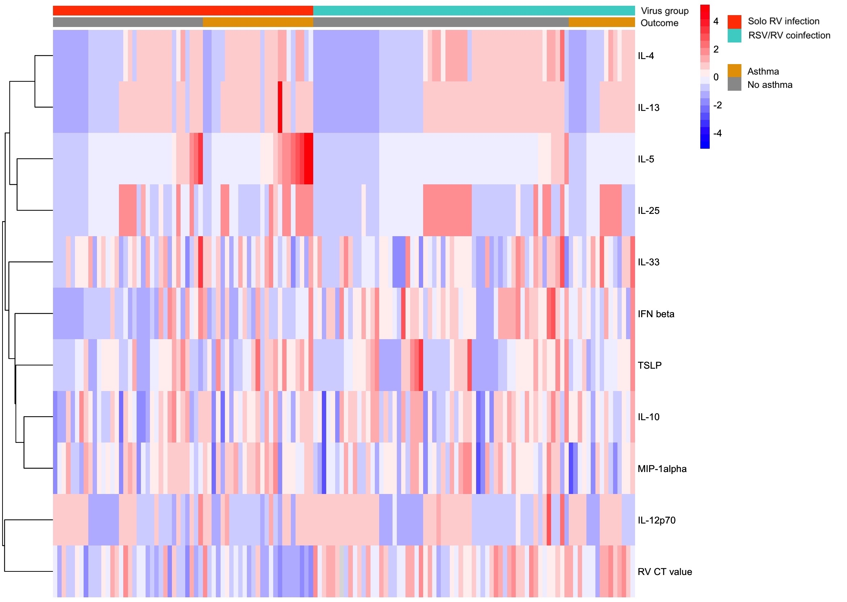
Figure E2. Association of nasopharyngeal cytokine levels in infants hospitalized for bronchiolitis with risk of asthma at age 4 years, according to virology
The fitted lines represent locally estimated scatterplot smoothed (loess) curve for infants with solo RV bronchiolitis and those with RV/RSV coinfection. A) IL-4, B) IL-5, C) IL-10, D) IL-12, E) IL-13, F) IL-25, G) IL-33, H) IFN-β, I) MIP-1α, and J) TSLP levels. The grey bar represents the range in which 95% of data are present.
Abbreviations: IFN, interferon; IL, interleukin; IQR, interquartile range; MIP; macrophage inflammatory protein; RSV, respiratory syncytial virus; RV, rhinovirus; TSLP, thymic stromal lymphopoietin.
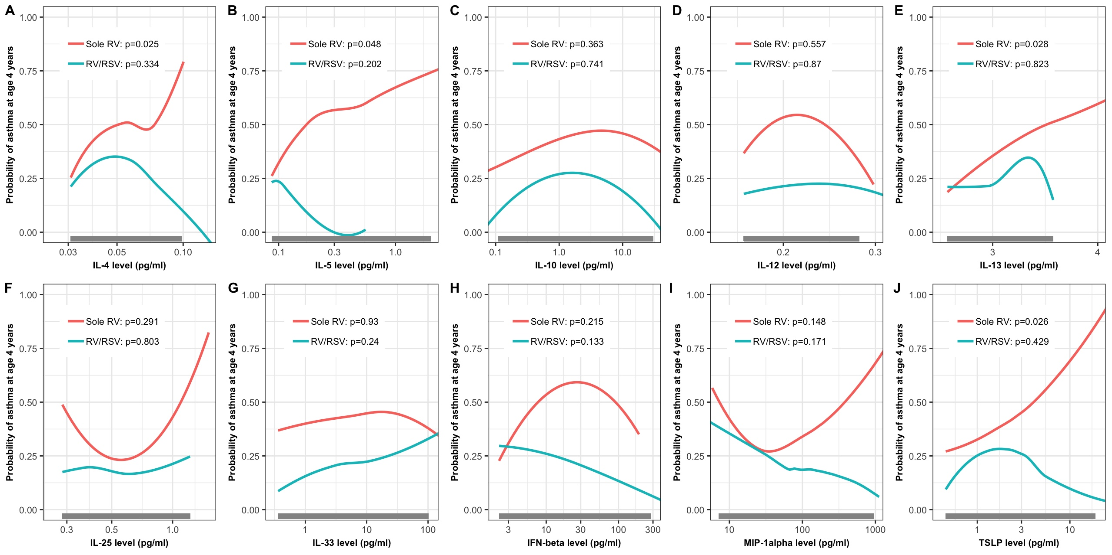
Figure E3. Association of normalized nasopharyngeal cytokine levels in infants hospitalized for bronchiolitis with risk of asthma at age 4 years, according to virology
The fitted lines represent locally estimated scatterplot smoothed (loess) curve for infants with solo RV bronchiolitis and those with RV/RSV coinfection. The levels of A) IL-4, B) IL-5, C) IL-10, D) IL-12, E) IL-13, F) IL-25, G) IL-33, H) IFN-β, I) MIP-1α, and J) TSLP were normalized using RNase P copy number. The grey bar represents the range in which 95% of data are present.
Abbreviations: IFN, interferon; IL, interleukin; IQR, interquartile range; MIP; macrophage inflammatory protein; RSV, respiratory syncytial virus; RV, rhinovirus; TSLP, thymic stromal lymphopoietin.
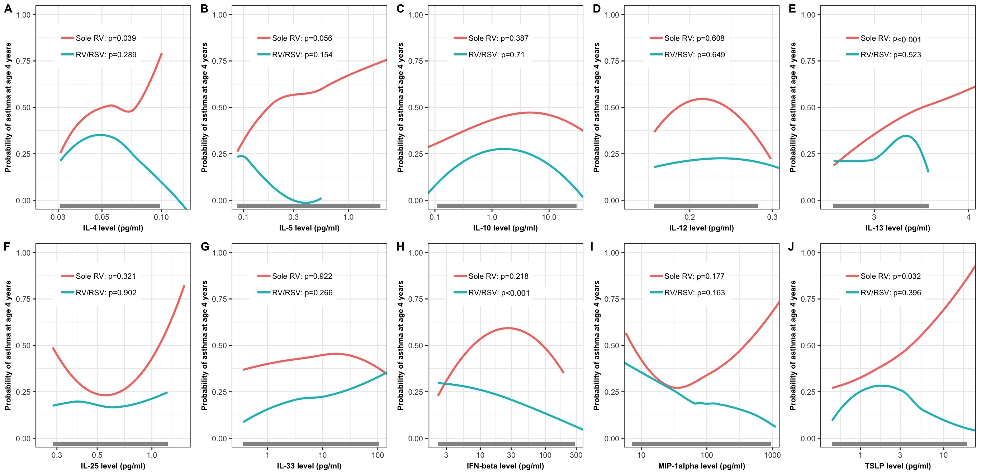

Figure E4. Association of nasopharyngeal cytokine levels in infants hospitalized for bronchiolitis with risk of asthma at age 4 years, excluding 37 infants who had a breathing problem prior to enrollment
The fitted lines represent locally estimated scatterplot smoothed (loess) curve for infants with solo RV bronchiolitis and those with RV/RSV coinfection. A) IL-4, B) IL-5, C) IL-10, D) IL-12, E) IL-13, F) IL-25, G) IL-33, H) IFN-β, I) MIP-1α, and J) TSLP levels. The grey bar represents the range in which 95% of data are present.
Abbreviations: IFN, interferon; IL, interleukin; IQR, interquartile range; MIP; macrophage inflammatory protein; RSV, respiratory syncytial virus; RV, rhinovirus; TSLP, thymic stromal lymphopoietin.

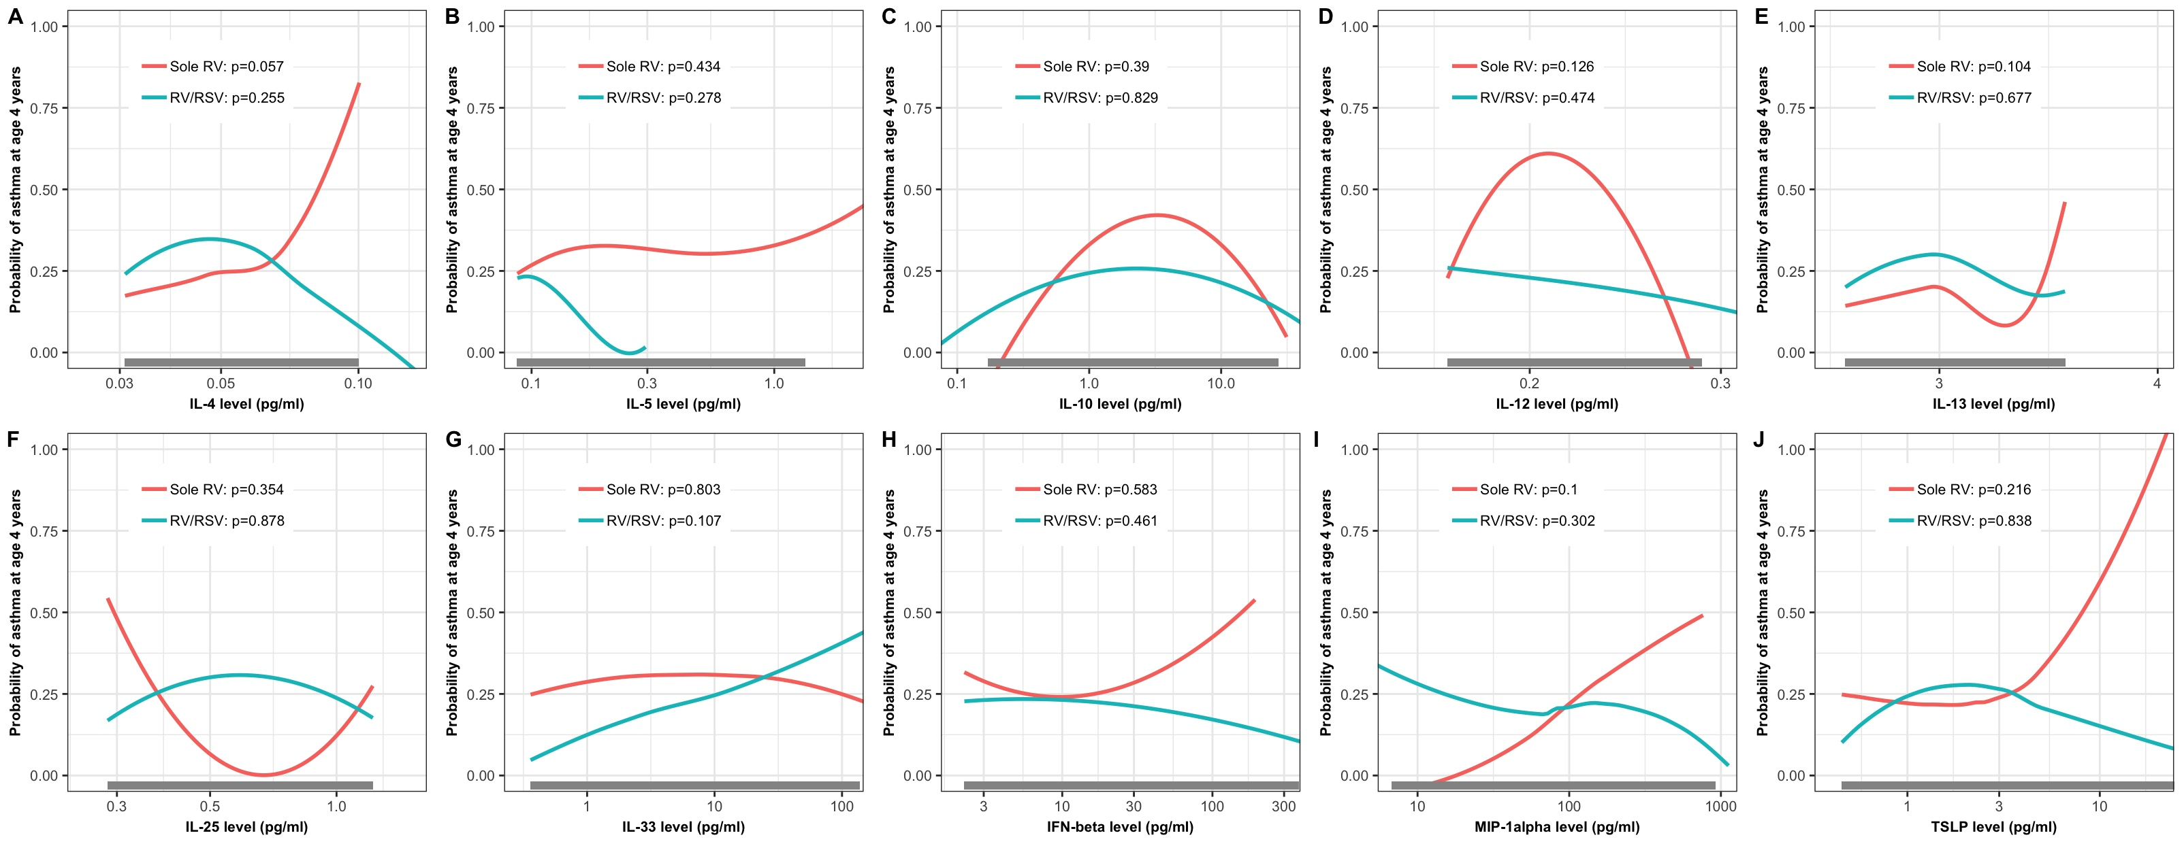

Figure E5. Correlations between nasopharyngeal airway interleukin-5 levels and blood eosinophil count in infants hospitalized with bronchiolitis
The fitted line represents locally estimated scatterplot smoothed (loess) curve with 95% CI. There was a significant correlation between IL-5 levels and blood eosinophil count (rho=0.27, P=0.01).

