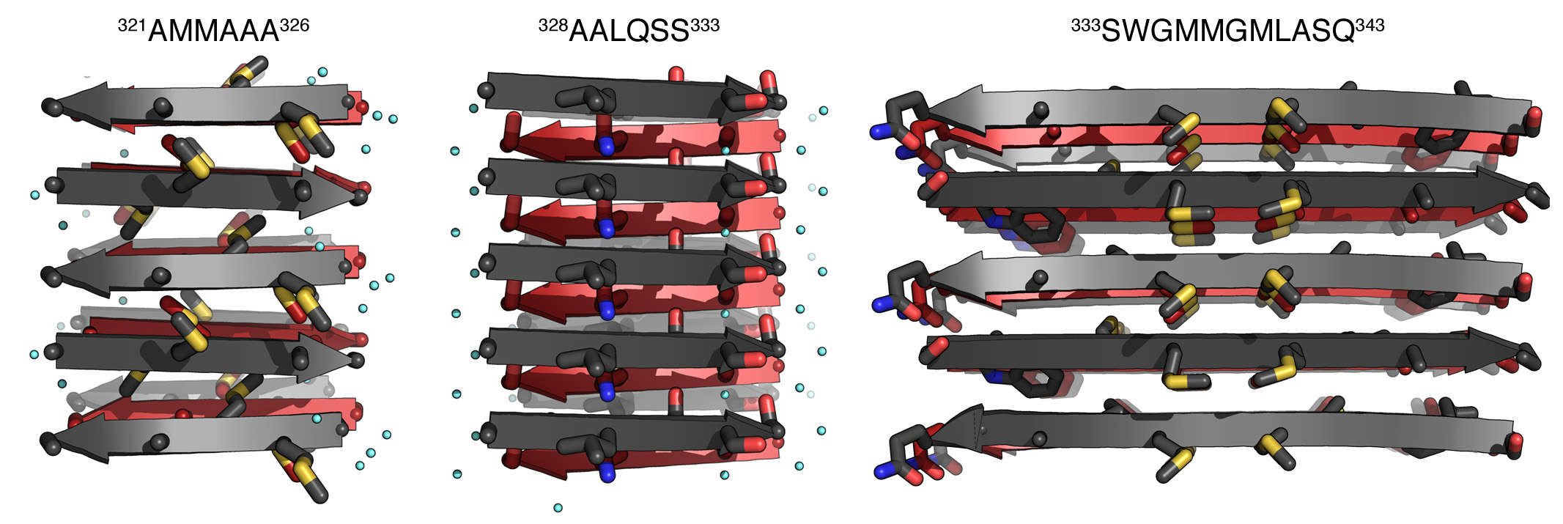
Supplementary Figure 1

³²¹AMMAAA³²⁶ and ³³³SWGMMGMLASQ³⁴³ form anti-parallel steric-zipper structures.

Views perpendicular to the fibril axis (vertical) are shown for three steric-zipper structures of Fig. 1. ³²¹AMMAAA³²⁶ and ³³³SWGMMGMLASQ³⁴³ are two zippers that adopt anti-parallel packing, as shown by the alternating orientation of arrows representing the direction of strands. ³²⁸AALOSS³³³ is shown as an example of the zippers which adopt parallel packing, as shown by the same orientation of arrows in each sheet.

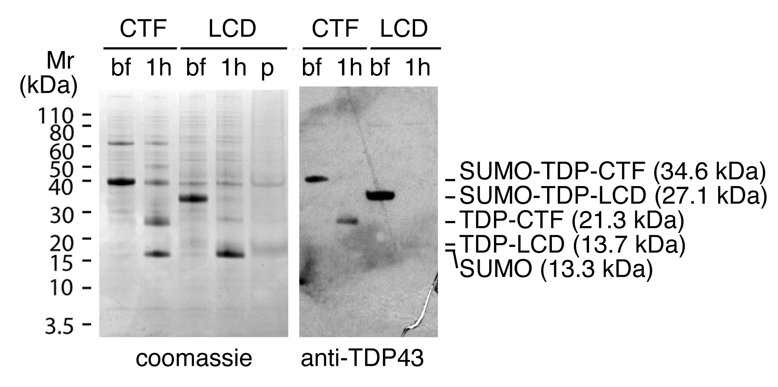

Supplementary Figure 2

Validation of TDP-CTF and TDP-LCD constructs.
The SUMO tagged TDP-CTF and TDP-LCD were analyzed by SDS-PAGE and stained with coomassie blue and anti-TDP-43 antibody. For TDP-CTF, notice that 1 hour after (1h) ULP1 cleavage, it generates SUMO protein and tag-free TDP-CTF, and both SUMO-tagged and tag-free TDP-CTF can be recognized by anti-TDP-43 antibody. SUMO tagged TDP-LCD also can be recognized by anti-TDP-43 antibody, and generates SUMO protein and tag-free TDP-LCD after cleavage. The molecular weight of SUMO and tag-free TDP-LCD are so close to each other that the two bands are indistinguishable on SDS-PAGE when stained by coomassie blue. However, the existence of tag-free TDP-LCD can be detected by anti-TDP-43 antibody, forming a band (although very dim) at its expected position. Tag-free TDP-LCD can also be detected by SDS-PAGE of the TDP-LCD pellet, showing a band at its expected position, and SUMO protein remains soluble as shown in Fig. 2A.
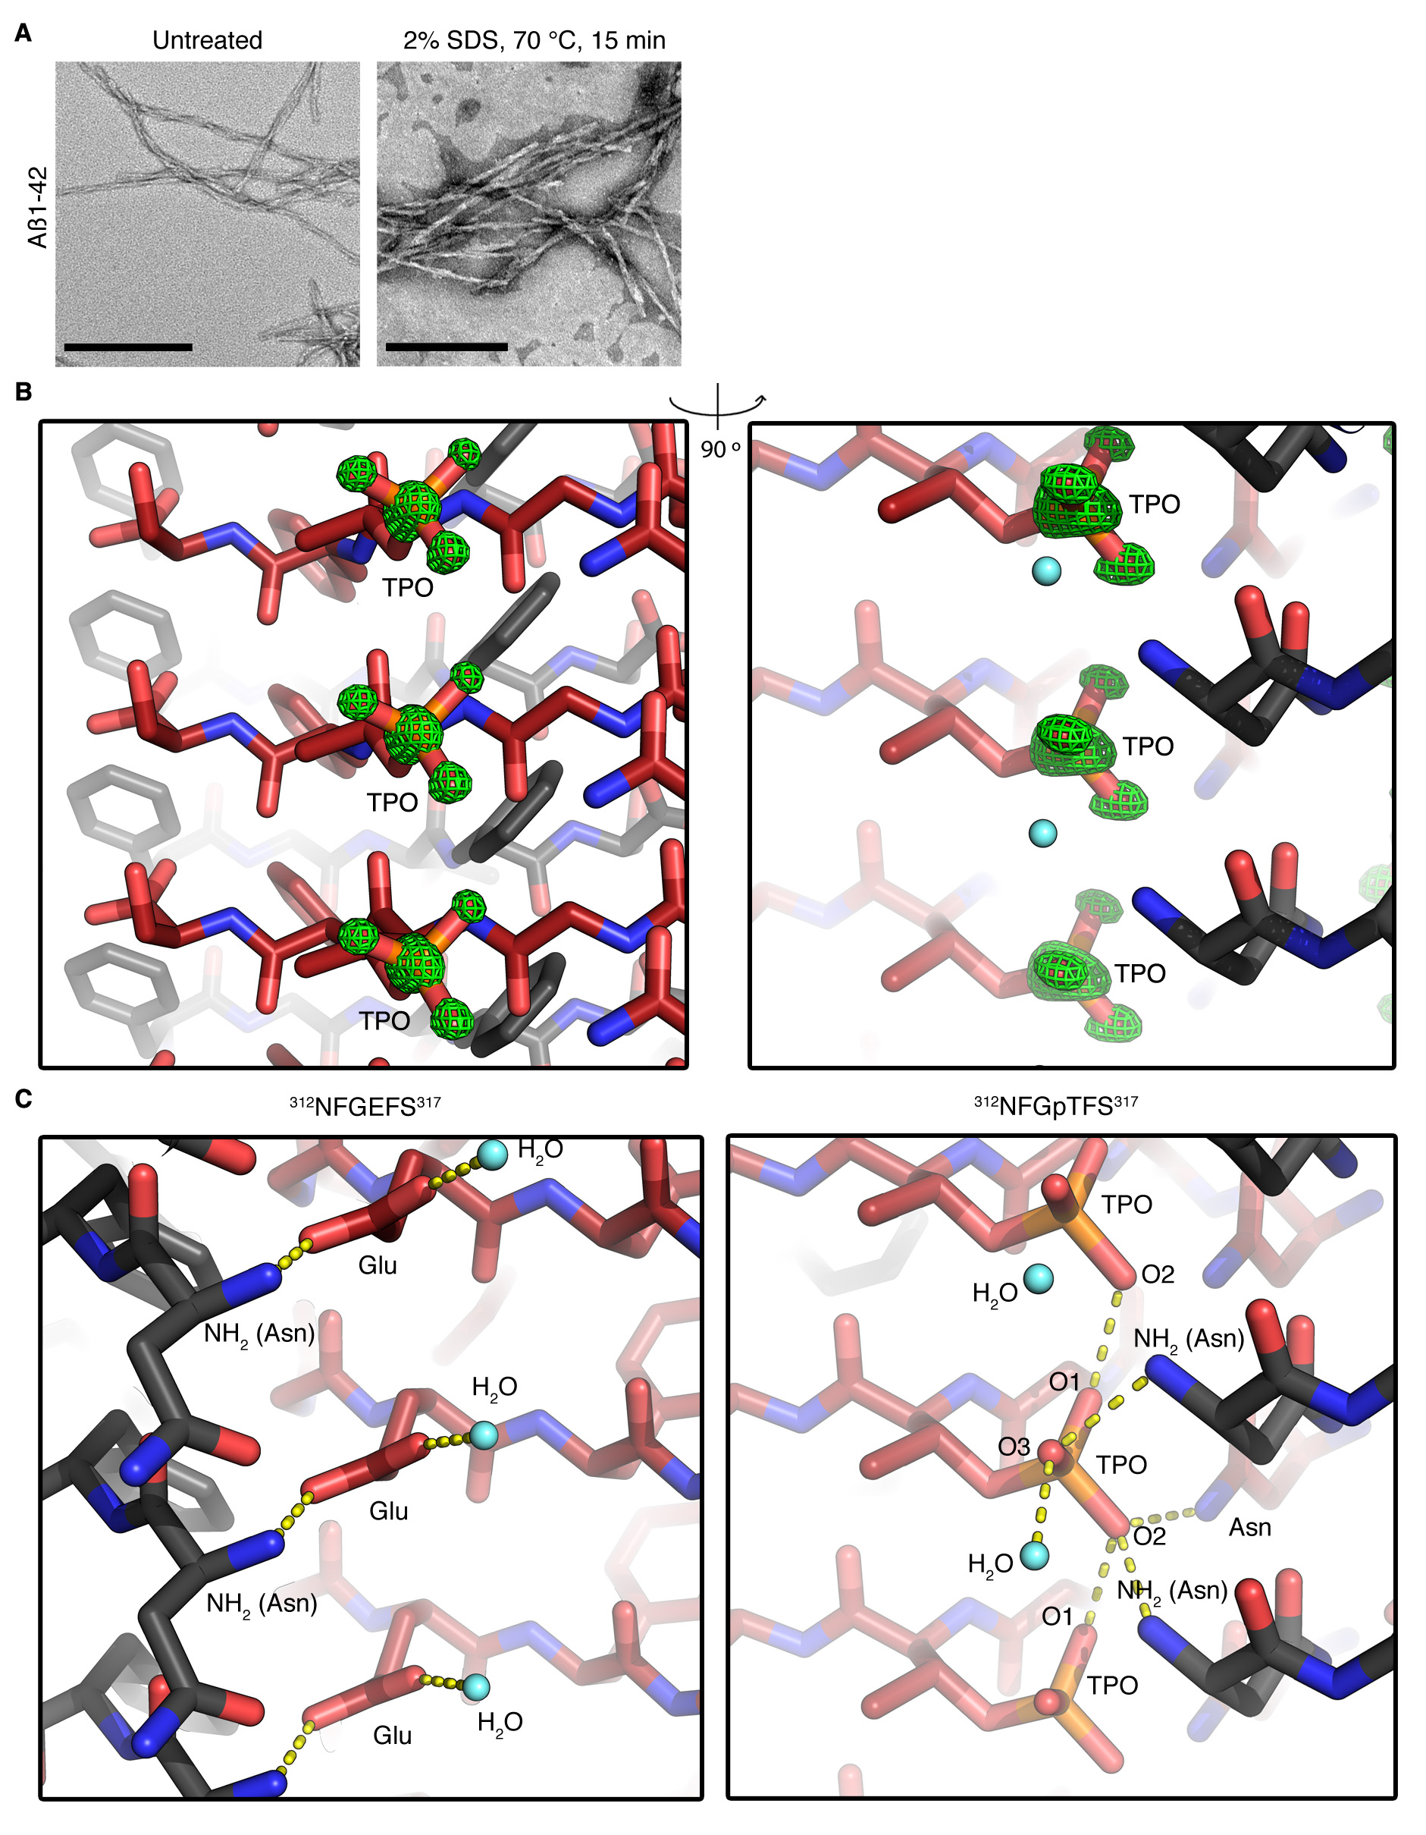
Supplementary Figure 3

Positive control of denaturing conditions shown in Fig. 3B, and structural details of ³¹²NFGEFS³¹⁷ and ³¹²NFGpTFS³¹⁷.
(A) Negative stain EM images of Aβ1-42 fibrils, typical amyloid fibrils, before and after treatment with 2% SDS and 70 °C for 15 mins. Notice that Aβ1-42 fibrils are stable and maintain their morphology after treatment in denaturing conditions. Scale bar = 200 nm. (B) Omit map of phosphate in ³¹²NFGpTFS³¹⁷ structure viewed from two angles. Green mesh shows the electron density of the Fo-Fc map with sigma > 4.5. Notice that the electron density of the same map with sigma <-4.5 is also computed as red mesh, however there is no observable negative density. TPO: phosphorylated threonine. (C) Hydrogen bond networks that stabilizes the packing of ³¹²NFGEFS³¹⁷ and ³¹²NFGpTFS³¹⁷. In each structure, three Glu/pThr residues from three adjacent strands of same sheet are shown, as well as the residues hydrogen-bonded to them. The hydrogen bonds formed by all Glu and the central pThr are shown as yellow dash lines, with distances between 2.3 and 3.2 Å.

