Supplementary Figures and legends

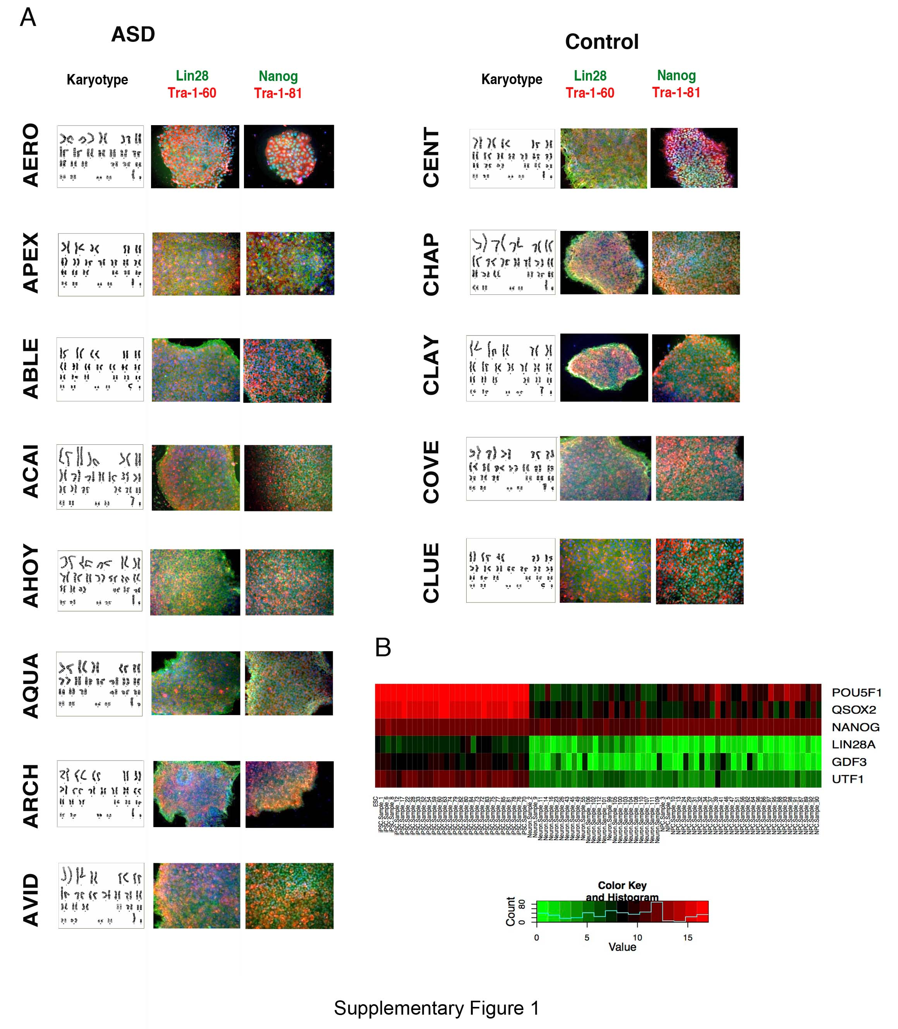

Supplementary Figure 1. Characterization of iPSCs derived from controls and ASD subjects. (A) Quality control of fibroblast reprogramming showing normal karyotype and expression of pluripotent markers for at least 2 clones of each iPSC. Scale bar: 20 µm. (B) Global gene expression showing that all the iPSCs derived in this study cluster together with a hESC line but not with iPSC-derived neurons or neural progenitor cells.

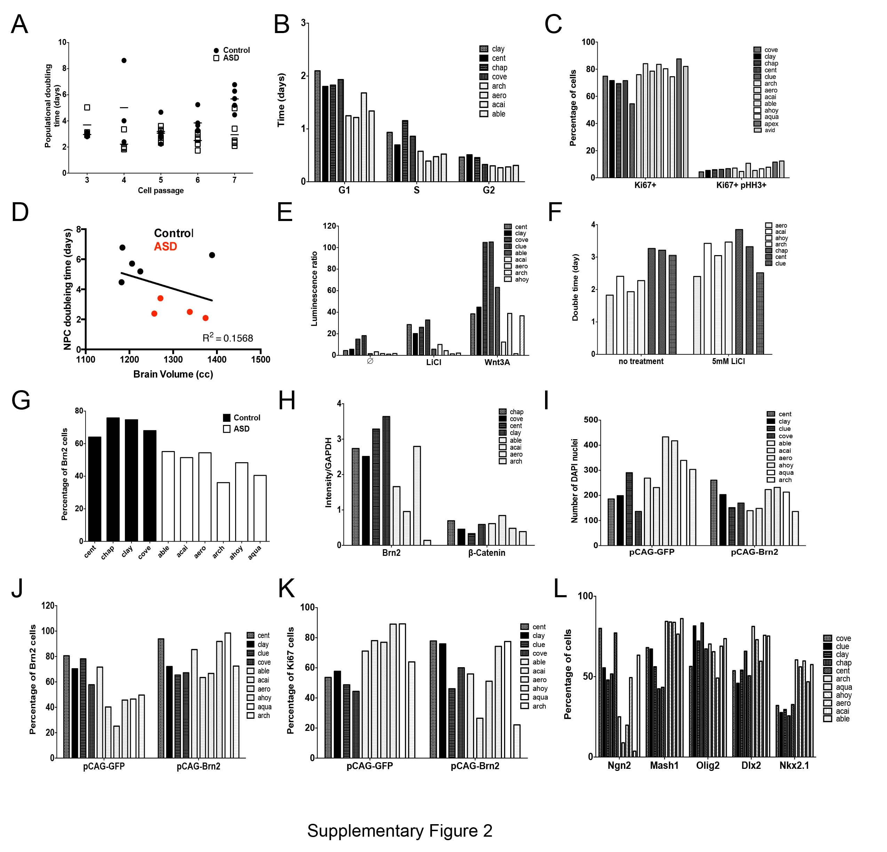
Supplementary Figure 2. NPC proliferation is affected in ASD. (A) Individual variation of control and ASD lines of NPC population-doubling time during passage. (B) Cell cycle analyses of different NPCs lines from control and ASD. (C) Percentage of Ki67⁺ and Ki67⁺pHH3⁺ labeled NPC lines derived from control and ASD. (D) Pairwise correlation between individual brain size (volume) and respective NPC doubling time rates at passage 7. (E) TOP-Flash assay in control and ASD NPC lines treated with either 5 mM LiCl or 100ng/ml Wnt3A. (F) Doubling time of control and ASD NPCs lines, treated or not with 5 mM LiCl. (G) Percentage of Brn2⁺ labeled NPC lines derived from control and ASD. (H) Levels of Brn2 and -catenin in control and ASD NPC lines. (I) Number of DAPI⁺ nuclei, percentage of Brn2⁺ (J) and ki67⁺ (K) in NPC lines derived from control and ASD. (L) Percentage of Ngn2⁺, Mash1⁺, Olig2, Dlx2⁺ and Nkx2.1⁺ labeled cells in control and ASD NPCs lines.

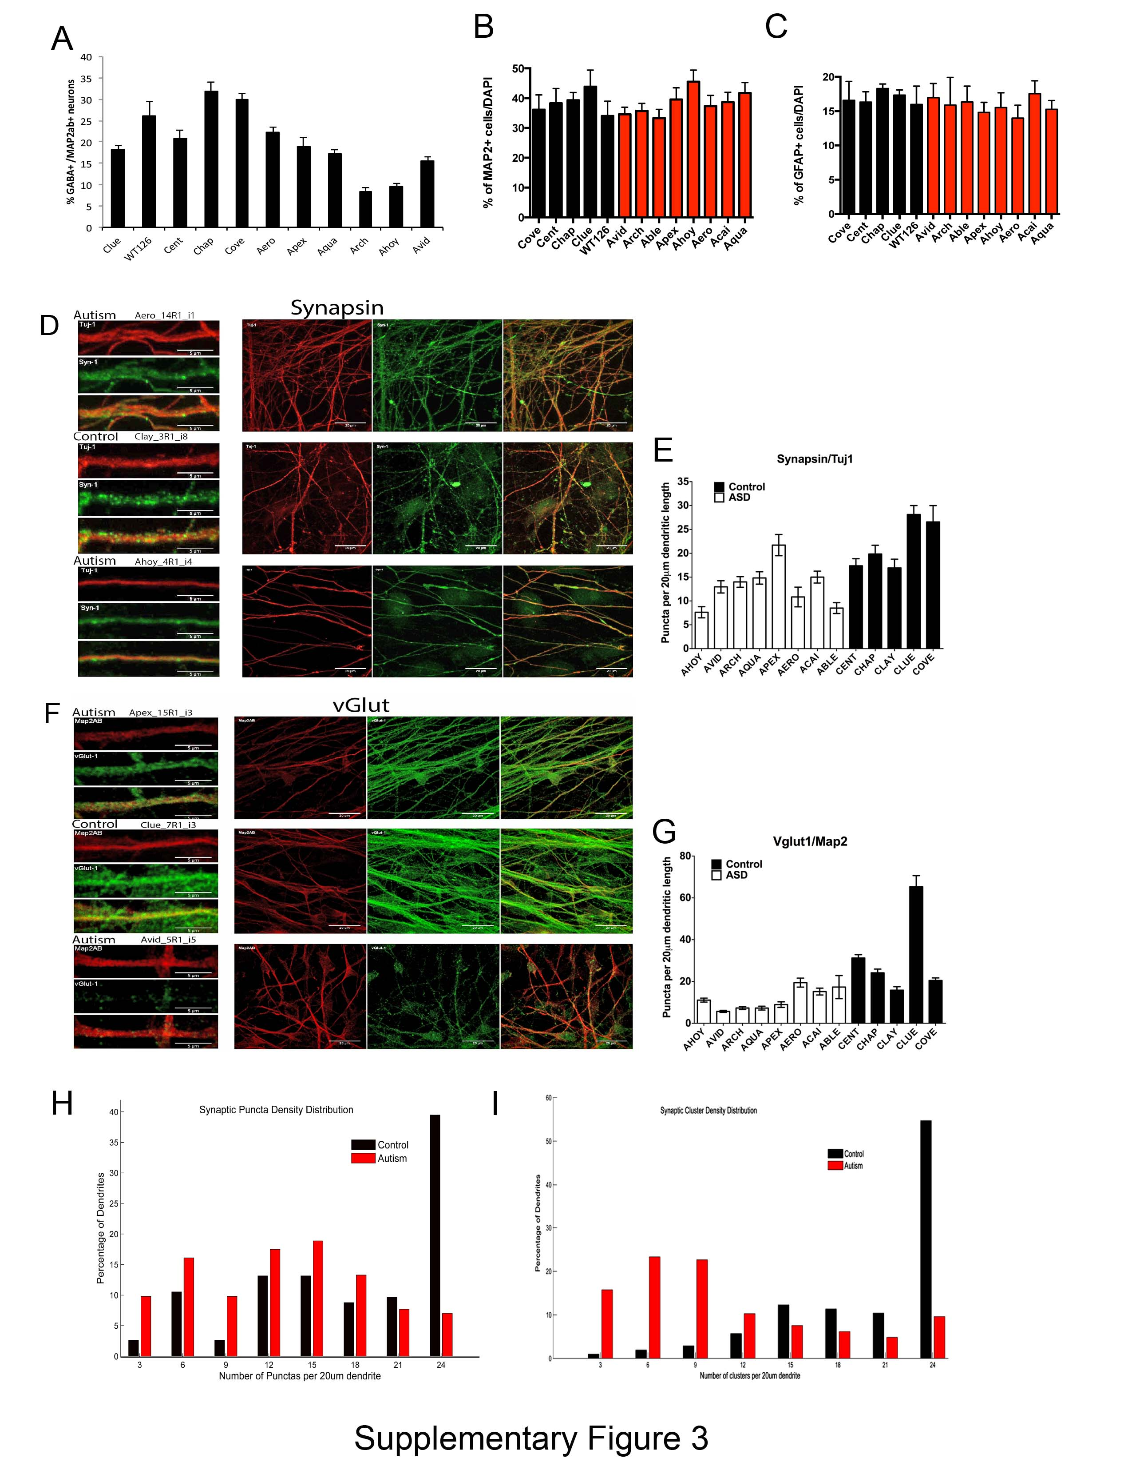

Supplementary Figure 3. Synaptic analyses in iPSC-derived neurons from ASD patients and controls. (A) The graph shows the quantification of GABA-positive neurons in all ASD-derived neurons compared to all controls. (B) Quantification of the percentage of neurons after 4-weeks of differentiation using Map2 as a panneuronal marker. (C) Quantification of the percentage of astrocytes after 4-weeks of differentiation using GFAP as a glial marker. (D) Representative images of ASD and control neurons showing Synapsin puncta on Tuj1 neurites. (E) Bar graph showing synaptic density (Synapsin/TuJ1) distributed in every ASD and control individual analyzed. (F) Representative images of ASD and control neurons showing VGlut1 puncta on Map2 neurites. (G) Bar graph showing synaptic density (VGlut1/Map2) distributed in every ASD and control individual analyzed. (H) Synaptic puncta distribution in dendrites contrasting controls and ASD-derived neurons. (I) Synaptic cluster density distribution in dendrites contrasting controls and ASD-derived neurons.

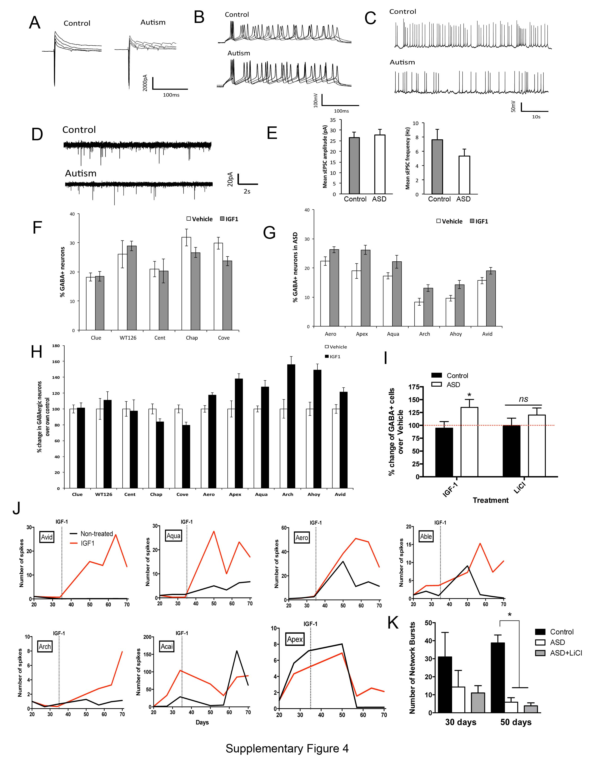

Supplementary Figure 4. Functional characterization of ASD and control neurons and response to IGF1 and LiCl treatment on multi-electrode arrays (MEA). (A-E) Electrophysiological whole-cell recordings of iPSC-derived neurons at 8-week differentiation. Both control and ASD iPSC-derived neurons exhibited (A) Na+/K+ currents, (B) evoked action potentials, and (C) spontaneous action potentials. (D) Representative traces of spontaneous excitatory postsynaptic currents (sEPSCs) recorded from control and ASD-derived neurons. (E) Quantification of sEPSC events revealed no difference in terms of amplitude or frequency across control and ASD cells. (F, G) Percentage of GABAergic cells on MAP2 positive neurons on Controls (F) or ASD (G) neurons after IGF1 treatment. (H) Normalized percentage of change of GABAergic neurons in ASD neuronal cultures after IGF1 treatment during neuronal differentiation for each individual. (I) Normalized percentage of change in GBAergic cell numbers in ASD versus Controls after treatment with IGF1 or LiCl. ns: non significant. (J) Examples of MEA spike activity tracings from ASD patients with and without IGF1 treatment showing different sensitivities to the drug. (K) Increase of GABAergic neurons in ASD neuronal cultures after IGF1 treatment, but not after LiCl treatment during neuronal differentiation. Results are presented as mean ± SEM (**p<0.0001 for comparing the results of the ASD with control).

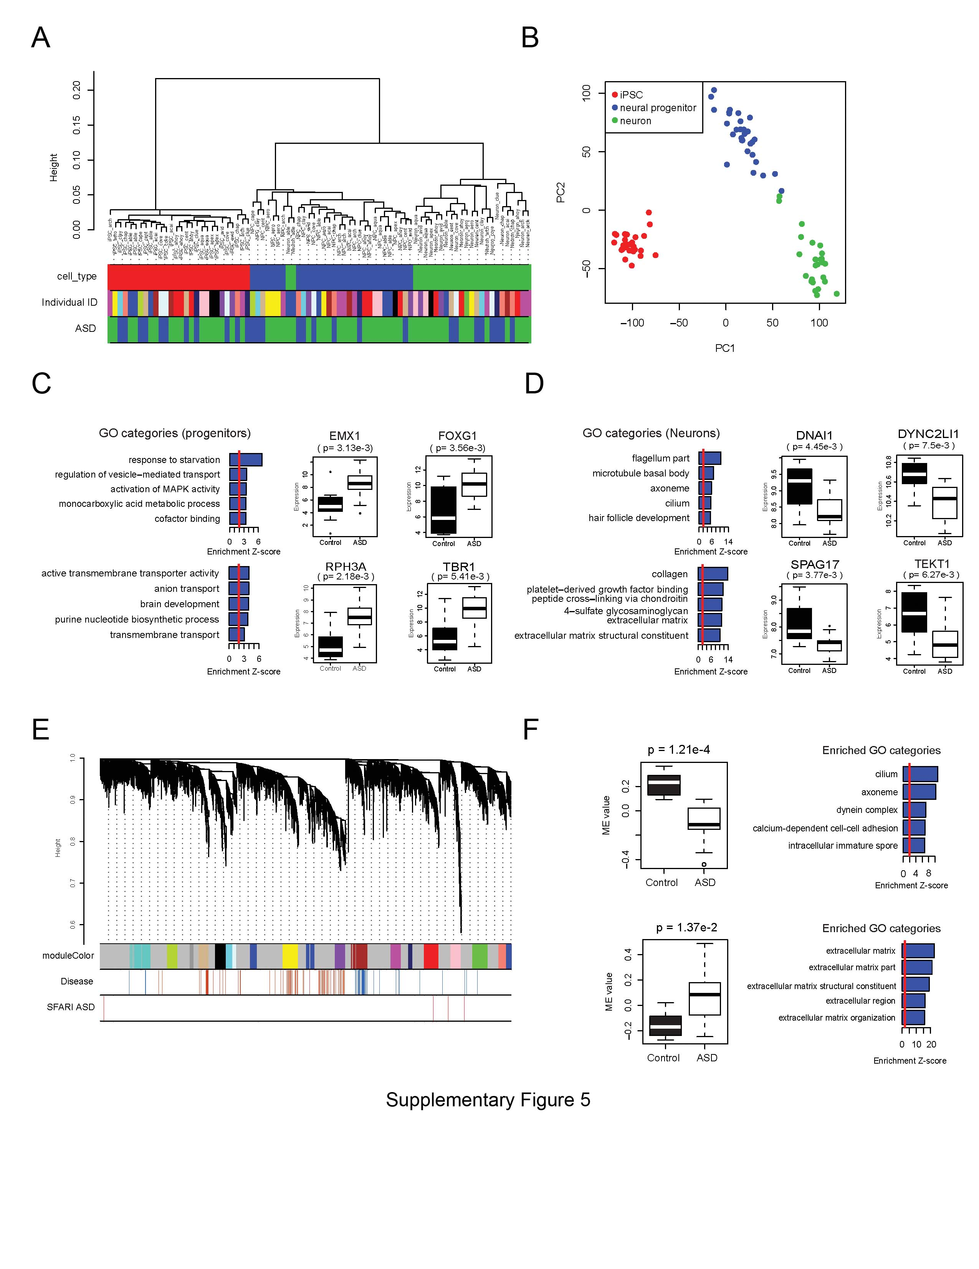
Supplementary Figure 5. Gene expression analysis in iPSCs and derived cell types. (A) Clustering of samples based on inter-sample Spearman correlation using log2 transformed RNA seq read counts. Samples were clustered by cell type differences as shown on the top color bar. Red: iPSCs; blue: iPSC-derived neural progenitors; green: iPSC-derived neurons. Different subjects are indicated using different colors in “Individual ID” color bar. In the “ASD” color bar, green bars represent cell lines derived from patient and blue bars represent cell lines from controls. (B) Sample separation based on the top two principal components of genome-wide expression profiles. (C) and (D) Barplots showing the enrichment z-scores of the top 5 enriched gene ontology (GO) categories in the down-regulated genes (top) and up-regulated genes (bottom) in ASD samples, respectively. (C), right panel: Boxplots showing the gene expression patterns of the 4 up-regulated genes in patient progenitors that contributes to the enrichment of the GO category “brain development”. (D), right panel: Expression pattern of the genes involved in the enrichment of GO category “axoneme” among the down-regulated genes in patient iPSC-derived neurons. (E) Hierarchical clustering of WGCNA network at neuronal stage. The top colored bar represents the module colors. The “disease” color bar represents the correlation values between gene expression and ASD status. Red means up-regulation in ASD vs. controls, while blue means down-regulation in ASD vs. controls. Only the genes with disease correlation larger than 0.5 or smaller than -0.5 are marked in the plot. ASD candidate genes from SFARI database (level 1-4) are indicated by the red lines in the “SFARI ASD” color bar. The brown module and the tan module are associated with ASD status. (F) Boxplot on the left showing the module eigengene values of the brown module and the tan module in control neurons (black) and ASD neurons (white). The p-value at top of plot represents the significance of the difference between ASD vs. controls. The top 5 enriched GO categories among the genes in the brown module and tan module are shown on the right.

