Supplemental Table 1. Reference model
Step | Variable label | Variable name* | Equation/source
1 | Incident vaccinations on that day | vac_{d} | Input data
2 | Vaccine effectiveness | ve_{d} | Input data
3 | Incident cases on that day without vaccination | casen_{d} | Input data
4 | Infection rate | r_{d} | casen_{d}/popn_{d-1}
5 | Incident cases on that day with vaccination | case_{d} | r_{d} · (A_{d-1} + C_{d-1} + B_{d-1})
6 | Non-cases if no vaccination | popn_{d} | Initial value: starting population  Subsequent values: popn_{d-1} - casen_{d}
7 | Averted cases | avert_{d} | casen_{d} - case_{d}
8 | Vaccination rate | v_{d} | vac_{d}/(A_{d-1} + E_{d-1})
9 | Vaccinated non-cases incident | b_{d} | A_{d-1} · v_{d}
10 | Non-vaccinated non-cases | A_{d} | Initial value: starting population  Subsequent values: A_{d-1} · (1 - r_{d}) – b_{d}
11 | Vaccinated non-cases from prior 14 days | b_{d-1}  …  b_{d-14} | b_{d-1} · (1 - r_{d})  …  b_{d-14} · (1 - r_{d})
12 | Vaccinated non-cases prevalent | B_{d} | B_{d-1} · (1 - r_{d}) + b_{d} – b_{d-14}
13 | Vaccinated non-cases susceptible | C_{d} | C_{d-1} · (1 - r_{d}) + b_{d-14} · (1 - ve_{d})
14 | Vaccinated non-cases immune | D_{d} | D_{d-1} + b_{d-14} · ve_{d}
15 | Non-vaccinated cases | E_{d} | E_{d-1} + A_{d-1} · r_{d} - E_{d-1} · v_{d}
16 | Vaccinated cases | F_{d} | F_{d-1} + (C_{d-1} + B_{d-1}) · r_{d} + E_{d-1} · v_{d}
* Single letter variable names correspond to Figure 1 compartments.
Notes:
Subscripts indicate day, i.e., “d” indicates current day, “d-1” indicates prior day, and “d-14” indicates 14 days before.
These equations are for a 14-day immune lag, but lags of different durations were also tested (Table 3).

Supplemental Table 2. Test methods. Note that variable names and concepts are defined separately for each method and apply only to that method.
Method 1. (Current method)
Step | Variable label | Variable name | Equation or value
1 | Incident cases during the month | case_{m} | Input data
2 | Incident proportion of the starting population vaccinated during the month | vc_{m} | Input data
3 | Vaccine effectiveness | ve_{m} | Input data
4 | Vaccine coverage lagged | vc_lag_{m} | (vc_{m} + vc_{m-1})/2
5 | Susceptible population | pops_{m} | Initial value: starting population  Subsequent values: (pops_{m-1}-case_{m-1})·(1-vc_lag_{m}·ve_{m})
6 | Infection risk | r_{m} | case_{m}/pops_{m}
7 | Non-cases if no vaccination | popn_{m} | Initial value: starting population  Subsequent values: popn_{m-1}-casen_{m-1}
8 | Cases if no vaccination | casen_{m} | r_{m}*popn_{m}
9 | Averted cases | avert_{m} | casen_{m}-case_{m}
Note:
Subscripts indicate month, i.e., “m” indicates current month, “m-1” indicates prior month

Method 2.

Step | Variable label | Variable name | Equation
1 | Incident cases during the month | case_{m} | Input data
2 | Incident proportion of the starting population vaccinated during the month | vc_{m} | Input data
3 | Vaccine effectiveness | ve_{m} | Input data
4 | No. effectively vaccinated during the month | vef_{m} | pop_{m-1} · vc_{m} · ve_{m}
5 | Non-cases with vaccination | pop_{m} | Initial value: starting population  Subsequent values: pop_{m-1} - case_{m}
6 | Susceptible population | pops_{m} | Initial value: starting population  Subsequent values: pops_{m-1} - case_{m} – vef_{m}
7 | Infection risk | r_{m} | case_{m}/pops_{m-1}
8 | Non-cases if no vaccination | popn_{m} | Initial value: starting population  Subsequent values: popn_{m-1} - casen_{m-1}
9 | Cases if no vaccination | casen_{m} | r_{m} · popn_{m}
10 | Averted cases | avert_{m} | casen_{m} - case_{m}
Note: subscripts indicate month, i.e., “m” indicates current month, “m-1” indicates prior month
Method 1 applies vaccine coverage (vc) and vaccine effectiveness (ve) to the susceptible population (i.e., non-cases who have not yet been effectively vaccinated), whereas method 2 applies vc and ve to all non-cases. The latter approach is appropriate since vc data is received as a proportion of the total population, including both cases and non-cases. Cases are assumed to be immune, and so the number effectively immunized equals the total population minus cases multiplied by vc and ve.

Method 3.
Step | Variable name | Variable* | Equation
1 | Incident cases during the month | case_{m} | Input data
2 | Incident vaccinations during the month | vac_{m} | Input data
3 | Vaccine effectiveness | ve_{m} | Input data
4 | Infection rate | r_{m} | case_{m}/(A_{m-1} + C_{m-1})
5 | Vaccination rate | v_{m} | vac_{m}/(A_{m-1} + E_{m-1})
6 | Vaccinated non-cases incident | b_{m} | A_{m-1}·v_{m}
7 | Non-vaccinated non-cases | A_{m} | Initial value: starting population  Subsequent values: A_{m-1}·(1-r_{m}) – b_{m}
8 | Vaccinated non-cases susceptible | C_{m} | C_{m-1} · (1-r_{m}) + b_{m} · (1-ve_{m})
9 | Vaccinated non-cases immune | D_{m} | D_{m-1} + b_{m} · ve_{m}
10 | Non-vaccinated cases | E_{m} | E_{m-1} · (1-v_{m}) + A_{m-1} · r_{m}
11 | Vaccinated cases | F_{m} | F_{m-1} + (C_{m-1} + E_{m-1}) · v_{m}
12 | Cases if no vaccination | casen_{m} | popn_{m-1} · r_{m}
13 | Non-cases if no vaccination | popn_{m} | Initial value: starting population  Subsequent values: popn_{m-1} - casen_{m}
14 | Averted cases | avert_{m} | casen_{m}- case_{m}
* Single letter variable names correspond to Figure 1 compartments
Notes: subscripts indicate month, e.g., “m” indicates current month, “m-1” indicates prior month
Includes all features of the reference model, including possible vaccination of unvaccinated cases, except does not track persons during the 14-day immune lag period (Figure 1, oval B).

Method 4.
Step | Variable name | Variable* | Equation
1 | Incident cases during the month | case_{m} | Input data
2 | Incident vaccinations during the month | vac_{m} | Input data
3 | Vaccine effectiveness | ve_{m} | Input data
4 | Infection rate | r_{m} | case_{m}/(A_{ave} + C_{ave})
5 | Vaccination rate | v_{m} | vac_{m}/(A_{ave} + E_{ave})
6 | Vaccinated non-cases incident | b_{m} | A_{ave} · v_{m}
7 | Non-vaccinated non-cases | A_{m} | Initial value: starting population  Subsequent values: A_{m-1} - A_{ave} · r_{m} – b_{m}
8 | Vaccinated non-cases susceptible | C_{m} | C_{m-1} - C_{ave} · r_{m} + b_{m} · (1-ve_{m})
9 | Vaccinated non-cases immune | D_{m} | D_{m-1} + b_{m} · ve_{m}
10 | Non-vaccinated cases | E_{m} | E_{m-1} - E_{ave} · v_{m} + A_{ave} · r_{m}
11 | Vaccinated cases | F_{m} | F_{m-1} + (C_{ave} + E_{ave}) · v_{m}
12 | Cases if no vaccination | casen_{m} | popn_{ave} · r_{m}
13 | Non-cases if no vaccination | popn_{m} | Initial value: starting population  Subsequent values: popn_{ave} - casen_{m}
14 | Averted cases | avert_{m} | casen_{m}- case_{m}
* Single letter variable names correspond to Figure 1 compartments
Notes: subscript “m” indicates current month, “ave” indicates the average of current and prior months

Method 5.

Step | Variable name | Variable | Equation
1 | Vaccine effectiveness | ve_{m} | Input data
2 | Cumulative proportion of population vaccinated by the end of the month | vc_cum_{m} | Input data
3 | The number of cases that month | case_{m} | Input data
4 | Cases without vaccination | casen_{m} | case_{m}/(1-ve_{m}*vc_cum_{m})
5 | Averted cases | avert_{m} | casen_{m}-case_{m}
Note: Subscript “m” indicates current month, “m-1” indicates prior month

Method 6.
Step | Variable name | Variable | Equation
1 | Vaccine effectiveness | ve_{s} | Input data
2 | Cumulative proportion of population vaccinated by the end of the season | vc_cum_{s} | Input data
3 | Total number of cases during the season | case | Input data
4 | Total number of cases without vaccination during the season | casen_{s} | cases/(1-ve_{s}*ve_{s})
5 | Total averted cases for the season | avert_{s} | casen_{s}-case
Note: Subscript “s” indicates data for the entire influenza season

Method 7.
Uses the reference model (Appendix 1) with steps 3-5 changed as follows:
Step | Variable name | variable | Equation
3 | Number of cases on that day with vaccination | case_{d} | Input data
4 | Infection rate | r_{d} | case_{d} / (A_{d-1} + C_{d-1} + B_{d-1})
5 | Number of cases on that day without vaccination | casen_{d} | popn_{d-1} · r_{d}

Supplemental Table 3. Simulated data used to test methods for determining numbers of influenza cases averted by vaccination
Month | Vaccine coverage | Cases without vaccination | Number  Vaccinated | Cases with vaccination | Averted cases
Aug | 0.0413 | 1.0 | 41,339.7 | 1.0 | 0.0
Sep | 0.0899 | 31.6 | 89,867.8 | 30.6 | 0.9
Oct | 0.1389 | 531.4 | 138,913.2 | 490.4 | 41.0
Nov | 0.1341 | 4,102.8 | 134,121.1 | 3,526.9 | 575.9
Dec | 0.0919 | 17,341.9 | 91,932.0 | 13,873.2 | 3,468.7
Jan | 0.0400 | 36,026.0 | 39,981.1 | 27,412.6 | 8,613.4
Feb | 0.0109 | 34,312.4 | 10,925.0 | 25,508.9 | 8,803.4
Mar | 0.0026 | 21,097.1 | 2,564.3 | 15,562.6 | 5,534.6
Apr | 0.0003 | 5,710.8 | 325.7 | 4,204.3 | 1,506.5
May | 0.0000 | 845.0 | 30.0 | 621.9 | 223.1
Total | 0.5500 | 120,000.0 | 550,000.0 | 91,232.5 | 28,767.5
Starting population=1,000,000; vaccine effectiveness=0.48. Values for vaccine coverage, cases without vaccination, and number vaccinated were generated in a normal distribution (Table 2). Cases with vaccination and averted cases were calculated using the Reference Model on day-level data and aggregated by month

Supplemental Table 4. Evaluation of test methods with data simulated based on real data
- Start with real data (counts of influenza cases and vaccinations) aggregated by month and stratified by season and age group
- Divide counts by the number of days per month to create a proxy for daily values (dotted lines in Figure S1).
- Smooth using Loess procedure (solid lines in Figure S1).
- Use reference model on smoothed daily data to calculate “true” averted cases.
- Aggregate daily data by month to simulate the format that real data would be available in.
- Use test methods 1-7 on monthly-aggregated data to estimate averted cases
- Calculate error, i.e., percent difference between averted cases calculated by the reference model on daily data vs. test methods on monthly-aggregated data.
- Test methods with smallest error are considered most accurate

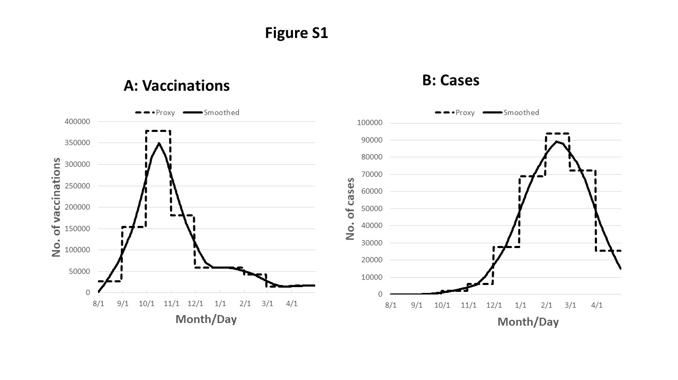
Supplemental Table 5. Effect of modifying specific steps in methods 1 and 2.

Step | Variable | Method 1 | Method 1a | Method 1b | Method 1c | Method 2
1 | vc_lag_{m} | (vc_{m}+vc_{m-1})/2 |  | (vc_{m}+vc_{m-1})/2
2 | pops_{m} | pops_{m-1}-case_{m-1} | pops_{m-1}-case_{m-1} | pops_{m-1}-case_{m-1} | pops_{m-1}-case_{m-1} | pops_{m-1}-case_{m}
3 |  |  |  | pop_{m-1}-case_{m-1} | pop_{m-1}-case_{m-1} | pop_{m-1}-case_{m}
4 | vef_{m} | pops_{m}·vc_lag_{m}· ve_{m} | pops_{m} · vc_{m} · ve_{m} | pop_{m} · vc_lag_{m} · ve_{m} | pop_{m} · vc_{m} · ve_{m} | pop_{m-1} · vc_{m} · ve_{m}
5 | pops_{m} | pops_{m}-vef_{m} | pops_{m}-vef_{m} | pops_{m}-vef_{m} | pops_{m}-vef_{m} | pops_{m}-vef_{m}
6 | r_{m} | case_{m}/pops_{m} | case_{m}/pops_{m} | case_{m}/pops_{m} | case_{m}/pops_{m} | case_{m}/pops_{m-1}
7 | popn_{m} | popn_{m-1}-case_{m-1} | popn_{m-1}-case_{m-1} | popn_{m-1}-case_{m-1} | popn_{m-1}-case_{m-1} | popn_{m-1}-case_{m-1}
8 | casen_{m} | r_{m} · popn_{m} | r_{m} · popn_{m} | r_{m} · popn_{m} | r_{m} · popn_{m} | r_{m} · popn_{m}
9 | avert_{m} | casen_{m}-case_{m} | casen_{m}-case_{m} | casen_{m}-case_{m} | casen_{m}-case_{m} | casen_{m}-case_{m}
Averted cases (number) |  | 26,175.90 | 27,216.30 | 29,883.80 | 31,182.60 | 28,810.70
Error compared with reference model, % |  | -9.01 | -5.39 | 3.88 | 8.39 | 0.15
Input data described in Table 2 and Supplemental Table 3. True averted cases per reference model = 28,767.5. Variable names: vc, incident proportion of the starting population vaccinated during the month; case, incident cases during the month; vc_lag, vaccine coverage lagged; pops, susceptible population; pop, non-cases with vaccination; vef, number effectively vaccinated during the month; r, infection risk; popn, non-cases if no vaccination; casen, number of cases if no vaccination; avert, cases averted by vaccination.
Bold type indicates a change from method in prior column
Method 1 (current method) and method 2 are described in Methods section and Supplemental Table 2. For method 1, step 5 in Supplemental Table 2 has been expanded to steps 2, 4 and 5 in this table to facilitate comparisons with other methods.
Method 1a: method 1 modified, no immune lag
Method 1b: method 1 modified, includes vaccine lag, vaccine coverage applied to all non-cases. Method 1 applies vaccine coverage (vc) and vaccine effectiveness (ve) to the susceptible population (i.e., non-cases who have not yet been effectively vaccinated), whereas method 2 applies vc and ve to all non-cases. The latter approach is appropriate since vc data is received as a proportion of the total population, including both cases and non-cases. Cases are assumed to be immune, and so the number effectively immunized equals the total population minus cases multiplied by vc and ve.
Method 1c: method 1 modified, no immune lag, vaccine coverage applied to all non-cases
Method 1d: (not shown above), same as method 2 except for step 4 (=pop_{m} · vc_{m} · ve_{m} ): 28,635.50 averted cases, -0.46% error
Method 2: no vaccine lag, vaccine coverage applied to all non-cases, and incorporating additional edits

