Appendix A. The KPSC NLP system is a rule-based system in which patterns are matched using regular expressions. The system is capable of handling certain linguistic variations such as uppercase, lowercase, and proper case by specifying whether the matching should be performed in a case sensitive or insensitive way. Although the system does not handle word conjugation, identify spelling errors, or recognize abbreviations automatically, users can program terminology and rules into an algorithm to address the variations with specific project goals in mind. The ability to handle these linguistic variations significantly enhanced the performance of our NLP algorithms.
In this study, the terminologies (lexicons) were gathered by searching standard ontologies such as MedDRA and SNOMED. Then the terminologies were enriched by applying any variations found in the training datasets. We identified such variations by applied synonym discovery search using techniques such as word co-occurrences. Abbreviations and misspelling occurred frequently in the clinical notes but often are not listed in the standard ontologies. Adding abbreviations and misspelling was essential to achieve good sensitivity for the NLP algorithm.
For negation, the terminologies were collected first from NegEx and enriched by data from KPSC over the past several years.
The relationship search was based on the algorithm-specified distance between two terms. The distance could be number of words, within the same sentence, within the same section, or within the same document. For example, a specified distance of 6 words will identify both a spatial (‘left arm’) and temporal (‘3 days’) relationship associated with the symptoms of interest from the sentence, “RESPONSE TO IMMUNIZATIO AND/OR SKIN TEST - reaction to immunization, redness, itching, swollen on left arm, x 3 days”.

Appendix B. Pre-defined terminologies
The linguistic variations and spelling errors were handled by the customized terminology that was saved as a JSON file (provided as a separated file ‘NLP local reaction json.txt’) and was loaded at the time the NLP program was run. The JSON file stores the list of keywords, their modifiers terms, and the distance between them to forge a relationship.
A set of pre-defined terminologies were loaded at the time the NLP program was executed:
- Local reaction related sign and symptoms
- Reaction, injection, and vaccination site
- Tdap vaccination
- Vaccinations other than Tdap
- Causes of S/S that are similar to vaccine related local reaction
- Vaccine or vaccination
- Explicitly stated local reaction or vaccination reaction

Appendix C. Sample clinical note with NLP identified concepts and relationships highlighted
Spatial relationship
typo
Patient presents with:
RESPONSE TO IMMUNIZATIO AND/OR SKIN TEST - reaction to immunization, redness, itching, swollen on left
arm, x 3 days
Section
Temporal relationship
Pt reports she received 2 vaccines 2 days ago - 1 in each arm (HPV, TDaP).
She reports that yesterday, she noticed pain, itching, swelling, and redness in left arm at injection site.
She reports she took 400mg of Advil prior to sleep yesterday and she has been putting ice on area with minimal relief.
Reports redness and swelling is less today than yesterday.
She reports her right arm feels sore but no erythema or edema.
Negation
Review of Systems
…
Skin: Positive for itching and rash.
Sentence
Physical Exam
…
ASSESSMENT/PLAN:
NON ANAPHYLACTIC REACTION FOLLOWING TEST OR INJECTION (primary encounter diagnosis).
Note:
Injection reaction at left posterior upper arm.
Patient to use benadryl, ice, motrin for symptoms.
Area outlined with pen - patient to return to clinic if erythema extends beyond lines or if she develops fever, chills, nausea, vomiting,
or other worrisome symptoms.
---------------------------------------------------------------------------------------------------------------------
Color notations:
reaction: vaccine reaction
immunization: vaccination
redness: sign or symptom
left arm: spatial location
injection site: matched spatial location
x 3 days: temporal relationship
no: negation

Appendix D. Figure of the accuracy measurements of NLP (based on Table 4 data)
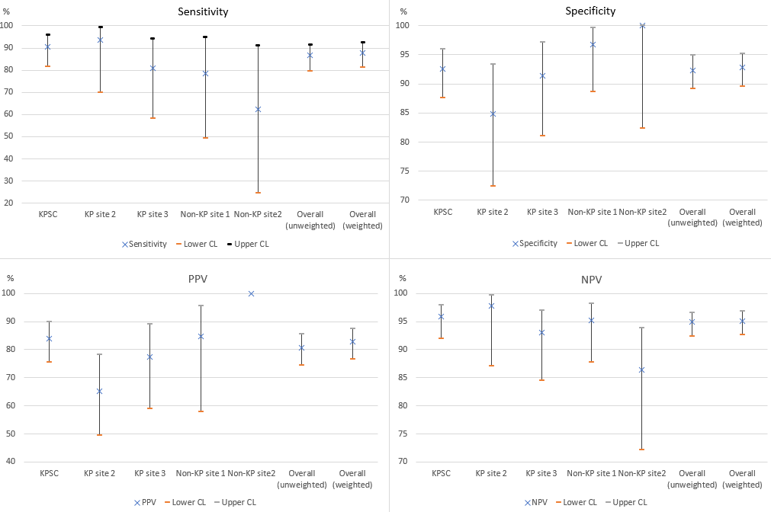
Appendix E. Accuracy measurements of NLP in identifying Tdap-related local reaction, as compared with chart-confirmed validation data (after removing factors not related to NLP)
Site | Reference  Standard  (n/N) | Chart confirmation rate (%) | TP | TN | FN | FP | Sensitivity  (%) | Specificity  (%) | PPV  (%) | NPV  (%) | LR+ | LR- | * | ** | ***
KPSC | 74/249 | 29.7  24.1-35.8 | 69 | 164 | 5 | 11 | 93.2  84.9-97.8 | 93.7  89.0-96.8 | 86.3  77.9-91.8 | 97.0  93.4-98.7 | 14.8  8.3-26.4 | 0.07  0.03-0.17 | 3 | 1
KP site 2 | 19/68 | 27.9  17.7-40.2 | 19 | 45 | 0 | 4 | 100  82.4-100 | 91.8  80.4-97.7 | 82.6  65.0-92.4 | 100  (NA) | 12.3  4.8-31.3 | 0  (NA) | 5 |  | 1
KP site 3 | 23/79 | 29.1  19.4-40.4 | 19 | 53 | 4 | 3 | 82.6  61.2-95.1 | 94.6  85.1-98.9 | 86.4  67.5-95.1 | 93.0  84.4-97.0 | 15.4  5.1-47.1 | 0.18  0.08-0.45 | 2
Non-KP site 1 | 12/69 | 17.4  9.3-28.4 | 11 | 55 | 1 | 2 | 91.7  61.5-99.8 | 96.5  87.9-99.6 | 84.6  58.2-95.6 | 98.2  89.4-99.7 | 26.1  6.6-103.0 | 0.09  0.01-0.56 |  | 2 | 4
Non-KP site 2 | 7/22 | 31.8  13.9-54.9 | 5 | 15 | 2 | 0 | 71.4  29.0-96.3 | 100  78.2-100 | 100  (NA) | 88.2  69.9-96.0 | NA | 0.29  0.09-0.92 |  | 1 | 4
Overallª | 135/487 | 27.7  23.8- 31.9 | 123 | 332 | 12 | 20 | 91.1  85.0-95.3 | 94.3  91.4- 96.5 | 86.0  80.0-90.4 | 96.5  94.2-97.9 | 16.0  10.4-24.6 | 0.09  0.05-0.16 | 10 | 4 | 9
Overall^{b} | 138/487 | 28.3  24.4-32.6 | 127 | 329 | 11 | 20 | 92.0  86.2-96.0 | 94.3  91.3-96.5 | 86.4  80.5-90.7 | 96.8  94.4-98.1 | 16.1  10.5-24.7 | 0.08  0.05-0.15
Note: 95% confidence intervals are displayed beneath point estimates.
Kept in analysis:
Column marked with *: Chart review errors corrected (i.e., cases incorrectly labelled (positive / negative) by chart reviewers).
Removed from analysis:
Column marked with **: Incomplete chart notes (i.e., cases with chart notes indicating a positive case were available to abstractor but not to NLP).
Column marked with ***: No chart notes were available to NLP during the -2 to +8 days with the vaccination date as the index date.
ª: Unweighted results for Tdap-related local reaction. N=487 after the cases in the two rightmost columns were removed.
^{b}: Weighted results for Tdap-related local reaction.

Appendix F. Chart Review Errors
Type of Chart Review Error | # of cases | Descriptions or examples
Failed to attribute the cause to Tdap | 6 | “Hx of tdap given on five days ago, started to swell on Monday, and tender, no itching, inc swelling to golf ball, and tenderness, no pus, no fever, warm ... Skin: Positive for rash. ... left arm, shoulder with 1.5 x1.5 inch swelling without floculence, pos erythema, pos calor, no striae, no discharge”. Chart reviewer thought the cause was unknown, but the physician reviewer deemed it was a positive case based on the information documented.  "Skin issue appears to be infection at immunization site” and chart reviewer attributed the cause to infection rather than local reaction. However, the physician reviewer attributed it to local reaction based on the symptom onset timing and the typical symptoms and their progression (no fever, starting to get better even without treatment).
Incorrectly attributed the cause to Tdap | 2 | “Nothing noted @ the tet inj site”. Chart reviewer failed to recognize that ‘tet’ is the abbreviation for tetanus/Tdap vaccine.
Failed to capture the symptom location | 1 | Earlier note did not state left or right arm of the symptom. Chart reviewer stopped and failed to capture the specific arm location stated in later note.
Entry error | 1 | Chart reviewer entered incorrect information.

Appendix G. Frequencies of NLP identified sign or symptoms in NLP positive cases among the validation data
Sign or symptom | %
swelling | 68
erythema | 68
pain | 52
rash | 32
cellulitis | 29
induration | 10
lymphadenopathy | 3
ulceration | 1

Appendix H. Clinical note types that were included or excluded from the study.
Note types listed in the table below were included in the study.
Note type | Percentage of total notes % | Percentage of notes that were NLP positive % | Days since vaccination among NLP positive cases  Median [interquartile range] | NLP output level  among positive cases  Median [interquartile range]
Progress Note | 36.5 | 9.7 | 3 [2-4] | 3 [1-5]
Telephone / Email | 23.5 | 5.8 | 2 [2-3] | 3 [1-4]
Nursing Note | 19.7 | 2.0 | 3 [2-4] | 3 [2-6]
Emergency Department | 6.7 | 5.7 | 2 [1-3] | 2 [1-3]
Procedure | 6.7 | 0
Discharge Summary | 0.9 | 3.8 | 3 [3-5] | 2 [1-3]
Consults | 0.7 | 2.0 | 3 [1-3] | 4 [1-8]
History and Physical | 0.5 | 6.3 | 3 [2-4] | 2 [2-4]
Addendum Note | 0.5 | 0
Assessments | 0.2 | 0
Other | 4.1 | 0.4 | 4 [3-6] | 5 [4-6]
Total | 100 | 5.8 | 3 [2-4] | 3 [1-5]

Note types that were not included in the study:
- Anesthesia Note
- Patient Instruction
- Letter
- Operating Room Note
- Pathology
- Radiology

Appendix I. Accuracy measurements along with 95% confidence intervals of the NLP system in identifying Tdap-related local reaction, as compared with the chart-confirmed validation data grouped by diagnosis codes
Diagnosis code | Reference  Standard  (n/N) | Chart confirmation rate (%) | TP | TN | FN | FP | Sensitivity  (%) | Specificity  (%) | PPV  (%) | NPV  (%) | LR+ | LR-
682 | 39/127 | 30.7  22.8-39.5 | 35 | 79 | 4 | 9 | 89.7  75.8-97.1 | 89.8  81.5-95.2 | 79.5  67.5-87.9 | 95.2  88.6-98.0 | 8.8  4.7-16.4 | 0.11  0.05-0.29
709 | 0/39 | 0  0-9.0 | 0 | 38 | 0 | 1 | NA | 97.4  86.5-99.9 | NA | 100  (NA) | NA | NA
729 | 14/157 | 8.9  5.0-14.5 | 11 | 139 | 3 | 4 | 78.6  49.2-95.3 | 97.2  93.0-99.2 | 73.3  50.2-88.2 | 97.9  94.4-99.2 | 28.1  10.3-76.7 | 0.22  0.08-0.60
785 | 5/21 | 23.8  8.2-47.2 | 3 | 14 | 2 | 2 | 60.0  14.7-94.7 | 87.5  61.7-98.5 | 60.0  25.4-86.8 | 87.5  70.2-95.4 | 4.8  1.1-21.1 | 0.46  0.15-1.36
995 | 30/78 | 38.5  27.7-50.2 | 24 | 44 | 6 | 4 | 80.0  61.4-92.3 | 91.7  80.0-97.7 | 85.7  69.8-94.0 | 88.0  78.1-93.8 | 9.6  3.7-25.0 | 0.22  0.11-0.45
999 | 33/45 | 73.3  58.1-85.4 | 30 | 8 | 3 | 4 | 90.9  75.7-98.1 | 66.7  34.9-90.1 | 88.2  77.0-94.4 | 72.7  45.8-89.4 | 2.7  1.2-6.1 | 0.14  0.04-0.43
Other/Multiple codes | 13/33 | 39.4  22.9-57.9 | 13 | 16 | 0 | 4 | 100  75.3-100 | 80.0  56.3-94.3 | 76.5  57.5-88.7 | 100  (NA) | 5.0  2.1-12.0 | 0.00
Overall | 134/500 | 26.8  23.0-30.9 | 116 | 338 | 18 | 28 | 86.6  79.6-91.8 | 92.3  89.1-94.9 | 80.6  74.3-85.6 | 94.9  92.4-96.6 | 11.3  7.9-16.3 | 0.15  0.09-0.22

682 (Other cellulitis and abscess):
- 682.3 (Cellulitis and abscess of upper arm and forearm)
- 682.9 (Cellulitis NOS)
709 (Other disorders of skin and subcutaneous tissue):
- 709.8 (Skin disorder NEC)
- 709.9 (Skin disorder NOS)
729 (Other disorders of soft tissues):
- 729.5 (pain in limb)
- 729.81 (Swelling of limb)
785
- 785.6 (Lymphadenopathy)
995 (Certain adverse effects NEC):
- 995.20 (Unspecified adverse effect of unspecified drug, medicinal and biological substance)
- 995.27 (Drug allergy)
- 995.29 (Unspecified adverse effect of other drug, medicinal and biological substance)
- 995.3 (Allergy, unspecified)
999 (Complications of medical care NEC):
- 999.52 (Other serum reaction due to vaccination)
- 999.59 (Other serum reaction)
- 999.9 (Complications of medical care)
Other/Multiple codes:
- 289.3 (Lymphadenitis)
- 683 (Acute lymphadenitis)
Code combination from two or more code groups (682, 709, 729, 785, 995, or 999)

Appendix J. Error analysis of NLP applied to cases without local reaction diagnosis codes (41 false positives out of 200 chart reviewed cases)
Type of NLP Error | # of cases | Description
Local reaction (possibly Tdap-related) | 15 | These were vaccine-related local reactions. However, multiple vaccines were given at the same time, and the local reaction could not be attributed to Tdap due to lack of information about the location (left/right) of the reaction.
Not local reaction (symptoms) | 12 | Neck, shoulder, elbow pain; chest pain radiating to arm.
Not local reaction (signs) | 6 | Signs such as skin manifestations caused by infection, injury, etc. In one case, Tdap was given for wound management, and the wound had signs similar to local reaction.
Non-vaccine cause | 3 | Allergic reaction to medication such as antibiotic.
Not real sign/symptom | 2 | NLP falsely identified local reaction sign/symptom such as medication indication for shoulder pain or sign/symptom in the vaccine information statement.
Sentence splitter error | 1 | Several sentences were not separated due to lack of punctuation (period).
Negation error | 1 | Negation failed on a long string of text.
Keyword search error | 1 | Pattern matching incorrectly identified ‘maxillary’ as ‘axillary’.

