Supplemental Figure 3: Modified VES-13 Mean Changes from Baseline to 18 Months Follow-up for ARI and Non-ARI Exposed Matched Cohort, Nakhon Phanom Province, Thailand, May 2015–May 2017¹
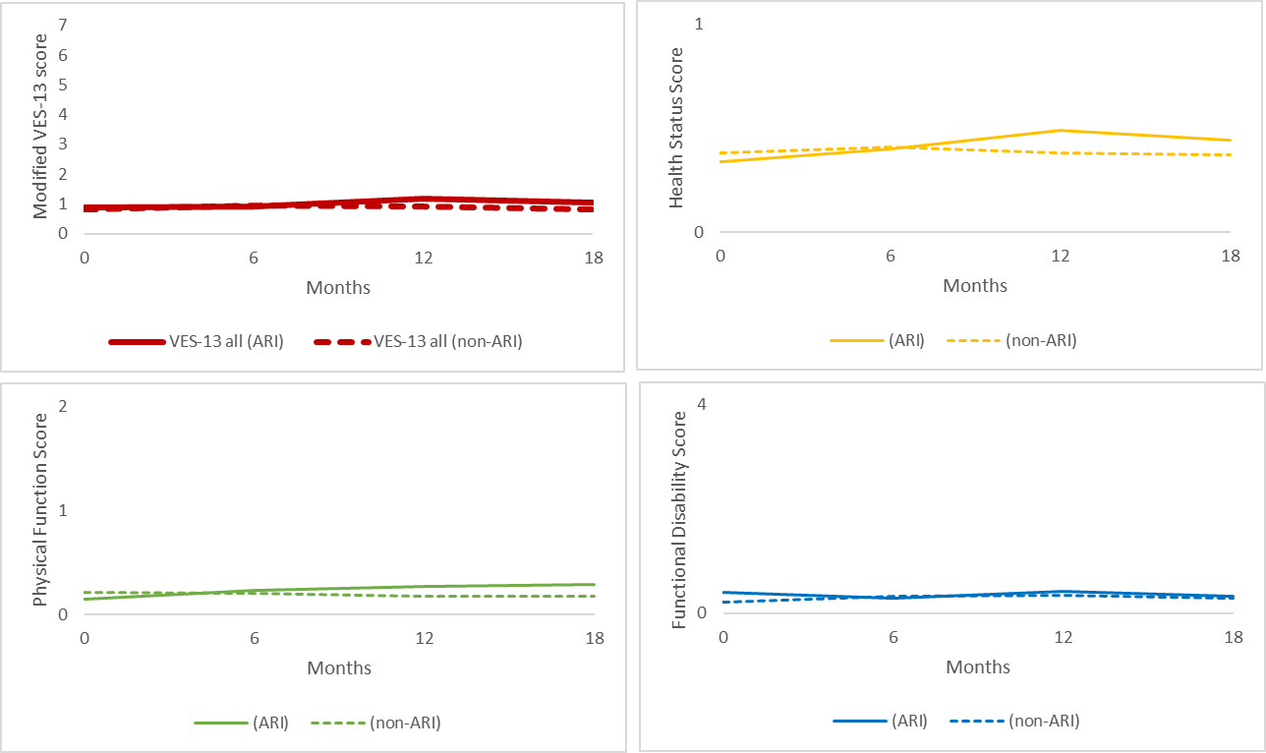

¹ Modified VES-13 composite score range = 0–7. Individual VES-13 components value ranges: Health Status (0,1), Physical Function (0,1,2), and Functional Disability (0,4).

