Cost-Effectiveness of Breast Cancer Screening in the National Breast and Cervical Cancer Early Detection Program

Sun Hee Rim, PhD^{1*}, Benjamin T. Allaire, MS², Donatus U. Ekwueme, PhD¹, Jacqueline W. Miller, MD¹, Sujha Subramanian, PhD², Ingrid J. Hall, PhD¹, Thomas J. Hoerger, PhD²

Author’s Affiliation
¹Division of Cancer Prevention and Control, National Center for Chronic Disease Prevention and Health Promotion, Centers for Disease Control and Prevention, Atlanta, Georgia, USA
²RTI International, Research Triangle Park, NC, USA

*Corresponding author: Sun Hee Rim, PhD, MPH, E-mail: srim@cdc.gov

Technical Appendix

Screening and Diagnostic Costs
The total costs and the number of women screened were averaged over the 3 years of CAT data collection to minimize the effect of yearly variation (Ekwueme et al). We excluded clinical costs for women who were served by the NBCCEDP but received their screening mammogram elsewhere because of difficulties associated with modeling outcomes for these women. After making these adjustments, we obtained an adjusted average cost per woman screened by dividing total cost by the number of women screened. We adjusted costs within each program year to real dollars using the Consumer Price Index (in 2018 U.S dollars). We omitted data from tribes, territories, and programs with poor quality data from the calculations. In addition, we excluded values for one outlier state that had costs that significantly increased the average costs across states. This state had relatively few screenings.
The cost estimates included costs associated with breast cancer screening and program delivery. Because the NBCCEDP costs also reflect costs associated with cervical cancer screening, we adjusted total costs to reflect only those attributable to breast cancer screening. After adjusting for the number of women who only receive breast cancer diagnostic testing (i.e., those who enter the program because they have symptoms of potential breast cancer), we estimated that the screening cost was $296.97 (Table A1).

Table A1. Screening and Program Costs
Adjusted Average Cost Per Woman Screened
Main Analysis | $296.97
Sensitivity Analysis (25th, 75th percentiles) | $($257.64, $517.13)

Cost of Diagnostic Follow-up. Excluding clinical costs associated with women who were not initially screened by the NBCCEDP required estimating the average clinical cost of diagnostic follow-up. The methods used to obtain this value were based on Ekwueme et al (personal communication). This involved estimating the average cost associated with office visits and the average cost of diagnostic follow-up procedures.
Using CAT data, we calculated the total cost of office visits for all patients. Because the number of office visits was not collected in the CAT, we estimated the total number of office visits by assuming that each screening and diagnostic follow-up case is associated with one office visit each. The NBCCEDP Minimum Data Elements (MDE) report the number of women screened and the number of diagnostic follow-ups conducted by each program using federal funds. For women served using non-federal funds, the CAT does not explicitly collect the number of women screened who required diagnostic follow-up. Thus, we assumed that women screened using non-federal funds undergo diagnostic follow-up at the same rate as women who are screened with federal funds. Using this assumption, we calculated the total number of women receiving diagnostic follow-up with non-federal funds, and subsequently the total number of office visits associated with either screening or diagnostic follow-up from any funding source. By dividing the total cost of office visits by this value, we obtained the average cost of an office visit in the NBCCEDP.
The average cost of diagnostic follow-up in the NBCCEDP included both procedural costs and the cost of office visits. We obtained the total cost of diagnostic procedures by summing the total cost of each individual diagnostic procedure reported in the CAT. The total number of women receiving diagnostic follow-up is equal to the number of women receiving diagnostic follow-up with federal funds from the MDE and the number of women estimated to have received diagnostic follow-up with non-federal funds from the CAT, as described earlier. Dividing the total cost of diagnostic follow-up procedures by the total number of women receiving diagnostic follow-up gives the average procedural cost of diagnostic follow-up. Adding the average cost of an office visit to this value yields the average clinical cost of diagnostic follow-up in the NBCCEDP.
Sensitivity Analysis. For screening costs in the one-way sensitivity analyses, we used the 25th and 75th percentile costs from the CAT ($257.64 and $517.13).

Treatment Costs
We derived the cost of breast cancer treatment (Table A2) from three separate sources. Our baseline treatment costs were taken from a study by Mariotto et al. This study estimates the total cost of cancer care in the United States from a health care perspective. Attributable costs for breast cancer treatments were calculated using Medicare claims data from 1975–2005 as well as incidence and survival data from the SEER program (Table A2a). The average cost of breast cancer treatment was divided into annualized initial, continuing and last year of life phases (survival time is allocated sequentially to the last year of life, then the initial phase, with the remaining survival time assigned to the continuing phase). This study derived adjustment factors using Fireman et al in order to estimate the cost of care for younger women under the age of 65. This study has the benefit of well-defined time frames and a nationally representative sample population. However, it does not stratify costs by disease severity at diagnosis.
To address this issue (Table A2b), we estimated the cost of local, regional and distant disease using ratios obtained from Fireman et al. First, we calculated the annual attributable cost of initial, continuing and terminal breast cancer treatment using the results reported in this study. Then we obtained the ratio of treatment costs for local, regional and distant disease relative to the all-stage average for each treatment phase. We applied these ratios to the costs reported in Mariotto et al to estimate the cost of each phase of breast cancer treatment stratified by disease severity at diagnosis.
Table A2. Calculation of Breast Cancer Treatment Costs
Table A2a. Attributable Annual Treatment Costs for Breast Cancer, Age <65, Medicare from Mariotto et al. (2011)
Cost | Initial | Continuing | Cancer Death | Other Cause
Cost (2018 dollars) | 31,902 | 2,542 | 108,615 | 862
Note: Costs allocated to last year of life first, then initial phase, then continuing phase. The cost data reported in Mariotto, et al were reported in 2010 dollars. All cost estimates in this analysis were adjusted to 2018 dollars.
Table A2b. Total Treatment Costs for Breast Cancer and Controls by Stage at Diagnosis, All Ages from Fireman et al. (1997)
Stage at Diagnosis | Control (1 year) | Initial (6 months) | Continuing (6 months) | Terminal (6 months)
Local | 2,961 | 16,669 | 2,457 | 22,198
Regional | 2,685 | 20,495 | 3,002 | 20,759
Distant | 2,762 | 17,156 | 4,535 | 19,933
All Stages | 2,849 | 16,977 | 2,586 | 21,204
Note: Initial cost of distant disease is lower than regional disease. This is probably because an individual who dies after 6 months has 3 months allocated to initial and 3 months allocated to terminal.
Attributable Annual Treatment Costs for Breast Cancer by Stage at Diagnosis, All Ages
Stage at Diagnosis | Initial | Continuing | Terminal
Local | 16,166 | 1,954 | 21,694
Regional | 20,812 | 3,319 | 21,076
Distant | 18,929 | 6,308 | 21,706
All Stages | 16,714 | 2,324 | 20,941
Ratios for Annual Treatment Costs by Stage at Diagnosis, All Ages
Stage at Diagnosis | Initial | Continuing | Terminal
Local | 0.97 | 0.84 | 1.04
Regional | 1.25 | 1.43 | 1.01
Distant | 1.13 | 2.71 | 1.04
Calculated Annual Cost of Treatment by Stage at Diagnosis, Age <65, Medicare
Stage at Diagnosis | Initial | Continuing | Cancer Death | Other Cause
Local | 30,945 | 2,136 | 112,959 | 896
Regional | 39,878 | 3,636 | 109,702 | 870
Distant | 36,050 | 6,890 | 112,959 | 896
Table A2c. Calculated Annual Cost of Treatment by Stage at Diagnosis, Age <65, Adjusted for Medicaid
Stage at Diagnosis | Initial | Continuing | Cancer Death | Other Cause
Local | 22,281 | 1,538 | 81,331 | 645
Regional | 28,712 | 2,617 | 78,985 | 627
Distant | 25,956 | 4,961 | 81,331 | 645
Calculated Annual Cost of Treatment by Stage at Diagnosis, Age ≥65, Medicare
Stage at Diagnosis | Initial | Continuing | Cancer Death | Other Cause
Local | 25,789 | 2,136 | 75,306 | 896
Regional | 33,233 | 3,636 | 73,135 | 870
Distant | 30,042 | 6,890 | 75,306 | 896

Mariotto et al reports the cost of treatment under Medicare, but women diagnosed with breast cancer by the NBCCEDP are treated by Medicaid. A study of select Medicaid fees by Zuckerman et al. found that Medicaid pays an average of 72 cents on the dollar relative to Medicare. Although the procedures used to obtain this value did not explicitly include oncology services, it is not unreasonable to assume that this relationship holds for procedures that were not included in the sample. Thus, we applied a ratio of 0.72 to the treatment costs for women younger than age 65 obtained using Mariotto et al. and Fireman et al. to estimate the cost of breast cancer treatment for women covered by Medicaid. Costs for women 65 and older were not adjusted because these women would likely qualify for coverage under Medicare. The final treatment costs are presented in Table A2c and included in the main manuscript as Table 2.

Health State Utility Variables
We used health state utility values (Table A3) taken from Yabroff et al. in the main analysis of our NBCCEDP cost-effectiveness model. These utility values have the benefit of well-defined time frames since detection (initial, continuing, final year of life) that are identical to the time frames used to report our breast cancer treatment costs. This study also included controls for age, education, phase of care and comorbidities, ensuring that the reported decrement is age-independent and specifically attributable to breast cancer. However, this study does not stratify utility values by disease stage at diagnosis. To account for this, we included an additional utility decrement for distant breast cancer in a sensitivity analysis. This decrement is derived from a meta-analysis of breast cancer utility values.
Table A3. Health Utility Decrements, by Year since Diagnosis
 | Main Analysis | Sensitivity Analysis, Option 1 |  | Sensitivity Analysis, Option 2
Time Frame | All Breast Cancers | Local/  Regional | Distant | Local/  Regional | Distant
Initial | 0.07 | 0.06 | 0.23 | 0.06 | 0.31
Continuing | 0.04 | 0.03 | 0.20 | 0.03 | 0.28
Final Year of Life | 0.08 | 0.07 | 0.24 | 0.07 | 0.32

During our literature review, we identified a meta-analysis of breast cancer utility values by Peasgood et al. (2010a). Although a meta-analysis would be an ideal source for utility values, we encountered several problems which preclude using it in our main analysis. The studies used to perform this meta-analysis include many divergent disease states (i.e., treatment specific or side-effect specific utility values) and a wide variety of valuation methods. Due to these differing methods, it is unclear what constitutes full health for this pooled sample population. Additionally, the correct time frame over which to apply these values is ambiguous, and the reported models do not include values for remission from breast cancer. These considerations make it difficult to ensure that the utility values from this meta-analysis accurately reflect the health states that we wish to represent in the model.
The utility values reported by Yabroff et al. account for many of these issues. This study identified individuals with breast cancer in the 1986–94 National Health Interview Survey (NHIS), which includes the Health Activities and Limitations Index (HALex). Individuals with breast cancer were divided into initial, continuing, and last year of life care phases. They were then matched with controls based on age, education, phase of care and comorbidities in order to determine a utility decrement that is attributable to breast cancer. This study reports utility decrements of 0.07, 0.04 and 0.08 for the initial, continuing and last year of life phases, respectively.
Using this source in our model ensures that there is a consistent utility valuation method with a clear value for full health. The time periods in this study are well defined and coincide with the time periods that our costs are reported in. These time periods also account for remission from breast cancer because women in remission are not dropped from the sample. Although these utility values do not explicitly account for age heterogeneity, age-specific QALYs gained will reflect survival rates that are conditioned on age. The primary drawback to this study is that the utility values are not stratified by disease severity at diagnosis. Thus, in our main analysis, incremental utility increases for earlier detection would be primarily driven by increased life expectancy and a longer duration until the final year of life (with its larger decrement in utility) occurs.
To account for possible decreased utility in individuals with more advanced breast cancer, we examined the effects of adding an additional decrement for distant breast cancer as a sensitivity analysis. This decrement was derived from Peasgood et al. (2010b). We identified two alternative strategies for deriving this value. The first involves comparing similar health states across the two models in the meta-analysis, which are for early breast cancer and metastatic breast cancer. This method results in an additional decrement of 0.17 for distant breast cancer. For this decrement, we adjusted the utility values in the model using SEER incidence data to ensure that the average utility value for the population is equivalent to the values observed in Yabroff et al.

Screening Frequency
In the model, patients are divided into categories based on whether they are assumed to receive annual, biennial, or irregular screening. For participants in the NBCCEDP, we used MDE patient data to estimate the frequency of mammograms within the program and the age distribution of the program population. For each woman for whom we had MDE data, we used the dates of each program mammogram and the dates of any out-of-program mammograms reported by the women to calculate the frequency of receiving a mammogram. To limit our analysis to “screening” mammograms, we excluded any mammograms less than 9 months after the previous reported mammogram. After estimating the mean time between mammograms, we categorized each woman as receiving annual screening (< 1.5 years), biennial screening (1.5 to < 2.5 years), or irregular screening (2.5 years or more) according to the definitions used by Cronin et al. All analyses were restricted to the population aged 40 to 64 years. For uninsured women outside the NBCCEDP, we used 1990–2005 National Health Interview Survey data on uninsured women to estimate the proportion of women in each category. Our estimates are presented in Table A4.

Table A4. Percentage of Annual, Biennial, and Irregular Screeners among Uninsured Women, Stratified by Age
 |  | General Uninsured Population |  |  |  |  |  | NBCCEDP Uninsured Population
Age | Annual |  | Biannual | Irregular |  |  | Annual |  | Biannual | Irregular
20 | 0.0629 |  | 0.1219 | 0.8152 |  |  | 0.0629 |  | 0.1219 | 0.8152
40 | 0.1767 |  | 0.1833 | 0.64 |  |  | 0.4692 |  | 0.2559 | 0.2750
50 | 0.2872 |  | 0.207 | 0.5059 |  |  | 0.5601 |  | 0.2394 | 0.2005
60 | 0.3596 |  | 0.1675 | 0.4729 |  |  | 0.6899 |  | 0.2159 | 0.0943
65 | 0.605 |  | 0.1416 | 0.2535 |  |  | 0.605 |  | 0.1416 | 0.2535
70 | 0.5571 |  | 0.1566 | 0.2863 |  |  | 0.5571 |  | 0.1566 | 0.2863
80 | 0.4021 |  | 0.1563 | 0.4416 |  |  | 0.4021 |  | 0.1563 | 0.4416
Note: The percentage splits for ages greater than 65 years represent the proportions observed among all women older than 65 years in the National Health Interview Survey data; almost all women aged 65 or older have insurance coverage through Medicare, and we assume that screening is similar for all women in this age group.
Appendix Figure 1a. Cost-Effectiveness Acceptability Curves: Program vs. No Program
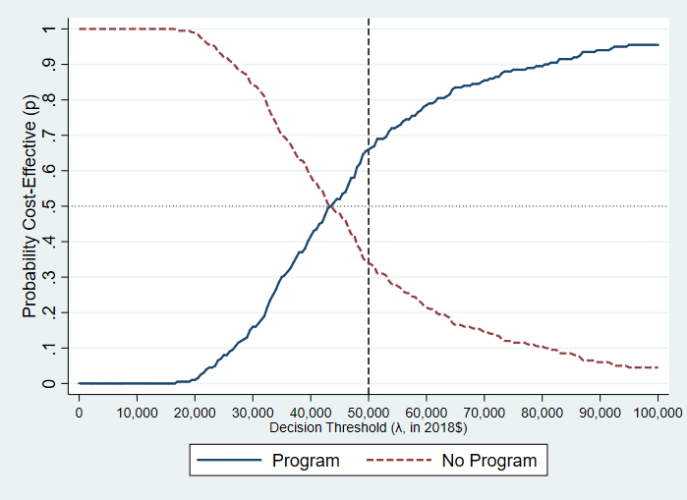
CEACs were generated based on results from probabilistic sensitivity analyses by multiplying the incremental costs between the Program and No Program (or Program and No Screening) scenarios by societal willingness-to-pay values (WTPs) and subtracting incremental costs. The share of runs with positive net benefits (WTP * Δ QALY − Δ cost > 0) was plotted for each strategy.

Appendix Figure 1b. Cost-Effectiveness Acceptability Curves: Program vs. No Screening
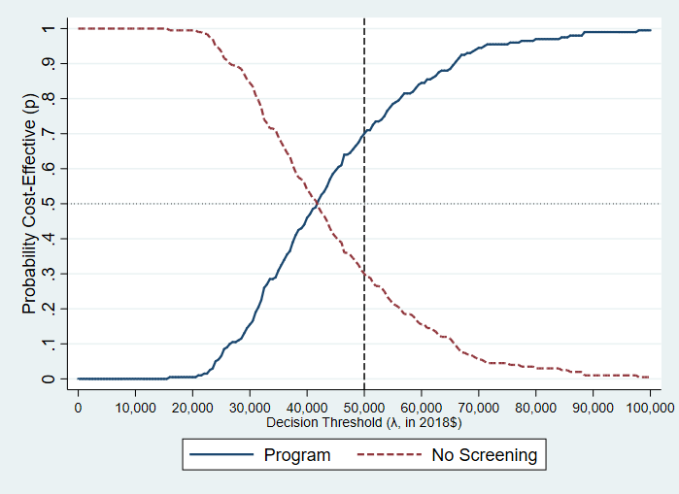
CEACs were generated based on results from probabilistic sensitivity analyses by multiplying the incremental costs between the Program and No Program (or Program and No Screening) scenarios by societal willingness-to-pay values (WTPs) and subtracting incremental costs. The share of runs with positive net benefits (WTP * Δ QALY − Δ cost > 0) was plotted for each strategy.

REFERENCES

Cronin KA, Yu B, Krapcho M, et al. (2005) Modeling the dissemination of mammography in the United States. Cancer Causes Control. 16: 701-12.

Ekwueme DU, Subramanian S, Khushalani JS, Miller JW, Wong FF, Trogdon JG. Economic Cost of the National Breast and Cervical Cancer Early Detection Program (under review).

Fireman BH, Quesenberry CP, Somkin CP, et al. (1997) Cost of care for cancer in a health maintenance organization. Health Care Financ Rev. 18: 51-76.

Mariotto AB, Yabroff KR, Shao Y, Feuer EJ, Brown ML. (2011) Projections of the cost of cancer care in the United States: 2010-2020. J Natl Cancer Inst. 103: 117-28.

Peasgood T, Ward SE, Brazier J. A review and meta analysis of health state utility values in breast cancer. HEDS Discussion Paper Series X/10. University of Sheffield, UK; 2010a.

Peasgood T, Ward SE, Brazier J. Health-state utility values in breast cancer. Expert Rev Pharmacoecon Outcomes Res; 2010b:553–566.

Yabroff KR, McNeel TS, Waldron WR, et al. (2007) Health limitations and quality of life associated with cancer and other chronic diseases by phase of care. Med Care. 45: 629-37.

Zuckerman S, Williams A, Stockley K. Trends in Medicaid physician fees, 2003–2008. Health Affairs. 2009;28(3):W510–519.

