Supplementary Materials
Frailty Score
During the enrollment interview, each participant was asked five questions comprising a frailty short interview based on the components of the frailty phenotype defined by Fried et al. [27]. Participants were asked the following questions:
“In the last year, before this current illness, have you lost more than 10 pounds unintentionally (i.e., not due to dieting or exercise)?” [YES;NO]; adapted from [27].
“In the last month, before this current illness, have you had too little energy to do the things you wanted to do?” [YES;NO]; adapted from [28].
“Before this current illness, how difficult was it for you to lift or carry something as heavy as 10 pounds, such as a full bag of groceries, by yourself, and without using any special equipment?” [NO DIFFICULTY; A LITTLE…; SOME…; A LOT…; UNABLE TO DO]; adapted from [29].
“Before this current illness, did you have difficulty walking 100 yards (around the size of a football field) because of a health problem?” [NO DIFFICULTY; A LITTLE…; SOME…; A LOT…; UNABLE TO DO]; adapted from [28].
“Before this current illness, how often did you engage in activities that require a low or moderate level of energy such as gardening, cleaning the car, or going for a walk?” [>ONCE PER WEEK; ONCE PER WEEK; 1-3 TIMES PER MONTH; HARDLY EVER/NEVER]; adapted from [28].
Responses to the last three questions were recoded as dichotomous variables with at least some difficulty or engaging in physical less than once per week indicating positive responses indicative of frailty. The responses to each element of the five elements were summed to create a frailty score (values 0 to 5) which was included as a continuous covariate in multivariable regression models.
Hemagglutination-inhibition assay
The hemagglutination-inhibition assay (HAI) assays were performed to measure antibodies that block hemagglutinin (HA) receptor binding. Prior to HAI testing, all sera were treated overnight with receptor destroying enzyme and heat inactivated to prevent nonspecific inhibition; sera were also adsorbed with red blood cells to remove nonspecific agglutinins. Serial 2-fold dilutions (with an initial dilution of 1:10) were prepared for each serum specimen in 96-well microtiter plates. The serum dilutions were then incubated with standardized concentrations (4 HA units per 25 μL) of monovalent IIV subunit material (provided by Sanofi-Pasteur) representing the A/Texas/50/2012 (H3N2) virus present in the 2014-2015 Northern Hemisphere influenza vaccine and the A/Hong Kong /4801/2014 (H3N2) virus present in the 2016-2017 Northern Hemisphere influenza vaccine and belonging to the 3C.2a genetic group. Turkey red blood cells were added to wells and allowed to settle. The strain-specific HAI antibody titers at each time point for each individual were calculated as the reciprocal (eg, 40) of the highest dilution of sera (eg, 1:40) that inhibited hemagglutination. HAI titers below the limits of detection (ie, <10) were denoted as half of the threshold detection value (ie, 5); titers greater than the upper test value (ie, 5120) were denoted as having twice that value (ie, 10240).
Enzyme-linked lectin assay
Neuraminidase-inhibition (NAI) antibody titers were measured by enzyme-linked lectin assay (ELLA) [30]. This assay used a reassortant influenza viruses with a mismatched HA (H6 subtype), to avoid interference by HA-specific antibodies, and with the neuraminidase (NA) antigen representing either the A/Texas/50/2012 (H3N2) virus present in the 2014-2015 Northern Hemisphere influenza vaccine or the A/California/7/2009 (H1N1)pdm09 virus present in the 2015-2016 Northern Hemisphere influenza vaccine. Serum specimens were heat inactivated, and serial 2-fold dilutions (with an initial dilution of 1:10) were incubated with virus and then added to 96-well microtiter plates coated with fetuin in duplicate. A 25mM MES buffer is used throughout the assay as diluent and for plate washing. A final solution of 20mM CaCl2 and 1% BSA are added to the diluents with a pH of 6.5. Following incubation, peroxidase-labeled peanut agglutinin (the lectin) and, later, peroxidase substrate were added to detect enzymatic cleavage of fetuin by viral NA, and the reaction optical density was measured with a microplate reader. The percentage inhibition of NA enzymatic activity at each serum dilution was calculated by comparison with values from virus control wells (virus but no serum); endpoint NAI titers were calculated as the reciprocal of the highest dilution with at least 50% inhibition.

Supplementary Table 1. Comparison of subject characteristics by serum specimen availability among adults hospitalized for acute respiratory illness during the 2014-2015 influenza season.
 | University of Michigan Hopital
Characteristic | Total Participants Enrolled  No. | Specimens Retrieved  No. (%) | P-valueª
Overall | 341 | 315 (92) | -
Sex |  |  | 0.65
Female | 169 | 155 (92)
Male | 172 | 160 (93)
Age category (y) |  |  | 0.74
18-49 | 90 | 84 (93)
50-64 | 108 | 98 (91)
≥65 | 143 | 133 (93)
Race/ethnicity^{b} |  |  | 0.96
White (not Hispanic) | 262 | 242 (92)
Black | 47 | 43 (91)
Other | 30 | 28 (93)
Frailty score (range 0-5) |  |  | 0.49
0-2 | 243 | 226 (93)
3-5 | 98 | 89 (91)
Charlson comorbidity index category |  |  | 0.25
0 | 34 | 33 (97)
1 | 81 | 71 (88)
2 | 56 | 53 (95)
3+ | 170 | 158 (93)
Influenza vaccination status |  |  | 0.12
Vaccinated | 253 | 237 (94)
Unvaccinated | 88 | 78 (89)

ª P-values are calculated from chi-square tests.
^{b} 2 participants with serum specimens had missing Race/ethnicity data

Supplementary Table 2. Comparison of subject characteristics by serum specimen availability among adults hospitalized for acute respiratory illness during the 2015-2016 influenza season.
 | University of Michigan Hopital |  |  | Henry Ford Hospital
Characteristic | Total Participants Enrolled  No. | Specimens Retrieved  No. (%) | P-valueª | Total Participants Enrolled  No. | Specimens Retrieved  No. (%) | P-valueª
Overall | 257 | 243 (95) | - | 184 | 96 (52) | -
Sex |  |  | 0.47 |  |  | 0.53
Female | 134 | 128 (96) |  | 117 | 59 (50)
Male | 123 | 115 (94 |  | 67 | 37 (55)
Age category (y) |  |  | 0.27 |  |  | 0.40
18-49 | 86 | 79 (92) |  | 60 | 27 (45)
50-64 | 81 | 79 (98) |  | 77 | 43 (56)
≥65 | 90 | 85 (94) |  | 47 | 26 (55)
Race/ethnicity^{b} |  |  | 0.66 |  |  | 0.03
White (not Hispanic) | 182 | 172 (95) |  | 37 | 26 (70)
Black | 35 | 34 (97) |  | 128 | 61 (48)
Other | 39 | 36 (92) |  | 14 | 5 (36)
Frailty score (range 0-5) |  |  | 0.83 |  |  | 0.28
0-2 | 177 | 167 (94) |  | 131 | 65 (50)
3-5 | 80 | 76 (95) |  | 53 | 31 (58)
Charlson comorbidity index category |  |  | 0.30 |  |  | 0.02
0 | 29 | 27 (93) |  | 36 | 14 (39)
1 | 40 | 36 (90) |  | 47 | 19 (40)
2 | 36 | 33 (92) |  | 17 | 12 (71)
3+ | 152 | 147 (97) |  | 84 | 51 (61)
Influenza vaccination status |  |  | 0.16 |  |  | 0.46
Vaccinated | 199 | 186 (93) |  | 93 | 51 (55)
Unvaccinated | 58 | 57 (98) |  | 91 | 45 (49)

ª P-values are calculated from chi-square tests.
^{b} 5 participants with serum specimens had missing Race/ethnicity data

Supplementary Figure 1. Hemagglutination-inhibition antibody titers by days from illness onset to serum specimen collection during acute illness, among vaccinated (A) and unvaccinated (B) influenza A(H3N2) positive cases during the 2014-2015 season. Neuraminidase-inhibition antibody titers by time from illness onset to serum specimen collection during acute illness, among vaccinated (C) and unvaccinated (D) influenza A(H3N2) positive cases during the 2014-2015 season.
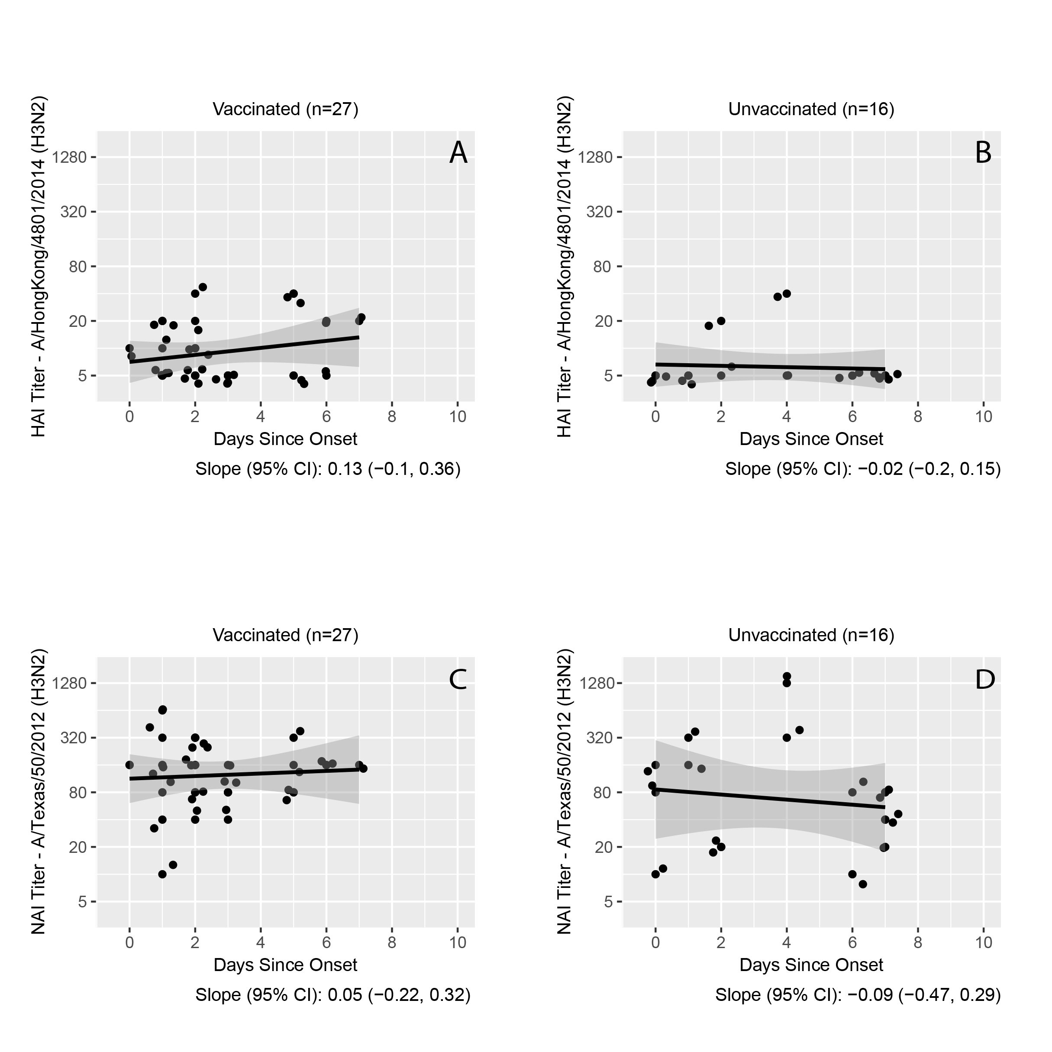

Supplementary Figure 2. Hemagglutination-inhibition antibody titers by days from illness onset to serum specimen collection during acute illness, among vaccinated (A) and unvaccinated (B) influenza A(H1N1)pdm09 positive cases during the 2015-2016 season. Neuraminidase-inhibition antibody titers by time from illness onset to serum specimen collection during acute illness, among vaccinated (C) and unvaccinated (D) influenza A(H1N1)pdm09 positive cases during the 2015-2016 season.
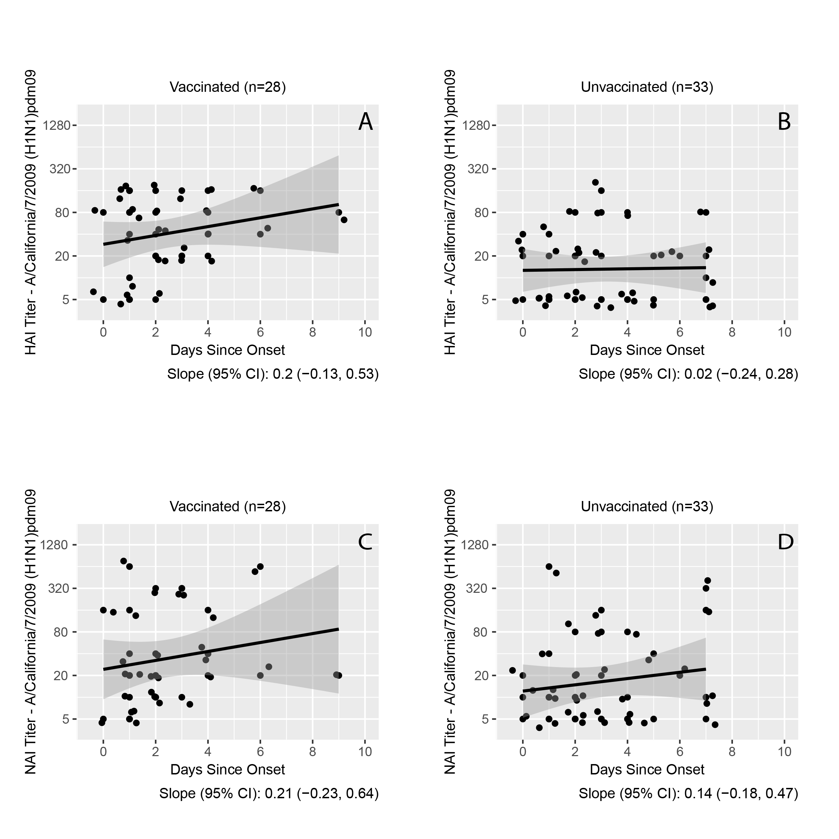

Supplementary Figure 3. A and B: Hemagglutination-inhibition and neuraminidase-inhibition antibody titers by calendar date of enrollment, among negative participants cases during the 2014-2015 season. C and D: Hemagglutination-inhibition and neuraminidase-inhibition antibody titers by calendar date of enrollment, among negative participants cases during the 2015-2016 season.
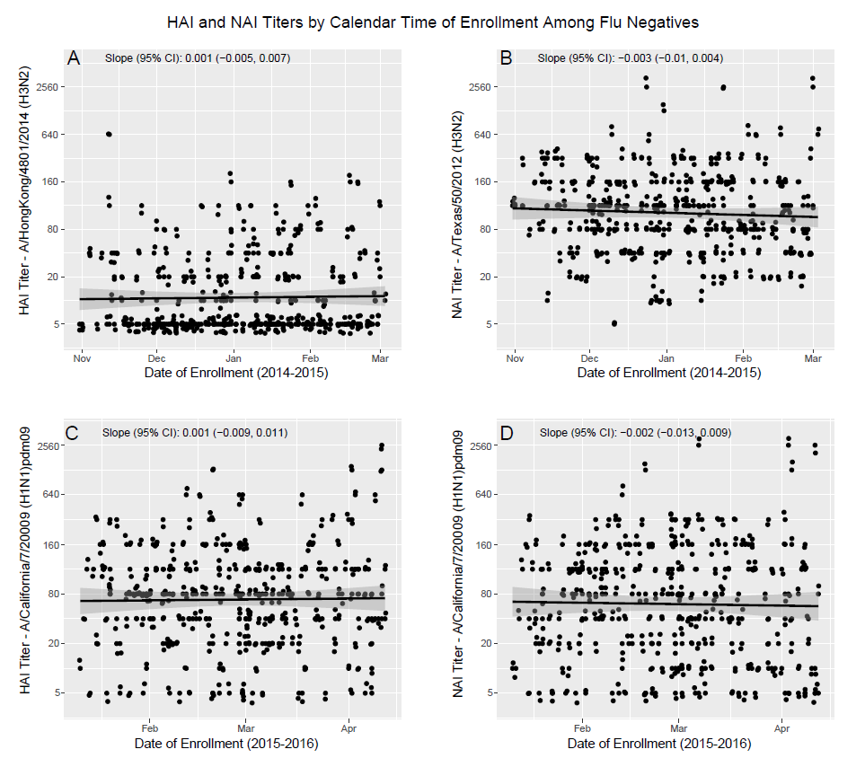

Supplementary References
1. Fried LP, Tangen CM, Walston J, et al. Frailty in Older AdultsEvidence for a Phenotype. J Gerontol Ser A. 2001; 56:M146–57.
2. Romero-Ortuno R, Walsh CD, Lawlor BA, Kenny RA. A frailty instrument for primary care: findings from the Survey of Health, Ageing and Retirement in Europe (SHARE). BMC Geriatr. 2010; 10:57.
3. Centers for Disease Control and Prevention (CDC). 2014 NHIS Questionnaire - Adult. Available at: ftp://ftp.cdc.gov/pub/Health_Statistics/NCHS/Survey_Questionnaires/NHIS/2014/english/qadult.pdf. Accessed 13 July 2018.
4. Couzens L, Gao J, Westgeest K, et al. An optimized enzyme-linked lectin assay to measure influenza A virus neuraminidase inhibition antibody titers in human sera. J Virol Methods. 2014; 210:7–14.

