Supplemental Material

Manuscript Title: Climate Change, Extreme Events and Increased Risk of Salmonellosis in Maryland, USA: Evidence for Coastal Vulnerability
Author List: Chengsheng Jiang, Kristi S. Shaw, Crystal Romeo, David Blythe, Clifford Mitchell, Raghu Murtugudde, Amy R. Sapkota, Amir Sapkota

Table of Contents:
Supplemental Material, Table S1 Page 2
Supplemental Material, Figure S1 Page 3
Supplemental Material, Figure S2 Page 4

Supplemental Material, Table S1: Incidence Rate Ratios (IRR) and 95% Confidence Intervals (CIs) for exposures to extreme temperature (ETT₉₅ exceedance) and precipitation (EPT₉₀ exceedance) events and the risk of salmonellosis in Maryland, 2002-2012.
Characteristics |  | Extreme Temp. (ETT₉₅) | Extreme Precip. (EPT₉₀)
Overall Model |  | 1.041[1.013-1.069] | 1.056[1.035-1.078]
Season
 | Spring | 0.961[0.926-0.997] | 1.013[0.984-1.042]
 | Summer | 1.045[1.014-1.077] | 1.017[0.989-1.046]
 | Fall | 1.004[0.964-1.045] | 1.037[1.015-1.060]
 | Winter | 0.962[0.928-0.998] | 1.012[0.972-1.053]
Geographical Location
 | Coastal Counties | 1.051[1.023-1.081] | 1.071[1.044-1.099]
 | Non-Coastal Counties | 1.015[0.977-1.055] | 1.036[1.017-1.054]
Age
 | <5 | 1.023[0.982-1.065] | 1.047[1.015-1.080]
 | Age 5-17 | 1.017[0.998-1.037] | 1.033[1.008-1.059]
 | Age 18-64 | 1.047[1.020-1.074] | 1.057[1.037-1.077]
 | Age ≥ 65 | 1.055[0.998-1.116] | 1.066[1.026-1.107]
Race
 | Non-Hispanic White | 1.049[1.012-1.088] | 1.083[1.054-1.112]
 | Non-Hispanic Black | 1.012[0.969-1.057] | 1.023[0.989-1.058]
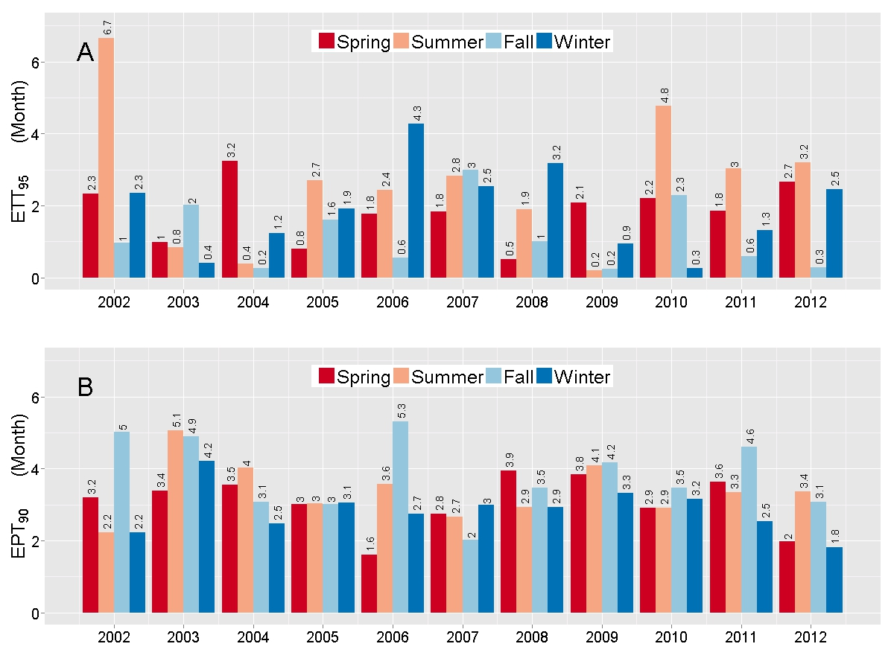
Supplemental Material, Figure S1. Monthly total extreme temperature (ETT₉₅ exceedance: Panel A) and precipitation (EPT₉₀ exceedance: Panel B) events by season in Maryland, 2002-2012.

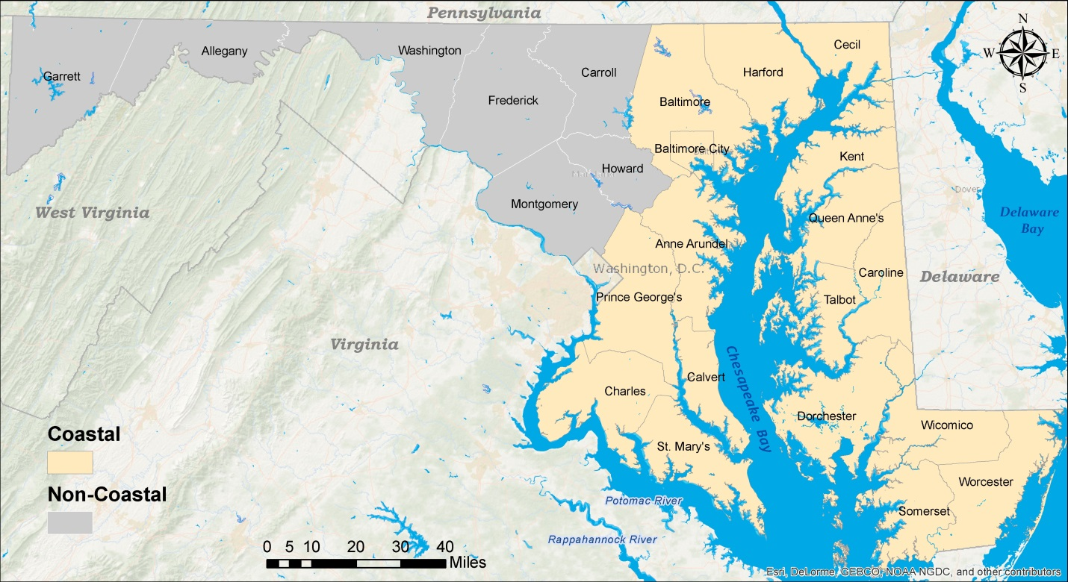
Supplemental Material, Figure S2. County map of Maryland depicting coastal and non-coastal counties.

