Supplementary Information

Supplementary Figure 1 – Probability a given number of SNPs can uniquely assign a cell correctly to its donor given the number of samples multiplexed. Probability calculated over 100 simulated cells. Error bar determined by 10 simulation replicates. 3
Supplementary Figure 2 – Number of usable singlets (triangle) and total number of cells sequenced (circle) as a function of number of individuals multiplexed at a fixed undetected doublet rate estimated from 1000 cells (1% - 10%). 4
Supplementary Figure 3 – Cost per singlet (triangle) and per all cells (circle) as a function of number of individuals multiplexed at a fixed undetected doublet rate estimated from 1000 cells (1% - 10%). 5
Supplementary Figure 4 – Probability to demultiplex up to 64 unrelated individuals versus number of reads overlapping SNPs. 6
Supplementary Figure 5 – Probability and error rates to detect doublets from up to 64 unrelated individuals versus number of reads overlapping SNPs. Dashed lines designate the theoretical limit for doublet detection (1/(1-N)). 7
Supplementary Figure 6 –Number of SNPs detected per cell (y-axis) versus number of UMIs (x-axis). 8
Supplementary Figure 7 – Proportion of correctly assigned cells as a function of reads overlapping SNPs for 8 related individuals from 1000 Genomes. Circles represent averages over 6,145 cells downsampled to a total of 5,000, 10,000, 25,000, 50,000, 75,000 or 90,000 reads overlapping SNPs over all individuals. 9
Supplementary Figure 8 – Detection boundaries of likelihood differences between mixture model for doublets (LLK12) and singlets (SNG.LLK1). 10
Supplementary Figure 9 – Cell type-specific expression of single cells versus bulk. Average expression over single cells for each cell type (y-axis) versus the bulk expression of B cells, CD4+ T cells and monocytes (x-axis). Single cell averages were estimated for 8 individuals. Bulk expression was generated for 6 individuals. 11
Supplementary Figure 10 – Estimates of cell type proportion from three well experiment of unstimulated PBMCs. Estimates of cell type proportion for wells W1 and W2 (x-axis) versus estimates of cell type proportion for the same individuals in well W3 (y-axis). 12
Supplementary Figure 11 – A. TSNE plot for wells W1, W2 and W3 separately. B. QQ plot comparing differential expression analysis between W1 and W2 with W3 for the same individuals. 13
Supplementary Figure 12 – Estimated versus observed doublet rates for unstimulated cells. Expected doublet rates for each pair of individuals (i,j) are calculated as pi * pj, where pi and pj are the proportion of singlets individuals i and j. 14
Supplementary Figure 13 – Detected doublets from the IFN-beta stimulation experiment. Red (confidently called doublets). Pink (ambiguous). Gray (singlets). 15
Supplementary Figure 14 - Estimates of cell type proportion from unstimulated and IFN-beta stimulated PBMCs. Estimates of cell type proportion for unstimulated cells (x-axis) versus stimulated cells (y-axis) for 8 individuals. 16
Supplementary Figure 15 – Scatter plot of estimates of cell type proportion from dscRNA-seq (x-axis) and FACS sorting (y-axis) for 6 lupus patients after IFN-beta stimulation. 17
Supplementary Figure 16 – Gene expression correlation between dscRNA-seq data and ImmGen mouse microarray data. 18
Supplementary Figure 17 – Correlation of foldChange before and after IFN-beta stimulation of ~1000 expressed genes between published CD4 microarray (Ye et al., Science) and monocyte derived dendritic cells RNA-seq (Ye et al., unpublished) (y-axis) with dscRNA-seq cell type specific response (x-axis). 19
Supplementary Figure 18 – IFN-beta fold change correlation between dscRNA-seq data (y axis) and qPCR data from CD4+ T cells (x axis). 20
Supplementary Figure 19 – Expected versus observed variability in cell populations. Variance of average expression over single cells across 8 individuals (y) versus variance of average expression over single cells across 8 synthetic replicates matching cell number for each individual (x). 21
Supplementary Figure 20 – Observed variability in gene expression is correlated between batches. 22
Supplementary Figure 21 – Example of flow cytometry gating strategy for quantifying immune cell populations. 23

Supplementary Figure 1 – Probability a given number of SNPs can uniquely assign a cell correctly to its donor given the number of samples multiplexed. Probability calculated over 100 simulated cells. Error bar determined by 10 simulation replicates.

Supplementary Figure 2 – Number of usable singlets (triangle) and total number of cells sequenced (circle) as a function of number of individuals multiplexed at a fixed undetected doublet rate estimated from 1000 cells (1% - 10%).

Supplementary Figure 3 – Cost per singlet (triangle) and per all cells (circle) as a function of number of individuals multiplexed at a fixed undetected doublet rate estimated from 1000 cells (1% - 10%).

Supplementary Figure 4 – Probability to demultiplex up to 64 unrelated individuals versus number of reads overlapping SNPs.

Supplementary Figure 5 – Probability and error rates to detect doublets from up to 64 unrelated individuals versus number of reads overlapping SNPs. Dashed lines designate the theoretical limit for doublet detection (1/(1-N)).

Supplementary Figure 6 –Number of SNPs detected per cell (y-axis) versus number of UMIs (x-axis).

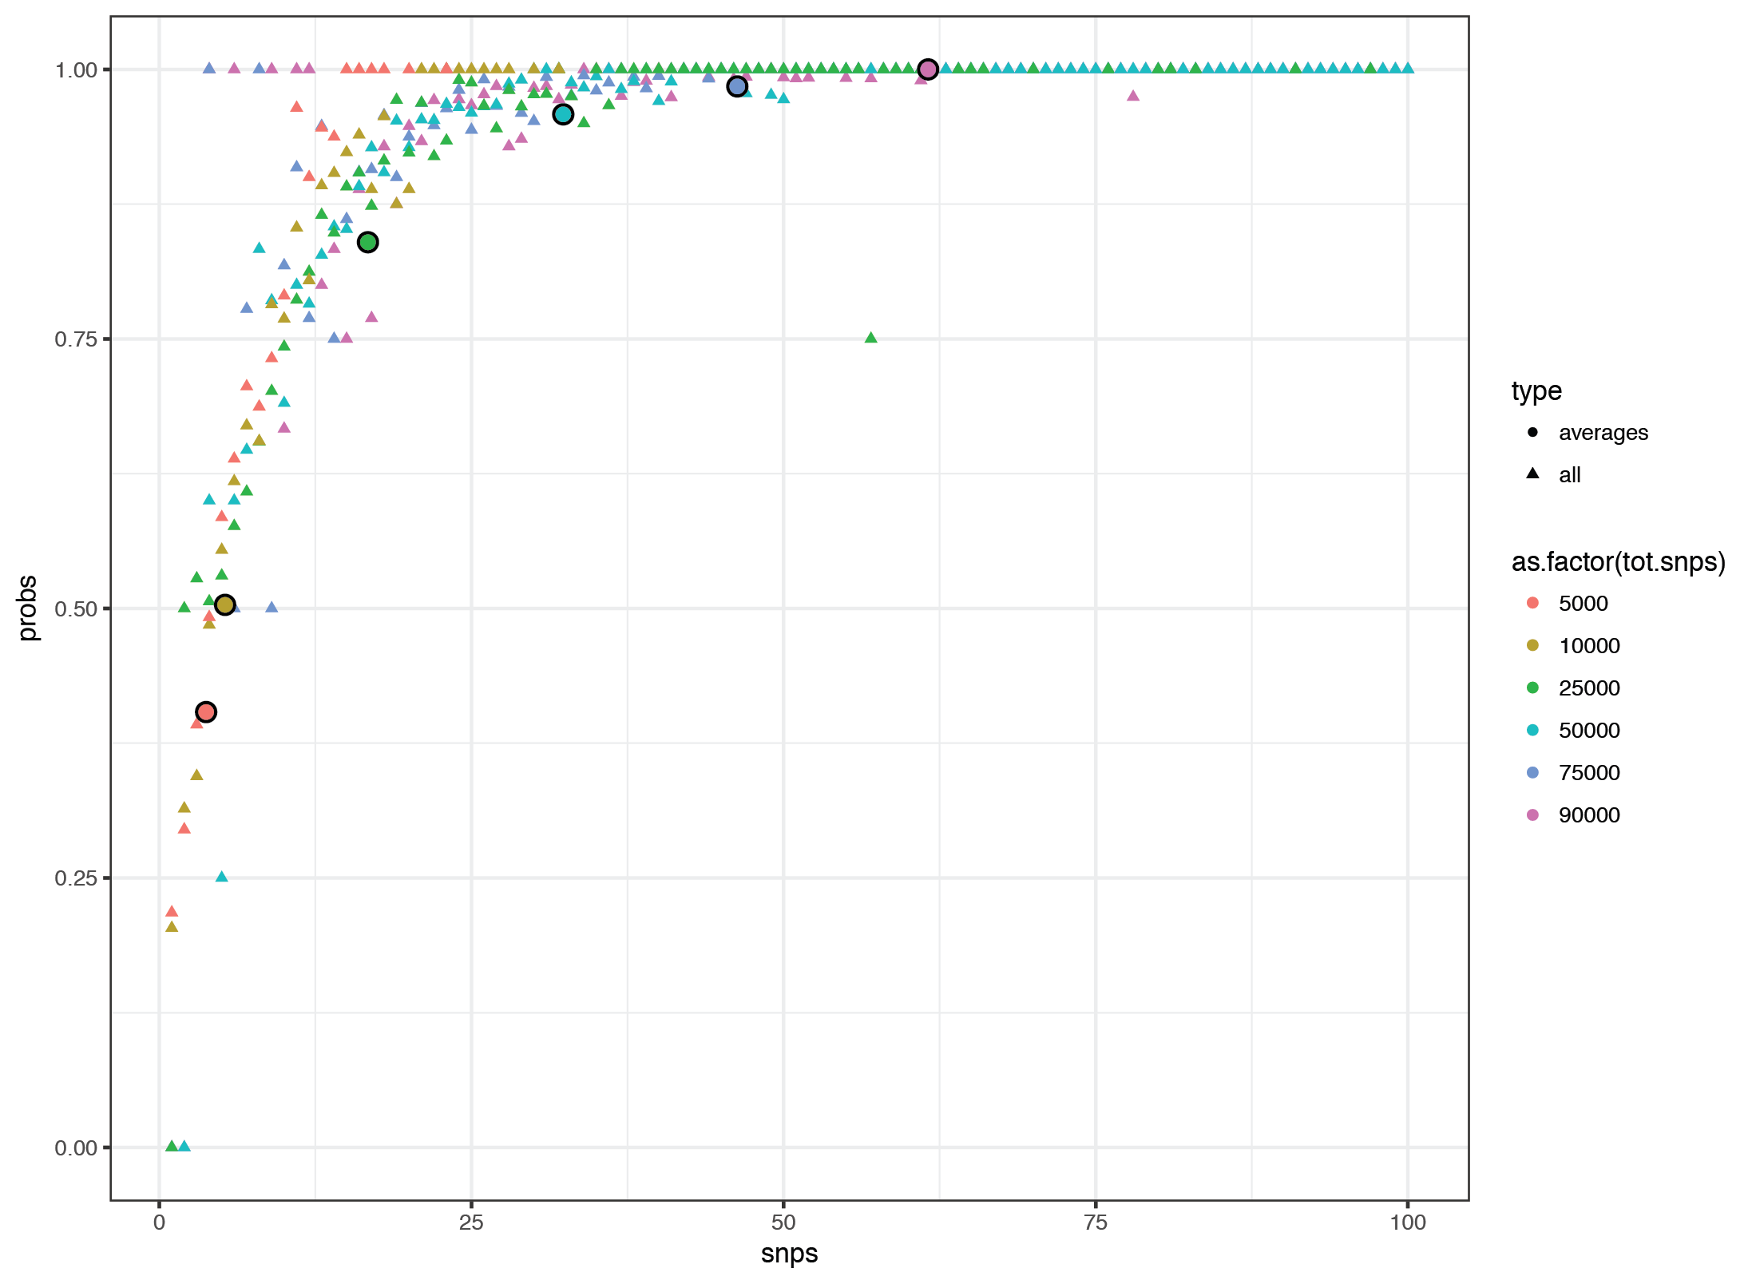
Supplementary Figure 7 – Proportion of correctly assigned cells as a function of reads overlapping SNPs for 8 related individuals from 1000 Genomes. Circles represent averages over 6,145 cells downsampled to a total of 5,000, 10,000, 25,000, 50,000, 75,000 or 90,000 reads overlapping SNPs over all individuals.
Supplementary Figure 8 – Detection boundaries of likelihood differences between mixture model for doublets (LLK12) and singlets (SNG.LLK1).

Supplementary Figure 9 – Cell type-specific expression of single cells versus bulk. Average expression over single cells for each cell type (y-axis) versus the bulk expression of B cells, CD4+ T cells and monocytes (x-axis). Single cell averages were estimated for 8 individuals. Bulk expression was generated for 6 individuals.
Supplementary Figure 10 – Estimates of cell type proportion from three well experiment of unstimulated PBMCs. Estimates of cell type proportion for wells W1 and W2 (x-axis) versus estimates of cell type proportion for the same individuals in well W3 (y-axis).

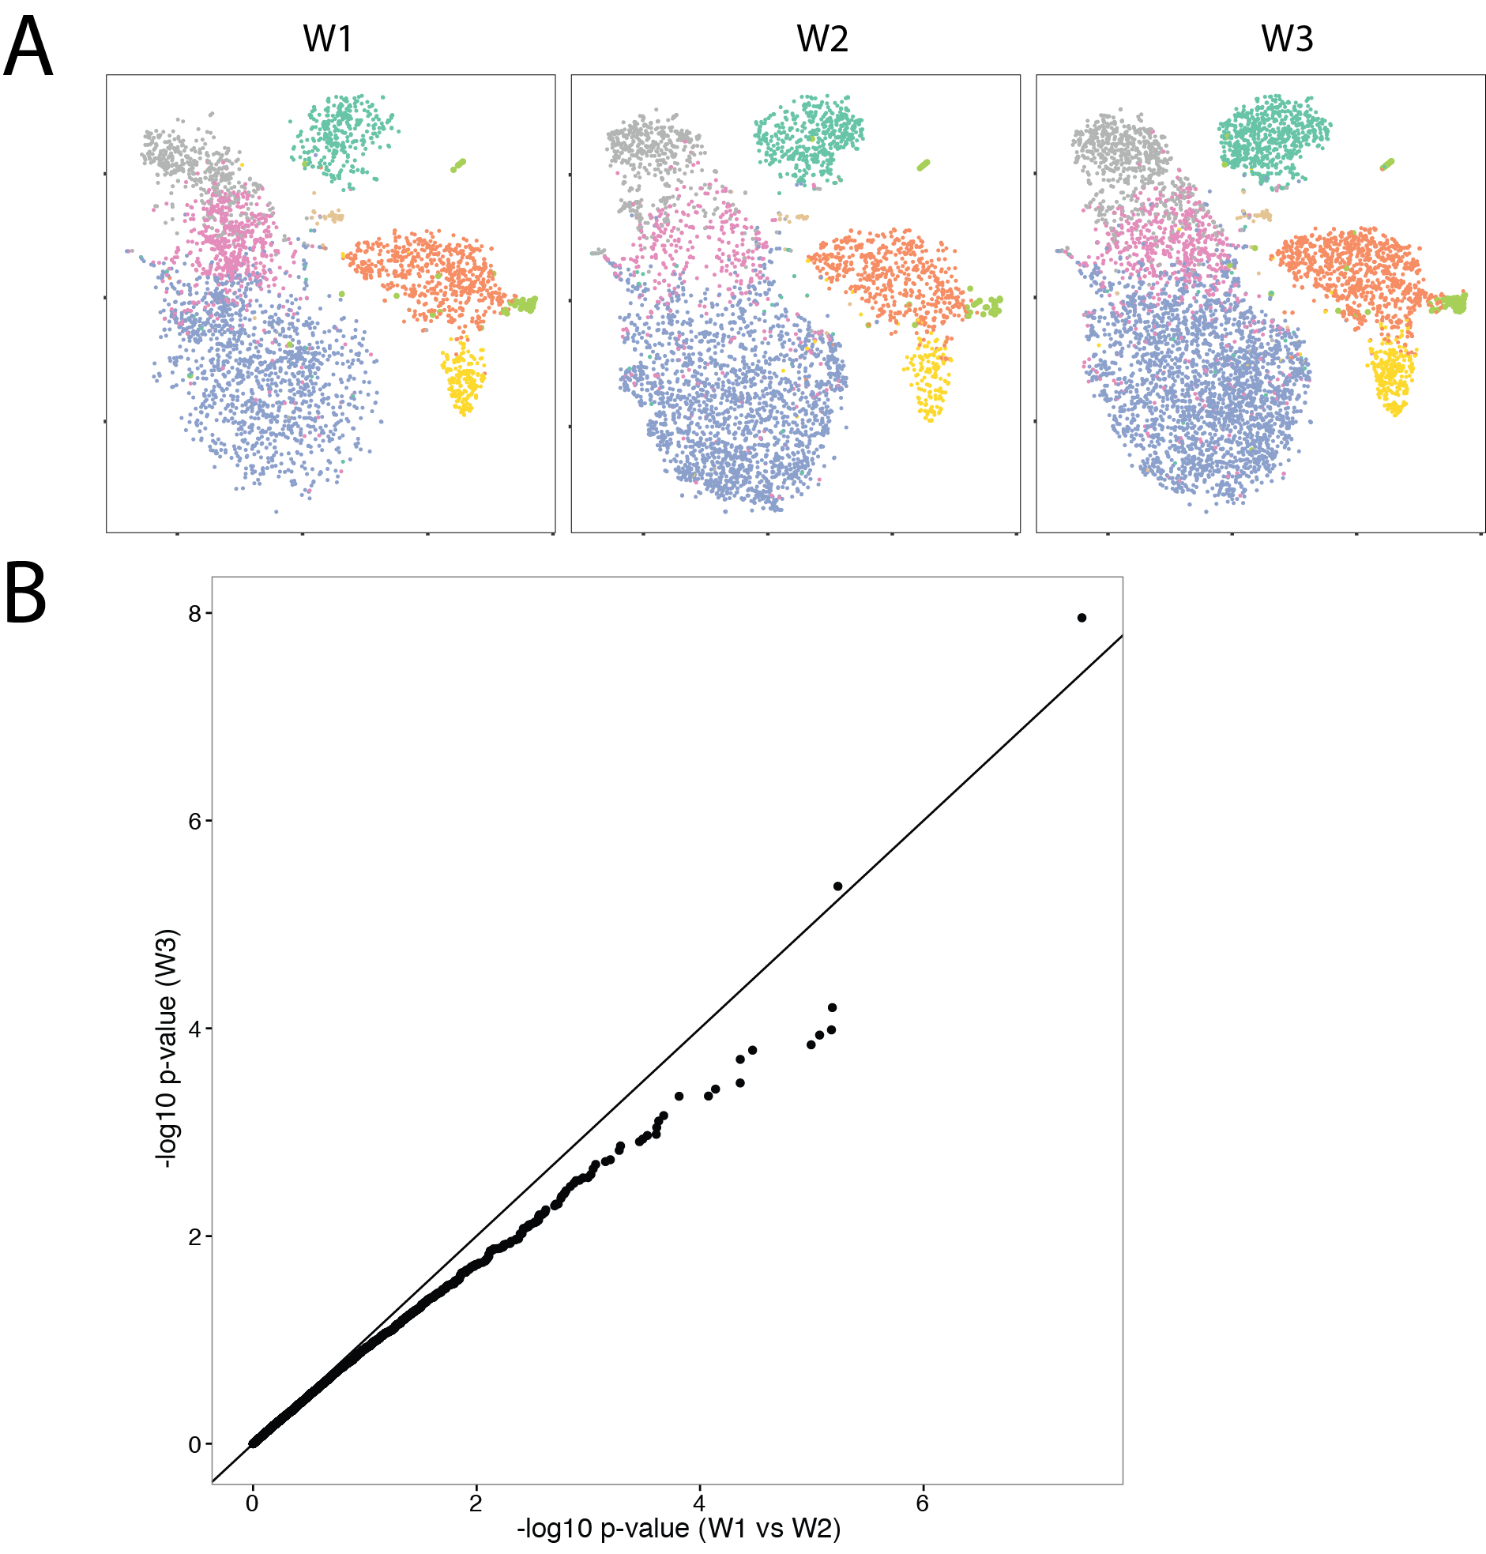

Supplementary Figure 11 – A. TSNE plot for wells W1, W2 and W3 separately. B. QQ plot comparing differential expression analysis between W1 and W2 with W3 for the same individuals.
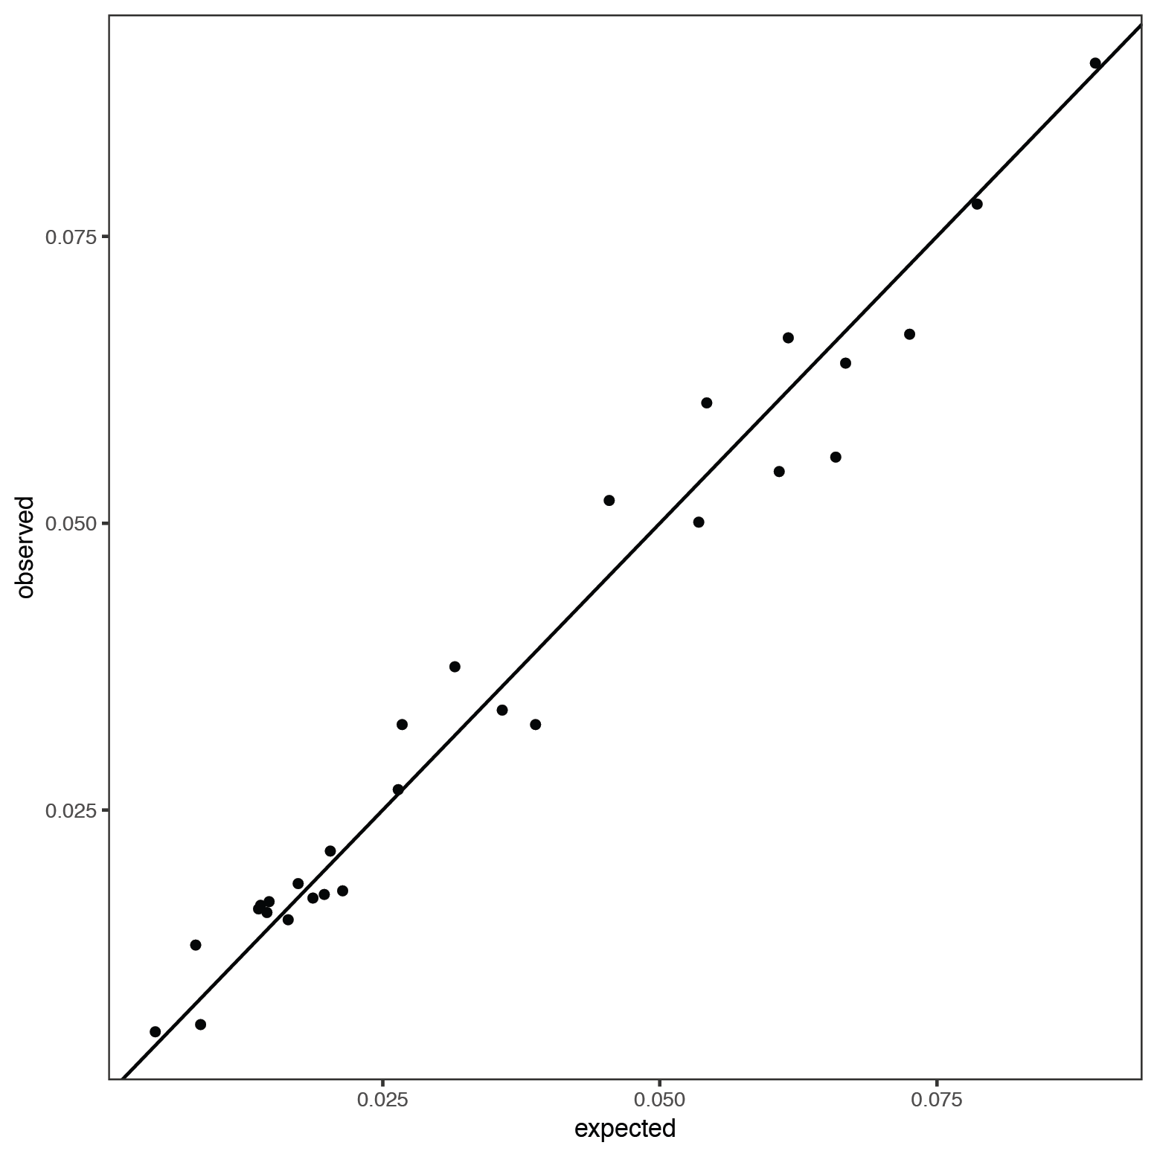
Supplementary Figure 12 – Estimated versus observed doublet rates for unstimulated cells. Expected doublet rates for each pair of individuals (i,j) are calculated as pi * pj, where pi and pj are the proportion of singlets individuals i and j.

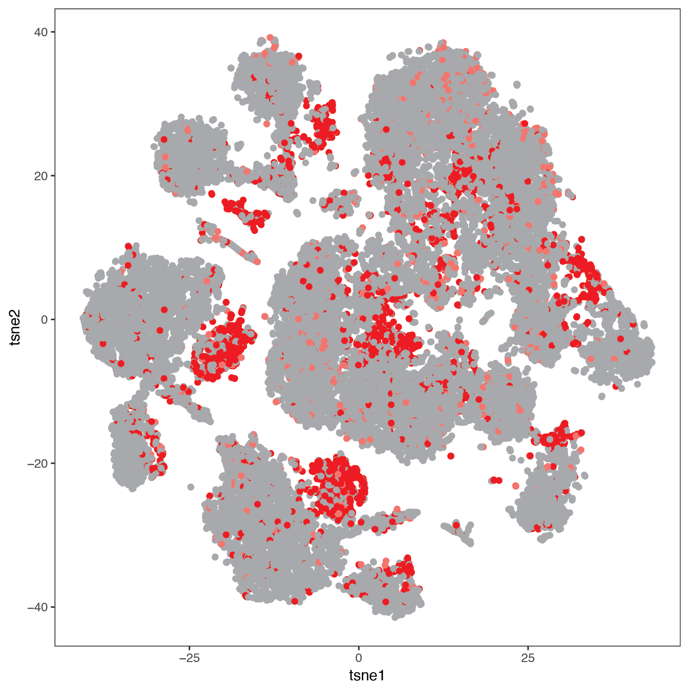
Supplementary Figure 13 – Detected doublets from the IFN-beta stimulation experiment. Red (confidently called doublets). Pink (ambiguous). Gray (singlets).

Supplementary Figure 14 - Estimates of cell type proportion from unstimulated and IFN-beta stimulated PBMCs. Estimates of cell type proportion for unstimulated cells (x-axis) versus stimulated cells (y-axis) for 8 individuals.

Supplementary Figure 15 – Scatter plot of estimates of cell type proportion from dscRNA-seq (x-axis) and FACS sorting (y-axis) for 6 lupus patients after IFN-beta stimulation.

Supplementary Figure 16 – Gene expression correlation between dscRNA-seq data and ImmGen mouse microarray data.
Average abundance is calculated for each cell-type by stimulation. ~2000 homologous genes are used.

Supplementary Figure 17 – Correlation of foldChange before and after IFN-beta stimulation of ~1000 expressed genes between published CD4 microarray (Ye et al., Science) and monocyte derived dendritic cells RNA-seq (Ye et al., unpublished) (y-axis) with dscRNA-seq cell type specific response (x-axis).

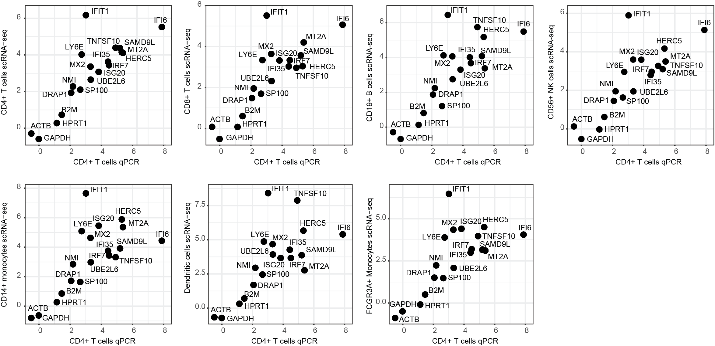

Supplementary Figure 18 – IFN-beta fold change correlation between dscRNA-seq data (y axis) and qPCR data from CD4+ T cells (x axis).

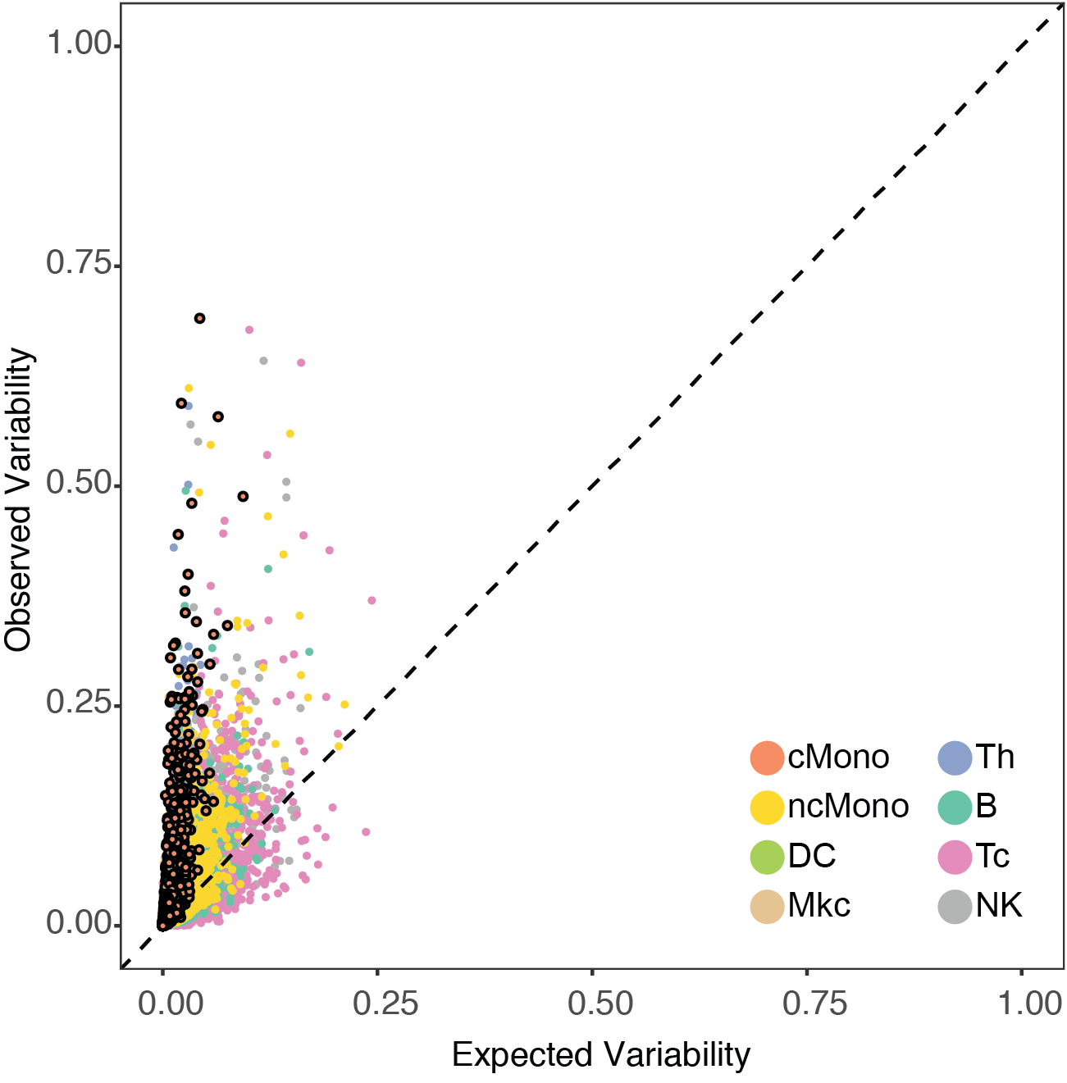
Supplementary Figure 19 – Expected versus observed variability in cell populations. Variance of average expression over single cells across 8 individuals (y) versus variance of average expression over single cells across 8 synthetic replicates matching cell number for each individual (x).

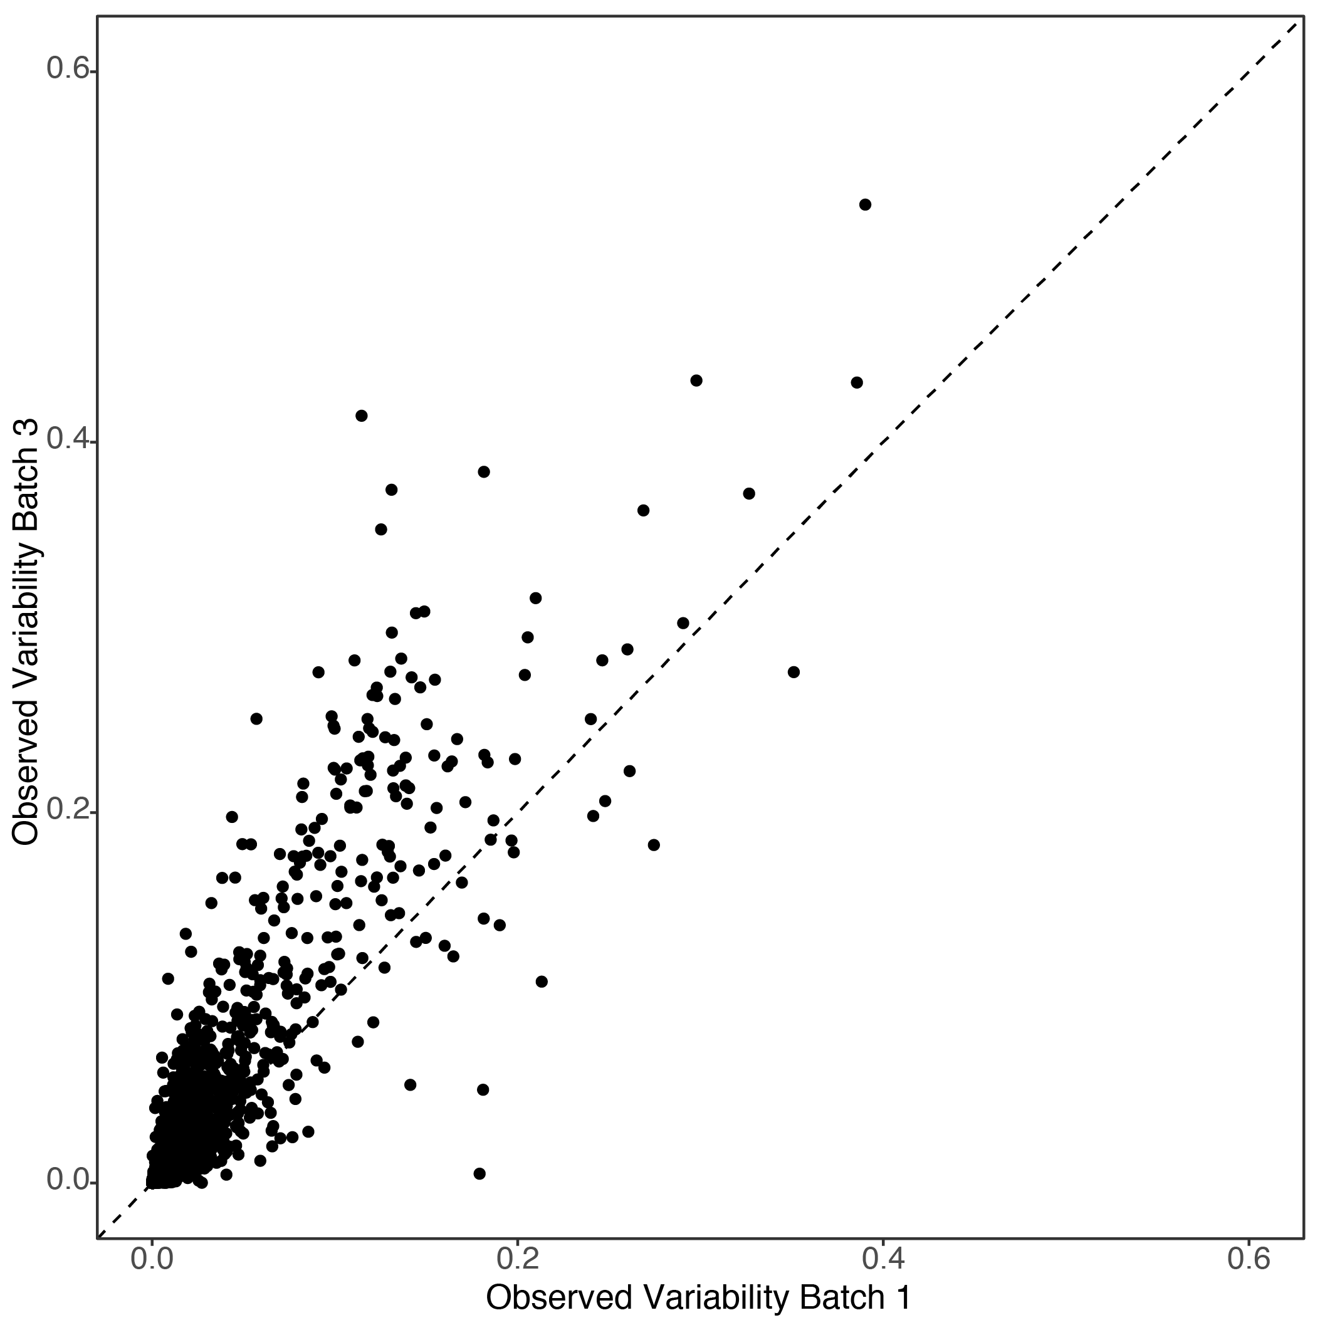
Supplementary Figure 20 – Observed variability in gene expression is correlated between batches.

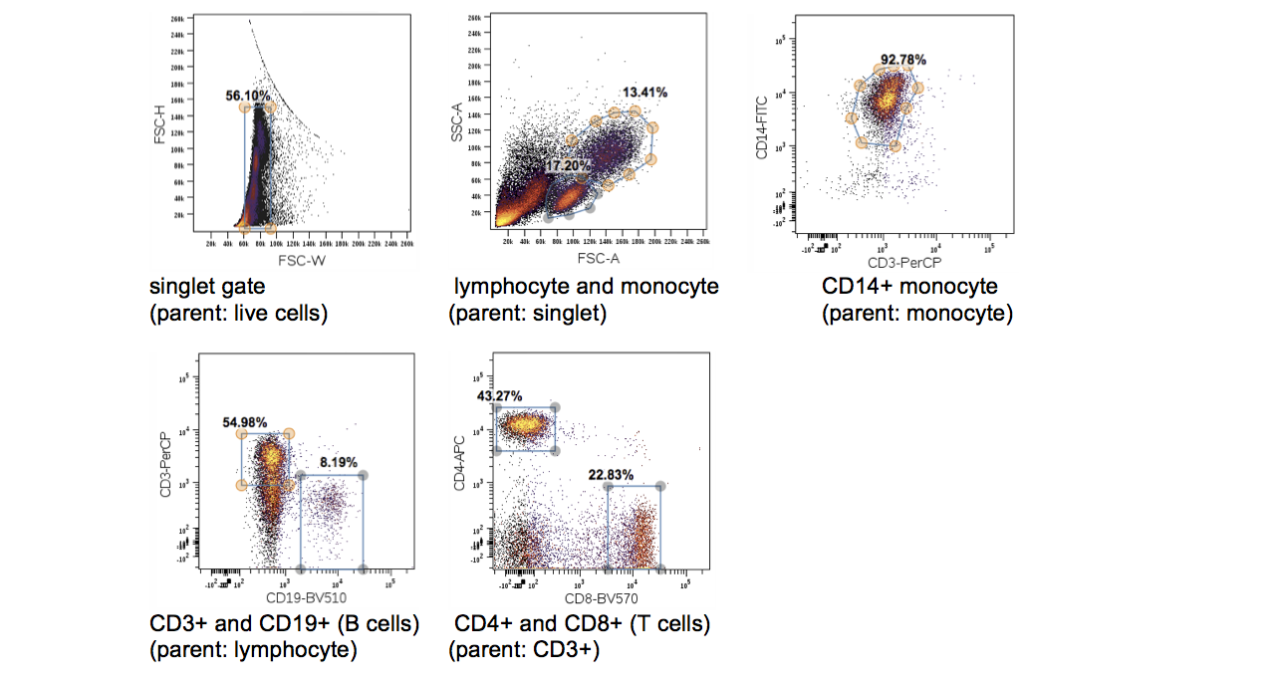
Supplementary Figure 21 – Example of flow cytometry gating strategy for quantifying immune cell populations.

