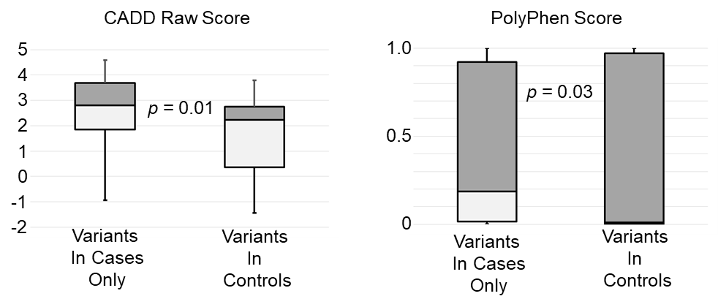Figure S3. From the 5 genes listed in Table III, the functional impact of all protein-altering variants was estimated using 2 predictive algorithms. Left panel: CADD (Combined Annotation Dependent Depletion [Rentzsch et al 2019]); Right panel: PolyPhen2 [Adzhubei et al 2010]. Variants were divided into two groups: those occurring in cases only (left distribution in both panels, N=33), and those seen in controls (or both cases and controls, N=15). Both tools return a score reflecting the likelihood of deleteriousness. CADD scores are un-scaled (raw). Using either algorithm, the distribution of scores was significantly different in the two groups, indicating a greater likelihood of impaired alleles in cases.

