A. BHMT Major Allele Control Homozygote
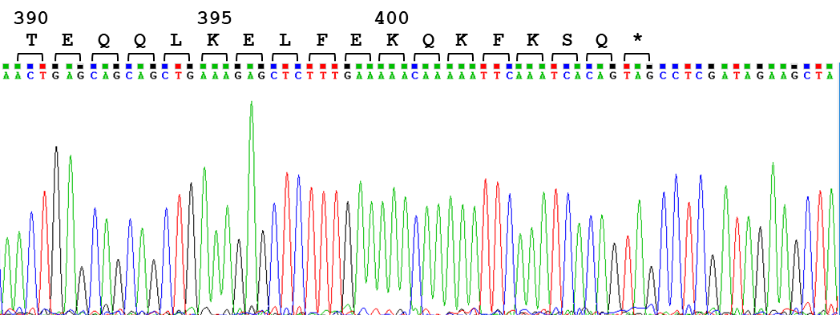

B. BHMT K400fs(delA) heterozygote
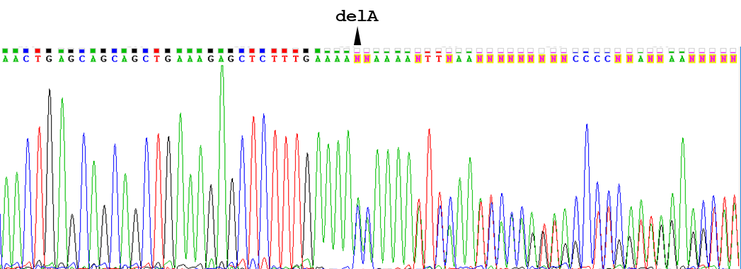

Figure S2. Sanger sequencing traces of the region surrounding the K400fs(delA) mutation. Panel A: a control newborn, homozygous for the BHMT major allele. Amino acid identity and numbering at the C-terminus of BHMT are shown at the top of the panel. Panel B: a case newborn heterozygous for the frameshift allele. Mixed peaks following the deletion in one allele indicate the subsequent offset in DNA sequence characteristic of this mutation.

