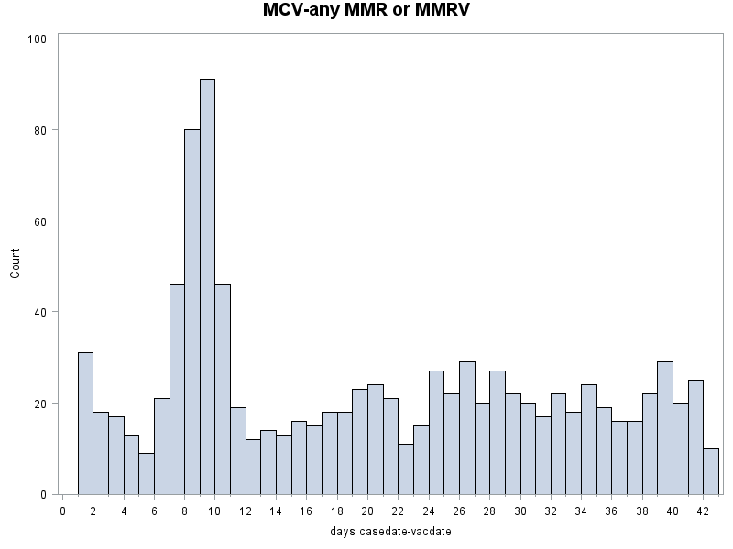

MCV-any MMR or MMRV
Ncases | Scan_width | Scan_window | Observed | Expected | LLR | p_value
996 | 4 days | 7 to 10 days | 263 | 92.651 | 121.221 | 0
996 | 3 days | 7 to 9 days | 217 | 69.488 | 112.015 | 0
996 | 3 days | 8 to 10 days | 217 | 69.488 | 112.015 | 0
996 | 2 days | 8 to 9 days | 171 | 46.326 | 107.214 | 0
996 | 5 days | 6 to 10 days | 284 | 115.814 | 103.761 | 0
996 | 5 days | 7 to 11 days | 282 | 115.814 | 101.553 | 0
996 | 4 days | 6 to 9 days | 238 | 92.651 | 91.564 | 0
996 | 4 days | 8 to 11 days | 236 | 92.651 | 89.337 | 0
996 | 6 days | 6 to 11 days | 303 | 138.977 | 88.949 | 0
996 | 6 days | 7 to 12 days | 294 | 138.977 | 80.215 | 0

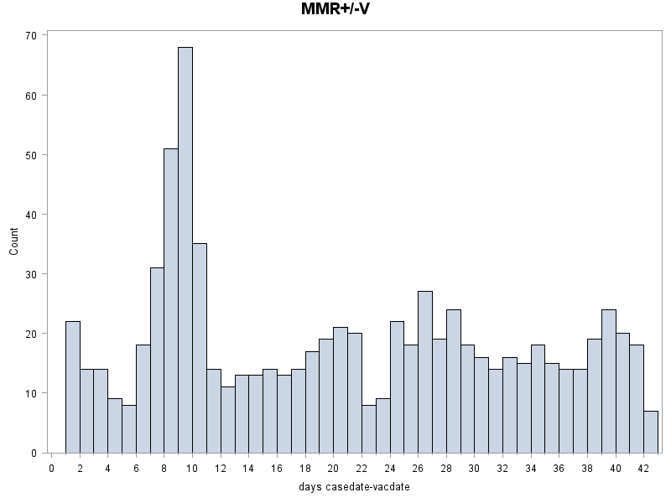

MMR+/-V
Ncases | Scan_width | Scan_window | Observed | Expected | LLR | p_value
794 | 4 days | 7 to 10 days | 185 | 73.860 | 67.7783 | 0
794 | 3 days | 8 to 10 days | 154 | 55.395 | 65.7498 | 0
794 | 2 days | 8 to 9 days | 119 | 36.930 | 61.7897 | 0
794 | 3 days | 7 to 9 days | 150 | 55.395 | 61.1517 | 0
794 | 5 days | 6 to 10 days | 203 | 92.326 | 58.4934 | 0
794 | 5 days | 7 to 11 days | 199 | 92.326 | 54.7084 | 0
794 | 4 days | 6 to 9 days | 168 | 73.860 | 50.3609 | 0
794 | 4 days | 8 to 11 days | 168 | 73.860 | 50.3609 | 0
794 | 6 days | 6 to 11 days | 217 | 110.791 | 48.3899 | 0
794 | 6 days | 5 to 10 days | 211 | 110.791 | 43.4574 | 0

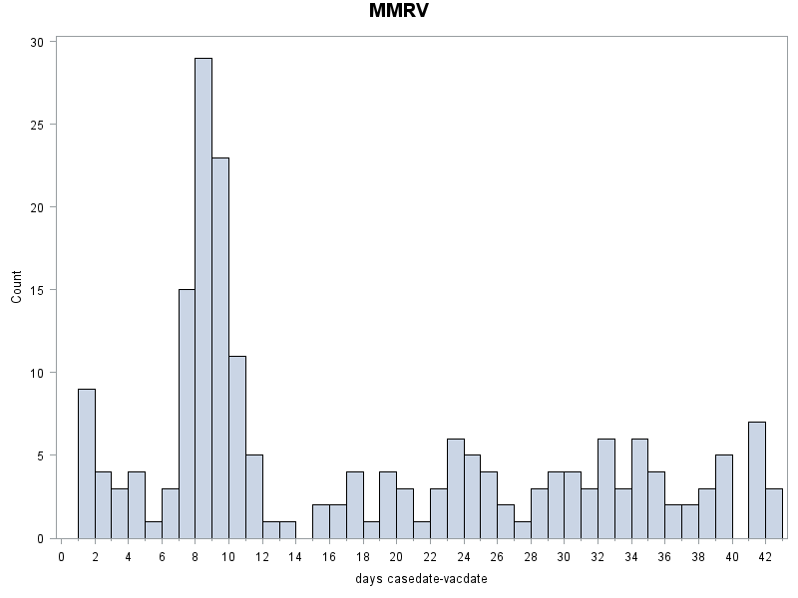

MMRV
Ncases | Scan_width | Scan_window | Observed | Expected | LLR | p_value
202 | 4 days | 7 to 10 days | 78 | 18.7907 | 62.6179 | 0
202 | 3 days | 7 to 9 days | 67 | 14.0930 | 59.8131 | 0
202 | 5 days | 7 to 11 days | 83 | 23.4884 | 56.5157 | 0
202 | 5 days | 6 to 10 days | 81 | 23.4884 | 53.2210 | 0
202 | 3 days | 8 to 10 days | 63 | 14.0930 | 52.4349 | 0
202 | 2 days | 8 to 9 days | 52 | 9.3953 | 51.4729 | 0
202 | 6 days | 6 to 11 days | 86 | 28.1860 | 49.0249 | 0
202 | 4 days | 6 to 9 days | 70 | 18.7907 | 48.7861 | 0
202 | 6 days | 7 to 12 days | 84 | 28.1860 | 46.0256 | 0
202 | 4 days | 8 to 11 days | 68 | 18.7907 | 45.5441 | 0

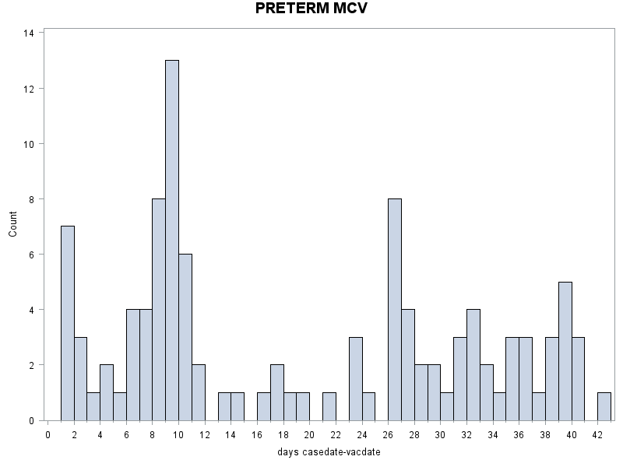

PRETERM MCV
Ncases | Scan_width | Scan_window | Observed | Expected | LLR | p_value
109 | 3 days | 8 to 10 days | 27 | 7.6047 | 16.8018 | .000001889
109 | 4 days | 7 to 10 days | 31 | 10.1395 | 16.1579 | .000003429
109 | 5 days | 6 to 10 days | 35 | 12.6744 | 16.0402 | .000003824
109 | 2 days | 8 to 9 days | 21 | 5.0698 | 15.2041 | .000008294
109 | 3 days | 7 to 9 days | 25 | 7.6047 | 13.9432 | .000026658
109 | 6 days | 6 to 11 days | 37 | 15.2093 | 13.8566 | .000028884
109 | 5 days | 7 to 11 days | 33 | 12.6744 | 13.5664 | .000037791
109 | 4 days | 6 to 9 days | 29 | 10.1395 | 13.5401 | .000038720
109 | 4 days | 8 to 11 days | 29 | 10.1395 | 13.5401 | .000038720
109 | 6 days | 5 to 10 days | 36 | 15.2093 | 12.7238 | .000082462

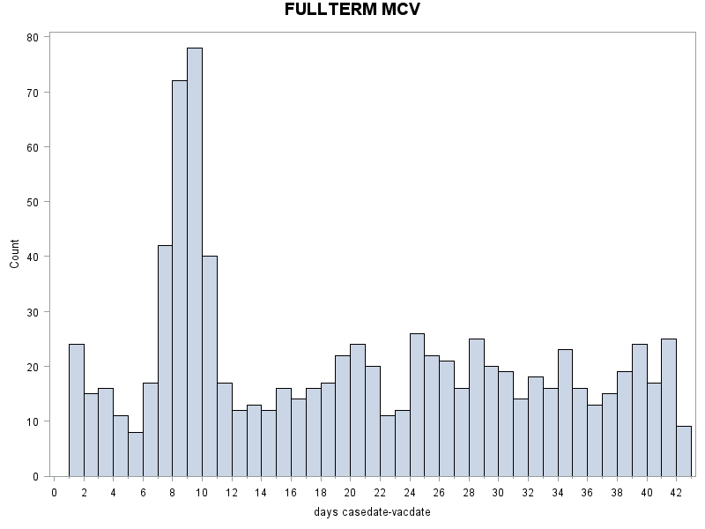

FULLTERM MCV
Ncases | Scan_width | Scan_window | Observed | Expected | LLR | p_value
887 | 4 days | 7 to 10 days | 232 | 82.512 | 105.192 | 0
887 | 3 days | 7 to 9 days | 192 | 61.884 | 98.119 | 0
887 | 3 days | 8 to 10 days | 190 | 61.884 | 95.525 | 0
887 | 2 days | 8 to 9 days | 150 | 41.256 | 92.194 | 0
887 | 5 days | 6 to 10 days | 249 | 103.140 | 88.102 | 0
887 | 5 days | 7 to 11 days | 249 | 103.140 | 88.102 | 0
887 | 4 days | 6 to 9 days | 209 | 82.512 | 78.265 | 0
887 | 4 days | 8 to 11 days | 207 | 82.512 | 76.077 | 0
887 | 6 days | 6 to 11 days | 266 | 123.767 | 75.445 | 0
887 | 6 days | 7 to 12 days | 261 | 123.767 | 70.655 | 0

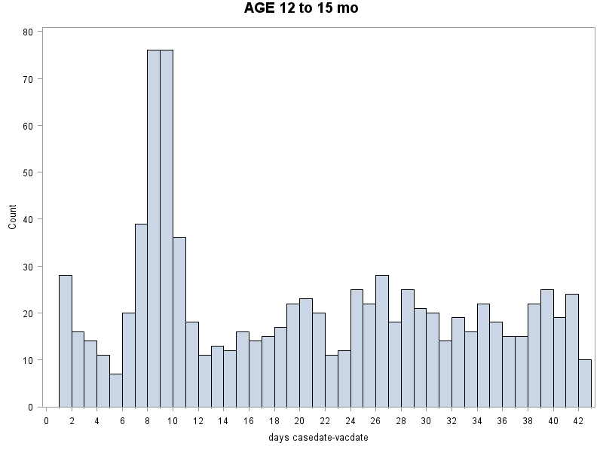

AGE 12 to 15 months
Ncases | Scan_width | Scan_window | Observed | Expected | LLR | p_value
905 | 4 days | 7 to 10 days | 227 | 84.186 | 95.5669 | 0
905 | 3 days | 7 to 9 days | 191 | 63.140 | 93.8048 | 0
905 | 2 days | 8 to 9 days | 152 | 42.093 | 92.5778 | 0
905 | 3 days | 8 to 10 days | 188 | 63.140 | 90.0198 | 0
905 | 5 days | 6 to 10 days | 247 | 105.233 | 82.3579 | 0
905 | 5 days | 7 to 11 days | 245 | 105.233 | 80.2724 | 0
905 | 4 days | 6 to 9 days | 211 | 84.186 | 77.4027 | 0
905 | 4 days | 8 to 11 days | 206 | 84.186 | 72.0471 | 0
905 | 6 days | 6 to 11 days | 265 | 126.279 | 70.8693 | 0
905 | 6 days | 7 to 12 days | 256 | 126.279 | 62.6501 | 0

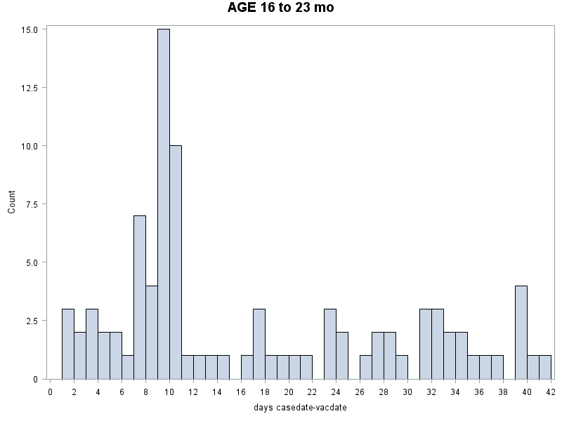

AGE 16 to 23 months
Ncases | Scan_width | Scan_window | Observed | Expected | LLR | p_value
91 | 4 days | 7 to 10 days | 36 | 8.4651 | 29.7885 | 9.2187E-12
91 | 2 days | 9 to 10 days | 25 | 4.2326 | 26.3457 | 2.2984E-10
91 | 5 days | 6 to 10 days | 37 | 10.5814 | 24.8112 | 9.6371E-10
91 | 5 days | 7 to 11 days | 37 | 10.5814 | 24.8112 | 9.6371E-10
91 | 3 days | 8 to 10 days | 29 | 6.3488 | 24.7446 | 1.02559E-9
91 | 6 days | 5 to 10 days | 39 | 12.6977 | 22.4782 | 8.52021E-9
91 | 6 days | 6 to 11 days | 38 | 12.6977 | 20.9692 | 3.48856E-8
91 | 6 days | 7 to 12 days | 38 | 12.6977 | 20.9692 | 3.48856E-8
91 | 7 days | 4 to 10 days | 41 | 14.8140 | 20.6803 | 4.56931E-8
91 | 8 days | 3 to 10 days | 44 | 16.9302 | 20.6455 | 4.7205E-8

