**Supplement Table 1. Within- and Between- Group Variance for Three Exposure Metrics (Mean, Bias-Corrected Mean, Median)**

|  |  |  |  |  |  |  |  |  |  |
| --- | --- | --- | --- | --- | --- | --- | --- | --- | --- |
|  | **JEM Mean** | | | **JEM-Bias-Corrected Mean** | | | **JEM-Median** | | |
| **Exposure Variable** | **Within** | **Between** | **R2** | **Within** | **Between** | **R2** | **Within** | **Between** | **R2** |
| Physical intensity | 6.13 | 492.03 | 0.41 | 7.62 | 1193.55 | 0.57 | 6.73 | 764.15 | 0.49 |
| Stand | 0.55 | 93.03 | 0.57 | 0.70 | 161.44 | 0.64 | 0.67 | 132.78 | 0.60 |
| Repetition | 0.97 | 26.61 | 0.19 | 1.43 | 137.88 | 0.46 | 1.27 | 80.82 | 0.36 |
| Change tasks | 1.11 | 16.18 | 0.11 | 1.71 | 144.20 | 0.42 | 1.31 | 58.41 | 0.28 |
| Rest eyes | 1.00 | 39.83 | 0.22 | 1.40 | 177.84 | 0.48 | 1.29 | 130.31 | 0.42 |
| Kneel or squat | 0.51 | 43.37 | 0.40 | 0.67 | 107.32 | 0.56 | 0.60 | 62.55 | 0.45 |
| Bend trunk | 0.62 | 44.41 | 0.35 | 0.83 | 126.28 | 0.53 | 0.75 | 83.02 | 0.45 |
| Drive machinery | 0.15 | 8.27 | 0.30 | 0.22 | 25.60 | 0.48 | 0.19 | 5.93 | 0.20 |
| Drive car or truck | 0.49 | 36.96 | 0.37 | 0.67 | 96.65 | 0.53 | 0.59 | 53.57 | 0.41 |
| Handle objects 1-4 kg | 1.34 | 109.85 | 0.38 | 1.72 | 283.32 | 0.55 | 1.70 | 213.50 | 0.48 |
| Handle objects >4 kg | 0.91 | 79.93 | 0.42 | 1.15 | 191.49 | 0.57 | 1.11 | 129.05 | 0.49 |
| Carry loads <10 kg | 0.83 | 61.99 | 0.38 | 1.08 | 163.83 | 0.55 | 1.02 | 93.17 | 0.43 |
| Carry loads 10-25 kg | 0.54 | 44.04 | 0.40 | 0.72 | 112.27 | 0.56 | 0.66 | 61.09 | 0.43 |
| Carry loads > 25 kg | 0.41 | 34.45 | 0.41 | 0.54 | 83.24 | 0.56 | 0.50 | 44.38 | 0.42 |
| Use vibrating tools | 0.16 | 8.60 | 0.31 | 0.22 | 27.73 | 0.51 | 0.18 | 8.48 | 0.27 |
| Use computer screen | 0.55 | 98.82 | 0.57 | 0.68 | 171.96 | 0.65 | 0.67 | 161.98 | 0.64 |
| Use keyboard or scanner | 0.61 | 89.89 | 0.54 | 0.77 | 164.81 | 0.63 | 0.73 | 145.56 | 0.62 |
| Bend neck | 1.14 | 15.06 | 0.09 | 1.80 | 168.31 | 0.40 | 1.27 | 50.23 | 0.22 |
| Arms above shoulder | 0.41 | 18.97 | 0.24 | 0.58 | 71.53 | 0.46 | 0.54 | 32.38 | 0.30 |
| Reach behind | 0.30 | 2.35 | 0.06 | 0.51 | 39.59 | 0.38 | 0.38 | 9.94 | 0.17 |
| Arms abducted | 0.49 | 20.01 | 0.22 | 0.72 | 91.07 | 0.47 | 0.61 | 28.77 | 0.25 |
| Bend elbow | 0.55 | 24.77 | 0.23 | 0.79 | 104.18 | 0.47 | 0.67 | 37.21 | 0.27 |
| Rotate forearm | 0.26 | 18.51 | 0.33 | 0.35 | 52.80 | 0.52 | 0.31 | 20.95 | 0.32 |
| Bend wrist | 0.50 | 19.16 | 0.21 | 0.72 | 89.55 | 0.47 | 0.60 | 29.63 | 0.26 |
| Press base of hand | 0.19 | 7.90 | 0.23 | 0.26 | 34.34 | 0.48 | 0.21 | 7.22 | 0.19 |
| Finger pinch | 0.69 | 14.50 | 0.13 | 1.08 | 112.92 | 0.42 | 0.87 | 36.91 | 0.23 |
| Work outdoors | 0.39 | 35.68 | 0.38 | 0.53 | 94.92 | 0.54 | 0.49 | 54.61 | 0.42 |

**Supplement Table 2. Comparison Between Individual-Level Reports and JEM-Assigned Exposure Values Using Three Exposure Metrics.**

|  |  |  |  |  |  |  |  |  |  |  |
| --- | --- | --- | --- | --- | --- | --- | --- | --- | --- | --- |
|  | **N** | **JEM Mean** | | | **JEM-Bias-Corrected Mean** | | | **JEM-Median** | | |
| **Exposure Variable** | **MeanDiff1** | **Absolute2** | **Variance3** | **MeanDiff1** | **Absolute2** | **Variance3** | **MeanDiff1** | **Absolute2** | **Variance3** |
| Physical intensity | 26821 | 0.002 | 1.979 | 6.060 | -0.004 | 2.022 | 0.097 | 0.234 | 1.868 | 3.802 |
| Stand | 29597 | -0.001 | 0.591 | 0.547 | -0.008 | 0.547 | 0.020 | -0.160 | 0.519 | 0.266 |
| Repetition | 26424 | -0.002 | 0.791 | 0.961 | 0.007 | 0.722 | 0.001 | 0.398 | 0.643 | 0.652 |
| Change tasks | 26581 | 0.001 | 0.886 | 1.098 | 0.004 | 0.922 | 0.000 | -0.199 | 0.847 | 0.776 |
| Rest eyes | 31848 | 0.000 | 0.823 | 0.990 | 0.003 | 0.756 | 0.002 | -0.273 | 0.722 | 0.417 |
| Kneel or squat | 29574 | 0.000 | 0.492 | 0.503 | -0.001 | 0.447 | 0.009 | 0.180 | 0.405 | 0.387 |
| Bend trunk | 30853 | -0.001 | 0.574 | 0.610 | -0.001 | 0.511 | 0.005 | 0.178 | 0.470 | 0.357 |
| Drive machinery | 29385 | 0.000 | 0.134 | 0.151 | 0.005 | 0.112 | 0.017 | 0.081 | 0.091 | 0.176 |
| Drive car or truck | 29357 | 0.003 | 0.435 | 0.483 | 0.007 | 0.372 | 0.019 | 0.210 | 0.321 | 0.398 |
| Handle objects 1-4 kg | 31116 | 0.001 | 0.878 | 1.324 | -0.050 | 0.770 | 0.055 | 0.355 | 0.701 | 0.690 |
| Handle objects >4 kg | 28306 | 0.001 | 0.678 | 0.893 | -0.004 | 0.604 | -0.006 | 0.267 | 0.554 | 0.569 |
| Carry loads <10 kg | 28240 | 0.000 | 0.643 | 0.816 | -0.010 | 0.587 | -0.006 | 0.313 | 0.520 | 0.663 |
| Carry loads 10-25 kg | 28297 | 0.001 | 0.510 | 0.536 | -0.012 | 0.469 | -0.013 | 0.242 | 0.412 | 0.457 |
| Carry loads > 25 kg | 28271 | 0.000 | 0.442 | 0.404 | -0.007 | 0.395 | 0.011 | 0.215 | 0.349 | 0.370 |
| Use vibrating tools | 28437 | 0.001 | 0.143 | 0.154 | 0.000 | 0.123 | 0.001 | 0.070 | 0.098 | 0.160 |
| Use computer screen | 31017 | 0.000 | 0.503 | 0.538 | -0.008 | 0.422 | 0.001 | -0.038 | 0.416 | 0.075 |
| Use keyboard or scanner | 28437 | 0.000 | 0.536 | 0.597 | 0.002 | 0.463 | -0.003 | -0.095 | 0.439 | 0.160 |
| Bend neck | 32048 | 0.000 | 0.924 | 1.129 | 0.003 | 1.002 | 0.039 | -0.089 | 0.882 | 0.887 |
| Arms above shoulder | 32712 | 0.000 | 0.440 | 0.407 | 0.005 | 0.411 | 0.041 | 0.240 | 0.353 | 0.371 |
| Reach behind | 29482 | 0.000 | 0.395 | 0.301 | -0.003 | 0.374 | 0.013 | 0.251 | 0.264 | 0.305 |
| Arms abducted | 32634 | 0.000 | 0.464 | 0.487 | -0.006 | 0.422 | -0.010 | 0.248 | 0.357 | 0.487 |
| Bend elbow | 33722 | 0.000 | 0.491 | 0.547 | 0.004 | 0.439 | 0.010 | 0.247 | 0.375 | 0.524 |
| Rotate forearm | 32647 | 0.001 | 0.259 | 0.258 | 0.005 | 0.222 | 0.018 | 0.137 | 0.182 | 0.259 |
| Bend wrist | 32599 | 0.000 | 0.444 | 0.492 | 0.002 | 0.395 | -0.001 | 0.229 | 0.326 | 0.471 |
| Press base of hand | 33127 | 0.000 | 0.187 | 0.184 | 0.006 | 0.156 | 0.003 | 0.099 | 0.123 | 0.199 |
| Finger pinch | 33128 | 0.000 | 0.588 | 0.681 | -0.007 | 0.549 | 0.004 | 0.354 | 0.422 | 0.652 |
| Work outdoors | 35187 | 0.001 | 0.393 | 0.384 | -0.003 | 0.345 | 0.000 | 0.162 | 0.297 | 0.287 |

1Mean differences between mean individual and JEM exposure estimates. 2Differences of average absolute values between individual and JEM estimates. 3Differences in variance between individual and JEM exposure estimates

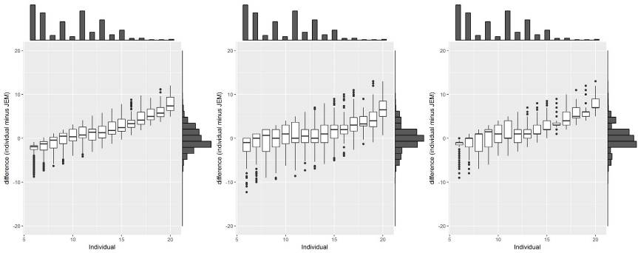

C

B

A

Supplement, Figure 1. Box-plots of the differences between individual-level reports and group-level exposure estimates (individual – JEM) at each exposure intensity level for three exposure metrics: (A) JEM Mean, (B) JEM Bias Corrected Mean, and (C) JEM Median. Distributions of individual (top axis) and JEM (right axis) are plotted. Bias-corrected mean determined using empirical quantile mapping methods (EQM). Exposure Variable: **Physical Intensity**

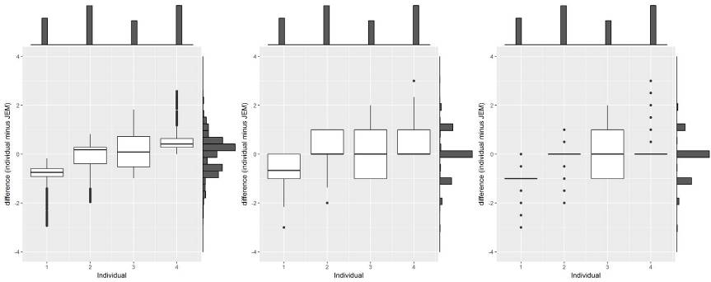

C

B

A

Supplement, Figure 2. Box-plots of the differences between individual-level reports and group-level exposure estimates (individual – JEM) at each exposure intensity level for three exposure metrics: (A) JEM Mean, (B) JEM Bias Corrected Mean, and (C) JEM Median. Distributions of individual (top axis) and JEM (right axis) are plotted. Bias-corrected mean determined using empirical quantile mapping methods (EQM). Exposure Variable: **Stand**

C:\Users\marcus.yung\AppData\Local\Microsoft\Windows\INetCache\Content.Word\residual boxplots side by sideAQ_EXPOACT_TrRepet.tif

A

B

C

Supplement, Figure 3. Box-plots of the differences between individual-level reports and group-level exposure estimates (individual – JEM) at each exposure intensity level for three exposure metrics: (A) JEM Mean, (B) JEM Bias Corrected Mean, and (C) JEM Median. Distributions of individual (top axis) and JEM (right axis) are plotted. Bias-corrected mean determined using empirical quantile mapping methods (EQM). Exposure Variable: **Repetition**

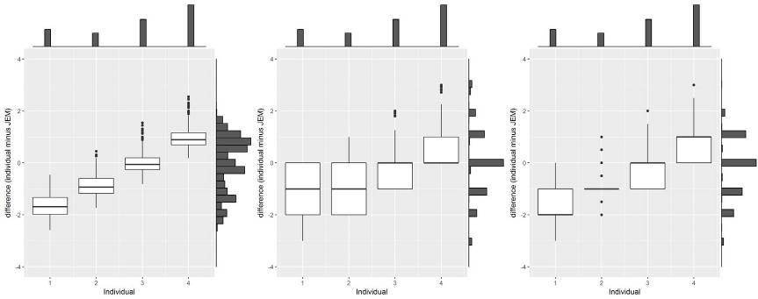

A

B

C

Supplement, Figure 4. Box-plots of the differences between individual-level reports and group-level exposure estimates (individual – JEM) at each exposure intensity level for three exposure metrics: (A) JEM Mean, (B) JEM Bias Corrected Mean, and (C) JEM Median. Distributions of individual (top axis) and JEM (right axis) are plotted. Bias-corrected mean determined using empirical quantile mapping methods (EQM). Exposure Variable: **Change Tasks**

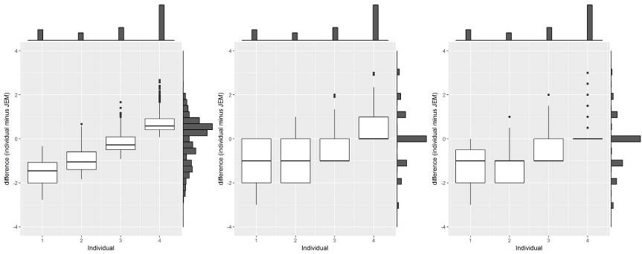

A

B

C

Supplement, Figure 5. Box-plots of the differences between individual-level reports and group-level exposure estimates (individual – JEM) at each exposure intensity level for three exposure metrics: (A) JEM Mean, (B) JEM Bias Corrected Mean, and (C) JEM Median. Distributions of individual (top axis) and JEM (right axis) are plotted. Bias-corrected mean determined using empirical quantile mapping methods (EQM). Exposure Variable: **Rest Eyes**

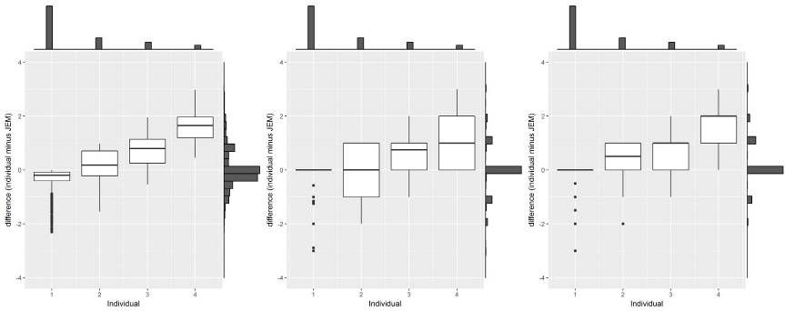

A

B

C

Supplement, Figure 6. Box-plots of the differences between individual-level reports and group-level exposure estimates (individual – JEM) at each exposure intensity level for three exposure metrics: (A) JEM Mean, (B) JEM Bias Corrected Mean, and (C) JEM Median. Distributions of individual (top axis) and JEM (right axis) are plotted. Bias-corrected mean determined using empirical quantile mapping methods (EQM). Exposure Variable: **Kneel or Squat**

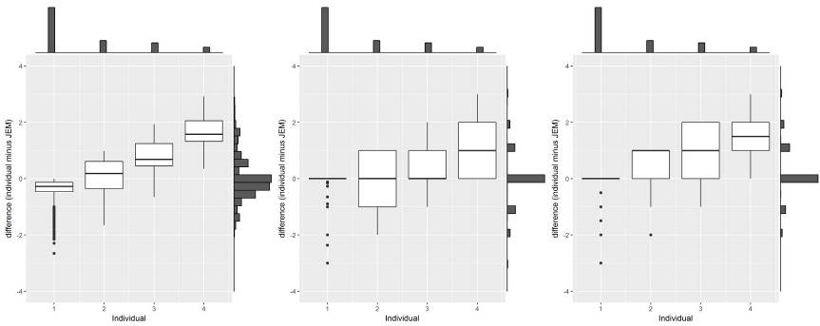

A

B

C

Supplement, Figure 7. Box-plots of the differences between individual-level reports and group-level exposure estimates (individual – JEM) at each exposure intensity level for three exposure metrics: (A) JEM Mean, (B) JEM Bias Corrected Mean, and (C) JEM Median. Distributions of individual (top axis) and JEM (right axis) are plotted. Bias-corrected mean determined using empirical quantile mapping methods (EQM). Exposure Variable: **Bend Trunk**

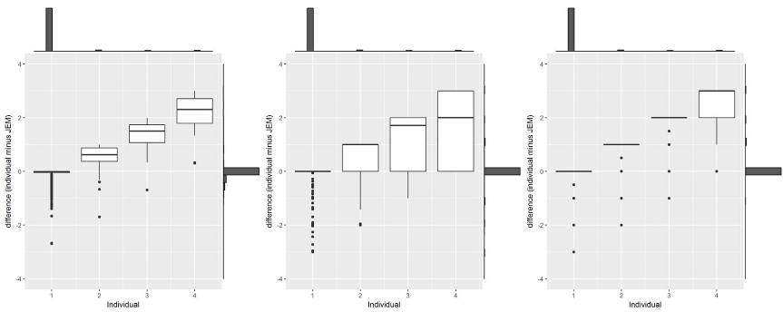

A

B

C

Supplement, Figure 8. Box-plots of the differences between individual-level reports and group-level exposure estimates (individual – JEM) at each exposure intensity level for three exposure metrics: (A) JEM Mean, (B) JEM Bias Corrected Mean, and (C) JEM Median. Distributions of individual (top axis) and JEM (right axis) are plotted. Bias-corrected mean determined using empirical quantile mapping methods (EQM). Exposure Variable: **Drive Machinery**

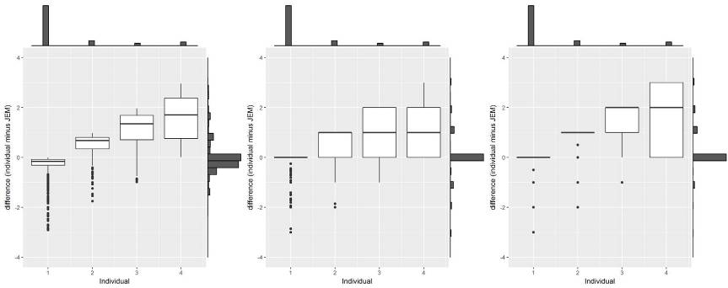

A

B

C

Supplement, Figure 9. Box-plots of the differences between individual-level reports and group-level exposure estimates (individual – JEM) at each exposure intensity level for three exposure metrics: (A) JEM Mean, (B) JEM Bias Corrected Mean, and (C) JEM Median. Distributions of individual (top axis) and JEM (right axis) are plotted. Bias-corrected mean determined using empirical quantile mapping methods (EQM). Exposure Variable: **Drive Car or Truck**

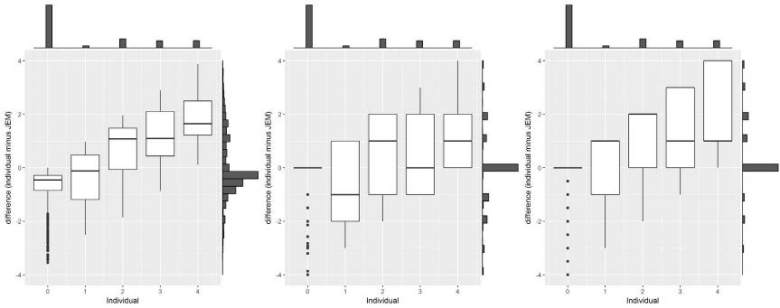

A

B

C

Supplement, Figure 10. Box-plots of the differences between individual-level reports and group-level exposure estimates (individual – JEM) at each exposure intensity level for three exposure metrics: (A) JEM Mean, (B) JEM Bias Corrected Mean, and (C) JEM Median. Distributions of individual (top axis) and JEM (right axis) are plotted. Bias-corrected mean determined using empirical quantile mapping methods (EQM). Exposure Variable: **Handle Objects 1-4 kg**

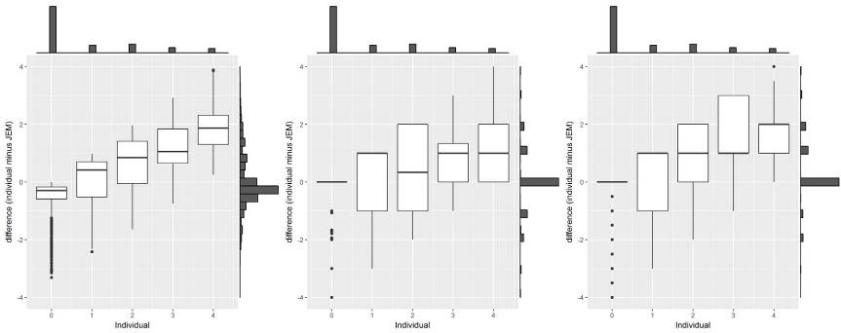

A

B

C

Supplement, Figure 11. Box-plots of the differences between individual-level reports and group-level exposure estimates (individual – JEM) at each exposure intensity level for three exposure metrics: (A) JEM Mean, (B) JEM Bias Corrected Mean, and (C) JEM Median. Distributions of individual (top axis) and JEM (right axis) are plotted. Bias-corrected mean determined using empirical quantile mapping methods (EQM). Exposure Variable: **Handle Objects > 4 kg**

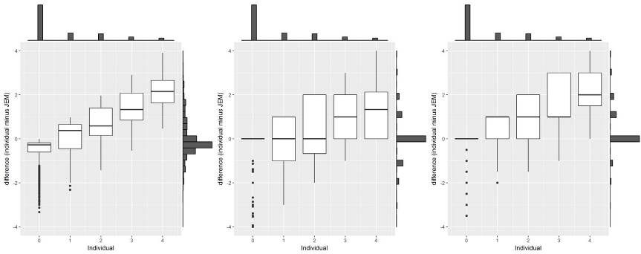

A

B

C

Supplement, Figure 12. Box-plots of the differences between individual-level reports and group-level exposure estimates (individual – JEM) at each exposure intensity level for three exposure metrics: (A) JEM Mean, (B) JEM Bias Corrected Mean, and (C) JEM Median. Distributions of individual (top axis) and JEM (right axis) are plotted. Bias-corrected mean determined using empirical quantile mapping methods (EQM). Exposure Variable: **Carry Loads < 10 kg**

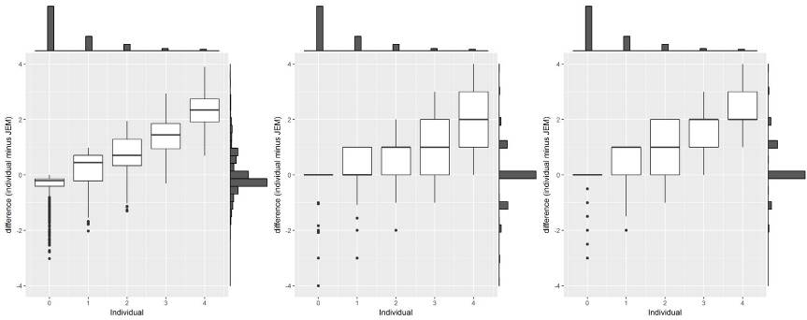

A

B

C

Supplement, Figure 13. Box-plots of the differences between individual-level reports and group-level exposure estimates (individual – JEM) at each exposure intensity level for three exposure metrics: (A) JEM Mean, (B) JEM Bias Corrected Mean, and (C) JEM Median. Distributions of individual (top axis) and JEM (right axis) are plotted. Bias-corrected mean determined using empirical quantile mapping methods (EQM). Exposure Variable: **Carry Loads 10 – 25 kg**

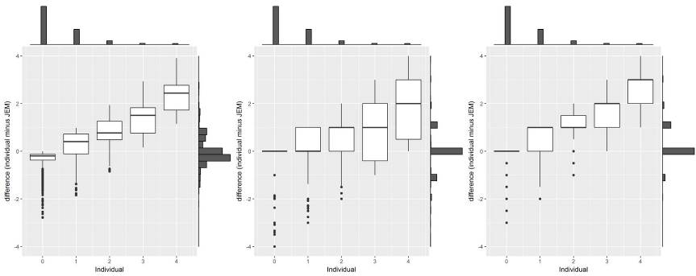

A

B

C

Supplement, Figure 14. Box-plots of the differences between individual-level reports and group-level exposure estimates (individual – JEM) at each exposure intensity level for three exposure metrics: (A) JEM Mean, (B) JEM Bias Corrected Mean, and (C) JEM Median. Distributions of individual (top axis) and JEM (right axis) are plotted. Bias-corrected mean determined using empirical quantile mapping methods (EQM). Exposure Variable: **Carry Loads > 25 kg**

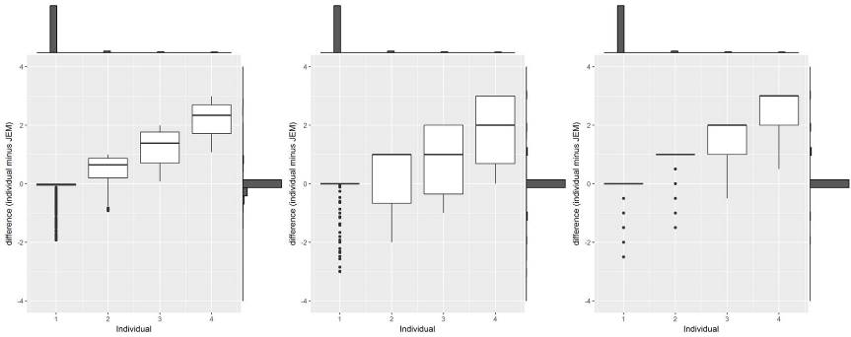

A

B

C

Supplement, Figure 15. Box-plots of the differences between individual-level reports and group-level exposure estimates (individual – JEM) at each exposure intensity level for three exposure metrics: (A) JEM Mean, (B) JEM Bias Corrected Mean, and (C) JEM Median. Distributions of individual (top axis) and JEM (right axis) are plotted. Bias-corrected mean determined using empirical quantile mapping methods (EQM). Exposure Variable: **Use Vibrating Tools**

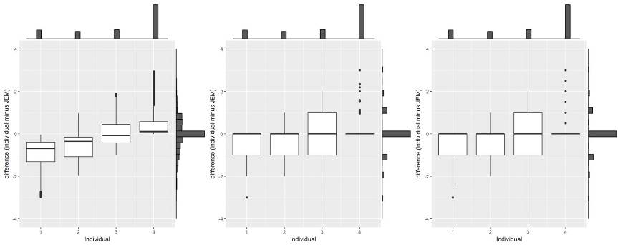

A

B

C

Supplement, Figure 16. Box-plots of the differences between individual-level reports and group-level exposure estimates (individual – JEM) at each exposure intensity level for three exposure metrics: (A) JEM Mean, (B) JEM Bias Corrected Mean, and (C) JEM Median. Distributions of individual (top axis) and JEM (right axis) are plotted. Bias-corrected mean determined using empirical quantile mapping methods (EQM). Exposure Variable: **Use Computer Screen**

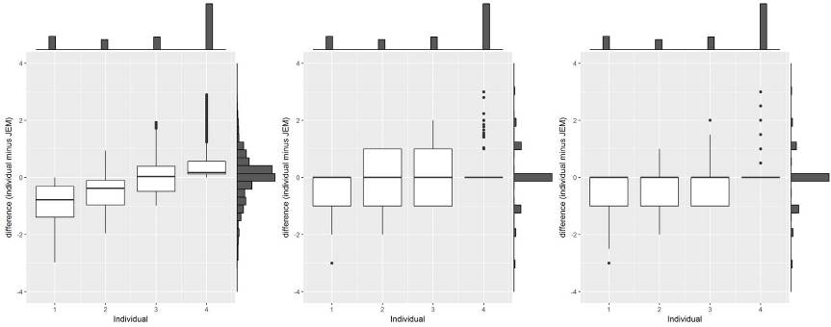

A

B

C

Supplement, Figure 17. Box-plots of the differences between individual-level reports and group-level exposure estimates (individual – JEM) at each exposure intensity level for three exposure metrics: (A) JEM Mean, (B) JEM Bias Corrected Mean, and (C) JEM Median. Distributions of individual (top axis) and JEM (right axis) are plotted. Bias-corrected mean determined using empirical quantile mapping methods (EQM). Exposure Variable: **Use Keyboard or Scanner**

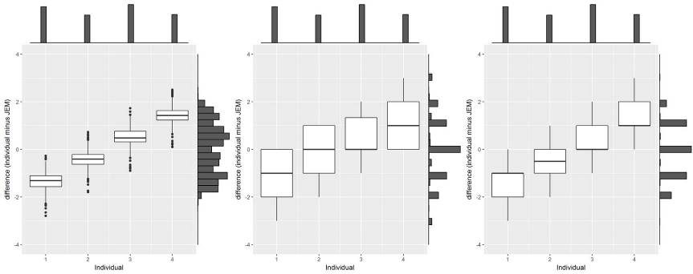

A

B

C

Supplement, Figure 18. Box-plots of the differences between individual-level reports and group-level exposure estimates (individual – JEM) at each exposure intensity level for three exposure metrics: (A) JEM Mean, (B) JEM Bias Corrected Mean, and (C) JEM Median. Distributions of individual (top axis) and JEM (right axis) are plotted. Bias-corrected mean determined using empirical quantile mapping methods (EQM). Exposure Variable: **Bend Neck**

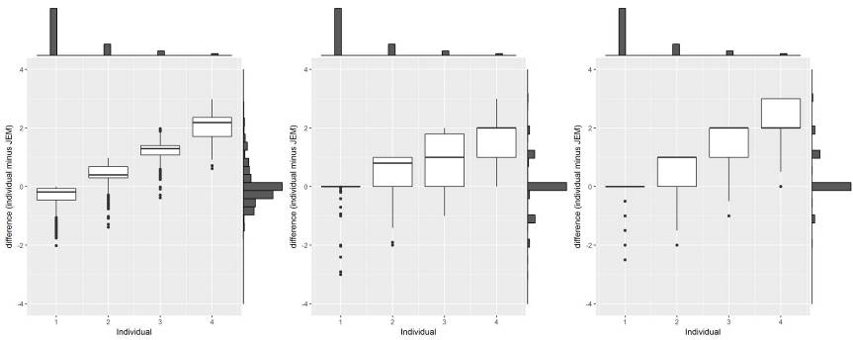

A

B

C

Supplement, Figure 19. Box-plots of the differences between individual-level reports and group-level exposure estimates (individual – JEM) at each exposure intensity level for three exposure metrics: (A) JEM Mean, (B) JEM Bias Corrected Mean, and (C) JEM Median. Distributions of individual (top axis) and JEM (right axis) are plotted. Bias-corrected mean determined using empirical quantile mapping methods (EQM). Exposure Variable: **Arms Above Shoulder**

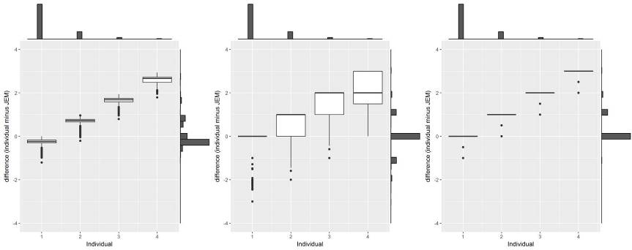

A

B

C

Supplement, Figure 20. Box-plots of the differences between individual-level reports and group-level exposure estimates (individual – JEM) at each exposure intensity level for three exposure metrics: (A) JEM Mean, (B) JEM Bias Corrected Mean, and (C) JEM Median. Distributions of individual (top axis) and JEM (right axis) are plotted. Bias-corrected mean determined using empirical quantile mapping methods (EQM). Exposure Variable: **Reach Behind**

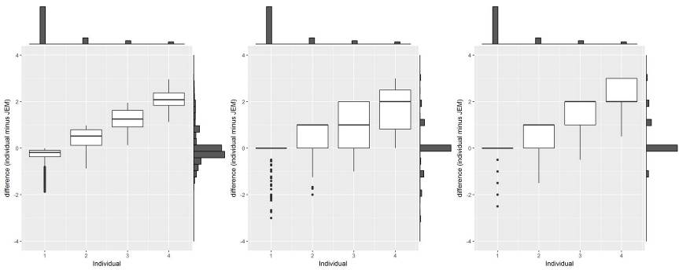

A

B

C

Supplement, Figure 21. Box-plots of the differences between individual-level reports and group-level exposure estimates (individual – JEM) at each exposure intensity level for three exposure metrics: (A) JEM Mean, (B) JEM Bias Corrected Mean, and (C) JEM Median. Distributions of individual (top axis) and JEM (right axis) are plotted. Bias-corrected mean determined using empirical quantile mapping methods (EQM). Exposure Variable: **Arms Abducted**

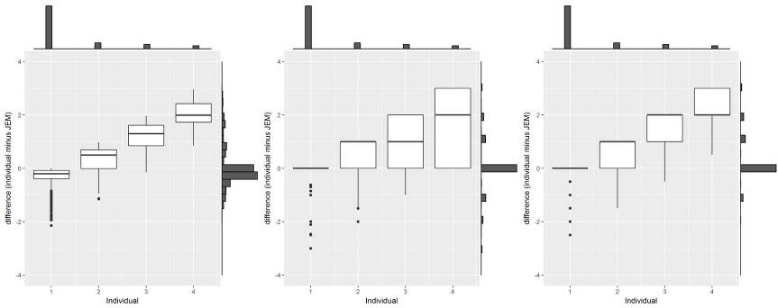

A

B

C

Supplement, Figure 22. Box-plots of the differences between individual-level reports and group-level exposure estimates (individual – JEM) at each exposure intensity level for three exposure metrics: (A) JEM Mean, (B) JEM Bias Corrected Mean, and (C) JEM Median. Distributions of individual (top axis) and JEM (right axis) are plotted. Bias-corrected mean determined using empirical quantile mapping methods (EQM). Exposure Variable: **Bend Elbow**

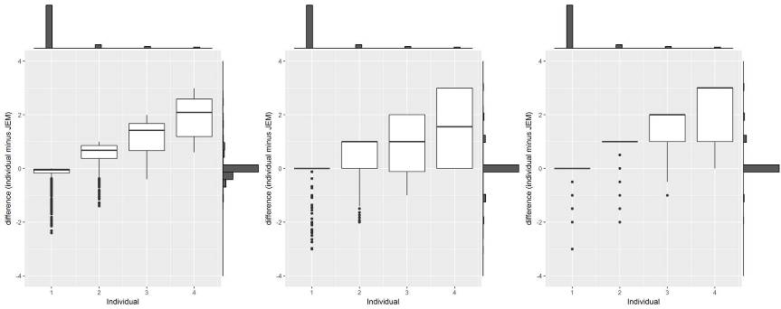

A

B

C

Supplement, Figure 23. Box-plots of the differences between individual-level reports and group-level exposure estimates (individual – JEM) at each exposure intensity level for three exposure metrics: (A) JEM Mean, (B) JEM Bias Corrected Mean, and (C) JEM Median. Distributions of individual (top axis) and JEM (right axis) are plotted. Bias-corrected mean determined using empirical quantile mapping methods (EQM). Exposure Variable: **Rotate Forearm**

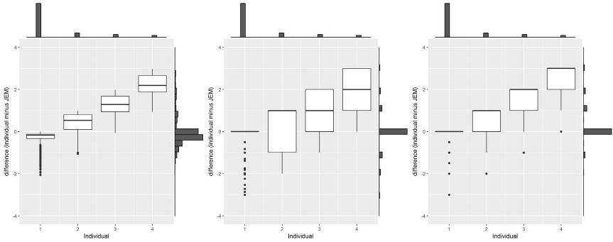

A

B

C

Supplement, Figure 24. Box-plots of the differences between individual-level reports and group-level exposure estimates (individual – JEM) at each exposure intensity level for three exposure metrics: (A) JEM Mean, (B) JEM Bias Corrected Mean, and (C) JEM Median. Distributions of individual (top axis) and JEM (right axis) are plotted. Bias-corrected mean determined using empirical quantile mapping methods (EQM). Exposure Variable: **Bend Wrist**



A

B

C

Supplement, Figure 25. Box-plots of the differences between individual-level reports and group-level exposure estimates (individual – JEM) at each exposure intensity level for three exposure metrics: (A) JEM Mean, (B) JEM Bias Corrected Mean, and (C) JEM Median. Distributions of individual (top axis) and JEM (right axis) are plotted. Bias-corrected mean determined using empirical quantile mapping methods (EQM). Exposure Variable: **Press Base or Hand**



A

B

C

Supplement, Figure 26. Box-plots of the differences between individual-level reports and group-level exposure estimates (individual – JEM) at each exposure intensity level for three exposure metrics: (A) JEM Mean, (B) JEM Bias Corrected Mean, and (C) JEM Median. Distributions of individual (top axis) and JEM (right axis) are plotted. Bias-corrected mean determined using empirical quantile mapping methods (EQM). Exposure Variable: **Finger Pinch**



A

B

C

Supplement, Figure 27. Box-plots of the differences between individual-level reports and group-level exposure estimates (individual – JEM) at each exposure intensity level for three exposure metrics: (A) JEM Mean, (B) JEM Bias Corrected Mean, and (C) JEM Median. Distributions of individual (top axis) and JEM (right axis) are plotted. Bias-corrected mean determined using empirical quantile mapping methods (EQM). Exposure Variable: **Work Outdoors**