Supplementary Table 1: Lung cancer demographics and clinical characteristics

Variable | Overall | SEER Synchronous | Medicare Lifetime
n | 70974 | 6789 | 9440
Age - continuous | 75.27 (6.96) | 73.40 (6.33) | 73.33 (6.30)
Race
American Indian | 232 ( 0.3) | 24 ( 0.4) | 37 ( 0.4)
Asian/Pacific Islander | 4043 ( 5.7) | 436 ( 6.4) | 536 ( 5.7)
Black | 6484 ( 9.1) | 704 ( 10.4) | 944 ( 10.0)
White Hispanic | 3708 ( 5.2) | 338 ( 5.0) | 451 ( 4.8)
White Non-Hispanic | 56410 ( 79.6) | 5284 ( 77.9) | 7462 ( 79.1)
Histology
Adenocarcinoma, Nos | 23801 ( 33.5) | 2806 ( 41.3) | 3748 ( 39.7)
Carcinoma, Nos | 5127 ( 7.2) | 571 ( 8.4) | 599 ( 6.3)
Non-Small Cell Carcinoma, Nos | 5547 ( 7.8) | 745 ( 11.0) | 831 ( 8.8)
Other | 11819 ( 16.7) | 784 ( 11.5) | 1074 ( 11.4)
Small Cell Carcinoma, Nos | 8467 ( 11.9) | 1144 ( 16.9) | 1915 ( 20.3)
Squamous Cell Carcinoma, Nos | 16213 ( 22.8) | 739 ( 10.9) | 1273 ( 13.5)
Size in mm | 43.10 (32.62) | 48.01 (29.01) | 46.26 (27.77)
SEER Stage
Distant | 39100 ( 55.1) | 6789 (100.0) | 7416 ( 78.6)
In situ | 180 ( 0.3) | 0 ( 0.0) | NA
Localized | 13102 ( 18.5) | 0 ( 0.0) | 552 ( 5.8)
Regional, direct | 5634 ( 7.9) | 0 ( 0.0) | 306 ( 3.2)
Regional, extension and nodes | 4987 ( 7.0) | 0 ( 0.0) | 473 ( 5.0)
Regional, lymph nodes only | 5769 ( 8.1) | 0 ( 0.0) | 555 ( 5.9)
Unknown | 2202 ( 3.1) | 0 ( 0.0) | 128 ( 1.4)
Bone metastases: Yes | 11288 ( 16.9) | 1962 ( 29.8) | 2383 ( 26.3)
Liver metastases: Yes | 7828 ( 11.7) | 1338 ( 20.3) | 1495 ( 16.6)
Supplementary Table 1 This table shows summary statistics for lung cancer cases diagnosed in 2010 through 2012. The column labeled “SEER Synchronous” reflects patients diagnosed with brain metastases during staging workup, and the column “Medicare Lifetime” reflects patients with evidence of brain metastases at any time throughout available Medicare claims data. None of the columns in this table are mutually exclusive. Continuous data are presented as “mean (standard deviation)”; categorical, “count (%)”.

Supplementary Table 2: Breast cancer demographics and clinical characteristics
Variable | Overall | SEER Synchronous | Medicare Lifetime
n | 67096 | 203 | 1009
Age - continuous | 74.21 (7.12) | 74.09 (6.79) | 73.43 (6.81)
Race
Black | 6190 ( 9.3) | 29 ( 14.3) | 134 (13.3)
Other | 4273 ( 6.4) | NA | 31 ( 3.1)
White Hispanic | 4709 ( 7.0) | 23 ( 11.3) | 62 ( 6.2)
White Non-Hispanic | 51667 (77.3) | 146 ( 71.9) | 780 (77.5)
Histology
Adenoid Carcinoma | 1169 ( 1.7) | NA | 0 ( 0.0)
Duct Carcinoma | 44967 (67.0) | 124 ( 61.1) | 705 (69.9)
Lobular And Other Ductal Ca. | 15187 (22.6) | 21 ( 10.3) | 159 (15.8)
Mucinous Adenocarcinoma | 1551 ( 2.3) | NA | NA
Other | 4222 ( 6.3) | 54 ( 26.6) | 137 (13.6)
Size in mm | 21.13 (21.60) | 48.80 (38.83) | 39.96 (30.98)
SEER Stage
Distant | 3334 ( 5.0) | 203 (100.0) | 432 (42.8)
In situ | 10929 (16.3) | 0 ( 0.0) | 31 ( 3.1)
Localized | 38096 (56.8) | 0 ( 0.0) | 232 (23.0)
Regional, direct | 1481 ( 2.2) | 0 ( 0.0) | 25 ( 2.5)
Regional, extension and nodes | 2069 ( 3.1) | 0 ( 0.0) | 75 ( 7.4)
Regional, lymph nodes only | 10468 (15.6) | 0 ( 0.0) | 191 (18.9)
Unknown | 719 ( 1.1) | 0 ( 0.0) | 23 ( 2.3)
Bone metastases: Yes | 2044 ( 3.1) | 117 ( 60.0) | 275 (28.4)
Liver metastases: Yes | 656 ( 1.0) | 41 ( 22.0) | 86 ( 8.9)
Lung metastases: Yes | 1081 ( 1.6) | 71 ( 37.8) | 149 (15.5)
PR Status
PR Negative | 16025 (23.9) | 85 ( 41.9) | 469 (46.5)
PR Other and unknown | 4884 ( 7.3) | 36 ( 17.7) | 85 ( 8.4)
PR Positive | 46187 (68.8) | 82 ( 40.4) | 455 (45.1)
ER Status
ER Negative | 8939 (13.3) | 56 ( 27.6) | 331 (32.8)
ER Other and unknown | 4084 ( 6.1) | 31 ( 15.3) | 75 ( 7.4)
ER Positive | 54073 (80.6) | 116 ( 57.1) | 603 (59.8)
SEER Subtype
Her2+/HR(+/-) | 5900 ( 8.8) | 31 ( 15.3) | 185 (18.3)
Her2-/HR+ | 41135 (61.3) | 86 ( 42.4) | 444 (44.0)
Triple Negative | 5077 ( 7.6) | 36 ( 17.7) | 216 (21.4)
Unknown | 14984 (22.3) | 50 ( 24.6) | 164 (16.3)
Supplementary Table 2 This table shows summary statistics for breast cancer cases diagnosed in 2010 through 2012. The column labeled “SEER Synchronous” reflects patients diagnosed with brain metastases during staging workup, and the column “Medicare Lifetime” reflects patients with evidence of brain metastases at any time throughout available Medicare claims data. None of the columns in this table are mutually exclusive. Continuous data are presented as “mean (standard deviation)”; categorical, “count (%)”.

Supplementary Table 3: Melanoma demographics and clinical characteristics

Variable | Overall | SEER Synchronous | Medicare Lifetime
n | 21860 | 230 | 685
Age - continuous | 75.21 (7.37) | 74.11 (7.03) | 75.47 (7.09)
Race
Other | 234 ( 1.1) | NA | 18 ( 2.6)
White Hispanic | 483 ( 2.3) | NA | 21 ( 3.1)
White Non-Hispanic | 20338 ( 96.6) | 216 ( 93.9) | 645 ( 94.3)
Histology
Mal. Mel. In Junct. Nevus | 7382 ( 33.8) | NA | 115 ( 16.8)
Nevi & Melanomas | 13862 ( 63.4) | 206 ( 89.6) | 523 ( 76.4)
Other | 616 ( 2.8) | 17 ( 7.4) | 47 ( 6.9)
Size in mm | 17.67 (37.45) | 6.82 (20.71) | 19.50 (44.20)
SEER Stage
Distant | 797 ( 3.6) | 230 (100.0) | 231 ( 33.7)
In situ | 8450 ( 38.7) | 0 ( 0.0) | 27 ( 3.9)
Localized | 10503 ( 48.0) | 0 ( 0.0) | 238 ( 34.7)
Regional, direct | 583 ( 2.7) | 0 ( 0.0) | 38 ( 5.5)
Regional, extension and nodes | 133 ( 0.6) | 0 ( 0.0) | 16 ( 2.3)
Regional, lymph nodes only | 761 ( 3.5) | 0 ( 0.0) | 81 ( 11.8)
Unknown | 633 ( 2.9) | 0 ( 0.0) | 54 ( 7.9)
Bone metastases: Yes | 131 ( 0.6) | 35 ( 16.2) | 38 ( 5.9)
Liver metastases: Yes | 166 ( 0.8) | 50 ( 23.1) | 42 ( 6.4)
Supplementary Table 3 This table shows summary statistics for melanoma cases diagnosed in 2010 through 2012, its columns are not mutually exclusive. The column labeled “SEER Synchronous” reflects patients diagnosed with brain metastases during staging workup, and the column “Medicare Lifetime” reflects patients with evidence of brain metastases at any time throughout available Medicare claims data. None of the columns in this table are mutually exclusive. Continuous data are presented as “mean (standard deviation)”; categorical, “count (%)”.
Supplementary Table 4: Stage-specific incidence proportions of Brain Metastases

Stage | Lung |  | Breast |  | Melanoma
Distant | 18.8 | (12,440 / 66,100) | 13.6 | (748 / 5,501) | 30.4 | (381 / 1,253)
Regional, LN | 10.5 | (1,067 / 10,149) | 2.4 | (424 / 17,363) | 13.2 | (159 / 1,202)
Regional, ext | 9.9 | (813 / 8,228) | 4.0 | (140 / 3,484) | 15.2 | (35 / 230)
Regional, dir | 5.9 | (544 / 9,158) | 2.0 | (54 / 2,697) | 7.8 | (76 / 969)
Unknown | 6.7 | (267 / 3,963) | 4.2 | (54 / 1,287) | 9.5 | (101 / 1,068)
In situ | 7.3 | (24 / 330) | 0.4 | (68 / 18,200) | 0.4 | (59 / 13,412)
Localized | 4.8 | (1,068 / 22,455) | 0.9 | (533 / 62,451) | 2.6 | (448 / 17,134)

Supplementary Table 4: Using the lifetime brain metastases identification algorithm that relies on the presence of a diagnosis code for secondary cancer of the CNS and a diagnostic imaging procedure code, each within sixty days of the other, this table shows stage-specific incidence proportions (%) of brain metastases for each primary cancer. The population under consideration includes patients diagnosed during any of the five years (2008-2012) for which data was available; stage is reported according to SEER Summary Stage 2000, which reflects stage at primary cancer diagnosis. Values are presented as incidence proportions followed by a numerator and denominator for that calculation. Regional, LN refers to primary cancers that were found to have spread only to regional lymph nodes; Regional, dir, to those that have spread by “direct extension” only; and Regional, ext, to those that had “both direct extension and lymph node involvement”.

Supplementary Figure 1: Exclusion Diagram
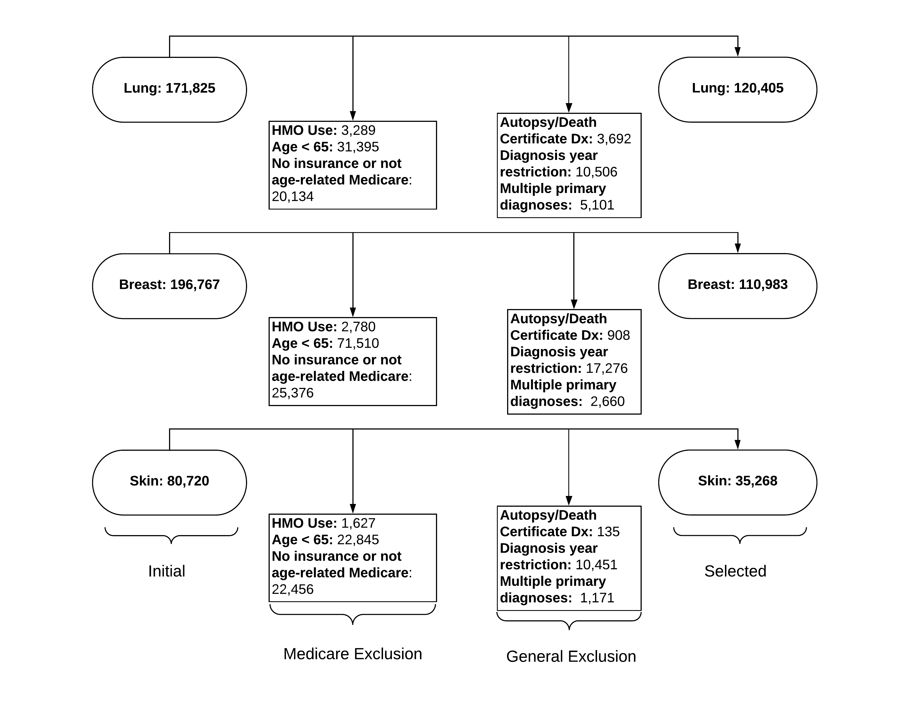
Supplementary Figure 1 This figure shows the numbers of primary cancer cases available (labeled “initial”), the exclusion criteria applied to these cases, and the final selected number of cases (labeled “selected”). Exclusion criteria are organized by restrictions imposed due to the use of Medicare data as opposed to more general exclusion criteria. Note that these numbers of subjects meeting exclusion criteria are not mutually exclusive, and these values reflect cases diagnosed in 2008-2012.

