Appendix Figure 1. Emergency department visits due to nonmedical use of pharmaceuticals, by sex, 2016.

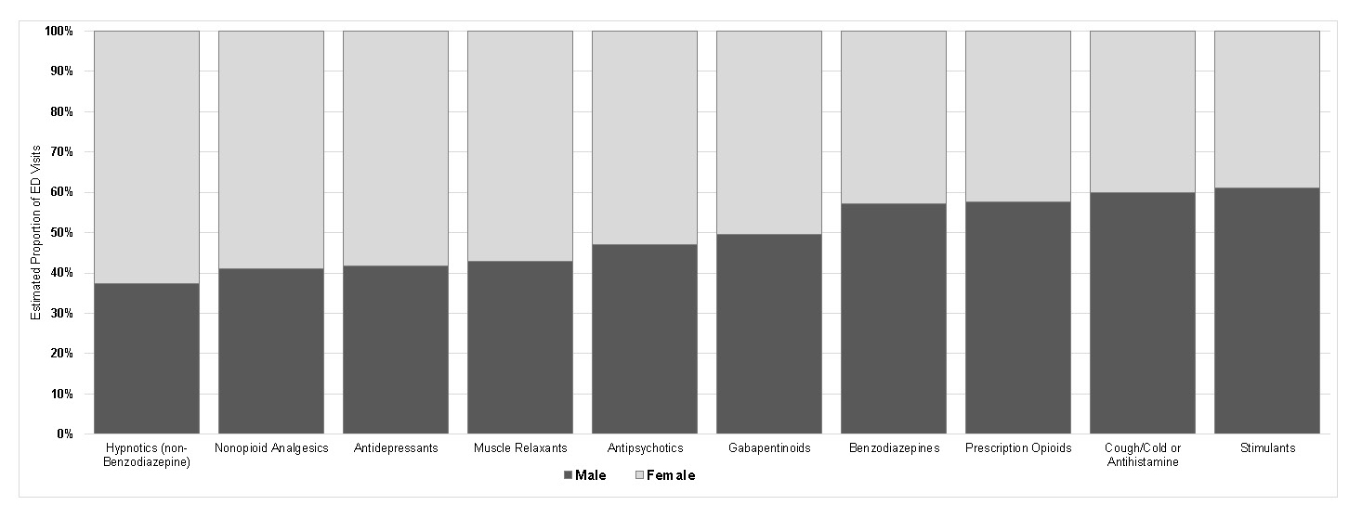

Notes: Estimates from the National Electronic Injury Surveillance System–Cooperative Adverse Drug Event Surveillance project, CDC. Not shown: emergency department visits involving pharmaceutical categories individually representing <3.0% of estimated nonmedical use visits.

Appendix Figure 2. Emergency department visits due to nonmedical use of pharmaceuticals, by age group, 2016.

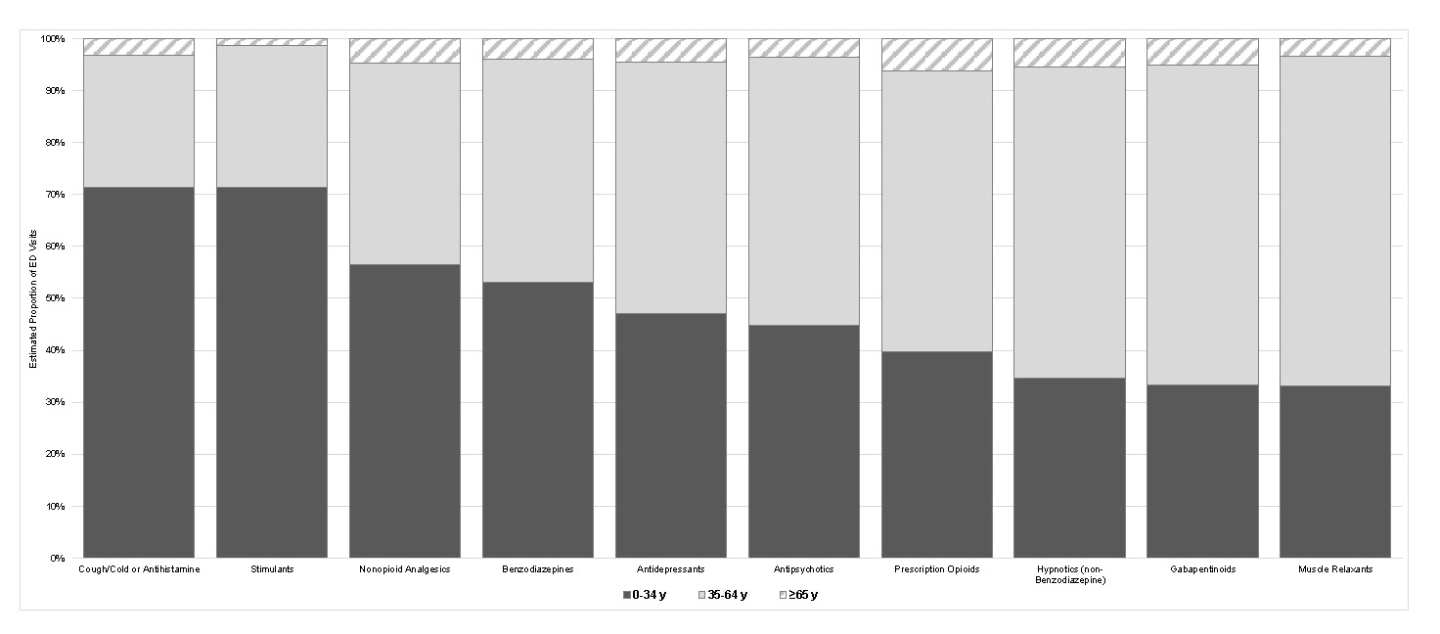

Notes: Estimates from the National Electronic Injury Surveillance System–Cooperative Adverse Drug Event Surveillance project, CDC. Not shown: emergency department visits involving pharmaceutical categories individually representing <3.0% of estimated nonmedical use visits. Estimates of nonmedical emergency department visits involving the ≥65 year age group for the following categories are based on <20 cases and thus considered statistically unstable: cough/cold or antihistamine, stimulants, nonopioid analgesics, antidepressants, antipsychotics, hypnotics (non-benzodiazepine), gabapentinoids, and muscle relaxants).

Appendix Table 1. ED Visits Due to Nonmedical Use of Pharmaceuticals, 2016 National Estimates, by Type of Useª

Case characteristics | Nonmedical use of pharmaceuticals |  |  |  |  |  | Therapeutic use of pharmaceuticals^{b}
Case characteristics | Abuse |  | Therapeutic misuse |  | Overdose without indication of Intent
Case characteristics | n | % (95% CI) | n | % (95% CI) | n | % (95% CI) | n | % (95% CI)
Age, years^{c}
<15 | 2,251^{d} | 1.6 (0.5, 2.7) | 1,252^{d} | 2.1 (0.6, 3.6) | 3,831 | 2.4 (1.4, 3.5) | 109,960 | 7.5 (5.6, 9.3)
15–24 | 39,242 | 27.6 (22.9, 32.3) | 12,209 | 20.5 (16.7, 24.3) | 30,477 | 19.5 (15.9, 23.0) | 109,099 | 7.4 (6.0, 8.8)
25–34 | 43,173 | 30.4 (27.0, 33.8) | 13,529 | 22.7 (19.5, 25.9) | 36,477 | 23.3 (19.5, 27.1) | 131,658 | 8.9 (7.6, 10.2)
35–44 | 26,489 | 18.6 (16.0, 21.3) | 9,563 | 16.0 (12.2, 19.9) | 25,384 | 16.2 (14.4, 18.0) | 129,988 | 8.8 (7.7, 9.9)
45–54 | 16,092 | 11.3 (8.6, 14.1) | 11,011 | 18.5 (15.6, 21.4) | 27,801 | 17.8 (14.8, 20.8) | 178,225 | 12.1 (10.6, 13.5)
55–64 | 12,124 | 8.5 (6.2, 10.8) | 6,259 | 10.5 (7.9, 13.1) | 23,778 | 15.2 (12.5, 17.9) | 226,195 | 15.3 (14.4, 16.2)
65–74 | 2,530 | 1.8 (1.0, 2.5) | 3,786 | 6.3 (4.6, 8.1) | 7,139 | 4.6 (3.2, 6.0) | 252,805 | 17.1 (14.7, 19.6)
>74 | ~ | ~ | 2,019^{d} | 3.4 (0.8, 5.9) | ~ | ~ | 336,626 | 22.8 (19.1, 26.6)
Sex
Female | 52,626 | 37.0 (33.9, 40.2) | 32,470 | 54.5 (50.7, 58.2) | 73,577 | 47.0 (43.8, 50.2) | 821,106 | 55.7 (53.1, 58.3)
Male | 89,488 | 63.0 (59.8, 66.1) | 27,159 | 45.5 (41.8, 49.3) | 82,928 | 53.0 (49.8, 56.2) | 653,450 | 44.3 (41.7, 46.9)
Discharge disposition^{e}
Hospitalized | 51,578 | 36.3 (25.5, 47.1) | 16,421 | 27.5 (21.4, 33.7) | 79,092 | 50.5 (41.4, 59.7) | 401,231 | 27.2 (21.6, 32.8)
Not hospitalized | 90,536 | 63.7 (52.9, 74.5) | 43,208 | 72.5 (66.3, 78.6) | 77,413 | 49.5 (40.3, 58.6) | 1,073,325 | 72.8 (67.2, 78.4)
Number of implicated pharmaceuticals
1 | 105,101 | 74.0 (69.4, 78.5) | 46,925 | 78.7 (74.7, 82.6) | 106,317 | 67.9 (64.2, 71.6) | 1,274,211 | 86.4 (84.7, 88.2)
2 | 27,359 | 19.3 (15.5, 23.0) | 8,974 | 15.1 (11.5, 18.6) | 32,450 | 20.7 (17.7, 23.7) | 158,326 | 10.7 (9.1, 12.3)
3 | 7,870 | 5.5 (3.9, 7.1) | 3,072 | 5.2 (3.1, 7.2) | 11,273 | 7.2 (5.6, 8.8) | 29,528 | 2.0 (1.7, 2.3)
4 or more | 1,783 | 1.3 (0.6, 1.9) | ~ | ~ | 6,465 | 4.1 (3.1, 5.2) | 12,491 | 0.8 (0.6, 1.1)
Additional substances documented
Any substance | 88,385 | 62.2 (58.3, 66.1) | 10,958 | 18.4 (14.0, 22.8) | 90,122 | 57.6 (53.8, 61.3) | 23,174 | 1.6 (1.1, 2.0)
Alcohol | 30,908 | 21.7 (19.1, 24.4) | 6,612 | 11.1 (8.0, 14.2) | 40,707 | 26.0 (23.5, 28.5) | 15,280 | 1.0 (0.7, 1.3)
Illicit substances | 62,719 | 44.1 (40.5, 47.8) | 5,583 | 9.4 (7.0, 11.7) | 53,731 | 34.3 (29.0, 39.6) | 8,896 | 0.6 (0.4, 0.8)
Marijuana | 32,058 | 22.6 (18.1, 27.1) | 3,588 | 6.0 (3.7, 8.3) | 27,661 | 17.7 (14.6, 20.7) | 6,463 | 0.4 (0.3, 0.6)
Cocaine | 21,737 | 15.3 (11.4, 19.2) | 1,342^{d} | 2.2 (0.7, 3.8) | 14,373 | 9.2 (6.6, 11.7) | 2,174 | 0.1 (0.1, 0.2)
Heroin | 13,602 | 9.6 (6.5, 12.6) | ~ | ~ | 13,948 | 8.9 (5.9, 12.0) | ~ | ~
Methamphetamines | 11,074 | 7.8 (4.2, 11.4) | ~ | ~ | 6,103 | 3.9 (2.0, 5.8) | ~ | ~
Other illicit substances^{f} | 7,331 | 5.2 (3.7, 6.7) | ~ | ~ | 3,716 | 2.4 (1.3, 3.4) | ~ | ~
Unspecified drugs^{g} | 18,935 | 13.3 (10.2, 16.4) | ~ | ~ | 19,148 | 12.2 (9.9, 14.6) | ~ | ~
No additional substances | 53,729 | 37.8 (33.9, 41.7) | 48,671 | 81.6 (77.2, 86.0) | 66,382 | 42.4 (38.7, 46.2) | 1,451,382 | 98.4 (98.0, 98.9)
Total | 142,114 | 39.7 (35.0, 44.3) | 59,629 | 16.6 (14.2, 19.1) | 156,505 | 43.7 (38.9, 48.5) | 1,474,556 | N/A
ªCase counts and estimates are from the National Electronic Injury Surveillance System–Cooperative Adverse Drug Event Surveillance project, CDC. Estimates based on <20 cases or total estimates <1,200 are considered statistically unstable and are not shown (~). Includes prescription and over-the-counter medications, dietary supplements, homeopathic products, and vaccines.
^{b}Includes therapeutic adverse drug events (e.g., adverse effects, allergic reactions, medication errors).
^{c}Missing for 5 cases of nonmedical use, and 1 case of therapeutic use.
^{d}Coefficient of variation >30%.
^{e}Hospitalized includes inpatient admissions, observation admissions, and transfers to other hospitals. Not hospitalized includes treated-and-released and left against medical advice/without being seen.
^{f}Includes illicit fentanyl, LSD, MDMA, phencyclidine, and other illicit drugs.
^{g}Includes unspecified opioids and unspecified amphetamines. For these visits, there was not enough information to determine if the opioid was a prescription product or illicit substance (e.g., heroin) or if the amphetamine was a prescription amphetamine or illicit methamphetamine.
ED, emergency department; N/A, not applicable.

