APPENDIX A. SUPPLEMENTARY INFORMATION

Real-Time Monitoring of Spray Drift from Three Different Orchard Sprayers

Magali N. Blanco, MS¹; Richard A. Fenske, PhD¹; Edward J. Kasner, PhD¹; Michael G. Yost, PhD¹; Edmund Seto, PhD¹; Elena Austin, PhD¹

¹Environmental and Occupational Health Sciences, University of Washington, Seattle, WA, United States

Contact Author

Magali N. Blanco
HSB F230
1959 NE Pacific Street
Seattle, WA 98195
magali@uw.edu
Figure A.1. Histograms of particle mass concentration (PMC) by sprayer type show that data were log normal. The x-axis is on the log scale.

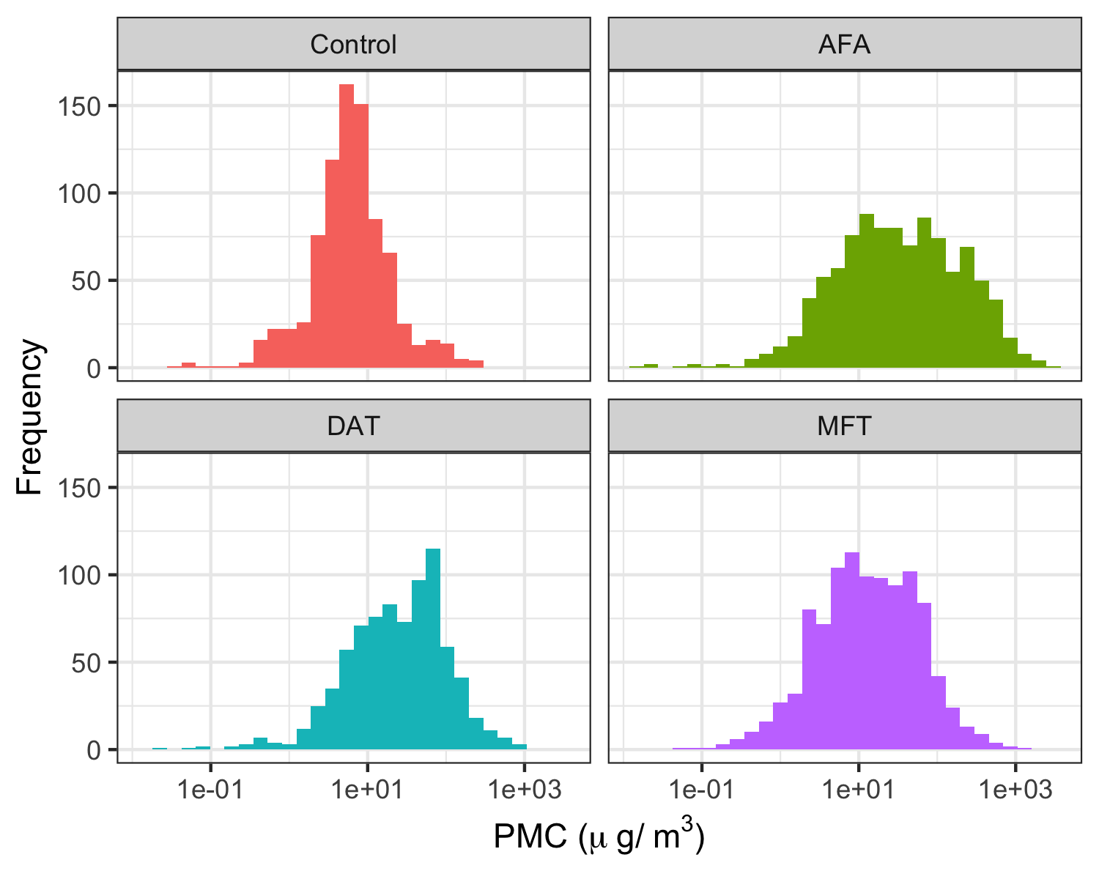

Figure A.2. Time series plot comparing one-minute particle mass concentrations (PMC) during spray events and control periods for one of our study days (September 28th, 2016).

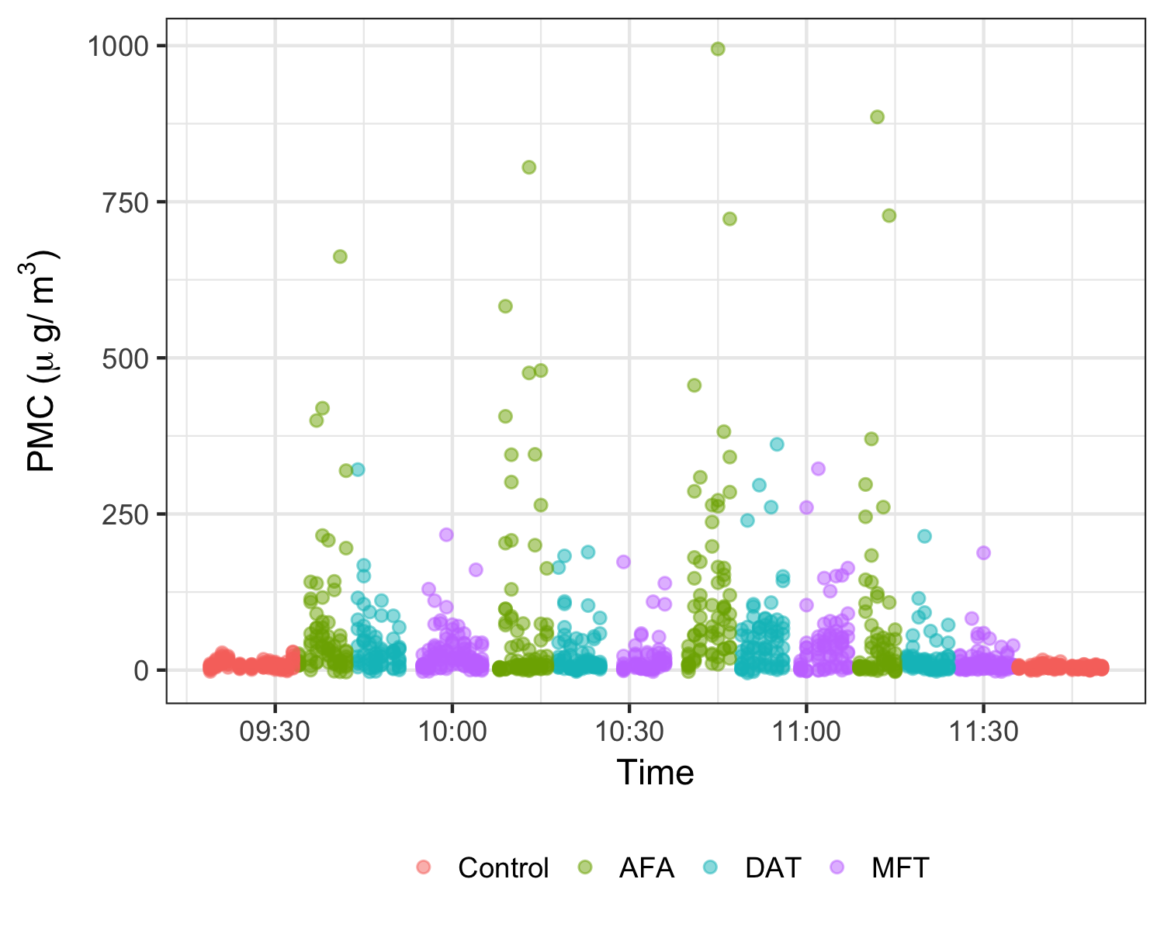
Table A.1. Randomized order for spray quadrants and application technologies.

Day | Date  (m/d/y)ª | Quadrant-Technology |  |  |  | Spray Event Count
Day | Date  (m/d/y)ª |  |  |  |  | AFA | DAT | MFT
1 | 6/10/2016 | 3-AFA  4-AFA  2-AFA  1-AFA | 3-MFT  4-MFT  2-MFT  1-MFT | -  -  -  - |  | -^{b}  1  2  3 | -  -  -  - | 1  2  3  4
2 | 9/28/2016 | 2-AFA  1-AFA  3-AFA  4-AFA | 2-DAT  1-DAT  3-DAT  4-DAT | 2-MFT  1-MFT  3-MFT  4-MFT |  | 4  5  6  7 | 1  2  3  4 | 5  6  7  8
3 | 9/29/2016 | 1-DAT  3-DAT  4-DAT  2-DAT | 1-MFT  3-MFT  4-MFT  2-MFT | 1-AFA  3-AFA  4-AFA  2-AFA |  | 8  9  10  11 | 5  6  7  8 | 9  10  11  12
4 | 9/30/2016 | 2-MFT  1-MFT  4-MFT  3-MFT | 2-AFA  1-AFA  4-AFA  3-AFA | 2-DAT  1-DAT  4-DAT  3-DAT |  | 12  13  14  15 | 9  10  11  12 | 13  14  15  16
Note: Each day, the spray quadrant order was randomized, while the application technology order was rotated so that each technology had a day where it was the first to spray. For example, on our second sampling day, Quadrant 2 was sprayed by the AFA sprayer, followed by the DAT sprayer and finally, the MFT sprayer. Quadrants 1, 3 and 4 were afterwards sprayed in the same order. On our third sampling day, the quadrant spray order was again randomized, but this time, the DAT was the first to spray, followed by the MFT and finally, the AFA sprayer.
ªmonth/day/year
^{b}This spray event was dropped from our analyses because the wind was not blowing south towards our sample field.

Table A.2. Sprayer Calibration Settings.

Calibration Settings | AFA | DAT | MFT
Operating Pressure | 14 bar | 6.9 bar | 6.9 bar
Nozzles | Disc-core (D3-D5 nozzles with 25 cores) | Disc-core (D3 nozzles with 25 cores) | One-piece (VK08 and VK04)
Droplet Sizeª | Fine | Fine | Very fine
Droplet Diameter | 110-125 µm | 125-130 µm | 61-105 µm
Tower Height | - | 2.7 m | 3.7 m
Note: All sprayers were calibrated while running at 1.3 m/s, outputting 935 L/ha, using an air volume flow rate of approximately 566-850 m³/min and using nozzles that produced hollow cone spray patterns.
ªcategories are defined by the ASABE 572.1 droplet size classification standard (ASABE 2013)
Table A.3. Quantile regression of 50th percentile PMC (μg/m³) by sprayer type, adjusting for sampling height and wind speed.
Covariate | Coefficient (95% CI)
(Intercept) | 14.7 (12.7, 17.3)
AFA Sprayer | 24.5 (20.4, 28.6)
DAT Sprayer | 19.8 (16.2, 22.8)
MFT Sprayer | 6.9 (5.5, 8.4)
Above Canopy | -3.0 (-4.5, -1.6)
Wind (m/s) | -1.9 (-2.5, -1.4)
Note: Results are based on 2,927 one-minute spray event and 849 one-minute control observations. The intercept represents the background PMC level at a sampling height below the canopy with no wind. All covariates were statistically significant.

