Afghanistan Serosurvey Supplement
Report generated on: 2018-04-23
This document was created by RMarkdown in Rstudio Version 1.0.143.
Source file: polio_merged7.sas7bdat

Background
This serosurvey used existing specimens from a nutrition survey conducted in Afghanistan during 2013 as a collaborative effort between Afghanistan Ministry of Public Health and Agha Khan University. The nutrition survey employed a stratified two-stage sample design with 30 enumeration areas (EAs) selected from each of 34 provinces. A micronutrient assessment collected serum specimens from participants in a subset of 80 EAs from 26 provinces. There were 981 participants in the micronutrient assessment, of which 690 (70%) were available for testing with a polio neutralization assay
This supplement documents the multiple imputation process applied using the mi package.
Survey design variables:
*stratum (stratum)
*first stage cluster (psu)
*sampling weight adjusted for non-response in the original nutrition survey (samp.wts)
Geographic variables:
*5 regions:central, eastern, north, south, west (region)
Demographic variables:
*age of child (agemos)
*child's sex (sex)
*mother's education: Illierate, PreSchool/Religious/Some Schooling, High School/14+years schooling/Bacchelors Degree (momeduc)
NOTE: 43% of the 981 observations are missing mothers education info (13% of observations are missing both mother's education and outcome variables (Sabin1,Sabin2, Sabin3))
Health/micro-nutrition:
*height
*weight
*diarrhea in the past 2 weeks (yes/no) (diarr)
*hemoglobin (g/dL) (hb)
NOTE: 11% of observations are missing child's height (4% of observations are missing both weight and Sabin1)
NOTE: 11% of observations are missing child's weight (4% of observations are missing both weight and Sabin1)
NOTE: 42% of observations are missing diarrhea variable (13% of observations are missing both diarrhea and Sabin1)
NOTE: 7% of observations are missing hemoglobin variable (0.5% of observations are missing both hemoglobin and Sabin1)
Primary outcomes of interest:
*neutralizing antibody titer for sabin type1 (Sabin1)
*neutralizing antibody titer for sabin type2 (Sabin2)
*neutralizing antibody titer for sabin type3 (Sabin3)
NOTE: either all 3 polio titers outcomes are observed or all are missing
NOTE: For the final analysis titers are dichotomitized into seropositive for titers $≥$ 8, or seronegative for titer < 8.

Missing Data Patterns
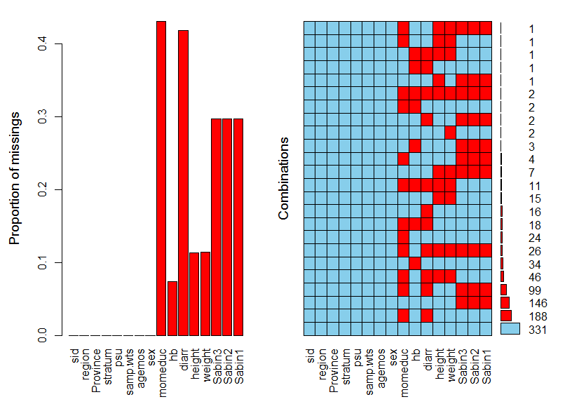
Figure 1: Missing Data Patterns
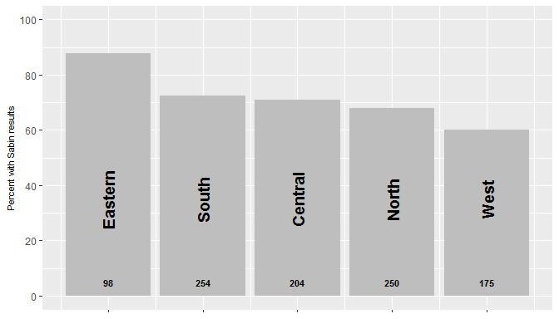
Figure 2: Organ pipe plot of % observed Sabin titers by region. Sample size is given at base of each bar.

Margin Plots
*Blue dots: both observed
*Red dots on horizontal access: x-axis variable observed, y-axis variable missing
*Red dots on vertical access: y-axis variable observed, x-axis variable missing
*Yellow in lower left corner: some observations are missing both
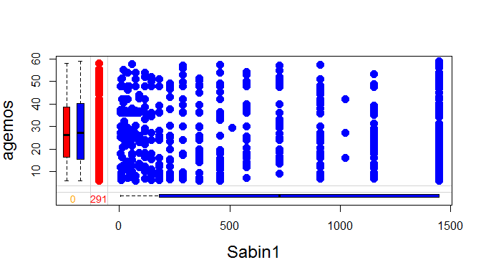
Figure 3a: Margin plot of Sabin1 titer and age in months.
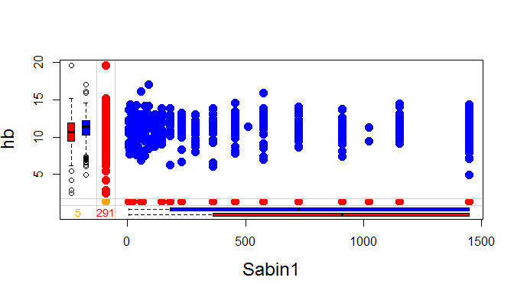
Figure 3b: Margin plot of Sabin1 titer and hemoglobin.
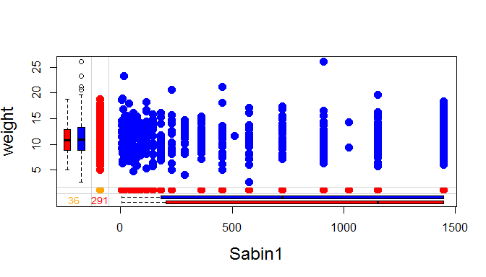
Figure 3c: Margin plot of Sabin1 titer and child's weight.

sex | Sabin1 | Count
Male | Neg | 5
Male | Pos | 346
Male | NA | 157
Female | Neg | 13
Female | Pos | 326
Female | NA | 134
Table 1: sex by pos/neg for Sabin1.
momeduc | Sabin1 | Count
Illit/ | Neg | 7
Illit/ | Pos | 299
Illit/ | NA | 118
Pre/Relig/Some | Neg | 3
Pre/Relig/Some | Pos | 69
Pre/Relig/Some | NA | 31
High,14yrs,Bach | Neg | 1
High,14yrs,Bach | Pos | 21
High,14yrs,Bach | NA | 10
NA | Neg | 7
NA | Pos | 283
NA | NA | 132
Table 2: Mom's Education by pos/neg for Sabin1.
Diarrhea | Sabin1 | Count
Yes | Neg | 4
Yes | Pos | 132
Yes | NA | 75
No | Neg | 7
No | Pos | 266
No | NA | 87
NA | Neg | 7
NA | Pos | 274
NA | NA | 129
Table 3: Diarrhea by pos/neg for Sabin1.

Imputation
Imputation was completed using the mi package version 1.0. Details can be found at https://CRAN.R-project.org/package=mi, including the package documentation and a vignette by Goodrich et al. In addition an article Su, et al. [2].
Variable | type | missing | method | model
region | unordered-categorical | 0
Province | unordered-categorical | 0
stratum | unordered-categorical | 0
psu | unordered-categorical | 0
samp.wts | continuous | 0
agemos | positive-continuous | 0
sex | binary | 0
momeduc | ordered-categorical | 422 | ppd | ologit
hb | positive-continuous | 72 | ppd | linear
diarr | binary | 410 | ppd | logit
height | positive-continuous | 111 | ppd | linear
weight | continuous | 112 | ppd | linear
Sabin3 | bounded-continuous | 291 | ppd | linear
Sabin2 | bounded-continuous | 291 | ppd | linear
Sabin1 | bounded-continuous | 291 | ppd | linear
Table 4: Variable list with number missing values and the variable types
In choosing a variable type for imputation of the Sabin variables, we considered continuous, positive-continuous, bounded continuous, and ordered categorical. We opted for bounded continuous though we saw little difference when using ordered categorical (28-30 unique values).
*R Syntax:
##########################################################
# Imputation using the mi package
library(mi)
mdf <- missing_data.frame(as.data.frame(temp2))
show(mdf)
mdf <- change(mdf, y = c("stratum", "momeduc","agemos","hb","weight","height"), what = "type",
to = c("un", "or",rep("positive-continuous",4)))
mdf <- change(mdf, y = c("Sabin1","Sabin2","Sabin3"), what = "type",
to = c(rep("bounded-continuous",3)), lower=5, upper=1449)
show(mdf)
> imp <- mi(mdf, n.iter = 30, n.chains = 10,max.minutes = 300)
> Rhats(imp)
# 15 additional iterations
> imp <- mi(imp, n.iter = 15,max.minutes = 300)
> Rhats(imp)
#plot(imp)
#summary(imp)

Imputation diagnostics
The following diagnostic plots are derived from the plot function in the mi package.
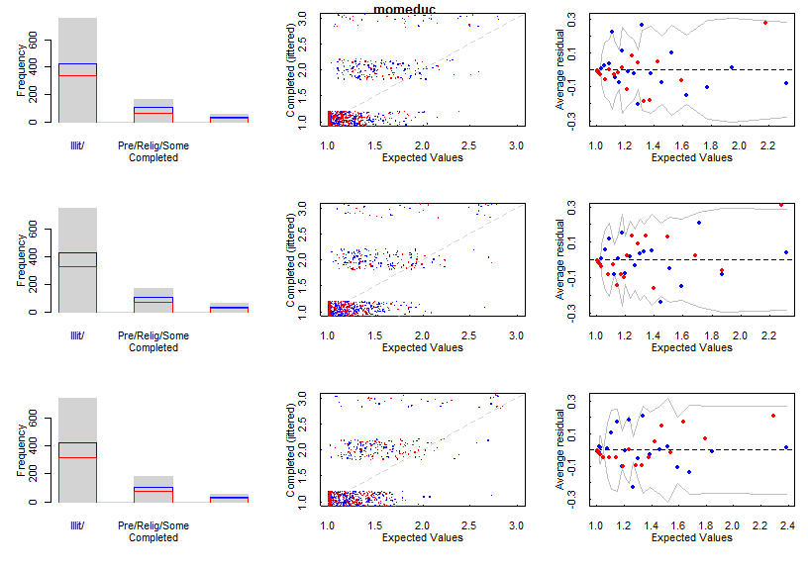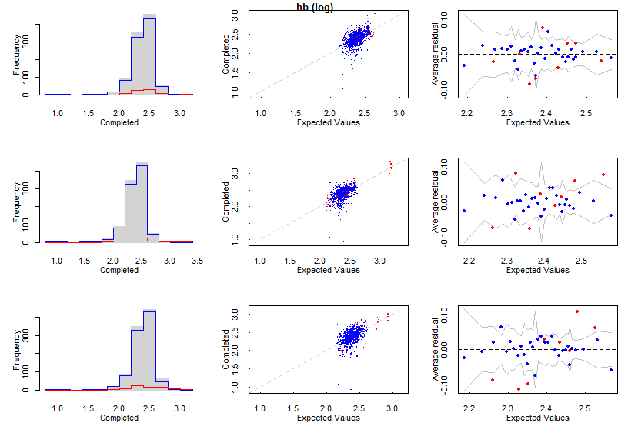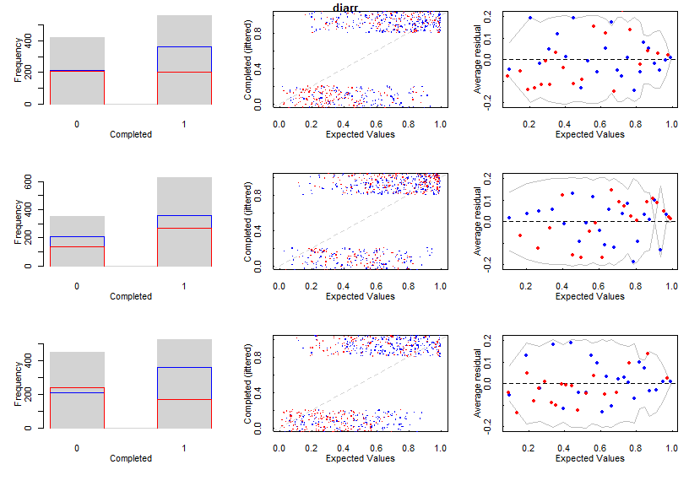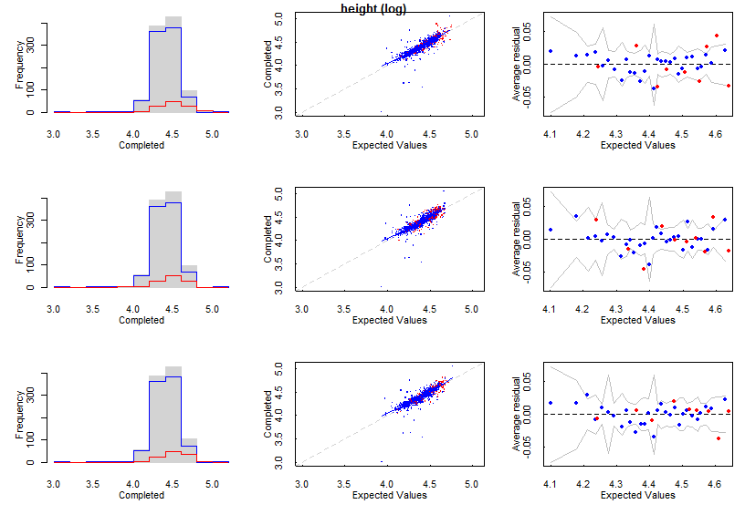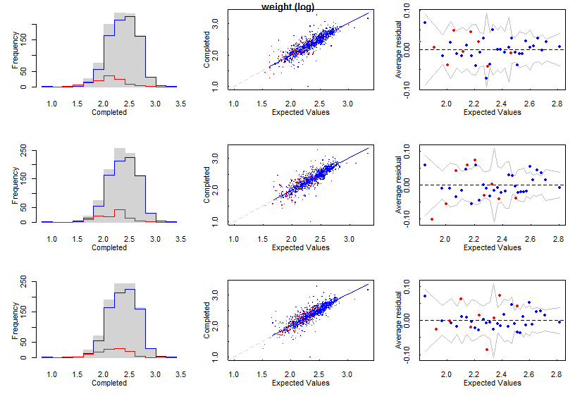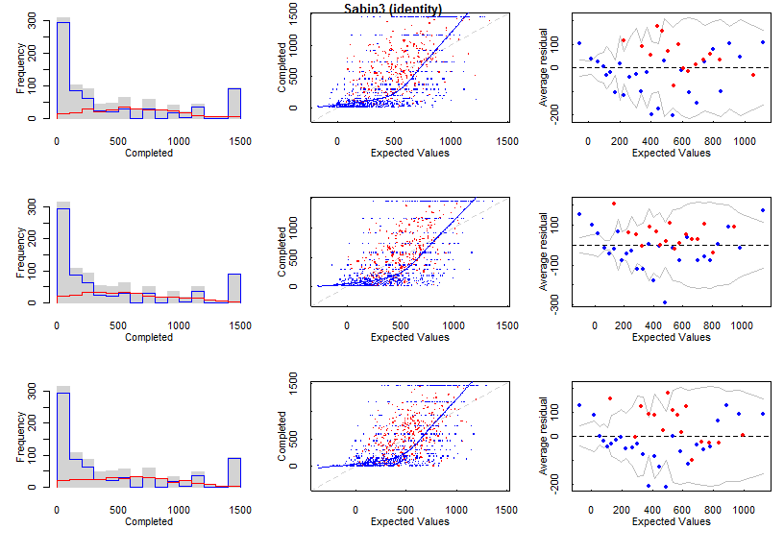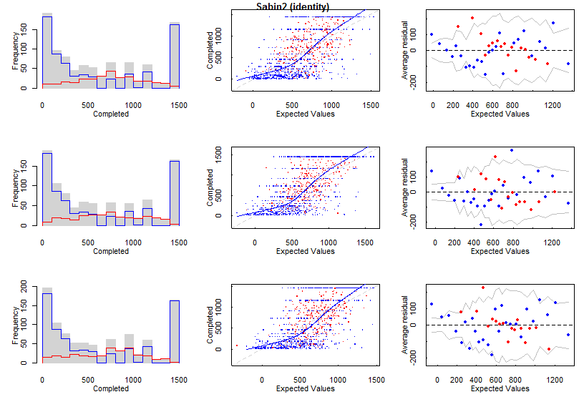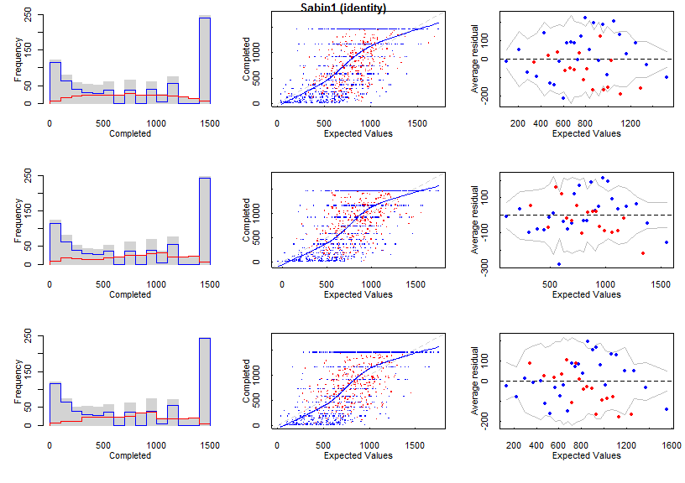
Figure 4: Diagnostic plots of first 3 chains of imputation.
mean_momeduc | 1.0130076
mean_hb | 1.0412961
mean_diarr | 1.0203095
mean_height | 1.0049738
mean_weight | 1.0187661
mean_Sabin3 | 0.9946073
mean_Sabin2 | 1.0001075
mean_Sabin1 | 0.9995673
sd_momeduc | 1.0005806
sd_hb | 1.0671859
sd_diarr | 1.0074987
sd_height | 1.0287234
sd_weight | 1.0382263
sd_Sabin3 | 0.9906683
sd_Sabin2 | 0.9961686
sd_Sabin1 | 0.9937356
Table 5: R statistic (if <1.1 then the imputation is considered coverged).

Data preparation
Finally we extracted 30 imputed datasets. Thirty was chosen because ~30% of the primary outcome observations of interest, Sabin titer for type 1, 2 and 3, were missing.

Data analysis
The analysis of each imputed dataset was completed in the survey package. We used the adjusted degrees of freedom as described on page 358 from the book: Applied Survey Data Analysis, Heeringa, West and Beglund (2010).

R Packages
*VIM
Alexander Kowarik, Matthias Templ (2016). Imputation with the R Package VIM. Journal of Statistical Software, 74(7), 1-16. doi:10.18637/jss.v074.i07
*MI
Gelman A and Hill J (2011). “Opening Windows to the Black Box.” Journal of Statistical Software, 40.
Vignette by Ben Goodrich and Jonathan Kropko, for this version, based on earlier versions written by Yu-Sung Su, Masanao Yajima, Maria Grazia Pittau, Jennifer Hill, and Andrew Gelman. "An example of mi Usage"
*ggplot2
H. Wickham. ggplot2: Elegant Graphics for Data Analysis. Springer-Verlag New York, 2009.
- survey T. Lumley (2017) "survey: analysis of complex survey samples". R package version 3.32.
- mitools
Thomas Lumley (2014). mitools: Tools for multiple imputation of missing data. R package version 2.3. https://CRAN.R-project.org/package=mitools

