Supplemental Figure 1. Annual national and regional respiratory syncytial virus activity in Argentina by epidemiological week, 2007–2013
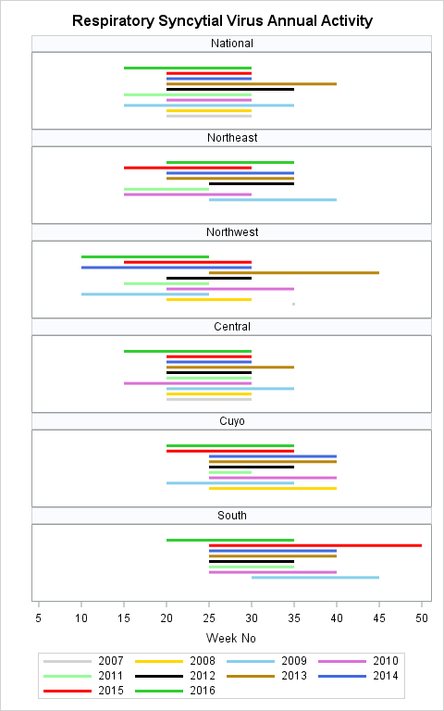

Supplemental Figure 2. Annual national and regional influenza activity in Argentina by epidemiological week, 2007–2013

