Maternal Residential Exposure to Agricultural Pesticide Active Ingredients and Ten Birth Defects in a 2003-2005 North Carolina Birth Cohort

Kristen M. Rappazzo¹, Joshua L. Warren², Angel D. Davalos³, Robert E. Meyer⁴, Amy H. Herring³, Alison P. Sanders⁵, Naomi C. Brownstein^{6,7}, and Thomas J. Luben⁸

Supplemental Materials

Table S.1: Descriptive statistics by exposure status for included births in North Carolina 2003-2005
Demographic characteristic | 2, 4-D |  | Glyphosate |  | Cyhalothrin |  | Mepiquat chloride
 | Unexposed | Exposed | Unexposed | Exposed | Unexposed | Exposed | Unexposed | Exposed
N | 232159 | 72747 | 135581 | 169325 | 157518 | 147388 | 210935 | 93971
Race/ethnicity
White, non-Hispanic | 137,001 (59) | 46,681 (64) | 84,614 (62) | 99,068 (59) | 94,883 (60) | 88,799 (60) | 128,779 (61) | 54,903 (58)
Black, non-Hispanic | 52,345 (23) | 14,400 (20) | 28,955 (21) | 37,790 (22) | 32,867 (21) | 33,878 (23) | 43,903 (21) | 22,842 (24)
Hispanic | 33,479 (14) | 8,898 (12) | 16,701 (12) | 25,676 (15) | 23,746 (15) | 18,631 (13) | 30,145 (14) | 12,232 (13)
Other, non-Hispanic | 9,334 (4) | 2,768 (4) | 5,311 (4) | 6,791 (4) | 6,022 (4) | 6,080 (4) | 8,108 (4) | 3,994 (4)
Sex
Female | 112,991 (49) | 35,469 (49) | 66,038 (49) | 82,422 (49) | 76,755 (49) | 71,705 (49) | 102,726 (49) | 45,734 (49)
Male | 119,168 (51) | 37,278 (51) | 69,543 (51) | 86,903 (51) | 80,763 (51) | 75,683 (51) | 108,209 (51) | 48,237 (51)
Maternal education
Greater than high school | 114,631 (49) | 34,807 (48) | 65,111 (48) | 84,327 (50) | 80,570 (51) | 68,868 (47) | 106,899 (51) | 42,539 (45)
High school | 65,614 (28) | 22,087 (30) | 41,021 (30) | 46,680 (28) | 42,380 (27) | 45,321 (31) | 58,092 (28) | 29,609 (32)
Less than high school | 51,914 (22) | 15,853 (22) | 29,449 (22) | 38,318 (23) | 34,568 (22) | 33,199 (23) | 45,944 (22) | 21,823 (23)
Marital status
Married | 147,435 (64) | 47,499 (65) | 87,596 (65) | 107,338 (63) | 101,709 (65) | 93,225 (63) | 137,281 (65) | 57,653 (61)
Unmarried | 84,724 (36) | 25,248 (35) | 47,985 (35) | 61,987 (37) | 55,809 (35) | 54,163 (37) | 73,654 (35) | 36,318 (39)
Smoking status
Non-smoker | 204,092 (88) | 62,885 (86) | 117,474 (87) | 149,503 (88) | 139,333 (88) | 127,644 (87) | 185,780 (88) | 81,197 (86)
Smoker | 28,067 (12) | 9,862 (14) | 18,107 (13) | 19,822 (12) | 18,185 (12) | 19,744 (13) | 25,155 (12) | 12,774 (14)
Diabetes status
No | 225,813 (97) | 70,602 (97) | 131,760 (97) | 164,655 (97) | 153,184 (97) | 143,231 (97) | 205,170 (97) | 91,245 (97)
Yes | 6,346 (3) | 2,145 (3) | 3,821 (3) | 4,670 (3) | 4,334 (3) | 4,157 (3) | 5,765 (3) | 2,726 (3)
Parity
Primiparous | 95,897 (41) | 29,800 (41) | 55,624 (41) | 70,073 (41) | 65,568 (42) | 60,129 (41) | 87,586 (42) | 38,111 (41)
Multiparous | 136,262 (59) | 42,947 (59) | 79,957 (59) | 99,252 (59) | 91,950 (58) | 87,259 (59) | 123,349 (58) | 55,860 (59)
Age group
Less than 20 | 26,160 (11) | 8,470 (12) | 15,798 (12) | 18,832 (11) | 16,858 (11) | 17,772 (12) | 22,854 (11) | 11,776 (13)
20 - less than 35 | 177,003 (76) | 55,937 (77) | 103,815 (77) | 129,125 (76) | 119,884 (76) | 113,056 (77) | 160,935 (76) | 72,005 (77)
35+ | 28,996 (12) | 8,340 (11) | 15,968 (12) | 21,368 (13) | 20,776 (13) | 16,560 (11) | 27,146 (13) | 10,190 (11)

Table S.1 continued: Descriptive statistics by exposure status for included births in North Carolina 2003-2005
Demographic characteristic | S, Metolachlor |  | Paraquat |  | Pendimethalin
 | Unexposed | Exposed | Unexposed | Exposed | Unexposed | Exposed
N | 213058 | 91848 | 51227 | 253679 | 194622 | 110284
Race/ethnicity
White, non-Hispanic | 127,063 (60) | 56,619 (62) | 25,707 (50) | 157,975 (62) | 117,396 (60) | 66,286 (60)
Black, non-Hispanic | 46,768 (22) | 19,977 (22) | 13,681 (27) | 53,064 (21) | 40,810 (21) | 25,935 (24)
Hispanic | 30,623 (14) | 11,754 (13) | 9,516 (19) | 32,861 (13) | 28,755 (15) | 13,622 (12)
Other, non-Hispanic | 8,604 (4) | 3,498 (4) | 2,323 (5) | 9,779 (4) | 7,661 (4) | 4,441 (4)
Sex
Female | 103,715 (49) | 44,745 (49) | 25,066 (49) | 123,394 (49) | 94,875 (49) | 53,585 (49)
Male | 109,343 (51) | 47,103 (51) | 26,161 (51) | 130,285 (51) | 99,747 (51) | 56,699 (51)
Maternal education
Greater than high school | 106,662 (50) | 42,776 (47) | 25,897 (51) | 123,541 (49) | 98,063 (50) | 51,375 (47)
High school | 59,292 (28) | 28,409 (31) | 13,039 (25) | 74,662 (29) | 53,630 (28) | 34,071 (31)
Less than high school | 47,104 (22) | 20,663 (22) | 12,291 (24) | 55,476 (22) | 42,929 (22) | 24,838 (23)
Marital status
Married | 137,083 (64) | 57,851 (63) | 31,334 (61) | 163,600 (64) | 125,181 (64) | 69,753 (63)
Unmarried | 75,975 (36) | 33,997 (37) | 19,893 (39) | 90,079 (36) | 69,441 (36) | 40,531 (37)
Smoking status
Non-smoker | 187,672 (88) | 79,305 (86) | 46,426 (91) | 220,551 (87) | 171,390 (88) | 95,587 (87)
Smoker | 25,386 (12) | 12,543 (14) | 4,801 (9) | 33,128 (13) | 23,232 (12) | 14,697 (13)
Diabetes status
No | 207,295 (97) | 89,120 (97) | 49,885 (97) | 246,530 (97) | 189,220 (97) | 107,195 (97)
Yes | 5,763 (3) | 2,728 (3) | 1,342 (3) | 7,149 (3) | 5,402 (3) | 3,089 (3)
Parity
Primiparous | 88,078 (41) | 37,619 (41) | 21,794 (43) | 103,903 (41) | 80,747 (41) | 44,950 (41)
Multiparous | 124,980 (59) | 54,229 (59) | 29,433 (57) | 149,776 (59) | 113,875 (59) | 65,334 (59)
Age group
Less than 20 | 23,526 (11) | 11,104 (12) | 5,552 (11) | 29,078 (11) | 21,276 (11) | 13,354 (12)
20 - less than 35 | 162,790 (76) | 70,150 (76) | 39,019 (76) | 193,921 (76) | 148,345 (76) | 84,595 (77)
35+ | 26,742 (13) | 10,594 (12) | 6,656 (13) | 30,680 (12) | 25,001 (13) | 12,335 (11)

Table S.2: Odds ratios and 95% confidence intervals for single pesticide active ingredient analyses all models, adjusted for maternal race/ethnicity, age at delivery, education, marital status, and smoking status.
Birth defect | Exposure level | Pesticide active ingredient
 |  | 2, 4-D | Glyphosate | Cyhalothrin | Mepiquat chloride | S, Metolachlor | Paraquat | Pendimethalin
ASD | Unexposed | ref | ref | ref | ref | ref | ref | ref
 | <10th | 1.06 (0.75, 1.50) | 1.12 (0.82, 1.52) | 0.96 (0.74, 1.25) | 0.80 (0.58, 1.10) | 0.82 (0.54, 1.25) | 1.25 (0.97, 1.61) | 1.07 (0.76, 1.52)
 | [10-50) | 0.92 (0.72, 1.16) | 1.14 (0.96, 1.35) | 1.15 (0.97, 1.37) | 0.96 (0.77, 1.19) | 1.14 (0.94, 1.37) | 0.98 (0.81, 1.18) | 1.16 (0.97, 1.39)
 | [50-90) | 1.22 (1.00, 1.49) | 1.24 (1.06, 1.46) | 1.25 (1.06, 1.46) | 1.30 (1.09, 1.55) | 1.35 (1.13, 1.61) | 1.05 (0.87, 1.27) | 1.31 (1.11, 1.55)
 | >90th | 1.99 (1.48, 2.67) | 1.72 (1.35, 2.21) | 1.81 (1.43, 2.29) | 1.97 (1.51, 2.57) | 1.46 (1.07, 1.98) | 1.42 (1.12, 1.81) | 2.09 (1.63, 2.68)
PDA | Unexposed | ref | ref | ref | ref | ref | ref | ref
 | <10th | 1.15 (0.86, 1.54) | 1.14 (0.89, 1.47) | 1.08 (0.87, 1.33) | 1.16 (0.80, 1.67) | 1.06 (0.77, 1.45) | 1.09 (0.86, 1.37) | 1.13 (0.85, 1.51)
 | [10-50) | 1.28 (1.07, 1.53) | 1.09 (0.95, 1.26) | 1.02 (0.87, 1.18) | 1.29 (1.00, 1.66) | 1.10 (0.94, 1.30) | 1.07 (0.91, 1.26) | 1.05 (0.90, 1.23)
 | [50-90) | 1.39 (1.18, 1.64) | 1.14 (0.99, 1.32) | 1.12 (0.98, 1.29) | 1.47 (1.17, 1.83) | 1.23 (1.06, 1.44) | 1.09 (0.92, 1.28) | 1.27 (1.10, 1.47)
 | >90th | 1.68 (1.26, 2.24) | 1.29 (1.01, 1.64) | 1.27 (1.01, 1.61) | 1.70 (1.16, 2.48) | 1.09 (0.80, 1.49) | 1.32 (1.06, 1.64) | 1.64 (1.29, 2.08)
HPS | Unexposed | ref | ref | ref | ref | ref | ref | ref
 | <10th | 1.11 (0.71, 1.74) | 1.19 (0.80, 1.76) | 1.18 (0.85, 1.64) | 1.16 (0.80, 1.67) | 1.34 (0.86, 2.08) | 0.89 (0.60, 1.33) | 1.11 (0.70, 1.76)
 | [10-50) | 1.13 (0.85, 1.50) | 1.38 (1.11, 1.70) | 1.19 (0.94, 1.50) | 1.29 (1.00, 1.66) | 1.15 (0.90, 1.48) | 1.01 (0.77, 1.31) | 1.36 (1.09, 1.71)
 | [50-90) | 1.48 (1.16, 1.88) | 1.37 (1.11, 1.69) | 1.46 (1.20, 1.79) | 1.47 (1.17, 1.83) | 1.44 (1.15, 1.81) | 1.22 (0.94, 1.57) | 1.48 (1.19, 1.83)
 | >90th | 1.78 (1.19, 2.67) | 1.87 (1.36, 2.57) | 1.55 (1.11, 2.17) | 1.70 (1.16, 2.48) | 1.69 (1.16, 2.47) | 1.75 (1.29, 2.39) | 1.66 (1.15, 2.39)
Hypospadias | Unexposed | ref | ref | ref | ref | ref | ref | ref
 | <10th | 1.15 (0.86, 1.54) | 1.14 (0.89, 1.47) | 1.08 (0.87, 1.33) | 1.16 (0.80, 1.67) | 1.06 (0.77, 1.45) | 1.09 (0.86, 1.37) | 1.13 (0.85, 1.51)
 | [10-50) | 1.28 (1.07, 1.53) | 1.09 (0.95, 1.26) | 1.02 (0.87, 1.18) | 1.29 (1.00, 1.66) | 1.10 (0.94, 1.30) | 1.07 (0.91, 1.26) | 1.05 (0.90, 1.23)
 | [50-90) | 1.39 (1.18, 1.64) | 1.14 (0.99, 1.32) | 1.12 (0.98, 1.29) | 1.47 (1.17, 1.83) | 1.23 (1.06, 1.44) | 1.09 (0.92, 1.28) | 1.27 (1.10, 1.47)
 | >90th | 1.68 (1.26, 2.24) | 1.29 (1.01, 1.64) | 1.27 (1.01, 1.61) | 1.70 (1.16, 2.48) | 1.09 (0.80, 1.49) | 1.32 (1.06, 1.64) | 1.64 (1.29, 2.08)
HLHS | Unexposed | ref | ref | ref | ref | ref | ref | ref
 | <50th | 0.91 (0.43, 1.91) | 1.24 (0.72, 2.16) | 1.01 (0.57, 1.80) | 1.29 (0.69, 2.39) | 1.47 (0.80, 2.68) | 1.17 (0.57, 2.40) | 1.01 (0.53, 1.91)
 | >=50th | 1.23 (0.64, 2.35) | 1.17 (0.67, 2.05) | 1.27 (0.74, 2.16) | 1.65 (0.94, 2.90) | 1.75 (1.00, 3.06) | 1.41 (0.70, 2.87) | 1.72 (1.01, 2.91)
TEF | Unexposed | ref | ref | ref | ref | ref | ref | ref
 | <50th | 0.86 (0.43, 1.72) | 1.54 (0.94, 2.51) | 1.11 (0.65, 1.88) | 0.95 (0.51, 1.77) | 1.27 (0.73, 2.21) | 2.23 (0.99, 4.99) | 1.15 (0.66, 1.98)
 | >=50th | 0.77 (0.37, 1.59) | 0.96 (0.54, 1.71) | 1.16 (0.69, 1.95) | 1.20 (0.68, 2.12) | 0.80 (0.41, 1.56) | 2.17 (0.97, 4.89) | 0.94 (0.52, 1.70)
Choanal Atresia | Unexposed | ref | ref | ref | ref | ref | ref | ref
 | <50th* | 1.84 (0.88, 3.87) | 1.33 (0.68, 2.61) | 0.74 (0.35, 1.58) | 0.98 (0.53, 1.79) | 1.44 (0.68, 3.03) | 4.10 (1.25, 13.42) | 0.91 (0.42, 1.97)
 | >=50th | 2.08 (1.02, 4.26) | 1.37 (0.70, 2.70) | 1.26 (0.67, 2.39) |  | 1.95 (0.99, 3.83) | 2.14 (0.62, 7.36) | 1.27 (0.64, 2.54)
Hirschsprung's | Unexposed | ref | ref | ref | ref | ref | ref | ref
 | <50th | 1.10 (0.54, 2.23) | 1.82 (1.08, 3.06) | 1.62 (0.93, 2.82) | 1.41 (0.77, 2.57) | 0.96 (0.48, 1.89) | 0.98 (0.48, 2.00) | 1.81 (1.04, 3.15)
 | >=50th | 1.53 (0.84, 2.81) | 1.39 (0.79, 2.43) | 1.80 (1.06, 3.06) | 1.77 (1.03, 3.04) | 1.67 (0.97, 2.87) | 1.62 (0.83, 3.17) | 1.86 (1.09, 3.19)
Upper limb defects | Unexposed | ref | ref | ref | ref | ref | ref | ref
 | <50th | 1.36 (0.75, 2.48) | 0.95 (0.54, 1.70) | 0.96 (0.53, 1.73) | 0.83 (0.42, 1.63) | 1.20 (0.67, 2.16) | 0.83 (0.43, 1.61) | 0.54 (0.26, 1.14)
 | >=50th | 1.02 (0.52, 1.99) | 1.52 (0.93, 2.48) | 1.83 (1.13, 2.95) | 1.60 (0.95, 2.68) | 1.32 (0.76, 2.32) | 1.30 (0.69, 2.42) | 1.49 (0.91, 2.43)
Lower limb defects | Unexposed | ref | ref | ref | ref | ref | ref | ref
 | <50th | 2.01 (0.86, 4.68) | 1.19 (0.48, 2.92) | 1.33 (0.55, 3.21) | 1.22 (0.49, 3.00) | 1.71 (0.72, 4.07) | 2.91 (0.66, 12.82) | 0.90 (0.34, 2.40)
 | >=50th | 2.48 (1.14, 5.37) | 2.77 (1.38, 5.56) | 2.78 (1.36, 5.69) | 2.06 (0.99, 4.27) | 3.04 (1.50, 6.17) | 4.65 (1.09, 19.84) | 2.33 (1.17, 4.63)
ASD: atrial septal defects
PDA: patent ductus arteriosus
HPS: hypertrophic pyloric stenosis
HLHS: hypoplastic left heart syndrome
TEF: tracheal esophageal fistula
“*exposure categories were further collapsed to unexposed/exposed for analysis

Table S.3: Odds ratios and 95% confidence intervals for atrial septal defects, two pesticide active ingredient models, adjusted for maternal race/ethnicity, age at delivery, education, marital status, and smoking status.
Initial pesticide | Exposure level | Single model result | Adjusted for
 |  |  | 2,4-D | Glyphosate | Cyhalothrin | Mepiquat | Metolachlor | Paraquat | Pendimethlin
2,4,D | Unexposed | ref |  | ref | ref | ref | ref | ref | ref
 | <10th | 1.06 (0.75, 1.50) |  | 1.01 (0.70, 1.47) | 1.12 (0.79, 1.59) | 1.14 (0.81, 1.62) | 1.08 (0.73, 1.60) | 1.03 (0.73, 1.47) | 1.09 (0.77, 1.54)
 | [10-50) | 0.92 (0.72, 1.16) |  | 0.86 (0.66, 1.11) | 0.95 (0.75, 1.21) | 0.97 (0.76, 1.24) | 0.83 (0.63, 1.10) | 0.95 (0.74, 1.21) | 0.92 (0.73, 1.17)
 | [50-90) | 1.22 (1.00, 1.49) |  | 1.10 (0.88, 1.36) | 1.15 (0.94, 1.41) | 1.17 (0.95, 1.44) | 1.04 (0.80, 1.34) | 1.24 (1.00, 1.54) | 1.07 (0.87, 1.33)
 | >90th | 1.99 (1.48, 2.67) |  | 1.59 (1.11, 2.27) | 1.55 (1.11, 2.16) | 1.46 (1.05, 2.05) | 1.84 (1.25, 2.73) | 1.78 (1.24, 2.56) | 1.35 (0.94, 1.93)
Glyphosate | Unexposed | ref | ref |  | ref | ref | ref | ref | ref
 | <10th | 1.12 (0.82, 1.52) | 1.18 (0.84, 1.67) |  | 1.16 (0.85, 1.58) | 1.16 (0.85, 1.57) | 1.12 (0.80, 1.57) | 1.12 (0.82, 1.53) | 1.14 (0.84, 1.55)
 | [10-50) | 1.14 (0.96, 1.35) | 1.15 (0.96, 1.38) |  | 1.18 (0.96, 1.44) | 1.22 (1.03, 1.46) | 1.12 (0.93, 1.35) | 1.19 (1.00, 1.43) | 1.10 (0.89, 1.37)
 | [50-90) | 1.24 (1.06, 1.46) | 1.18 (0.99, 1.41) |  | 1.15 (0.93, 1.43) | 1.19 (1.01, 1.41) | 1.16 (0.97, 1.39) | 1.31 (1.08, 1.59) | 1.06 (0.85, 1.33)
 | >90th | 1.72 (1.35, 2.21) | 1.41 (1.05, 1.90) |  | 1.21 (0.87, 1.69) | 1.24 (0.92, 1.67) | 1.59 (1.18, 2.16) | 1.63 (1.19, 2.23) | 1.01 (0.70, 1.45)
Cyhalothrin | Unexposed | ref | ref | ref |  | ref | ref | ref | ref
 | <10th | 0.96 (0.74, 1.25) | 0.95 (0.73, 1.24) | 0.89 (0.67, 1.18) |  | 1.25 (0.83, 1.89) | 0.98 (0.75, 1.29) | 0.99 (0.75, 1.30) | 0.86 (0.62, 1.19)
 | [10-50) | 1.15 (0.97, 1.37) | 1.14 (0.96, 1.36) | 1.05 (0.86, 1.29) |  | 1.31 (1.05, 1.64) | 1.13 (0.95, 1.34) | 1.28 (1.05, 1.55) | 1.01 (0.79, 1.29)
 | [50-90) | 1.25 (1.06, 1.46) | 1.18 (1.00, 1.40) | 1.15 (0.93, 1.43) |  | 1.11 (0.88, 1.40) | 1.19 (1.01, 1.41) | 1.46 (1.17, 1.82) | 1.02 (0.80, 1.31)
 | >90th | 1.81 (1.43, 2.29) | 1.57 (1.21, 2.05) | 1.66 (1.21, 2.27) |  | 1.15 (0.71, 1.84) | 1.69 (1.29, 2.20) | 2.11 (1.51, 2.94) | 1.14 (0.76, 1.69)
Mepiquat | Unexposed | ref | ref | ref | ref |  | ref | ref | ref
 | <10th | 0.80 (0.58, 1.10) | 0.78 (0.56, 1.08) | 0.78 (0.56, 1.08) | 0.67 (0.40, 1.11) |  | 0.80 (0.57, 1.12) | 0.80 (0.58, 1.12) | 0.73 (0.52, 1.02)
 | [10-50) | 0.96 (0.77, 1.19) | 0.94 (0.75, 1.17) | 0.92 (0.74, 1.14) | 0.78 (0.59, 1.03) |  | 0.91 (0.72, 1.13) | 0.99 (0.79, 1.24) | 0.85 (0.67, 1.07)
 | [50-90) | 1.30 (1.09, 1.55) | 1.20 (0.99, 1.45) | 1.26 (1.04, 1.52) | 1.23 (0.95, 1.59) |  | 1.21 (0.99, 1.48) | 1.37 (1.11, 1.70) | 1.10 (0.89, 1.37)
 | >90th | 1.97 (1.51, 2.57) | 1.72 (1.28, 2.32) | 1.86 (1.35, 2.57) | 1.81 (1.07, 3.07) |  | 1.88 (1.38, 2.56) | 2.07 (1.48, 2.89) | 1.39 (0.94, 2.06)
Metolachlor | Unexposed | ref | ref | ref | ref | ref |  | ref | ref
 | <10th | 0.82 (0.54, 1.25) | 0.82 (0.51, 1.31) | 0.77 (0.50, 1.20) | 0.85 (0.56, 1.31) | 0.94 (0.60, 1.45) |  | 0.79 (0.52, 1.20) | 0.78 (0.51, 1.19)
 | [10-50) | 1.14 (0.94, 1.37) | 1.21 (0.96, 1.52) | 1.08 (0.87, 1.34) | 1.12 (0.93, 1.36) | 1.14 (0.94, 1.38) |  | 1.17 (0.96, 1.42) | 1.09 (0.90, 1.32)
 | [50-90) | 1.35 (1.13, 1.61) | 1.26 (1.00, 1.59) | 1.20 (0.98, 1.46) | 1.21 (1.00, 1.45) | 1.20 (0.98, 1.47) |  | 1.36 (1.12, 1.66) | 1.11 (0.91, 1.36)
 | >90th | 1.46 (1.07, 1.98) | 1.02 (0.69, 1.53) | 1.08 (0.74, 1.56) | 1.09 (0.77, 1.54) | 1.01 (0.70, 1.45) |  | 1.22 (0.84, 1.76) | 0.94 (0.65, 1.36)
Paraquat | Unexposed | ref | ref | ref | ref | ref | ref |  | ref
 | <10th | 1.25 (0.97, 1.61) | 1.25 (0.96, 1.61) | 1.19 (0.92, 1.55) | 1.23 (0.95, 1.60) | 1.27 (0.98, 1.64) | 1.26 (0.97, 1.64) |  | 1.22 (0.94, 1.58)
 | [10-50) | 0.98 (0.81, 1.18) | 0.98 (0.81, 1.19) | 0.90 (0.73, 1.10) | 0.90 (0.73, 1.10) | 0.98 (0.81, 1.19) | 0.94 (0.77, 1.14) |  | 0.92 (0.75, 1.12)
 | [50-90) | 1.05 (0.87, 1.27) | 0.99 (0.81, 1.21) | 0.89 (0.72, 1.10) | 0.80 (0.63, 1.02) | 0.95 (0.77, 1.17) | 0.94 (0.77, 1.15) |  | 0.85 (0.68, 1.05)
 | >90th | 1.42 (1.12, 1.81) | 1.15 (0.87, 1.52) | 1.07 (0.79, 1.43) | 0.83 (0.59, 1.17) | 0.96 (0.71, 1.31) | 1.23 (0.93, 1.62) |  | 0.87 (0.64, 1.19)
Pendimethlin | Unexposed | ref | ref | ref | ref | ref | ref | ref
 | <10th | 1.07 (0.76, 1.52) | 1.07 (0.76, 1.52) | 0.99 (0.68, 1.46) | 1.18 (0.78, 1.79) | 1.12 (0.79, 1.58) | 1.09 (0.77, 1.55) | 1.06 (0.74, 1.50)
 | [10-50) | 1.16 (0.97, 1.39) | 1.16 (0.97, 1.39) | 1.10 (0.88, 1.37) | 1.18 (0.91, 1.52) | 1.26 (1.04, 1.54) | 1.17 (0.98, 1.41) | 1.24 (1.03, 1.50)
 | [50-90) | 1.31 (1.11, 1.55) | 1.27 (1.06, 1.52) | 1.28 (1.01, 1.61) | 1.28 (0.99, 1.66) | 1.26 (1.03, 1.54) | 1.27 (1.06, 1.52) | 1.46 (1.18, 1.79)
 | >90th | 2.09 (1.63, 2.68) | 1.81 (1.34, 2.45) | 2.11 (1.47, 3.04) | 1.87 (1.24, 2.82) | 1.62 (1.12, 2.36) | 2.05 (1.51, 2.79) | 2.30 (1.68, 3.15)

Table S.4: Odds ratios and 95% confidence intervals for patent ductus arteriosus, two pesticide active ingredient models, adjusted for maternal race/ethnicity, age at delivery, education, marital status, and smoking status.
Initial pesticide | Exposure level | Single model result | Adjusted for
 |  |  | 2,4-D | Glyphosate | Cyhalothrin | Mepiquat | Metolachlor | Paraquat | Pendimethlin
2,4,D | Unexposed | ref |  | ref | ref | ref | ref | ref | ref
 | <10th | 1.15 (0.86, 1.54) |  | 1.17 (0.85, 1.59) | 1.16 (0.86, 1.55) | 1.16 (0.86, 1.55) | 1.27 (0.91, 1.77) | 1.14 (0.85, 1.53) | 1.18 (0.88, 1.58)
 | [10-50) | 1.28 (1.07, 1.53) |  | 1.30 (1.06, 1.59) | 1.29 (1.08, 1.55) | 1.31 (1.10, 1.58) | 1.38 (1.11, 1.72) | 1.29 (1.07, 1.55) | 1.30 (1.08, 1.55)
 | [50-90) | 1.39 (1.18, 1.64) |  | 1.39 (1.16, 1.68) | 1.37 (1.16, 1.62) | 1.40 (1.17, 1.67) | 1.50 (1.20, 1.88) | 1.42 (1.19, 1.71) | 1.28 (1.07, 1.53)
 | >90th | 1.68 (1.26, 2.24) |  | 1.66 (1.17, 2.34) | 1.56 (1.14, 2.15) | 1.48 (1.07, 2.05) | 2.12 (1.45, 3.11) | 1.53 (1.09, 2.17) | 1.31 (0.93, 1.84)
Glyphosate | Unexposed | ref | ref |  | ref | ref | ref | ref | ref
 | <10th | 1.14 (0.89, 1.47) | 0.97 (0.73, 1.30) |  | 1.15 (0.89, 1.49) | 1.16 (0.90, 1.50) | 1.10 (0.83, 1.47) | 1.14 (0.88, 1.48) | 1.16 (0.90, 1.50)
 | [10-50) | 1.09 (0.95, 1.26) | 0.98 (0.83, 1.14) |  | 1.13 (0.95, 1.34) | 1.13 (0.97, 1.31) | 1.05 (0.90, 1.24) | 1.10 (0.94, 1.28) | 1.07 (0.89, 1.28)
 | [50-90) | 1.14 (0.99, 1.32) | 1.01 (0.86, 1.18) |  | 1.11 (0.92, 1.34) | 1.12 (0.96, 1.30) | 1.08 (0.92, 1.27) | 1.12 (0.95, 1.32) | 0.94 (0.78, 1.15)
 | >90th | 1.29 (1.01, 1.64) | 1.01 (0.76, 1.36) |  | 1.12 (0.81, 1.54) | 1.07 (0.80, 1.42) | 1.27 (0.95, 1.69) | 1.14 (0.85, 1.52) | 0.76 (0.54, 1.07)
Cyhalothrin | Unexposed | ref | ref | ref |  | ref | ref | ref | ref
 | <10th | 1.08 (0.87, 1.33) | 1.04 (0.84, 1.28) | 1.02 (0.81, 1.28) |  | 1.06 (0.73, 1.53) | 1.06 (0.86, 1.32) | 1.06 (0.85, 1.31) | 0.96 (0.73, 1.26)
 | [10-50) | 1.02 (0.87, 1.18) | 0.99 (0.85, 1.15) | 0.95 (0.80, 1.14) |  | 1.07 (0.88, 1.31) | 0.99 (0.85, 1.16) | 1.00 (0.85, 1.18) | 0.87 (0.70, 1.09)
 | [50-90) | 1.12 (0.98, 1.29) | 1.06 (0.92, 1.23) | 1.06 (0.88, 1.28) |  | 1.03 (0.84, 1.25) | 1.09 (0.94, 1.26) | 1.09 (0.90, 1.31) | 0.82 (0.65, 1.02)
 | >90th | 1.27 (1.01, 1.61) | 1.13 (0.87, 1.46) | 1.22 (0.90, 1.66) |  | 0.83 (0.52, 1.33) | 1.24 (0.95, 1.61) | 1.15 (0.85, 1.58) | 0.68 (0.46, 1.00)
Mepiquat | Unexposed | ref | ref | ref | ref |  | ref | ref | ref
 | <10th | 1.16 (0.80, 1.67) | 0.99 (0.78, 1.27) | 1.05 (0.83, 1.34) | 1.02 (0.67, 1.57) |  | 1.04 (0.81, 1.35) | 1.06 (0.83, 1.35) | 1.05 (0.82, 1.36)
 | [10-50) | 1.29 (1.00, 1.66) | 0.87 (0.72, 1.06) | 0.93 (0.77, 1.13) | 0.90 (0.71, 1.15) |  | 0.91 (0.75, 1.10) | 0.94 (0.78, 1.15) | 0.89 (0.73, 1.09)
 | [50-90) | 1.47 (1.17, 1.83) | 1.04 (0.88, 1.24) | 1.15 (0.97, 1.36) | 1.17 (0.93, 1.48) |  | 1.12 (0.93, 1.33) | 1.14 (0.94, 1.38) | 0.95 (0.78, 1.16)
 | >90th | 1.70 (1.16, 2.48) | 1.29 (0.96, 1.73) | 1.46 (1.07, 2.00) | 1.76 (1.04, 2.98) |  | 1.46 (1.08, 1.98) | 1.37 (0.99, 1.89) | 0.99 (0.68, 1.46)
Metolachlor | Unexposed | ref | ref | ref | ref | ref |  | ref | ref
 | <10th | 1.06 (0.77, 1.45) | 0.83 (0.58, 1.19) | 1.02 (0.72, 1.42) | 1.05 (0.76, 1.46) | 1.07 (0.77, 1.50) |  | 1.05 (0.76, 1.44) | 1.07 (0.77, 1.47)
 | [10-50) | 1.10 (0.94, 1.30) | 0.89 (0.73, 1.09) | 1.06 (0.88, 1.28) | 1.10 (0.94, 1.30) | 1.11 (0.94, 1.31) |  | 1.09 (0.93, 1.29) | 1.07 (0.91, 1.27)
 | [50-90) | 1.23 (1.06, 1.44) | 0.92 (0.74, 1.14) | 1.16 (0.97, 1.39) | 1.18 (1.00, 1.39) | 1.17 (0.98, 1.39) |  | 1.21 (1.02, 1.43) | 1.05 (0.88, 1.26)
 | >90th | 1.09 (0.80, 1.49) | 0.70 (0.47, 1.04) | 0.94 (0.65, 1.35) | 0.96 (0.69, 1.36) | 0.88 (0.62, 1.26) |  | 0.90 (0.63, 1.29) | 0.76 (0.53, 1.08)
Paraquat | Unexposed | ref | ref | ref | ref | ref | ref |  | ref
 | <10th | 1.09 (0.86, 1.37) | 1.07 (0.84, 1.35) | 1.05 (0.83, 1.34) | 1.07 (0.85, 1.36) | 1.08 (0.86, 1.37) | 1.07 (0.84, 1.36) |  | 1.07 (0.84, 1.35)
 | [10-50) | 1.07 (0.91, 1.26) | 1.00 (0.85, 1.19) | 1.02 (0.86, 1.21) | 1.06 (0.89, 1.26) | 1.07 (0.90, 1.26) | 1.04 (0.88, 1.23) |  | 1.04 (0.88, 1.23)
 | [50-90) | 1.09 (0.92, 1.28) | 0.97 (0.81, 1.15) | 1.02 (0.85, 1.22) | 1.04 (0.85, 1.27) | 1.05 (0.88, 1.26) | 1.02 (0.86, 1.22) |  | 0.95 (0.79, 1.14)
 | >90th | 1.32 (1.06, 1.64) | 1.11 (0.86, 1.42) | 1.21 (0.94, 1.57) | 1.19 (0.88, 1.60) | 1.13 (0.86, 1.48) | 1.29 (1.01, 1.66) |  | 0.95 (0.72, 1.25)
Pendimethlin | Unexposed | ref | ref | ref | ref | ref | ref | ref | ref
 | <10th | 1.13 (0.85, 1.51) | 1.15 (0.87, 1.54) | 1.07 (0.78, 1.48) | 1.18 (0.83, 1.68) | 1.12 (0.84, 1.49) | 1.14 (0.85, 1.52) | 1.11 (0.83, 1.48)
 | [10-50) | 1.05 (0.90, 1.23) | 1.02 (0.87, 1.19) | 1.04 (0.86, 1.27) | 1.17 (0.93, 1.46) | 1.07 (0.91, 1.28) | 1.03 (0.88, 1.22) | 1.07 (0.90, 1.26)
 | [50-90) | 1.27 (1.10, 1.47) | 1.20 (1.02, 1.40) | 1.37 (1.12, 1.68) | 1.52 (1.20, 1.92) | 1.32 (1.11, 1.57) | 1.27 (1.09, 1.49) | 1.34 (1.12, 1.61)
 | >90th | 1.64 (1.29, 2.08) | 1.45 (1.09, 1.93) | 2.03 (1.45, 2.83) | 2.27 (1.52, 3.38) | 1.67 (1.17, 2.38) | 1.79 (1.34, 2.38) | 1.74 (1.30, 2.34)

Table S.5: Odds ratios and 95% confidence intervals for hypertrophic pyloric stenosis, two pesticide active ingredient models, adjusted for maternal race/ethnicity, age at delivery, education, marital status, and smoking status.
Initial pesticide | Exposure level | Single model result | Adjusted for
 |  |  | 2,4-D | Glyphosate | Cyhalothrin | Mepiquat | Metolachlor | Paraquat | Pendimethlin
2,4,D | Unexposed | ref |  | ref | ref | ref | ref | ref | ref
 | <10th | 1.11 (0.71, 1.74) |  | 1.08 (0.67, 1.75) | 1.17 (0.74, 1.84) | 1.16 (0.73, 1.82) | 1.00 (0.59, 1.67) | 1.21 (0.77, 1.92) | 1.14 (0.72, 1.79)
 | [10-50) | 1.13 (0.85, 1.50) |  | 1.03 (0.75, 1.42) | 1.18 (0.89, 1.57) | 1.13 (0.85, 1.51) | 1.05 (0.74, 1.48) | 1.19 (0.89, 1.60) | 1.12 (0.84, 1.48)
 | [50-90) | 1.48 (1.16, 1.88) |  | 1.27 (0.97, 1.65) | 1.36 (1.06, 1.74) | 1.32 (1.03, 1.71) | 1.26 (0.91, 1.73) | 1.36 (1.05, 1.76) | 1.31 (1.02, 1.69)
 | >90th | 1.78 (1.19, 2.67) |  | 1.30 (0.81, 2.10) | 1.46 (0.93, 2.27) | 1.37 (0.87, 2.16) | 1.36 (0.80, 2.31) | 1.19 (0.74, 1.89) | 1.46 (0.90, 2.36)
Glyphosate | Unexposed | ref | ref |  | ref | ref | ref | ref | ref
 | <10th | 1.19 (0.80, 1.76) | 1.14 (0.73, 1.77) |  | 1.23 (0.83, 1.84) | 1.25 (0.84, 1.86) | 1.13 (0.73, 1.76) | 1.30 (0.87, 1.95) | 1.21 (0.81, 1.80)
 | [10-50) | 1.38 (1.11, 1.70) | 1.31 (1.04, 1.65) |  | 1.44 (1.12, 1.86) | 1.39 (1.12, 1.74) | 1.30 (1.02, 1.66) | 1.45 (1.16, 1.83) | 1.29 (0.99, 1.69)
 | [50-90) | 1.37 (1.11, 1.69) | 1.26 (1.00, 1.59) |  | 1.12 (0.85, 1.48) | 1.27 (1.02, 1.59) | 1.26 (0.99, 1.60) | 1.24 (0.97, 1.58) | 1.13 (0.84, 1.51)
 | >90th | 1.87 (1.36, 2.57) | 1.64 (1.13, 2.39) |  | 1.50 (0.98, 2.29) | 1.53 (1.05, 2.23) | 1.61 (1.09, 2.39) | 1.33 (0.90, 1.97) | 1.50 (0.94, 2.40)
Cyhalothrin | Unexposed | ref | ref | ref |  | ref | ref | ref | ref
 | <10th | 1.18 (0.85, 1.64) | 1.14 (0.82, 1.59) | 0.99 (0.70, 1.41) |  | 1.11 (0.61, 2.01) | 1.11 (0.79, 1.56) | 1.18 (0.84, 1.65) | 0.99 (0.66, 1.51)
 | [10-50) | 1.19 (0.94, 1.50) | 1.16 (0.92, 1.46) | 1.00 (0.77, 1.31) |  | 1.03 (0.75, 1.42) | 1.14 (0.90, 1.44) | 1.15 (0.89, 1.48) | 0.95 (0.69, 1.31)
 | [50-90) | 1.46 (1.20, 1.79) | 1.39 (1.12, 1.71) | 1.39 (1.06, 1.83) |  | 1.30 (0.98, 1.72) | 1.37 (1.11, 1.69) | 1.24 (0.94, 1.63) | 1.18 (0.86, 1.61)
 | >90th | 1.55 (1.11, 2.17) | 1.40 (0.97, 2.02) | 1.27 (0.82, 1.98) |  | 1.03 (0.54, 1.97) | 1.32 (0.91, 1.92) | 1.09 (0.70, 1.70) | 1.15 (0.68, 1.92)
Mepiquat | Unexposed | ref | ref | ref | ref |  | ref | ref | ref
 | <10th | 1.16 (0.80, 1.67) | 1.10 (0.76, 1.60) | 1.10 (0.76, 1.60) | 1.09 (0.55, 2.15) |  | 1.07 (0.72, 1.58) | 1.15 (0.79, 1.66) | 1.04 (0.71, 1.53)
 | [10-50) | 1.29 (1.00, 1.66) | 1.21 (0.93, 1.58) | 1.21 (0.93, 1.57) | 1.27 (0.89, 1.81) |  | 1.19 (0.91, 1.56) | 1.22 (0.94, 1.60) | 1.12 (0.85, 1.48)
 | [50-90) | 1.47 (1.17, 1.83) | 1.33 (1.04, 1.70) | 1.40 (1.10, 1.79) | 1.20 (0.87, 1.66) |  | 1.31 (1.02, 1.69) | 1.22 (0.93, 1.60) | 1.28 (0.97, 1.68)
 | >90th | 1.70 (1.16, 2.48) | 1.54 (1.01, 2.33) | 1.46 (0.93, 2.30) | 1.71 (0.83, 3.56) |  | 1.44 (0.93, 2.23) | 1.23 (0.78, 1.93) | 1.50 (0.89, 2.55)
Metolachlor | Unexposed | ref | ref | ref | ref | ref |  | ref | ref
 | <10th | 1.34 (0.86, 2.08) | 1.28 (0.77, 2.13) | 1.17 (0.73, 1.89) | 1.35 (0.85, 2.15) | 1.29 (0.80, 2.07) |  | 1.41 (0.90, 2.21) | 1.20 (0.76, 1.90)
 | [10-50) | 1.15 (0.90, 1.48) | 1.10 (0.81, 1.49) | 1.04 (0.78, 1.37) | 1.14 (0.89, 1.47) | 1.09 (0.85, 1.41) |  | 1.16 (0.90, 1.50) | 1.09 (0.85, 1.41)
 | [50-90) | 1.44 (1.15, 1.81) | 1.24 (0.92, 1.68) | 1.22 (0.95, 1.58) | 1.31 (1.03, 1.66) | 1.26 (0.98, 1.62) |  | 1.29 (1.01, 1.64) | 1.28 (1.00, 1.63)
 | >90th | 1.69 (1.16, 2.47) | 1.41 (0.87, 2.30) | 1.26 (0.79, 1.99) | 1.41 (0.92, 2.15) | 1.32 (0.85, 2.06) |  | 1.16 (0.74, 1.81) | 1.40 (0.90, 2.20)
Paraquat | Unexposed | ref | ref | ref | ref | ref | ref |  | ref
 | <10th | 0.89 (0.60, 1.33) | 0.87 (0.58, 1.30) | 0.81 (0.54, 1.21) | 0.86 (0.57, 1.29) | 0.87 (0.58, 1.31) | 0.84 (0.56, 1.26) |  | 0.86 (0.58, 1.29)
 | [10-50) | 1.01 (0.77, 1.31) | 0.96 (0.73, 1.26) | 0.85 (0.64, 1.14) | 0.95 (0.72, 1.25) | 0.97 (0.74, 1.27) | 0.95 (0.72, 1.25) |  | 0.93 (0.71, 1.23)
 | [50-90) | 1.22 (0.94, 1.57) | 1.10 (0.84, 1.45) | 1.03 (0.77, 1.38) | 1.06 (0.78, 1.45) | 1.10 (0.83, 1.45) | 1.10 (0.84, 1.44) |  | 1.05 (0.79, 1.40)
 | >90th | 1.75 (1.29, 2.39) | 1.61 (1.14, 2.26) | 1.46 (1.01, 2.12) | 1.50 (0.98, 2.29) | 1.49 (1.02, 2.18) | 1.56 (1.10, 2.22) |  | 1.45 (1.00, 2.12)
Pendimethlin | Unexposed | ref | ref | ref | ref | ref | ref | ref
 | <10th | 1.11 (0.70, 1.76) | 1.11 (0.70, 1.77) | 0.91 (0.55, 1.51) | 1.14 (0.66, 1.98) | 1.12 (0.70, 1.79) | 1.11 (0.70, 1.76) | 1.15 (0.72, 1.85)
 | [10-50) | 1.36 (1.09, 1.71) | 1.33 (1.06, 1.67) | 1.19 (0.90, 1.57) | 1.38 (1.00, 1.91) | 1.31 (1.03, 1.68) | 1.31 (1.04, 1.65) | 1.33 (1.05, 1.68)
 | [50-90) | 1.48 (1.19, 1.83) | 1.36 (1.08, 1.71) | 1.33 (0.99, 1.80) | 1.30 (0.94, 1.81) | 1.30 (1.00, 1.68) | 1.35 (1.07, 1.70) | 1.26 (0.97, 1.64)
 | >90th | 1.66 (1.15, 2.39) | 1.37 (0.89, 2.12) | 1.26 (0.75, 2.12) | 1.46 (0.84, 2.55) | 1.20 (0.72, 2.02) | 1.33 (0.86, 2.05) | 1.22 (0.79, 1.88)

Table S.6: Odds ratios and 95% confidence intervals for hypospadias, two pesticide active ingredient models, adjusted for maternal race/ethnicity, age at delivery, education, marital status, and smoking status.
Initial pesticide | Exposure level | Single model result | Adjusted for
 |  |  | 2,4-D | Glyphosate | Cyhalothrin | Mepiquat | Metolachlor | Paraquat | Pendimethlin
2,4,D | Unexposed | ref |  | ref | ref | ref | ref | ref | ref
 | <10th | 1.15 (0.86, 1.54) |  | 1.10 (0.87, 1.38) | 1.10 (0.89, 1.37) | 1.12 (0.89, 1.40) | 1.26 (0.95, 1.67) | 1.08 (0.86, 1.35) | 1.07 (0.85, 1.34)
 | [10-50) | 1.28 (1.07, 1.53) |  | 1.27 (0.88, 1.82) | 1.26 (0.90, 1.77) | 1.26 (0.90, 1.78) | 1.14 (0.77, 1.70) | 1.24 (0.88, 1.75) | 1.22 (0.87, 1.71)
 | [50-90) | 1.39 (1.18, 1.64) |  | 1.28 (1.00, 1.63) | 1.25 (1.00, 1.55) | 1.23 (0.99, 1.54) | 1.29 (0.99, 1.69) | 1.21 (0.97, 1.52) | 1.21 (0.97, 1.50)
 | >90th | 1.68 (1.26, 2.24) |  | 1.30 (0.85, 1.99) | 1.36 (0.91, 2.02) | 1.38 (0.92, 2.08) | 1.45 (0.90, 2.34) | 1.37 (0.90, 2.11) | 1.46 (0.95, 2.25)
Glyphosate | Unexposed | ref | ref |  | ref | ref | ref | ref | ref
 | <10th | 1.14 (0.89, 1.47) | 1.10 (0.91, 1.32) |  | 1.11 (0.88, 1.38) | 1.13 (0.94, 1.34) | 1.16 (0.96, 1.40) | 1.09 (0.90, 1.32) | 1.03 (0.82, 1.31)
 | [10-50) | 1.09 (0.95, 1.26) | 0.94 (0.67, 1.33) |  | 1.13 (0.83, 1.54) | 1.14 (0.83, 1.54) | 1.01 (0.72, 1.43) | 1.12 (0.82, 1.53) | 1.13 (0.83, 1.53)
 | [50-90) | 1.14 (0.99, 1.32) | 0.93 (0.77, 1.13) |  | 1.01 (0.82, 1.24) | 1.00 (0.84, 1.20) | 0.96 (0.78, 1.17) | 0.98 (0.81, 1.18) | 0.95 (0.76, 1.19)
 | >90th | 1.29 (1.01, 1.64) | 1.28 (0.91, 1.79) |  | 1.27 (0.86, 1.85) | 1.30 (0.93, 1.82) | 1.34 (0.95, 1.90) | 1.30 (0.91, 1.84) | 1.38 (0.92, 2.08)
Cyhalothrin | Unexposed | ref | ref |  | ref | ref | ref | ref | ref
 | <10th | 1.08 (0.87, 1.33) | 1.12 (0.94, 1.33) |  | 1.05 (0.83, 1.31) | 1.13 (0.90, 1.42) | 1.13 (0.95, 1.35) | 1.05 (0.84, 1.31) | 0.98 (0.75, 1.27)
 | [10-50) | 1.02 (0.87, 1.18) | 0.87 (0.67, 1.15) |  | 0.90 (0.67, 1.20) | 0.95 (0.60, 1.52) | 0.82 (0.62, 1.09) | 0.88 (0.67, 1.16) | 0.83 (0.59, 1.17)
 | [50-90) | 1.12 (0.98, 1.29) | 1.05 (0.88, 1.26) |  | 1.05 (0.85, 1.29) | 1.01 (0.80, 1.29) | 1.05 (0.87, 1.25) | 1.01 (0.84, 1.23) | 0.95 (0.73, 1.22)
 | >90th | 1.27 (1.01, 1.61) | 1.26 (0.92, 1.72) |  | 1.17 (0.80, 1.70) | 1.24 (0.74, 2.07) | 1.27 (0.92, 1.75) | 1.20 (0.83, 1.74) | 1.29 (0.84, 1.97)
Mepiquat | Unexposed | ref | ref | ref | ref |  | ref | ref | ref
 | <10th | 1.16 (0.80, 1.67) | 1.06 (0.86, 1.31) | 1.04 (0.84, 1.28) | 0.98 (0.74, 1.29) |  | 1.10 (0.88, 1.37) | 1.01 (0.80, 1.27) | 1.01 (0.80, 1.28)
 | [10-50) | 1.29 (1.00, 1.66) | 0.82 (0.59, 1.13) | 0.88 (0.64, 1.21) | 0.92 (0.53, 1.60) |  | 0.75 (0.54, 1.06) | 0.84 (0.61, 1.16) | 0.83 (0.60, 1.16)
 | [50-90) | 1.47 (1.17, 1.83) | 1.05 (0.85, 1.31) | 1.10 (0.88, 1.36) | 1.08 (0.82, 1.43) |  | 1.06 (0.85, 1.32) | 1.04 (0.84, 1.30) | 1.01 (0.81, 1.27)
 | >90th | 1.70 (1.16, 2.48) | 1.26 (0.87, 1.82) | 1.21 (0.81, 1.79) | 1.13 (0.62, 2.05) |  | 1.27 (0.86, 1.88) | 1.22 (0.82, 1.81) | 1.38 (0.86, 2.20)
Metolachlor | Unexposed | ref | ref | ref | ref | ref |  | ref | ref
 | <10th | 1.06 (0.77, 1.45) | 0.85 (0.65, 1.11) | 0.92 (0.73, 1.15) | 0.94 (0.76, 1.16) | 0.94 (0.75, 1.18) |  | 0.93 (0.75, 1.15) | 0.92 (0.74, 1.15)
 | [10-50) | 1.10 (0.94, 1.30) | 1.24 (0.84, 1.82) | 1.50 (1.05, 2.16) | 1.59 (1.13, 2.24) | 1.61 (1.13, 2.28) |  | 1.47 (1.06, 2.05) | 1.43 (1.02, 2.01)
 | [50-90) | 1.23 (1.06, 1.44) | 0.87 (0.68, 1.12) | 1.02 (0.81, 1.28) | 1.01 (0.82, 1.23) | 1.00 (0.81, 1.23) |  | 0.99 (0.81, 1.22) | 0.98 (0.80, 1.21)
 | >90th | 1.09 (0.80, 1.49) | 1.18 (0.77, 1.82) | 1.18 (0.79, 1.76) | 1.25 (0.86, 1.81) | 1.25 (0.85, 1.85) |  | 1.27 (0.85, 1.89) | 1.29 (0.88, 1.92)
Paraquat | Unexposed | ref | ref | ref | ref | ref | ref |  | ref
 | <10th | 1.09 (0.86, 1.37) | 1.10 (0.89, 1.36) | 1.09 (0.88, 1.37) | 1.12 (0.88, 1.42) | 1.13 (0.91, 1.41) | 1.15 (0.93, 1.42) |  | 1.08 (0.86, 1.34)
 | [10-50) | 1.07 (0.91, 1.26) | 0.93 (0.69, 1.26) | 0.95 (0.70, 1.29) | 0.98 (0.72, 1.33) | 0.97 (0.71, 1.31) | 0.91 (0.67, 1.23) |  | 0.96 (0.71, 1.30)
 | [50-90) | 1.09 (0.92, 1.28) | 1.03 (0.83, 1.26) | 1.07 (0.87, 1.33) | 1.09 (0.88, 1.35) | 1.09 (0.89, 1.33) | 1.07 (0.87, 1.32) |  | 1.07 (0.87, 1.31)
 | >90th | 1.32 (1.06, 1.64) | 1.19 (0.88, 1.62) | 1.16 (0.84, 1.60) | 1.19 (0.83, 1.71) | 1.24 (0.89, 1.72) | 1.23 (0.90, 1.69) |  | 1.20 (0.87, 1.66)
Pendimethlin | Unexposed | ref | ref | ref | ref | ref | ref | ref
 | <10th | 1.13 (0.85, 1.51) | 1.18 (0.97, 1.43) | 1.15 (0.90, 1.47) | 1.21 (0.92, 1.59) | 1.19 (0.96, 1.47) | 1.21 (1.00, 1.47) | 1.14 (0.92, 1.41)
 | [10-50) | 1.05 (0.90, 1.23) | 0.94 (0.64, 1.36) | 0.96 (0.64, 1.45) | 1.05 (0.67, 1.64) | 0.95 (0.65, 1.38) | 0.90 (0.62, 1.32) | 0.92 (0.63, 1.35)
 | [50-90) | 1.27 (1.10, 1.47) | 1.09 (0.90, 1.30) | 1.13 (0.90, 1.42) | 1.17 (0.90, 1.52) | 1.13 (0.92, 1.38) | 1.06 (0.87, 1.28) | 1.08 (0.89, 1.30)
 | >90th | 1.64 (1.29, 2.08) | 1.06 (0.72, 1.57) | 0.97 (0.61, 1.53) | 0.99 (0.61, 1.61) | 1.00 (0.62, 1.60) | 1.13 (0.76, 1.68) | 1.10 (0.75, 1.63)

Table S.7: Odds ratios and 95% confidence intervals for Bayesian sensitivity analysis, including all seven pesticide active ingredients in each outcome model. Adjusted for maternal race/ethnicity, age at delivery, education, marital status, and smoking status.
Pesticide | Exposure level | ASD | HPS | Hypospadias | PDA
2,4,D | Unexposed | ref | ref | ref | ref
 | <10th | 1.08 (0.67 ,1.63) | 1.22 (0.65 ,2.12) | 1.21 (0.79 ,1.88) | 1.26 (0.88 ,1.79)
 | [10-50) | 0.94 (0.69 ,1.28) | 1.05 (0.72 ,1.52) | 1.35 (1.04 ,1.77) | 1.48 (1.15 ,1.82)
 | [50-90) | 1.08 (0.80 ,1.43) | 1.16 (0.84 ,1.62) | 1.25 (0.93 ,1.67) | 1.55 (1.21 ,1.97)
 | >90th | 1.51 (0.94 ,2.32) | 1.06 (0.62 ,1.95) | 1.42 (0.88 ,2.32) | 1.77 (1.11 ,2.69)
Glyphosate | Unexposed | ref | ref | ref | ref
 | <10th | 1.15 (0.79 ,1.67) | 1.35 (0.84 ,2.12) | 0.93 (0.64 ,1.32) | 0.96 (0.70 ,1.35)
 | [10-50) | 1.07 (0.79 ,1.45) | 1.60 (0.91 ,2.32) | 0.87 (0.64 ,1.21) | 0.90 (0.68 ,1.16)
 | [50-90) | 1.00 (0.73 ,1.39) | 1.25 (0.82 ,1.92) | 1.05 (0.74 ,1.48) | 0.83 (0.63 ,1.09)
 | >90th | 0.96 (0.62 ,1.54) | 1.65 (0.93 ,2.86) | 1.27 (0.79 ,2.10) | 0.72 (0.47 ,1.09)
Cyhalothrin | Unexposed | ref | ref | ref | ref
 | <10th | 1.27 (0.66 ,2.25) | 0.73 (0.30 ,1.57) | 1.05 (0.53 ,2.08) | 1.02 (0.55 ,1.80)
 | [10-50) | 1.32 (0.93 ,1.88) | 0.66 (0.39 ,1.12) | 0.95 (0.64 ,1.42) | 1.08 (0.79 ,1.51)
 | [50-90) | 1.16 (0.78 ,1.70) | 0.95 (0.57 ,1.62) | 0.90 (0.59 ,1.34) | 0.95 (0.68 ,1.36)
 | >90th | 1.08 (0.57 ,1.93) | 0.59 (0.26 ,1.39) | 1.03 (0.54 ,1.90) | 0.65 (0.35 ,1.17)
Mepiquat | Unexposed | ref | ref | ref | ref
 | <10th | 0.69 (0.38 ,1.40) | 1.26 (0.56 ,3.32) | 0.66 (0.32 ,1.35) | 0.95 (0.54 ,1.75)
 | [10-50) | 0.74 (0.53 ,1.02) | 1.54 (0.92 ,2.48) | 1.02 (0.71 ,1.45) | 0.76 (0.56 ,1.02)
 | [50-90) | 1.11 (0.78 ,1.58) | 1.39 (0.88 ,2.27) | 1.06 (0.73 ,1.51) | 0.94 (0.69 ,1.30)
 | >90th | 1.60 (0.88 ,2.97) | 2.18 (0.95 ,4.90) | 1.35 (0.66 ,2.53) | 1.42 (0.79 ,2.75)
Metolachlor | Unexposed | ref | ref | ref | ref
 | <10th | 0.74 (0.44 ,1.27) | 0.82 (0.42 ,1.48) | 1.45 (0.93 ,2.29) | 0.82 (0.55 ,1.22)
 | [10-50) | 1.12 (0.84 ,1.45) | 0.83 (0.57 ,1.22) | 0.86 (0.64 ,1.13) | 0.89 (0.71 ,1.12)
 | [50-90) | 1.12 (0.83 ,1.48) | 0.90 (0.63 ,1.31) | 0.79 (0.57 ,1.08) | 0.89 (0.70 ,1.15)
 | >90th | 0.80 (0.49 ,1.26) | 0.78 (0.43 ,1.36) | 1.00 (0.62 ,1.68) | 0.60 (0.39 ,0.94)
Paraquat | Unexposed | ref | ref | ref | ref
 | <10th | 1.21 (0.92 ,1.62) | 0.81 (0.52 ,1.25) | 0.91 (0.66 ,1.27) | 1.06 (0.84 ,1.36)
 | [10-50) | 0.84 (0.68 ,1.02) | 0.86 (0.65 ,1.15) | 1.06 (0.85 ,1.34) | 1.00 (0.84 ,1.19)
 | [50-90) | 0.76 (0.58 ,0.99) | 0.90 (0.66 ,1.27) | 1.08 (0.85 ,1.40) | 0.95 (0.77 ,1.16)
 | >90th | 0.70 (0.48 ,1.03) | 1.23 (0.79 ,1.99) | 1.02 (0.67 ,1.49) | 1.05 (0.76 ,1.42)
Pendimethlin | Unexposed | ref | ref | ref | ref
 | <10th | 0.85 (0.54 ,1.39) | 1.07 (0.53 ,2.01) | 1.03 (0.61 ,1.73) | 1.19 (0.74 ,1.80)
 | [10-50) | 1.16 (0.87 ,1.58) | 1.26 (0.89 ,1.79) | 1.15 (0.84 ,1.55) | 1.21 (0.91 ,1.58)
 | [50-90) | 1.26 (0.92 ,1.73) | 1.03 (0.70 ,1.45) | 1.14 (0.83 ,1.54) | 1.58 (1.21 ,2.01)
 | >90th | 1.55 (0.95 ,2.41) | 0.84 (0.41 ,1.68) | 0.72 (0.39 ,1.42) | 2.20 (1.39 ,3.32)

Table S.8: Odds ratios and 95% confidence intervals for hypoplastic left heart syndrome, two pesticide active ingredient models, adjusted for maternal race/ethnicity, age at delivery, education, marital status, and smoking status.
Initial pesticide | Exposure level | Single model result | Adjusted for
 |  |  | 2,4-D | Glyphosate | Cyhalothrin | Mepiquat | Metolachlor | Paraquat | Pendimethalin
2,4-D | Unexposed | ref |  | ref | ref | ref | ref | ref | ref
 | <50th | 0.91 (0.43, 1.91) |  | 0.80 (0.35, 1.79) | 0.94 (0.45, 2.00) | 0.92 (0.43, 1.95) | 0.58 (0.23, 1.43) | 0.90 (0.42, 1.93) | 0.96 (0.45, 2.01)
 | >=50th | 1.23 (0.64, 2.35) |  | 1.13 (0.55, 2.33) | 1.15 (0.58, 2.26) | 0.98 (0.48, 1.97) | 0.68 (0.30, 1.53) | 1.09 (0.54, 2.20) | 0.94 (0.46, 1.90)
Glyphosate | Unexposed | ref | ref |  | ref | ref | ref | ref | ref
 | <50th | 1.24 (0.72, 2.16) | 1.31 (0.71, 2.41) |  | 1.38 (0.74, 2.58) | 1.30 (0.74, 2.31) | 0.96 (0.50, 1.86) | 1.22 (0.68, 2.19) | 1.28 (0.68, 2.43)
 | >=50th | 1.17 (0.67, 2.05) | 1.12 (0.60, 2.08) |  | 0.94 (0.45, 1.97) | 0.98 (0.54, 1.79) | 0.83 (0.42, 1.64) | 0.99 (0.52, 1.88) | 0.65 (0.30, 1.43)
Cyhalothrin | Unexposed | ref | ref | ref |  | ref | ref | ref | ref
 | <50th | 1.01 (0.57, 1.80) | 1.00 (0.56, 1.79) | 0.89 (0.47, 1.70) |  | 0.72 (0.29, 1.77) | 0.92 (0.51, 1.66) | 0.92 (0.49, 1.72) | 0.78 (0.31, 1.98)
 | >=50th | 1.27 (0.74, 2.16) | 1.22 (0.69, 2.14) | 1.40 (0.68, 2.88) |  | 0.75 (0.29, 1.91) | 1.07 (0.60, 1.92) | 1.07 (0.53, 2.17) | 0.60 (0.22, 1.67)
Mepiquat | Unexposed | ref | ref | ref | ref |  | ref | ref | ref
 | <50th | 1.29 (0.69, 2.39) | 1.31 (0.69, 2.46) | 1.22 (0.65, 2.29) | 1.67 (0.63, 4.39) |  | 1.11 (0.57, 2.14) | 1.26 (0.66, 2.41) | 1.27 (0.65, 2.49)
 | >=50th | 1.65 (0.94, 2.90) | 1.65 (0.90, 3.05) | 1.78 (0.96, 3.30) | 2.06 (0.76, 5.59) |  | 1.34 (0.69, 2.62) | 1.62 (0.82, 3.20) | 1.25 (0.61, 2.58)
Metolachlor | Unexposed | ref | ref | ref | ref | ref |  | ref | ref
 | <50th | 1.47 (0.80, 2.68) | 2.01 (0.96, 4.21) | 1.50 (0.74, 3.06) | 1.49 (0.81, 2.75) | 1.41 (0.75, 2.65) |  | 1.46 (0.78, 2.72) | 1.44 (0.78, 2.67)
 | >=50th | 1.75 (1.00, 3.06) | 2.17 (1.08, 4.37) | 1.93 (0.98, 3.80) | 1.69 (0.92, 3.13) | 1.49 (0.76, 2.92) |  | 1.67 (0.88, 3.16) | 1.43 (0.75, 2.73)
Paraquat | Unexposed | ref | ref | ref | ref | ref | ref |  | ref
 | <50th | 1.17 (0.57, 2.40) | 1.19 (0.57, 2.49) | 1.08 (0.50, 2.32) | 1.19 (0.56, 2.53) | 1.11 (0.53, 2.30) | 1.03 (0.49, 2.18) |  | 1.15 (0.55, 2.41)
 | >=50th | 1.41 (0.70, 2.87) | 1.39 (0.66, 2.90) | 1.38 (0.63, 3.02) | 1.38 (0.58, 3.28) | 1.10 (0.49, 2.47) | 1.10 (0.51, 2.39) |  | 1.08 (0.48, 2.45)
Pendimethalin | Unexposed | ref | ref | ref | ref | ref | ref | ref
 | <50th | 1.01 (0.53, 1.91) | 1.01 (0.53, 1.93) | 0.95 (0.45, 2.02) | 1.25 (0.46, 3.44) | 0.92 (0.46, 1.85) | 0.93 (0.49, 1.79) | 0.98 (0.50, 1.92)
 | >=50th | 1.72 (1.01, 2.91) | 1.75 (0.98, 3.12) | 2.40 (1.15, 5.00) | 2.61 (0.96, 7.11) | 1.50 (0.76, 2.94) | 1.47 (0.80, 2.68) | 1.73 (0.89, 3.34)

Table S.9: Odds ratios and 95% confidence intervals for tracheal/esophageal fistula, two pesticide active ingredient models, adjusted for maternal race/ethnicity, age at delivery, education, marital status, and smoking status.
Initial pesticide | Exposure level | Single model result | Adjusted for
 |  |  | 2,4-D | Glyphosate | Cyhalothrin | Mepiquat | Metolachlor | Paraquat | Pendimethalin
2,4-D | Unexposed | ref |  | ref | ref | ref | ref | ref | ref
 | <50th | 0.86 (0.43, 1.72) |  | 0.61 (0.29, 1.30) | 0.87 (0.43, 1.76) | 0.88 (0.43, 1.79) | 0.58 (0.25, 1.38) | 0.75 (0.37, 1.53) | 0.84 (0.42, 1.70)
 | >=50th | 0.77 (0.37, 1.59) |  | 0.68 (0.31, 1.49) | 0.72 (0.34, 1.53) | 0.68 (0.31, 1.49) | 0.74 (0.30, 1.86) | 0.66 (0.31, 1.43) | 0.77 (0.35, 1.68)
Glyphosate | Unexposed | ref | ref |  | ref | ref | ref | ref | ref
 | <50th | 1.54 (0.94, 2.51) | 1.85 (1.08, 3.15) |  | 1.73 (0.99, 3.04) | 1.65 (1.00, 2.74) | 1.60 (0.90, 2.84) | 1.33 (0.80, 2.21) | 1.60 (0.91, 2.83)
 | >=50th | 0.96 (0.54, 1.71) | 1.08 (0.58, 1.99) |  | 0.70 (0.34, 1.45) | 0.85 (0.46, 1.57) | 1.09 (0.57, 2.07) | 0.75 (0.40, 1.43) | 0.96 (0.43, 2.12)
Cyhalothrin | Unexposed | ref | ref | ref |  | ref | ref | ref | ref
 | <50th | 1.11 (0.65, 1.88) | 1.13 (0.67, 1.92) | 0.91 (0.50, 1.64) |  | 1.27 (0.64, 2.54) | 1.10 (0.64, 1.87) | 0.91 (0.52, 1.58) | 1.10 (0.52, 2.34)
 | >=50th | 1.16 (0.69, 1.95) | 1.22 (0.71, 2.09) | 1.63 (0.82, 3.23) |  | 1.03 (0.46, 2.29) | 1.28 (0.74, 2.22) | 0.95 (0.49, 1.86) | 1.44 (0.68, 3.03)
Mepiquat | Unexposed | ref | ref | ref | ref |  | ref | ref | ref
 | <50th | 0.95 (0.51, 1.77) | 1.01 (0.53, 1.90) | 0.86 (0.46, 1.61) | 0.78 (0.35, 1.78) |  | 0.93 (0.48, 1.79) | 0.83 (0.44, 1.58) | 0.90 (0.46, 1.77)
 | >=50th | 1.20 (0.68, 2.12) | 1.33 (0.72, 2.45) | 1.47 (0.78, 2.75) | 1.21 (0.49, 2.94) |  | 1.42 (0.74, 2.72) | 1.06 (0.54, 2.05) | 1.44 (0.70, 2.97)
Metolachlor | Unexposed | ref | ref | ref | ref | ref |  | ref | ref
 | <50th | 1.27 (0.73, 2.21) | 1.71 (0.86, 3.43) | 0.97 (0.51, 1.85) | 1.26 (0.72, 2.22) | 1.27 (0.71, 2.27) |  | 1.11 (0.63, 1.95) | 1.25 (0.71, 2.19)
 | >=50th | 0.80 (0.41, 1.56) | 0.94 (0.41, 2.17) | 0.73 (0.35, 1.55) | 0.72 (0.35, 1.46) | 0.67 (0.31, 1.44) |  | 0.66 (0.32, 1.35) | 0.79 (0.38, 1.65)
Paraquat | Unexposed | ref | ref | ref | ref | ref | ref |  | ref
 | <50th | 2.23 (0.99, 4.99) | 2.36 (1.05, 5.34) | 2.02 (0.87, 4.66) | 2.30 (1.01, 5.26) | 2.29 (1.02, 5.15) | 2.19 (0.97, 4.98) |  | 2.26 (1.00, 5.11)
 | >=50th | 2.17 (0.97, 4.89) | 2.43 (1.06, 5.56) | 2.34 (0.99, 5.55) | 2.28 (0.91, 5.74) | 2.21 (0.93, 5.26) | 2.41 (1.04, 5.57) |  | 2.42 (1.02, 5.73)
Pendimethalin | Unexposed | ref | ref | ref | ref | ref | ref | ref
 | <50th | 1.15 (0.66, 1.98) | 1.17 (0.67, 2.02) | 0.91 (0.48, 1.75) | 1.04 (0.48, 2.27) | 1.19 (0.66, 2.16) | 1.12 (0.64, 1.95) | 0.97 (0.56, 1.70)
 | >=50th | 0.94 (0.52, 1.70) | 1.01 (0.54, 1.90) | 1.03 (0.46, 2.31) | 0.70 (0.31, 1.62) | 0.76 (0.36, 1.60) | 1.03 (0.54, 1.97) | 0.77 (0.39, 1.50)

Table S.10: Odds ratios and 95% confidence intervals for choanal atresia, two pesticide active ingredient models, adjusted for maternal race/ethnicity, age at delivery, education, marital status, and smoking status.
Initial pesticide | Exposure level | Single model result | Adjusted for
 |  |  | 2,4-D | Glyphosate | Cyhalothrin | Mepiquat | Metolachlor | Paraquat | Pendimethalin
2,4-D | Unexposed | ref |  | ref | ref | ref | ref | ref | ref
 | <50th | 1.84 (0.88, 3.87) |  | 1.90 (0.82, 4.40) | 1.97 (0.93, 4.19) | 1.89 (0.90, 3.98) | 1.97 (0.74, 5.26) | 1.32 (0.62, 2.81) | 1.87 (0.89, 3.95)
 | >=50th | 2.08 (1.02, 4.26) |  | 2.07 (0.89, 4.79) | 1.98 (0.93, 4.24) | 2.40 (1.09, 5.29) | 1.62 (0.58, 4.49) | 3.39 (1.41, 8.15) | 2.06 (0.92, 4.59)
Glyphosate | Unexposed | ref | ref |  | ref | ref | ref | ref | ref
 | <50th | 1.33 (0.68, 2.61) | 0.95 (0.44, 2.07) |  | 1.75 (0.83, 3.71) | 1.34 (0.68, 2.63) | 1.07 (0.48, 2.38) | 0.99 (0.49, 1.97) | 1.57 (0.73, 3.36)
 | >=50th | 1.37 (0.70, 2.70) | 1.03 (0.47, 2.27) |  | 1.21 (0.48, 3.08) | 1.40 (0.70, 2.81) | 0.97 (0.43, 2.20) | 1.87 (0.83, 4.20) | 1.43 (0.54, 3.77)
Cyhalothrin | Unexposed | ref | ref | ref |  | ref | ref | ref | ref
 | <50th | 0.74 (0.35, 1.58) | 0.68 (0.32, 1.47) | 0.57 (0.25, 1.32) |  | 0.77 (0.31, 1.90) | 0.67 (0.31, 1.44) | 0.67 (0.31, 1.46) | 0.62 (0.20, 1.95)
 | >=50th | 1.26 (0.67, 2.39) | 1.15 (0.57, 2.30) | 1.24 (0.49, 3.10) |  | 1.32 (0.57, 3.03) | 1.02 (0.50, 2.06) | 2.48 (0.99, 6.24) | 1.10 (0.38, 3.17)
Mepiquat | Unexposed | ref | ref | ref | ref |  | ref | ref | ref
 | Exposed | 0.98 (0.53, 1.79) | 0.75 (0.39, 1.47) | 0.92 (0.49, 1.71) | 0.93 (0.41, 2.14) |  | 0.67 (0.33, 1.34) | 1.09 (0.55, 2.13) | 0.86 (0.42, 1.77)
Metolachlor | Unexposed | ref | ref | ref | ref |  |  | ref | ref
 | <50th | 1.44 (0.68, 3.03) | 0.91 (0.34, 2.47) | 1.38 (0.58, 3.33) | 1.54 (0.72, 3.27) | 1.62 (0.75, 3.51) |  | 1.14 (0.53, 2.42) | 1.49 (0.69, 3.18)
 | >=50th | 1.95 (0.99, 3.83) | 1.44 (0.55, 3.76) | 1.97 (0.87, 4.44) | 1.92 (0.92, 4.03) | 2.45 (1.13, 5.32) |  | 3.04 (1.35, 6.84) | 2.02 (0.93, 4.37)
Paraquat | Unexposed | ref | ref | ref | ref | ref | ref |  | ref
 | <50th | 4.10 (1.25, 13.42) | 3.73 (1.12, 12.45) | 3.93 (1.16, 13.29) | 4.36 (1.30, 14.57) | 3.93 (1.16, 13.29) | 3.75 (1.12, 12.52) |  | 4.19 (1.26, 13.89)
 | >=50th | 2.14 (0.62, 7.36) | 1.28 (0.34, 4.85) | 1.51 (0.39, 5.82) | 1.24 (0.29, 5.25) | 1.51 (0.39, 5.82) | 1.26 (0.33, 4.79) |  | 1.53 (0.39, 5.96)
Pendimethalin | Unexposed | ref | ref | ref | ref | ref | ref | ref
 | <50th | 0.91 (0.42, 1.97) | 0.84 (0.39, 1.84) | 0.68 (0.28, 1.68) | 1.27 (0.39, 4.13) | 0.95 (0.42, 2.14) | 0.82 (0.37, 1.81) | 0.81 (0.37, 1.78)
 | >=50th | 1.27 (0.64, 2.54) | 1.02 (0.46, 2.23) | 1.03 (0.38, 2.78) | 1.18 (0.38, 3.65) | 1.39 (0.62, 3.13) | 0.92 (0.42, 2.04) | 2.06 (0.84, 5.03)

Table S.11: Odds ratios and 95% confidence intervals for Hirschsprung’s disease, two pesticide active ingredient models, adjusted for maternal race/ethnicity, age at delivery, education, marital status, and smoking status.
Initial pesticide | Exposure level | Single model result | Adjusted for
 |  |  | 2,4-D | Glyphosate | Cyhalothrin | Mepiquat | Metolachlor | Paraquat | Pendimethlin
2,4-D | Unexposed | ref |  | ref | ref | ref | ref | ref | ref
 | <50th | 1.10 (0.54, 2.23) |  | 0.79 (0.37, 1.70) | 1.14 (0.56, 2.33) | 1.10 (0.53, 2.26) | 1.26 (0.51, 3.08) | 1.20 (0.58, 2.49) | 1.07 (0.53, 2.19)
 | >=50th | 1.53 (0.84, 2.81) |  | 1.29 (0.65, 2.55) | 1.27 (0.67, 2.40) | 1.19 (0.61, 2.32) | 1.12 (0.48, 2.57) | 1.19 (0.62, 2.29) | 1.20 (0.61, 2.34)
Glyphosate | Unexposed | ref | ref |  | ref | ref | ref | ref | ref
 | <50th | 1.82 (1.08, 3.06) | 1.88 (1.05, 3.35) |  | 1.90 (1.02, 3.55) | 1.97 (1.14, 3.40) | 2.04 (1.13, 3.69) | 2.00 (1.13, 3.55) | 1.47 (0.78, 2.78)
 | >=50th | 1.39 (0.79, 2.43) | 1.25 (0.67, 2.35) |  | 0.80 (0.40, 1.61) | 1.10 (0.60, 2.01) | 1.16 (0.60, 2.26) | 1.02 (0.54, 1.94) | 0.73 (0.34, 1.58)
Cyhalothrin | Unexposed | ref | ref | ref |  | ref | ref | ref | ref
 | <50th | 1.62 (0.93, 2.82) | 1.58 (0.91, 2.76) | 1.25 (0.66, 2.34) |  | 1.63 (0.78, 3.41) | 1.59 (0.91, 2.80) | 1.59 (0.84, 3.00) | 1.10 (0.46, 2.61)
 | >=50th | 1.80 (1.06, 3.06) | 1.71 (0.97, 3.01) | 2.38 (1.19, 4.74) |  | 1.41 (0.62, 3.21) | 1.58 (0.89, 2.83) | 1.48 (0.71, 3.07) | 1.23 (0.51, 2.96)
Mepiquat | Unexposed | ref | ref | ref | ref |  | ref | ref | ref
 | <50th | 1.41 (0.77, 2.57) | 1.35 (0.73, 2.52) | 1.23 (0.67, 2.27) | 0.99 (0.44, 2.21) |  | 1.41 (0.74, 2.67) | 1.28 (0.68, 2.42) | 1.09 (0.56, 2.10)
 | >=50th | 1.77 (1.03, 3.04) | 1.67 (0.92, 3.05) | 2.06 (1.11, 3.80) | 1.42 (0.60, 3.36) |  | 1.55 (0.80, 2.98) | 1.41 (0.74, 2.71) | 1.44 (0.71, 2.93)
Metolachlor | Unexposed | ref | ref | ref | ref | ref |  | ref | ref
 | <50th | 0.96 (0.48, 1.89) | 0.83 (0.35, 1.98) | 0.64 (0.30, 1.36) | 0.89 (0.45, 1.77) | 0.84 (0.41, 1.72) |  | 0.95 (0.47, 1.91) | 0.83 (0.41, 1.65)
 | >=50th | 1.67 (0.97, 2.87) | 1.56 (0.74, 3.29) | 1.48 (0.78, 2.81) | 1.39 (0.77, 2.51) | 1.29 (0.67, 2.49) |  | 1.34 (0.73, 2.45) | 1.33 (0.71, 2.51)
Paraquat | Unexposed | ref | ref | ref | ref | ref | ref |  | ref
 | <50th | 0.98 (0.48, 2.00) | 0.94 (0.45, 1.96) | 0.72 (0.33, 1.56) | 0.80 (0.37, 1.74) | 0.93 (0.45, 1.91) | 0.98 (0.47, 2.04) |  | 0.81 (0.38, 1.71)
 | >=50th | 1.62 (0.83, 3.17) | 1.52 (0.75, 3.08) | 1.43 (0.67, 3.05) | 1.14 (0.48, 2.74) | 1.33 (0.62, 2.86) | 1.46 (0.71, 3.02) |  | 1.16 (0.53, 2.55)
Pendimethlin | Unexposed | ref | ref | ref | ref | ref | ref | ref
 | <50th | 1.81 (1.04, 3.15) | 1.79 (1.02, 3.12) | 1.55 (0.79, 3.06) | 1.67 (0.71, 3.96) | 1.77 (0.97, 3.22) | 1.83 (1.04, 3.22) | 1.79 (0.99, 3.24)
 | >=50th | 1.86 (1.09, 3.19) | 1.76 (0.97, 3.19) | 2.44 (1.17, 5.09) | 1.58 (0.66, 3.82) | 1.50 (0.75, 3.00) | 1.63 (0.87, 3.04) | 1.55 (0.80, 2.98)

Table S.12: Odds ratios and 95% confidence intervals for upper limb defects, two pesticide active ingredient models, adjusted for maternal race/ethnicity, age at delivery, education, marital status, and smoking status.
Initial pesticide | Exposure level | Single model result | Adjusted for
 |  |  | 2,4-D | Glyphosate | Cyhalothrin | Mepiquat | Metolachlor | Paraquat | Pendimethlin
2,4-D | Unexposed | ref |  | ref | ref | ref | ref | ref | ref
 | <50th | 1.36 (0.75, 2.48) |  | 1.61 (0.82, 3.17) | 1.61 (0.87, 2.96) | 1.53 (0.83, 2.83) | 1.35 (0.61, 2.96) | 1.58 (0.84, 2.97) | 1.50 (0.82, 2.73)
 | >=50th | 1.02 (0.52, 1.99) |  | 0.80 (0.38, 1.66) | 0.79 (0.40, 1.58) | 0.80 (0.39, 1.65) | 0.74 (0.31, 1.73) | 0.80 (0.39, 1.61) | 0.77 (0.37, 1.59)
Glyphosate | Unexposed | ref | ref |  | ref | ref | ref | ref | ref
 | <50th | 0.95 (0.54, 1.70) | 0.82 (0.43, 1.57) |  | 1.09 (0.57, 2.09) | 1.03 (0.57, 1.85) | 0.84 (0.43, 1.64) | 1.01 (0.55, 1.86) | 1.31 (0.70, 2.44)
 | >=50th | 1.52 (0.93, 2.48) | 1.64 (0.96, 2.81) |  | 1.03 (0.54, 1.96) | 1.36 (0.81, 2.29) | 1.44 (0.81, 2.55) | 1.33 (0.74, 2.39) | 1.60 (0.77, 3.33)
Cyhalothrin | Unexposed | ref | ref | ref |  | ref | ref | ref | ref
 | <50th | 0.96 (0.53, 1.73) | 0.95 (0.53, 1.72) | 0.92 (0.48, 1.77) |  | 1.07 (0.49, 2.32) | 0.93 (0.51, 1.69) | 1.01 (0.53, 1.93) | 1.65 (0.82, 3.33)
 | >=50th | 1.83 (1.13, 2.95) | 2.05 (1.24, 3.39) | 1.82 (0.96, 3.46) |  | 1.92 (0.99, 3.70) | 1.84 (1.10, 3.07) | 1.83 (0.92, 3.65) | 2.31 (1.18, 4.51)
Mepiquat | Unexposed | ref | ref | ref | ref |  | ref | ref | ref
 | <50th | 0.83 (0.42, 1.63) | 0.81 (0.41, 1.60) | 0.83 (0.42, 1.64) | 0.83 (0.34, 2.03) |  | 0.78 (0.38, 1.58) | 0.77 (0.38, 1.55) | 0.98 (0.48, 2.01)
 | >=50th | 1.60 (0.95, 2.68) | 1.81 (1.03, 3.18) | 1.41 (0.80, 2.49) | 0.94 (0.46, 1.92) |  | 1.55 (0.84, 2.84) | 1.31 (0.71, 2.42) | 1.30 (0.67, 2.55)
Metolachlor | Unexposed | ref | ref | ref | ref | ref |  | ref | ref
 | <50th | 1.20 (0.67, 2.16) | 1.03 (0.48, 2.24) | 1.31 (0.66, 2.59) | 1.25 (0.69, 2.27) | 1.24 (0.67, 2.29) |  | 1.26 (0.69, 2.32) | 1.27 (0.70, 2.30)
 | >=50th | 1.32 (0.76, 2.32) | 1.57 (0.77, 3.20) | 1.09 (0.57, 2.10) | 1.02 (0.56, 1.85) | 1.07 (0.55, 2.08) |  | 1.10 (0.59, 2.02) | 1.07 (0.57, 2.03)
Paraquat | Unexposed | ref | ref | ref | ref | ref | ref |  | ref
 | <50th | 0.83 (0.43, 1.61) | 0.74 (0.37, 1.47) | 0.81 (0.40, 1.64) | 0.80 (0.40, 1.62) | 0.85 (0.44, 1.67) | 0.78 (0.39, 1.55) |  | 0.93 (0.47, 1.82)
 | >=50th | 1.30 (0.69, 2.42) | 1.32 (0.69, 2.53) | 1.12 (0.55, 2.29) | 0.88 (0.38, 2.02) | 1.22 (0.60, 2.46) | 1.22 (0.62, 2.39) |  | 1.30 (0.64, 2.63)
Pendimethlin | Unexposed | ref | ref | ref | ref | ref | ref | ref
 | <50th | 0.54 (0.26, 1.14) | 0.54 (0.26, 1.13) | 0.43 (0.19, 0.99) | 0.37 (0.15, 0.89) | 0.55 (0.25, 1.20) | 0.52 (0.25, 1.11) | 0.52 (0.24, 1.11)
 | >=50th | 1.49 (0.91, 2.43) | 1.68 (0.98, 2.87) | 1.07 (0.51, 2.25) | 0.79 (0.40, 1.57) | 1.28 (0.68, 2.42) | 1.44 (0.82, 2.52) | 1.21 (0.67, 2.20)

Table S.13: Odds ratios and 95% confidence intervals for lower limb defects, adjusted for maternal race/ethnicity, age at delivery, education, marital status, and smoking status.
Initial pesticide | Exposure level | Single model result | Adjusted for
 |  |  | 2,4-D | Glyphosate | Cyhalothrin | Mepiquat | Metolachlor | Paraquat | Pendimethlin
2,4-D | Unexposed | ref |  | ref | ref | ref | ref | ref | ref
 | <50th | 2.01 (0.86, 4.68) |  | 2.56 (0.98, 6.68) | 2.47 (1.03, 5.92) | 2.16 (0.91, 5.16) | 1.90 (0.62, 5.80) | 1.91 (0.79, 4.61) | 2.19 (0.93, 5.14)
 | >=50th | 2.48 (1.14, 5.37) |  | 1.59 (0.66, 3.82) | 1.74 (0.77, 3.90) | 1.94 (0.81, 4.65) | 1.18 (0.42, 3.32) | 1.76 (0.76, 4.06) | 1.69 (0.71, 4.03)
Glyphosate | Unexposed | ref | ref |  | ref | ref | ref | ref | ref
 | <50th | 1.19 (0.48, 2.92) | 0.78 (0.28, 2.14) |  | 1.26 (0.46, 3.43) | 1.21 (0.48, 3.04) | 0.82 (0.29, 2.33) | 0.97 (0.39, 2.45) | 1.47 (0.55, 3.93)
 | >=50th | 2.77 (1.38, 5.56) | 2.36 (1.07, 5.21) |  | 1.88 (0.74, 4.77) | 2.49 (1.19, 5.23) | 1.83 (0.78, 4.30) | 2.15 (0.95, 4.90) | 2.77 (0.99, 7.77)
Cyhalothrin | Unexposed | ref | ref | ref |  | ref | ref | ref | ref
 | <50th | 1.33 (0.55, 3.21) | 1.23 (0.51, 2.98) | 1.11 (0.41, 2.95) |  | 1.20 (0.36, 3.93) | 1.16 (0.47, 2.84) | 1.05 (0.42, 2.66) | 1.79 (0.60, 5.36)
 | >=50th | 2.78 (1.36, 5.69) | 2.75 (1.27, 5.99) | 1.84 (0.68, 4.97) |  | 3.01 (1.18, 7.64) | 2.13 (0.97, 4.68) | 2.21 (0.82, 5.96) | 2.70 (0.96, 7.57)
Mepiquat | Unexposed | ref | ref | ref | ref |  | ref | ref | ref
 | <50th | 1.22 (0.49, 3.00) | 1.00 (0.39, 2.51) | 1.20 (0.48, 2.98) | 1.18 (0.35, 4.04) |  | 0.88 (0.34, 2.30) | 0.93 (0.37, 2.36) | 1.18 (0.44, 3.13)
 | >=50th | 2.06 (0.99, 4.27) | 1.75 (0.75, 4.05) | 1.44 (0.65, 3.20) | 0.87 (0.33, 2.27) |  | 1.16 (0.47, 2.84) | 1.40 (0.59, 3.29) | 1.25 (0.48, 3.23)
Metolachlor | Unexposed | ref | ref | ref | ref | ref |  | ref | ref
 | <50th | 1.71 (0.72, 4.07) | 1.15 (0.37, 3.60) | 1.86 (0.68, 5.07) | 1.73 (0.72, 4.17) | 1.75 (0.71, 4.33) |  | 1.47 (0.61, 3.57) | 1.71 (0.71, 4.14)
 | >=50th | 3.04 (1.50, 6.17) | 2.75 (1.07, 7.10) | 2.17 (0.91, 5.16) | 2.20 (1.02, 4.78) | 2.85 (1.19, 6.78) |  | 2.35 (1.06, 5.24) | 2.39 (1.04, 5.51)
Paraquat | Unexposed | ref | ref | ref | ref | ref | ref |  | ref
 | <50th | 2.91 (0.66, 12.82) | 2.41 (0.53, 10.97) | 2.76 (0.60, 12.68) | 2.73 (0.59, 12.54) | 2.91 (0.65, 12.93) | 2.51 (0.55, 11.40) |  | 3.05 (0.68, 13.62)
 | >=50th | 4.65 (1.09, 19.84) | 3.69 (0.83, 16.37) | 2.97 (0.62, 14.20) | 2.70 (0.51, 14.28) | 4.07 (0.88, 18.80) | 3.06 (0.67, 14.02) |  | 3.71 (0.79, 17.44)
Pendimethlin | Unexposed | ref | ref | ref | ref | ref | ref | ref
 | <50th | 0.90 (0.34, 2.40) | 0.84 (0.31, 2.24) | 0.60 (0.20, 1.82) | 0.58 (0.17, 1.94) | 0.85 (0.30, 2.43) | 0.79 (0.29, 2.13) | 0.72 (0.27, 1.95)
 | >=50th | 2.33 (1.17, 4.63) | 2.08 (0.95, 4.56) | 1.11 (0.40, 3.09) | 1.11 (0.41, 2.98) | 2.04 (0.84, 4.96) | 1.54 (0.69, 3.47) | 1.69 (0.74, 3.90)

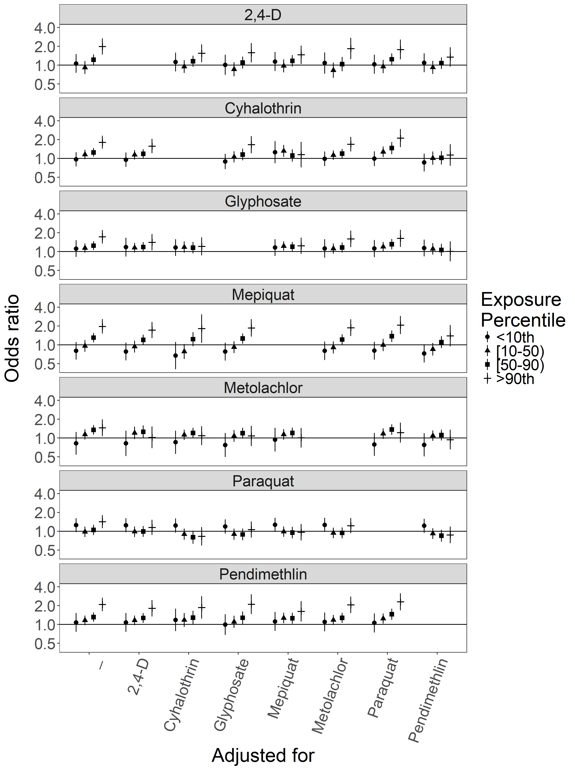
Figure S.1: Odds ratios and 95% confidence intervals for Atrial Septal Defects (ASD) with exposure to pesticide active ingredients compared to unexposed, adjusted for co-pesticide exposure. Numerical ORs and 95% CIs are reported in Supplementary Table S.3.
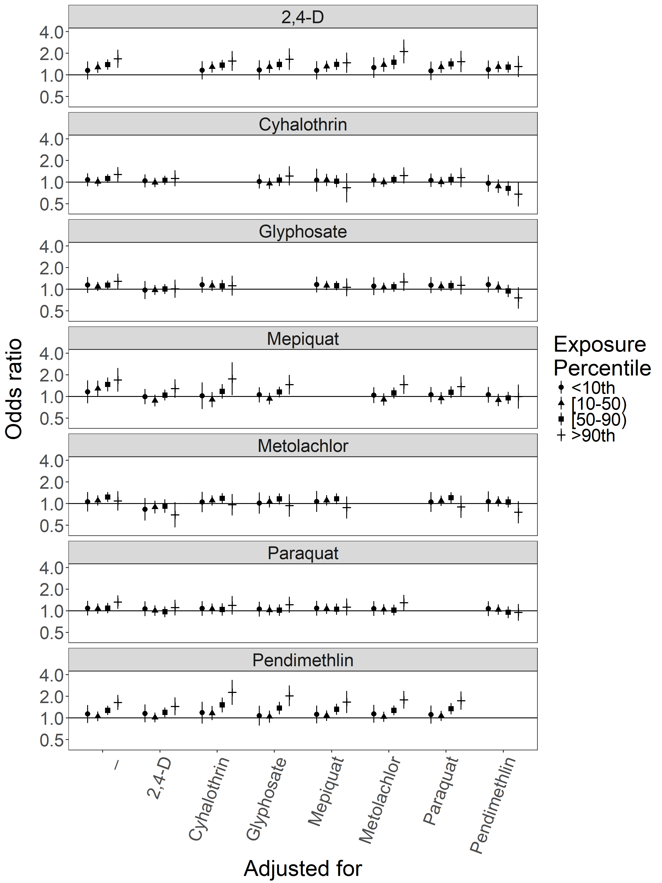
Figure S.2: Odds ratios and 95% confidence intervals for Patent Ductus Arteriosus (PDA) with exposure to pesticide active ingredients compared to unexposed, adjusted for co-pesticide exposure. Numerical ORs and 95% CIs are reported in Supplementary Table S.4.
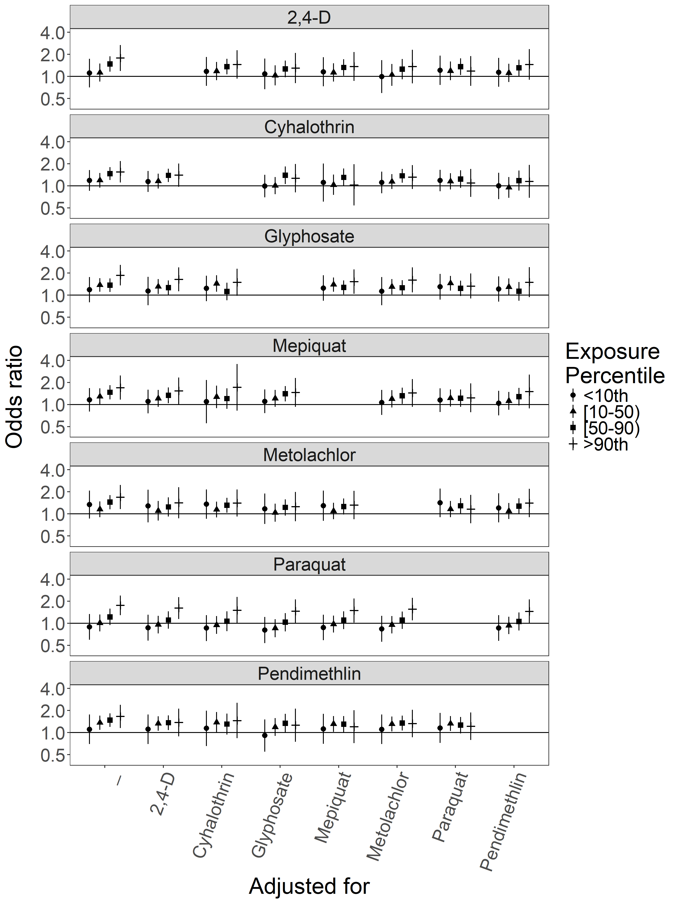
Figure S.3: Odds ratios and 95% confidence intervals for hypertrophic pyloric stenosis (HPS) with exposure to pesticide active ingredients compared to unexposed, adjusted for co-pesticide exposure. Numerical ORs and 95% CIs are reported in Supplementary Table S.5.
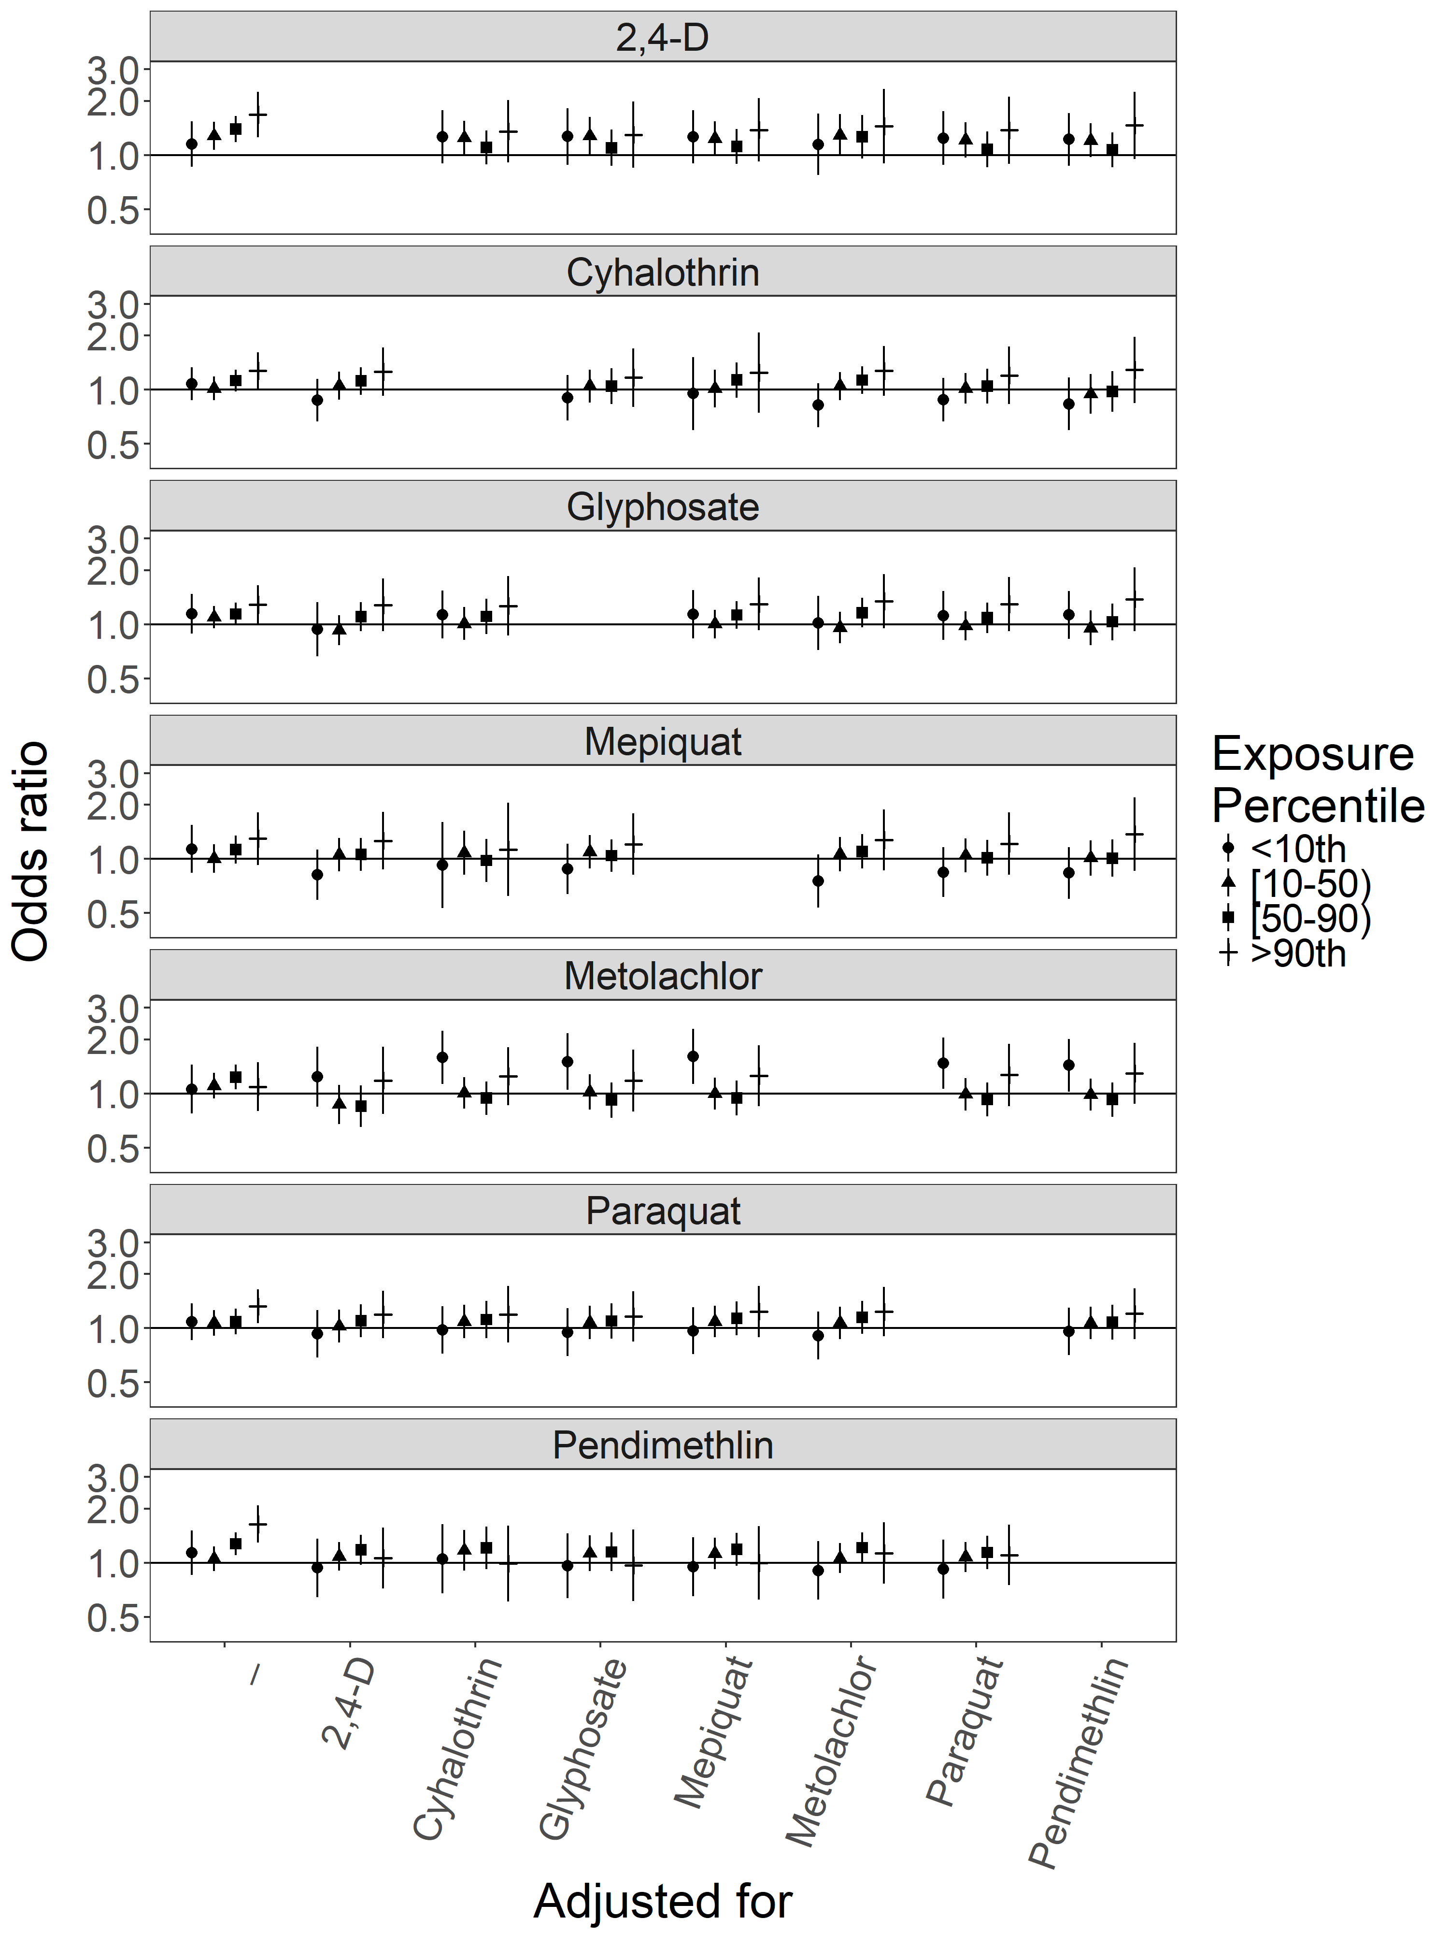
Figure S.4: Odds ratios and 95% confidence intervals for hypospadias with exposure to pesticide active ingredients compared to unexposed, adjusted for co-pesticide exposure. Numerical ORs and 95% CIs are reported in Supplementary Table S.6.

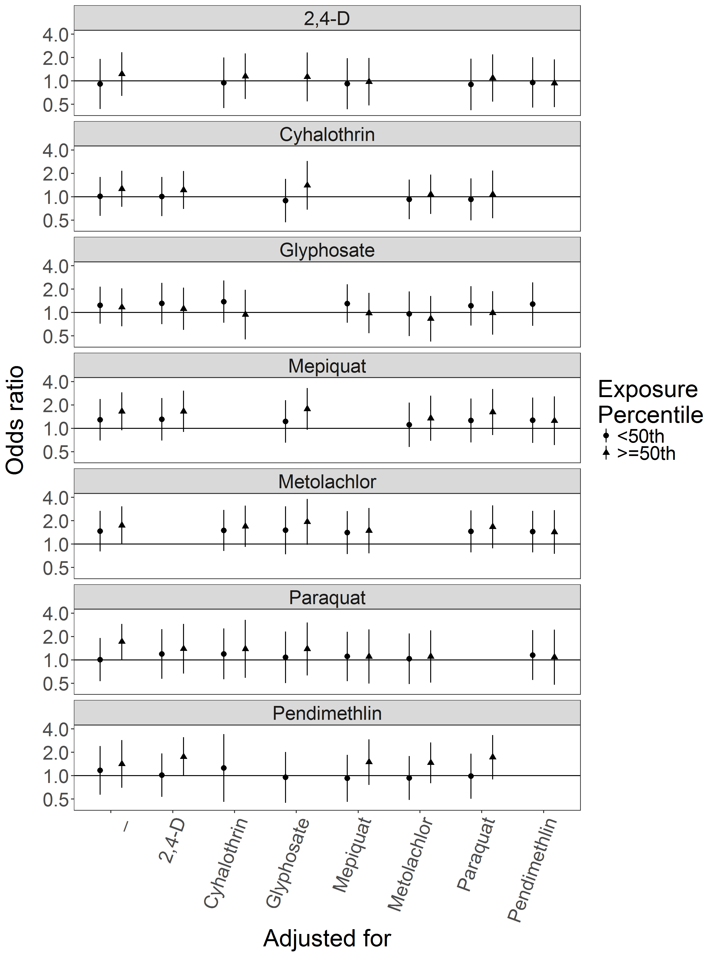
Figure S.5: Odds ratios and 95% confidence intervals for hypoplastic left heart syndrome (HLHS) with exposure to pesticide active ingredients compared to unexposed, adjusted for co-pesticide exposure. Numerical ORs and 95% CIs are reported in Supplementary Table S.7.
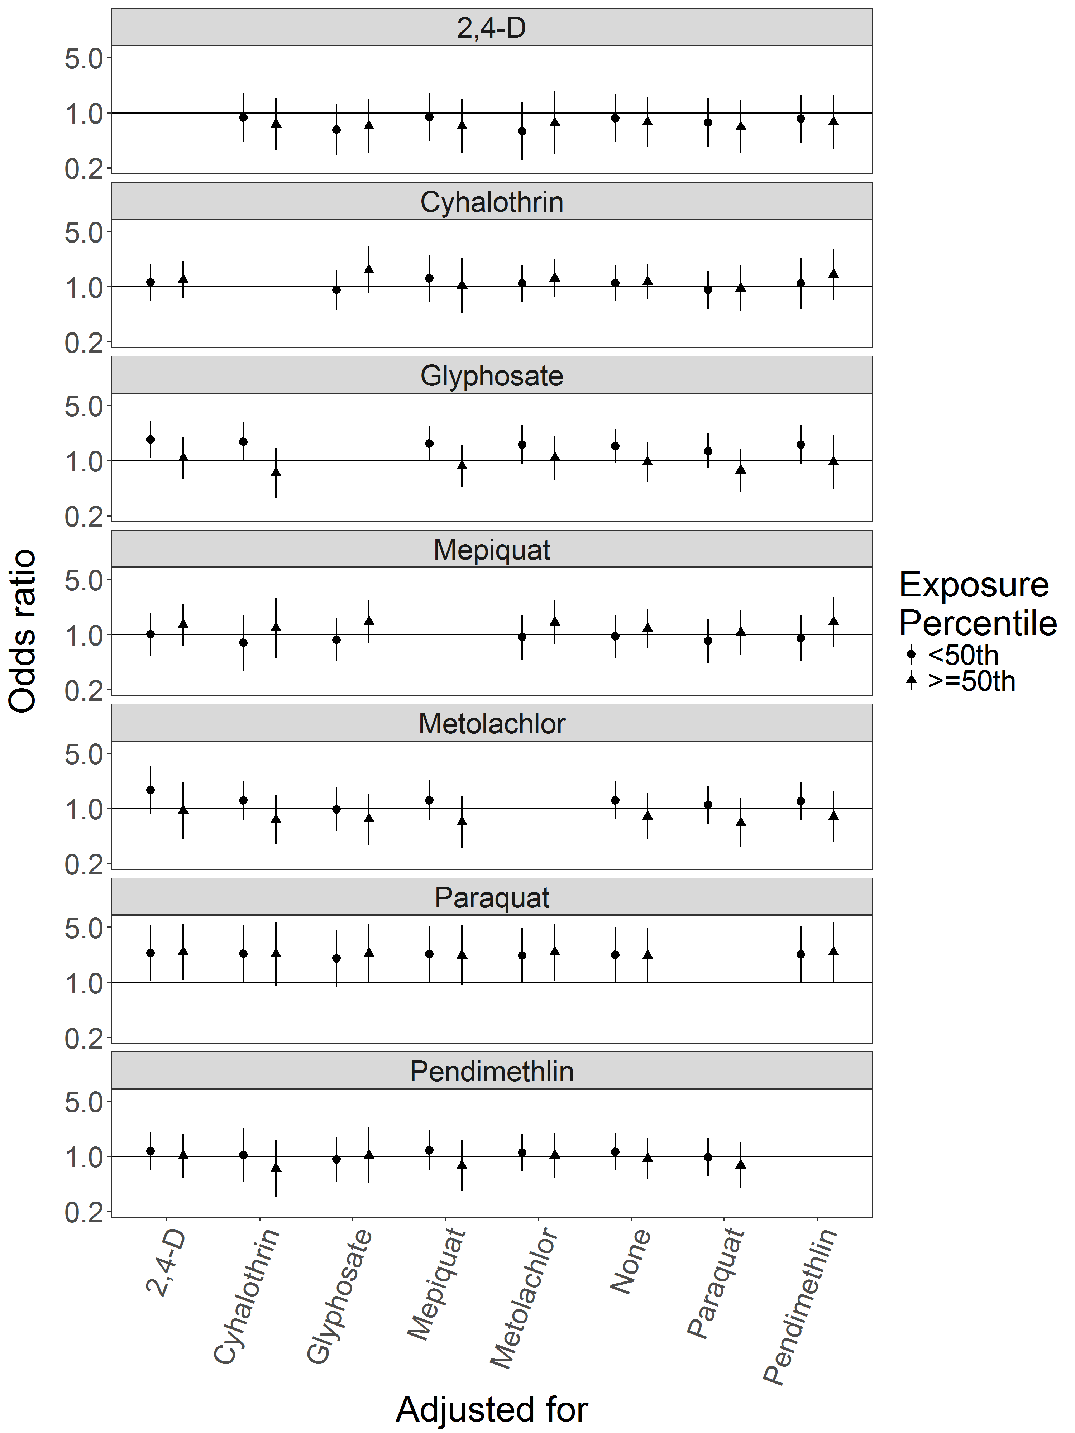
Figure S.6: Odds ratios and 95% confidence intervals for tracheal/esophageal fistula (TEF) with exposure to pesticide active ingredients compared to unexposed, adjusted for co-pesticide exposure. Numerical ORs and 95% CIs are reported in Supplementary Table S.8.

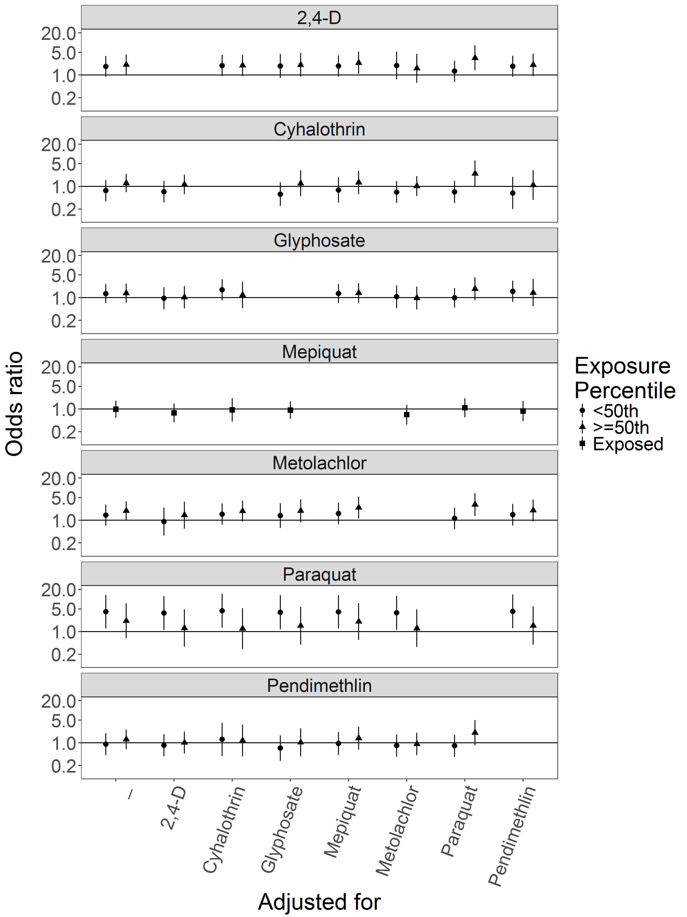
Figure S.7: Odds ratios and 95% confidence intervals for choanal atresia with exposure to pesticide active ingredients compared to unexposed, adjusted for co-pesticide exposure. Numerical ORs and 95% CIs are reported in Supplementary Table S.9.

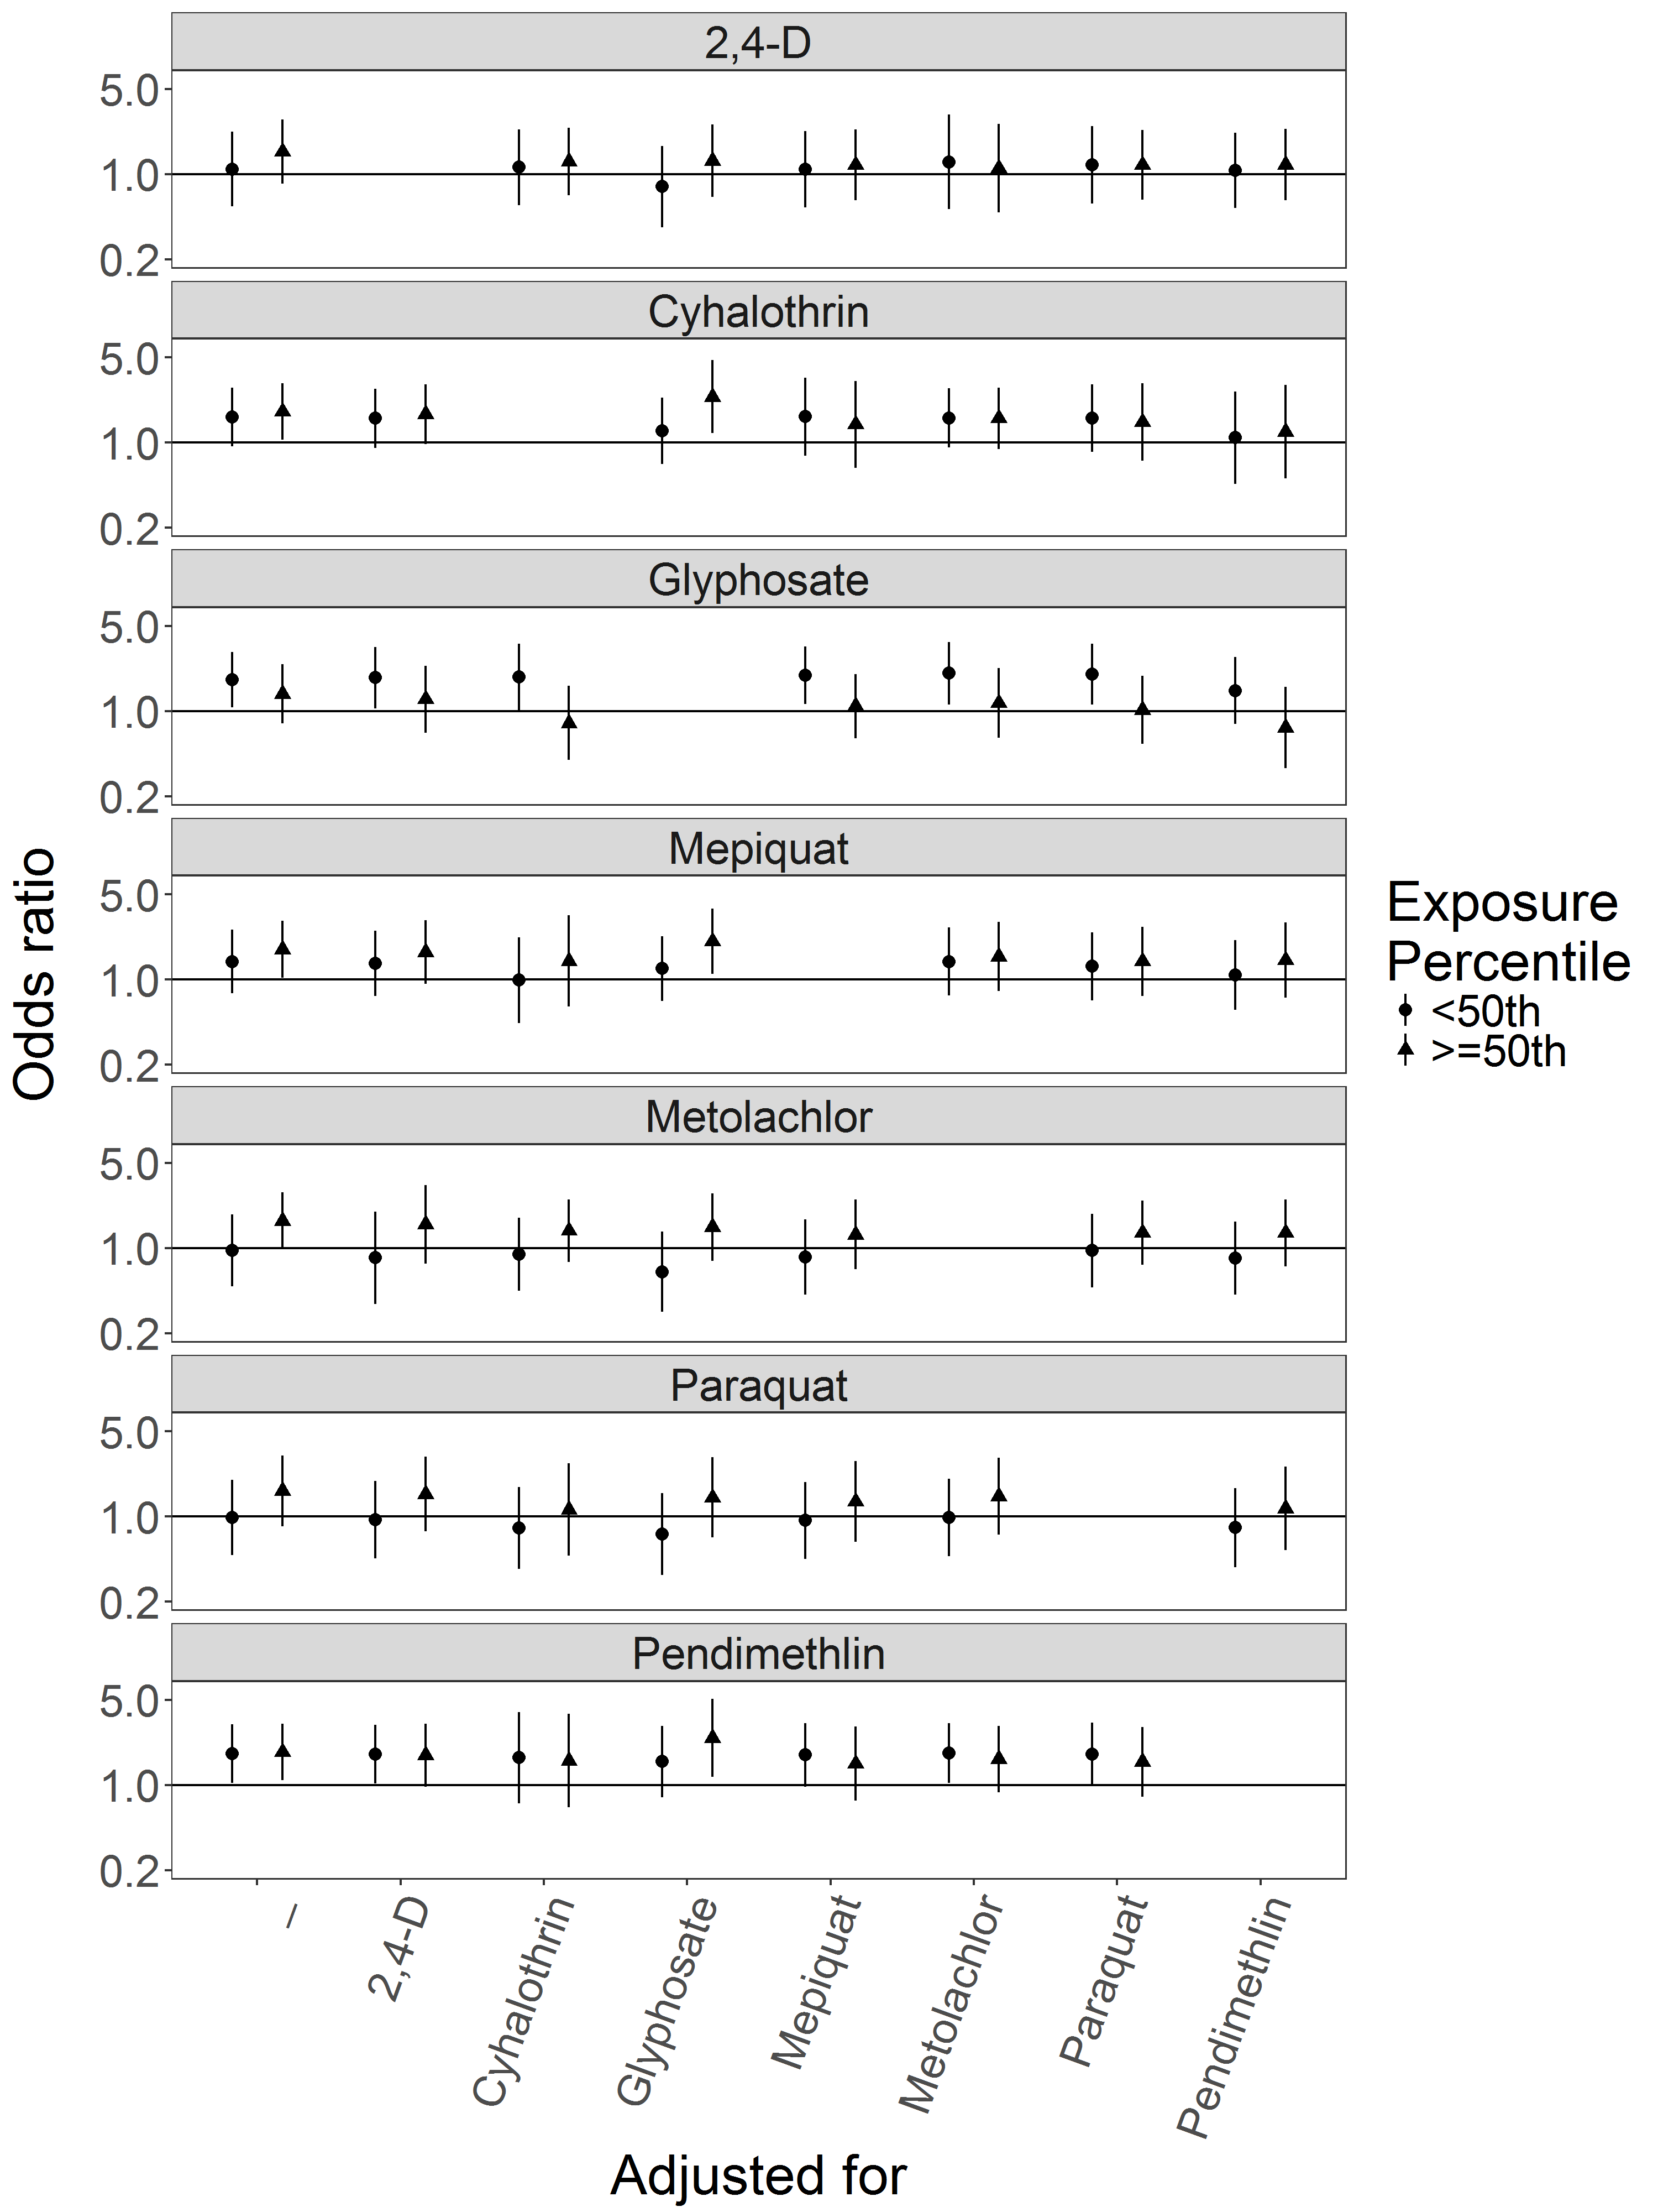
Figure S.8: Odds ratios and 95% confidence intervals for Hirschsprung’s disease with exposure to pesticide active ingredients compared to unexposed, adjusted for co-pesticide exposure. Numerical ORs and 95% CIs are reported in Supplementary Table S.10.

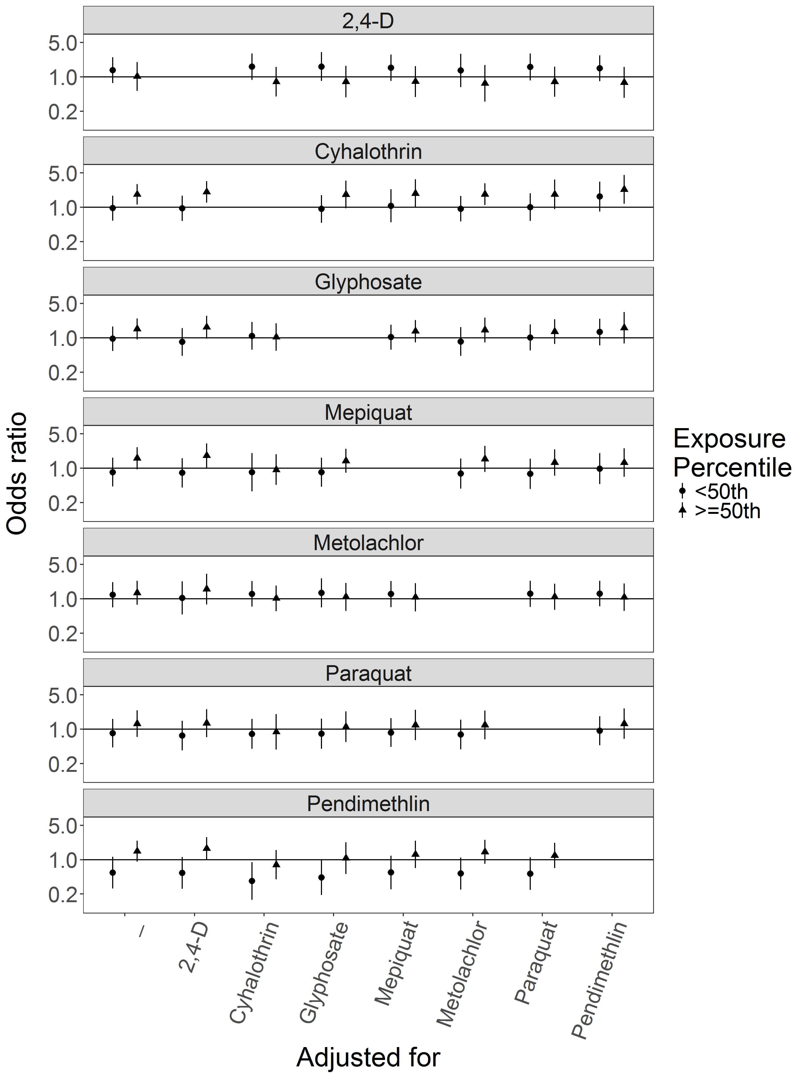
Figure S.9: Odds ratios and 95% confidence intervals for upper limb defects with exposure to pesticide active ingredients compared to unexposed, adjusted for co-pesticide exposure. Numerical ORs and 95% CIs are reported in Supplementary Table S.11.

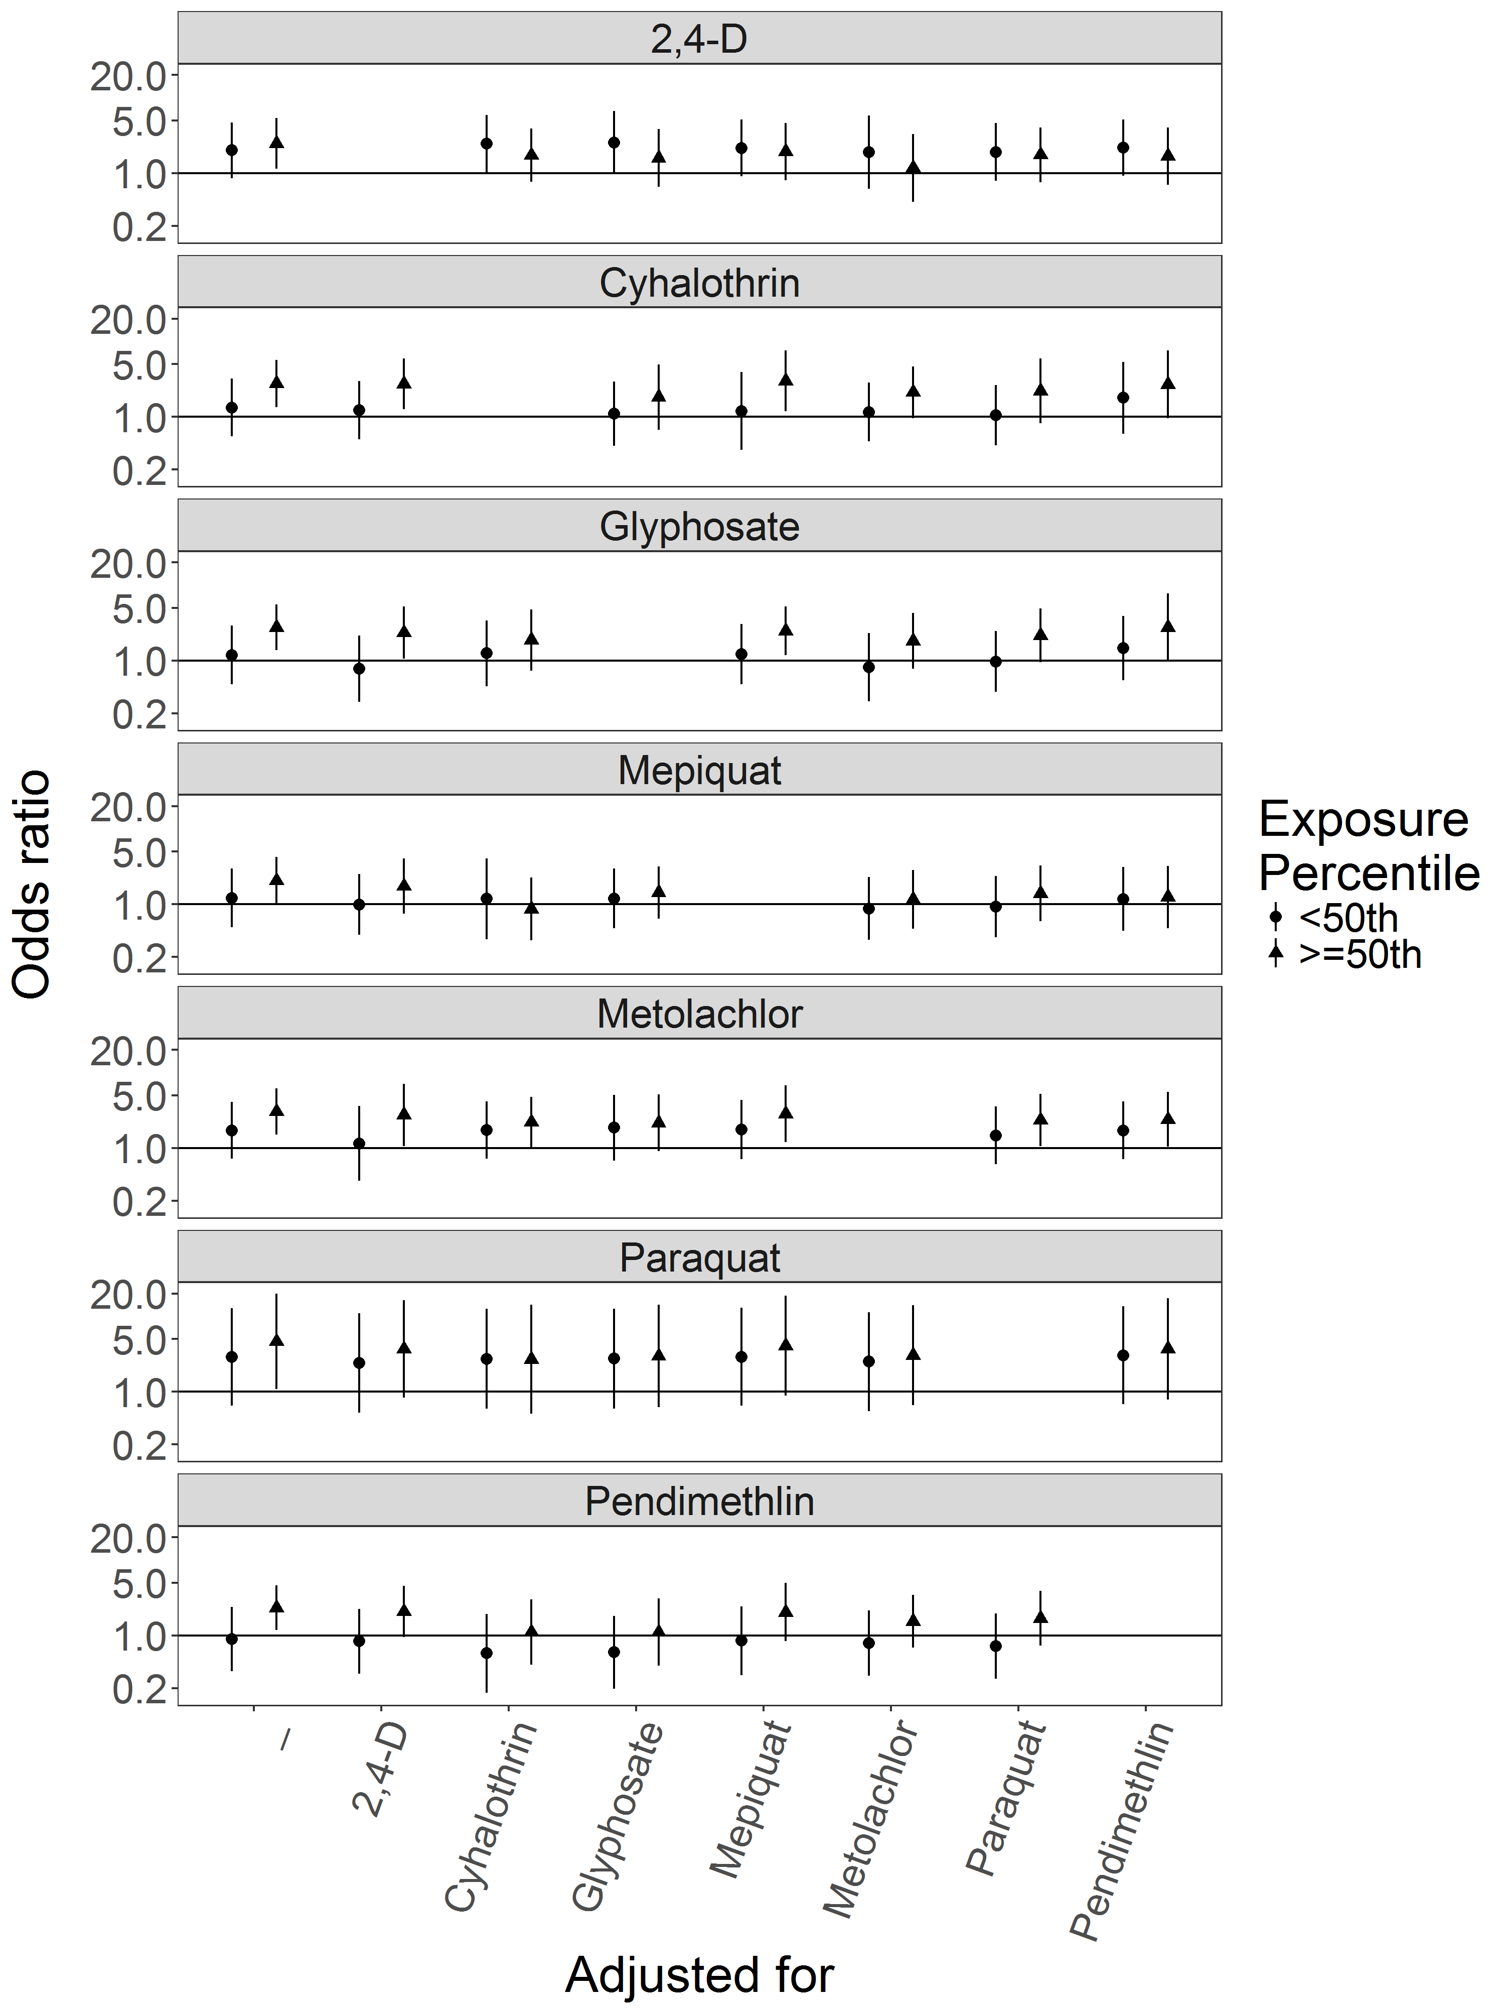
Figure S.10: Odds ratios and 95% confidence intervals for lower limb defects with exposure to pesticide active ingredients compared to unexposed, adjusted for co-pesticide exposure. Numerical ORs and 95% CIs are reported in Supplementary Table S.12.

