Supplementary Information

Supplementary Methods: Additional description of study methods
Supplementary Table 1: Sensitivity analysis of top SNP mental composite score P-values when stratifying over multiple groups of covariates
Supplementary Table 2: Sensitivity analysis of top SNP motor composite score P-values when stratifying over multiple groups of covariates
Supplementary Table 3: Resampling median P-value of top SNPs
Supplementary Table 4: Top twenty-five SNPs associated with mental composite score after meta-analysis
Supplementary Table 5: Top twenty-five SNPs associated with motor composite score after meta-analysis
Supplementary Table 6: Top significant regions in Generalized Higher Criticism set-based testing of 100 kb moving windows over WWTR1 and LRP1B
Supplementary Table 7: Top functional imputed SNP in LRP1B and its association with infant neurodevelopment
Supplementary Table 8: Representative subset of annotation scores providing information about possible transcription regulation roles and conserved functionality.
Supplementary Figure 1: Cohort-specific QQ-plots for P-values from testing for association with mental and motor composite score
Supplementary Figure 2: Meta-analysis QQ-plots for P-values from testing for association with mental and motor composite score
Supplementary Figure 3: Population mean mental and motor composite score by number of minor alleles at rs13013197
Supplementary Figure 4: Local Manhattan plot for WWTR1 using cohort specific P-values for mental composite score and motor composite score
Supplementary Figure 5: Local Manhattan plot for LRP1B using cohort specific P-values for mental composite score and motor composite score
Supplementary Figure 6: Cohort-specific principal components analysis plots using first two principal components
Supplementary Figure 7: Cohort-specific correlation between mental and motor composite scores
References: References for Supplementary Information

Supplementary Methods

Recruitment and enrollment of subjects
In Bangladesh, pregnant women were recruited between 2008 and 2011 from rural health clinics in the Sirajdikhan and Pabna Sadar Upazilas of Bangladesh. These women were 18 years or older, planned to receive prenatal care through the Dhaka Community Hospital, and intended to live in the same house through the pregnancy. One original objective of the cohort was to study the effect of arsenic exposure on reproductive outcomes, and so the Upazilas were selected based on water quality. In Mexico, participants recruited between 2007 and 2011 were healthy pregnant women, at least 18 years of age, received healthcare through the Mexican social security system, and lived within the Mexico City metropolitan area. They also had access to a telephone and planned to continue living in the city for the next three years. This cohort was originally formed to study the effect of toxins on neurodevelopment outcomes.

Collection of data on exposure to potentially hazardous metals
In addition to standard demographic data on infants and their mothers, we were also able to collect information on exposure to potentially hazardous metals for a majority of the subjects. This collection procedure has also been previously described,¹ and it provided us with data on exposure to lead and manganese for 479 (96%) of the children used in the Bangladesh cohort primary analysis. Specifically, the concentrations of these two metals (ug/dl) were measured in the infants’ umbilical cord blood. The same measurements for lead and manganese were collected for 389 (84%) of the infants used in the Mexico cohort primary analysis. We used these measurements in gene-environment interaction models with the top two SNPs from the main analysis.

Exclusion of outlier subjects
Three mother-infant pairs were excluded from all Bangladesh cohort analyses for very preterm births, which was defined as a gestational age of less than or equal to 32 months. Another three mother-infant pairs were excluded from all Mexico cohort analyses for the same reason. These subjects were determined to be significant outliers with developmental patterns that may differ from full-term children. No other exclusions to the primary analysis were made due to non-genetic covariate information. The final sample sizes after exclusion were 502 mother-infant pairs in Bangladesh and 462 pairs in Mexico.

Upon inspection, a few of the recorded metal concentrations in the Bangladesh cohort appeared to be errors, describing values that might be fatal to infants. Thus whenever a metal measurement was used in a gene-environment interaction model, we additionally removed all subjects who recorded a concentration greater than 5 standard deviations from the mean for that metal. This resulted in the removal of an additional two subjects when using lead and three when using manganese, all from Bangladesh. No outliers for metal concentration were removed from the Mexico cohort. The final sample size for metals-related models was then either 477 or 476 in Bangladesh and 389 in Mexico.

Further details on genotyping and genotype quality control

Blood samples were collected from the umbilical cord during delivery of infants in both the Bangladesh and Mexico cohorts. An umbilical cord catheter and Paxgene DNA collection tubes were used. We extracted DNA from whole blood using Puregene DNA isolation kits and stored samples at -20 ºC.

Standard quality control measures² were applied to both subjects and SNPs. In particular, we excluded samples if their overall genotype completion rate was less than 95%, if there was a gender mismatch, if there were duplicates or probable relatives (using PLINK to identify parameter pi_hat > 0.185), if there were outlying heterozygosity rates greater than six standard deviations from the mean, or outliers identified during principal components analysis. We excluded SNPs if they had a call rate of less than 95%, if the Hardy-Weinberg equilibrium P-value was less than 10⁻⁶, or if SNPs were monomorphic in our sample. Finally we also filtered out SNPs with minor allele frequency (MAF) less than 1% in our sample, as rare SNPs may not have produced test statistics following the assumed normal distribution. After these filtering steps, there were 552,487 SNPs common to both populations available for analysis.

Controlling for population stratification
To assess if there was any population stratification within the two cohorts, we used EIGENSTRAT³ to generate genotype principal components for each cohort separately. Exploratory analysis of the components seemed to show very little differentiation within each cohort, which was to be expected since the participants were recruited from two small and ethnically homogenous geographic areas. As our models already contained many covariates to adjust for potential confounders, and because the analysis strategy described in the main text also protects from population stratification, we made the decision to use only two principal components in the genome-wide association scan to lessen the risk of overfitting.

Power simulations

Power simulations were carried out using custom scripts in R version 3.3.1. Our study was slightly underpowered to detect effects of moderate size; we found that power to detect a highly impactful variant accounting for 2.5% of the total phenotypic variance was approximately 32%. Larger sample sizes, though difficult to obtain, would increase power.

Sensitivity analyses

We performed a number of sensitivity analyses (Supplementary Tables 1-3) to check the robustness of the top results. We first stratified the cohort by a number of covariates including gender, gestational age, mother’s educational level, and household smoking. None of the stratified associations were multiple orders of magnitude more significant than the unstratified association. We also performed nonparametric bootstrapping to recalculate the top SNP P-values 1,000 times. The median P-value in each case was close to the originally reported P-value. Thus we considered the originally presented results to offer a fairly representative summary of the associations at the most significant SNPs.

Imputation
Imputation was carried out in the genes containing the top SNPs from the initial scan. We used IMPUTE2⁴ with the entire 1000 Genomes Phase 3⁵ reference panel to fine-map regions containing our genes of interest, defining each region as the gene location from NCBI Human Genome Build 37.13 and then adding a 10 kb buffer to each end of the gene. The same single-SNP models used in the initial genome-wide association testing were applied to all imputed SNPs with MAF greater than 1%.

Functional analysis of variants in LRP1B
To search for the most functional variants in LRP1B, we first searched for all SNPs within 50 kb of the original rs13013197 association that also demonstrated a similarly strong association with at least one of the composite scores. Here similarly strong meant that the P-value was either less than or at most one order of magnitude (i.e. a factor of ten) greater than the original associations. We found eight imputed SNPs meeting these criteria. We then collected data from dozens of multi-omics sources and used them to check if the top variants fell into one of two functional classes that could be inferred from publicly available data: (1) regulators of transcription and (2) evolutionarily conserved.

To see if a SNP was conserved, we checked eight evolutionary conservation scores (GERP_NR, GERP_RS, PhyloPri, PhyloPla, PhyloVer, PhastPri, PhastPla, PhastVer) taken from the EIGEN⁶ database. To check if a SNP regulated transcription, we used 28 annotations from the CADD v1.3 database,⁷ including histone modification marks, open chromatin marks, transcription factor binding site location, and ChromHMM states. The full list of scores taken from the database included: GC, CpG, ENCODE histone modification marks EncH3K27Ac, EncH3K4Me1, EncH3K4Me3, EncExp, EncOCCombPVal, EncOCDNasePVal, EncOCFairePVal, EncOCpolIIPVal, EncOCctcfPVal, EncOCmycPVal, EncOCDNaseSig, EncOCFaireSig, EncOCpolIISig, EncOCctcfSig, and EncOCmycSig, TFBS, TFBSPeaks, TFBSPeaksMax, cHmmTSS, cHmmTx, cHmmEnh, cHmmZnf, cHmmRepr, bStatistic, minDistTSS, and minDistTSE.

Representative values of annotation scores from both classes are given in Supplementary Table 8. We manually inspected all scores for each of the eight highly associated imputed SNPs as well as the originally genotyped SNP.

Supplementary Table 1: Sensitivity analysis of top SNP mental composite score P-values when stratifying over multiple groups of covariates

SNP | Original  P-value | Males | Females | Low Gestage | High Gestage | Low Educ | High Educ | Non-Smoking Household | Smoking Household
rs1055153 | 1.56$×{10}^{-8}$ | 4.36$×{10}^{-3}$ | 9.08$×{10}^{-8}$ | 2.53$×{10}^{-3}$ | 2.65$×{10}^{-6}$ | 4.99$×{10}^{-6}$ | 3.83$×{10}^{-8}$ | 6.83$×{10}^{-5}$ | 2.27$×{10}^{-5}$
rs13013197 | 1.87$×{10}^{-5}$ | 8.11$×{10}^{-5}$ | 2.26$×{10}^{-2}$ | 2.50$×{10}^{-4}$ | 1.22$×{10}^{-3}$ | 1.12$×{10}^{-1}$ | 3.43$×{10}^{-5}$ | 5.71$×{10}^{-4}$ | 1.77$×{10}^{-2}$
rs13035290 | 3.31$×{10}^{-4}$ | 2.86$×{10}^{-5}$ | 2.38$×{10}^{-1}$ | 1.01$×{10}^{-2}$ | 2.74$×{10}^{-3}$ | 1.81$×{10}^{-1}$ | 1.00$×{10}^{-3}$ | 7.20$×{10}^{-8}$ | 1.36$×{10}^{-1}$

Abbreviations: Gestage, gestational age (low refers to <36 weeks, high refers to greater than or equal to 36 weeks); Educ, education (low refers to primary school or less, high refers to more than primary school)

\

Supplementary Table 2: Sensitivity analysis of top SNP motor composite score P-values when stratifying over multiple groups of covariates

SNP | Original  P-value | Males | Females | Low Gestage | High Gestage | Low Educ | High Educ | Non-Smoking Household | Smoking Household
rs1055153 | 2.17$×{10}^{-5}$ | 3.35$×{10}^{-2}$ | 8.28$×{10}^{-5}$ | 1.60$×{10}^{-4}$ | 3.09$×{10}^{-3}$ | 7.00$×{10}^{-4}$ | 1.05$×{10}^{-2}$ | 4.75$×{10}^{-4}$ | 1.18$×{10}^{-2}$
rs13013197 | 3.63$×{10}^{-5}$ | 8.82$×{10}^{-5}$ | 5.34$×{10}^{-2}$ | 1.68${×10}^{-1}$ | 6.50$×{10}^{-5}$ | 6.07$×{10}^{-2}$ | 7.75$×{10}^{-5}$ | 1.08$×{10}^{-4}$ | 6.80$×{10}^{-2}$
rs13035290 | 5.81$×{10}^{-5}$ | 8.68$×{10}^{-6}$ | 1.69$×{10}^{-1}$ | 4.16$×{10}^{-1}$ | 5.55$×{10}^{-5}$ | 9.73$×{10}^{-2}$ | 8.87$×{10}^{-3}$ | 1.29$×{10}^{-5}$ | 2.93$×{10}^{-1}$

Abbreviations: Gestage, gestational age (low refers to <36 weeks, high refers to greater than or equal to 36 weeks); Educ, education (low refers to primary school or less, high refers to more than primary school)

Supplementary Table 3: Resampling median P-value of top SNPs

SNP | Original P-value | Bootstrap Median P-value
Mental Composite Score
rs1055153 | 1.56$×{10}^{-8}$ | 1.72$×{10}^{-8}$
rs13013197 | 1.87$×{10}^{-5}$ | 1.95$×{10}^{-5}$
rs13035290 | 3.31$×{10}^{-4}$ | 3.29$×{10}^{-4}$
Motor Composite Score
rs1055153 | 2.17$×{10}^{-5}$ | 2.57$×{10}^{-8}$
rs13013197 | 3.63$×{10}^{-5}$ | 1.98$×{10}^{-5}$
rs13035290 | 5.81$×{10}^{-5}$ | 3.81$×{10}^{-4}$

Supplementary Table 4: Top twenty-five SNPs associated with mental composite score

SNP | Effect  Sizeª | 95% CI | P-value |  | Chr | Location^{b}
rs6021602 | -2.89 | -3.88 to -1.89 | 1.26$×{10}^{-8}$ |  | 20 | 50606329
rs1055153 | -6.04 | -8.13 to -3.94 |  | 1.56$×{10}^{-8}$ | 3 | 149374873
rs6096686 | -2.23 | -3.13 to -1.32 | 1.55$×{10}^{-6}$ |  | 20 | 50586703
rs4363243 | -2.90 | -4.09 to -1.70 | 2.13$×{10}^{-6}$ |  | 8 | 73067682
rs3806830 | 4.50 | 2.58 to 6.41 | 4.20$×{10}^{-6}$ |  | 5 | 140796099
rs1392872 | -2.69 | -3.85 to -1.54 | 4.50$×{10}^{-6}$ |  | 8 | 132921441
rs12961876 | 8.73 | 4.96 to 12.5 | 5.78$×{10}^{-6}$ |  | 18 | 32233906
rs1201289 | -1.99 | -2.86 to -1.12 | 7.65$×{10}^{-6}$ |  | 3 | 176822676
rs12592703 | -2.13 | -3.08 to -1.18 | 1.05$×{10}^{-5}$ |  | 15 | 54311885
rs10044763 | 5.23 | 2.90 to 7.57 | 1.12$×{10}^{-5}$ |  | 5 | 140937935
rs9344125 | 2.41 | 1.33 to 3.49 | 1.15$×{10}^{-5}$ |  | 6 | 81904308
rs4751252 | 2.29 | 1.27 to 3.32 | 1.16$×{10}^{-5}$ |  | 10 | 132406880
rs720899 | 2.21 | 1.22 to 3.19 | 1.18$×{10}^{-5}$ |  | 1 | 145550922
rs17349020 | -3.57 | -5.17 to -1.96 | 1.28$×{10}^{-5}$ |  | 1 | 4652284
rs4381915 | 2.57 | 1.40 to 3.73 | 1.51$×{10}^{-5}$ |  | 3 | 184468603
rs7732160 | -4.16 | -6.06 to -2.26 | 1.72$×{10}^{-5}$ |  | 5 | 140800708
rs1146908 | 2.53 | 1.37 to 3.69 | 1.83$×{10}^{-5}$ |  | 13 | 76935296
rs13013197 | 2.01 | 1.09 to 2.93 | 1.86$×{10}^{-5}$ |  | 2 | 141882963
rs9479664 | 4.10 | 2.22 to 5.98 | 1.94$×{10}^{-5}$ |  | 6 | 153945567
rs10477147 | 4.66 | 2.52 to 6.80 | 1.94$×{10}^{-5}$ |  | 5 | 140882770
rs7631725 | 2.88 | 1.55 to 4.21 | 2.27$×{10}^{-5}$ |  | 3 | 169304895
rs7018386 | -1.88 | -2.75 to -1.01 | 2.47$×{10}^{-5}$ |  | 8 | 128519957
rs9544249 | 1.87 | 1 to 2.75 | 2.59$×{10}^{-5}$ |  | 13 | 76912859
rs12412410 | -2.87 | -4.21 to -1.53 | 2.66$×{10}^{-5}$ |  | 10 | 119694680
rs6786351 | 1.83 | 0.96 to 2.69 | 3.38$×{10}^{-5}$ |  | 3 | 176887272

Abbreviations: SNP, Single Nucleotide Polymorphism; CI, Confidence Interval; Chr, Chromosome.
ª Effect size refers to the estimated mean change in mental composite score for one additional minor allele, holding all other covariates constant.
^{b} BP according to NCBI Build 37/UCSC hg19.

Supplementary Table 5: Top twenty-five SNPs associated with motor composite score

SNP | Effect Sizeª |  | 95% CI |  | P-value |  | Chr |  | Location^{b}
rs2064040 | 1.09 |  | 0.68 to 1.50 |  | 2.08$×{10}^{-7}$ |  | 21 |  | 16584341
rs7326020 | 1.64 | 0.94 to 2.34 |  | 3.89$×{10}^{-6}$ |  | 13 |  | 74126153
rs243570 | -1.67 |  | -2.38 to -0.95 |  | 5.17$×{10}^{-6}$ |  | 21 |  | 19128706
rs10197080 | -1.88 |  | -2.70 to -1.07 |  | 5.62$×{10}^{-6}$ |  | 2 |  | 224096286
rs7223173 | -0.99 |  | -1.42 to -0.56 |  | 6.52$×{10}^{-6}$ |  | 17 |  | 18805887
rs1813454 | 1.03 |  | 0.57 to 1.49 |  | 1.22$×{10}^{-5}$ |  | 5 |  | 17961096
rs4822843 | -1.38 |  | -2.00 to -0.76 |  | 1.24$×{10}^{-5}$ |  | 22 |  | 27471525
rs9973600 | -1.08 |  | -1.58 to -0.59 |  | 1.56$×{10}^{-5}$ |  | 2 |  | 80283255
rs764324 | -1.04 |  | -1.51 to -0.56 |  | 1.78$×{10}^{-5}$ |  | 4 |  | 867866
rs4770844 | 0.93 |  | 0.50 to 1.35 |  | 1.85$×{10}^{-5}$ |  | 13 |  | 26115298
rs10421422 | -0.93 |  | -1.35 to -0.50 |  | 1.89$×{10}^{-5}$ |  | 19 |  | 14246429
rs9578871 | 0.93 |  | 0.50 to 1.35 |  | 2.00$×{10}^{-5}$ |  | 13 |  | 26079627
rs7596307 | 1.01 |  | 0.55 to 1.48 |  | 2.04$×{10}^{-5}$ |  | 2 |  | 80286981
rs10912994 | 0.93 |  | 0.50 to 1.36 |  | 2.08$×{10}^{-5}$ |  | 1 |  | 175488409
rs1055153 | -2.21 |  | -3.22 to -1.19 |  | 2.17$×{10}^{-5}$ |  | 3 |  | 149374873
rs12705771 | 1.33 |  | 0.71 to 1.95 |  | 2.50$×{10}^{-5}$ |  | 7 |  | 78403188
rs9581364 | 0.94 |  | 0.50 to 1.37 |  | 2.52$×{10}^{-5}$ |  | 13 |  | 26084060
rs2823149 | 0.95 |  | 0.51 to 1.39 |  | 2.59$×{10}^{-5}$ |  | 21 |  | 16585201
rs4630608 | 0.95 |  | 0.51 to 1.39 |  | 2.76$×{10}^{-5}$ |  | 17 |  | 18678548
rs11931372 | 1.72 |  | 0.91 to 2.52 |  | 3.04$×{10}^{-5}$ |  | 4 |  | 165361556
rs7239026 | 2.37 |  | 1.26 to 3.49 |  | 3.04$×{10}^{-5}$ |  | 18 |  | 68173054
rs1950826 | -0.98 |  | -1.44 to -0.52 |  | 3.06$×{10}^{-5}$ |  | 14 |  | 38039969
rs7618427 | -1.30 |  | -1.92 to -0.68 |  | 3.62$×{10}^{-5}$ |  | 3 |  | 106615905
rs13013197 | 0.95 |  | 0.50 to 1.40 |  | 3.63$×{10}^{-5}$ |  | 2 |  | 141882963
rs12595839 | 1.34 |  | 0.70 to 1.98 |  | 4.38$×{10}^{-5}$ |  | 15 |  | 38617062

Abbreviations: SNP, Single Nucleotide Polymorphism; CI, Confidence Interval; Chr, Chromosome
ª Effect size refers to the estimated mean change in motor composite score for one additional minor allele, holding all other covariates constant.
^{b} BP according to NCBI Build 37/UCSC hg19.

Supplementary Table 6: Top significant regions in Generalized Higher Criticism set-based testing of 100 kb moving windows over WWTR1 and LRP1B

Gene | Chr | Start (BP)ª | End (BP) | Number  of SNPs | Mental Composite Score P-value | Motor Composite Score P-value
WWTR1 | 3 | 149335022 | 149435021 | 426 | $$1.18×{10}^{-5}$$ | $$8.60×{10}^{-4}$$
LRP1B | 2 | 140988996 | 141088995 | 256 | $$2.19×{10}^{-3}$$ | $$1.08×{10}^{-3}$$

Abbreviations: Chr, chromosome; BP, base pair.
ªGene locations taken from NCBI Build 37/UCSC hg19.

Supplementary Table 7: Top functional imputed SNP in LRP1B and its association with infant mental and motor composite score

 | Mental Composite Score |  |  | Motor Composite Score
Cohort | Effect Sizeª (SD) | 95% CI | P-value | Effect Sizeª  (SD) | 95% CI | P-value | MAF
rs13035290/Chr2:141 908 304^{b}
Meta-Analysis | 1.69 (0.47) | 0.77 to 2.61 | 3.31$×{10}^{-4}$ | 0.92 (0.34) | 0.47 to 1.37 | 5.81$×{10}^{-5}$ | 0.33
Bangladesh | 1.44 (0.73) | 0.01 to 2.87 | 4.97$×{10}^{-2}$ | 0.70 (0.35) | 0.35 to 1.38 | 4.66$×{10}^{-2}$ | 0.28
Mexico | 1.87 (0.61) | 0.66 to 5.53 | 4.97$×{10}^{-2}$ | 1.09 (0.30) | 0.79 to 1.40 | 3.63$×{10}^{-4}$ | 0.40
Abbreviations: SD, standard error; CI, confidence interval; MAF, minor allele frequency
ª Effect size refers to the estimated mean change in outcome for one additional minor allele, holding all other covariates constant.
^{b} SNP position recorded from NCBI Build 37/UCSC hg19 coordinates. This SNP resides in the gene LRP1B, and the minor allele is T.

Supplementary Table 8: Representative subset of annotation scores providing information about possible transcription regulation roles and conserved functionality.

Position (BP) | priPhCons | priPhyloP | CADD | EncH3K27Ac | EncH3K4Me1 | EncH3K4Me3
141882709 | 0.024 | -0.451 | 2.904 | 2.56 | 1 | 2
141882963 | 0.079 | 0.509 | 6.373 | 2 | 4 | 4.4
141884925 | 0.304 | 0.243 | 7.436 | NA | 1 | 4
141893894 | 0.269 | 0.53 | 9.154 | 2.56 | 2 | 2
141899578 | 0.039 | -0.449 | 2.415 | 1 | 1 | 2
141903393 | 0.001 | -1.201 | 0.192 | 2 | 2 | 1
141906551 | 0.25 | 0.188 | 6.118 | 3 | 1 | 1.72
141908304 | 0.831 | 0.581 | 15.93 | 3 | 7.88 | 1.92

Abbreviations: priPhCons, primate phastCons score; priPhyloP, primate phyloP score
Supplementary Figure 1: Cohort-specific QQ-plots for P-values from testing for association with mental and motor composite score
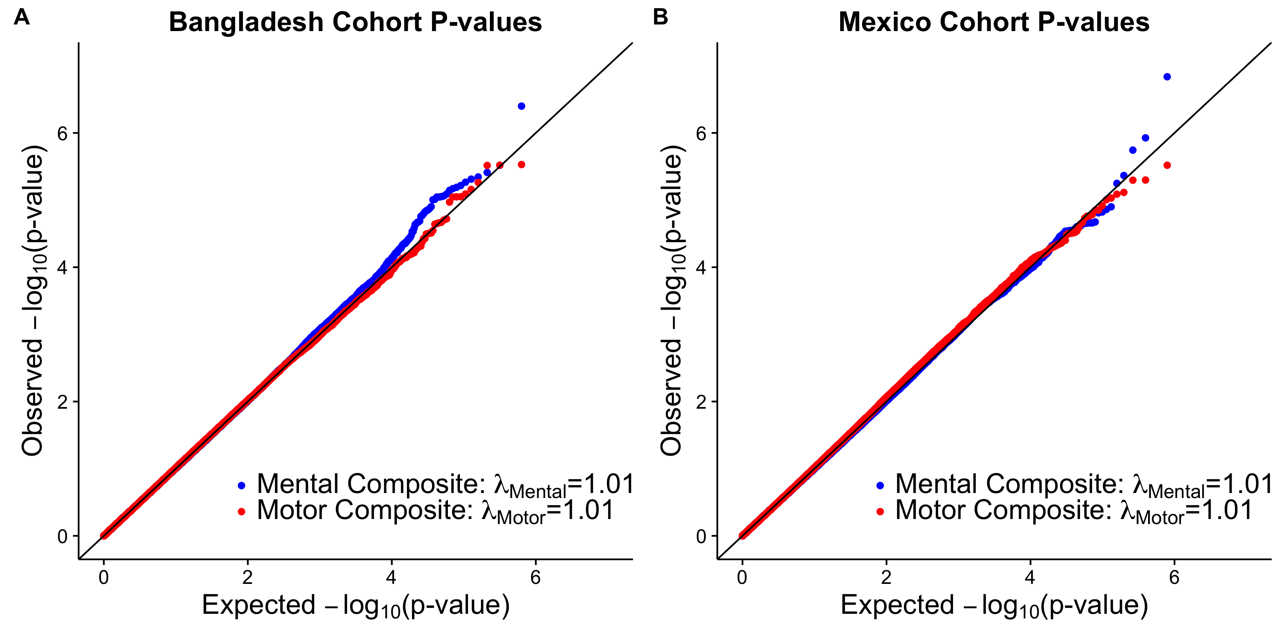
The P-values from cohort-specific GWAS scans are plotted prior to being combined for meta-analysis. On the left is the Bangladesh cohort (Panel A), and on the right is the Mexico cohort (Panel B). The Genomic Inflation Factor, defined as the ratio of the median of the empirically observed distribution of test statistics to the expected median, is given in the legend. We see that all four combinations of cohort and outcome show almost no inflation, which provides a measure of assurance in the inference procedure and subsequent meta-analysis.

Supplementary Figure 2: Meta-analysis QQ-plots for P-values from testing for association with mental and motor composite score
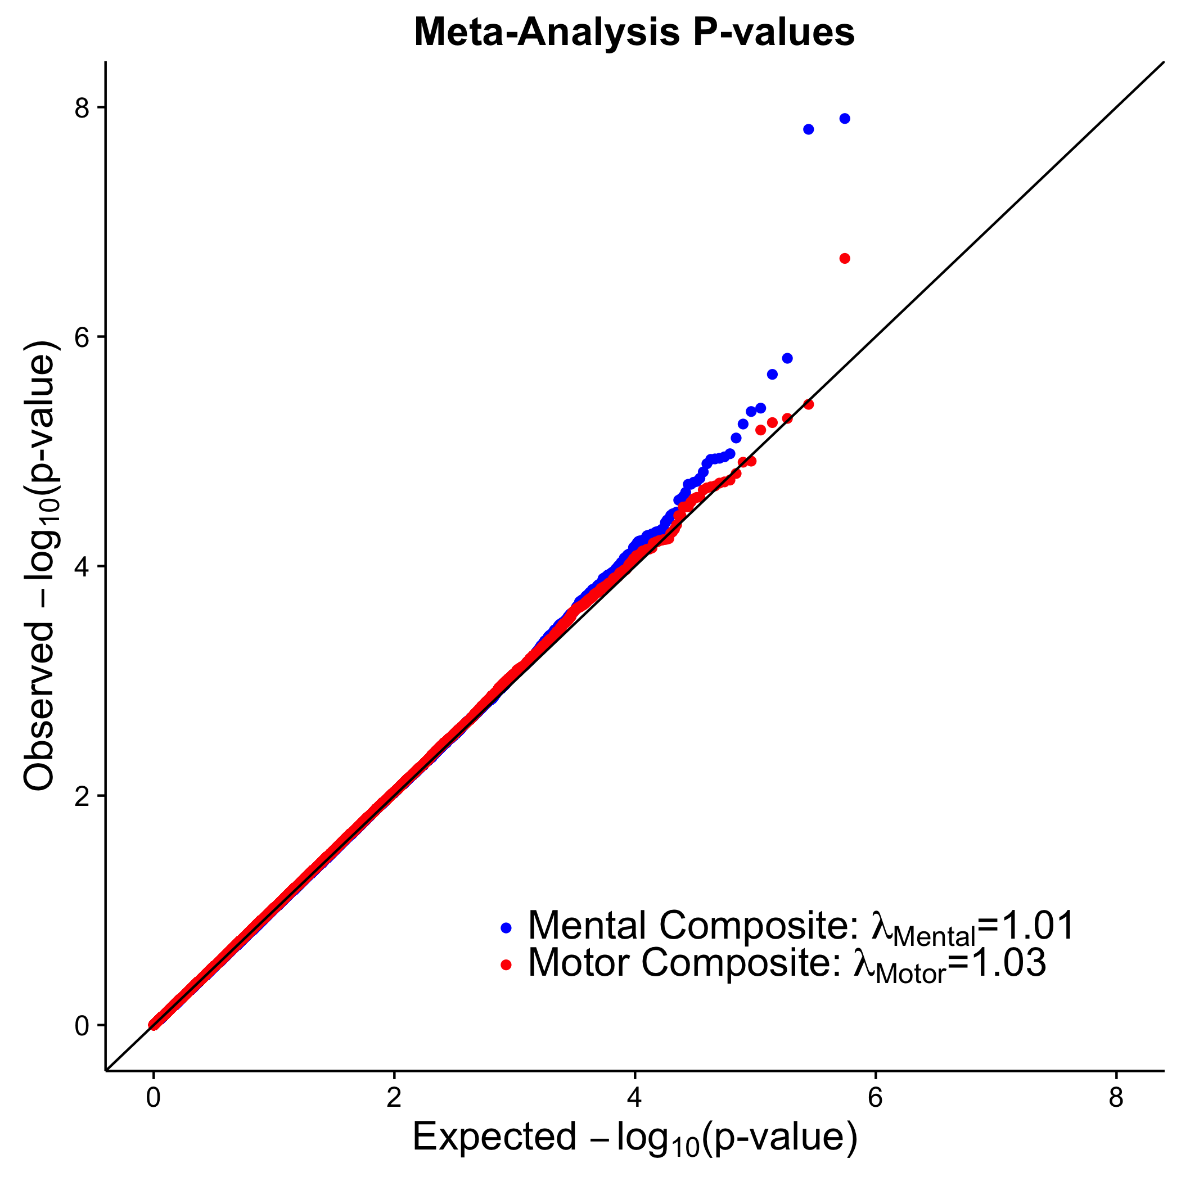
The meta-analysis P-values for mental composite score and motor composite score are plotted. The Genomic Inflation Factor, defined as the ratio of the median of the empirically observed distribution of test statistics to the expected median, is given in the legend. We see that the amount of inflation present in these P-values is very slight, which provides an additional degree of confidence in our top hits.
Supplementary Figure 3: Population mean mental and motor composite score by number of minor alleles at rs13013197
Boxplots for mean mental composite score (Panel A) and motor composite score (Panel B) within Bangladesh and Mexico for rs13013197. Thick black line shows the median, and the box ends at the first and third quartiles. Whiskers extend to 1.5 times the interquartile range.

Supplementary Figure 4: Local Manhattan plot for WWTR1 using cohort specific P-values for mental composite score and motor composite score

Cohort-specific P-values including both originally genotyped SNPs and imputed SNPs for mental composite score (top) and motor composite score (bottom). Asterisks (*) are used to denote the top SNP from the initial analysis (rs1055153). Solid icons denote SNPs that have squared Pearson correlation coefficient r² greater than or equal to 0.5 with the top SNPs. SNPs with cohort-specific P-values less than 0.01 are shown in gray to demonstrate contrast in gene-wide association levels between the two outcomes.

Supplementary Figure 5: Local Manhattan plot for LRP1B using cohort specific P-values for mental composite score and motor composite score

Cohort-specific P-values including both originally genotyped SNPs and imputed SNPs for mental composite score (top) and motor composite score (bottom). Asterisks (*) are used to denote the top SNP from the initial analysis (rs13013197). Solid icons denote SNPs that have squared Pearson correlation coefficient r² greater than or equal to 0.5 with the top SNPs. SNPs with cohort-specific P-values less than 0.01 are shown in gray to demonstrate contrast in gene-wide association levels between the two outcomes.

Supplementary Figure 6: Cohort-specific principal components analysis plots using first two principal components

Cohort-specific principal components show very little population stratification; the Bangladesh cohort (top) appears to be fairly homogenous, and the Mexico cohort (bottom) separates almost entirely on the first principal component except for a few outliers. The close grouping of subjects on these plots suggests that adding more principal components into the regression is largely unnecessary and may lead to risk of overfitting.

Supplementary Figure 7: Cohort-specific correlation between mental and motor composite scores

The mental and motor composite scores show a moderate amount of correlation in both the
Bangladesh (Panel A) and Mexico (Panel B) cohorts. The squared Pearson correlation between the scores in the Bangladesh cohort is r²=0.67 and in the Mexico cohort it is r²=0.56.

Supplementary References

1. Wang Z, Henn BC, Wang C, Wei Y, Su L, Sun R, et al. Genome-wide gene by lead exposure interaction analysis identifies UNC5D as a candidate gene for neurodevelopment. Environmental Health. 2017;16(1).
2. Anderson CA, Pettersson FH, Clarke GM, Cardon LR, Morris AP, Zondervan KT. Data quality control in genetic case-control association studies. Nature protocols. 2010;5(9):1564.
3. Price AL, Patterson NJ, Plenge RM, Weinblatt ME, Shadick NA, Reich D. Principal components analysis corrects for stratification in genome-wide association studies. Nature genetics. 2006;38(8):904.
4. Howie B, Marchini J, Stephens M. Genotype imputation with thousands of genomes. G3 (Bethesda, Md). 2011;1(6):457.
5. Altshuler DM, Albers CA, Abecasis GR, et al. A global reference for human genetic variation. Nature. 2015;526:68-74.
6. Iuliana I-L, Kenneth M, Bin X, Joseph DB. A spectral approach integrating functional genomic annotations for coding and noncoding variants. Nature Genetics. 2016;48(2).
7. Kircher M, Witten DM, Jain P, O'roak BJ, Cooper GM, Shendure J. A general framework for estimating the relative pathogenicity of human genetic variants. Nature genetics. 2014;46(3):310.

