Supplemental Tables for manuscript “The Associations between Prenatal Exposure to Triclocarban, Phenols and Parabens with Gestational Age and Birth Weight in Northern Puerto Rico” by Aker at al., 2018
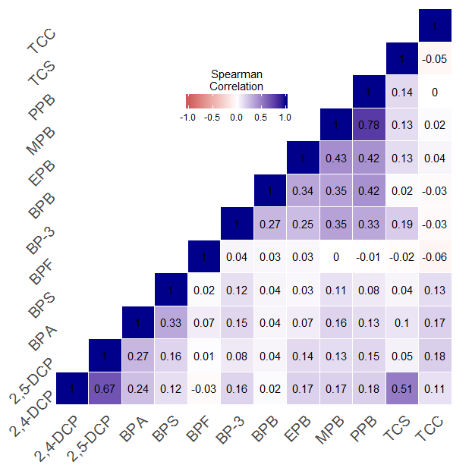
Supplemental Figure 1: Heat map of Spearman correlation coefficients of specific gravity corrected average triclocarban, phenol and paraben urinary biomarkers

Given the left-skewed distribution of gestational age, we ran sensitivity analyses to test the robustness of our results. In an effort to transform gestational age to a normal distribution, we created a new variable by subtracting the individual gestational age from the maximum gestational age (44 gestation weeks), and then calculating the value’s logarithm. We then used this new transformed variable (referred to as “transformed GA”) in the MLR models. The results of associations between the transformed GA and the urinary biomarkers are presented in Table 1 below. As shown, there were no differences in the interpretation of the results between the two GA variables; therefore, we kept the models with the untransformed GA for our final results. Note that the main effect estimates (β) across the two gestational age variables have opposite directions of associations since the transformed GA variable subtracts the gestational age from the maximum, thereby flipping the order of the gestational age values, and flipping the direction of association.
Supplementary Table 1: Comparison of main effect estimates and p values of the two gestational age variables calculated as a sensitivity analysis.
 |  | Untransformed GA |  | Transformed GA
 | N | β | p-value | β | p-value
2,4-dichlorophenol | 748 | 0.01 | 0.92 | -0.004 | 0.71
2,5-dichlorophenol | 749 | -0.03 | 0.46 | 0.001 | 0.87
BPA | 748 | 0.14 | 0.17 | -0.021 | 0.23
BPS | 540 | -0.06 | 0.53 | 0.008 | 0.62
BPF | 500 | -0.14 | 0.15 | 0.021 | 0.20
BP-3 | 749 | 0.11 | 0.01** | -0.018 | 0.01**
Triclosan | 749 | 0.0005 | 0.90 | 0.001 | 0.85
Triclocarban | 544 | -0.07 | 0.08* | 0.011 | 0.09*
Ethyl-paraben | 550 | -0.01 | 0.82 | 0.003 | 0.70
Methyl-paraben | 751 | 0.12 | 0.01** | -0.015 | 0.06*
Butyl-paraben | 746 | 0.02 | 0.52 | -0.002 | 0.77
Propyl-paraben | 752 | 0.11 | 0.01** | -0.015 | 0.03**

Supplementary Table 2: Comparing MLR results using continuous BPF and ethyl-paraben variables versus categorical BPF and ethyl-paraben variables
 |  | Continuous Variable |  | Categorical Variable
BPF | Average | -1.19 (-2.80, 0.42) | 0.15 | 0.06 (-0.28, 0.41) | 0.72
 | Visit 1 | -1.20 (-2.61, 0.20) | 0.09 | 0.12 (-0.27, 0.51) | 0.55
 | Visit 2 | 0.42 (-0.84, 1.69) | 0.51 | -0.22 (-0.62, 0.18) | 0.28
 | Visit 3 | -1.18 (-2.75, 0.40) | 0.14 | 0.24 (-0.19, 0.68) | 0.27
Ethyl-paraben | Average | -0.23 (-2.15, 1.69) | 0.82 | -0.11 (-0.44, 0.23) | 0.53
 | Visit 1 | 0.61 (-1.20, 2.42) | 0.51 | -0.20 (-0.55, 0.16) | 0.28
 | Visit 2 | -0.86 (-2.40, 0.68) | 0.28 | 0.06 (-0.3, 0.41) | 0.75
 | Visit 3 | 0.32 (-1.31, 1.95) | 0.70 | -0.12 (-0.51, 0.26) | 0.53

Supplementary Table 3: Beta coefficients of MLR and logistic regression models regressing birth outcomes against urinary exposure biomarkers with the addition of an interaction term between fetal sex and the urinary exposure biomarker
 | Gestational Age
 | N | Main effect estimate | p | Fetal sex effect estimate | p | Interaction effect estimate | p
2,4-DCP | 687 | -0.058 | 0.54 | -0.09 | 0.51 | 0.172 | 0.18
2,5-DCP | 688 | -0.019 | 0.78 | -0.104 | 0.7 | 0.012 | 0.9
BPA | 687 | 0.21 | 0.15 | -0.026 | 0.89 | -0.045 | 0.8
BPFª | 451 | -0.112 | 0.44 | -0.047 | 0.88 | 0.05 | 0.8
BPS | 488 | 0.059 | 0.68 | -0.255 | 0.26 | -0.133 | 0.49
BP-3 | 688 | 0.075 | 0.19 | -0.141 | 0.66 | 0.025 | 0.75
TCS | 688 | -0.079 | 0.12 | -0.669 | 0.01 | 0.194 | 0.006
TCC | 492 | -0.034 | 0.57 | -0.116 | 0.54 | -0.044 | 0.56
EPBª | 498 | -0.072 | 0.34 | -0.267 | 0.16 | 0.102 | 0.3
MPB | 690 | 0.126 | 0.07 | -0.04 | 0.93 | -0.006 | 0.95
BPB | 685 | 0.048 | 0.41 | -0.091 | 0.55 | -0.038 | 0.63
PPB | 691 | 0.124 | 0.03 | -0.058 | 0.82 | -0.006 | 0.94
 | Birth Weight
 | N | Main effect estimate | p | Fetal sex effect estimate | p | Interaction effect estimate | p
2,4-DCP | 683 | 0.032 | 0.57 | 0.016 | 0.85 | -0.080 | 0.29
2,5-DCP | 684 | 0.051 | 0.21 | 0.193 | 0.24 | -0.073 | 0.18
BPA | 683 | 0.018 | 0.84 | -0.004 | 0.97 | 0.007 | 0.95
BPFª | 449 | -0.140 | 0.39 | -0.030 | 0.82 | 0.104 | 0.63
BPS | 486 | 0.069 | 0.43 | 0.044 | 0.75 | 0.012 | 0.92
BP-3 | 684 | 0.053 | 0.13 | 0.122 | 0.53 | -0.033 | 0.48
TCS | 684 | -0.055 | 0.07 | -0.138 | 0.38 | 0.048 | 0.26
TCC | 490 | 0.007 | 0.85 | 0.034 | 0.77 | 0.000 | 1.00
EPBª | 496 | -0.219 | 0.18 | -0.070 | 0.55 | 0.302 | 0.16
MPB | 686 | -0.009 | 0.84 | 0.060 | 0.82 | -0.014 | 0.80
BPB | 681 | 0.014 | 0.69 | 0.018 | 0.84 | 0.016 | 0.74
PPB | 687 | -0.006 | 0.87 | -0.017 | 0.91 | 0.006 | 0.90
 | Small for Gestational Age
 | N | Main effect estimate | p | Fetal sex effect estimate | p | Interaction effect estimate | p
2,4-DCP | 683 | 0.052 | 0.78 | 0.037 | 0.89 | 0.235 | 0.33
2,5-DCP | 684 | -0.118 | 0.42 | -0.631 | 0.23 | 0.285 | 0.11
BPA | 683 | 0.045 | 0.87 | 0.205 | 0.57 | -0.106 | 0.76
BPFª | 449 | 0.345 | 0.50 | 0.243 | 0.57 | -0.388 | 0.56
BPS | 486 | 0.124 | 0.65 | 0.060 | 0.89 | 0.100 | 0.78
BP-3 | 684 | -0.097 | 0.42 | -0.239 | 0.70 | 0.107 | 0.50
TCS | 684 | 0.243 | 0.01 | 0.636 | 0.27 | -0.141 | 0.30
TCC | 490 | -0.117 | 0.32 | -0.099 | 0.77 | 0.069 | 0.64
EPBª | 496 | 1.069 | 0.03 | 0.409 | 0.32 | -1.092 | 0.10
MPB | 686 | -0.108 | 0.44 | 0.643 | 0.41 | -0.125 | 0.49
BPB | 681 | -0.341 | 0.02 | 0.401 | 0.27 | 0.224 | 0.22
PPB | 687 | -0.114 | 0.33 | 0.290 | 0.52 | -0.062 | 0.68
 | Large for Gestational Age
 | N | Main effect estimate | p | Fetal sex effect estimate | p | Interaction effect estimate | p
2,4-DCP | 683 | 0.032 | 0.85 | -0.193 | 0.46 | -0.067 | 0.78
2,5-DCP | 684 | 0.108 | 0.36 | 0.093 | 0.86 | -0.111 | 0.50
BPA | 683 | -0.292 | 0.28 | -0.449 | 0.19 | 0.412 | 0.23
BPFª | 449 | 0.100 | 0.83 | 0.050 | 0.90 | -0.622 | 0.35
BPS | 486 | 0.389 | 0.12 | -0.175 | 0.64 | -0.092 | 0.79
BP-3 | 684 | 0.159 | 0.10 | -0.190 | 0.76 | -0.006 | 0.96
TCS | 684 | -0.082 | 0.38 | -0.320 | 0.51 | 0.049 | 0.72
TCC | 490 | 0.085 | 0.41 | -0.036 | 0.92 | -0.089 | 0.51
EPBª | 496 | 0.315 | 0.49 | -0.004 | 0.99 | -0.342 | 0.59
MPB | 686 | -0.038 | 0.77 | -0.449 | 0.59 | 0.061 | 0.74
BPB | 681 | -0.107 | 0.34 | -0.039 | 0.89 | 0.182 | 0.21
PPB | 687 | -0.033 | 0.76 | -0.525 | 0.29 | 0.121 | 0.42
2,4-DCP: 2,4-dichlorophenol; 2,5-DCP: 2,5-dichlorophenol; BP-3: Benzophenone; TCS: Triclosan; TCC: Triclocarban; EPB: ethyl-paraben; MPB: Methyl-paraben; BPB: Butyl-paraben; PPB: Propyl-paraben

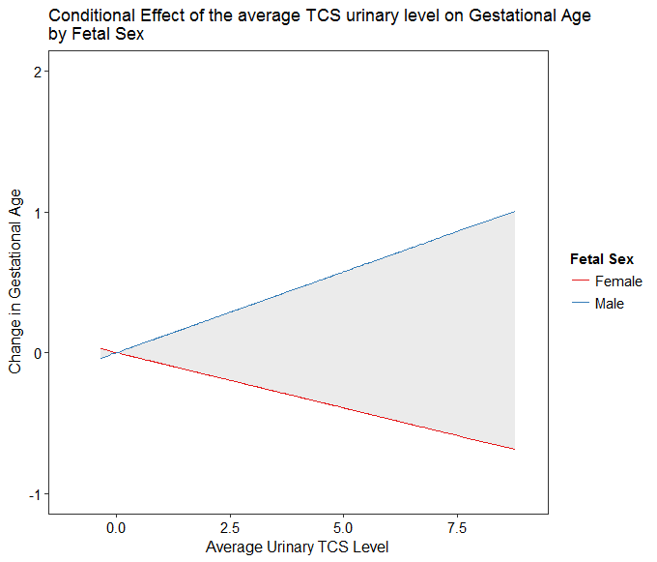

Supplemental Figure 2: Conditional effect of the average triclosan concentration across the three study visits on gestational age, stratified by fetal sex.

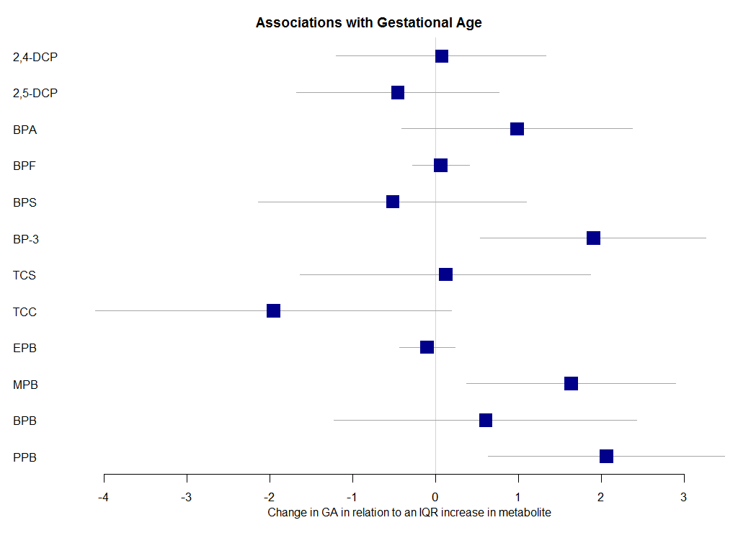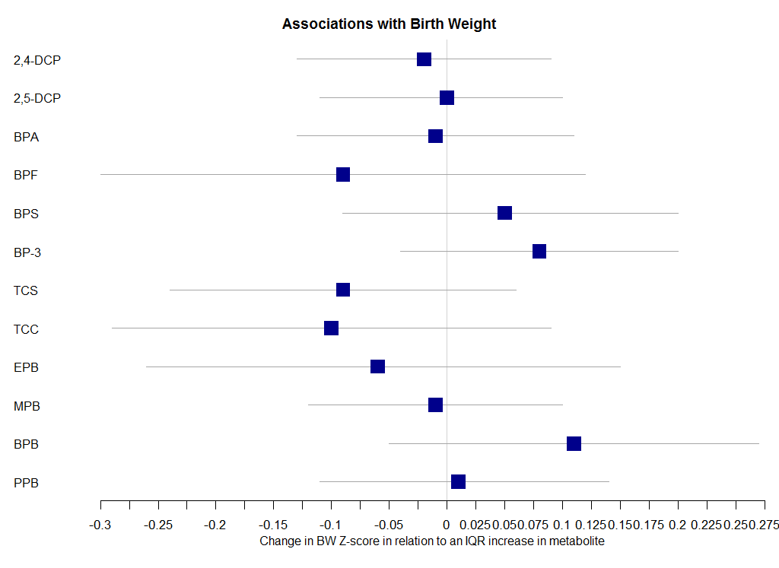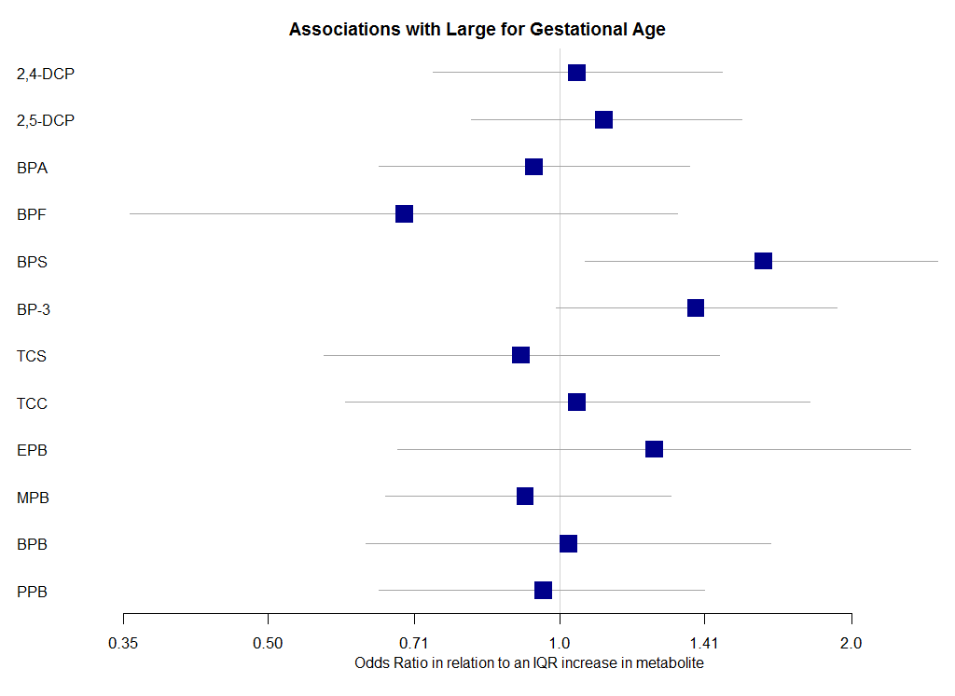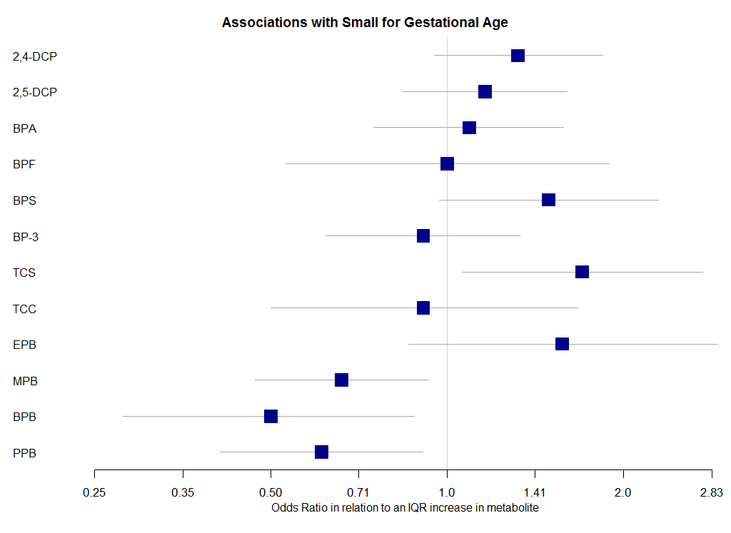
Supplemental Figure 3: Summary results of models regressing birth outcomes against average phenol, paraben and triclocarban.

