Supplemental Material
Appendix A
Apart from Hg, multi-element stock solutions (Ba, Be, Pb, Mn, As, Mo, Cd, Ni, Cr, Tl, Sn, W, U, Cu, Zn, Se) were utilized in the analysis. These stock solutions were purchased from High Purity Standards (Charleston, South Carolina). The mercury stock solution concentration was 1000ppm and the multi-element solution concentration was 10 ppm. Serial dilutions were employed with ASTM Type I deionized water to obtain the working standards. Gold was added to all rinse solutions at a concentration of 8ppm to aid in the rinsing of Hg from the system.
Considering that biological samples have high levels of carbon and chloride, the laboratory selected the appropriate isotopes for the requested elements to best avoid interferences where possible. For a few elements that are either monoisotopic or have interferences at all isotopes, kinetic energy discrimination (KED) was utilized. Examples of elements that required KED analysis are ⁵²Cr due to ⁴⁰Ar¹²C⁺ and ³⁵Cl¹⁷O⁺, ⁵³Cr due to ³⁷Cl¹⁶O⁺ and ⁴⁰Ar¹³C⁺, ⁷⁵As due to ⁴⁰Ar³⁵Cl⁺ and ³⁸Ar³⁷Cl⁺, ⁸²Se due to ¹²C³⁵Cl₂⁺, ⁵¹V due to ³⁵Cl¹⁶O⁺.
The unpreserved urine samples, working standards, quality control samples and blanks were diluted 10-fold in a laboratory prepared diluent. The prepared 2 L diluent contained 10 ppb of Yttrium, 5 ppb of Indium, 2.5 ppb of Terbium and 2 ppm of Gold in a 2% nitric matrix. The ICP-MS was calibrated with a blank and a minimum of 4 standards for each element of interest. An R² value of >0.995 was the minimum criteria for an acceptable calibration curve. The calibration curves were verified by initial checks at three calibration points within the curve. Continuing calibration checks and blanks after every 10 samples were also utilized throughout the analytical run to ensure the ICPMS system was maintaining acceptable performance. Samples that exceeded the highest calibration point of any element were further diluted to ensure the concentration of that element was within the range of the calibration curve.

Table A. Specific gravity-corrected urinary trace metal concentrations in cases and controls of preterm birth: median (25th, 75th percentiles) or n (%) detect.
Metals | Cases  (n = 99) | Controls  (n = 291) | p¹
As | 18.1 (9.66, 32.5) | 18.0 (9.59, 32.6) | 0.77
Ba | 1.88 (1.20, 4.13) | 1.95 (0.95, 3.35) | 0.09
Cd | 0.10 (0.05, 0.17) | 0.08 (0.04, 0.13) | 0.62
Cu | 10.03 (7.79, 13.7) | 8.99 (6.73, 12.0) | 0.01
Hg | 0.54 (0.28, 0.97) | 0.50 (0.27, 0.97) | 0.33
Mn | 0.68 (0.47, 1.55) | 0.73 (0.52, 1.13) | 0.32
Mo | 52.1 (36.6, 72.8) | 51.1 (37.1, 69.3) | 0.92
Ni | 2.79 (1.77, 4.13) | 2.84 (1.89, 3.95) | 0.80
Pb | 0.38 (0.18, 0.63) | 0.35 (0.15, 0.62) | 0.29
Se | 39.8 (31.2, 50.1) | 36.9 (29.6, 45.4) | 0.08
Sn | 0.59 (0.36, 1.25) | 0.63 (0.35, 1.22) | 0.51
Tl | 0.13 (0.09, 0.16) | 0.13 (0.08, 0.18) | 0.80
Zn | 283.9 (167.3, 440.5) | 242.5 (146.6, 357.3) | 0.33
Be | 5 (5.10) | 29 (10.0) | 0.14
Cr | 21 (21.2) | 39 (13.4) | 0.06
U | 16 (16.2) | 32 (11.0) | 0.18
W | 24 (24.2) | 57 (19.6) | 0.33
¹p value calculated from unadjusted logistic regression models. Shading denotes metals with >70% of samples below the limit of detection.

Table B. Urinary trace metal specific gravity-corrected geometric means (GM) or percent detected by demographic characteristics of the study population.
 | GM |  |  |  |  |  |  |  |  |  |  |  |  | Percent detect
Demographic Characteristic | As | Ba | Cd | Cu | Hg | Mn | Mo | Ni | Pb | Se | Sn | Tl | Zn | Be | Cr | U | W
Maternal age
24 years or younger | 16.4 | 1.2* | 0.05* | 8.7 | 0.5 | 0.7 | 54.5 | 2.1 | 0.2 | 36.9 | 1.4* | 0.09 | 231.9 | 4  (9.8) | 5  (12.2) | 5  (12.2) | 10 (24.4)
25-29 years (ref) | 16.7 | 1.8 | 0.07 | 10.7 | 0.4 | 0.9 | 52.3 | 2.7 | 0.3 | 37.8 | 0.7 | 0.10 | 223.7 | 6  (7.9) | 9  (11.8) | 5  (6.6) | 20 (26.3)
30-34 years | 19.3 | 1.7 | 0.10* | 10.0 | 0.5 | 0.8 | 51.0 | 2.7 | 0.3 | 38.3 | 0.6 | 0.10 | 228.0 | 14 (8.8) | 28 (17.6) | 24 (15.1) | 32 (20.1)
35+ years | 19.6 | 2.1 | 0.09 | 8.9* | 0.5 | 0.9 | 51.2 | 2.6 | 0.3 | 37.1 | 0.7 | 0.11 | 224.5 | 10 (8.8) | 18 (15.8) | 14 (12.3) | 19 (16.7)
Race/ethnicity
White (ref) | 17.7 | 2.0 | 0.08 | 9.3 | 0.4 | 0.9 | 52.0 | 2.8 | 0.2 | 36.8 | 0.6 | 0.10 | 204.2 | 24 (10.3) | 29 (12.4) | 23  (9.8) | 42 (18.0)
African American | 20.6 | 1.2* | 0.09 | 10.0 | 0.6 | 0.8 | 47.1 | 2.2* | 0.3 | 40.7* | 1.0* | 0.10 | 270.9* | 2  (3.5) | 13 (22.4) | 13 (22.4)* | 16 (27.6)
Other | 19.3 | 1.5* | 0.07 | 10.4 | 0.5 | 0.9 | 53.8 | 2.5 | 0.3 | 38.2 | 0.9* | 0.10 | 261.1* | 8  (8.2) | 18 (18.4) | 12 (12.2) | 23 (23.5)
Education
High school degree or less  (ref) | 16.0 | 1.4 | 0.07 | 9.7 | 0.6 | 0.6 | 49.6 | 2.5 | 0.3 | 37.9 | 1.2 | 0.10 | 257.1 | 5  (9.4) | 8  (15.1) | 4  (7.6) | 12 (22.6)
Technical college or some  college | 16.3 | 1.5 | 0.07 | 10.2 | 0.4 | 0.9* | 47.3 | 2.3 | 0.2 | 39.1 | 0.8* | 0.08 | 256.4 | 4  (6.8) | 13 (22.0) | 16 (27.1)* | 18 (30.5)
Junior college or some  college | 19.3 | 1.7 | 0.08 | 10.0 | 0.5 | 0.9* | 55.2 | 2.8 | 0.3 | 37.4 | 0.7* | 0.11 | 250.5 | 12 (10.3) | 15 (12.9) | 6  (5.2) | 23 (19.8)
≥ College graduate | 20.3 | 2.1* | 0.09 | 9.3 | 0.4 | 0.9* | 52.6 | 2.7 | 0.3 | 37.4 | 0.5* | 0.11 | 189.1* | 13 (8.6) | 22 (14.5) | 20 (13.2) | 27 (17.8)
Health insurance
Private/HMO/self-pay (ref) | 19.1 | 1.9 | 0.09 | 9.5 | 0.5 | 0.9 | 52.4 | 2.7 | 0.3 | 37.5 | 0.6 | 0.10 | 219.1 | 28 (8.8) | 49 (15.5) | 42 (13.3) | 64 (20.2)
Public | 16.7 | 1.2* | 0.06* | 10.4 | 0.6 | 0.6* | 49.0 | 2.1* | 0.2 | 38.8 | 1.3* | 0.09 | 252.8 | 5  (7.8) | 10 (15.6) | 6  (9.4) | 15 (23.4)
Pre-pregnancy BMI
<25 kg/m² (ref) | 18.8 | 1.9 | 0.08 | 8.8 | 0.4 | 0.8 | 53.3 | 2.7 | 0.3 | 36.4 | 0.6 | 0.11 | 203.8 | 22 (9.7) | 36 (15.9) | 27 (12.0) | 46 (20.4)
25-30 kg/m² | 18.9 | 1.7 | 0.09 | 11.0* | 0.5 | 0.9 | 51.1 | 2.6 | 0.2 | 38.8 | 0.9* | 0.10 | 215.0 | 7  (7.5) | 7  (7.5)* | 10 (10.6) | 18 (19.2)
>30 kg/m² | 17.1 | 1.4* | 0.07 | 10.7* | 0.5 | 0.8 | 47.4 | 2.3 | 0.3 | 40.6* | 0.9* | 0.09 | 342.0* | 5  (7.1) | 17 (24.3) | 11 (15.7) | 17 (24.3)
Tobacco use
None in pregnancy (ref) | 18.9 | 1.8 | 0.08 | 9.5 | 0.5 | 0.9 | 52.6 | 2.6 | 0.3 | 37.6 | 0.7 | 0.10 | 219.8 | 33 (9.2) | 52 (14.4) | 45 (12.5) | 77 (21.4)
Some in pregnancy | 14.0 | 1.4 | 0.13* | 12.4* | 0.5 | 0.7 | 41.4* | 2.3 | 0.5* | 38.9 | 0.7 | 0.11 | 342.3* | 1  (4.0) | 8  (32.0)* | 3  (12.0) | 3  (12.0)
Alcohol use
None in pregnancy (ref) | 18.6 | 1.8 | 0.08 | 9.6 | 0.5 | 0.9 | 52.0 | 2.6 | 0.3 | 37.8 | 0.7 | 0.10 | 229.0 | 32 (8.7) | 57 (15.6) | 43 (11.8) | 75 (20.5)
Some in pregnancy | 17.2 | 1.8 | 0.06 | 9.4 | 0.5 | 0.8 | 53.4 | 2.5 | 0.3 | 36.5 | 0.6 | 0.12 | 183.4 | 2 (13.3) | 3  (20.0) | 4  (26.7) | 2  (13.3)
Parity
Nulliparous (ref) | 19.5 | 2.0 | 0.07 | 9.6 | 0.4 | 0.9 | 52.2 | 2.6 | 0.3 | 37.9 | 0.8 | 0.10 | 218.3 | 18 (10.5) | 20 (11.7) | 17  (9.9) | 38 (22.2)
Parous | 17.8 | 1.6* | 0.09 | 9.7 | 0.5 | 0.9 | 51.2 | 2.6 | 0.3 | 37.5 | 0.7 | 0.10 | 233.1 | 16 (7.3) | 40 (18.3) | 31 (14.2) | 43 (19.6)
History of PTB
No (ref) | 18.2 | 1.7 | 0.08 | 9.5 | 0.5 | 0.8 | 50.9 | 2.5 | 0.3 | 37.5 | 0.7 | 0.10 | 223.3 | 30 (8.6) | 51 (14.6) | 40 (11.4) | 72 (50.6)
Yes | 21.4 | 2.1 | 0.09 | 10.7 | 0.5 | 1.2* | 58.5 | 3.7* | 0.3 | 39.4 | 0.8 | 0.12 | 256.5 | 4 (10.0) | 9 (22.5) | 8 (20.0) | 9 (22.5)
Use of ART
No (ref) | 18.0 | 1.7 | 0.08 | 9.6 | 0.5 | 0.8 | 51.8 | 2.6 | 0.3 | 37.7 | 0.7 | 0.10 | 225.8 | 31 (8.7) | 58 (16.3) | 45 (12.7) | 74 (20.9)
Yes | 24.7 | 1.9 | 0.09 | 9.9 | 0.6 | 0.9 | 50.2 | 2.4 | 0.3 | 38.1 | 0.7 | 0.09 | 234.5 | 3  (8.6) | 2  (5.7) | 3  (8.6) | 7  (20.0)
Multivitamin use
No (ref) | 18.2 | 1.8 | 0.07 | 9.8 | 0.5 | 0.8 | 51.5 | 2.6 | 0.3 | 39.6 | 0.9 | 0.11 | 250.2 | 10 (9.2) | 23 (21.1) | 15 (13.8) | 28 (25.7)
Yes | 18.7 | 1.7 | 0.08 | 9.6 | 0.5 | 0.9 | 51.9 | 2.6 | 0.3 | 37.0 | 0.6* | 0.10 | 217.3 | 24 (8.7) | 37 (13.4) | 33 (12.0) | 52 (18.8)
Sex of neonate
Male (ref) | 18.9 | 1.7 | 0.08 | 10.0 | 0.5 | 0.9 | 52.4 | 2.6 | 0.3 | 39.2 | 0.7 | 0.10 | 236.6 | 21 (12.4) | 28 (16.5) | 32 (18.8) | 37 (21.8)
Female | 18.3 | 1.8 | 0.08 | 9.4 | 0.5 | 0.8 | 51.1 | 2.6 | 0.3 | 36.5* | 0.7 | 0.10 | 219.1 | 13 (5.9)* | 32 (14.6) | 16  (7.3)* | 44 (20.0)
Abbreviations: BMI, body mass index; PTB, preterm birth; ART, assisted reproductive technology

Figure A. Pearson correlation matrix¹ of 17 trace metal concentrations measured in third trimester urine samples from pregnant women in the LIFECODES birth cohort.
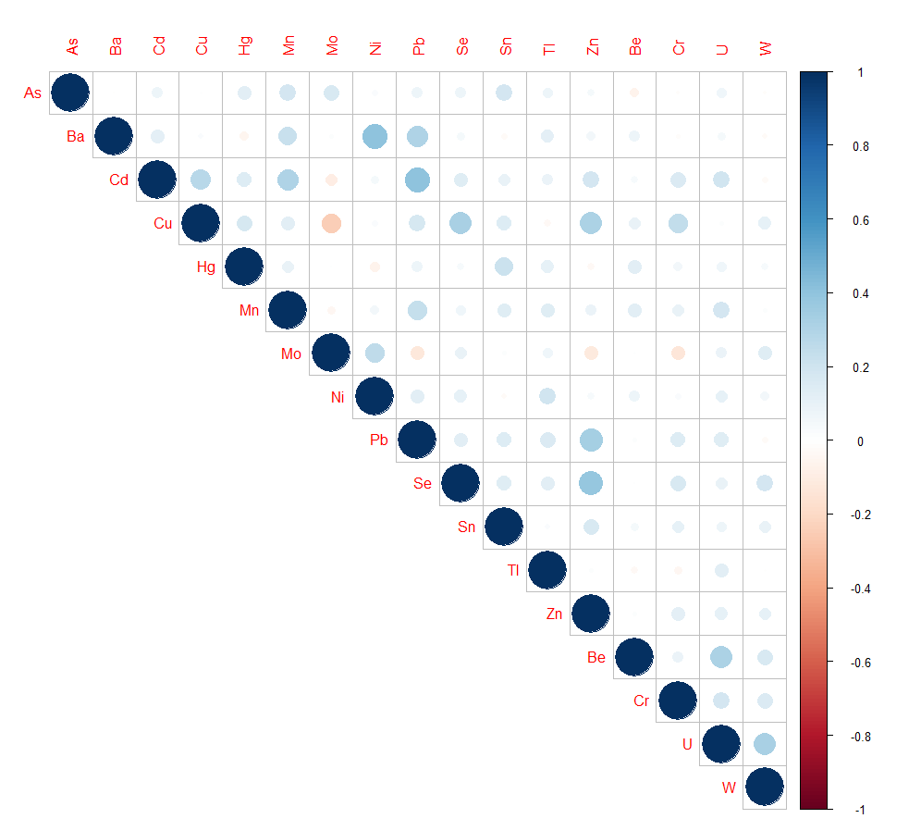
¹Blue represents positive correlations and red represents inverse correlations. Increased circle size as well as color intensity reflect greater magnitude of correlation.

Table D. Loading factors for each variable within each principal component (PC)
 | Factor Loadings
 | PC 1 | PC2 | PC3
As | 0.17 | -0.07 | 0.57*
Cd | 0.73* | 0.16 | 0.10
Cu | 0.18 | 0.64* | 0.16
Hg | 0.09 | 0.00 | 0.66*
Mn | 0.67* | -0.09 | 0.23
Mo | -0.21 | -0.10 | 0.16
Ni | 0.23 | 0.12 | -0.25
Pb | 0.72* | 0.27 | -0.05
Se | -0.07 | 0.78* | 0.14
Sn | 0.04 | 0.23 | 0.65*
Zn | 0.24 | 0.73* | -0.08
* indicates a factor loading value ≥ 0.40; Bold indicates the 3 highest factor loading values for each PC

