Epigenome-Wide Association Study for 28-day Survival of Acute Respiratory Distress Syndrome
Online Supplementary Materials
Yichen Guo^{1, 2}, Ruyang Zhang^{1, 3}, Zhaozhong Zhu^{1, 4}, Sipeng Shen^{1, 3}, Li Su¹, David C. Christiani^{1, 4, 5}
¹ Department of Environmental Health, Harvard T.H. Chan School of Public Health, Boston, MA
² Department of Biostatistics, Harvard T.H. Chan School of Public Health, Boston, MA
³ Department of Biostatistics, Ministry of Education Key Laboratory for Modern Toxicology, School of Public Health, Nanjing Medical University, Nanjing, China
⁴ Department of Epidemiology, Harvard T.H. Chan School of Public Health, Boston, MA
⁵ Pulmonary and Critical Care Division, Department of Medicine, Massachusetts General Hospital and Harvard Medical School, Boston, MA

Supplementary Methods
Study populations
The ARDS population was described previously [1]. In this study, 185 patients were collected in two batches from the Molecular Epidemiology of ARDS (MEARDS) prospective cohort study (ClinicalTrials.gov Identifier: NCT00006496), with one batch of 92 patients assigned to the discovery phase and the other 93 patients assigned to the validation phase. All patients were recruited at the intensive care units (ICUs) of Massachusetts General Hospital (MGH) and Beth Israel Deaconess Medical Center (BIDMC) between 1998 and 2014. The two batches of patients were recruited from two periods of time (Supplementary Figure 3). Patients (98%) in the discovery cohort were recruited at/after 2006 (median = 2008), while patients (99%) in the validation cohort were recruited at/before 2005 (median =2002). All ARDS patients met the Berlin definition [2] and were moderate-to-severe ARDS patients. The study was reviewed and approved by institutional review boards of Harvard T.H. Chan School of Public Health, MGH and BIDMC. All participants or their surrogate care providers gave written informed consent.
Clinical outcomes
The primary outcome was 28-day overall survival time after ARDS onset [3], which was calculated from ARDS onset to the 28th day of admission [4-6]. Survival status for patients alive or lost to follow-up before/at the end of 28th day was defined as censored.
DNA methylation profiles
Peripheral blood was collected from participants within 24 hours of ARDS onset and stored at −80°C. DNA was extracted from whole blood and methylation was assessed by Illumina Infinium HumanMethylation450 BeadChips (Illumina Inc., SanDiego, CA, USA). DNA methylation was measured separately for the two cohorts (two 96-well plates). GenomeStudio Methylation Module V1.8 (Illumina Inc.) was used to transform the raw image data into Illumina beta values (continuous numbers ranging from 0 to 1, reflecting fully un-methylated to fully methylated). Probes meeting the following criteria were removed: (a) detection P > 0.05 over 5% of samples; (b) coefficient of variance (CV) < 5%; (c) common single nucleotide polymorphisms located in probe sequence or in 10-bp flanking regions; and (d) cross-reactive [7] or cross-hybridizing probes [8]. Samples with >5% undetectable probes were excluded. Methylation signals were further processed for quantile normalization [9], type I and II probe design bias correction [10], and batch effects adjustment [11].
Survival analysis between DNA methylation and 28-day survival
Associations between methylation sites and overall survival were evaluated by Cox models in discovery and validation phases separately. Clinical variables, including age, gender and Acute Physiology and Chronic Health Evaluation (APACHE) III score, were included into the models to adjust for potential confounders. Five cell-type components, estimated by ReFACTor [12], were also included to adjust for cell-type heterogeneity. Multiple testing corrections were performed using Benjamini & Hochberg false discovery rate (FDR) [13]. DNA methylation sites were screened in the discovery phase. 427 probes were significantly associated with 28-day survival after correcting for multiple testing (FDR<0.05). Those 427 probes were further tested in the validation phase. Four probes were significantly associated with survival (FDR<0.05). Results were described as hazard ratio (HR) and 95% confidence interval (95% CI) per 0.01 increment of the beta value (Supplementary Table 2) as well as per 0.1 increment of the beta value (Supplementary Table 7). Odds ratio (OR) of 28-day death and 95% CI for each site were measured by logistic regression adjusted for age, gender, APACHE III and cell-type components (Supplementary Table 8).
Methylation risk score
A risk score was calculated for each patient in discovery and validation phases by the weighted summation of the methylation level of each site:
where the weights in the equation were coefficients estimated by univariate Cox models in the discovery phase. The risk score ranged from -16.34 to -9.90 (median = -14.41) in discovery cohort and from -15.72 to -9.56 (median = -14.50) in validation cohort.
HR and 95% CI of methylation risk score and APACHE III were estimated by Cox models adjusted for age, gender, APACHE III and cell-type components (Supplementary Table 3). Predictive effects of methylation risk score and APACHE III on 28-day survival were estimated by the area under the receiver operating characteristic (ROC) curve (AUC) (Supplementary Figure 1) [14].
Kaplan-Meier curves were plotted for survival distributions in different groups, and log-rank tests were performed to test the equality of the distributions (Supplementary Figure 2). Patients with risk scores above the median were assigned into the high-risk group, while the others were assigned into the low-risk group (Supplementary Figure 2a). For the classifier of APACHE III, patients with APACHE III scores above the median were assigned into a high APACHE III group, while the others were assigned into a low APACHE III group (Supplementary Figure 2b).
Sensitivity analysis
We performed survival analysis on the four sites after removing all cancer patients in our cohorts (three in discovery phase and seven in validation phase) (Supplementary Table 4). The hazard ratio and confidence interval remained almost the same after removing cancer patients, compared with original results in Supplementary Table 2.
We also performed a sensitivity analysis on 77 patients with available tidal volume data. After adjusting for initial tidal volume (added as a covariate into the model) and other covariates (age, gender, APACHE III and cell-type components) (Supplementary Table 5), the associations between each DNA methylation site and 28-day survival were similar to the original results. Further, the results remained the same whether tidal volume was adjusted or not (Supplementary Table 5). All associations remained significant even among these 77 patients (Supplementary Table 5). We further tested the association between initial tidal volume and DNA methylation of the four sites using linear regression. There was no significant association detected between methylation and tidal volume (Supplementary Table 6).
Mortality in our cohort is high. There are two possible reasons:
- All patients in our cohorts are moderate-to-severe cases (PaO₂/FiO₂ ≤ 200) (Table 1). In the discovery cohort, 39 (42.39%) patients are severe (PaO₂/FiO₂ <100). In the validation cohort, 43 (46.24%) patients are severe.
- Most patients were recruited into this study in an early era (Supplementary Figure 3), when in-hospital mortality was commonly high. In particular, in the validation cohort, 93% of patients were recruited at/before 2004.
Generally, early-year recruited ARDS patients with high severity have a high mortality [15-16]. In several early studies, the in-hospital mortality was as high as 73%-89% [17], 52%-72% [18], 57%-59% [19], and 68.5% [20], which is comparable to the mortality in our cohorts.
We further performed a sensitivity analysis to test if our findings hold in populations with lower mortality. In this analysis, each time we randomly drew 60 samples from the total population with 20 dead and 40 living people, to ensure those 60 samples have a 28-day mortality around 40% (a more common mortality in recent years for moderate-to-severe patients [21]). Then, we tested the associations between each DNA methylation site and survival using a Cox model, adjusted for age, gender, APACHE III and cell-type components. We repeated this process 20 times. All results are shown in Supplementary Table 3. The hazard ratios (HR) were all consistent with our original results. Most of the associations remained significant even in those sub-populations with only 60 samples. In summary, our findings are robust in sub-populations with common mortality.
All analyses were performed in R Version 3.3.0 (The R Foundation for Statistical Computing, Vienna, Austria).

Supplemental Tables and Figures

Supplementary Table 1. Association between DNA methylation at four CpG sites and ARDS 28-day mortality in all patients
Probe | Gene | Location | Region | Discovery (N=92) |  |  |  | Validation (N=93)
 |  |  |  | HR¹ | 95% CI | P | FDR | HR | 95% CI | P | FDR
cg08719289 | CITED4³ | Chr1: 41328378 | TSS1500² | 1.36 | (1.20,1.55) | 3.05E-06 | 0.010 | 1.25 | (1.15,1.35) | 1.16E-07 | <0.001
cg04740513 | ATP11A⁴ | Chr13: 113492559 | Body | 0.97 | (0.96,0.98) | 1.23E-05 | 0.024 | 0.98 | (0.96,0.99) | 1.06E-04 | 0.017
cg08504659 | PTGDR⁵ | Chr14: 52734888 | 1stExon | 1.34 | (1.18,1.52) | 7.53E-06 | 0.017 | 1.22 | (1.10,1.35) | 1.58E-04 | 0.017
cg06777472 |  | Chr20: 57873033 |  | 0.86 | (0.80,0.92) | 5.80E-05 | 0.049 | 0.90 | (0.85,0.95) | 1.63E-04 | 0.017
¹ The hazard ratio of mortality per 0.01 unit increment of DNA methylation beta value
All resulted were estimated by Cox regression model adjusted for age, gender, APACHE III and cell-type components.
²TSS1500: -200 to -1,500 nt upstream of the transcription start site
³CITED4: Cbp/P300 Interacting Transactivator With Glu/Asp Rich Carboxy-Terminal Domain 4
⁴ATP11A: ATPase Phospholipid Transporting 11A
⁵PTGDR: Prostaglandin D2 Receptor

Supplementary Table 2. Hazard ratio of 28-day mortality for methylation risk score and APACHE III
Variable | Total population (N=185) |  |  | Discovery (N=92) |  |  | Validation (N=93)
Variable | HR | 95% CI | P | HR | 95% CI | P | HR | 95% CI | P
Methylation risk score | 1.72¹ | (1.40, 2.12) | 2.73E-07 | 1.84¹ | (1.40, 2.42) | 1.32E-05 | 1.87¹ | (1.57, 2.22) | 1.14E-12
APACHE III | 1.71² | (1.26, 2.31) | 5.00E-04 | 1.98² | (1.29, 3.06) | 1.99E-03 | 1.31² | (0.86, 2.04) | 2.00E-01
¹ Hazard ratio per 1 unit increment of methylation risk score
² Hazard ratio per 40 units increment of APACHE III
All resulted were estimated by Cox regression model adjusted for age and gender.

Supplementary Table 3. Association between DNA methylation at 4 CpG sites and 28-day survival in twenty randomly selected sub-populations with mortality around 40%
Sub-cohort | Probe | HR¹ | 95% CI |  | P |  | Sub-cohort | Probe | HR | 95% CI |  | P
1 | cg08719289 | 1.95 | 1.18 | 3.21 | 8.63E-03 |  | 11 | cg08719289 | 2.49 | 1.10 | 5.62 | 2.87E-02
1 | cg04740513 | 0.94 | 0.91 | 0.97 | 4.85E-04 |  | 11 | cg04740513 | 0.96 | 0.94 | 0.99 | 1.90E-03
1 | cg08504659 | 2.07 | 1.36 | 3.16 | 7.51E-04 |  | 11 | cg08504659 | 2.02 | 1.53 | 2.69 | 1.01E-06
1 | cg06777472 | 0.74 | 0.53 | 1.04 | 8.10E-02 |  | 11 | cg06777472 | 0.87 | 0.78 | 0.97 | 1.07E-02
2 | cg08719289 | 1.35 | 1.20 | 1.52 | 4.70E-07 |  | 12 | cg08719289 | 1.65 | 1.24 | 2.20 | 6.51E-04
2 | cg04740513 | 0.96 | 0.93 | 0.99 | 5.18E-03 |  | 12 | cg04740513 | 0.90 | 0.75 | 1.09 | 2.71E-01
2 | cg08504659 | 1.59 | 1.24 | 2.04 | 2.44E-04 |  | 12 | cg08504659 | 1.54 | 1.25 | 1.90 | 4.92E-05
2 | cg06777472 | 0.92 | 0.78 | 1.09 | 3.55E-01 |  | 12 | cg06777472 | 0.76 | 0.59 | 0.98 | 3.54E-02
3 | cg08719289 | 1.56 | 1.12 | 2.18 | 8.06E-03 |  | 13 | cg08719289 | 1.46 | 1.27 | 1.67 | 4.17E-08
3 | cg04740513 | 0.95 | 0.91 | 1.00 | 3.00E-02 |  | 13 | cg04740513 | 0.97 | 0.94 | 0.99 | 7.51E-03
3 | cg08504659 | 2.05 | 1.46 | 2.90 | 3.99E-05 |  | 13 | cg08504659 | 1.97 | 1.34 | 2.91 | 6.38E-04
3 | cg06777472 | 0.82 | 0.74 | 0.91 | 1.25E-04 |  | 13 | cg06777472 | 0.82 | 0.66 | 1.02 | 6.94E-02
4 | cg08719289 | 1.33 | 1.20 | 1.48 | 6.94E-08 |  | 14 | cg08719289 | 1.68 | 1.00 | 2.82 | 4.84E-02
4 | cg04740513 | 0.91 | 0.76 | 1.09 | 3.21E-01 |  | 14 | cg04740513 | 0.97 | 0.95 | 0.99 | 2.75E-03
4 | cg08504659 | 1.36 | 1.18 | 1.57 | 1.62E-05 |  | 14 | cg08504659 | 1.60 | 1.29 | 1.98 | 1.97E-05
4 | cg06777472 | 0.96 | 0.82 | 1.12 | 5.93E-01 |  | 14 | cg06777472 | 0.84 | 0.79 | 0.90 | 1.71E-07
5 | cg08719289 | 2.41 | 1.64 | 3.55 | 7.56E-06 |  | 15 | cg08719289 | 2.69 | 1.30 | 5.54 | 7.45E-03
5 | cg04740513 | 0.95 | 0.93 | 0.98 | 1.13E-04 |  | 15 | cg04740513 | 0.83 | 0.62 | 1.11 | 2.12E-01
5 | cg08504659 | 2.04 | 1.46 | 2.84 | 2.81E-05 |  | 15 | cg08504659 | 1.43 | 1.22 | 1.68 | 1.15E-05
5 | cg06777472 | 0.82 | 0.73 | 0.93 | 1.27E-03 |  | 15 | cg06777472 | 0.85 | 0.80 | 0.90 | 5.63E-08
6 | cg08719289 | 1.55 | 0.97 | 2.49 | 6.67E-02 |  | 16 | cg08719289 | 1.55 | 1.18 | 2.04 | 1.51E-03
6 | cg04740513 | 0.76 | 0.61 | 0.94 | 9.88E-03 |  | 16 | cg04740513 | 0.95 | 0.89 | 1.00 | 6.41E-02
6 | cg08504659 | 2.01 | 1.19 | 3.38 | 8.79E-03 |  | 16 | cg08504659 | 2.25 | 1.27 | 3.99 | 5.59E-03
6 | cg06777472 | 0.87 | 0.78 | 0.97 | 1.47E-02 |  | 16 | cg06777472 | 0.83 | 0.73 | 0.93 | 2.06E-03
7 | cg08719289 | 1.54 | 1.00 | 2.37 | 4.76E-02 |  | 17 | cg08719289 | 2.07 | 1.07 | 3.99 | 3.00E-02
7 | cg04740513 | 0.92 | 0.89 | 0.96 | 3.66E-05 |  | 17 | cg04740513 | 0.83 | 0.64 | 1.08 | 1.56E-01
7 | cg08504659 | 1.69 | 1.32 | 2.17 | 2.94E-05 |  | 17 | cg08504659 | 1.39 | 1.16 | 1.67 | 4.06E-04
7 | cg06777472 | 0.82 | 0.73 | 0.92 | 9.10E-04 |  | 17 | cg06777472 | 0.85 | 0.79 | 0.91 | 2.54E-06
8 | cg08719289 | 1.32 | 1.20 | 1.46 | 3.62E-08 |  | 18 | cg08719289 | 1.31 | 1.17 | 1.47 | 2.83E-06
8 | cg04740513 | 0.97 | 0.95 | 0.99 | 4.47E-03 |  | 18 | cg04740513 | 0.98 | 0.95 | 1.00 | 8.07E-02
8 | cg08504659 | 1.24 | 1.09 | 1.41 | 8.72E-04 |  | 18 | cg08504659 | 1.39 | 1.20 | 1.61 | 8.85E-06
8 | cg06777472 | 0.95 | 0.68 | 1.33 | 7.64E-01 |  | 18 | cg06777472 | 0.81 | 0.76 | 0.86 | 7.88E-11
9 | cg08719289 | 2.87 | 1.74 | 4.72 | 3.42E-05 |  | 19 | cg08719289 | 1.73 | 1.06 | 2.81 | 2.83E-02
9 | cg04740513 | 0.94 | 0.89 | 0.98 | 1.09E-02 |  | 19 | cg04740513 | 0.92 | 0.71 | 1.20 | 5.54E-01
9 | cg08504659 | 1.48 | 1.11 | 1.98 | 7.68E-03 |  | 19 | cg08504659 | 1.42 | 1.25 | 1.61 | 8.90E-08
9 | cg06777472 | 0.81 | 0.71 | 0.92 | 1.43E-03 |  | 19 | cg06777472 | 0.86 | 0.77 | 0.97 | 1.13E-02
10 | cg08719289 | 3.26 | 1.53 | 6.97 | 2.25E-03 |  | 20 | cg08719289 | 2.06 | 1.44 | 2.95 | 8.07E-05
10 | cg04740513 | 0.96 | 0.93 | 0.98 | 1.04E-03 |  | 20 | cg04740513 | 0.83 | 0.70 | 0.99 | 3.89E-02
10 | cg08504659 | 2.21 | 1.45 | 3.36 | 2.11E-04 |  | 20 | cg08504659 | 1.55 | 1.25 | 1.91 | 5.19E-05
10 | cg06777472 | 0.85 | 0.67 | 1.09 | 1.99E-01 |  | 20 | cg06777472 | 0.81 | 0.64 | 1.02 | 7.42E-02
¹ The hazard ratio of mortality per 0.01 unit increment of DNA methylation beta value
All resulted were estimated by Cox regression model adjusted for age, gender, APACHE III and cell-type components.

Supplementary Table 4. Sensitivity analysis of association between DNA methylation at 4 CpG sites and ARDS 28-day mortality in non-cancer patients
Probe | Discovery (N=92) |  |  | Validation (N=93)
Probe | HR¹ | 95% CI | P | HR | 95% CI | P
cg08719289 | 1.38 | (1.19,1.59) | 3.05E-06 | 1.27 | (1.17,1.38) | 1.35E-08
cg04740513 | 0.97 | (0.96,0.99) | 1.43E-03 | 0.97 | (0.96,0.99) | 5.97E-05
cg08504659 | 1.39 | (1.23,1.58) | 2.59E-07 | 1.20 | (1.09,1.33) | 1.58E-04
cg06777472 | 0.85 | (0.79,0.91) | 4.45E-06 | 0.89 | (0.84,0.94) | 1.63E-04
¹ The hazard ratio of mortality per 0.01 unit increment of DNA methylation beta value
All resulted were estimated by Cox regression model adjusted for age, gender, APACHE III and cell-type components.

Supplementary Table 5. Association between DNA methylation at 4 CpG sites and ARDS 28-day mortality with/without adjustment of tidal volume
Probe | With adjustment of tidal volume |  |  | Without adjustment of tidal volume
Probe | HR¹ | 95% CI | P | HR | 95% CI | P
cg08719289 | 1.33 | (1.23,1.44) | 3.84E-12 | 1.31 | (1.21,1.41) | 8.11E-12
cg04740513 | 0.97 | (0.96,0.98) | 3.66E-06 | 0.97 | (0.96,0.99) | 7.10E-06
cg08504659 | 1.19 | (1.03,1.37) | 1.80E-02 | 1.19 | (1.03,1.37) | 1.99E-02
cg06777472 | 0.89 | (0.81,0.99) | 2.41E-02 | 0.90 | (0.82,0.98) | 2.21E-02
¹ The hazard ratio of mortality per 0.01 unit increment of DNA methylation beta value
All resulted were estimated by Cox regression model adjusted for age, gender, APACHE III and cell-type components.

Supplementary Table 6. Association between DNA methylation at 4 CpG sites and initial tidal volume
Probe | Coefficient | Standard error | P
cg08719289 | -9.35E-05 | 8.85E-04 | 9.16E-01
cg04740513 | 5.38E-03 | 4.19E-03 | 2.02E-01
cg08504659 | 6.92E-05 | 8.41E-04 | 9.34E-01
cg06777472 | 1.30E-03 | 1.14E-03 | 2.57E-01
All resulted were estimated by linear regression.

Supplementary Table 7. Association between DNA methylation at 4 CpG sites and ARDS 28-day mortality in all patients
Probe | Discovery (N=92) |  |  |  | Validation (N=93)
Probe | HR¹ | 95% CI | P | FDR | HR | 95% CI | P | FDR
cg08719289 | 21.67 | (6.19,80.04) | 3.05E-06 | 0.010 | 9.31 | (4.05,20.11) | 1.16E-07 | <0.001
cg04740513 | 0.74 | (0.66,0.82) | 1.23E-05 | 0.024 | 0.82 | (0.66,0.90) | 1.06E-04 | 0.017
cg08504659 | 18.67 | (5.23,65.83) | 7.53E-06 | 0.017 | 7.30 | (2.59,20.11) | 1.58E-04 | 0.017
cg06777472 | 0.22 | (0.11,0.43) | 5.80E-05 | 0.049 | 0.35 | (0.20,0.60) | 1.63E-04 | 0.017
¹ The hazard ratio of mortality per 0.1 unit increment of DNA methylation beta value
All resulted were estimated by Cox regression model adjusted for age, gender, APACHE III and cell-type components.

Supplementary Table 8. Odds ratios of 28-day mortality per 0.01 unit increment of DNA methylation
Probe | Discovery (N=92) |  |  | Validation (N=93) |  |  | Combined (N=185)
Probe | OR | 95% CI | P | OR | 95% CI | P | OR | 95% CI | P
cg08719289 | 1.29 | (0.52,3.17) | 5.79E-01 | 2.78 | (1.45,5.30) | 2.00E-03 | 2.01 | (1.26,3.18) | 2.91E-03
cg04740513 | 0.66 | (0.35,1.24) | 1.95E-01 | 0.93 | (0.78,1.11) | 4.29E-01 | 0.91 | (0.75,1.11) | 3.44E-01
cg08504659 | 4.52 | (1.06,19.25) | 4.15E-02 | 1.24 | (0.83,1.86) | 2.92E-01 | 1.58 | (1.10,2.27) | 1.40E-02
cg06777472 | 0.33 | (0.09,1.23) | 9.97E-02 | 0.97 | (0.81,1.16) | 7.10E-01 | 0.92 | (0.78,1.08) | 2.87E-01
All resulted were estimated by logistic regression model adjusted for age, gender, APACHE III and cell-type components.

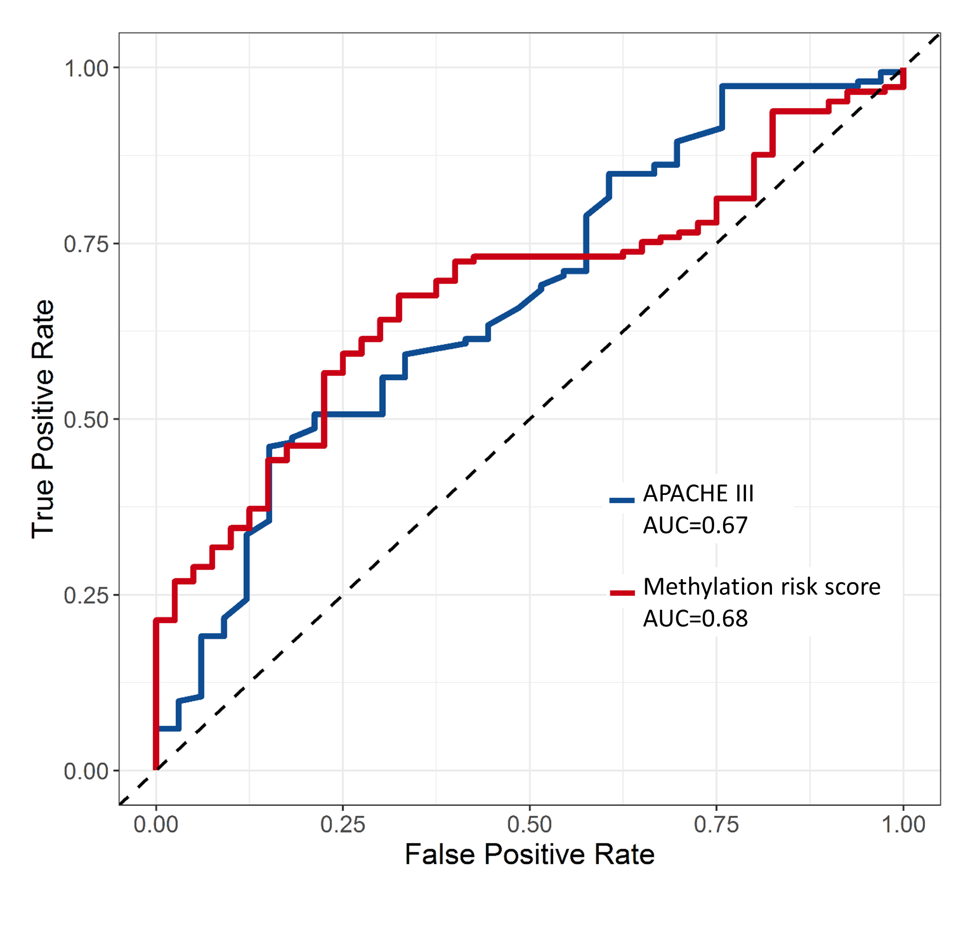
Supplementary Figure 1. Receiver operating characteristic (ROC) curves for methylation risk score and APACHE III score for prediction of 28-day ARDS mortality. AUC: area under the ROC curve.
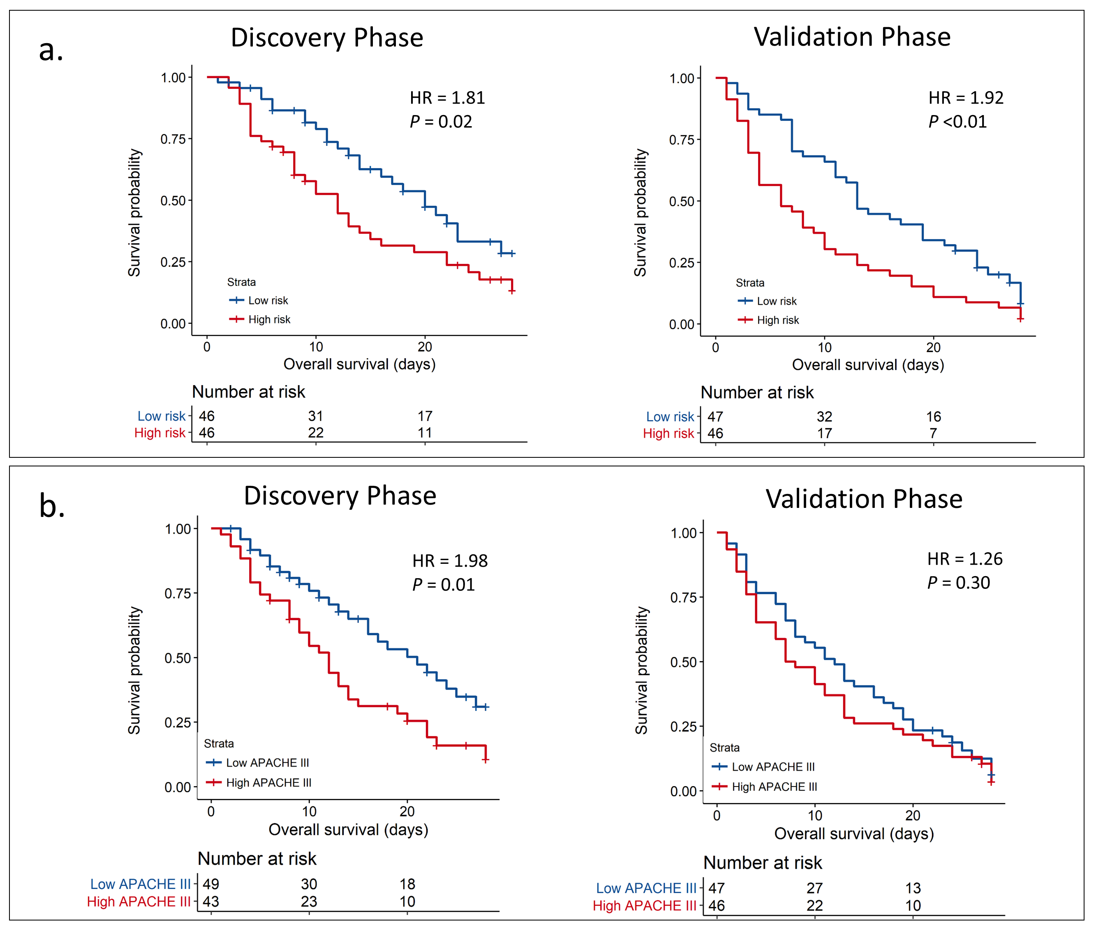
Supplementary Figure 2. Kaplan–Meier survival analysis according to the a) DNA methylation risk score classifier and b) APACHE III score classifier. All p-values were estimated by log-rank test.
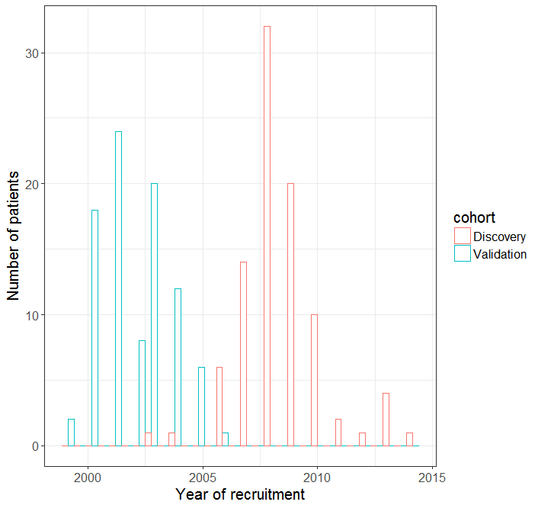
Supplementary Figure 3. The number of patients recruited at each year of study period.

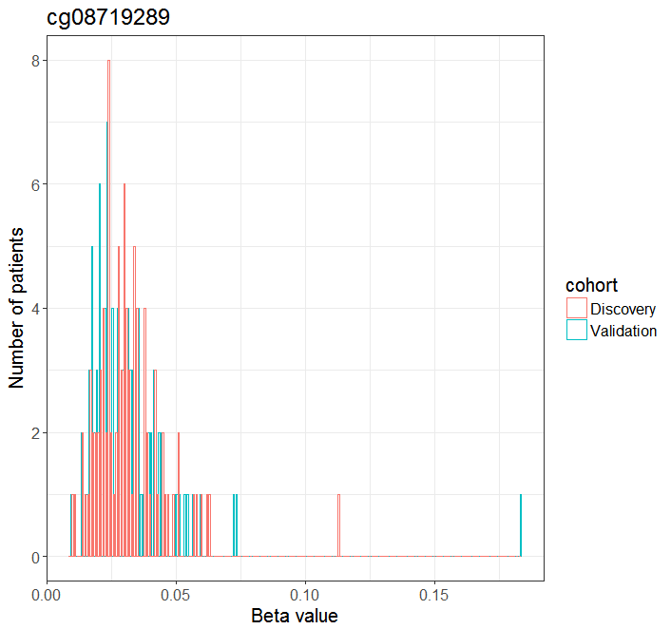
Supplementary Figure 4. The distribution of beta values of probe cg08719289

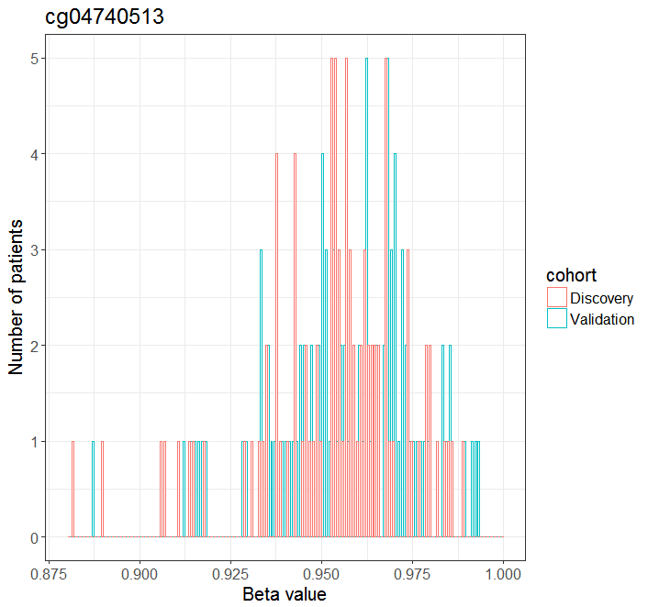
Supplementary Figure 5. The distribution of beta values of probe cg04740513

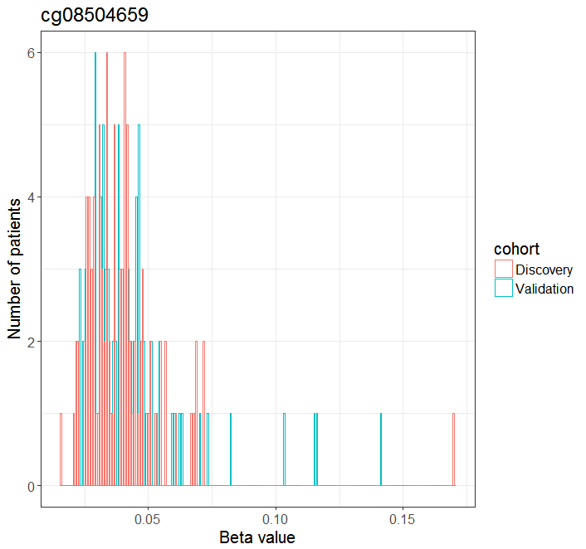
Supplementary Figure 6. The distribution of beta values of probe cg08504659

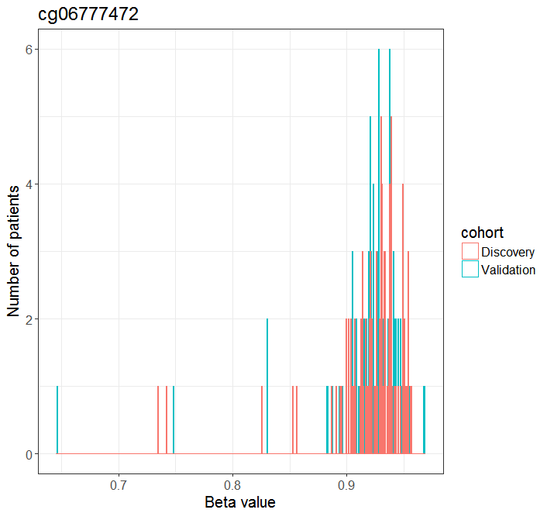
Supplementary Figure 7. The distribution of beta values of probe cg0677747

Reference
- Zhang R, Wang Z, Tejera P, Frank AJ, Wei Y, Su L, Zhu Z, Guo Y, Chen F, Bajwa EK, Thompson BT, Christiani DC (2017) Late-onset moderate to severe acute respiratory distress syndrome is associated with shorter survival and higher mortality: a two-stage association study. Intensive Care Medicine 43(3):399-407.
- Ferguson ND, Fan E, Camporota L, Antonelli M, Anzueto A, Beale R, Brochard L, Brower R, Esteban A, Gattinoni L, Rhodes A (2012) The Berlin definition of ARDS: an expanded rationale, justification, and supplementary material. Intensive Care Medicine 38(10):1573-82.
- Liao KM, Chen CW, Hsiue TR, Lin WC (2009) Timing of acute respiratory distress syndrome onset is related to patient outcome. Journal of the Formosan Medical Association 108(9):694-703.
- Hernu R, Wallet F, Thiollière F, Martin O, Richard JC, Schmitt Z, Wallon G, Delannoy B, Rimmelé T, Démaret C, Magnin C (2013) An attempt to validate the modification of the American-European consensus definition of acute lung injury/acute respiratory distress syndrome by the Berlin definition in a university hospital. Intensive Care Medicine 39(12):2161-70.
- Boissier F, Katsahian S, Razazi K, Thille AW, Roche-Campo F, Leon R, Vivier E, Brochard L, Vieillard-Baron A, Brun-Buisson C, Dessap AM (2013) Prevalence and prognosis of cor pulmonale during protective ventilation for acute respiratory distress syndrome. Intensive Care Medicine 39(10):1725-33.
- Atabai K, Matthay MA (2002) The pulmonary physician in critical care• 5: Acute lung injury and the acute respiratory distress syndrome: definitions and epidemiology. Thorax 57(5):452-8.
- Chen YA, Lemire M, Choufani S, Butcher DT, Grafodatskaya D, Zanke BW, Gallinger S, Hudson TJ, Weksberg R (2013) Discovery of cross-reactive probes and polymorphic CpGs in the Illumina Infinium HumanMethylation450 microarray. Epigenetics 8, 203-209.
- McCartney DL, Walker RM, Morris SW, McIntosh AM, Porteous DJ, Evans KL (2016) Identification of polymorphic and off-target probe binding sites on the Illumina Infinium MethylationEPIC BeadChip. Genomics Data 9, 22-24.
- Pidsley R, CC YW, Volta M, Lunnon K, Mill J, Schalkwyk LC (2013) A data-driven approach to preprocessing Illumina 450K methylation array data. BMC Genomics 14, 293.
- Teschendorff AE, Marabita F, Lechner M, Bartlett T, Tegner J, Gomez-Cabrero D, Beck S (2013) A beta-mixture quantile normalization method for correcting probe design bias in Illumina Infinium 450 k DNA methylation data. Bioinformatics (Oxford, England) 29, 189-196.
- Johnson WE, Li C, Rabinovic A (2007) Adjusting batch effects in microarray expression data using empirical Bayes methods. Biostatistics (Oxford, England) 8, 118-127.
- Rahmani E, Zaitlen N, Baran Y, Eng C, Hu D, Galanter J, Oh S, Burchard EG, Eskin E, Zou J, Halperin E (2016) Sparse PCA corrects for cell type heterogeneity in epigenome-wide association studies. Nature Methods 13(5):443-5.
- Benjamini Y, Hochberg Y (1995) Controlling the false discovery rate: a practical and powerful approach to multiple testing. Journal of the Royal Statistical Society. Series B (Methodological) Jan 1:289-300.
- Heagerty PJ, Lumley T, Pepe MS (2000) Time-dependent ROC curves for censored survival data and a diagnostic marker. Biometrics Jun 1;56(2):337-44.
- Zambon M, Vincent JL (2008) Mortality rates for patients with acute lung injury/ARDS have decreased over time. Chest 133(5):1120-7.
- Phua J, Badia JR, Adhikari NK, Friedrich JO, Fowler RA, Singh JM, Scales DC, Stather DR, Li A, Jones A, Gattas DJ (2009) Has mortality from acute respiratory distress syndrome decreased over time? A systematic review. American Journal of Respiratory and Critical Care Medicine 179(3):220-7.
- Bauer TT, Valencia M, Badia JR, Ewig S, González J, Ferrer M, Torres A (2005) Respiratory microbiology patterns within the first 24 h of ARDS diagnosis: influence on outcome. Chest 128(1):273-9.
- Chastre J, Trouillet JL, Vuagnat A, Joly-Guillou ML, Clavier H, Dombret MC, Gibert C (1998) Nosocomial pneumonia in patients with acute respiratory distress syndrome. American Journal of Respiratory and Critical Care Medicine 157(4):1165-72.
- MARKOWICZ P, Wolff M, Djedaini K, Cohen Y, Chastre J, Delclaux C, Merrer J, Herman B, Veber B, Fontaine A, Dreyfuss D (2000) Multicenter prospective study of ventilator-associated pneumonia during acute respiratory distress syndrome: incidence, prognosis, and risk factors. American Journal of Respiratory and Critical Care Medicine 161(6):1942-8.
- Lu Y, Song Z, Zhou X, Huang S, Zhu D, Bai XY, Sun B, Spragg R, Shanghai ARDS Study Group (2004) A 12-month clinical survey of incidence and outcome of acute respiratory distress syndrome in Shanghai intensive care units. Intensive Care Medicine 30(12):2197-203.
- Bellani G, Laffey JG, Pham T, Fan E, Brochard L, Esteban A, Gattinoni L, Van Haren F, Larsson A, McAuley DF, Ranieri M (2016) Epidemiology, patterns of care, and mortality for patients with acute respiratory distress syndrome in intensive care units in 50 countries. JAMA 315(8):788-800.

