The influence of hydrogeological and anthropogenic variables on phthalate contamination in eogenetic karst groundwater systems

Norma I. Torres ª, Xue Yu^{b}, Ingrid Y. Padillaª, Raul E. Macchiavelli^{c}, Reza Ghasemizadeh^{b}, David Kaeli^{d}, Jose F. Cordero^{e}, John D. Meeker^{f}, and Akram N. Alshawabkeh^{b}

ªDepartment of Civil Engineering and Surveying, University of Puerto Rico, Mayagüez, PR 00681, USA

^{b}Department of Civil and Environmental Engineering, Northeastern University, Boston, MA 02115, USA

^{c}Department of Agroenvironmental Sciences, University of Puerto Rico, Mayagüez, PR 00681, USA

^{d}Department of Electrical and Computer Engineering, Northeastern University, Boston, MA 02115, USA

^{e}Department of Epidemiology and Biostatistics, University of Georgia, Athens, GA 30602, USA

^{f}Department of Environmental Health Sciences, University of Michigan School of Public Health, Ann Arbor, MI 48109, USA

Corresponding author: Ingrid Y. Padilla
Address: Department of Civil Engineering and Surveying, University of Puerto Rico at Mayagüez,
PO Box 9000 Mayagüez, PR 00681
Email: ingrid.padilla@upr.edu; Phone: 787-832-4040 x.3417

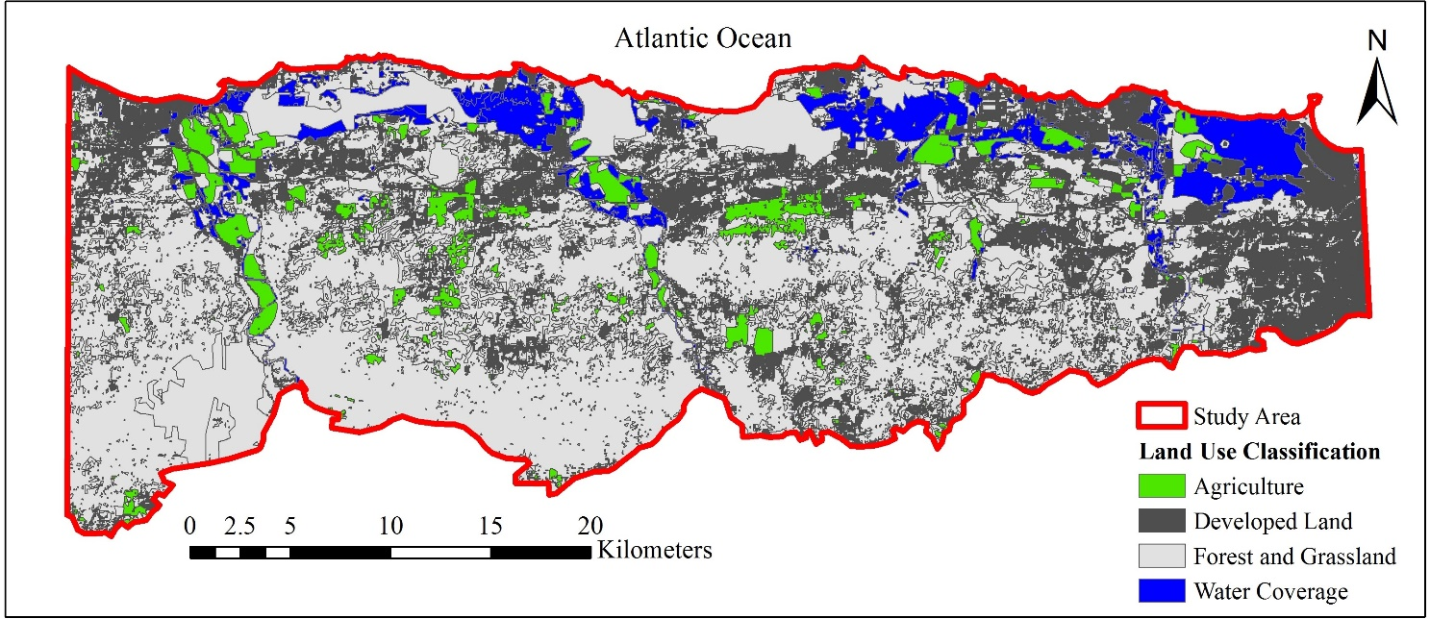
Figure S1. Land use distribution in the study area. Developed lands include: construction, high/low-density residential, high/low-density trade and services, industrial, infrastructure, mining, public and recreation, and utilities uses. Natural land use includes: forest, grassland, rangeland and rocky cliffs and shelves areas. Water coverage includes: surface water (such as rivers), mangroves, and swamps.

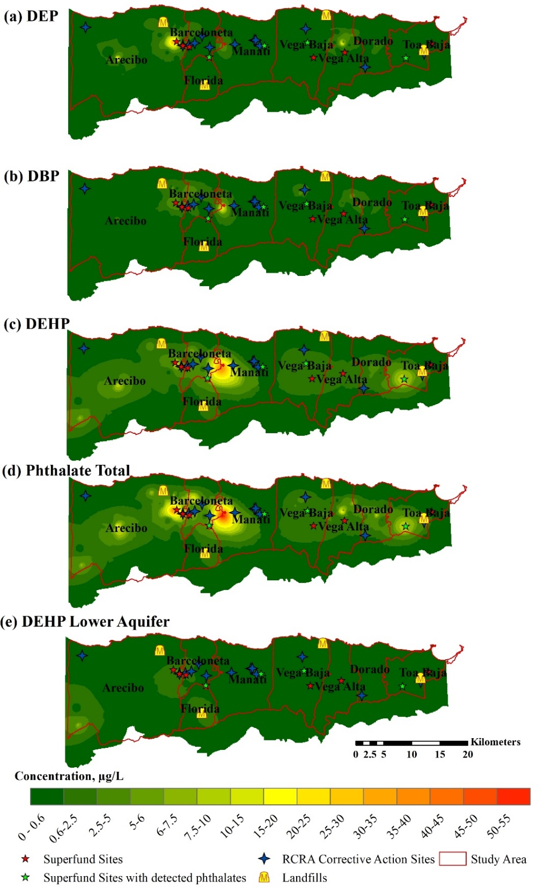
Figure S2. Spatial distribution of (a) DEP (b) DBP, (c) DEHP, and (d) total phthalate (µg L⁻¹) in the upper aquifer and of DEHP in the lower aquifer including potential contamination sites in the study area.
Phthalate sampling and analysis method
- Duplicate samples were collected at each site.
- Field, shipment and laboratory blanks were collected for each sampling day.
- Samples were collected in 1 L amber bottles and stored in a refrigerator (4 ºC) before extraction and analysis.
- The analysis of collected samples followed modified procedures of U.S. EPA methods 3510C and 8270D (Cotto, 2015), and involved liquid-liquid extraction with dichloromethane (DCM), extract concentration, and solvent exchange before analytical measurement. Extraction efficiency studies for DEHP as a model phthalate (Cotto 2015) show that percent recoveries of the analysis varies between 13.0 and 96%. (Cotto, 2015). These recoveries are comparable with other studies (Cotto 2015).
- Sample extractions were performed within 7 days of collection, and entailed conducting three consecutive extractions of 100 mL of water sample with 18 mL of DCM in a 250 mL separatory funnel.
- The 18-mL extract was then concentrated to 1 mL in a Kuderna-Danish apparatus (H6161-TUWHPL, Organomation Associates, Inc., Berlin MA, USA), followed by solvent exchange into hexane.
- An Agilent GC 7820A chromatograph equipped with an MSD 5975 mass spectrometric detector (Agilent Technologies, Santa Clara, CA, USA) was used to analyze the extractions based on U.S. EPA method 8270D.
- The instrument was calibrated every 24 hours using external standards prepared from a custom-made phthalate mixture standard in hexane (1000 ug L⁻¹ DEP, DBP and DEHP, AccuStandard® S-21960).
- Calibration and system performance were verified by analyzing calibration and system performance compounds (System Performance Check Compounds - 2.0 mg mL⁻¹ in DCM and Calibration Check Compounds -2.0 mg mL⁻¹ in DCM) during the sampling analysis.
- Quality control samples were prepared at calibration midrange and analyzed every 10 samples.
- Blanks were mostly below detection limits, but for cases in which concentrations were above detection limits, sample concentrations were corrected by subtracting average blank values.
- Detection limits were set at the instrument detection limit (IDL), which was assumed as the lowest point in the calibration curve that the instrument measures. Generally, the IDL for phthalates was 1 ug L⁻¹.

Table S1. Sampling, analysis, quality control and quality assurance process for phthalates analysis.

Phthalate Data Analysis Limitations:
- This study relies on a large number of data samples (n=2004) collected from various sources of information. The use of a diverse set of information sources increases data variability, but enhances statistical power in the estimates of averages. Large number of data samples, thus, ensures that any deviations from expected probable values are averaged out or evened out.
- In addition to differences in sampling frequencies, the different sources of information (i.e. our own sampling campaign, USGS, PRDOH, and U.S. EPA) apply different analytical methods for the quantification of water concentrations. All methods rely on sample extraction and concentration techniques, but differ in percent recoveries: extraction efficiency experiments for DEHP using our own sampling campaign show percent recoveries ranging between 13 and 96% (Cotto, 2015); analytical methods for phthalates used by the USGS report mean percent recoveries ranging between 49 and 225% (Zaugg et al., 2007; U.S.G.S., 1993); the PRDoH data is based on U.S. EPA Method 525.2, which reports percent recoveries for various phthalate species ranging between 114 and 137% (Munch, 1995); and the U.S. EPA uses documents several methods for the analysis (Munch, 1995; U.S. EPA 1994, 1996a,b,c,d, 2014), but their data do not indicate the method used for the analysis. Reported recoveries of phthalates in water for U.S. EPA methods vary widely (from detection to 158%) among tested laboratories (U.S. EPA 1994, 1996c, d, 2014).
- High variability in extraction recoveries could result on under- or over-estimation of individual sample values, but the application of large numbers of data is believed to provide appropriate averages among the conditions tested.

Table S2. Limitations on the phthalate data analysis
References:
Munch, J.W., 1995. Method 525.2. Revision 2.0: Determination of organic compounds in drinking water by liquid-solid extraction and capillary column gas chromatography/mass spectrometry. United States Environmental Protection Agency. National Exposure Research Laboratory, Cincinnati, Ohio.
U.S. EPA, US Environmental Protection Agency, 2014. Method 8270D: Semivolatile organic compounds by gas chromatography/mass spectrometry (GC/MS). Retrieved September, 2015 from http://www.epa.gov/wastes/hazard/testmethods/sw846/pdfs/8270d.pdf

U.S. EPA, US Environmental Protection Agency, 1996a. Method 3510C: Separatory funnel liquid-liquid extraction. Retrieved September, 2015 from http://www.epa.gov/wastes/hazard/testmethods/sw846/pdfs/3510c.pdf

U.S. EPA, US Environmental Protection Agency, 1996b. Method 3520C: Continuous liquid-liquid extraction. Retrieved September, 2015 from http://www.epa.gov/wastes/hazard/testmethods/sw846/pdfs/3520c.pdf

U.S. EPA, US Environmental Protection Agency, 1996c. Method 606: Methods for organic chemical analysis of municipal and indutrial wastewater: phthalate esters (GC/ECD). Retrieved September, 2015 from http://water.epa.gov/scitech/methods/cwa/organics/upload/2007_07_10_methods_method_organics_606.pdf

U.S. EPA, US Environmental Protection Agency, 1996d. Method 8061A: Phthalate esters by gas chromatography with electron capture detection (GC/ECD). Retrieved September, 2015 from http://www.epa.gov/wastes/hazard/testmethods/sw846/pdfs/8061a.pdf

U.S. EPA, US Environmental Protection Agency, 1994. Method 8250A: Semivolatile organic compounds by gas chomatography/mass spectrometry (GC/MS). Retrieved September, 2015 from http://legismex.mty.itesm.mx/secc_inter/SW-846/8250a.pdf

U.S.G.S., U.S. Geological Survey, 1993. National Water Quality Laboratory-Determination of
Inorganic and Organic Constituents in Water and Fluvial Sediments. M.J. Fishman Ed, USGS Open-File Report 93-125, Denver, Co.
Zaugg, S.D., Smith, S.G., Schroeder, M.P., 2006. Determination of wastewater compounds in whole water by continuous liquid–liquid extraction and capillary-column gas chromatography/mass spectrometry. U.S. Geological Survey Techniques and Methods, book 5, chap. B4, 30 p.

