SUPPORTING INFORMATION
Supporting Information 1: Phenology monitoring sites. Sites and the number of trees of each genus that were monitored at each site.
 |  | Number of trees monitored |  |  | Impervious surface area (average)
Site | Neighborhood | Quercus | Morus | Total | 100 m | 1 km | 2 km
A1 | Palmer Park | 14 | 3 | 17 | 47.6 | 36.1 | 46.7
A2 | University District | 21 | 1 | 22 | 38.7 | 42.8 | 49.5
A3 | Appoline St. | 9 | 2 | 11 | 57.0 | 67.6 | 64.8
B1 | Voight Park | 10 | 1 | 11 | 42.0 | 62.4 | 60.1
B2 | North End | 10 | 3 | 13 | 52.0 | 60.1 | 65.2
B3 | Lasalle Gardens | 10 |  | 10 | 66.2 | 62.1 | 66.3
C1 | Indian Village | 21 | 2 | 23 | 34.1 | 53.1 | 53.2
C2 | Concord Ave. | 11 | 8 | 19 | 64.0 | 62.6 | 59.4
C3 | Elmwood Park | 9 | 2 | 11 | 51.4 | 74.3 | 69.4
Total |  | 115 | 22 | 137
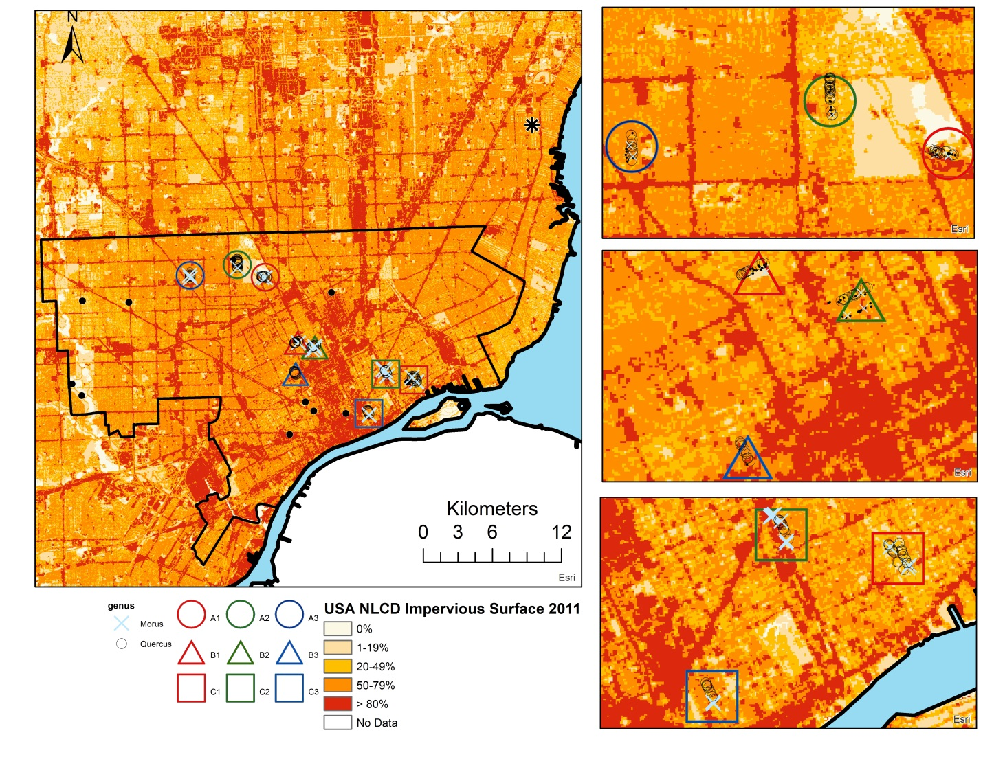

Supporting Information 2: Tree composition
Of the 6,846 oak street trees in Detroit, 5,108 (75%) are in the red oak group (below, left); the two species with the highest abundance are Quercus rubra (2231, 33%) and Quercus palustris (2071, 30%). Of the 115 oak trees monitored for this study (below, right), 97 (84%) are in the red oak group; the two species with the highest counts are Quercus rubra (67, 58%) and Quercus palustris (28, 24%).
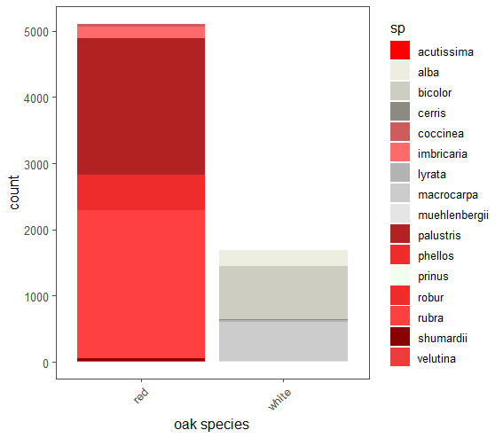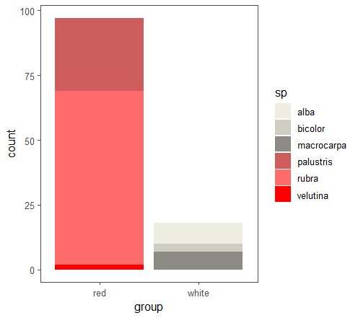

Supporting Information 3: Flowering phenology of tagged branches.
Average percent of labeled catkins open on each tree at each observation (black dots) compared to the percent of mature flowers across the entire tree (red dots). Note that some observations of tagged catkin clusters are missing because the tagged branches did not flower or tags were removed. 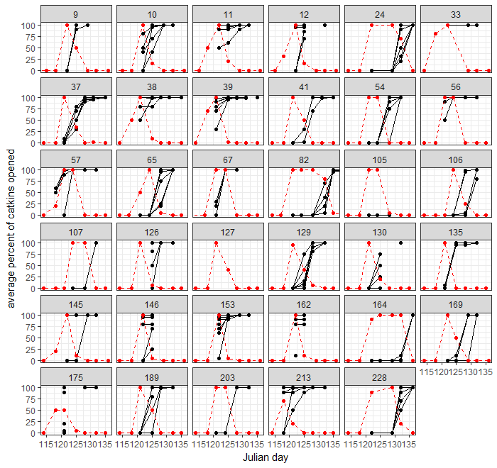

Supporting Information 4: Pollen measurement reproducibility
We assessed the reproducibility of our pollen measurements in several ways. Our measurements were taken with Rotorod samplers, which are one of the most commonly used pollen sampling devices, and are generally considered to have high sampling efficiencies for particles above 10 μ.
First, to assess pollen contamination, we used field blanks while sampling. The maximum number of pollens counted on a field blank was 15; the average number was 3. In comparison, the average number of pollen grains collected from a sample was 404. Data are presented below. 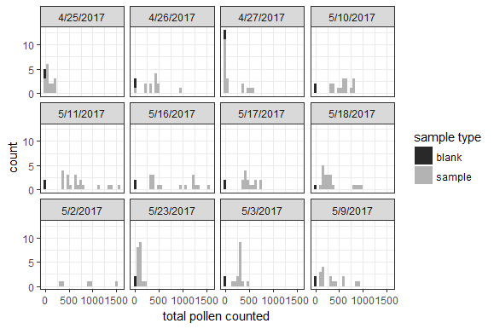

To assess how small difference in sampler deployment affected measurements, we placed duplicate rotorods next to each other (approximately 1 – 2 m apart) and compared differences in measurements (see figure below). Note that data are from a separate experiment from spring 2017 that used the same samplers. In one case, (x = 40, y = 52) the duplicates were not installed simultaneously (duplicate A was installed 30 minutes after Duplicate B; total run time was 1 hr 23 min vs. 1 hr 55 min).
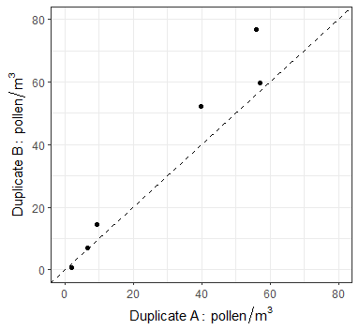
To compare differences caused by intra-sampler stochasticity, we also compared concentrations between the two duplicate rods that sampled simultaneously (figure is below). The one to one line is shown and the correlation (Pearson’s r) is 0.94. Note that data are from a separate experiment from spring 2017 that used the same samplers.
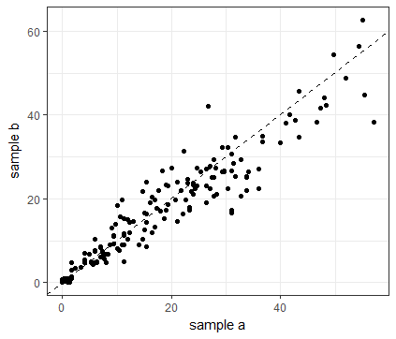

A reduced area of each rod was surveyed for mulberry pollen. To assess the effects of the decreased sampling area, we compared the mean of the first and second rods from each sample (figure is below). The one to one line is shown and the correlation (Pearson’s r) is 0.93. The mean of the first and second rod are used in the analyses.
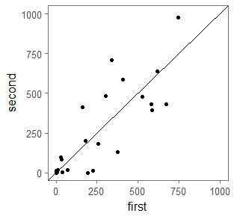

Supporting Information 5: Flowering period for each monitored oak tree. Sites form a gradient of North (A) to South (C). Colored lines and points are the average amount of mature flowers present on all oak trees at that site and gray lines are individual trees (note that some trees are not visible due to complete overlap with other trees). Trees were observed twice a week; daily values between those points are linear interpolations. Different letters above points represent significant differences in mature flowers between sites (note that significance is not shown for every day due to space constraints). The overall empirical mean for the percent of active flowers at a site as a function of days from peak is also shown (below). 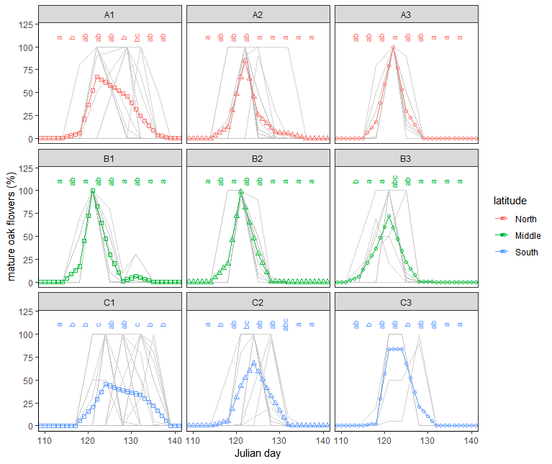
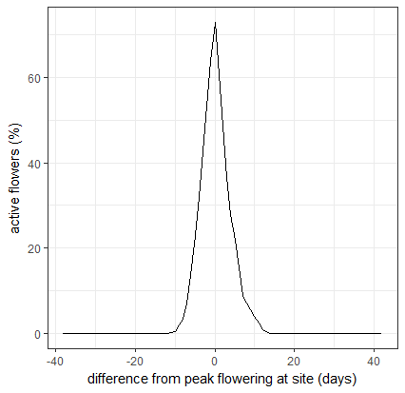

Supporting Information 6: Linear relationships between peak site flowering times as a function of MODIS land surface temperature (measured at the site level). The linear regression with the best fit with a single variable (February night time temperature) is in bold. Models with two or more variables are not shown.
Satellite | Overpass time | Month | R² | MSE | p | AIC
Terra | Day (10:30) | January | 0.10 | 7.05 | 0.411 | 45
 |  | February | 0.15 | 6.63 | 0.301 | 44
 |  | March | 0.77 | 1.80 | 0.002 | 32
 |  | April | 0.90 | 0.75 | p < 0.001 | 24
 |  | May | 0.56 | 3.43 | 0.020 | 38
 | Night (22:30) | January | 0.62 | 2.97 | 0.012 | 37
 |  | February | 0.94 | 0.51 | p < 0.001 | 21
 |  | March | 0.13 | 6.80 | 0.340 | 44
 |  | April | 0.27 | 5.71 | 0.152 | 43
 |  | May | 0.56 | 3.43 | 0.005 | 35
Aqua | Day (13:30) | January | 0.34 | 5.16 | 0.099 | 41
 |  | February | 0.68 | 2.48 | 0.006 | 35
 |  | March | 0.85 | 1.19 | p < 0.001 | 28
 |  | April | 0.80 | 1.54 | 0.001 | 31
 |  | May | 0.44 | 4.38 | 0.052 | 40
 | Night (1:30) | January | 0.11 | 6.95 | 0.379 | 44
 |  | February | 0.24 | 5.92 | 0.178 | 43
 |  | March | 0.00 | 7.82 | 0.995 | 45
 |  | April | 0.01 | 7.77 | 0.846 | 45
 |  | May | 0.56 | 3.45 | 0.021 | 38

Average night and day temperatures in each site for springtime months from 2007 – 2017. Land surface temperature is derived from MODIS satellite imagery for the relevant time period. Sites form a gradient of North (A) to South (C).

Site | Land Surface Temperature (MODIS): Terra
 | Day time temperature (°C) |  |  |  |  | Night time temperature (°C)
 | Jan | Feb | Mar | Apr | May | Jan | Feb | Mar | Apr | May
A1 | -3.54 | 1.04 | 13.79 | 22.92 | 28.88 | -9.18 | -8.15 | -1.32 | 6.01 | 12.69
A2 | -3.35 | 1.49 | 14.26 | 24.20 | 31.05 | -7.52 | -7.42 | -1.18 | 6.25 | 13.25
A3 | -3.45 | 2.25 | 14.21 | 24.40 | 30.81 | -8.11 | -7.24 | -1.03 | 6.66 | 13.44
B1 | -2.84 | 1.52 | 14.21 | 24.24 | 30.35 | -7.68 | -7.07 | -1.32 | 5.83 | 12.94
B2 | -3.12 | 2.44 | 14.50 | 24.14 | 30.82 | -8.50 | -7.23 | -1.18 | 5.85 | 13.17
B3 | -2.85 | 2.37 | 14.24 | 24.24 | 29.85 | -8.02 | -7.06 | -1.07 | 5.89 | 13.03
C1 | -2.05 | 2.22 | 12.85 | 22.57 | 28.03 | -9.19 | -8.59 | -1.26 | 5.22 | 12.15
C2 | -3.26 | 1.14 | 13.93 | 23.41 | 30.24 | -8.55 | -7.89 | -1.43 | 4.66 | 12.43
C3 | -2.54 | 1.37 | 13.49 | 23.36 | 30.73 | -8.44 | -8.07 | -0.94 | 5.17 | 12.77
NAB Station | -3.68 | 0.66 | 11.99 | 20.86 | 27.16 | -10.17 | -9.50 | -3.65 | 2.93 | 10.23

Site | Land Surface Temperature (MODIS): Aqua
 | Day time temperature (°C) |  |  |  |  | Night time temperature (°C)
 | Jan | Feb | Mar | Apr | May | Jan | Feb | Mar | Apr | May
A1 | -0.43 | 3.43 | 15.68 | 24.48 | 29.37 | -8.63 | -7.69 | -2.74 | 2.75 | 10.83
A2 | 1.05 | 6.33 | 17.96 | 25.95 | 31.22 | -8.19 | -8.11 | -2.54 | 2.95 | 11.14
A3 | 0.90 | 8.65 | 18.36 | 26.27 | 32.40 | -8.69 | -8.01 | -2.83 | 3.12 | 11.02
B1 | 1.50 | 6.18 | 17.73 | 25.69 | 31.70 | -8.87 | -5.99 | -2.93 | 2.65 | 10.76
B2 | 1.66 | 6.97 | 18.02 | 26.41 | 31.63 | -8.31 | -6.51 | -2.70 | 2.97 | 10.94
B3 | 0.93 | 6.73 | 18.13 | 26.96 | 32.74 | -8.20 | -7.13 | -3.02 | 2.84 | 10.81
C1 | 0.83 | 3.87 | 15.78 | 24.35 | 30.21 | -9.34 | -7.98 | -2.73 | 3.00 | 9.86
C2 | -1.08 | 4.82 | 16.89 | 25.35 | 31.55 | -7.78 | -6.88 | -3.24 | 2.35 | 10.29
C3 | 1.40 | 5.41 | 16.74 | 24.96 | 32.70 | -9.57 | -8.11 | -2.87 | 3.37 | 10.58
NAB Station | -1.02 | 4.02 | 13.83 | 22.08 | 28.75 | -11.74 | -11.06 | -5.18 | 0.51 | 8.50

Comparisons between 5 and 10 year average monthly February night time temperatures are shown below. Although the 5 year average was lower temperature than the 10 year average by ~ 1° C , the correlation is still high (Terra: 0.96, Aqua: 0.97). The standard deviation of the 5 year period was higher than the standard deviation of the 10 year period for Terra (0.79 vs 0.87) and Aqua (1.38 vs. 1.62).
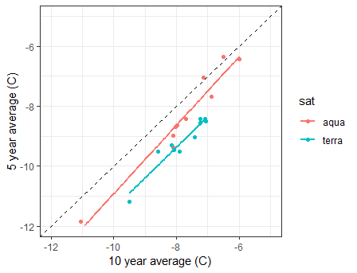

Supporting Information 7: Individual tree models. Linear relationships between peak flowering times and tree size and impervious surface area at various spatial scales for individual oak trees.
Variable | Spatial scale | R² | P | AIC
Tree diameter at 1.37 m (DBH) | – | 0.003 | 0.548 | 565
Impervious surface area  around each tree | 30 m | 0.089 | 0.002 | 565
 | 50 m | 0.084 | 0.002 | 566
 | 100 m | 0.085 | 0.002 | 566
 | 200 m | 0.051 | 0.019 | 570
 | 400 m | 0.090 | 0.002 | 565
 | 800 m | 0.098 | 0.001 | 564
 | 1600 m | 0.051 | 0.019 | 570

Supporting Information 8: Intra-genus differences in phenology
Others have found that white oaks (species in our study: Quercus alba, Quercus macrocarpa, Quercus bicolor) tend to flower at different times than red oaks (species in our study: Quercus rubra, Quercus palustris, Quercus velutina) (Gerst et al. 2017). However, intra-group flowering phenology in response to temperature showed the same overall patterns as the genus (at the individual tree level red oak linear regression: R² = 0.33, p < 0.0001, white oak linear regression: R² = 0.26, p <0.05; all oaks R² = 0.45, p <0.0001), although white oaks tended to flower a few days later on average. Given that oak pollen can only be readily identified to the genus level, we maintain genus as the unit of analysis in the main text.
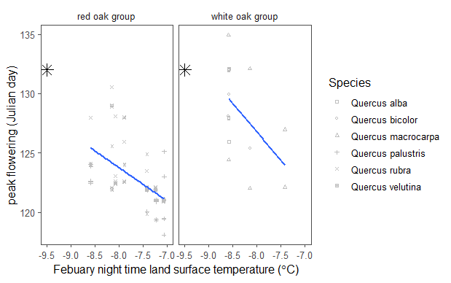

Supporting Information 9: Mulberry floral phenology and pollen. There was substantial variation in mulberry flowering phenology both within and between sites. 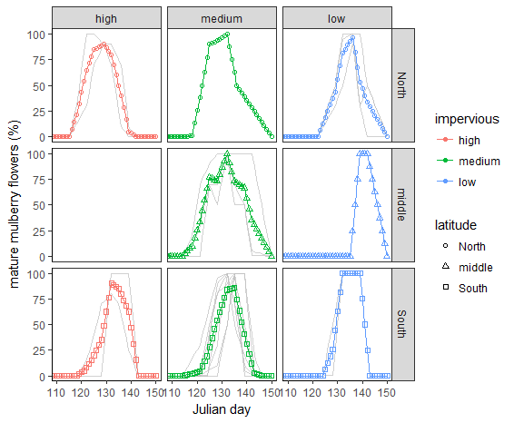
There was a relationship between temperature and mulberry flowering phenology. Note that one site did not have any mulberry trees (B2) and two sites had only one. The relationship between temperature and peak flowering was statistically significant at the individual tree level (R² = 0.22, p < 0.05). Given the small number of sites (8) and that two sites had only one individual, it is not surprising that the relationship at the site level was not statistically significant (the best single variable model, March night time temperatures: R² = 0.35, p = 0.12).
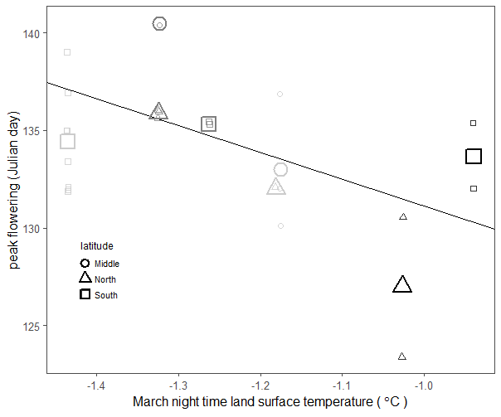
A) Mulberry pollen concentrations at pollen collection sites in Detroit (red) and at the NAB station (black). B) Mulberry pollen concentrations in Detroit as a function of estimated flowering. Note that mulberry pollen concentrations were estimated based on a smaller area analyzed per rod (1.7 mm² per rod instead of 9.2 mm² per rod for oak) due to logistical constraints.
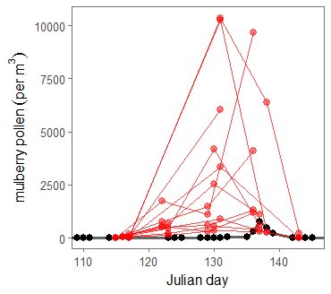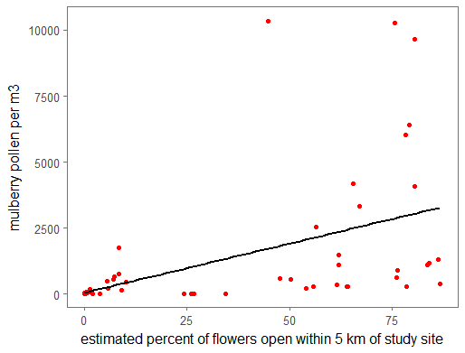

Supporting Information 10: Time series of monitored tree flowers and pollen concentrations measured at the pollen counting station. Status of mature flowers from unmeasured days are linearly interpolated and averaged to show the percentage of all flowers that were mature on each day. 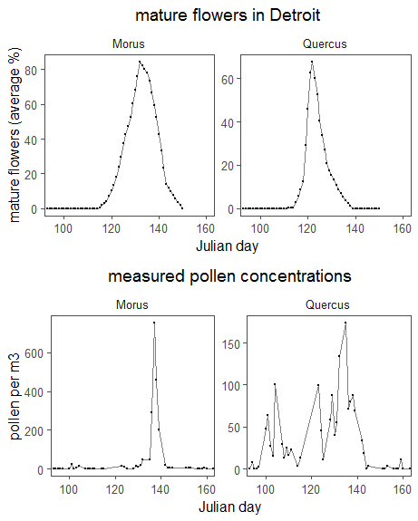
Supporting Information 11: Predicted flowering times and airborne pollen concentrations for oak and mulberry trees.
Dots indicate airborne pollen concentrations, lines indicate the proportion of active flowers at that sites, and color indicates relative temperature of the site. 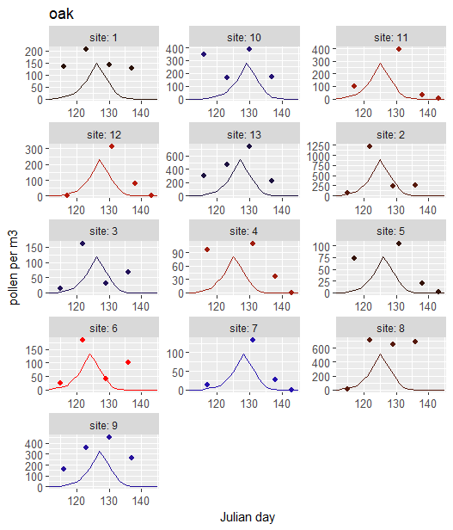
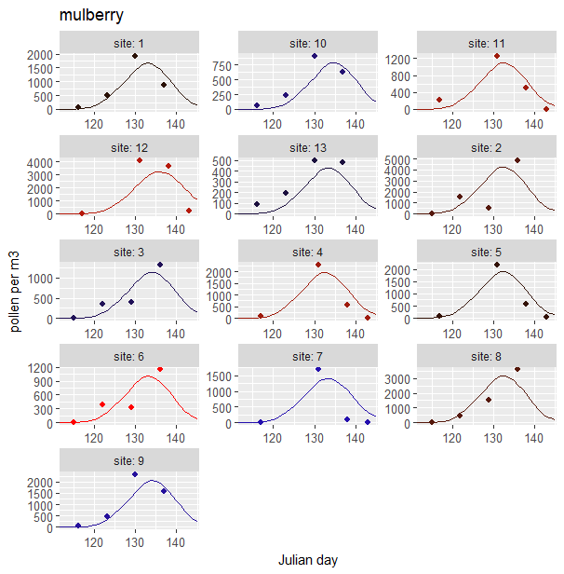
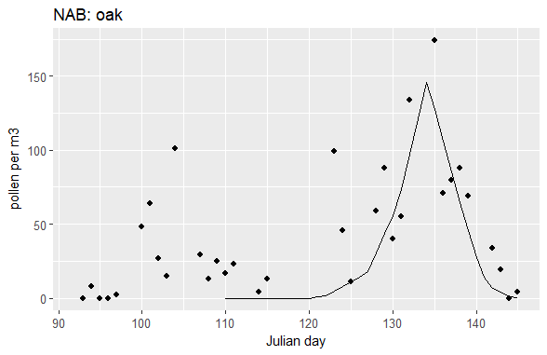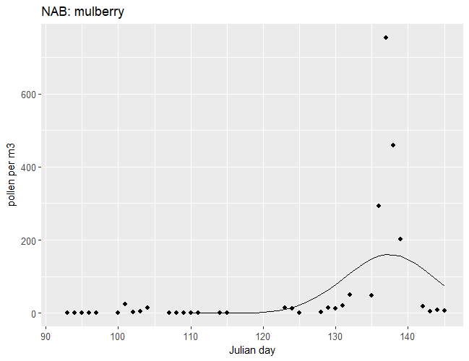

Supporting Information 12: Best spatial scales for airborne pollen concentrations. (without a lag term)
 | Oak |  | mulberry
Spatial scale | Detroit pollen ~ active flowers  linear | NAB pollen ~ active flowers  linear | Detroit pollen ~ active flowers  linear | NAB pollen ~ active flowers  exponential
0 | R² = 0.25  p < 0.001 | R² = 0.34  p < 0.0001 | R² = 0.54  p < 0.0001 | R² = 0.28  p < 0.0001
500 | R² = 0.25  p < 0.001 | R² = 0.29  p < 0.0001 | R² = 0.59  p < 0.0001 | R² = 0.08  p < 0.05
1000 | R² = 0.24  p < 0.001 | R² = 0.20  p < 0.001 | R² = 0.61  p < 0.0001 | R² = 0.08  p < 0.05
2000 | R² = 0.24  p < 0.001 | R² = 0.18  p < 0.01 | R² = 0.62  p <0.0001 | R² = 0.09  p < 0.05
3000 | R² = 0.23  p < 0.001 | R² = 0.16  p < 0.01 | R² = 0.67  p < 0.0001 | R² = 0.17  p < 0.01
4000 | R² = 0.22  p < 0.001 | R² = 0.14  p < 0.01 | R² = 0.67  p < 0.0001 | R² = 0.51  p < 0.0001
5000 | R² = 0.22  p < 0.001 | R² = 0.14  p < 0.01 | R² = 0.68  p < 0.0001 | R² = 0.89  p < 0.0001

Supporting Information 13: Lag between estimated flowering and peak airborne pollen
The monitored trees in this study were near streets and may therefore have flowered earlier than unmeasured trees farther from streets (e.g., in backyards). In order to test for this possibility, lags of 1, 2, 3, 4, and 8 days in flowering time are investigated (results below).
No lag
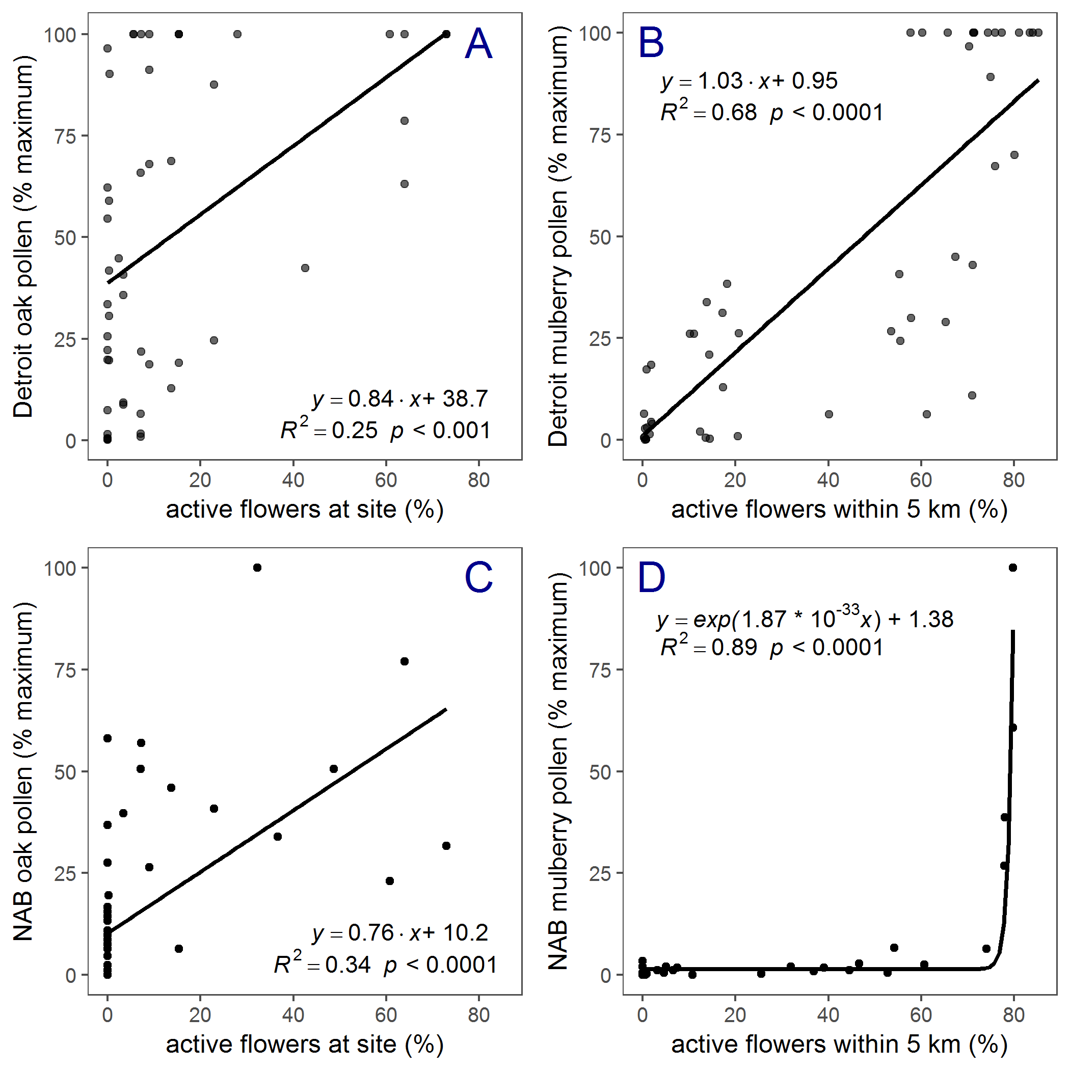
1 day lag
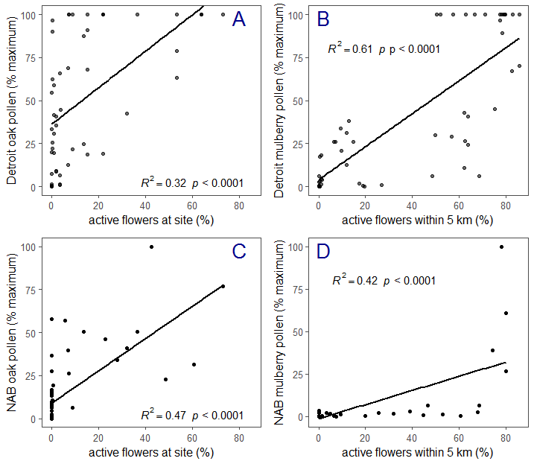
2 day lag
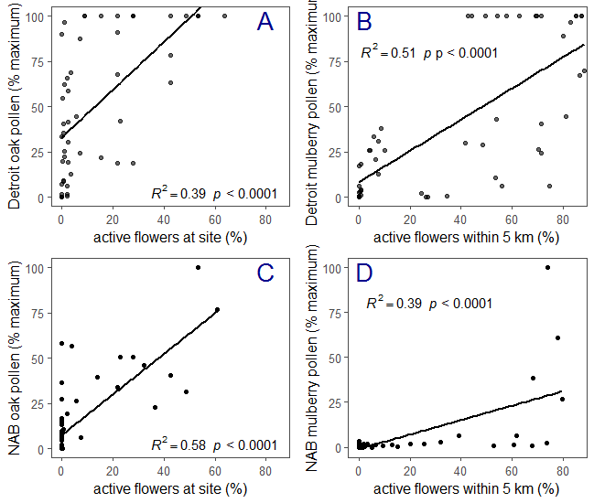
3 day lag
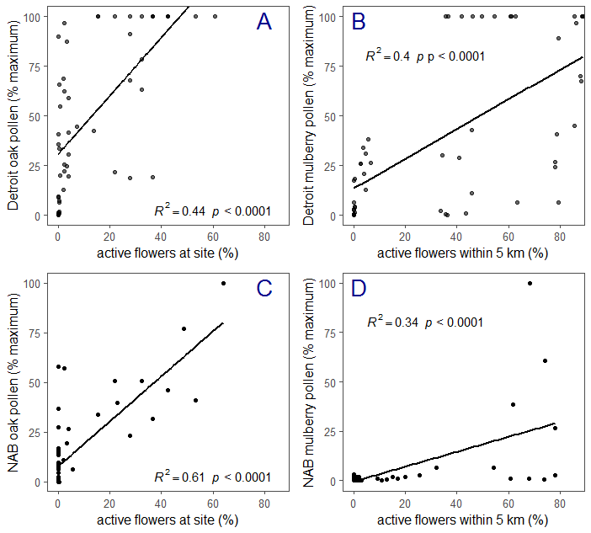
4 day lag
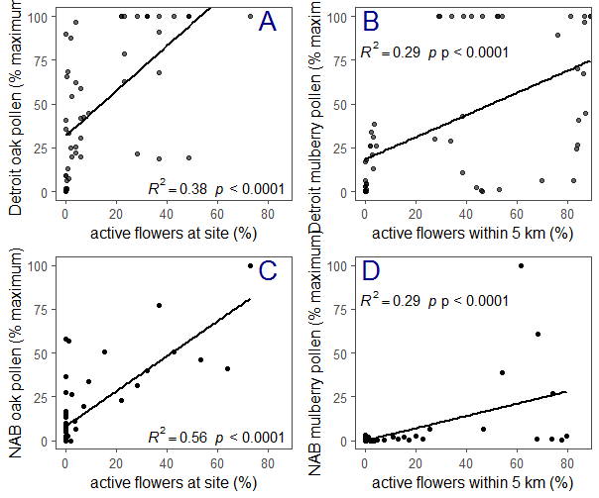
8 day lag
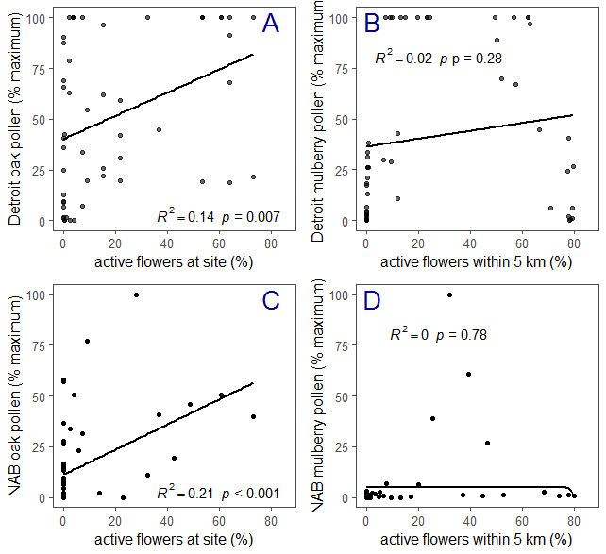

Supporting Information 14: Pollen concentrations from each site and each day.
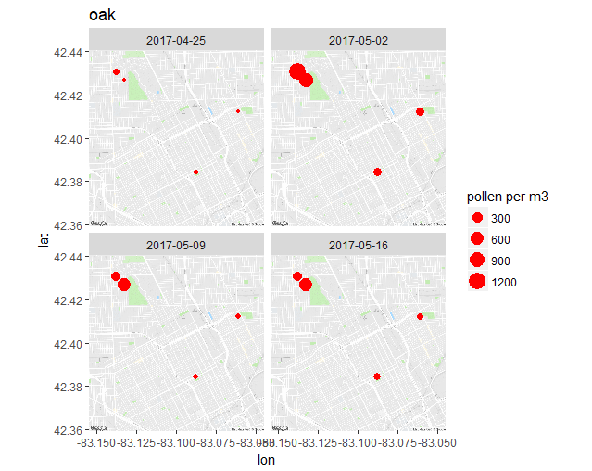
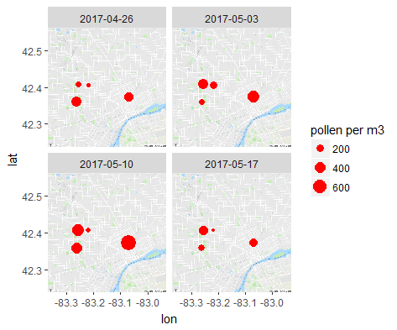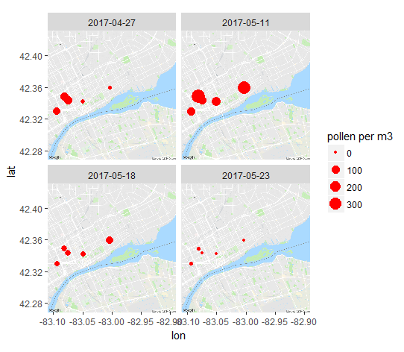
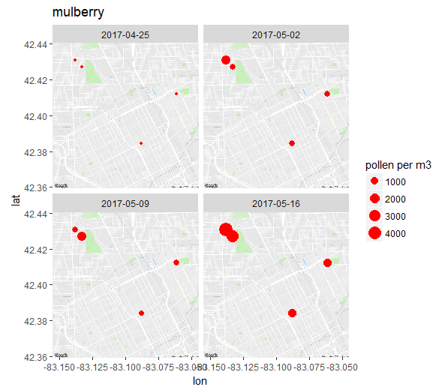
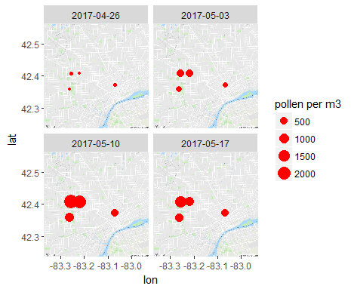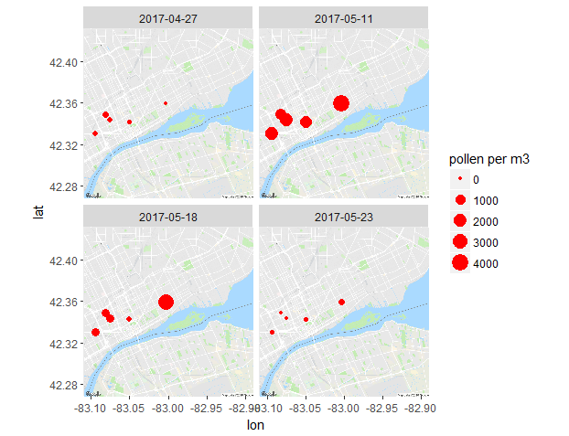
Supporting information 15: Local weather station measurements (from Detroit City Airport) over spring 2017. The arrows in the first panel indicate wind direction.
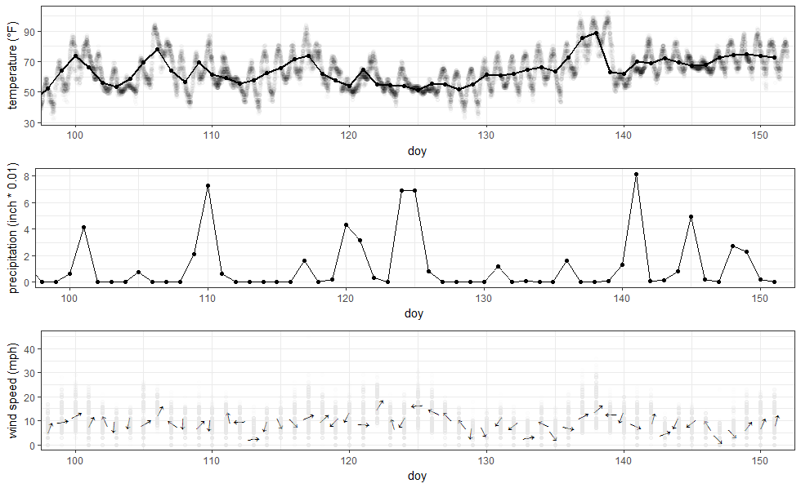

Supporting Information 16: Temperatures within 10 km of hospitals (including Wang et al. 2017, Konishi et al. 2014, Jariwala et al. 2014, and Sakata et al. 2017). Major waterbodies are not included in temperature histograms. The percentage of sites not within 1 C is 46.5%
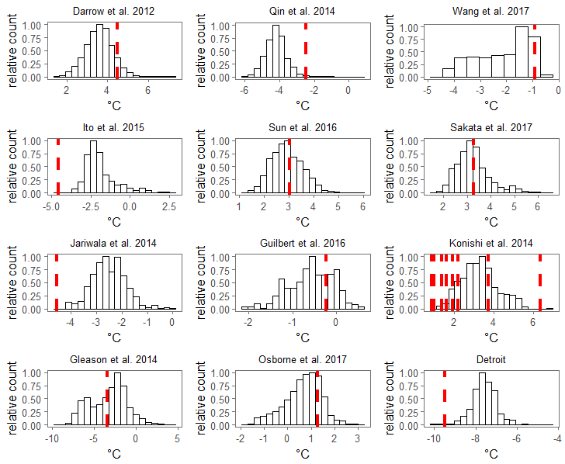

Temperatures within 2 km of the hospitals (including Wang et al. 2017, Konishi et al. 2014, Jariwala et al. 2014, and Sakata et al. 2017). Major waterbodies are not included in temperature histograms. The percentage of sites not within 1 C is 46.5%. The range of temperatures in the study regions was as low as 1.5° C (Wang et al. 2017b) and as high as 15° C (Gleason et al. 2014). The average percent of the study area that was not within 1° C of the pollen counting station (an equivalent of ~4 days for oak flowering in our study) was 50%.