A
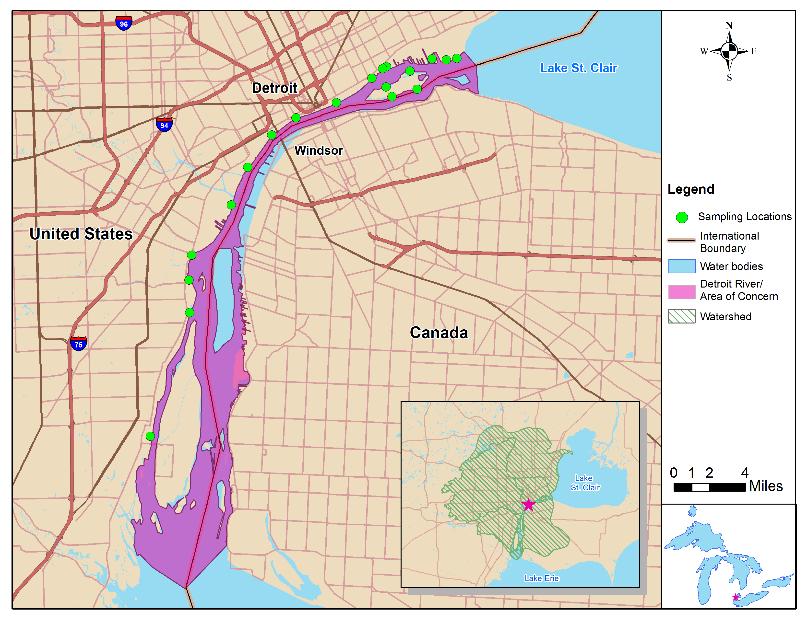
B
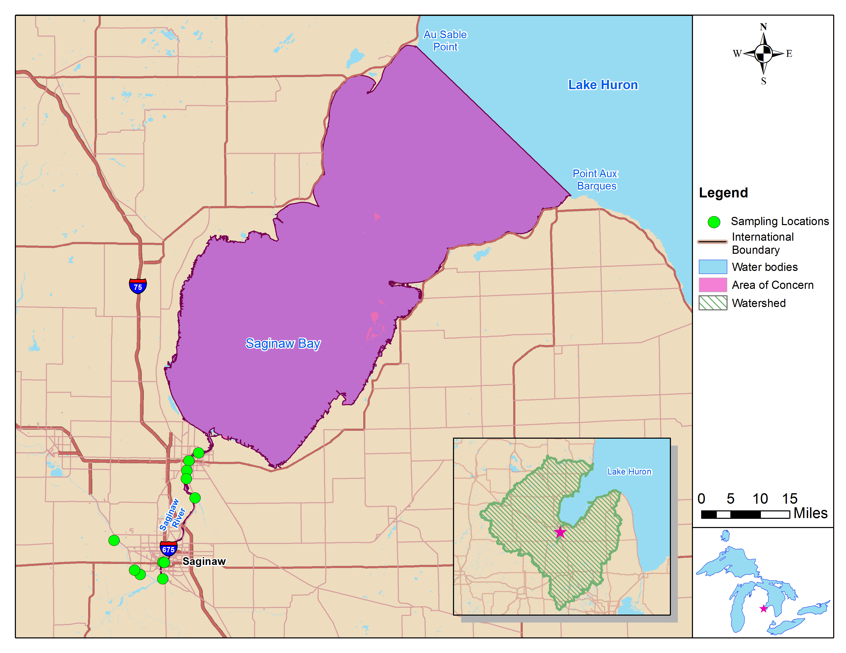

Supplemental Figure 1. Map of the Michigan Department of Health BGLP-I Program Targeted Areas of Concern and sampling locations. (A) the Detroit River; (B) the Saginaw River and Bay.

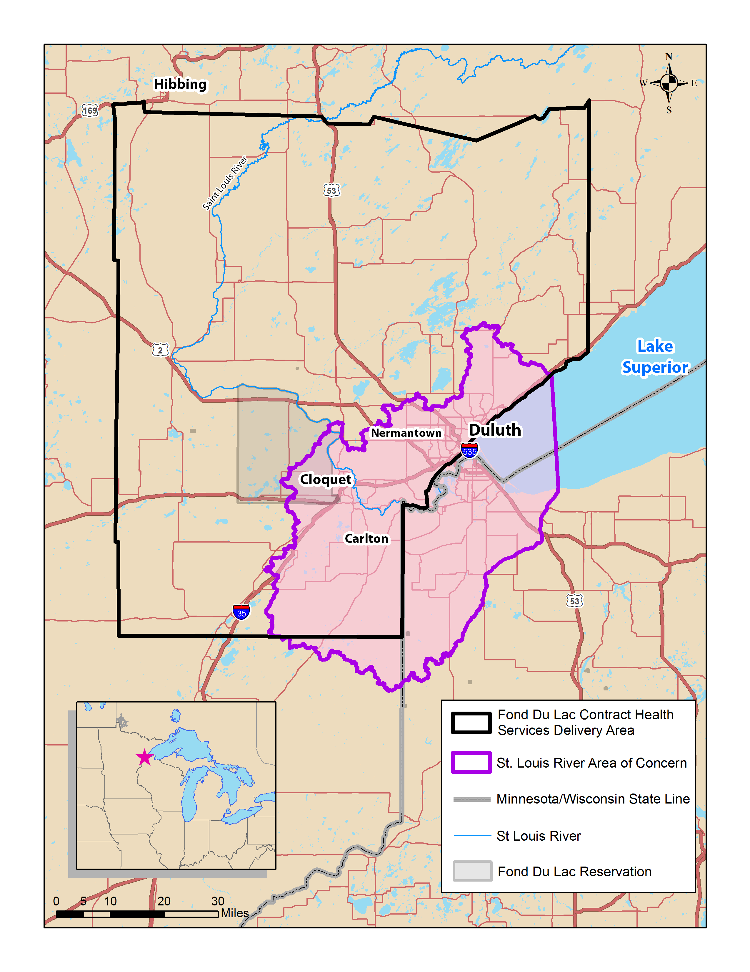
Supplemental Figure 2. Map of the Fond du Lac Contract Health Services Delivery Area (BGLP-I Study Area) and the St. Louis River Area of Concern.

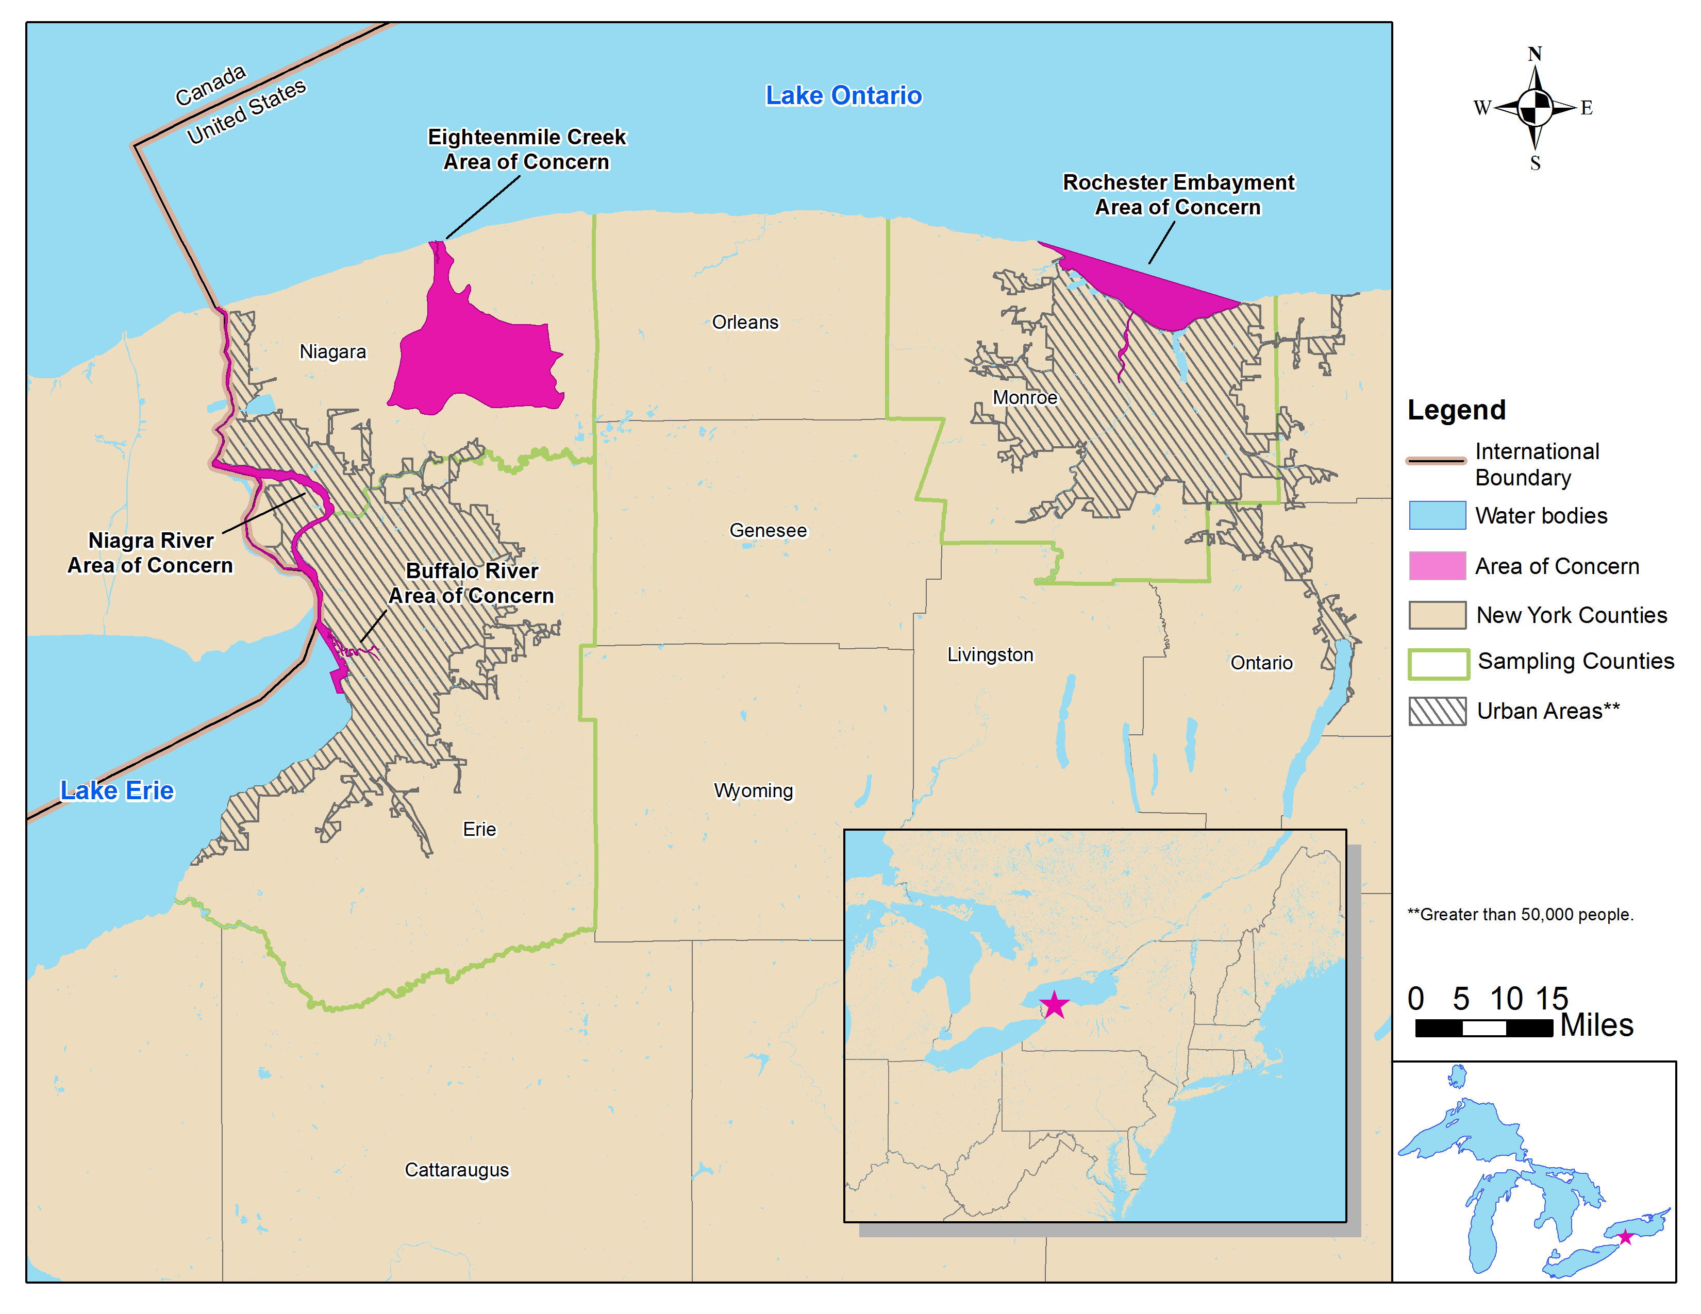
Supplemental Figure 3. Map of the New York State BGLP-I Program Targeted Areas of Concern and surrounding counties.

Supplemental Table 1. Summary of Recruitment Goals and Eligibility Criteria
 | Michigan Department of Health and Human Services | Minnesota Department of Health | New York State Department of Health  Licensed anglers | New York State Department of Health  Burmese refugees
Recruitment goal | 400 | 500 | 400 | 200
Eligibility Criteria
Characteristic
Age | 18 years and older | 18 years and older | 18-69 years in 2011 fishing license database | 18 years and older
Locally caught fish meals | At least 2 per month in the past year | None | At least 1 in the past year | At least 12 in the past year
Residency in area | At least 1 year | At least 1 year | At least 1 year | At least 1 year
Medically able to donate blood sample | Yes | Yes | Yes | Yes
Lost more than 15 pounds in the past year | Excluded | No exclusion | No exclusion | No exclusion
Pregnant women | Excluded (large volume of blood needed) | Excluded (culturally inappropriate to take blood) | No exclusion | No exclusion
Breast fed in past six months | Excluded | No exclusion | No exclusion | No exclusion

