Appendix A
References for individuals represented in Figure 1
and all 116 original internet URLs for online sources.
Use the numbers next to the individuals represented in Figure 1 below to find the associated internet links for the stories we used to build our transmission tree. The numbers associated with the stories we used for that individual are listed 15 in the Individuals listed in Figure 1 table, and can be looked up using the References numbers and URLs table.
For example, to find stories associated with the Nigeria index case (#15), find #15 in the Individuals listed in Figure 1 table immediately below Figure 1 and then look to the References numbers and URLs table. Use these numbers to find the internet links we used to build the stories related to this individual.
Figure 1

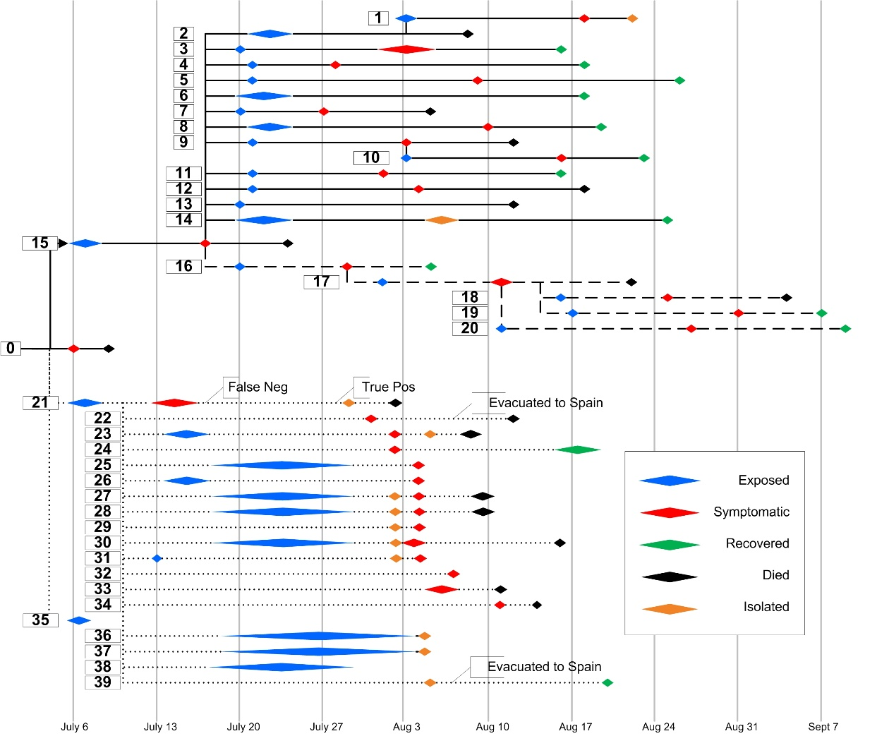

Individuals listed in Figure 1
Case # from Fig 1. Reference number(s)
- 13, 17, 18, 23, 25, 32, 62, 79
- 20
- 11, 20, 56, 114
- 56, 77
- 56, 77
- 36, 77
- 15, 19, 52, 108, 116
- 15, 56, 78, 114
- 19, 27, 40, 89, 116
- 6, 11, 20, 21, 50, 56, 73, 89, 102
- 11, 20, 56, 73
- 15, 56, 74, 107
- 9, 15, 21, 37, 38, 56, 81, 91, 100, 107, 110
- 4, 27, 31, 76, 101
- 81
- 4, 5, 6, 7, 8, 9, 12, 13, 15, 20, 21, 23, 25, 27, 31, 38, 41, 42, 63, 76, 89, 90, 91, 100, 101, 102, 104, 107, 108, 109, 116
- 41, 42, 45, 58, 63, 104, 109
- 29, 39, 42, 45, 55, 63, 104, 109, 112
- 39, 63
- 22, 29, 41, 105
- 22, 29, 63
- 14, 23, 32, 68, 99
- 32, 72, 99, 103
- 32, 51, 99
- 32, 51, 69
- 32
- 32
- 32, 99
- 32, 99
- 32
- 32, 68
- 32
- 32, 51, 69
- 32, 99
- 32, 99
- 23, 32
- 32
- 32
- 32
- 32, 51, 70, 103

Reference numbers and URLs
Reference | Original URL
1 | http://allafrica.com/stories/201405300804.html
2 | http://allafrica.com/stories/201406181683.html
3 | http://allafrica.com/stories/201407101069.html
4 | http://allafrica.com/stories/201408071299.html
5 | http://allafrica.com/stories/201408080625.html
6 | http://allafrica.com/stories/201408112155.html
7 | http://allafrica.com/stories/201408113253.html
8 | http://allafrica.com/stories/201408121178.html?page=2
9 | http://allafrica.com/stories/201408261017.html
10 | http://awoko.org/2014/06/02/sierra-leone-news-14-positive-three-die-of-ebola/
11 | http://blogs.unicef.org/2014/09/08/ebola-in-nigeria-a-survivors-story/
12 | http://cmiliberia.org/blog/2014/07/31/ebola-vaccine-ready-for-trial/
13 | http://cmiliberia.org/blog/2014/09/12/liberian-community-remembers-patrick-sawyer/
14 | http://crofsblogs.typepad.com/h5n1/2014/07/liberia-two-hospital-administrators-contract-ebola.html
15 | http://experts-dev.inpwrd.net/read?id=541253113
16 | http://frontpageafricaonline.com/index.php/health-sci/1944-deadly-ebola-bounces-back-in-liberia-10-unconfirmed-deaths
17 | http://frontpageafricaonline.com/index.php/op-ed/letters-comments/2562-ebola-the-deadliest-and-scariest-war
18 | http://frontpageafricaonline.com/index.php/politic/2476-letter-from-lagos-wish-liberia-had-done-this-much-to-curb-ebola
19 | http://naijaloaded.com/2014/08/18/good-news-four-more-ebola-patients-discharged-health-minister/
20 | http://naijaloaded.com.ng/2014/08/22/spouses-of-two-dead-nigerian-ebola-victims-test-positive-health-minister-confirms/
21 | http://ynaija.com/that-we-may-not-forget-dr-ameyo-adadevoh-justina-ejelonu/
22 | http://morenikejiblog.com/good-news-oau-student-testsnegative-late-enemous-wife-discharged/
23 | http://nationalchronicleliberia.com/news/health/1043/ebola-outbreak-no-immediate-solution-bad-news/
24 | http://nationalchronicleliberia.com/news/health/753/seven-die-in-monrovia-ebola-outbreak/
25 | http://nationalchronicleliberia.com/news/politics/1024/how-patrick-sawyer-contracted-ebola/
26 | http://nationalchronicleliberia.com/news/politics/792/ebola-on-the-rampage-in-monrovia-1/
27 | http://news.ecowas.int/presseshow.php?nb=150&lang=en&annee=2014
28 | http://news.sky.com/story/1293312/africa-battles-to-stop-deadly-spread-of-ebola
29 | http://newtelegraphonline.com/ebola-late-doctors-sister-339-others-discharged-minister/
30 | http://newtelegraphonline.com/my-ebola-story-nurse-infected-by-patrick-sawyer/
31 | http://northshorejournal.org/patrick-sawyer-the-ebola-killer
32 | http://www.myjoyonline.com/opinion/2014/October-2nd/the-ebola-crisis-in-st-joseph-catholic-hospital-liberia-as-witnessed.php
33 | http://politicosl.com/2014/06/ebola-hits-sierra-leone/
34 | http://promedmail.chip.org/pipermail/promed/2014-June/004320.html
35 | http://promedmail.chip.org/pipermail/promed/2014-June/004351.html
36 | http://saharareporters.com/2014/08/18/new-ebola-case-lagos-runaway-nurse-brought-back-enugu-discharged
37 | http://saharareporters.com/2014/08/19/dr-stella-adadevoh-first-doctor-attend-liberian-patrick-sawyer-dies-ebola
38 | http://saharareporters.com/2014/08/20/ameyo-adadevoh-i-knew-chidi-anselm-odinkalu
39 | http://scannewsnigeria.com/news/ebola-late-doctor-buried-in-ph/
40 | http://silverguyz.wapka.mobi/forum2_theme_110604812.xhtml?tema=332
41 | http://sunnewsonline.com/new/?p=80255
42 | http://theeagleonline.com.ng/ebola-how-nigerian-diplomat-infected-doctor-wife-their-three-month-old-baby/
43 | http://tlarremore.wordpress.com/2014/06/15/biological-hazard-hemorrhagic-fever-ebola-virus-disease-outbreak-continues-in-liberia/
44 | http://uncova.com/sad-top-liberian-doctor-treating-ebola-patients-dies
45 | http://uncova.com/update-10-things-you-should-know-about-ebola-in-port-harcourt
46 | http://wedoinsalone.tumblr.com/
47 | http://www.abc.net.au/news/2014-06-06/west-africa-ebola-outbreak-kills-at-least-200/5505046
48 | http://www.africareview.com/News/Sirleaf-consoles-hospital-staff-on-death-of-colleague/-/979180/2353026/-/format/xhtml/-/7uhciez/-/index.html
49 | http://www.afro.who.int/en/clusters-a-programmes/dpc/epidemic-a-pandemic-alert-and-response/outbreak-news/4143-ebola-virus-disease-west-africa-26-may-2014.html
50 | http://www.bellanaija.com/2014/08/14/ebola-nigerian-nurse-who-came-in-contact-with-patrick-sawyer-dies-at-25/
51 | http://www.cirm.org.mx/chantal-pascaline-mutwameme-nanebe
52 | http://www.cknnigeria.com/2014/08/ebolanurse-that-travelled-to-enugu-now.html
53 | http://www.critiqueecho.com/?p=5530
54 | http://www.dailymail.co.uk/news/article-2731473/Ebola-virus-spread-Sierra-Leone-one-healer.html
55 | http://www.dailytrust.com.ng/sunday/index.php/news-extra/18110-ebola-expatriates-flee-port-harcourt
56 | http://www.elombah.com/index.php/reports/26266-ebola-igbo-enterpreneurs-commend-fashola-for-support-to-first-consultants-hospital
57 | http://www.flutrackers.com/forum/showthread.php?t=220580&page=2
58 | http://www.flutrackers.com/forum/showthread.php?t=227005
59 | http://www.frontpageafricaonline.com/index.php/health-sci/2157-lives-at-risk-over-ebola-liberia-s-health-care-workers-in-danger
60 | http://www.frontpageafricaonline.com/index.php/news/91-health/2010-liberia-s-unheralded-fear-protecting-health-care-workers-from-ebola
61 | http://www.frontpageafricaonline.com/index.php/op-ed/letters-comments/2274-community-leadership-is-the-answer-to-protect-liberia-from-ebola
62 | http://www.gnnliberia.com/articles/2014/07/03/liberia-ugandan-medical-doctor-dies-ebola
63 | http://www.informationng.com/2014/08/how-late-doctor-deliberately-kept-ebola-infection-from-colleagues-rivers-govt.html
64 | http://www.ksdk.com/story/news/health/2014/08/06/nigerian-nurse-dies-of-ebola-as-death-toll-jumps/13669889/
65 | http://www.liberianobserver.com/health/ebola-resurfaces
66 | http://www.liberianobserver.com/health/stepping-campaign-against-ebola-health-promoters-commends-moh-partners
67 | http://www.liberianobserver.com/news/ebola-survivor-reunites-family
68 | http://www.mirror.co.uk/news/world-news/inside-ebola-hell-mirrorman-witnesses-4067533
69 | http://www.misionerasinmaculadaconcepcion.es/downloads/0001-buena-noticia.pdf
70 | http://www.misionerasinmaculadaconcepcion.es/downloads/comunicado-de-salida-.pdf
71 | http://www.mofa.gov.lr/public2/2press.php?news_id=1173&related=7&pg=sp
72 | http://www.mofa.gov.lr/public2/2press.php?news_id=1225&related=7&pg=sp
73 | http://www.naij.com/282896-ebola-fiance-dennis-akagha-speaks-survival-death-justina.html
74 | http://www.naij.com/291381-ebola-survival-story-dr-ada-igonoh-tells-full-ordeal.html
75 | http://thecallng.com/2014/08/dr-adadevohs-younger-sister-tested-negative-to-ebola-health-commissioner
76 | http://www.nairaland.com/1855166/ecowas-official-recieved-liberian-patrick
77 | http://www.nairaland.com/1863292/ebola-four-patients-declared-clean
78 | http://www.nbcnews.com/storyline/ebola-virus-outbreak/nigerian-nurse-who-treated-american-patrick-sawyer-dies-ebola-n173786
79 | http://www.newvision.co.ug/mobile/Detail.aspx?NewsID=657199&CatID=10
80 | http://www.newvision.co.ug/news/657141-ugandan-doctor-dies-of-ebola-in-liberia.html
81 | http://www.nigerianwatch.com/news/5170-dr-adadevohs-younger-sister-tests-positive-for-ebola-and-is-admitted-to-isolation-unit
82 | http://www.premiermedia.sl/content/six-new-suspected-cases-ebola
83 | http://www.promedmail.org/direct.php?id=20140528.2503946
84 | http://www.promedmail.org/direct.php?id=20140529.2506848
85 | http://www.promedmail.org/direct.php?id=20140531.2511620
86 | http://www.promedmail.org/direct.php?id=20140603.2515262
87 | http://www.promedmail.org/direct.php?id=20140615.2542247
88 | http://www.promedmail.org/direct.php?id=20140619.2553035
89 | http://www.punchng.com/metro-plus/how-lagos-nursing-mother-contracted-ebola-virus-doctor/
90 | http://www.reddit.com/r/ebola/comments/2eztba/damn_you_patrick_sawyer/
91 | http://www.reuters.com/article/2014/08/04/us-health-ebola-nigeria-idUSKBN0G413H20140804
92 | http://www.scribd.com/doc/229815355/Monday-June-16-2014-Edition
93 | http://www.scribd.com/doc/230280247/Wednesday-June-18-2014-Edition
94 | http://www.scribd.com/doc/230521623/Thursday-June-19-2014-Edition
95 | http://www.scribd.com/doc/231876206/Monday-June-30-2014-Edition
96 | http://www.scribd.com/doc/232396240/Thursday-July-03-2014-Edition
97 | http://www.scribd.com/doc/232807341/Monday-July-07-2014-Edition
98 | http://www.sierraexpressmedia.com/?p=67698
99 | http://www.staugustineprovinceofafrica.org/News1.html
100 | http://www.thecable.ng/editorial-fg-must-immortalise-dr-adadevoh
101 | http://www.frontpageafricaonline.com/index.php/politic/2661-muah-somersaults-reveals-patrick-sawyer-s-deception-over-nigeria-trip
102 | http://www.frontpageafricaonline.com/index.php/news/2636-clinging-on-to-life-nurse-who-treated-sawyer-battling-ebola
103 | http://www.thelocal.es/20140807/first-european-ebola-patient-arrives-in-spain
104 | http://www.thescoopng.com/rivers-health-commissioner-gives-details-of-how-amb-koye-took-ebola-to-port-harcourt/
105 | http://www.thisdaylive.com/articles/no-single-case-of-ebola-in-nigeria-says-chukwu/188681/
106 | http://www.tribune.com.ng/news/news-headlines/item/14444-adadevoh-s-sister-not-hospitalised-for-ebola-family/14444-adadevoh-s-sister-not-hospitalised-for-ebola-family
107 | http://www.vanguardngr.com/2014/08/dr-ameyo-adadevoh-woman-substance/
108 | http://www.vanguardngr.com/2014/08/ebola-nurse-flees-lagos-enugu/
109 | http://www.vanguardngr.com/2014/09/ebola-nigerians-want-ecowas-diplomat-jailed/
110 | http://www.vanguardngr.com/2014/09/survived-ebola-dennis-akagha/
111 | http://www.vanguardngr.com/2014/10/ebola-first-consultant-indicts-liberian-ambassador/
112 | http://www.who.int/mediacentre/news/ebola/3-september-2014/en/
113 | http://www.wuestenschiff.de/phpbb/ebola-guinea-liberia-sierra-leone-nigeria-cote-ivoire-t51201-60.html
114 | http://ynaija.com/ebola-died-place-dr-adadevoh-first-consultant-boss-recounts-losses/
115 | https://news.yahoo.com/sierra-leones-365-ebola-deaths-traced-back-one-065404276.html
116 | http://jokpeme.com/2014/08/12/revealed-how-lagos-nursing-mother-contracted-ebola-virus

